Mapping plant diversity in a northern boreal landscape using remotely sensed spectral variation
  - Supplementary information
  - Pauli Putkiranta¹, Aleksi Räsänen², Miska Luoto³, Heidi Mod³, Tarmo Virtanen¹
¹ Environmental Change Research Unit, Faculty of Biological and Environmental Sciences, P.O. Box 65, FI-00014 University of Helsinki, Finland
² Geography Research Unit, Faculty of Science, P.O. Box 8000, FI-90014 University of Oulu, Finland
³ BioGeoClimate Modelling Lab, Faculty of Science, P.O. Box 64, FI-00014 University of Helsinki, Finland

Plant data
Besides the genera listed in Section 2.1 of the article, some Stellaria individuals could only be identified to genus level. Other unidentified individuals (n=2) were included in taxonomic diversity metrics (as they were not members of any other species identified at their respective sites) but excluded from other analyses.

List of identified species
Table S1. Identified species and number of occurrences in each ecosystem.
Species | Peatland | Forest | Tundra
Achillea millefolium |  |  | 1
Agrostis capillaris |  | 1
Agrostis mertensii |  | 1
Alchemilla glomerulans |  |  | 1
Alchemilla sp. |  |  | 2
Alnus incana | 1 | 2
Andromeda polifolia | 121 | 9 | 1
Antennaria alpina |  |  | 2
Antennaria dioica |  | 2 | 7
Anthoxanthum nipponicum | 4 | 11 | 4
Arctostaphylos uva ursi |  | 1 | 15
Arctous alpina | 1 | 5 | 3
Avenella flexuosa | 22 | 86 | 76
Betula nana | 12 | 15 | 7
Betula pubescens | 3 | 34 | 2
Bistorta vivipara | 1 | 2 | 2
Botrychium boreale |  |  | 1
Calamagrostis lapponica | 6 | 11 | 29
Calamagrostis neglecta | 3 | 1
Calamagrostis phragmitoides | 26 | 28 | 4
Calluna vulgaris |  | 6 | 3
Caltha palustris | 8 | 1
Cardamine bellidifolia |  |  | 1
Cardamine pratensis | 1
Carex aquatilis | 35 | 11
Carex bigelowii |  |  | 5
Carex brunnescens | 2 | 2 | 17
Carex canescens | 43 | 28 | 8
Carex chordorrhiza | 25 | 1
Carex globularis | 1 | 2
Carex lachenalii |  |  | 2
Carex lasiocarpa | 34
Carex limosa | 4
Carex magellanica | 61 | 14 | 2
Carex nigra | 9 | 8 | 1
Carex pauciflora | 63 | 2
Carex rostrata | 96 | 3 | 1
Carex vaginata | 2 | 5 | 2
Carex vesicaria | 2 | 1
Cerastium alpinum | 1
Cerastium fontanum |  |  | 1
Chamaenerion angustifolium | 1 | 7 | 3
Cirsium heterophyllum | 2 | 3 | 1
Comarum palustre | 47 | 2
Corallorhiza trifida |  | 1
Cornus suecica | 8 | 49 | 13
Cryptogramma crispa |  |  | 5
Dactylorhiza maculata |  | 2
Dactylorhiza viridis |  | 2
Deschampsia cespitosa | 1 | 4 | 1
Diphasiastrum alpinum |  |  | 41
Diphasiastrum complanatum |  | 17 | 12
Drosera anglica | 5
Drosera rotundifolia | 61
Dryopteris expansa | 1
Empetrum nigrum | 9 | 81 | 19
Epilobium anagallidifolium |  |  | 2
Epilobium hornemannii | 2 | 2 | 3
Epilobium palustre | 9 | 3
Equisetum arvense | 5 | 6 | 2
Equisetum fluviatile | 25 | 2
Equisetum palustre | 8 | 8
Equisetum pratense | 9 | 13 | 4
Equisetum sylvaticum | 28 | 3
Eriophorum angustifolium | 73 | 1 | 1
Eriophorum russeolum | 24
Eriophorum vaginatum | 97 | 7 | 2
Eupharsia wettsteinii |  |  | 1
Euphrasia stricta |  |  | 1
Festuca ovina |  | 8 | 67
Festuca rubra | 1 |  | 1
Filipendula ulmaria | 4 | 1
Galium palustre |  | 1
Galium trifidum | 4 | 2
Galium uliginosum | 2 | 1
Geranium sylvaticum | 5 | 22 | 3
Goodyera repens |  | 1
Gymnocarpium dryopteris | 1 | 3 | 5
Hieracium | 1 | 16 | 12
Hippuris vulgaris | 1
Huperzia selago |  |  | 11
Juncus filiformis | 13 | 7 | 4
Juncus trifidus |  | 1 | 91
Juncus triglumis | 4
Juniperus communis | 9 | 5 | 64
Kalmia procumbens |  |  | 15
Linnaea borealis | 12 | 76 | 78
Luzula confusa | 1
Luzula multiflora | 1
Luzula pilosa |  | 24 | 13
Luzula sudetica | 2
Lycopodium clavatum |  | 1 | 18
Lysimachia europaea | 35 | 69 | 38
Maianthemum bifolium |  | 4
Melampyrum pratense | 32 | 64 | 15
Melampyrum sylvaticum | 5 | 18 | 2
Melica nutans |  | 2 | 1
Menyanthes trifoliata | 47 | 1
Milium effusum |  | 1 | 2
Moneses uniflora | 1 | 1
Myriophyllum spicatum |  | 1
Nardus stricta | 2 | 5 | 6
Neottia cordata | 14 | 33 | 3
Omalotheca norvegica |  | 1 | 3
Omalotheca supina |  |  | 1
Omalotheca sylvaticum | 1
Orthilia secunda | 4 | 19 | 5
Parnassia palustris | 1
Pedicularis lapponica | 3 | 3 | 5
Pedicularis palustris | 1
Phegopteris connectilis |  | 1
Phleum alpinum |  |  | 3
Phyllodoce caerulea |  | 1 | 69
Picea abies | 37 | 45 | 7
Pinguicula villosa | 5
Pinus sylvestris | 6 | 5 | 5
Poa alpigena |  | 2 | 1
Poa alpina |  |  | 1
Unidentified Poaceae |  | 1
Populus tremula |  | 4
Pseudathyrium alpestre |  |  | 1
Pyrola minor | 6 | 7 | 2
Pyrola rotundifolia | 14 | 14 | 1
Ranunculus acris | 1 | 7 | 4
Ranunculus lapponicus |  | 4
Ranunculus sp. |  | 2
Rhododendron tomentosum | 56 | 4 | 1
Ribes spicatum |  | 1
Rubus arcticus | 7 | 12
Rubus chamaemorus | 114 | 3 | 4
Rubus saxatilis |  | 3
Salix caprea | 1 | 3
Salix glauca | 27 | 16 | 9
Salix glauca x phylicifolia |  | 1
Salix hastata | 3 | 5 | 1
Salix herbacea |  |  | 4
Salix lanata |  |  | 2
Salix lapponum | 44 | 9 | 6
Salix myrsinifolia |  | 3
Salix myrtilloides | 15
Salix phylicifolia | 19 | 11 | 4
Scheuchzeria palustris | 22
Selaginella selaginoides | 2 | 2 | 1
Sibbaldia procumbens |  |  | 3
Solidago virgaurea | 7 | 55 | 48
Sorbus aucuparia | 4 | 35 | 11
Sparganium sp. | 1
Spinulum annotinum | 7 | 45 | 17
Stellaria borealis | 8 | 5 | 2
Stellaria nemorum | 1
Stellaria sp. | 2 | 2
Taraxacum sp. |  | 4 | 2
Trichophorum alpinum | 2
Trichophorum cespitosum | 2
Trollius europaeus |  | 1 | 1
Vaccinium microcarpum | 121 | 1
Vaccinium myrtillus | 49 | 93 | 83
Vaccinium oxycoccos | 67
Vaccinium uliginosum | 94 | 43 | 43
Vaccinium vitis idaea | 48 | 94 | 17
Vahlodea atropurpurea |  | 1
Veronica alpina |  |  | 1
Veronica serpyllifolia |  |  | 1
Viola epipsila | 11 | 12
Viola palustris | 3 | 1

Community data ordination and site classification
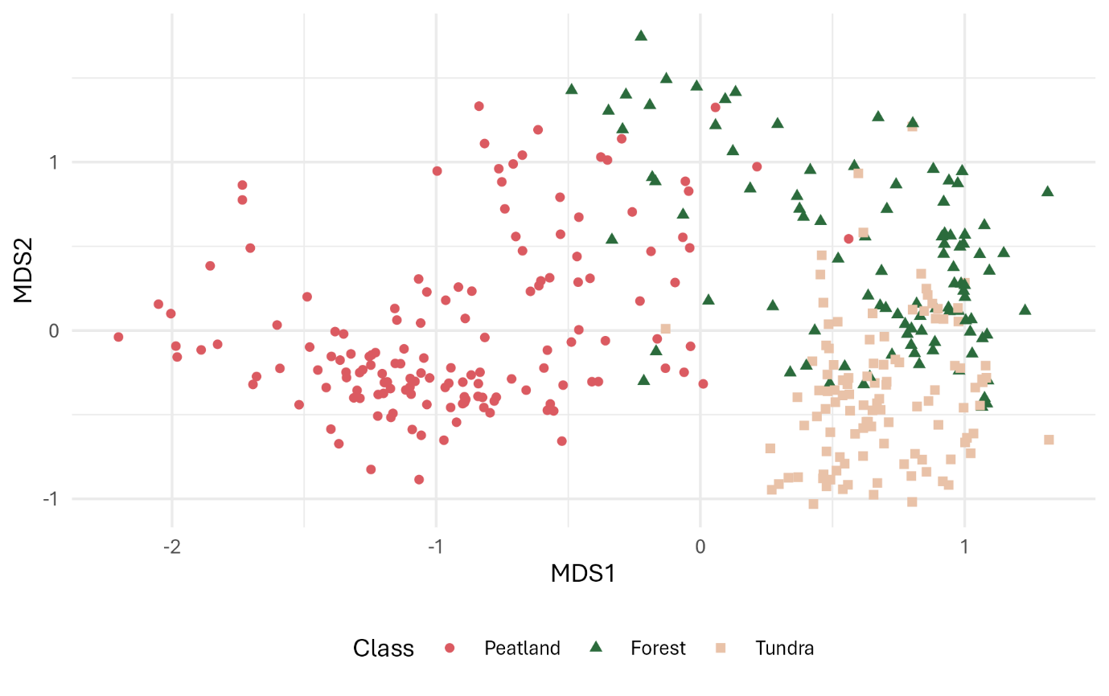
Figure S1. Sites with classifications plotted in two-dimensional ordination space. Ordination was performed in three dimensions using non-metric multidimensional scaling with Bray-Curtis dissimilarities (metaMDS in vegan; Oksanen et al., 2024). The stress of the ordination was 0.10.

Plant diversity metrics

Cross-correlations between plant diversity metrics
Many plant diversity metrics were strongly cross-correlated (Figure S2). While we excluded some with even stronger correlations, we included these to have a relatively large selection with representation of taxonomic (including beta diversity), phylogenetic, and functional metrics, as well as one indicator-based metric.
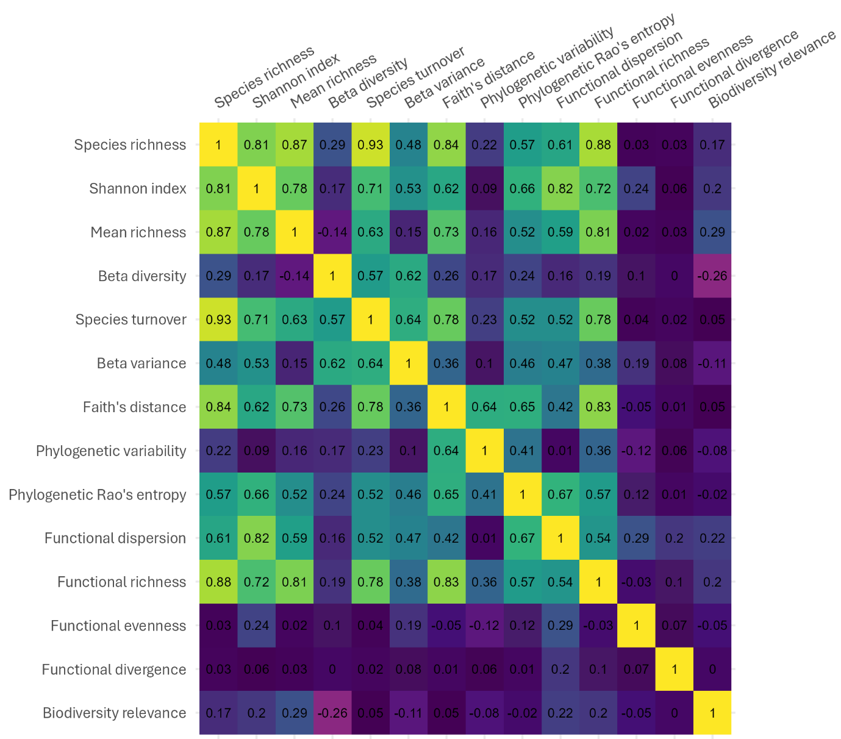
Figure S2. Cross-correlations between selected plant diversity metrics as Pearson’s coefficients.

Functional diversity
Table S2. Traits used for calculating functional diversity metrics, selected for variety and based on availability.
Trait | Description | Source
Height | Mean of height measurements | Own measurements, TRY (Kattge et al., 2020) where unavailable
Lateral spread | Lateral spread describing vegetative reproduction | TRY
LDMC | Leaf dry mass per leaf fresh mass | TRY
Leaf carbon content | the ratio of the mass of carbon in the leaf or component thereof, i.e. leaf lamina or leaflet per respective unit dry mass | TRY
Leaf nitrogen content | the ratio of the mass of nitrogen in the leaf or component thereof, i.e. leaf lamina or leaflet per respective unit dry mass | TRY
Leaf phosphorus content | the ratio of the mass of phosphorus in the leaf or component thereof, i.e. leaf lamina or leaflet per respective unit dry mass | TRY
Mycorrhizal intensity | Mycorrhizal infection intensity | TRY
Nectar production | Sugar production per area and year occupied by the species (i.e. considering the number of flowers produced and the duration of the flowering season) | Tyler et al., 2021
RDMC | Root dry mass per root fresh mass | TRY
Rooting depth |  | TRY
Seed mass |  | TRY
Specific leaf area | Leaf area per leaf dry mass | TRY
Growth form | One of: aquatic, fern, grass, herb, shrub, tree. | TRY
Nitrogen fixation | The ability or inability to form symbioses with bacteria capable of fixing atmospheric nitrogen (binary) | Tyler et al., 2021
Phenology type | Evergreen or deciduous (binary) | TRY
Strategy | Degree of each element of CSR (competitor, stress-tolerant, ruderal), quantified in three dimensions (C strategy, S strategy, R strategy) so that their sum is 1 for each species (i.e., a plant employing all strategies gets values 0.33 in all dimensions while a C strategy plant gets 1 in C strategy and 0 in others). This 3-dimensional quantification was chosen over categorisation since it can account for the relative similarity or dissimilarity of strategy combinations (i.e., CS is closer to C than to R).
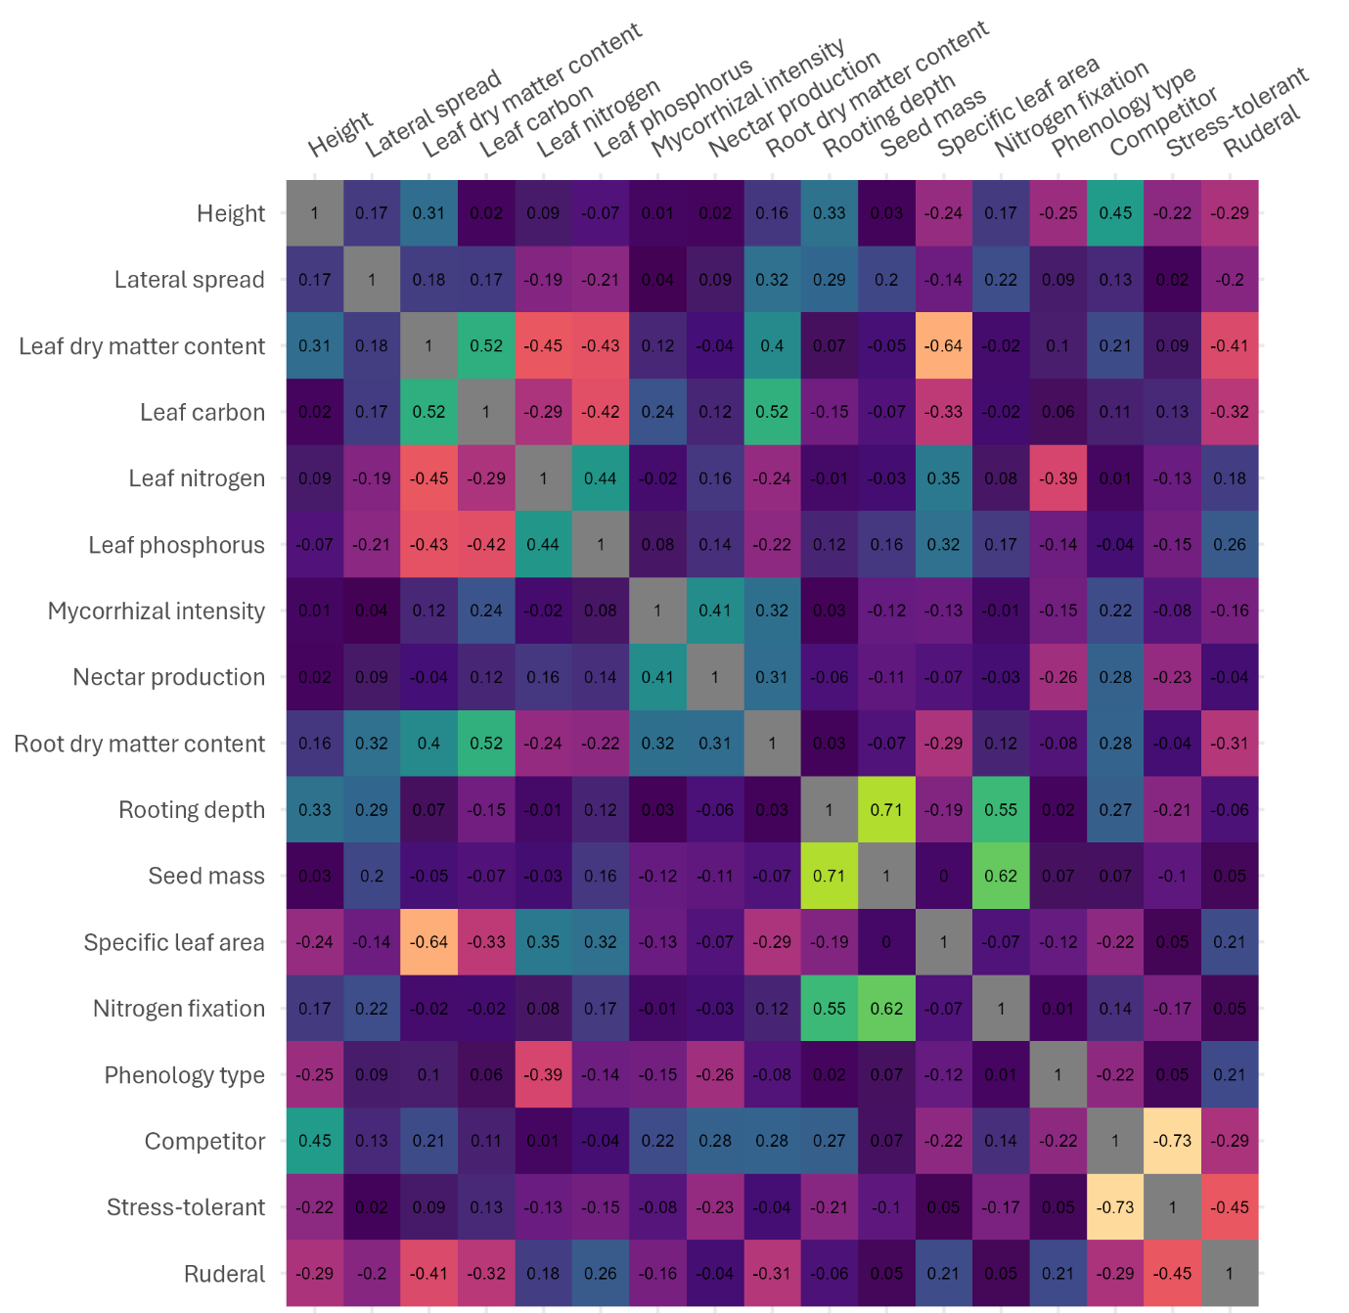
Figure S3. Pearson's correlation coefficients between different numeric traits for species in our data. Pollinator dependence was excluded because of correlation with nectar production, and limited variation (possible values 0, 1, 2, while nectar production varied continuously).

Remote sensing data
We combined some bands of WV3 and S2 imagery to increase cross-comparability, details of which are given in Table S3. From satellite data, we derived four explanatory datasets and modelling approaches, which are specified in Table S4. S2 data were available for 26 sites with no WV3 data (2 in peatlands, 17 in forests, and 7 in tundra), and we checked for statistically significant changes in the distributions of temporal spectral variation and plant diversity metrics between the original data and data where the sites with no WV3 data were removed. These data were not significantly different for any variable according to Kolmogorov–Smirnov tests (Figure S4) and thus we used the larger dataset for models with only S2 data.
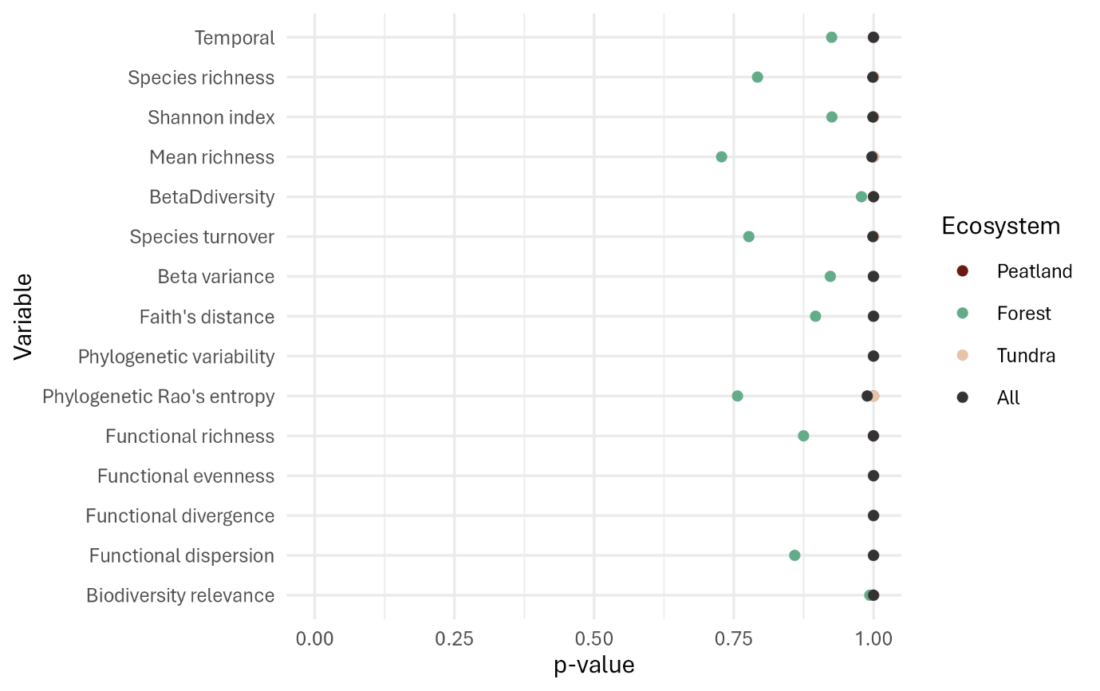
Figure S4. Two-sample Kolmogorov–Smirnov test p-values for the null hypothesis that samples from 1) the full dataset and 2) data where sites without WV3 data were removed come from the same distribution.
Table S3. Sentinel-2 and WorldView-3 approximate band correspondences, including definitions of bands or values used for index calculation (column C), which are given abbreviations. Res: spatial resolution of the band; λ: central wavelength of the band. Some bands with similar central wavelengths are not listed together as they differ notably in bandwidth.
C |  | S2 |  |  |  | WV3
 |  | Name | Res | λ |  | Name | Res |  | λ
 |  | B01 | 20 | 443 |  | Coastal Blue | 1.24 |  | 425
 |  | B02 | 10 | 490 |  | Blue | 1.24 |  | 480
G |  | B03 | 10 | 560 |  | Green | 1.24 |  | 545
 |  |  |  |  |  | Yellow | 1.24 |  | 605
R |  | B04 | 10 | 665 |  | Red | 1.24 |  | 660
 |  | B05 | 20 | 705
 |  | B06 | 20 | 740
RE |  | $$\frac{B05+B06}{2}$$ |  |  |  | Red edge | 1.24 |  | 725
 |  | B07 | 20 | 783
NIR |  | B08 | 10 | 842 |  | Near infrared 1 |  | 1.24 | 832.5
 |  | B8A | 20 | 865
 |  |  |  |  |  | Near infrared 2 |  | 1.24 | 950
 |  | B09 | 60 | 945
 |  |  |  |  |  | SWIR1 |  | 3.6 | 1110
 |  |  |  |  |  | SWIR2 |  | 3.6 | 1570
 |  |  |  |  |  | SWIR3 |  | 3.6 | 1660
SWIR1 |  | B11 | 20 | 1610 |  | $$\frac{SWIR2+SWIR3}{2}$$
 |  |  |  |  |  | SWIR4 |  | 3.6 | 1730
 |  |  |  |  |  | SWIR5 |  | 3.6 | 2165
 |  |  |  |  |  | SWIR6 |  | 3.6 | 2205
 |  |  |  |  |  | SWIR7 |  | 3.6 | 2260
 |  |  |  |  |  | SWIR8 |  | 3.6 | 2330
SWIR2 |  | B12 | 20 | 2190 |  | $$\frac{SWIR5+SWIR6+SWIR7+SWIR8}{4}$$

Radiometric validation
We compared NGRDI, NDREI, and NSDSI values derived from the WV3 image (July 9, 2023) and the temporally nearest available S2 image (July 12, 2023). Within the WV3 footprint, we created 100 randomly located points with at least 500 m spatial distance. We then removed points that were obscured by clouds in either image or that were over bodies of water (leaving 69 points for the analysis). We created a 20 m buffer around the points and extracted index values from WV3 and S2 data as weighted means within these areas. Finally, we calculated Pearson’s correlation coefficients between index values obtained from each data source (also Figure S5). While index numerical values were slightly different between the two sensors, correlations were strong.
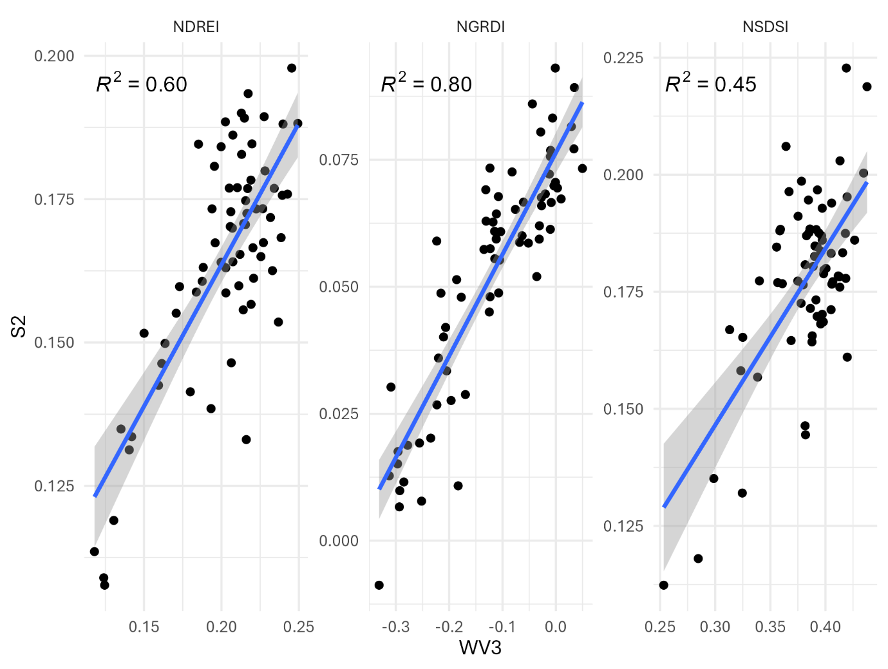
Figure S5. Scatterplots between NDREI, NGRDI, and NSDSI values derived from WV3 and S2 data.

Components of spectral variation
Spectral variation in different indices along spatial and temporal dimensions followed divergent spatial patterns (Figure S6). WV3-based spectral variation demonstrated some instability, and north–south-sweeping imaging patterns were discernible. Spatial variation in NSDSI showed high values at the western edge of the study area with no obvious environmental basis. Different indices also exhibit different amounts of variation (Figure S7), with NGRDI varying most in both space and time, and NSDSI varying least in space.
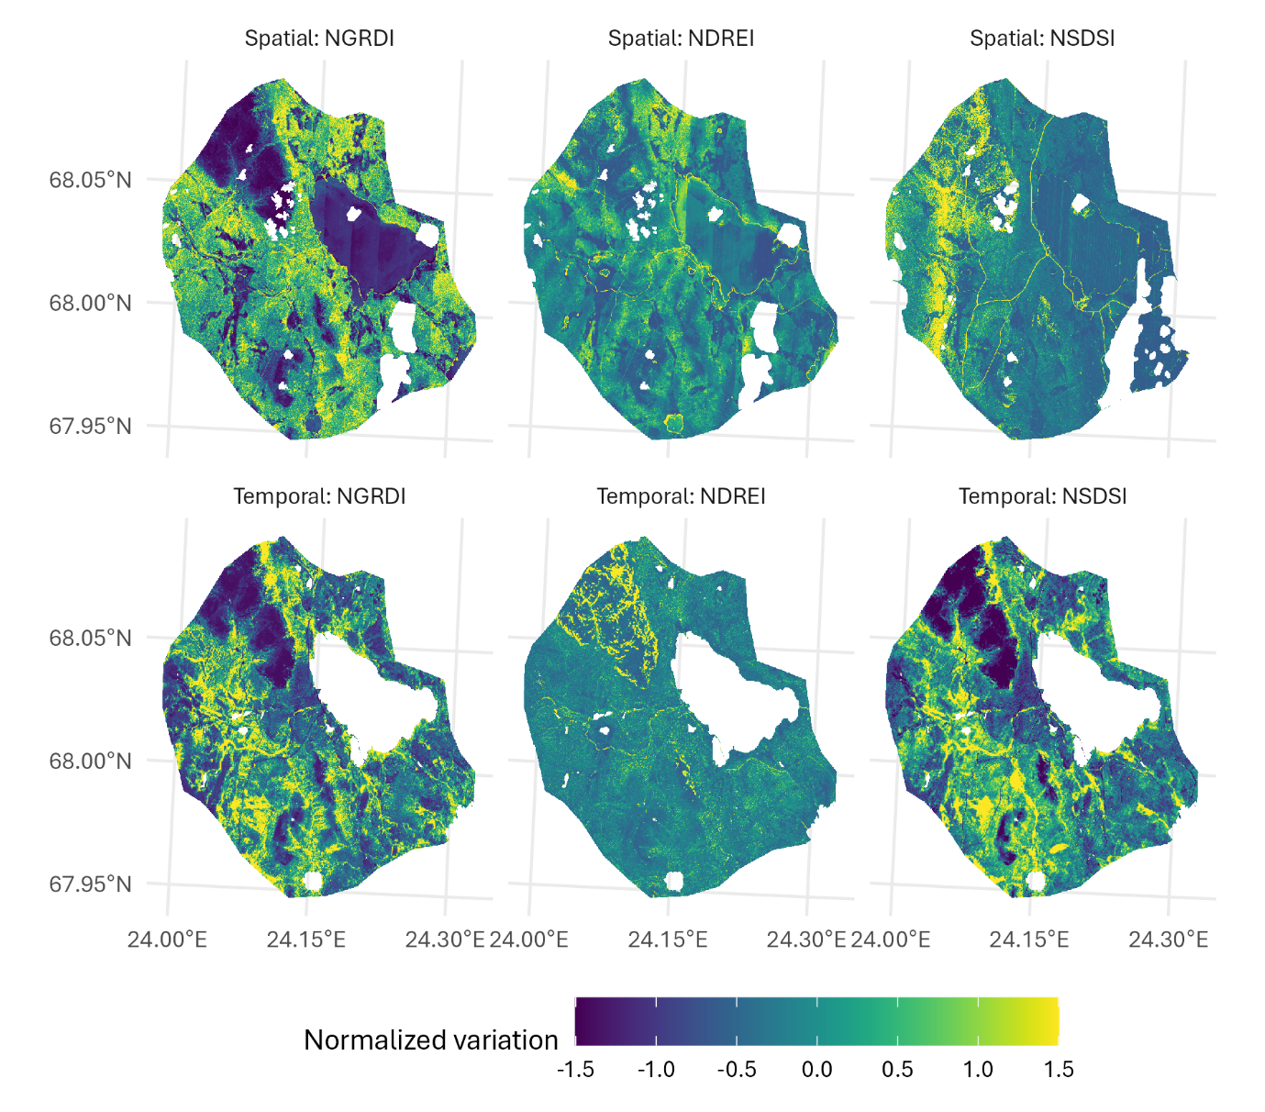
Figure S6. Normalized (µ: 0, σ: 1) variance in chosen vegetation indices in space (top row; cropped to WV3 footprint and clouds masked) and time (bottom row).
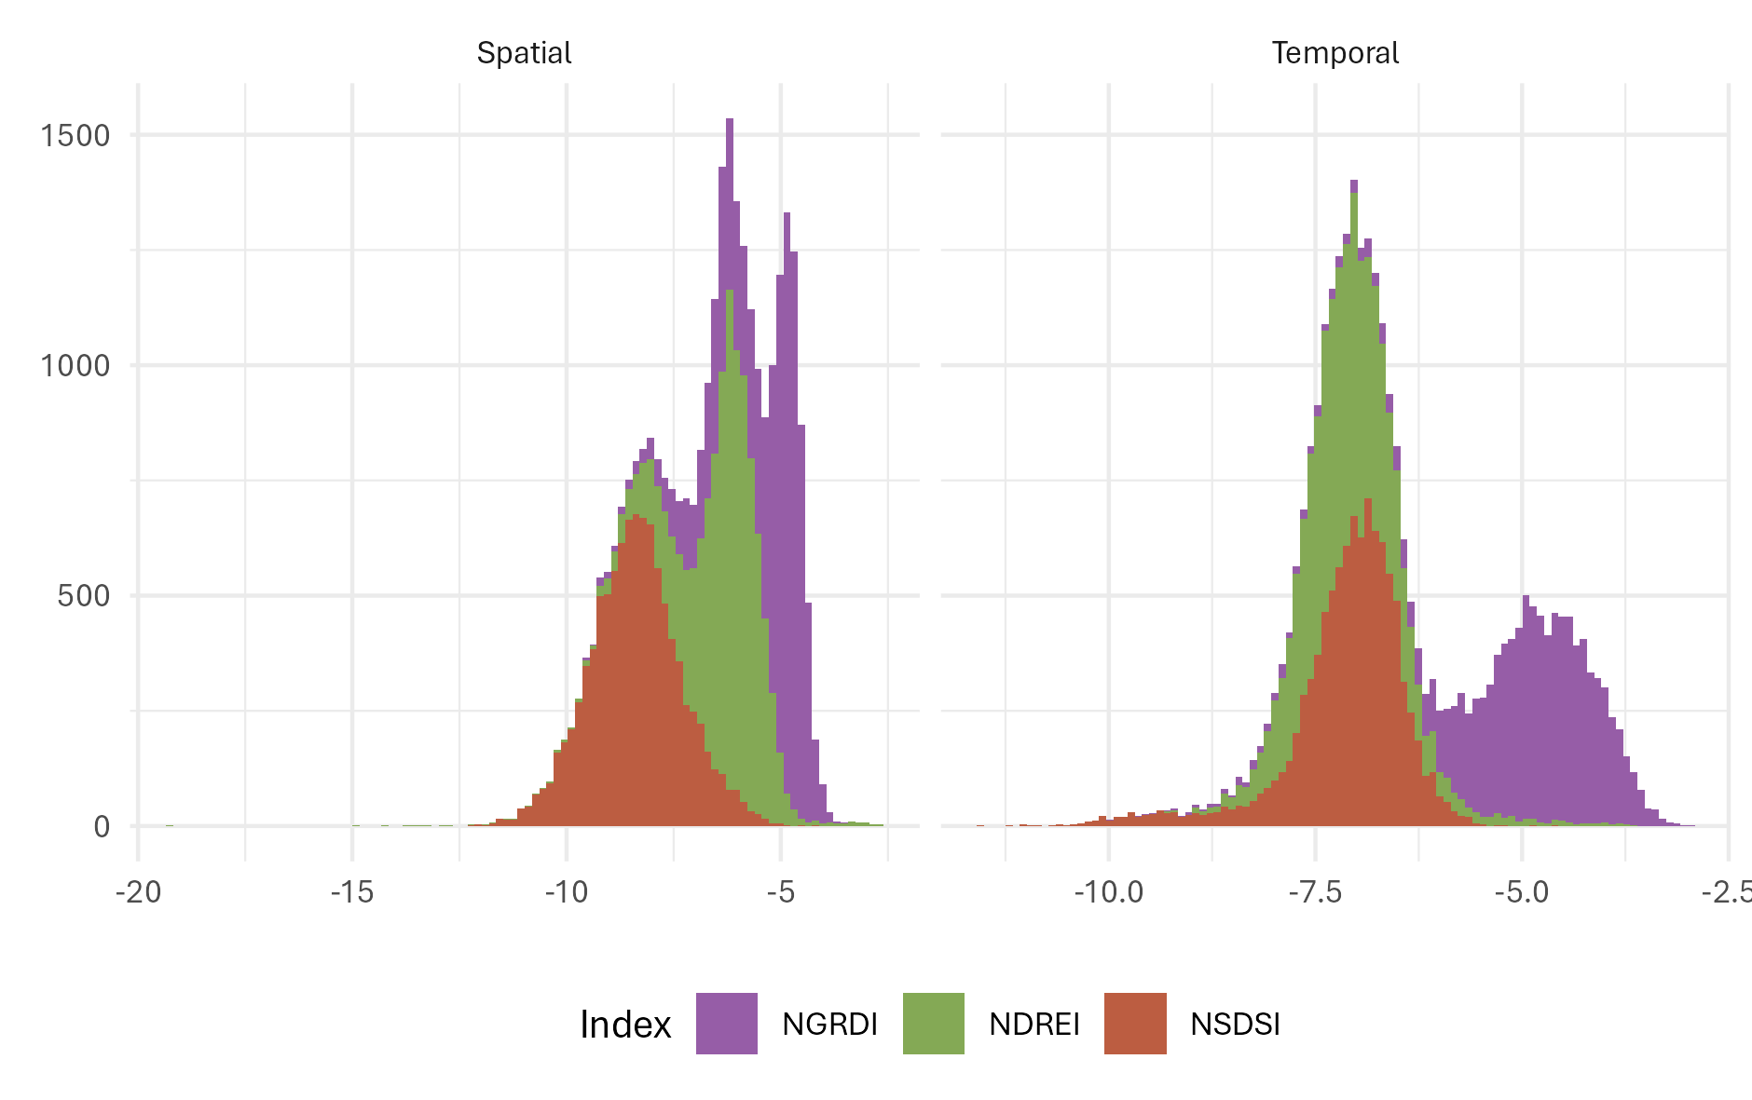
Figure S7. Distributions of (log-transformed) variance in the three vegetation indices that were averaged to obtain spectral variation values. Histograms are drawn using 10 000 randomly sampled points of each component across the study area.

Source data and resolution for spatial spectral variation
We used WV3 data to calculate spatial spectral variation at our sites because the high spatial resolution allowed windows of approximately the same size as the field sites. Using S2 data would have required increasing window size to at least 30 m (for a 3×3 pixel window), but in practice 60 metres, since most bands come at a 20 m resolution. Even in this approach, the higher-resolution WV3 data captures more variation in the landscape by an order of magnitude (Figure S8 right panel). Moreover, the difference between spatial variation as calculated from WV3 and S2 data differs between ecosystems. Most notably, while forest sites have highest spatial variation when calculated from WV3 data, they have lowest spatial variation in S2 data.
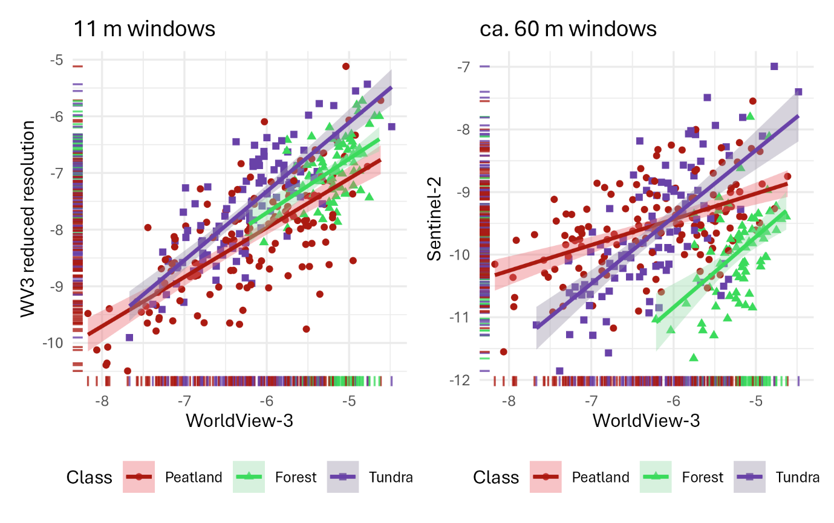
Figure S8. Natural logarithms of spatial spectral variation values at plots, calculated from NGRDI, NDREI, and NSDSI with original 1.22 m and reduced 3.6 m resolution WV3 data (left panel), and WV3 and S2 data in windows of roughly equal 60-metre size (right panel).
Additionally, the resolution of WV3 data used to compute spatial spectral variation had impacts on the observed amount of spatial spectral variation. We tested downsampling WV3 VNIR indices to 3.6 m resolution (equal to WV3 SWIR bands) and computing spatial spectral variation in 3×3-pixel windows, and again, spatial spectral variation was lower with reduced-resolution data. Moreover, reducing resolution (and thus, window size) reduced spatial variation more in peatlands and forests than in tundra. Our interpretation of these results was that more of the spatial variation in the target was captured with higher-resolution data, thus validating the use of original-resolution VNIR data.

Statistical modelling

Model variables
Table S4. Variables listed and briefly explained for each of four modelling approaches.
Model | List of variables | Additional explanation
Spatial | Spatial spectral variation | Mean of variances in NGRDI, NDREI, and NSDSI, each computed within approximately 11×11 m² windows from WV3 data.
Temporal | Temporal spectral variation | Mean of variances in NGRDI, NDREI, and NSDSI, each computed over June, July, August, and September 40th-percentile mosaics from S2 data.
Multivariate | Spatial, Temporal
Random forest | Spatial, Temporal, Coastal, Blue, Green, Yellow, Red, RedEdge, NIR1, NIR2, SWIR1, SWIR2, SWIR3, SWIR4, SWIR5, SWIR6, SWIR7, SWIR8, NDVI, NDREI, NGRDI, NSDSI, Jun_B01, Jun_B02, Jun_B03, Jun_B04, Jun_B05, Jun_B06, Jun_B07, Jun_B08, Jun_B8A, Jun_B09, Jun_B11, Jun_B12, Jun_NDVI, Jun_NDREI, Jun_NGRDI, Jun_NSDSI, Jul_B01, Jul_B02, Jul_B03, Jul_B04, Jul_B05, Jul_B06, Jul_B07, Jul_B08, Jul_B8A, Jul_B09, Jul_B11, Jul_B12, Jul_NDVI, Jul_NDREI, Jul_NGRDI, Jul_NSDSI, Aug_B01, Aug_B02, Aug_B03, Aug_B04, Aug_B05, Aug_B06, Aug_B07, Aug_B08, Aug_B8A, Aug_B09, Aug_B11, Aug_B12, Aug_NDVI, Aug_NDREI, Aug_NGRDI, Aug_NSDSI, Sep_B01, Sep_B02, Sep_B03, Sep_B04, Sep_B05, Sep_B06, Sep_B07, Sep_B08, Sep_B8A, Sep_B09, Sep_B11, Sep_B12, Sep_NDVI, Sep_NDREI, Sep_NGRDI, Sep_NSDSI | After spatial and temporal, WV3 data are listed, and then S2 data, which are prefixed with imaging month. Final model parametres are a subset based on variable selection.

Generalized linear models
Table S5. Explanatory (first two) and response (other) variables for generalized linear modelling, with information on possible values and applied transformations (explanatory) and link functions (response).
Variable | Possible values | Transformations / link functions | Model families
Spatial spectral variation | [0, 1] | identity, log | All
Temporal spectral variation | [0, 1] | identity, log | All
Species richness | $$Z_{0}^{+}$$ | identity, log | Gaussian, gamma, Poisson
Shannon’s index | $R_{0}^{+}$ | identity, log | Gaussian, gamma
Mean SR | $$R_{0}^{+}$$ | identity, log | Gaussian, gamma
Beta diversity | [0, 1] | identity, log, inverse | Gaussian, gamma
Species turnover | $$R_{0}^{+}$$ | identity, log | Gaussian, gamma
Beta variance | [0, 1] | identity, log, inverse | Gaussian, gamma
Faith’s distance | $$R_{0}^{+}$$ | identity, log | Gaussian, gamma
Phylogenetic variability | [0, 1] | identity, log, inverse | Gaussian, gamma
Phylogenetic Rao’s entropy | $$R_{0}^{+}$$ | identity, log | Gaussian, gamma
Functional dispersion | [0, 1] | identity, log, inverse | Gaussian, gamma
Functional richness | [0, 1] | identity, log, inverse | Gaussian, gamma
Functional evenness | [0, 1] | identity, log, inverse | Gaussian, gamma
Functional divergence | [0, 1] | identity, log, inverse | Gaussian, gamma
Biodiversity relevance | $$R_{0}^{+}$$ | identity, log | Gaussian, gamma

Spectral variation–plant diversity relationships

Spatial spectral variation
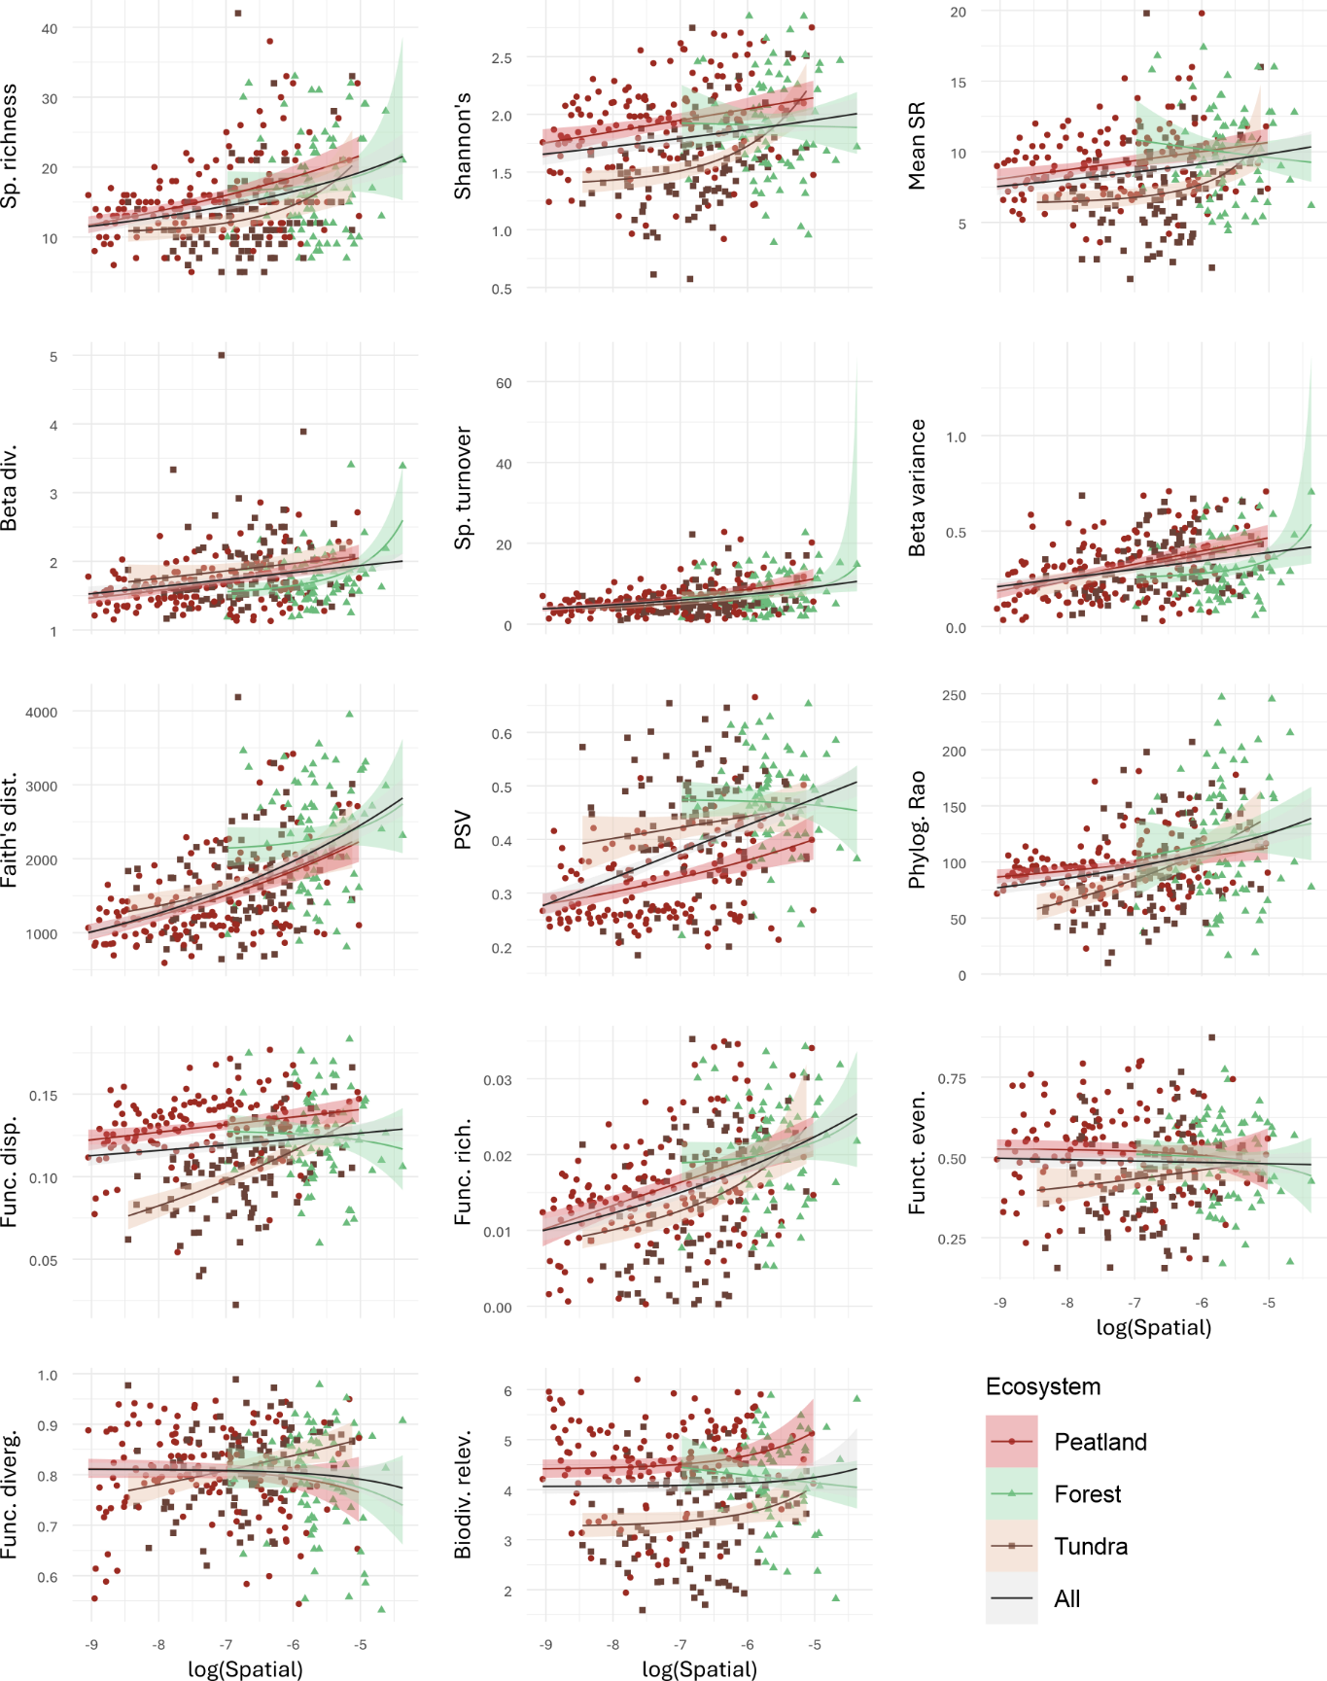
Figure S9. Scatterplots between all examined plant diversity metrics and spatial spectral variation, with best-fitting trendlines for each ecosystem.

Temporal spectral variation
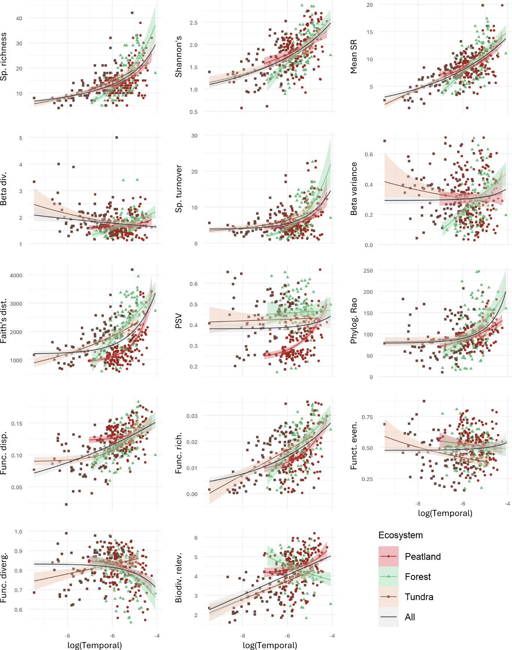
Figure S10. Scatterplots between all examined plant diversity metrics and temporal spectral variation, with best-fitting trendlines for each ecosystem.

Shadow masking

Methods
We constructed a shadow mask by 1) building a training dataset of shadow and non-shadow points in the WV3 VNIR image (41 points in each class), 2) training a simple random forest classifier on WV3 VNIR bands (overall accuracy 93%), 3) predicting a shadow mask for WV3 VNIR data, and 4) computing spatial spectral variation only from non-shadow pixels. The WV3 SWIR resolution was low enough that shadows were not visually identifiable in forested areas, so did not apply this process to the SWIR bands.

Results
Effects of shadow masking were minimal in peatlands and tundra, but in forests, the previously significant correlations with beta diversity and variance became insignificant, while a significant negative correlation was found with biodiversity relevance (Figure S11).

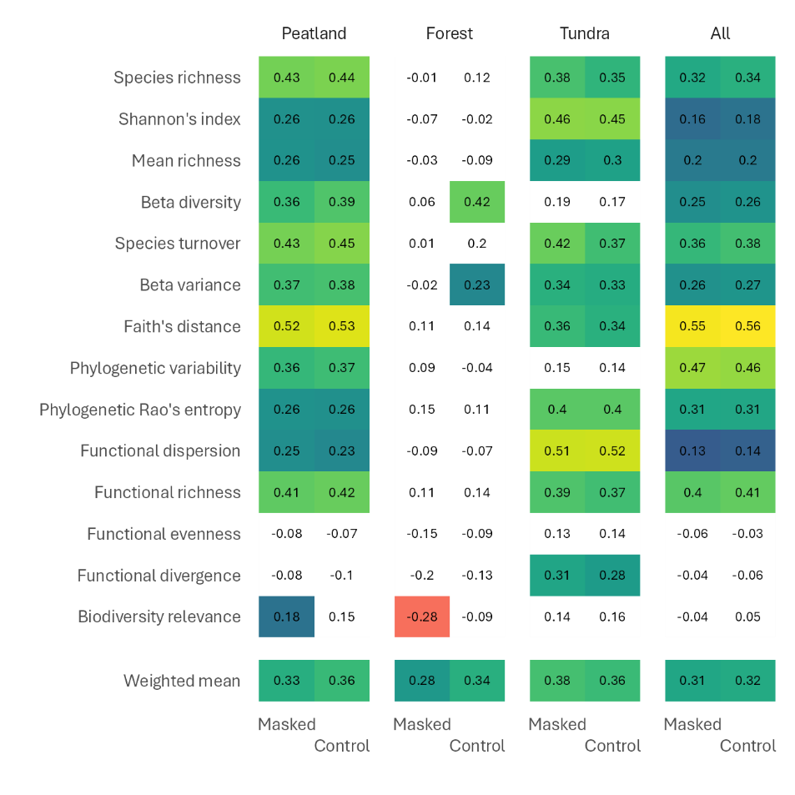
Figure S11. Correlations between spatial spectral variation and plant diversity metrics with shadows masked and not (Control).

Peatland temporal spectral variation
Temporal spectral variation in peatlands had a bimodal distribution, where one mode seemed to correspond to wooded peatlands and the other to open peatlands (Figure S12). Canopy cover was visually estimated in the field.
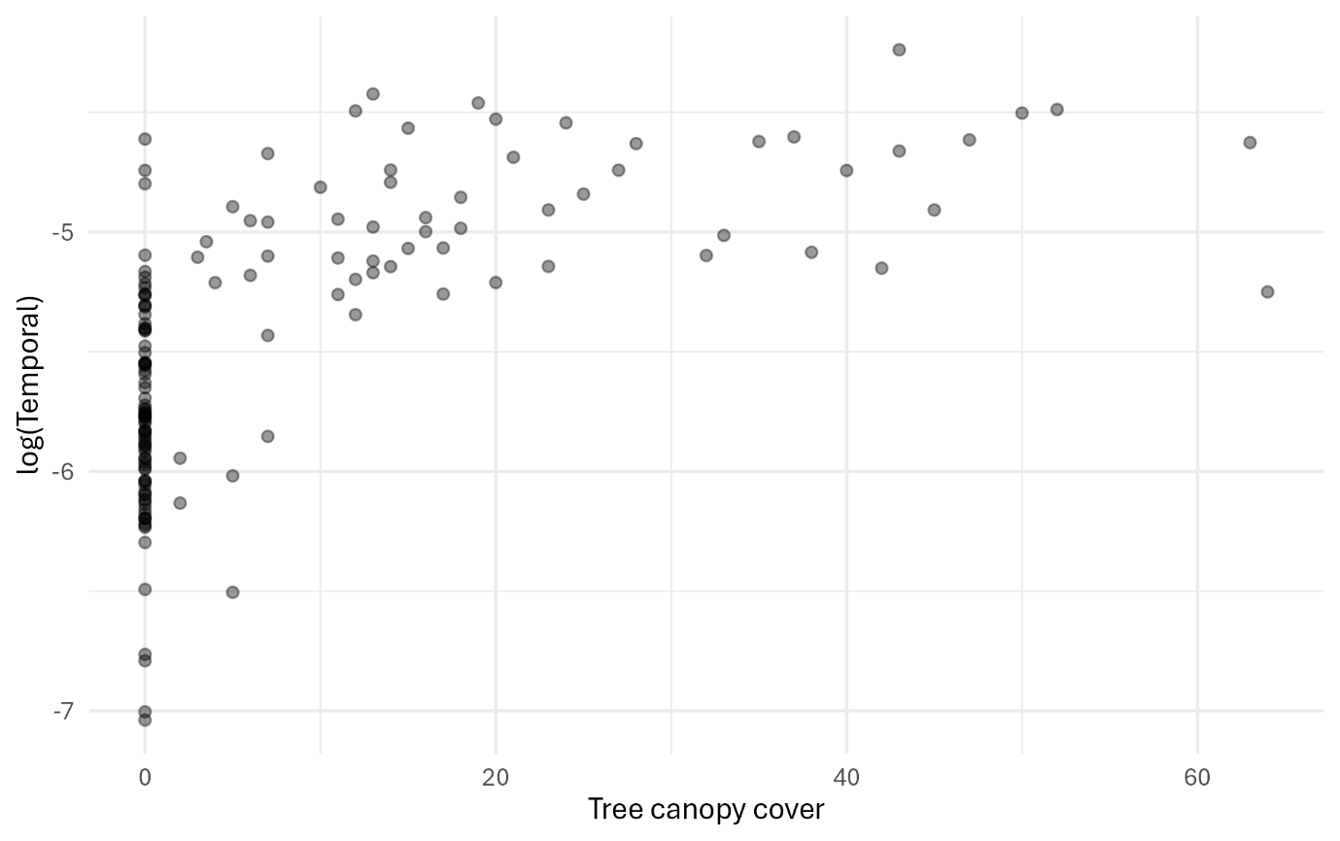
Figure S12. Temporal spectral variation in peatland sites as a function of canopy cover. Points are transparent to show bimodality at 0 canopy cover.

Faith’s distance
The relatively high correlations of spectral variation with Faith’s distance can, perhaps, be explained by the fact that phylogenetic data add variation to species data (Figure S13).
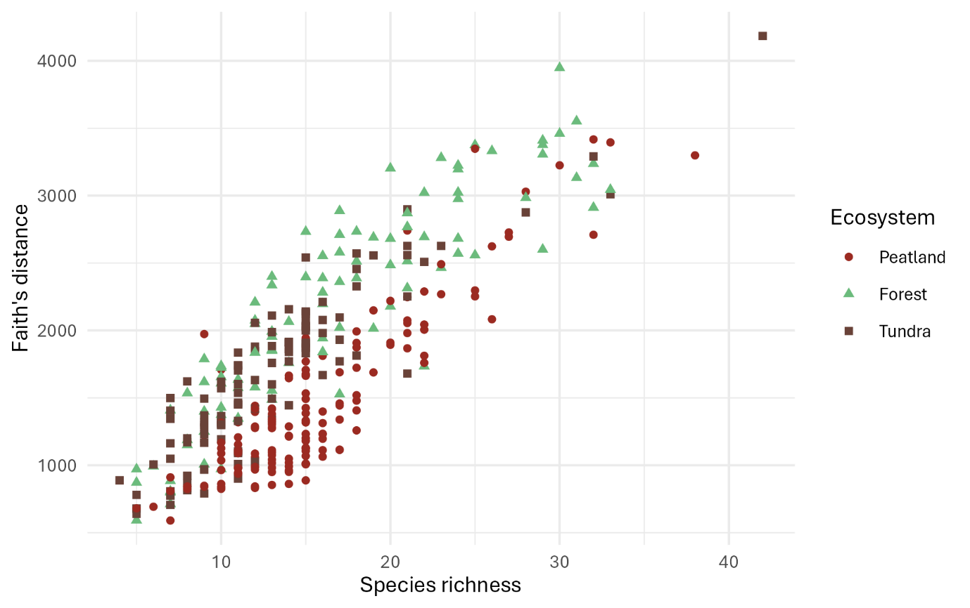
Figure S13. Faith's distance as a function of species richness in peatlands, forests and tundra.

Computing temporal spectral variation
As an alternative approach to 5-year monthly 40th percentile S2 mosaics, we calculated temporal spectral variation from S2 data by computing variance across four specific 2024 images (dates 30 May, 14 July, 6 August, and 15 September 2024). The low availability of cloud-free satellite data restricted the size of the time series, and we chose four almost completely cloud-free images from quite evenly separated points in the growing season. In 40th-percentile mosaics, more temporal variation was observed (Figure S14) and stronger correlations to plant diversity were found (Figure S15) than in the separate images.
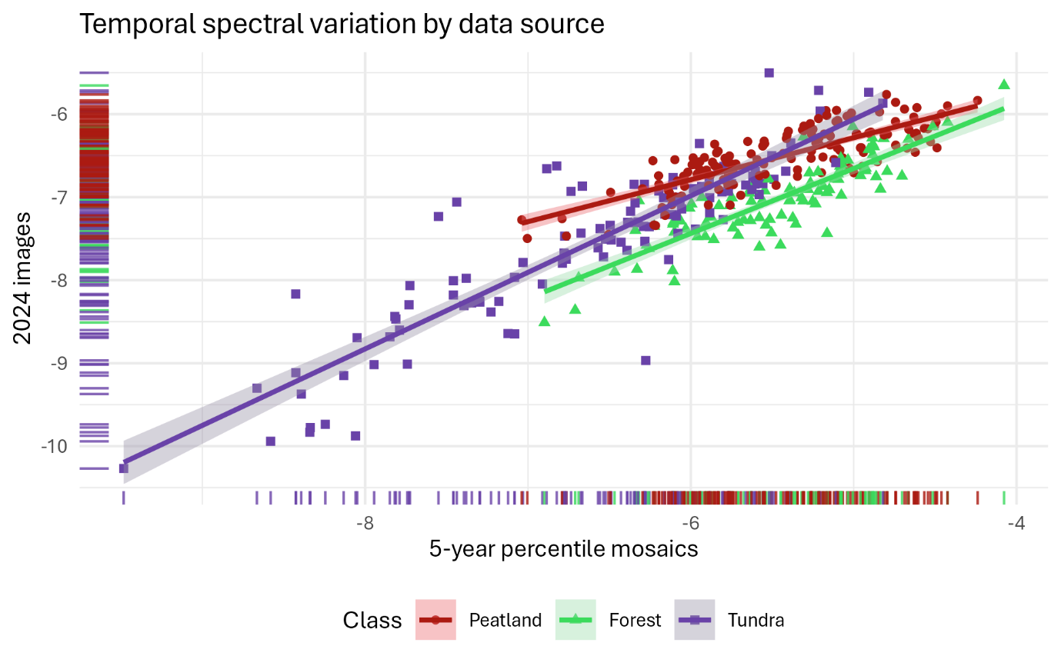
Figure S14. Scatterplot showing difference in temporal spectral variation values across ecosystems depending on calculation method.
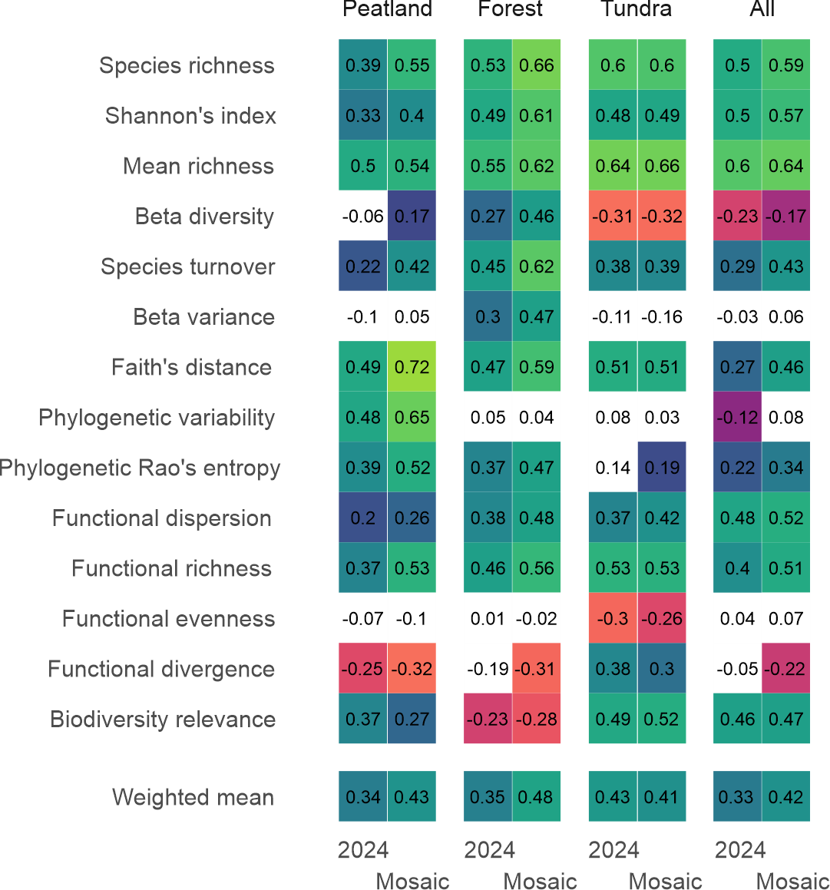
Figure S15. Correlations between temporal spectral variation and plant diversity metrics when temporal spectral variation was calculated from 4 images in 2024 and when calculated from multi-year percentile mosaics.

References
Kattge, J., Bönisch, G., Díaz, S., Lavorel, S., Prentice, I. C., Leadley, P., Tautenhahn, S., Werner, G. D. A., Aakala, T., Abedi, M., Acosta, A. T. R., Adamidis, G. C., Adamson, K., Aiba, M., Albert, C. H., Alcántara, J. M., Alcázar C, C., Aleixo, I., Ali, H., … Wirth, C. (2020). TRY plant trait database – enhanced coverage and open access. Global Change Biology, 26(1), 119–188. https://doi.org/10.1111/gcb.14904
Oksanen, J., Simpson, G. L., Blanchet, F. G., Kindt, R., Legendre, P., Minchin, P. R., O’Hara, R. B., Solymos, P., Stevens, M. H. H., Szoecs, E., Wagner, H., Barbour, M., Bedward, M., Bolker, B., Borcard, D., Carvalho, G., Chirico, M., Caceres, M. D., Durand, S., … Weedon, J. (2024). vegan: Community Ecology Package. https://CRAN.R-project.org/package=vegan
Tyler, T., Herbertsson, L., Olofsson, J., & Olsson, P. A. (2021). Ecological indicator and traits values for Swedish vascular plants. Ecological Indicators, 120, 106923. https://doi.org/10.1016/j.ecolind.2020.106923

corresponding author: pauli.putkiranta@helsinki.fi

