Title: Effect of prescribed fire on plant α- and ꞵ-diversity and their spatial patterns in mesquite-oak savanna
Journal: Landscape Ecology
Authors: Xavier A. Jaime ¹, Jay P. Angerer ², Samuel D. Fuhlendorf ³, John W. Walker ⁴, Chenghai Yang ⁵, Douglass R. Tolleson ⁶, and X. Ben Wu ^{1*}
¹ Department of Ecology and Conservation Biology, Texas A&M University, College Station, TX, USA
² Fort Keogh Livestock and Range Research Laboratory, USDA-Agricultural Research Service, Miles City, MT, USA
³ Department of Natural Resource Ecology and Management, Oklahoma State University, Stillwater, OK, USA
⁴ Texas A&M AgriLife Research and Extension Center, San Angelo, TX, USA
⁵ Aerial Application Technology Research Unit, USDA-Agricultural Research Service, College Station, TX, USA
⁶ Texas A&M AgriLife Research, Sonora, TX, USA

Corresponding author and email: X. Ben Wu, xbw@tamu.edu

Appendix A.1. Description of the USDA Agricultural Research Service’s Multispectral Imaging System and Remote Sensing Process
- Flight logistics before and after fire, remote sensing equipment, and image classification
Through coordinated flight missions before and after the fire, the USDA-ARS (College Station, TX) collected high-resolution aerial multispectral images (21-cm pixel resolution) at 1981.2 m above mean sea level (MSL), following standard USDA-ARS protocols (Song et al., 2017; Li et al., 2020; Yang et al., 2022). Image acquisitions took place during peak biomass season (August-September) and low biomass season (February-March) from 2018-2020 (Jaime et al. 2023). The two Nikon D810 digital cameras (one RGB and one NIR) used during the USDA flyovers and their respective multispectral data specifications are the same as those described in Jaime et al. (2023).
- Random Forest classification process
We created vegetation cover maps of woody and non-woody classes for each sampled year from 2018-2020 for both peak and low biomass seasons using the Random Forest (RF) supervised classification (Liaw and Wiener, 2001; Breiman, 2001). For each prefire (2018) mosaicked image, 500 training polygons were designated as sets of regions of interest (ROIs) for woody, non-woody, and bare ground. A similar RF supervised classification was performed for each burn unit after the 2019 prescribed burn to map the scorched material from the fire represented in the pixel data. For each (2019) postfire mosaicked image, an additional 500 training polygons were incorporated to the prefire ROI sets to capture burned areas (e.g., scorched material) from the high-resolution imagery. Using ENVI 5.5 (NV5 Geospatial Solutions, Inc., Broomfield, CO, USA), Jeffries-Matusita distance separability analysis was used to confirm the distinctiveness of each training class (Richards, 2022; Jaime et al., 2023). For accuracy assessment, we calculated a confusion matrix in ArcMap 10.8 (ESRI, 2022) to evaluate the RF classification accuracy for each cover class (woody vs. non-woody and bare ground vs. burned areas). An independent set of equally-stratified random points per soil type was used for each class for verification with a postfire UAV mosaicked image (3-cm resolution) (Jaime et al. 2023).
- Results of the Random Forest-based classification maps of vegetation cover before and after the fire
The overall accuracy for the RF classification with training samples for major cover types (non-woody, woody, burned, and bare ground) was 94.4% for prefire conditions with a Kappa coefficient of 89.7%. For postfire images, RF classification achieved 92.8% accuracy with a Kappa of 87.8%. User accuracy (UA) ranged from 83.6% for non-woody vegetation to 98.6% for burned areas (Table A1). Furthermore, the producer’s accuracy (PA) ranged from 90.2% for non-woody vegetation to 97.4% for bare ground (Table A1). The non-woody vegetation class consistently showed the lowest UA and PA, whereas bare ground had consistently high UA and PA. Verification of the RF model indicated that the majority of misclassification occurred between woody cover pixels misclassified as non-woody pixels.
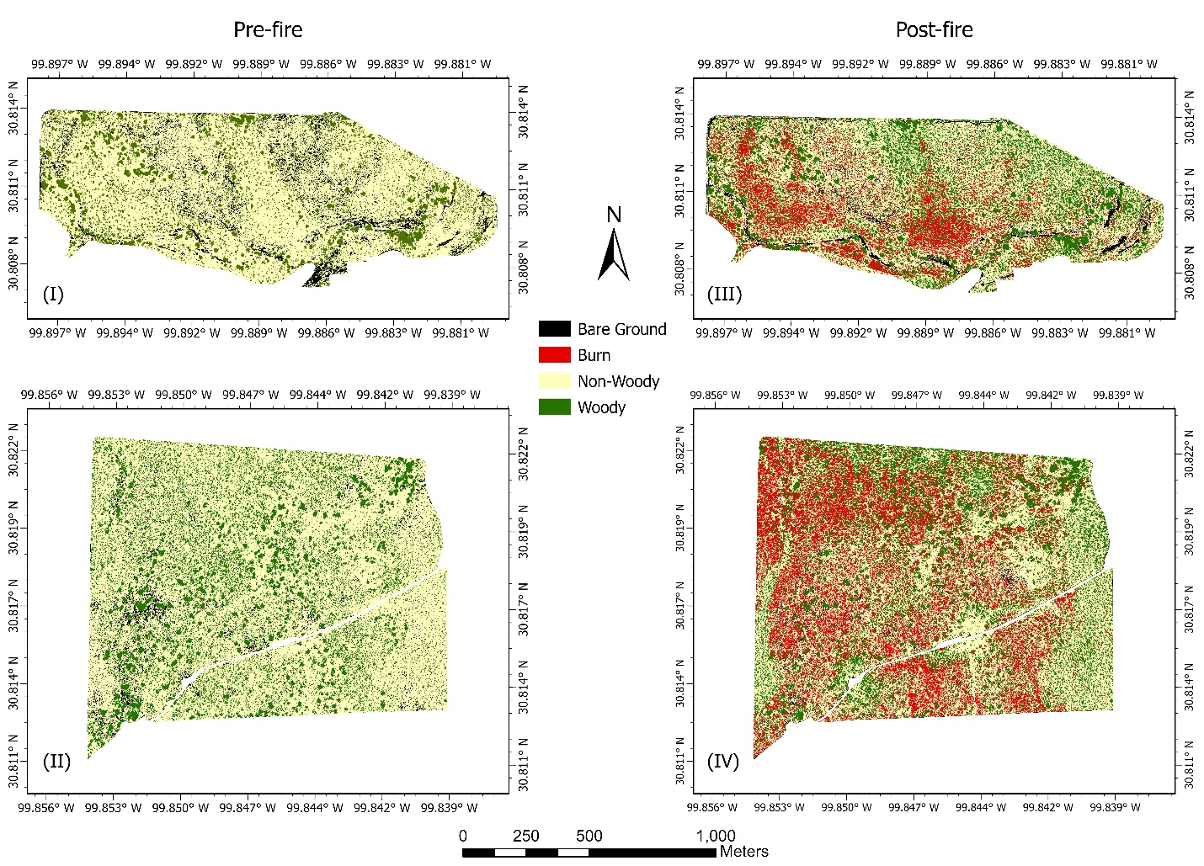
Figure A1. Random Forest supervised classification maps for burn units during the pre-fire season (I-II) and post-fire season (III-IV) in Martin Ranch (MR)

Table A1. Summary of error matrix accuracies for postfire RF classification classes
 |  | Reference Data
 |  | Bare Ground | Non-Woody | Woody | Burn | User’s Accuracy (%)
Classified data | Bare Ground | 998 | 12 | 0 | 10 | 97.8
Classified data | Non-Woody | 10 | 1091 | 128 | 75 | 83.6
Classified data | Woody | 0 | 48 | 1472 | 0 | 96.8
Classified data | Burn | 17 | 58 | 0 | 1054 | 93.4
Classified data | Producer’s Accuracy (%) | 97.4 | 90.2 | 92.0 | 92.5 | OA (92.8%)

Using the RF classification, we estimated that 17.6% of the area burned in the Lively burn unit. Of this burned area, 23.4% occurred within the deeper soil (VaB), compared to 14.4% in the very shallow soil (TA). The E6M burn unit had 22.1% of the total burned area, with 25.9% of the burned area within the TA soil and 10.1% within KaB soil. Regarding woody vegetation cover across prefire and postfire seasons, the RF model indicated that woody vegetation cover in the Lively unit was 26.9% during the prefire season and 31.4% during the postfire season. In the EM6 burn unit, 38.9% of the land area was classified as woody cover prior to the fire and 42.1% as woody cover after the fire. Within soil types, prefire woody cover on TA soils was 24.2% in the Lively unit and 38.9% in the E6M unit. For VaB soils, prefire woody cover was 28.3%, and for KaB soil, it was 32% across both burn units. Areas classified as bare ground accounted for 4.5-7.7% within the Lively unit and 3.5-4.3% in the E6M unit before and after the fire, respectively.

Appendix A.2. Generating maps of fire severity dNBR and maps of Voronoi polygons for each sampled location
- Fire Severity (dNBR) calculation from Copernicus Sentinel-2 postfire imagery.
To evaluate fire severity in burned areas, we used cloud-free Copernicus Sentinel-2 satellite images of the burn units before and after the prescribed fire. From the Sentinel-2 images, we calculated the Normalized Burn Ration ($NBR= \frac{(NIR-SWIR)}{(NIR+SWIR)}$ ) and Difference NBR ($dNBR=PrefireNBR-PostfireNBR)$ using the NIR (760 - 900 nm, 10-m resolution) and SWIR (2080 - 2350 nm, 20-m resolution) bands to map the extent of fire severity (Roteta et al., 2019; Hu et al., 2021). As shown in Figure A2.1, dNBR values provide insight into fire severity levels. dNBR < -0.1 indicates vegetation recovery, while dNBR between 0.1 and 0.27 represent low to moderate fire severity within burned areas. Using the dNBR image, we extracted the dNBR pixel data from the raster using the “Extract Multi Values to Point” in ArcMap 10.8 for each sampled location in the burned areas. Fire severity values were subsequently included as a covariate in the plant diversity statistical analyses.

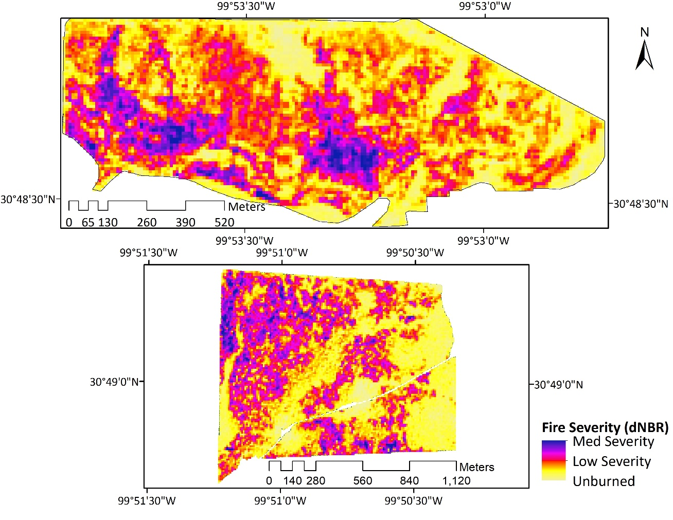
Figure A2.1 Fire severity (dNBR at 10-m resolution) raster maps of burn units at MR.

- Proximity between the focal sampling point and its immediate neighbors
The R package “dismo” was used to generate the Voronoi polygons (Fig. A2.2), while the “ggvoronoi” package was employed to identify the immediate neighbors of each sampling point (Garrett et al. 2018).

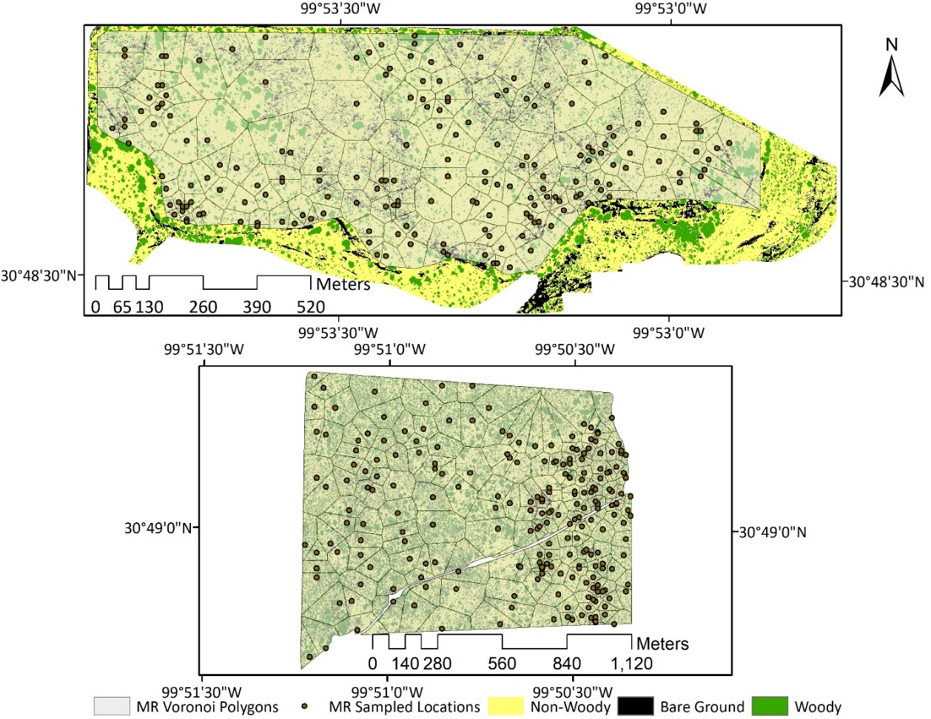
Figure A2.2 Voronoi polygons for field sampled points at both burn units in MR.

References
Breiman, L. 2001. Random Forests. Machine Learning 45 (1): 5–32. https://doi.org/10.1023/A:1010933404324.
Garrett, R. C., Nar, A., Fisher, T. J., and Maurer, K. 2018. Ggvoronoi: Voronoi Diagrams and Heatmaps with Ggplot2. Journal of Open Source Software 3 (32): 1096. https://doi.org/10.21105/joss.01096.
Hu, X., Ban, Y., & Nascetti, A. (2021). Uni-Temporal Multispectral Imagery for Burned Area Mapping with Deep Learning. Remote Sensing, 13(8), 1509. https://doi.org/10.3390/rs13081509
Jaime, X. A., Angerer, J. P., Yang, C., Walker, J., Mata, J., Tolleson, D. R., & Wu, X. B. (2023). Exploring Effective Detection and Spatial Pattern of Prickly Pear Cactus (Opuntia Genus) from Airborne Imagery before and after Prescribed Fires in the Edwards Plateau. Remote Sensing, 15(16), 4033. https://doi.org/10.3390/rs15164033
Li, X., Yang, C., Huang, W., Tang, J., Tian, Y., & Zhang, Q. (2020). Identification of Cotton Root Rot by Multifeature Selection from Sentinel-2 Images Using Random Forest. Remote Sensing, 12(21), 3504. https://doi.org/10.3390/rs12213504
Liaw, Andy, and Matthew Wiener. 2001. “Classification and Regression by RandomForest.” Forest 23.
Richards, J.A.; Richards, J.A. Remote Sensing Digital Image Analysis; Springer: Berlin/Heidelberg, Germany, 2022; Volume 5.
Roteta, E., Bastarrika, A., Padilla, M., Storm, T., & Chuvieco, E. (2019). Development of a Sentinel-2 burned area algorithm: Generation of a small fire database for sub-Saharan Africa. Remote Sensing of Environment, 222, 1-17. https://doi.org/10.1016/j.rse.2018.12.011
Song, X., Yang, C., Wu, M., Zhao, C., Yang, G., Hoffmann, W. C., & Huang, W. (2017). Evaluation of Sentinel-2A Satellite Imagery for Mapping Cotton Root Rot. Remote Sensing, 9(9), 906. https://doi.org/10.3390/rs9090906
Yang, C. Remote Sensing Technologies for Crop Disease and Pest Detection. In Soil and Crop Sensing for Precision Crop Production; Li, M., Yang, C., Zhang, Q., Eds.; Agriculture Automation and Control; Springer International Publishing: Cham, Switzerland, 2022; pp. 159–184. ISBN 978-3-030-70432-2.

