Supplementary materials
Title: Perceived urban microhabitat heterogeneity impacts carabid beetle communities
Authors: Basile Finand^{1,2}, Meeri Tahvanainen¹, Heikki Setälä¹, D. Johan Kotze¹
Affiliations:
¹Faculty of Biological and Environmental Sciences, Ecosystems and Environment Research Programme, Niemenkatu 73, FI-15140, Lahti, University of Helsinki, Finland
²Helsinki Institute of Urban and Regional Studies, University of Helsinki, Yliopistonkatu 3, FI-00100, Helsinki, Finland
Corresponding author: Basile Finand, finand.basile@gmail.com, +350505638535

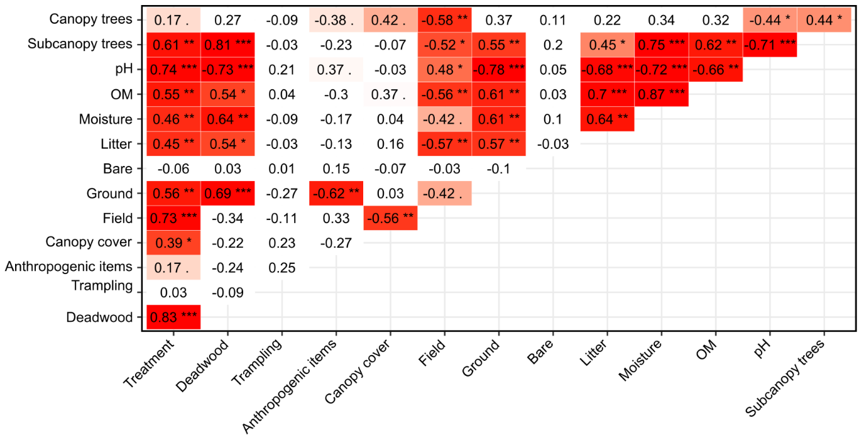
Fig. S1: Correlation heatmap between all the environmental variables measured in this study. Values in each box are the effect size (rho for the Spearman tests, and epsilon2 for the Kruskal-Wallis tests). Dark red indicates a p-value < 0.05, and light red a p-value < 0.1. Three stars indicate a p-value < 0.001, two stars a p-value < 0.01, one star a p-value < 0.05, and a dot a p-value < 0.1.
Table S1: Environmental characteristics measured for each site and coordinates. HET = heterogeneous forests, HOM = Homogeneous forests, and PARK = urban parks. Canopy cover, Field layer, Ground layer, Bare Layer, and Litter depth are means (see Methods).
Table S2: List of species per site. The values represent the number of individuals per species collected from this study.

