Supplementary Material

Beggars Can’t be Choosers: Feral Buffalo Show More Constrained Movement and Resource Selection During the Dry Season in the Northern Territory
Kyana N. Pike ^{a,b}, Scott W Forrest ^{c, d, e}, John McEvoy ª , Justin Perry ^{f, g}, Eric Vanderduys^{e}, John P.Y. Arnould^{h}, and Andrew J Hoskins ^{f, g, i}

ª Health & Biosecurity / Environment, Commonwealth Scientific and Industrial Research Organisation (CSIRO), Townsville, QLD 4811, Australia
^{b} College of Science & Engineering, James Cook University, Townsville, QLD, 4811, Australia

^{c} School of Mathematical Sciences, Queensland University of Technology, Brisbane, QLD 4000, Australia

^{d} Centre for Data Science, Queensland University of Technology, Brisbane, QLD 4000, Australia

^{e} Environment, CSIRO, Brisbane, QLD 4102, Australia

^{f} North Australian Indigenous Land and Sea Management Alliance, Darwin, NT, Australia

^{g} School of the Environment, University of Queensland, Brisbane QLD 4172, Australia

^{h} School of Life & Env Sciences, Deakin University, Burwood, VIC 3125, Australia
^{i} Discipline of Veterinary Science, James Cook University, Townsville and Cairns, QLD, Australia

*Corresponding author: Kyana N Pike
Email: kyana.pike@csiro.au
Building 145, James Cook University, James Cook Drive, Townsville QLD 4811
Wulgurukaba and Bindal Country
Supplementary Table 1: Reclassification of land cover classes produced by the phenology-based synthesis algorithm from Simonetti et. al (2015). The Delk IPA is a large area and more habitat types were present than were used by or available to buffalo within their home ranges. Those habitat types denoted in italics were part of the broader Djelk IPA, and only those denoted in bold were sampled by buffalo in our study.
Original Class | Reclassification
0 no data | No Data
1 Clouds | No Data
10 Evergreen Dense Forest | Forest
11 Evergreen Dense Forest | Forest
12 Evergreen Dense Forest | Forest
13 Evergreen Dense Forest/Shrubland | No Data
14 Evergreen Grassland | No Data
15 Evergreen Open Forest | Open Forest
16 Evergreen Shrubland | Forest
2 Temporary snow | No Data
20 Deciduous Closed Humid Forest | Shrubs and Grass
21 Deciduous Open Humid Forest | Forest
25 Deciduous Closed Dry Forest | Shrubs
26 Deciduous Open Dry Forest | Open Forest
27 Irrigated Agriculture | No Data
28 Deciduous Shrubland dense humid | Forest
29 Deciduous Shrubland | Trees and Grass
3 Snow | No Data
30 Deciduous Shrubland sparse | Dry Grassland
31 Grassland + Bush | Shrubs and Grass
32 Grassland | Dry Grassland
34 Soil and Grass | Exposed floodplain
35 Soil | Exposed floodplain
36 Dark Soil | Sparse Vegetation
41 Dark soil | Dark soil
6 Water + DRY | Salt Pan/Mudflat
7 Water >60% | Swamp
8 Water >80% | Open Water
9 Water and Forest (Green + Water >90%) | Open Water

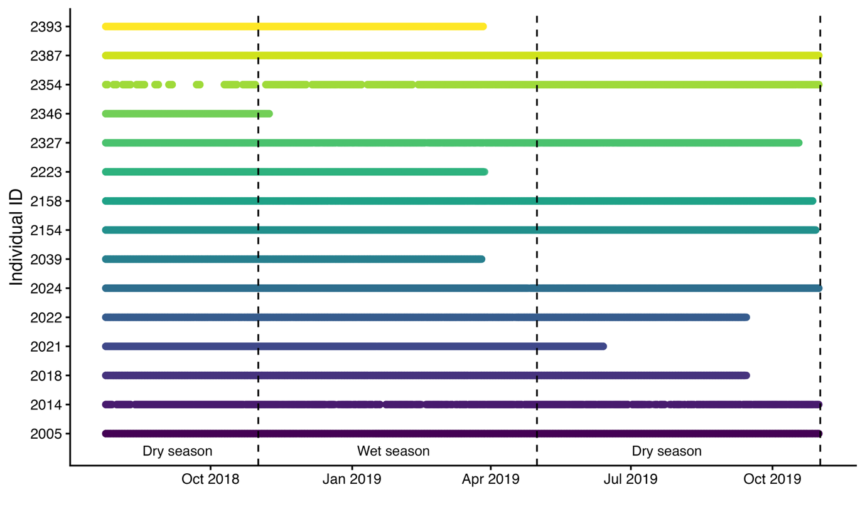
Supplementary Figure 1: Timeline of the GPS locations for each individual buffalo that was used for model fitting, with attempted 1-hour fix-intervals. The average tracking duration for each individual was mean ± SD = 373.53 days ± 112.38 days and ranged from 107 – 464 days. There were an average ± SD of 6442 ± 2327 GPS locations per individual, which ranged from 1922 to 9558 GPS locations.

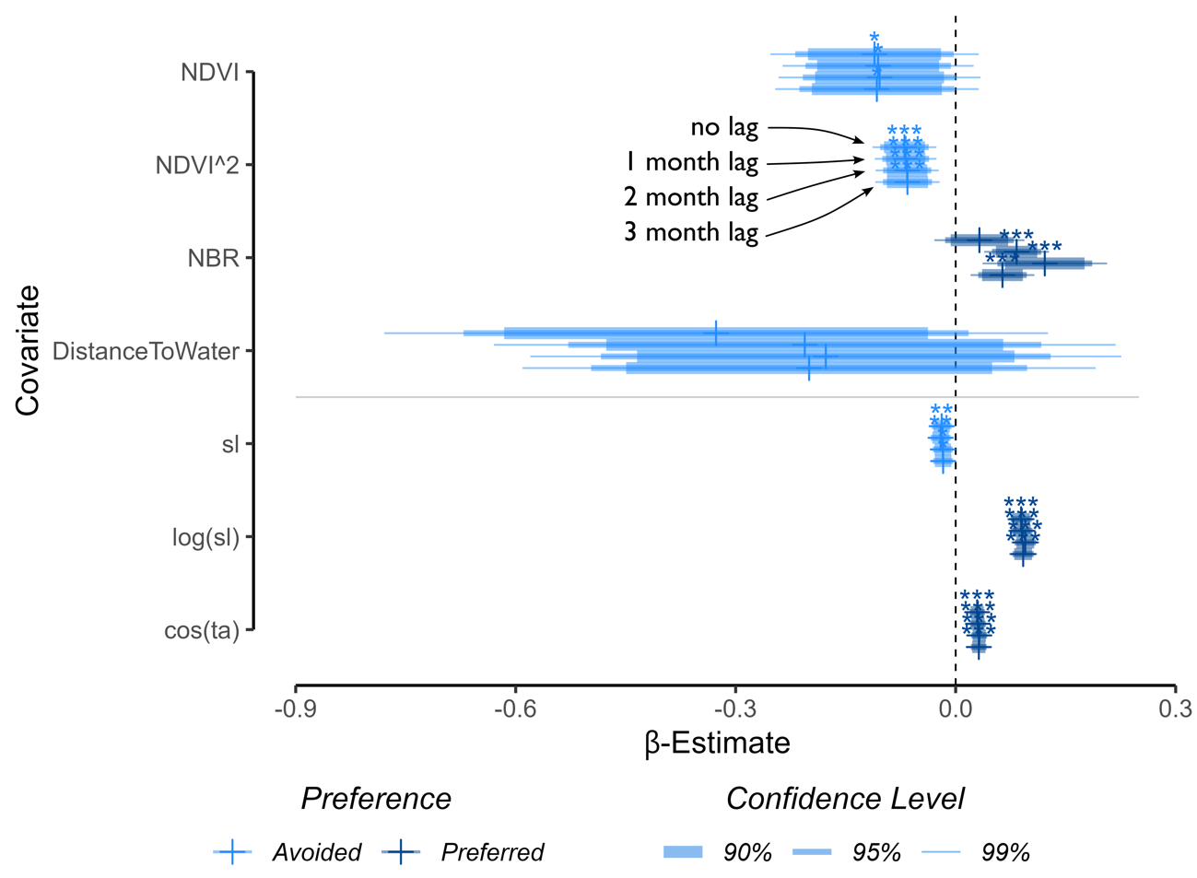
Supplementary Figure 2: Selection coefficients for the models fitted with remotely-sensed landscape layers during the wet season. The difference in Normalised Burn Ratio (NBR) was lagged in monthly intervals, and the four bars for each covariate show the selection coefficients of the models with the different NBR lags, with no lag at the bottom, which increase upwards (with no lag, 1, 2 and 3 months of lag). Although they are very similar between models, we show coefficient estimates for all parameters to illustrate that when changing the lag of NBR the estimation of the other parameters is robust, and their parameter estimates are not confounded by the change in NBR values.
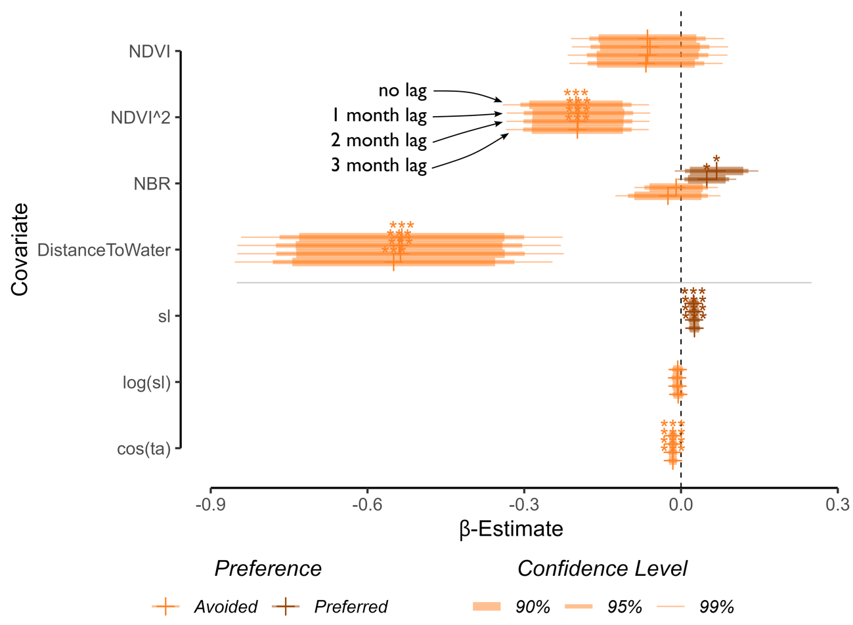
Supplementary Figure 3: Selection coefficients for the models fitted with remotely-sensed landscape layers during the dry season. Normalised Burn Ratio (NBR) was lagged in monthly intervals, and the four bars for each covariate show the selection coefficients of the models with the different NBR lags, with no lag at the bottom, which increase upwards (with no lag, 1, 2 and 3 months of lag). Although they are very similar between models, we show coefficient estimates for all parameters to illustrate that when changing the lag of NBR the estimation of the other parameters is robust, and their parameter estimates are not confounded by the change in NBR values.

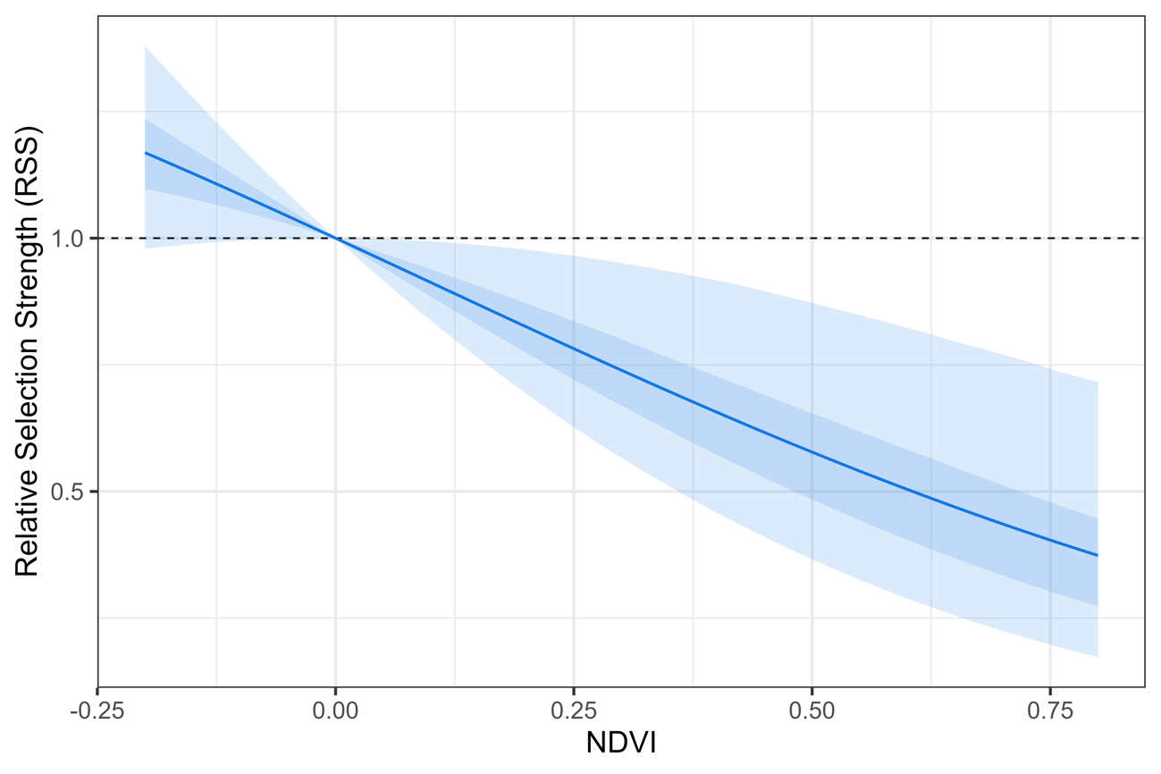
Supplementary Figure 4: Relative selection strength (Avgar et al, 2017) of NDVI from the linear and quadratic coefficients for the wet season. Here we see that buffalo positively selected for low NDVI values and selected against higher values. The coloured ribbons represent the 50% and 95% confidence intervals.

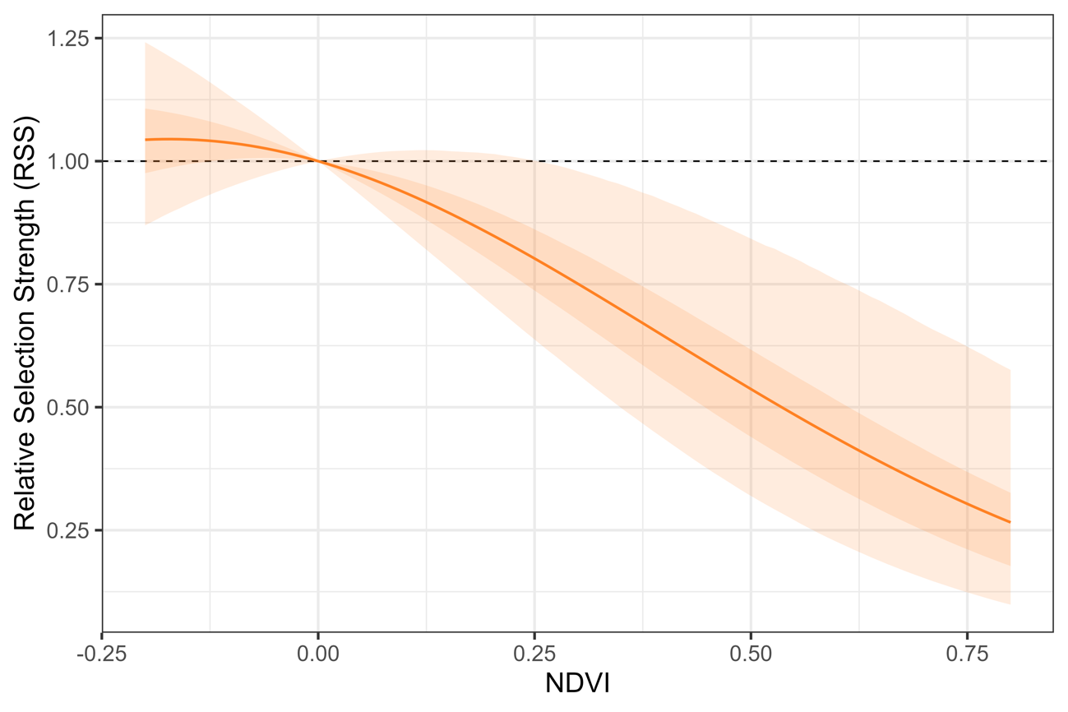
Supplementary Figure 5: Relative selection strength (Avgar et al, 2017) of NDVI from the linear and quadratic coefficients for the dry season. Buffalo did not select strongly for or against NDVI values less than 0 but selected against higher NDVI values. The coloured ribbons represent the 50% and 95% confidence intervals.

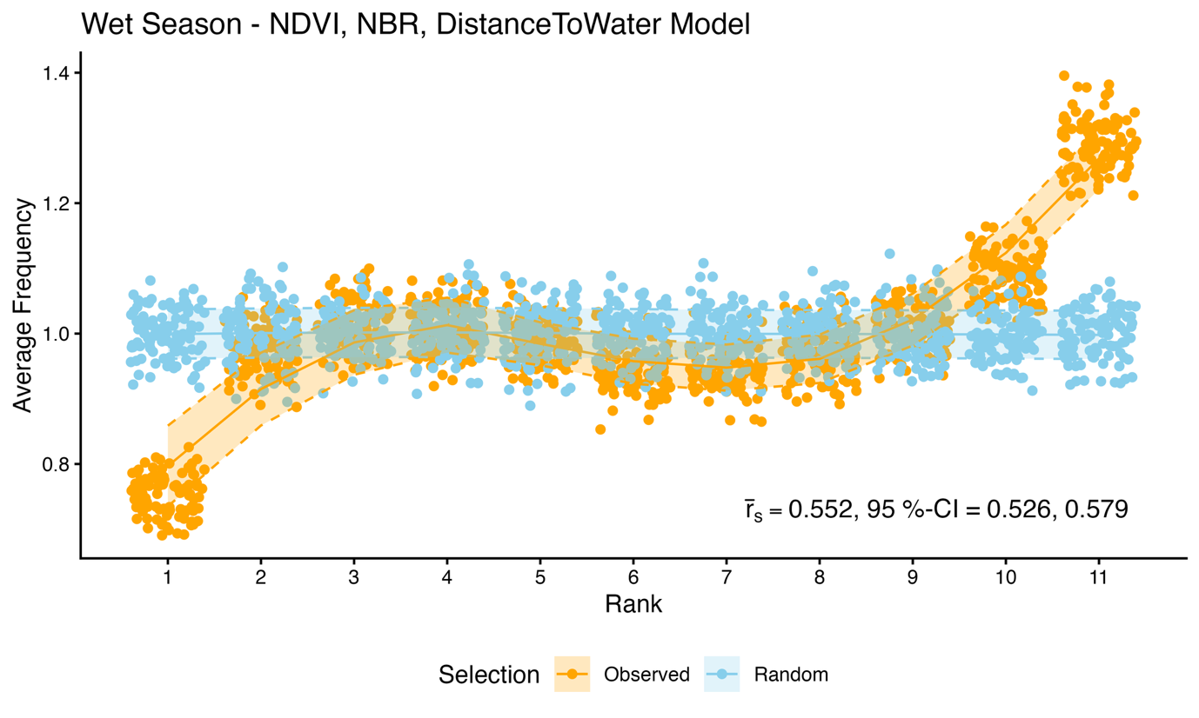
Supplementary Figure 6: K-fold cross-validation results for the SSF model of NDVI, NBR and distance to water, as well as movement covariates, fitted to the wet season data of the water buffalo. The data was split into 80% for model fitting and 20% for testing, and step selection weights were calculated for each step of the testing data (based on the model fit of the training data), and the observed and random steps were ranked according to these weights, with 1 being the lowest weight (lowest probability of selection), and 11 being the highest. The ranks were extracted at the observed step (orange) and one randomly selected step (blue), and the cumulative frequency was calculated for each rank, and divided by the number of steps and possible ranks, resulting in average frequencies with a value greater than 1 being selected more than by random chance, as indicated by the results in blue. This data splitting, model fitting and testing process was repeated 100 times, and each point in this plot shows the average frequency for each rank and each replicate. The Spearman correlation coefficient r_{s} was calculated using the rank and its associated frequency for the observed and randomly selected ranks, and the average and 95% confidence intervals for r_{s} across all replicates is shown for the ranks of the observed steps. These results indicate that the observed steps of the water buffalo were often highly ranked by the model.

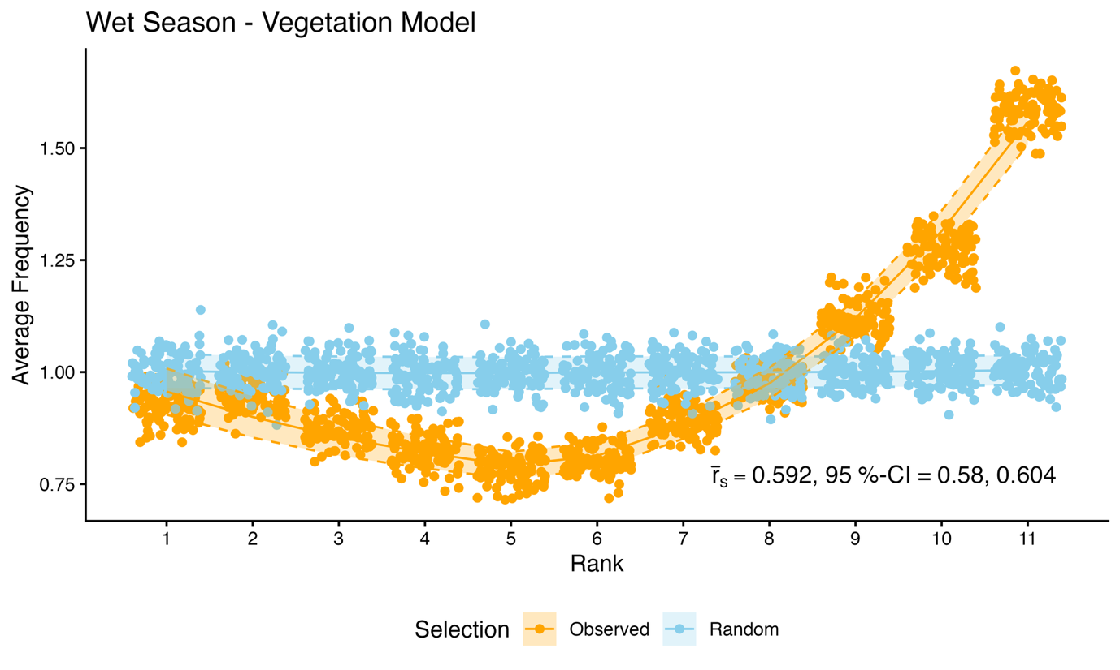
Supplementary Figure 7: Following the same k-fold cross-validation procedure as described above, we show the results for the SSF model of the vegetation categories, as well as movement covariates and movement interactions with the vegetation categories, fitted to the wet season data of the water buffalo. These results indicate that the observed steps of the water buffalo were often highly ranked by the model.

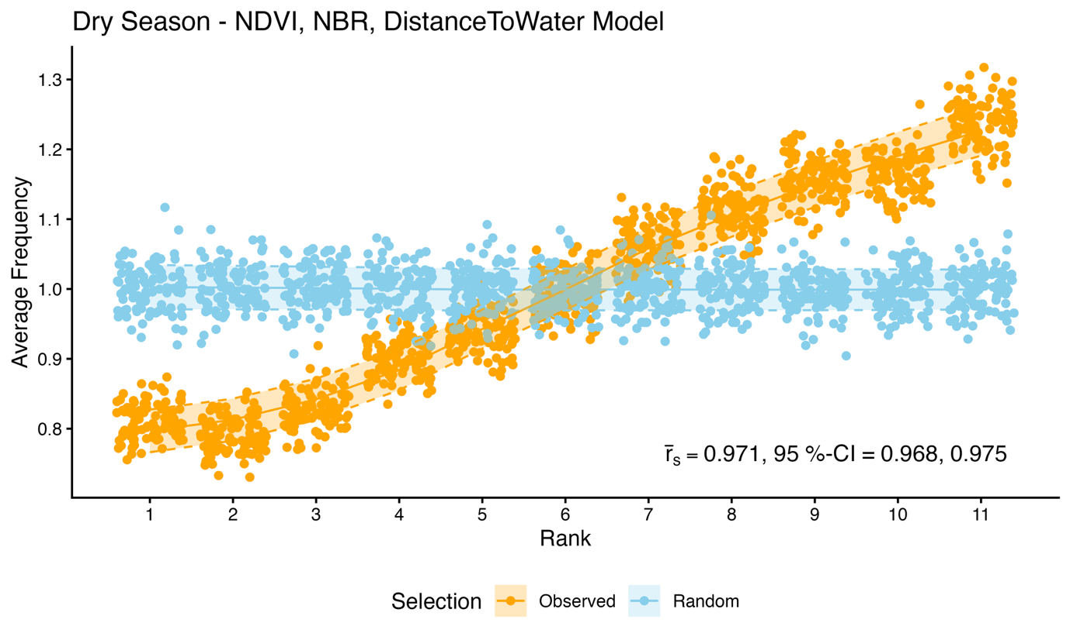
Supplementary Figure 8: Following the same k-fold cross-validation procedure as described above, we show the results for the SSF model of NDVI, NBR and distance to water, as well as movement covariates, fitted to the dry season data of the water buffalo. These results indicate that the observed steps of the water buffalo were often highly ranked by the model.

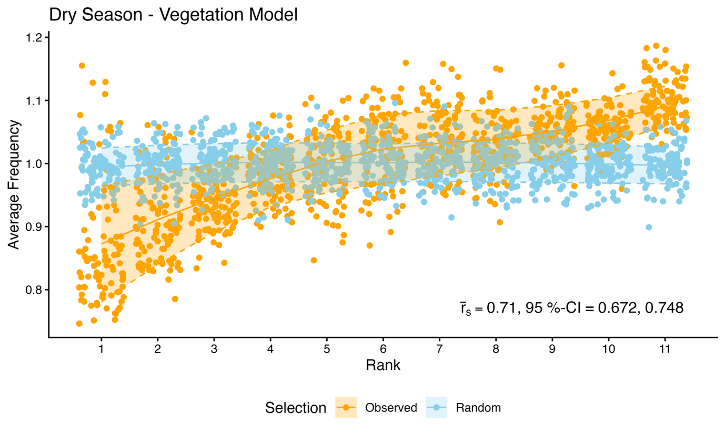
Supplementary Figure 9: Following the same k-fold cross-validation procedure as described above, we show the results for the SSF model of the vegetation categories, as well as movement covariates and movement interactions with the vegetation categories, fitted to the dry season data of the water buffalo. These results indicate that the observed steps of the water buffalo were more highly ranked by the model than by random chance.

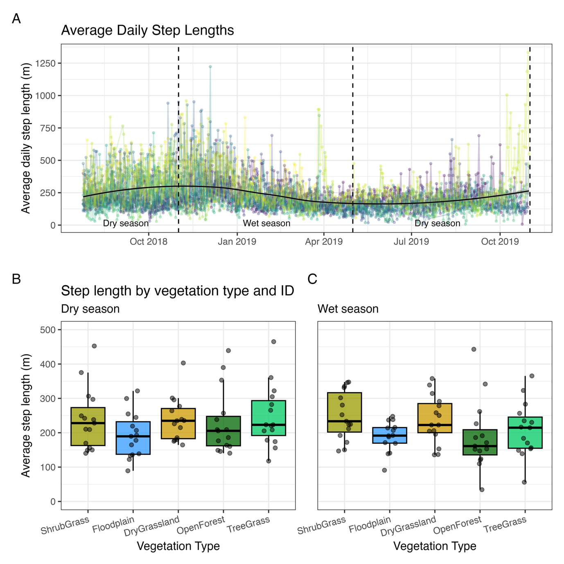
Supplementary Figure 10: Panel A shows the average daily step length for each individual buffalo (as different coloured lines). There is a general tendency for step lengths to increase as dry season progresses, before decreasing towards the end of the wet season. Panels B and C show the average step lengths that start in each vegetation category, for each individual buffalo.

