Supplementary material
Strategic placement of plantations enhances forest connectivity for birds in agricultural landscapes
Sara Pineda-Zapata^{1*}, Alejandra Morán-Ordoñez², Blas Mola-Yudego^{1,3}, Rémi Duflot^{4,5}

*Corresponding author: spineda@uef.fi

¹ School of Forest Sciences, University of Eastern Finland (UEF), Joensuu, Finland.
² Department of Environmental Sciences, University of Basel, Basel, Switzerland.
³ Department of Crop Production Ecology, Swedish University of Agricultural Sciences (SLU), Uppsala, Sweden.
⁴ Department of Biological and Environmental Science, University of Jyväskylä, Jyväskylä, Finland
⁵ School of Resource Wisdom, University of Jyväskylä, Jyväskylä, Finland

Species | Dispersal distance (km) | Paper ID | Comments ª
Fringilla coelebs | 0.787 | 6, 14, 9, 2, 1, 10, 5, 13, 8 | Forest and ecotone birds presence in tree stage SRC | Detected species in agroforestry and SRC strips | abundance more than 0 in poplar stands | positive preference for salix | density more than a 0 in one of all poplar states | presence in poplar plantation 1st year after coppicing | bird territories for different salix heights | more than 0 in poplar plantations | presence in willow tree groups, open woodland, canopy closed
Parus major | 0.797 | 6, 9, 2, 1, 13, 8, 3 | Forest and ecotone birds’ presence in tree stage SRC | abundance more than 0 in poplar stands | positive preference for salix | density more than a 0 in one of all poplar states | more than 0 in poplar plantations | presence in willow tree groups, open woodland, canopy closed | positive correlation between species abundance (n/km2) and surface area (ha) of tree plantations
Turdus merula | 0.264 | 14, 7, 9, 1, 10, 13, 3 | Detected species in agroforestry and SRC strips | Species with breeding attempts in poplar | abundance more than 0 in poplar stands | density more than a 0 in one of all poplar states | presence in poplar plantation 1st year after coppicing | more than 0 in poplar plantations | positive correlation between species abundance (n/km2) and surface area (ha) of tree plantations
Turdus philomelos | 0.591 | 6, 14, 7, 2, 1, 10, 13 | Forest and ecotone birds’ presence in tree stage SRC | Detected species in agroforestry and SRC strips | Species with breeding attempts in poplar | positive preference for salix | density more than a 0 in one of all poplar states | presence in poplar plantation 1st year after coppicing | more than 0 in poplar plantations
Dendrocopos major | 5.875 | 6, 9, 1, 8, 4, 12 | Forest and ecotone birds presence in tree stage SRC | abundance more than 0 in poplar stands | density more than a 0 in one of all poplar states | presence in willow tree groups, open woodland, canopy closed | cultivated vegetation (percentage cover of SRCs/reforestations, traditional poplar plantations, and number of tree plantation patches) positively influenced the presence | presence in plantation but significantly lower than natural woodland
Parus caeruleus | 0.796 | 6, 9, 2, 1, 13, 8 | Forest and ecotone birds’ presence in tree stage SRC | abundance more than 0 in poplar stands | positive preference for salix | density more than a 0 in one of all poplar states | more than 0 in poplar plantations | presence in willow tree groups, open woodland, canopy closed
Phylloscopus collybita | NA | 6, 14, 9, 1, 10, 8 | Forest and ecotone birds’ presence in tree stage SRC | Detected species in agroforestry and SRC strips | abundance more than 0 in poplar stands | density more than a 0 in one of all poplar states | presence in poplar plantation 1st year after coppicing | presence in willow tree groups, open woodland, canopy closed
Sylvia atricapilla | 17.539 | 14, 9, 1, 10, 5, 3 | Detected species in agroforestry and SRC strips | abundance more than 0 in poplar stands | density more than a 0 in one of all poplar states | presence in poplar plantation 1st year after coppicing | bird territories for different salix heights | positive correlation between species abundance (n/km2) and surface area (ha) of tree plantations
Erithacus rubecula | 0.571 | 14, 9, 1, 10, 13 | Detected species in agroforestry and SRC strips | abundance more than 0 in poplar stands | density more than a 0 in one of all poplar states | presence in poplar plantation 1st year after coppicing | more than 0 in poplar plantations
Phylloscopus trochilus | 2.172 | 14, 9, 2, 5, 13 | Detected species in agroforestry and SRC strips | abundance more than 0 in poplar stands | positive preference for salix | bird territories for different salix heights | more than 0 in poplar plantations
Sylvia communis | 2.815 | 14, 9, 2, 1, 5 | Detected species in agroforestry and SRC strips | abundance more than 0 in poplar stands | positive preference for salix | density more than a 0 in one of all poplar states | bird territories for different salix heights
Anthus trivialis | NA | 9, 2, 1, 8 | abundance more than 0 in poplar stands | positive preference for salix | density more than a 0 in one of all poplar states | presence in willow tree groups, open woodland, canopy closed
Carduelis carduelis | 1.663 | 14, 9, 13, 8 | Detected species in agroforestry and SRC strips | abundance more than 0 in poplar stands | more than 0 in poplar plantations | presence in willow tree groups, open woodland, canopy closed
Columba palumbus | 2.277 | 9, 1, 10, 8 | abundance more than 0 in poplar stands | density more than a 0 in one of all poplar states | presence in poplar plantation 1st year after coppicing | presence in willow tree groups, open woodland, canopy closed
Emberiza citrinella | 2.026 | 14, 7, 2, 8 | Detected species in agroforestry and SRC strips | Species with breeding attempts in poplar | positive preference for salix | presence in willow tree groups, open woodland, canopy closed
Sylvia borin | NA | 14, 2, 1, 5 | Detected species in agroforestry and SRC strips | positive preference for salix | density more than a 0 in one of all poplar states | bird territories for different salix heights
Acrocephalus palustris | NA | 14, 2, 5 | Detected species in agroforestry and SRC strips | positive preference for salix | bird territories for different salix heights
Carduelis chloris | 0.954 | 9, 2, 8 | abundance more than 0 in poplar stands | positive preference for salix | presence in willow tree groups, open woodland, canopy closed
Dryobates minor | NA | 4, 12, 11 | the cover of both riparian woodlands and traditional poplar plantations at the home-range scale and the one of woodland within 1.5 km positively influenced | presence in plantation but significantly lower than natural woodland | Tolerates or benefits when plantations are near native woodlands.
Luscinia megarhynchos | NA | 9, 1, 3 | abundance more than 0 in poplar stands | density more than a 0 in one of all poplar states | positive correlation between species abundance (n/km2) and surface area (ha) of tree plantations
Picus viridis | 2.049 | 9, 8, 4 | abundance more than 0 in poplar stands | presence in willow tree groups, open woodland, canopy closed | both natural and cultivated vegetation positively influenced its presence
Sturnus vulgaris | 1.1 | 6, 1, 8 | Forest and ecotone birds’ presence in tree stage SRC | density more than a 0 in one of all poplar states | presence in willow tree groups, open woodland, canopy closed
Carduelis cannabina | 0.694 | 9, 2 | abundance more than 0 in poplar stands | positive preference for salix
Certhia brachydactyla | NA | 1, 8 | density more than a 0 in one of all poplar states | presence in willow tree groups, open woodland, canopy closed
Cettia cetti | NA | 9, 3 | abundance more than 0 in poplar stands | positive correlation between species abundance (n/km2) and surface area (ha) of tree plantations
Coccothraustes coccothraustes | NA | 6, 9 | Forest and ecotone birds’ presence in tree stage SRC | abundance more than 0 in poplar stands
Corvus corone | 3.24 | 9, 8 | abundance more than 0 in poplar stands | presence in willow tree groups, open woodland, canopy closed
Cuculus canorus | NA | 9, 3 | abundance more than 0 in poplar stands | positive correlation between species abundance (n/km2) and surface area (ha) of tree plantations
Emberiza schoeniclus | 0.952 | 2, 5 | positive preference for salix | bird territories for different salix heights
Garrulus glandarius | 0.702 | 8, 4 | presence in willow tree groups, open woodland, canopy closed | the percentage cover of SRCs/ reforestation at the home range scale, and the edge density of tree plantation patches within 1 km best explained the occurrence
Locustella naevia | NA | 2, 1 | positive preference for salix | density more than a 0 in one of all poplar states
Luscinia luscinia | NA | 2, 5 | positive preference for salix | bird territories for different salix heights
Muscicapa striata | 3.377 | 8, 3 | presence in willow tree groups, open woodland, canopy closed | positive correlation between species abundance (n/km2) and surface area (ha) of tree plantations
Passer montanus | 0.717 | 14, 8 | Detected species in agroforestry and SRC strips | presence in willow tree groups, open woodland, canopy closed
Phasianus colchicus | NA | 2, 5 | positive preference for salix | bird territories for different salix heights
Pica pica | 1.033 | 10, 8 | presence in poplar plantation 1st year after coppicing | presence in willow tree groups, open woodland, canopy closed
Poecile palustris | NA | 4, 11 | number of the patches of tree plantations positively influenced presence | Negative at local scale, possibly neutral or weakly positive at landscape scale.
Saxicola rubetra | NA | 2, 5 | positive preference for salix | bird territories for different salix heights
Streptopelia turtur | 1.3 | 1, 3 | density more than a 0 in one of all poplar states | positive correlation between species abundance (n/km2) and surface area (ha) of tree plantations
Troglodytes troglodytes | 1.17 | 1, 13 | density more than a 0 in one of all poplar states | more than 0 in poplar plantations
Turdus viscivorus | 1.49 | 6, 8 | Forest and ecotone birds’ presence in tree stage SRC | presence in willow tree groups, open woodland, canopy closed
Accipiter nisus | 6.654 | 8 | presence in willow tree groups, open woodland, canopy closed
Acrocephalus dunetorum | NA | 2 | positive preference for salix
Acrocephalus schoenobaenus | 6.02 | 2 | positive preference for salix
Acrocephalus scirpaceus | 5.215 | 5 | bird territories for different salix heights
Aegithalos caudatus | 2.176 | 4 | both natural and cultivated vegetation in  the surrounding context positively influenced the presence
Alauda arvensis | 0.302 | 14 | Detected species in agroforestry and SRC strips
Alectoris rufa | NA | 10 | presence in poplar plantation 1st year after coppicing
Asio otus | 15.421 | 8 | presence in willow tree groups, open woodland, canopy closed
Buteo buteo | 12.096 | 8 | presence in willow tree groups, open woodland, canopy closed
Colinus virginianus | NA | 3 | positive correlation between species abundance (n/km2) and surface area (ha) of tree plantations
Corvus cornix | NA | 3 | positive correlation between species abundance (n/km2) and surface area (ha) of tree plantations
Corvus frugilegus | 1.964 | 8 | presence in willow tree groups, open woodland, canopy closed
Emberiza cirlus | NA | 9 | abundance more than 0 in poplar stands
Emberiza hortulana | NA | 2 | positive preference for salix
Falco tinnunculus | 14.005 | 8 | presence in willow tree groups, open woodland, canopy closed
Hippolais polyglotta | NA | 1 | density more than a 0 in one of all poplar states
Jynx torquilla | NA | 9 | abundance more than 0 in poplar stands
Lanius collurio | NA | 14 | Detected species in agroforestry and SRC strips
Lanius excubitor | NA | 6 | Forest and ecotone birds presence in tree stage SRC
Lullula arborea | NA | 2 | positive preference for salix
Motacilla alba | 5.164 | 14 | Detected species in agroforestry and SRC strips
Oriolus oriolus | NA | 6 | Forest and ecotone birds presence in tree stage SRC
Parus ater | 2.597 | 9 | abundance more than 0 in poplar stands
Parus palustris | NA | 8 | presence in willow tree groups, open woodland, canopy closed
Passer domesticus | 0.206 | 10 | presence in poplar plantation 1st year after coppicing
Perdix perdix | NA | 2 | positive preference for salix
Phoenicurus phoenicurus | 3.873 | 8 | presence in willow tree groups, open woodland, canopy closed
Phylloscopus sibilatrix | NA | 8 | presence in willow tree groups, open woodland, canopy closed
Regulus regulus | NA | 2 | positive preference for salix
Serinus serinus | NA | 9 | abundance more than 0 in poplar stands
Silvya borin | NA | 7 | Species with breeding attempts in poplar
Sylvia curruca | 16.886 | 14 | Detected species in agroforestry and SRC strips
Turdus iliacus | NA | 2 | positive preference for salix
Table S1. Species reported in fast-growing plantations in Europe. Dispersal distances are from (Paradis et al., 1998).
ª SRC: Short Rotation Coppice
Paper ID list
1. Archaux, F., & Martin, H. (2009). Hybrid poplar plantations in a floodplain have balanced impacts on farmland and woodland birds. Forest Ecology and Management, 257(6), 1474–1479. https://doi.org/10.1016/j.foreco.2008.12.021
2. Berg, Å. (2002). Breeding birds in short-rotation coppices on farmland in central Sweden—The importance of Salix height and adjacent habitats. Agriculture, Ecosystems & Environment, 90(3), 265–276. https://doi.org/10.1016/S0167-8809(01)00212-2
3. Chiatante, G., Giordano, M., & Meriggi, A. (2019). Bird Diversity in Short Rotation Coppice in Northern Italy. Ardea, 107(1), 5. https://doi.org/10.5253/arde.v107i1.a10
4. Chiatante, G., Porro, Z., Musacchio, A., Bazzocchi, A., & Meriggi, A. (2019). Multi-scale habitat requirements of forest bird species in a highly fragmented landscape. Journal of Ornithology, 160(3), 773–788. https://doi.org/10.1007/s10336-019-01664-9
5. Göransson, G. (1994). Bird fauna of cultivated energy shrub forests at different heights. Biomass and Bioenergy, 6(1–2), 49–52. https://doi.org/10.1016/0961-9534(94)90084-1
6. Gruss, H., & Schulz, U. (2014). Diversity and Composition of Breeding Bird Communities in Short Rotation Coppices and Surrounding Agricultural Landscape.
7. Linnebank, J., & Zitzmann, F. (2025). Mixing-in native thorny shrubs greatly improves the habitat quality of short rotation coppice strips within a modern agroforestry system for breeding birds. Global Ecology and Conservation, 58, e03506. https://doi.org/10.1016/j.gecco.2025.e03506
8. Londo, M., Dekker, J., & Terkeurs, W. (2005). Willow short-rotation coppice for energy and breeding birds: An exploration of potentials in relation to management. Biomass and Bioenergy, 28(3), 281–293. https://doi.org/10.1016/j.biombioe.2004.06.007
9. Martín-García, J., Barbaro, L., Diez, J., & Jactel, H. (2013). Contribution of poplar plantations to bird conservation in riparian landscapes. Silva Fennica, 47(4). https://doi.org/10.14214/sf.1043
10. Oliveira, N., Cañellas, I., Fuertes, A., Pascual, S., González, I., Montes, F., & Sixto, H. (2024). Beyond biomass production: Enhancing biodiversity while capturing carbon in short rotation coppice poplar plantations. Science of The Total Environment, 933, 172932. https://doi.org/10.1016/j.scitotenv.2024.172932
11. Porro, Z., Chiatante, G., & Bogliani, G. (2020). Associations between forest specialist birds and composition of woodland habitats in a highly modified landscape. Forest Ecology and Management, 458, 117732. https://doi.org/10.1016/j.foreco.2019.117732
12. Porro, Z., Odicino, M., Bogliani, G., & Chiatante, G. (2021). Intensive forestry and biodiversity: Use of poplar plantations by woodpeckers in a lowland area of Northern Italy. Forest Ecology and Management, 497, 119490. https://doi.org/10.1016/j.foreco.2021.119490
13. Sage, R. B., & Robertson, P. A. (1996). Factors affecting songbird communities using new short rotation coppice habitats in spring. Bird Study, 43(2), 201–213. https://doi.org/10.1080/00063659609461012
14. Zitzmann, F., & Langhof, M. (2023). Development of the breeding bird community of a silvoarable agroforestry system with short rotation coppice strips over a 16-year period. Agroforestry Systems, 97(8), 1601–1612. https://doi.org/10.1007/s10457-023-00881-9

- Spain
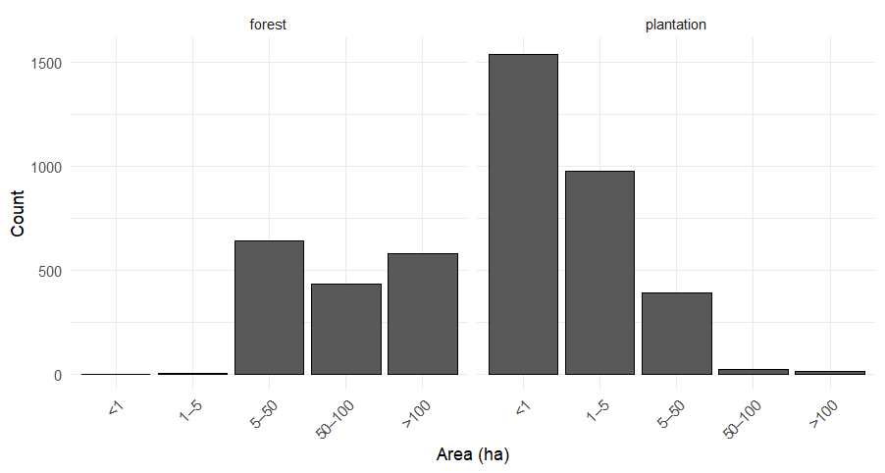
- France
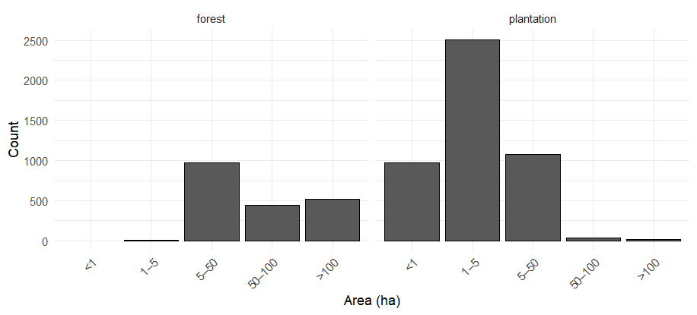
Figure S1. Size distribution of forest and plantation patches in a) Spain and b) France.

a)
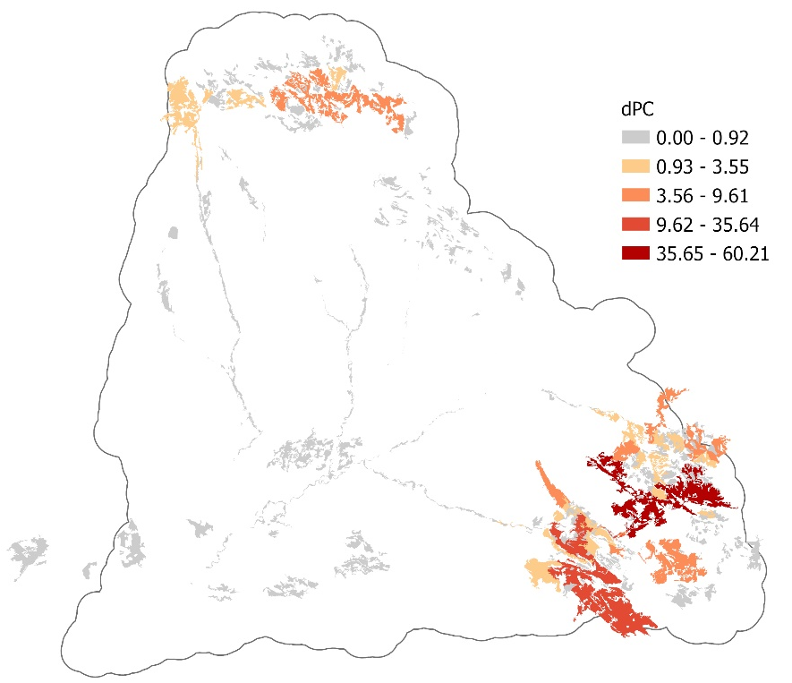
b)
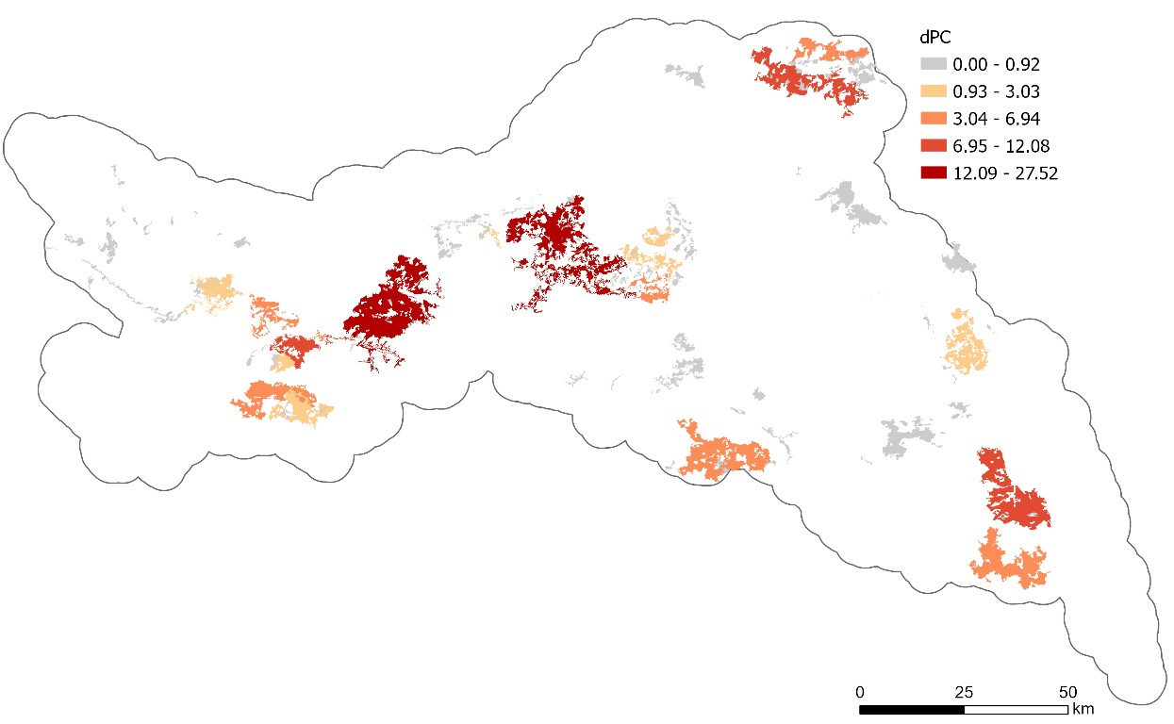
Figure S2. Node importance (dPC) for scenario 2 (forests and plantations intersecting Natura 2000 areas) in a) Spain and b) France using a median dispersal distance of 0.79 km (Common chaffinch). Darker colors represent the nodes with higher importance to maintain landscape connectivity

a)
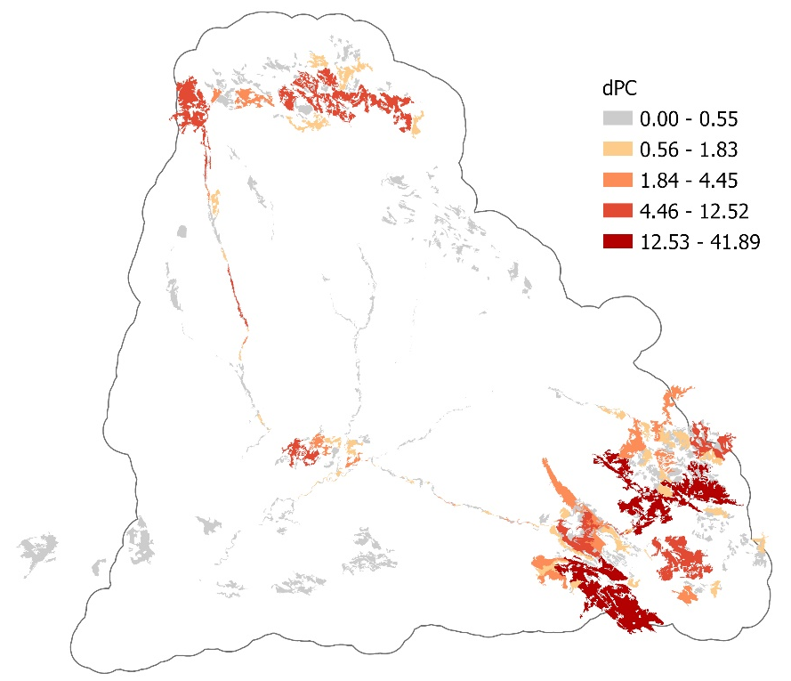
b)
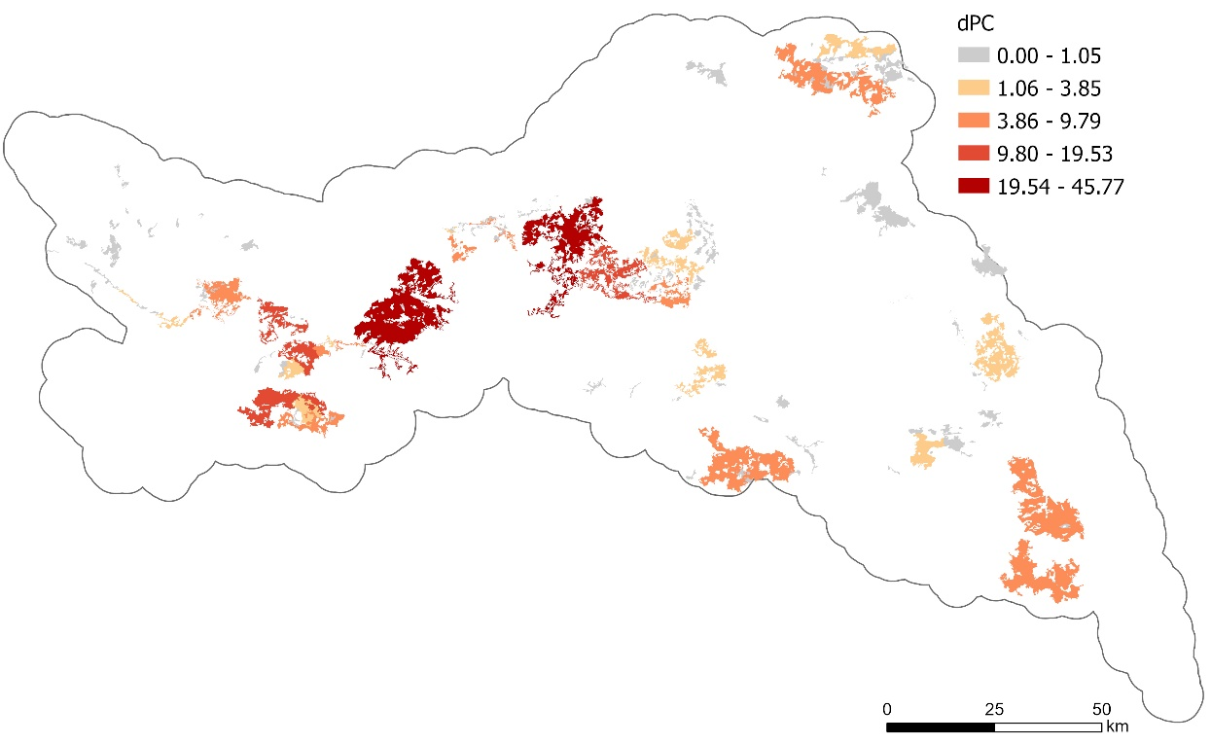
Figure S3. Node importance (dPC) for scenario 2 (forests and plantations intersecting Natura 2000 areas) in a) Spain and b) France using a median dispersal distance of 5.9 km (Great Spotted Woodpecker). Darker colors represent the nodes with higher importance to maintain landscape connectivity

a)
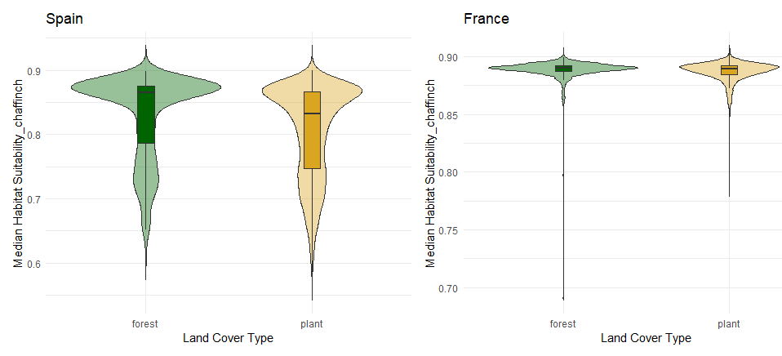
b)
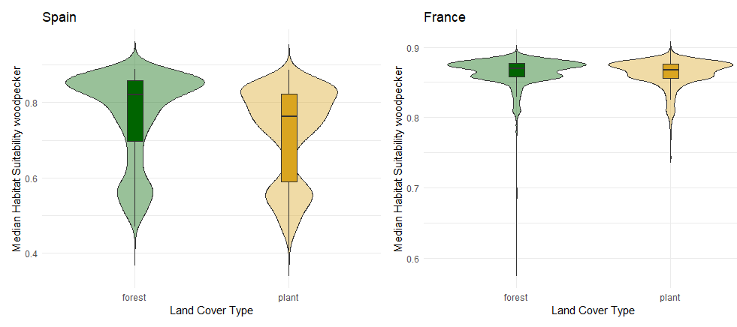
c)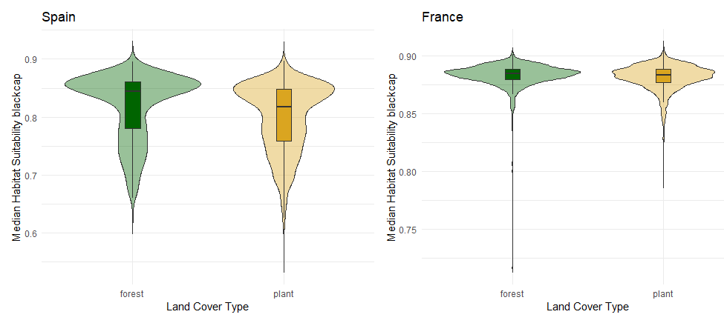
Figure S4. Median habitat suitability values for a) Common chaffinch, b) Great spotted woodpecker, c) Eurasian blackcap in plantations and natural forest patches. Median suitability values were extracted from a 1 km resolution dataset of modeled species distributions across Europe (Si-moussi & Thuiller, 2024). Higher values indicate greater predicted habitat suitability; error bars represent the standard deviation across patches.

