Supplementary Material

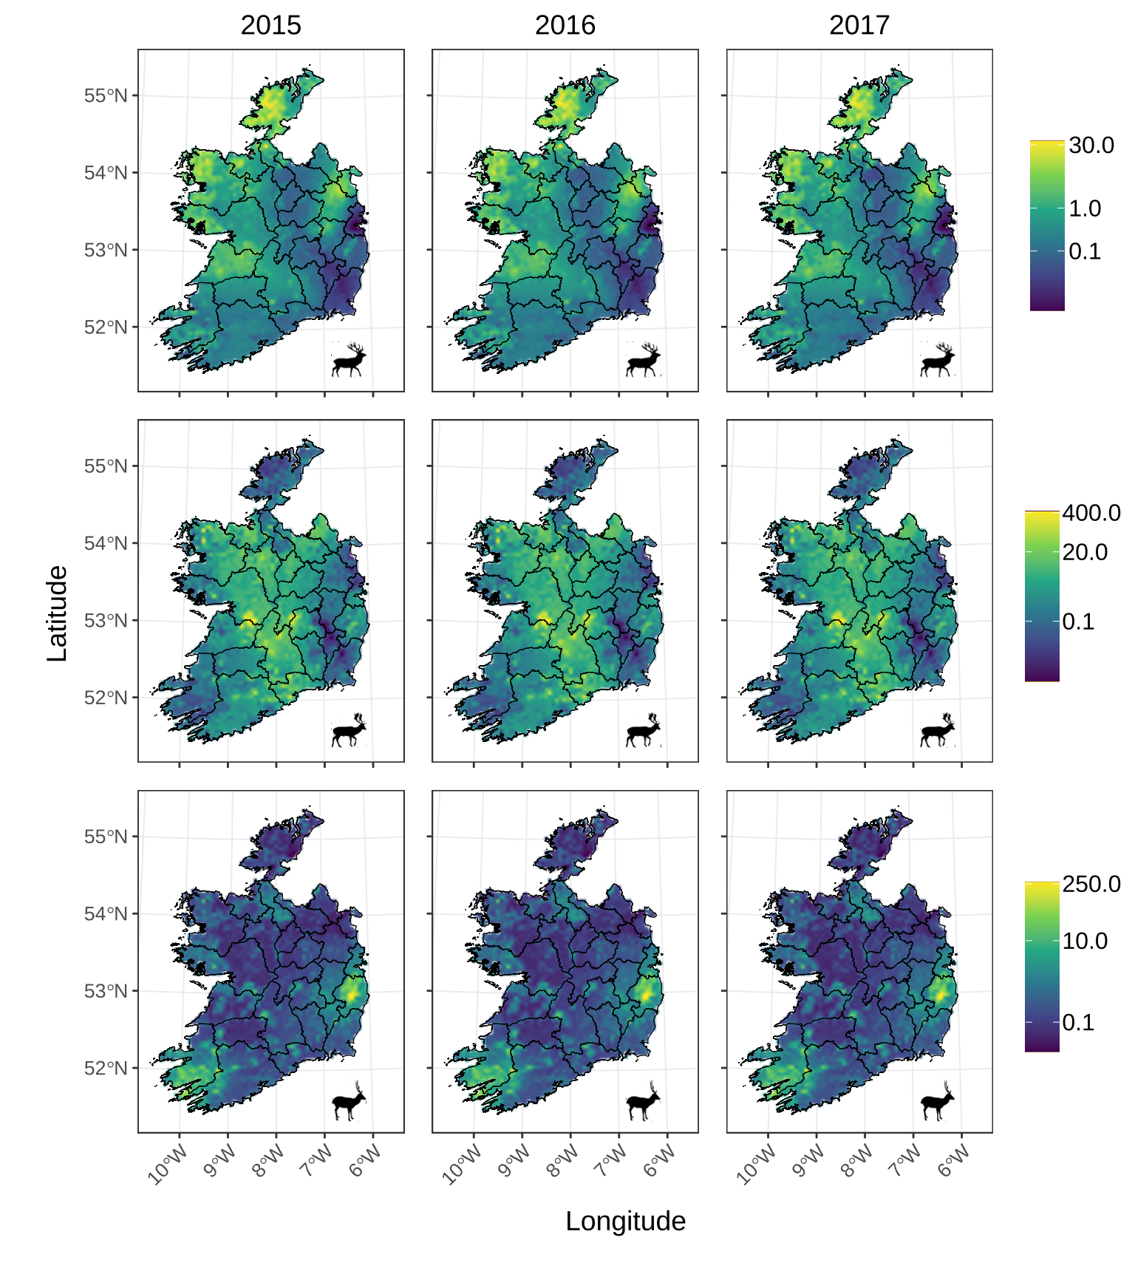
Supplementary Figure S1: Interpolated Relative Deer Density Rasters.
Rasters of 2015, 2016, and 2017 relative deer densities per 25 km². Top row, red deer; middle row, fallow deer; bottom row, sika deer. Relative densities were calculated by linear interpolation of 2012 and 2018 estimates (2012 and 2018 estimates were generated via disaggregated hunting returns by Murphy et al., 2023). Raster resolution is 25 km².
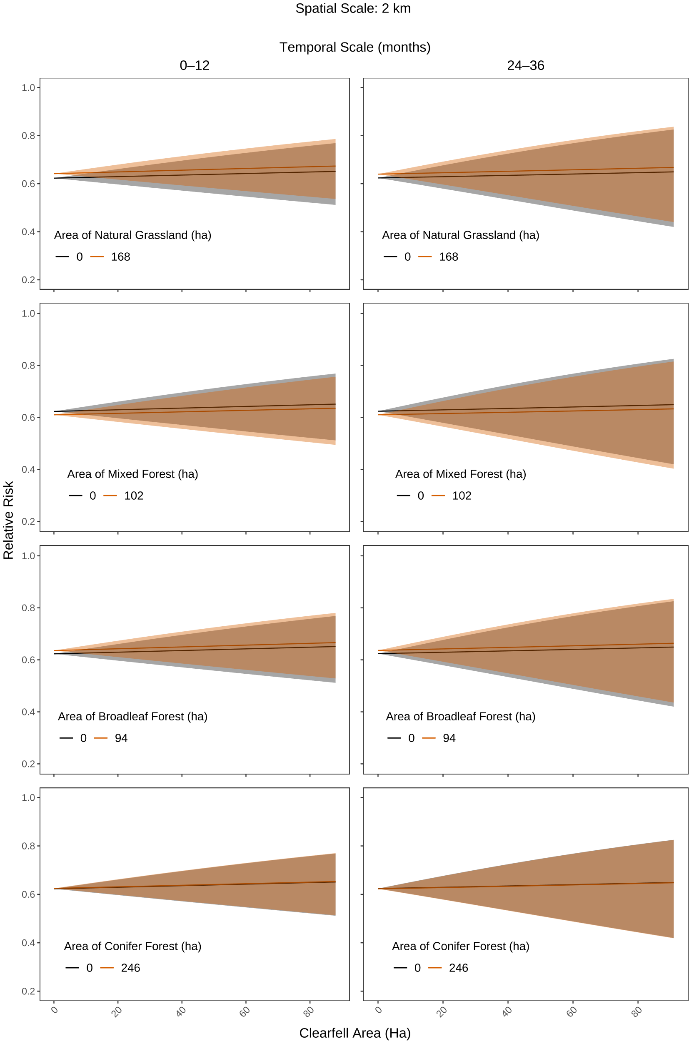
Supplementary Figure S2: Effect of Clearfell and Habitat Availability in a 2 km Buffer on bTB Breakdown Risk.
Predictions from conditional logistic regression models fit to clearfell data from two temporal scales (clearfell in prior 0–12 months and 24–36 months) within a 2 km buffer of farms. Predictions were made using median values for all predictors except habitat (natural grassland, mixed forest, broadleaf forest, and conifer forest) and clearfell area. The orange lines represent habitat availability at the 90th quantile. Clearfell values until the 90th quantile are shown. Shading denotes 95% conditional confidence intervals.
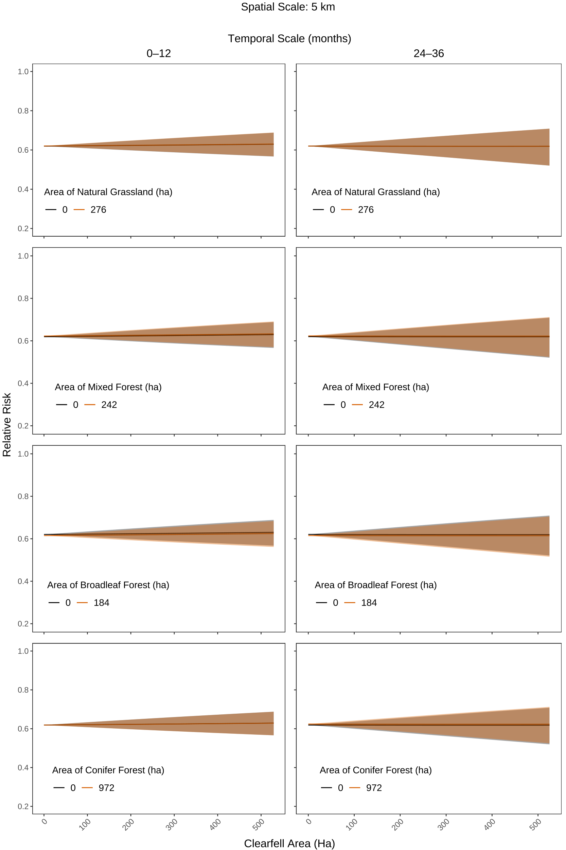
Supplementary Figure S3: Effect of Clearfell and Habitat Availability in a 5 km Buffer on bTB Breakdown Risk.
Predictions from conditional logistic regression models fit to clearfell data from two temporal scales (clearfell in prior 0–12 months and 24–36 months) within a 5 km buffer of farms. Predictions were made using median values for all predictors except natural grassland area, mixed forest, and clearfell area. The orange lines represent habitat availability at the 90th quantile. Clearfell values until the 90th quantile are shown. Shading denotes 95% conditional confidence intervals.
Supplementary Tables

Supplementary Table S1: Sensitivity Analysis for Badger Sett Data Selection.
Akaike Information Criterion (AIC) of conditional logistic regression models representing different spatial and temporal scales and fit to four subsets of badger sett data. Active badger sett density was calculated from the setts classified as active in 2015–2017, 2014–2018, 2013–2019, or 2012–2020. Models are ranked from lowest AIC (highest predictive power, or "top-ranked") to highest AIC to determine which models explain the most variability. The delta values compared to the top-ranked model are shown (ΔAIC). "df" = "degrees of freedom." Italicized and bolded models are presented in the main body of the manuscript.
Model |  |  | df | AIC | ΔAIC
Spatial Buffer  (km) | Time Lag (months) | Subset of Badger Data | df | AIC | ΔAIC
2 | 0–12 | 2012–2020 | 31 | 8029.48 | 0.00
5 | 24–36 | 2012–2020 | 31 | 8033.60 | 4.12
2 | 0–12 | 2013–2019 | 31 | 8039.06 | 9.59
5 | 0–12 | 2012–2020 | 31 | 8040.94 | 11.47
2 | 24–36 | 2012–2020 | 31 | 8042.17 | 12.69
5 | 24–36 | 2013–2019 | 31 | 8043.69 | 14.21
2 | 0–12 | 2014–2018 | 31 | 8048.17 | 18.69
5 | 0–12 | 2013–2019 | 31 | 8050.13 | 20.65
5 | 24–36 | 2014–2018 | 31 | 8052.48 | 23.01
2 | 24–36 | 2013–2019 | 31 | 8052.77 | 23.30
5 | 0–12 | 2014–2018 | 31 | 8058.72 | 29.24
2 | 0–12 | 2015–2017 | 31 | 8059.49 | 30.01
2 | 24–36 | 2014–2018 | 31 | 8062.19 | 32.72
5 | 24–36 | 2015–2017 | 31 | 8064.50 | 35.03
5 | 0–12 | 2015–2017 | 31 | 8071.06 | 41.58
2 | 24–36 | 2015–2017 | 31 | 8074.15 | 44.68

Supplementary Table S2: Summary of variables selected for model inclusion.
Names, descriptions, and hypothesised effects of variables included in models. Literature-based rationales for each variable were identified prior to inclusion in the models. “Variable × Variable” denotes an interaction term. Table is modified and expanded from Murphy et al. (2022).
Variable | Definition | Rationale and Hypothesised Effect | Reference
Herd type | Farm enterprise type. Divided into four categories to represent the main cattle farm enterprises in Ireland: Dairy, Beef, Suckler (also known as breeding beef herds) and Other. | We hypothesised that different forms of cattle enterprise would have different animal husbandry and management considerations which would affect bTB risk. We hypothesised that dairy enterprises would have higher relative bTB risk because dairy herds are typically larger; have older average age profile (therefore longer at-risk periods); prominent dairy breeds (e.g., Holstein) may have some genetic predisposition for bTB susceptibility; and the physiological stress on dams. | (Broughan et al., 2016)
Elevation | The altitude of the farm, measured in metres above sea level. | Elevation influences the ecology of the farm and the surrounding area, which may influence relative bTB risk after a clearfell. We hypothesised that farms with higher elevation would have lower likelihood of bTB risk because badgers favour habitat under an elevation threshold of 200 m. | (Byrne, Sleeman, et al., 2012)
Land parcels | The amount of land  subdivisions a farm is composed of. | We hypothesised that the number of land parcel subdivisions would influence bTB risk because farms with more land fragmentation would increase the probability of encounters with wildlife vectors. | (Byrne, Barrett, Breslin, Madden, O’keeffe, et al., 2020)
Cattle Number | Mean total number of cattle present on the farm during the study period. | We hypothesised that farms with higher numbers of cattle would be at an increased risk of relative bTB risk due to the likely increased risk of wildlife vector encounters. | (Brooks-Pollock & Keeling, 2009)
Natural Grassland Area | The area (in hectares)  of natural grassland  present within the  spatial buffer. | We hypothesised that greater area of natural grassland habitat would increase the likelihood of wildlife vector presence, thus increasing relative bTB risk when present near a farm. | (Reilly & Courtenay, 2007)
Mixed Forest Area | The area (in hectares)  of mixed forest  present within the  spatial buffer. | We hypothesised that greater area of mixed forest habitat would increase the likelihood of wildlife vector presence, thus increasing relative bTB risk when present near a farm. | (Winkler & Mathews, 2015)
Broadleaf Forest Area | The area (in hectares)  of broadleaf forest  present within the  spatial buffer. | We hypothesised that greater area of broadleaf forest habitat would increase the likelihood of wildlife vector presence, thus increasing relative bTB risk when present near a farm. | (Winkler & Mathews, 2015)

Supplementary Table S2 (continued): Summary of variables selected for model inclusion.
Names, descriptions, and hypothesised effects of variables included in models. Literature-based rationales for each variable were identified prior to inclusion in the models. “Variable × Variable” denotes an interaction term. Table is modified and expanded from Murphy et al. (2022).
Variable | Definition | Rationale and Hypothesised Effect | Reference
Conifer Forest Area | The area (in hectares)  of conifer forest  present within the  spatial buffer. | We hypothesised that greater area of conifer forest habitat would increase the likelihood of wildlife vector presence, thus increasing relative bTB risk when present near a farm. | (Liu & Nieuwenhuis, 2014)
Clearfell Area | The area (in hectares)  of forest felled during a clearfell event. | Habitat perturbation can influence the infectious disease transmission by modifying movement and dispersal patterns (which can increase contact rates between wildlife and cattle) and increasing stress (which can enhance disease susceptibility and shedding). We hypothesised that larger areas of habitat modification (i.e., clearfell) would increase relative bTB risk for nearby farms due to increased wildlife disturbance. | (Hing et al., 2016)  (Plowright et al., 2021)
Badger Active Sett Density | Density of active European badger (Meles meles) setts per 25 km² at the farm centroid. | Badgers are a well-documented maintenance host of bTB in the UK and Ireland. We hypothesised that a higher density of active badger setts would increase relative bTB risk. | (Gallagher & Clifton-Hadley, 2000)
Fallow Deer Density | Fallow deer (Dama dama) relative density per 25 km² at the farm centroid. | One semi-quantitative risk assessment conducted with samples from England found (with high uncertainty) that at a local level, fallow deer may pose a as much risk of bTB transmission to cattle as badgers. We hypothesised that at higher densities, fallow deer would increase relative bTB risk. | (Delahay et al., 2007)
Red Deer Density | Red deer (Cervus elaphus) relative density per 25 km² at the farm centroid. | bTB can reach high prevalence rates in herds of red deer. High prevalence of bTB in red deer has been associated with bTB breakdowns in the UK. We hypothesised that at higher densities, red deer would increase relative bTB risk. | (Collard, 2023)
Sika Deer Density | Sika deer (Cervus nippon) relative density per 25 km² at the farm centroid. | Genotyping studies have implicated sika deer as part of the transmission cycle of bTB infection in cattle, specifically in an area of high deer density (Wicklow County) in Ireland. We hypothesised that at higher densities, sika deer would increase relative bTB risk. | (Crispell et al., 2020)

Supplementary Table S2 (continued): Summary of variables selected for model inclusion.
Names, descriptions, and hypothesised effects of variables included in models. Literature-based rationales for each variable were identified prior to inclusion in the models. “Variable × Variable” denotes an interaction term. Table is modified and expanded from Murphy et al. (2022).
Variable | Definition | Rationale and Hypothesised Effect | Reference
Clearfell Area $×$ Badger Active Sett Density | Interaction between the area of forest clearfell (in hectares) and active sett density. | Using suitable habitat availability as a proxy for wildlife presence, Murphy et al. found a significant interaction between habitat availability and extent of clearfell on the risk of bTB breakdown. We hypothesised that greater areas of clearfell in the vicinity of higher badger sett density would result in greater disturbance and influence bTB relative risk in a spatially and temporally dependent manner. | (Murphy et al., 2022)
Clearfell Area $×$ Fallow Deer Density | Interaction between the area of forest clearfell (in hectares) and relative fallow deer density. | Using suitable habitat availability as a proxy for wildlife presence, Murphy et al. found a significant interaction between habitat availability and extent of clearfell on the risk of bTB breakdown. We hypothesised that greater areas of clearfell in the vicinity of higher fallow deer density would result in greater disturbance and influence bTB relative risk in a spatially and temporally dependent manner. | (Murphy et al., 2022)
Clearfell Area $×$ Red Deer Density | Interaction between the area of forest clearfell (in hectares) and relative red deer density. | Using suitable habitat availability as a proxy for wildlife presence, Murphy et al. found a significant interaction between habitat availability and extent of clearfell on the risk of bTB breakdown. We hypothesised that greater areas of clearfell in the vicinity of higher red deer density would result in greater disturbance and influence bTB relative risk in a spatially and temporally-dependent manner. | (Murphy et al., 2022)
Clearfell Area $×$ Sika Deer Density | Interaction between the area of forest clearfell (in hectares) and relative sika deer density. | Using suitable habitat availability as a proxy for wildlife presence, Murphy et al. found a significant interaction between habitat availability and extent of clearfell on the risk of bTB breakdown. We hypothesised that greater areas of clearfell in the vicinity of higher sika deer density would result in greater disturbance and influence bTB relative risk in a spatially and temporally-dependent manner. | (Murphy et al., 2022)

Supplementary Table S3: Summary of model fit to 0–12-month time lag and 2 km buffer data.
Summary of conditional logistic regression model fit to clearfell and habitat data from a 0–12-month time lag and 2 km spatial buffer. “Variable : variable” denotes an interaction term; “^2” denotes a quadratic effect. Exponentiated coefficients, “exp(coef),” represent the hazard ratio in this model structure. See Table 3 for summary of predictor significance.
Spatial Scale (km) | 2 |  | Temporal Scale (months) |  |  | 0–12
Concordance | 0.741 (SE = 0.007) |  | Likelihood ratio test |  |  | p < 0.001
Predictors | Exp(coef) | Lower .95 |  | Upper .95 | Pr(>|z|)
Dairy (ref: Beef)ª | 4.8437 | 3.8612 |  | 6.0763 | <0.001 |  | ***
Other (ref: Beef)ª | 0.8959 | 0.6165 |  | 1.3019 | 0.5643
Suckler (ref: Beef)ª | 2.6319 | 2.1455 |  | 3.2287 | <0.001 |  | ***
Elevation | 0.9988 | 0.9951 |  | 1.0025 | 0.5110
Elevation^2 | 1.0000 | 1.0000 |  | 1.0000 | 0.1768
LandParcels^{b} | 1.0123 | 0.9809 |  | 1.0447 | 0.4462
LandParcels^{b}^2 | 1.0001 | 0.9987 |  | 1.0016 | 0.8437
CattleNumber | 1.0140 | 1.0116 |  | 1.0165 | <0.001 |  | ***
CattleNumber^2 | 1.0000 | 1.0000 |  | 1.0000 | <0.001 |  | ***
NaturalGrassland^{c} | 1.0061 | 0.9989 |  | 1.0133 | 0.0966 |  | .
NaturalGrassland^{c}^2 | 1.0000 | 0.9999 |  | 1.0000 | 0.1566
BroadleafForest^{c} | 1.0013 | 0.9982 |  | 1.0045 | 0.4075
BroadleafForest^{c}^2 | 1.0000 | 1.0000 |  | 1.0000 | 0.6606
MixedForest^{c} | 0.9973 | 0.9942 |  | 1.0003 | 0.0767 |  | .
MixedForest^{c}^2 | 1.0000 | 1.0000 |  | 1.0000 | 0.0532 |  | .
ConiferForest^{c} | 1.0000 | 0.9987 |  | 1.0013 | 0.9907
ConiferForest^{d}^2 | 1.0000 | 1.0000 |  | 1.0000 | 0.8982
Clearfell^{d} | 1.0072 | 0.9997 |  | 1.0148 | 0.0593 |  | .
Clearfell^{d}^2 | 1.0000 | 1.0000 |  | 1.0000 | 0.6717
FallowDeer^{e} | 0.9978 | 0.9856 |  | 1.0102 | 0.7306
FallowDeer^{e}^2 | 1.0000 | 0.9999 |  | 1.0001 | 0.9675
RedDeer^{e} | 1.0209 | 0.8861 |  | 1.1762 | 0.7746
RedDeer^{e}^2 | 0.9959 | 0.9807 |  | 1.0113 | 0.5974
SikaDeer^{e} | 1.0685 | 1.0216 |  | 1.1176 | 0.0038 |  | **
SikaDeer^{e}^2 | 0.9990 | 0.9979 |  | 1.0001 | 0.0643 |  | .
ActiveSett^{f} | 1.0811 | 1.0459 |  | 1.1174 | <0.001 |  | ***
ActiveSett^{f} ^2 | 0.9982 | 0.9967 |  | 0.9997 | 0.0219 |  | *
Clearfell^{d} : FallowDeer^{e} | 0.9999 | 0.9992 |  | 1.0005 | 0.7223
Clearfell^{d} : RedDeer^{e} | 0.9911 | 0.9839 |  | 0.9985 | 0.0180 |  | *
Clearfell^{d} : SikaDeer^{e} | 0.9961 | 0.9929 |  | 0.9993 | 0.0155 |  | *
Clearfell^{d} : ActiveSett^{f} | 0.9998 | 0.9992 |  | 1.0004 | 0.5630

Herd typeª: Beef (reference), Dairy, Suckler, Other.
LandParcels^{b}: Number of farm subdivisions.
Habitat^{c}: Extent (ha) of each habitat type within the spatial buffer.
Clearfell^{d}: Extent (ha) of forest cut within the spatial buffer during the indicated time lag.
Deer^{e}: Relative deer densities (per 25 km²) for 2017 at the farm centroid.
ActiveSett^{f}: Density (per 25 km²) at the farm centroid of active badger setts (from 2012–2020).

Significance codes: 0 ‘***’ 0.001 ‘**’ 0.01 ‘*’ 0.05 ‘.’ 0.1 ‘ ’ 1
Supplementary Table S4: Summary of model fit to 24–36-month time lag and 2 km buffer data.
Summary of conditional logistic regression model fit to clearfell and habitat data from a 0–12-month time lag and 2 km spatial buffer. “Variable : variable” denotes an interaction term; “^2” denotes a quadratic effect. Exponentiated coefficients, “exp(coef),” represent the hazard ratio in this model structure. See Table 3 for summary of predictor significance.

Spatial Scale (km) | 2 |  | Temporal Scale (months) |  |  | 24–36
Concordance | 0.740 (SE = 0.007) |  | Likelihood ratio test |  |  | p < 0.001
Predictors | Exp(coef) | Lower .95 |  | Upper .95 | Pr(>|z|)
Dairy (ref: Beef)ª | 4.8604 | 3.8740 |  | 6.0980 | <0.001 |  | ***
Other (ref: Beef)ª | 0.9032 | 0.6215 |  | 1.3125 | 0.5933
Suckler (ref: Beef)ª | 2.6320 | 2.1455 |  | 3.2288 | <0.001 |  | ***
Elevation | 0.9988 | 0.9952 |  | 1.0025 | 0.5392
Elevation^2 | 1.0000 | 1.0000 |  | 1.0000 | 0.1952
LandParcels^{b} | 1.0123 | 0.9809 |  | 1.0446 | 0.4473
LandParcels^{b}^2 | 1.0002 | 0.9987 |  | 1.0016 | 0.8286
CattleNumber | 1.0140 | 1.0116 |  | 1.0164 | <0.001 |  | ***
CattleNumber^2 | 1.0000 | 1.0000 |  | 1.0000 | <0.001 |  | ***
NaturalGrassland^{c} | 1.0057 | 0.9988 |  | 1.0128 | 0.1078
NaturalGrassland^{c}^2 | 1.0000 | 0.9999 |  | 1.0000 | 0.1546
BroadleafForest^{c} | 1.0013 | 0.9982 |  | 1.0045 | 0.4115
BroadleafForest^{c}^2 | 1.0000 | 1.0000 |  | 1.0000 | 0.6438
MixedForest^{c} | 0.9974 | 0.9943 |  | 1.0004 | 0.0940 |  | .
MixedForest^{c}^2 | 1.0000 | 1.0000 |  | 1.0000 | 0.0879 |  | .
ConiferForest^{c} | 0.9999 | 0.9987 |  | 1.0011 | 0.8843
ConiferForest^{d}^2 | 1.0000 | 1.0000 |  | 1.0000 | 0.8842
Clearfell^{d} | 1.0028 | 0.9951 |  | 1.0106 | 0.4740
Clearfell^{d}^2 | 1.0000 | 1.0000 |  | 1.0000 | 0.9085
FallowDeer^{e} | 0.9981 | 0.9855 |  | 1.0108 | 0.7661
FallowDeer^{e}^2 | 1.0000 | 0.9999 |  | 1.0001 | 0.9765
RedDeer^{e} | 1.0793 | 0.8938 |  | 1.3032 | 0.4278
RedDeer^{e}^2 | 0.9847 | 0.9567 |  | 1.0136 | 0.2962
SikaDeer^{e} | 1.0773 | 1.0197 |  | 1.1381 | 0.0079 |  | **
SikaDeer^{e}^2 | 0.9987 | 0.9971 |  | 1.0002 | 0.0991 |  | .
ActiveSett^{f} | 1.0793 | 1.0444 |  | 1.1153 | <0.001 |  | ***
ActiveSett^{f} ^2 | 0.9982 | 0.9967 |  | 0.9998 | 0.0240 |  | *
Clearfell^{d} : FallowDeer^{e} | 0.9996 | 0.9988 |  | 1.0004 | 0.3350
Clearfell^{d} : RedDeer^{e} | 0.9909 | 0.9794 |  | 1.0026 | 0.1254
Clearfell^{d} : SikaDeer^{e} | 0.9975 | 0.9937 |  | 1.0014 | 0.2099
Clearfell^{d} : ActiveSett^{f} | 1.0004 | 0.9995 |  | 1.0012 | 0.3870

Herd typeª: Beef (reference), Dairy, Suckler, Other.
LandParcels^{b}: Number of farm subdivisions.
Habitat^{c}: Extent (ha) of each habitat type within the spatial buffer.
Clearfell^{d}: Extent (ha) of forest cut within the spatial buffer during the indicated time lag.
Deer^{e}: Relative deer densities (per 25 km²) for 2015 at the farm centroid.
ActiveSett^{f}: Density (per 25 km²) at the farm centroid of active badger setts (from 2012–2020).

Significance codes: 0 ‘***’ 0.001 ‘**’ 0.01 ‘*’ 0.05 ‘.’ 0.1 ‘ ’ 1
Supplementary Table S5: Summary of model fit to 0–12-month time lag and 5 km buffer data.
Summary of conditional logistic regression model fit to clearfell and habitat data from a 0–12-month time lag and 2 km spatial buffer. “Variable : variable” denotes an interaction term; “^2” denotes a quadratic effect. Exponentiated coefficients, “exp(coef),” represent the hazard ratio in this model structure. See Table 3 for summary of predictor significance.

Spatial Scale (km) | 5 |  | Temporal Scale (months) |  |  | 0–12
Concordance | 0.741 (SE = 0.007) |  | Likelihood ratio test |  |  | p < 0.001
Predictors | Exp(coef) | Lower .95 |  | Upper .95 | Pr(>|z|)
Dairy (ref: Beef)ª | 4.8376 | 3.8564 |  | 6.0683 | <0.001 |  | ***
Other (ref: Beef)ª | 0.8967 | 0.6170 |  | 1.3031 | 0.5674
Suckler (ref: Beef)ª | 2.6229 | 2.1380 |  | 3.2176 | <0.001 |  | ***
Elevation | 0.9988 | 0.9951 |  | 1.0025 | 0.5325
Elevation^2 | 1.0000 | 1.0000 |  | 1.0000 | 0.1993
LandParcels^{b} | 1.0113 | 0.9799 |  | 1.0436 | 0.4860
LandParcels^{b}^2 | 1.0002 | 0.9987 |  | 1.0016 | 0.8127
CattleNumber | 1.0141 | 1.0116 |  | 1.0165 | <0.001 |  | ***
CattleNumber^2 | 1.0000 | 1.0000 |  | 1.0000 | <0.001 |  | ***
NaturalGrassland^{c} | 1.0010 | 0.9991 |  | 1.0029 | 0.3005
NaturalGrassland^{c}^2 | 1.0000 | 1.0000 |  | 1.0000 | 0.1598
BroadleafForest^{c} | 0.9997 | 0.9986 |  | 1.0007 | 0.5541
BroadleafForest^{c}^2 | 1.0000 | 1.0000 |  | 1.0000 | 0.6196
MixedForest^{c} | 1.0000 | 0.9987 |  | 1.0013 | 0.9977
MixedForest^{c}^2 | 1.0000 | 1.0000 |  | 1.0000 | 0.7404
ConiferForest^{c} | 1.0000 | 0.9996 |  | 1.0004 | 0.9365
ConiferForest^{d}^2 | 1.0000 | 1.0000 |  | 1.0000 | 0.8788
Clearfell^{d} | 1.0003 | 0.9997 |  | 1.0009 | 0.3113
Clearfell^{d}^2 | 1.0000 | 1.0000 |  | 1.0000 | 0.7318
FallowDeer^{e} | 0.9977 | 0.9854 |  | 1.0101 | 0.7150
FallowDeer^{e}^2 | 1.0000 | 0.9999 |  | 1.0001 | 0.9605
RedDeer^{e} | 1.0148 | 0.8805 |  | 1.1697 | 0.8388
RedDeer^{e}^2 | 0.9963 | 0.9814 |  | 1.0114 | 0.6295
SikaDeer^{e} | 1.0810 | 1.0307 |  | 1.1337 | 0.0014 |  | **
SikaDeer^{e}^2 | 0.9988 | 0.9977 |  | 0.9999 | 0.0399 |  | *
ActiveSett^{f} | 1.0816 | 1.0461 |  | 1.1183 | <0.001 |  | ***
ActiveSett^{f} ^2 | 0.9983 | 0.9967 |  | 0.9998 | 0.0263 |  | *
Clearfell^{d} : FallowDeer^{e} | 1.0000 | 0.9999 |  | 1.0000 | 0.5265
Clearfell^{d} : RedDeer^{e} | 0.9999 | 0.9997 |  | 1.0001 | 0.3290
Clearfell^{d} : SikaDeer^{e} | 0.9999 | 0.9998 |  | 1.0000 | 0.0265 |  | *
Clearfell^{d} : ActiveSett^{f} | 1.0000 | 0.9999 |  | 1.0000 | 0.4916

Herd typeª: Beef (reference), Dairy, Suckler, Other.
LandParcels^{b}: Number of farm subdivisions.
Habitat^{c}: Extent (ha) of each habitat type within the spatial buffer.
Clearfell^{d}: Extent (ha) of forest cut within the spatial buffer during the indicated time lag.
Deer^{e}: Relative deer densities (per 25 km²) for 2017 at the farm centroid.
ActiveSett^{f}: Density (per 25 km²) at the farm centroid of active badger setts (from 2012–2020).

Significance codes: 0 ‘***’ 0.001 ‘**’ 0.01 ‘*’ 0.05 ‘.’ 0.1 ‘ ’ 1
Supplementary Table S6: Summary of model fit to 24–36-month time lag and 5 km buffer data.
Summary of conditional logistic regression model fit to clearfell and habitat data from a 0–12-month time lag and 2 km spatial buffer. “Variable : variable” denotes an interaction term; “^2” denotes a quadratic effect. Exponentiated coefficients, “exp(coef),” represent the hazard ratio in this model structure. See Table 3 for summary of predictor significance.

Spatial Scale (km) | 5 |  | Temporal Scale (months) |  |  | 24–36
Concordance | 0.742 (SE = 0.007) |  | Likelihood ratio test |  |  | p < 0.001
Predictors | Exp(coef) | Lower .95 |  | Upper .95 | Pr(>|z|)
Dairy (ref: Beef)ª | 4.8751 | 3.8854 |  | 6.1168 | <0.001 |  | ***
Other (ref: Beef)ª | 0.9027 | 0.6211 |  | 1.3118 | 0.5914
Suckler (ref: Beef)ª | 2.6304 | 2.1441 |  | 3.2269 | <0.001 |  | ***
Elevation | 0.9989 | 0.9952 |  | 1.0026 | 0.5621
Elevation^2 | 1.0000 | 1.0000 |  | 1.0000 | 0.2157
LandParcels^{b} | 1.0114 | 0.9800 |  | 1.0437 | 0.4816
LandParcels^{b}^2 | 1.0002 | 0.9987 |  | 1.0016 | 0.8008
CattleNumber | 1.0140 | 1.0116 |  | 1.0164 | <0.001 |  | ***
CattleNumber^2 | 1.0000 | 1.0000 |  | 1.0000 | <0.001 |  | ***
NaturalGrassland^{c} | 1.0010 | 0.9991 |  | 1.0029 | 0.2936
NaturalGrassland^{c}^2 | 1.0000 | 1.0000 |  | 1.0000 | 0.1467
BroadleafForest^{c} | 0.9997 | 0.9986 |  | 1.0008 | 0.5628
BroadleafForest^{c}^2 | 1.0000 | 1.0000 |  | 1.0000 | 0.6625
MixedForest^{c} | 1.0000 | 0.9987 |  | 1.0012 | 0.9397
MixedForest^{c}^2 | 1.0000 | 1.0000 |  | 1.0000 | 0.6397
ConiferForest^{c} | 1.0000 | 0.9997 |  | 1.0004 | 0.8519
ConiferForest^{d}^2 | 1.0000 | 1.0000 |  | 1.0000 | 0.9068
Clearfell^{d} | 1.0003 | 0.9995 |  | 1.0010 | 0.4664
Clearfell^{d}^2 | 1.0000 | 1.0000 |  | 1.0000 | 0.2903
FallowDeer^{e} | 0.9970 | 0.9844 |  | 1.0097 | 0.6376
FallowDeer^{e}^2 | 1.0000 | 0.9999 |  | 1.0001 | 0.9555
RedDeer^{e} | 1.1161 | 0.9241 |  | 1.3481 | 0.2542
RedDeer^{e}^2 | 0.9812 | 0.9537 |  | 1.0095 | 0.1903
SikaDeer^{e} | 1.0995 | 1.0360 |  | 1.1669 | 0.0018 |  | **
SikaDeer^{e}^2 | 0.9982 | 0.9965 |  | 1.0000 | 0.0437 |  | *
ActiveSett^{f} | 1.0802 | 1.0452 |  | 1.1164 | <0.001 |  | ***
ActiveSett^{f} ^2 | 0.9983 | 0.9968 |  | 0.9998 | 0.0264 |  | *
Clearfell^{d} : FallowDeer^{e} | 1.0000 | 0.9999 |  | 1.0000 | 0.4299
Clearfell^{d} : RedDeer^{e} | 0.9991 | 0.9982 |  | 1.0001 | 0.0729 |  | .
Clearfell^{d} : SikaDeer^{e} | 0.9998 | 0.9996 |  | 1.0000 | 0.0350 |  | *
Clearfell^{d} : ActiveSett^{f} | 1.0000 | 0.9999 |  | 1.0000 | 0.7146

Herd typeª: Beef (reference), Dairy, Suckler, Other.
LandParcels^{b}: Number of farm subdivisions.
Habitat^{c}: Extent (ha) of each habitat type within the spatial buffer.
Clearfell^{d}: Extent (ha) of forest cut within the spatial buffer during the indicated time lag.
Deer^{e}: Relative deer densities (per 25 km²) for 2015 at the farm centroid.
ActiveSett^{f}: Density (per 25 km²) at the farm centroid of active badger setts (from 2012–2020).

Significance codes: 0 ‘***’ 0.001 ‘**’ 0.01 ‘*’ 0.05 ‘.’ 0.1 ‘ ’ 1
Supplementary Table S7: Summary of model fit to 12–24-month time lag and 2 km buffer data, excluding County Wicklow.
Summary of conditional logistic regression model fit to clearfell and habitat data from a 0–12-month time lag and 2 km spatial buffer, excluding County Wicklow farms. “Variable : variable” denotes an interaction term; “^2” denotes a quadratic effect. Exponentiated coefficients, “exp(coef),” represent the hazard ratio in this model structure.
Spatial Scale (km) | 2 |  | Temporal Scale (months) |  |  | 12–24
Concordance | 0.743 (SE = 0.007) |  | Likelihood ratio test |  |  | p < 0.001
Predictors | Exp(coef) | Lower .95 |  | Upper .95 | Pr(>|z|)
Dairy (ref: Beef)ª | 4.9858 | 3.9531 |  | 6.2884 | <0.001 |  | ***
Other (ref: Beef)ª | 0.8603 | 0.5837 |  | 1.2679 | 0.4469
Suckler (ref: Beef)ª | 2.6831 | 2.1750 |  | 3.3099 | <0.001 |  | ***
Elevation | 0.9991 | 0.9952 |  | 1.0030 | 0.6421
Elevation^2 | 1.0000 | 1.0000 |  | 1.0000 | 0.2594
LandParcels^{b} | 1.0106 | 0.9792 |  | 1.0430 | 0.5135
LandParcels^{b}^2 | 1.0002 | 0.9988 |  | 1.0017 | 0.7531
CattleNumber | 1.0140 | 1.0115 |  | 1.0164 | <0.001 |  | ***
CattleNumber^2 | 1.0000 | 1.0000 |  | 1.0000 | <0.001 |  | ***
NaturalGrassland^{c} | 1.0067 | 0.9991 |  | 1.0144 | 0.0847 |  | .
NaturalGrassland^{c}^2 | 1.0000 | 0.9999 |  | 1.0000 | 0.1483
BroadleafForest^{c} | 1.0014 | 0.9982 |  | 1.0046 | 0.3809
BroadleafForest^{c}^2 | 1.0000 | 1.0000 |  | 1.0000 | 0.6198
MixedForest^{c} | 0.9976 | 0.9945 |  | 1.0007 | 0.1268
MixedForest^{c}^2 | 1.0000 | 1.0000 |  | 1.0000 | 0.0877 |  | .
ConiferForest^{c} | 1.0001 | 0.9988 |  | 1.0015 | 0.8705
ConiferForest^{d}^2 | 1.0000 | 1.0000 |  | 1.0000 | 0.9879
Clearfell^{d} | 1.0074 | 0.9998 |  | 1.0151 | 0.0563 |  | .
Clearfell^{d}^2 | 1.0000 | 1.0000 |  | 1.0000 | 0.6997
FallowDeer^{e} | 0.9984 | 0.9861 |  | 1.0108 | 0.7953
FallowDeer^{e}^2 | 1.0000 | 0.9999 |  | 1.0001 | 0.9768
RedDeer^{e} | 1.0090 | 0.8758 |  | 1.1625 | 0.9008
RedDeer^{e}^2 | 0.9969 | 0.9818 |  | 1.0122 | 0.6857
SikaDeer^{e} | 1.0079 | 0.9432 |  | 1.0771 | 0.8158
SikaDeer^{e}^2 | 0.9996 | 0.9977 |  | 1.0016 | 0.6977
ActiveSett^{f} | 1.0760 | 1.0411 |  | 1.1120 | <0.001 |  | ***
ActiveSett^{f} ^2 | 0.9984 | 0.9969 |  | 0.9999 | 0.0354 |  | *
Clearfell^{d} : FallowDeer^{e} | 0.9999 | 0.9993 |  | 1.0006 | 0.8092
Clearfell^{d} : RedDeer^{e} | 0.9909 | 0.9834 |  | 0.9985 | 0.0191 |  | *
Clearfell^{d} : SikaDeer^{e} | 0.9962 | 0.9925 |  | 0.9999 | 0.0416 |  | *
Clearfell^{d} : ActiveSett^{f} | 0.9997 | 0.9991 |  | 1.0004 | 0.4270

Herd typeª: Beef (reference), Dairy, Suckler, Other.
LandParcels^{b}: Number of farm subdivisions.
Habitat^{c}: Extent (ha) of each habitat type within the spatial buffer.
Clearfell^{d}: Extent (ha) of forest cut within the spatial buffer during the indicated time lag.
Deer^{e}: Relative deer densities (per 25 km²) for 2015 at the farm centroid.
ActiveSett^{f}: Density (per 25 km²) at the farm centroid of active badger setts (from 2012–2020).

Significance codes: 0 ‘***’ 0.001 ‘**’ 0.01 ‘*’ 0.05 ‘.’ 0.1 ‘ ’ 1
Supplementary Table S8: Summary of model fit to 24–36-month time lag and 2 km buffer data, excluding County Wicklow.
Summary of conditional logistic regression model fit to clearfell and habitat data from a 0–12-month time lag and 2 km spatial buffer, excluding County Wicklow farms. “Variable : variable” denotes an interaction term; “^2” denotes a quadratic effect. Exponentiated coefficients, “exp(coef),” represent the hazard ratio in this model structure.

Spatial Scale (km) | 2 |  | Temporal Scale (months) |  |  | 24–36
Concordance | 0.743 (SE = 0.007) |  | Likelihood ratio test |  |  | p < 0.001
Predictors | Exp(coef) | Lower .95 |  | Upper .95 | Pr(>|z|)
Dairy (ref: Beef)ª | 5.0006 | 3.9645 |  | 6.3074 | <0.001 |  | ***
Other (ref: Beef)ª | 0.8658 | 0.5875 |  | 1.2761 | 0.4667
Suckler (ref: Beef)ª | 2.6845 | 2.1761 |  | 3.3117 | <0.001 |  | ***
Elevation | 0.9991 | 0.9952 |  | 1.0030 | 0.6486
Elevation^2 | 1.0000 | 1.0000 |  | 1.0000 | 0.2671
LandParcels^{b} | 1.0102 | 0.9789 |  | 1.0425 | 0.5277
LandParcels^{b}^2 | 1.0002 | 0.9988 |  | 1.0017 | 0.7369
CattleNumber | 1.0139 | 1.0115 |  | 1.0164 | <0.001 |  | ***
CattleNumber^2 | 1.0000 | 1.0000 |  | 1.0000 | <0.001 |  | ***
NaturalGrassland^{c} | 1.0062 | 0.9988 |  | 1.0137 | 0.1006
NaturalGrassland^{c}^2 | 1.0000 | 0.9999 |  | 1.0000 | 0.1487
BroadleafForest^{c} | 1.0014 | 0.9982 |  | 1.0046 | 0.3962
BroadleafForest^{c}^2 | 1.0000 | 1.0000 |  | 1.0000 | 0.6148
MixedForest^{c} | 0.9977 | 0.9946 |  | 1.0008 | 0.1512
MixedForest^{c}^2 | 1.0000 | 1.0000 |  | 1.0000 | 0.1492
ConiferForest^{c} | 1.0000 | 0.9987 |  | 1.0013 | 0.9537
ConiferForest^{d}^2 | 1.0000 | 1.0000 |  | 1.0000 | 0.9745
Clearfell^{d} | 1.0028 | 0.9950 |  | 1.0107 | 0.4832
Clearfell^{d}^2 | 1.0000 | 1.0000 |  | 1.0000 | 0.9222
FallowDeer^{e} | 0.9984 | 0.9858 |  | 1.0112 | 0.8082
FallowDeer^{e}^2 | 1.0000 | 0.9999 |  | 1.0001 | 0.9945
RedDeer^{e} | 1.0675 | 0.8841 |  | 1.2889 | 0.4971
RedDeer^{e}^2 | 0.9860 | 0.9581 |  | 1.0148 | 0.3370
SikaDeer^{e} | 1.0090 | 0.9265 |  | 1.0989 | 0.8370
SikaDeer^{e}^2 | 0.9994 | 0.9964 |  | 1.0024 | 0.7035
ActiveSett^{f} | 1.0737 | 1.0391 |  | 1.1094 | <0.001 |  | ***
ActiveSett^{f} ^2 | 0.9984 | 0.9970 |  | 0.9999 | 0.0402 |  | *
Clearfell^{d} : FallowDeer^{e} | 0.9996 | 0.9988 |  | 1.0004 | 0.3431
Clearfell^{d} : RedDeer^{e} | 0.9908 | 0.9792 |  | 1.0027 | 0.1283
Clearfell^{d} : SikaDeer^{e} | 0.9980 | 0.9938 |  | 1.0022 | 0.3561
Clearfell^{d} : ActiveSett^{f} | 1.0003 | 0.9995 |  | 1.0012 | 0.4040

Herd typeª: Beef (reference), Dairy, Suckler, Other.
LandParcels^{b}: Number of farm subdivisions.
Habitat^{c}: Extent (ha) of each habitat type within the spatial buffer.
Clearfell^{d}: Extent (ha) of forest cut within the spatial buffer during the indicated time lag.
Deer^{e}: Relative deer densities (per 25 km²) for 2015 at the farm centroid.
ActiveSett^{f}: Density (per 25 km²) at the farm centroid of active badger setts (from 2012–2020).

Significance codes: 0 ‘***’ 0.001 ‘**’ 0.01 ‘*’ 0.05 ‘.’ 0.1 ‘ ’ 1
Supplementary Table S9: Summary of model fit to 12–24-month time lag and 5 km buffer data, excluding County Wicklow.
Summary of conditional logistic regression model fit to clearfell and habitat data from a 0–12-month time lag and 2 km spatial buffer, excluding County Wicklow farms. “Variable : variable” denotes an interaction term; “^2” denotes a quadratic effect. Exponentiated coefficients, “exp(coef),” represent the hazard ratio in this model structure.

Spatial Scale (km) | 5 |  | Temporal Scale (months) |  |  | 12–24
Concordance | 0.743 (SE = 0.007) |  | Likelihood ratio test |  |  | p < 0.001
Predictors | Exp(coef) | Lower .95 |  | Upper .95 | Pr(>|z|)
Dairy (ref: Beef)ª | 4.9842 | 3.9518 |  | 6.2863 | <0.001 |  | ***
Other (ref: Beef)ª | 0.8609 | 0.5841 |  | 1.2688 | 0.4491
Suckler (ref: Beef)ª | 2.6771 | 2.1701 |  | 3.3025 | <0.001 |  | ***
Elevation | 0.9991 | 0.9952 |  | 1.0030 | 0.6645
Elevation^2 | 1.0000 | 1.0000 |  | 1.0000 | 0.2916
LandParcels^{b} | 1.0095 | 0.9781 |  | 1.0419 | 0.5564
LandParcels^{b}^2 | 1.0003 | 0.9988 |  | 1.0017 | 0.7188
CattleNumber | 1.0140 | 1.0115 |  | 1.0164 | <0.001 |  | ***
CattleNumber^2 | 1.0000 | 1.0000 |  | 1.0000 | <0.001 |  | ***
NaturalGrassland^{c} | 1.0013 | 0.9992 |  | 1.0033 | 0.2203
NaturalGrassland^{c}^2 | 1.0000 | 1.0000 |  | 1.0000 | 0.1340
BroadleafForest^{c} | 0.9997 | 0.9986 |  | 1.0008 | 0.6291
BroadleafForest^{c}^2 | 1.0000 | 1.0000 |  | 1.0000 | 0.7134
MixedForest^{c} | 1.0001 | 0.9989 |  | 1.0014 | 0.8339
MixedForest^{c}^2 | 1.0000 | 1.0000 |  | 1.0000 | 0.9384
ConiferForest^{c} | 1.0000 | 0.9997 |  | 1.0004 | 0.9113
ConiferForest^{d}^2 | 1.0000 | 1.0000 |  | 1.0000 | 0.9918
Clearfell^{d} | 1.0003 | 0.9997 |  | 1.0010 | 0.2906
Clearfell^{d}^2 | 1.0000 | 1.0000 |  | 1.0000 | 0.6844
FallowDeer^{e} | 0.9983 | 0.9859 |  | 1.0109 | 0.7906
FallowDeer^{e}^2 | 1.0000 | 0.9999 |  | 1.0001 | 0.9585
RedDeer^{e} | 1.0049 | 0.8718 |  | 1.1583 | 0.9465
RedDeer^{e}^2 | 0.9970 | 0.9822 |  | 1.0120 | 0.6915
SikaDeer^{e} | 1.0208 | 0.9519 |  | 1.0947 | 0.5639
SikaDeer^{e}^2 | 0.9994 | 0.9974 |  | 1.0014 | 0.5596
ActiveSett^{f} | 1.0771 | 1.0418 |  | 1.1134 | <0.001 |  | ***
ActiveSett^{f} ^2 | 0.9984 | 0.9969 |  | 0.9999 | 0.0412 |  | *
Clearfell^{d} : FallowDeer^{e} | 1.0000 | 0.9999 |  | 1.0000 | 0.5537
Clearfell^{d} : RedDeer^{e} | 0.9999 | 0.9997 |  | 1.0001 | 0.3378
Clearfell^{d} : SikaDeer^{e} | 0.9999 | 0.9997 |  | 1.0000 | 0.0657 |  | .
Clearfell^{d} : ActiveSett^{f} | 1.0000 | 0.9999 |  | 1.0000 | 0.2907

Herd typeª: Beef (reference), Dairy, Suckler, Other.
LandParcels^{b}: Number of farm subdivisions.
Habitat^{c}: Extent (ha) of each habitat type within the spatial buffer.
Clearfell^{d}: Extent (ha) of forest cut within the spatial buffer during the indicated time lag.
Deer^{e}: Relative deer densities (per 25 km²) for 2015 at the farm centroid.
ActiveSett^{f}: Density (per 25 km²) at the farm centroid of active badger setts (from 2012–2020).

Significance codes: 0 ‘***’ 0.001 ‘**’ 0.01 ‘*’ 0.05 ‘.’ 0.1 ‘ ’ 1
Supplementary Table S10: Summary of model fit to 24–36-month time lag and 5 km buffer data, excluding County Wicklow.
Summary of conditional logistic regression model fit to clearfell and habitat data from a 0–12-month time lag and 2 km spatial buffer, excluding County Wicklow farms. “Variable : variable” denotes an interaction term; “^2” denotes a quadratic effect. Exponentiated coefficients, “exp(coef),” represent the hazard ratio in this model structure.

Spatial Scale (km) | 5 |  | Temporal Scale (months) |  |  | 24–36
Concordance | 0.744 (SE = 0.007) |  | Likelihood ratio test |  |  | p < 0.001
Predictors | Exp(coef) | Lower .95 |  | Upper .95 | Pr(>|z|)
Dairy (ref: Beef)ª | 5.0160 | 3.9763 |  | 6.3275 | <0.001 |  | ***
Other (ref: Beef)ª | 0.8661 | 0.5876 |  | 1.2766 | 0.4677
Suckler (ref: Beef)ª | 2.6826 | 2.1745 |  | 3.3094 | <0.001 |  | ***
Elevation | 0.9991 | 0.9952 |  | 1.0030 | 0.6525
Elevation^2 | 1.0000 | 1.0000 |  | 1.0000 | 0.2818
LandParcels^{b} | 1.0093 | 0.9779 |  | 1.0416 | 0.5670
LandParcels^{b}^2 | 1.0003 | 0.9989 |  | 1.0017 | 0.7000
CattleNumber | 1.0139 | 1.0115 |  | 1.0164 | <0.001 |  | ***
CattleNumber^2 | 1.0000 | 1.0000 |  | 1.0000 | <0.001 |  | ***
NaturalGrassland^{c} | 1.0013 | 0.9992 |  | 1.0033 | 0.2247
NaturalGrassland^{c}^2 | 1.0000 | 1.0000 |  | 1.0000 | 0.1248
BroadleafForest^{c} | 0.9997 | 0.9986 |  | 1.0008 | 0.6118
BroadleafForest^{c}^2 | 1.0000 | 1.0000 |  | 1.0000 | 0.7441
MixedForest^{c} | 1.0001 | 0.9988 |  | 1.0013 | 0.9133
MixedForest^{c}^2 | 1.0000 | 1.0000 |  | 1.0000 | 0.8097
ConiferForest^{c} | 1.0000 | 0.9997 |  | 1.0004 | 0.8252
ConiferForest^{d}^2 | 1.0000 | 1.0000 |  | 1.0000 | 0.8696
Clearfell^{d} | 1.0003 | 0.9996 |  | 1.0011 | 0.3853
Clearfell^{d}^2 | 1.0000 | 1.0000 |  | 1.0000 | 0.3427
FallowDeer^{e} | 0.9974 | 0.9848 |  | 1.0102 | 0.6920
FallowDeer^{e}^2 | 1.0000 | 0.9999 |  | 1.0001 | 0.9443
RedDeer^{e} | 1.1098 | 0.9190 |  | 1.3402 | 0.2792
RedDeer^{e}^2 | 0.9818 | 0.9545 |  | 1.0098 | 0.2005
SikaDeer^{e} | 1.0308 | 0.9442 |  | 1.1255 | 0.4978
SikaDeer^{e}^2 | 0.9989 | 0.9959 |  | 1.0020 | 0.4943
ActiveSett^{f} | 1.0749 | 1.0402 |  | 1.1107 | <0.001 |  | ***
ActiveSett^{f} ^2 | 0.9985 | 0.9970 |  | 1.0000 | 0.0432 |  | *
Clearfell^{d} : FallowDeer^{e} | 1.0000 | 0.9999 |  | 1.0000 | 0.3615
Clearfell^{d} : RedDeer^{e} | 0.9990 | 0.9981 |  | 1.0000 | 0.0531 |  | .
Clearfell^{d} : SikaDeer^{e} | 0.9998 | 0.9997 |  | 1.0000 | 0.1278
Clearfell^{d} : ActiveSett^{f} | 1.0000 | 0.9999 |  | 1.0000 | 0.7233

Herd typeª: Beef (reference), Dairy, Suckler, Other.
LandParcels^{b}: Number of farm subdivisions.
Habitat^{c}: Extent (ha) of each habitat type within the spatial buffer.
Clearfell^{d}: Extent (ha) of forest cut within the spatial buffer during the indicated time lag.
Deer^{e}: Relative deer densities (per 25 km²) for 2015 at the farm centroid.
ActiveSett^{f}: Density (per 25 km²) at the farm centroid of active badger setts (from 2012–2020).

Significance codes: 0 ‘***’ 0.001 ‘**’ 0.01 ‘*’ 0.05 ‘.’ 0.1 ‘ ’ 1

