Online Resource 5
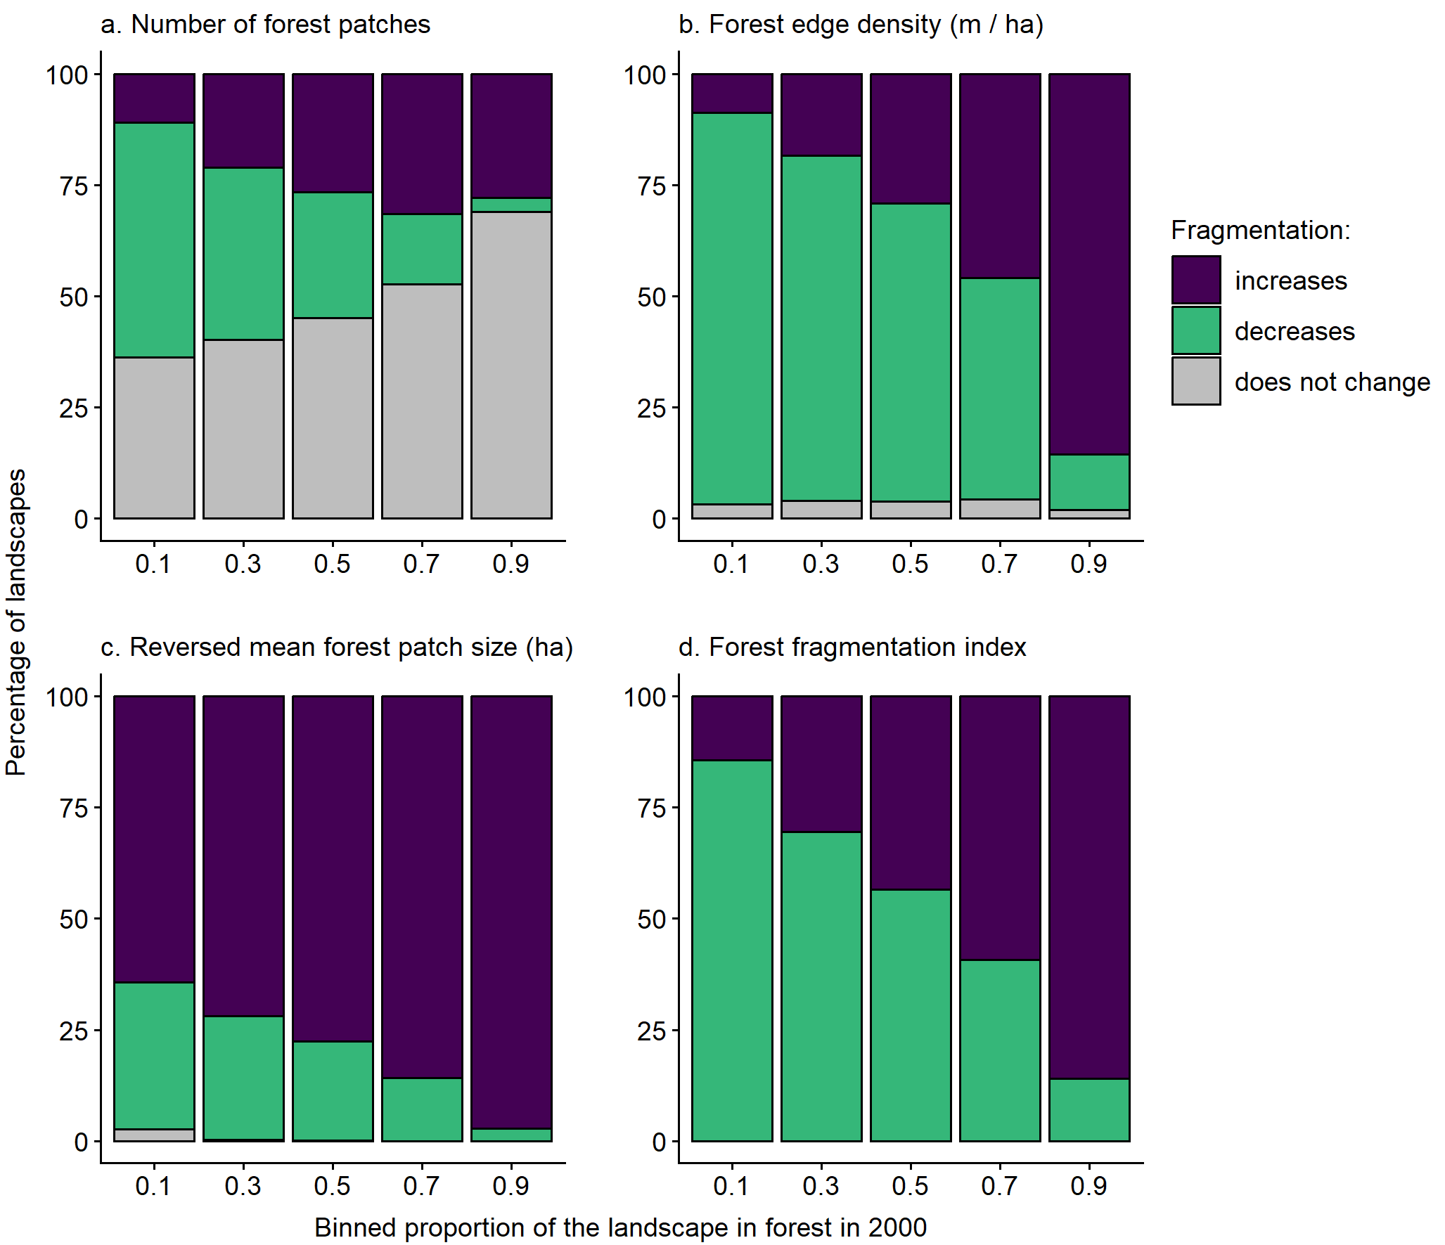
Fig. S1 Relationships between the proportion of the landscape in forest in 2000 and the percentages of landscapes that became more fragmented, less fragmented, and showed no change in fragmentation associated with forest loss. The proportion of the landscape in forest was binned into intervals of 0.2. Fragmentation was classified as increasing when there were (a) more forest patches, (b) higher forest edge density (meters of forest–non-forest edge per ha, including all patches in the landscape), (c) smaller mean forest patch sizes, and (d) higher forest fragmentation index values in 2020 than in 2000. Results are for landscapes with a 0.25-km radius (n = 36,482); only landscapes that lost forest between 2000 and 2020 are included
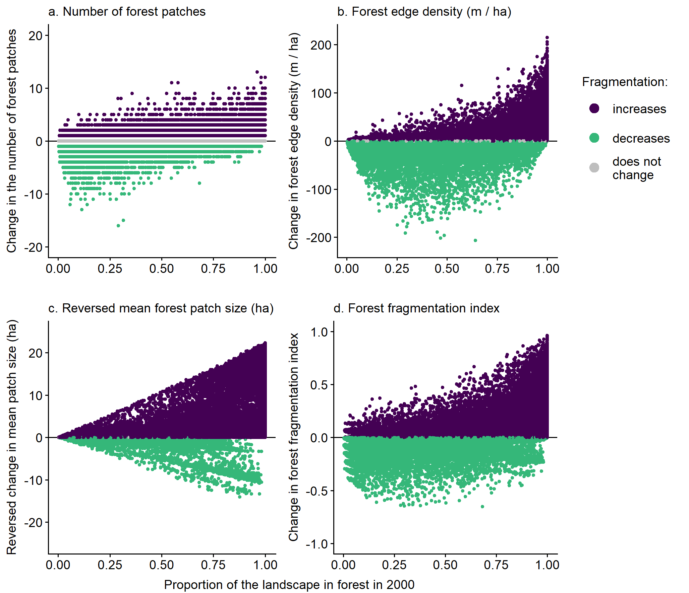
Fig. S2 Relationships between the proportion of the landscape in forest in 2000 and the change in forest fragmentation from 2000 to 2020, for each of four measures of forest fragmentation. An increase in fragmentation is indicated by (a) more forest patches, (b) higher forest edge density (meters of forest–non-forest edge per ha, including all patches in the landscape), (c) smaller mean forest patch sizes, and (d) higher forest fragmentation index values in 2020 than in 2000. We plot the reversed change in mean patch size, so that increased fragmentation is associated with positive values across all metrics. Results are for landscapes with a 0.25-km radius (n = 36,482); only landscapes that lost forest between 2000 and 2020 are included
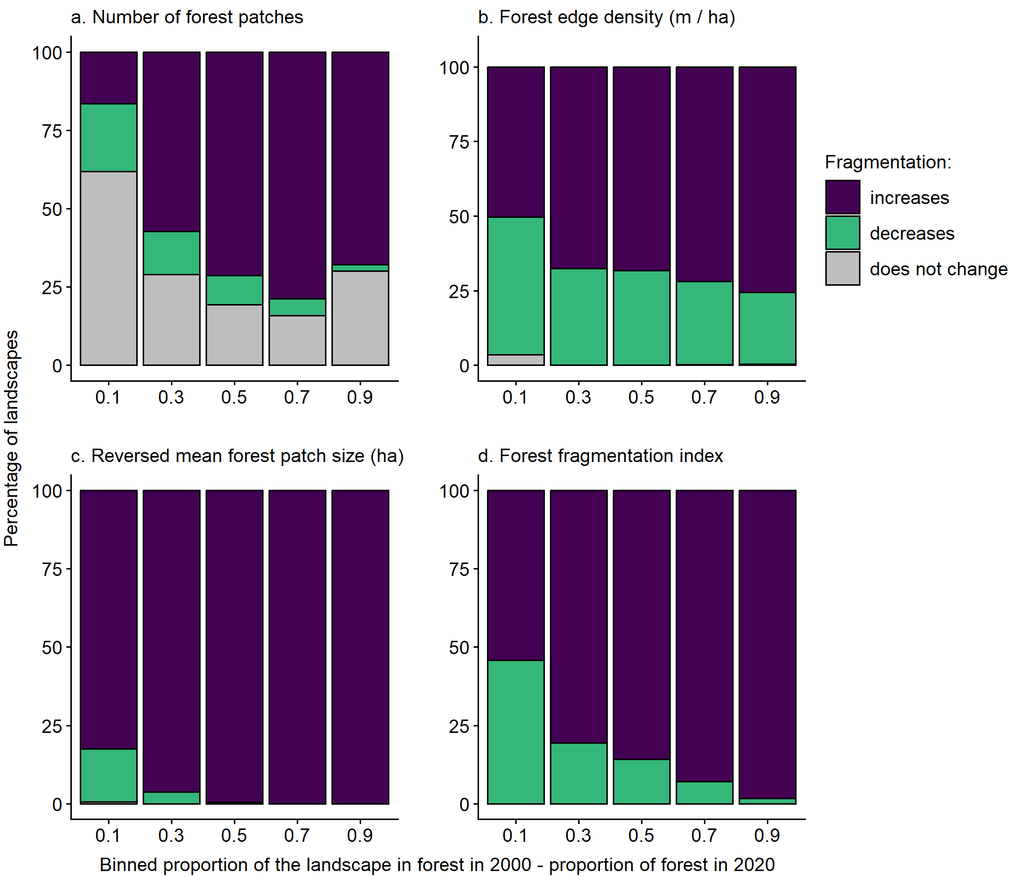
Fig. S3. Relationships between the magnitude of forest loss from 2000 and 2020 and the percentages of landscapes that became more fragmented, less fragmented, and showed no change in fragmentation associated with forest loss. Forest loss was binned into intervals of 0.2, where forest loss was the proportion of the landscape in forest in 2000 minus the proportion of the landscape in forest in 2020. Fragmentation was classified as increasing when there were (a) more forest patches, (b) higher forest edge density (meters of forest–non-forest edge per ha, including all patches in the landscape), (c) smaller mean forest patch sizes, and (d) higher forest fragmentation index values in 2020 than in 2000. Results are for landscapes with a 0.25-km radius (n = 36,482); only landscapes that lost forest between 2000 and 2020 are included
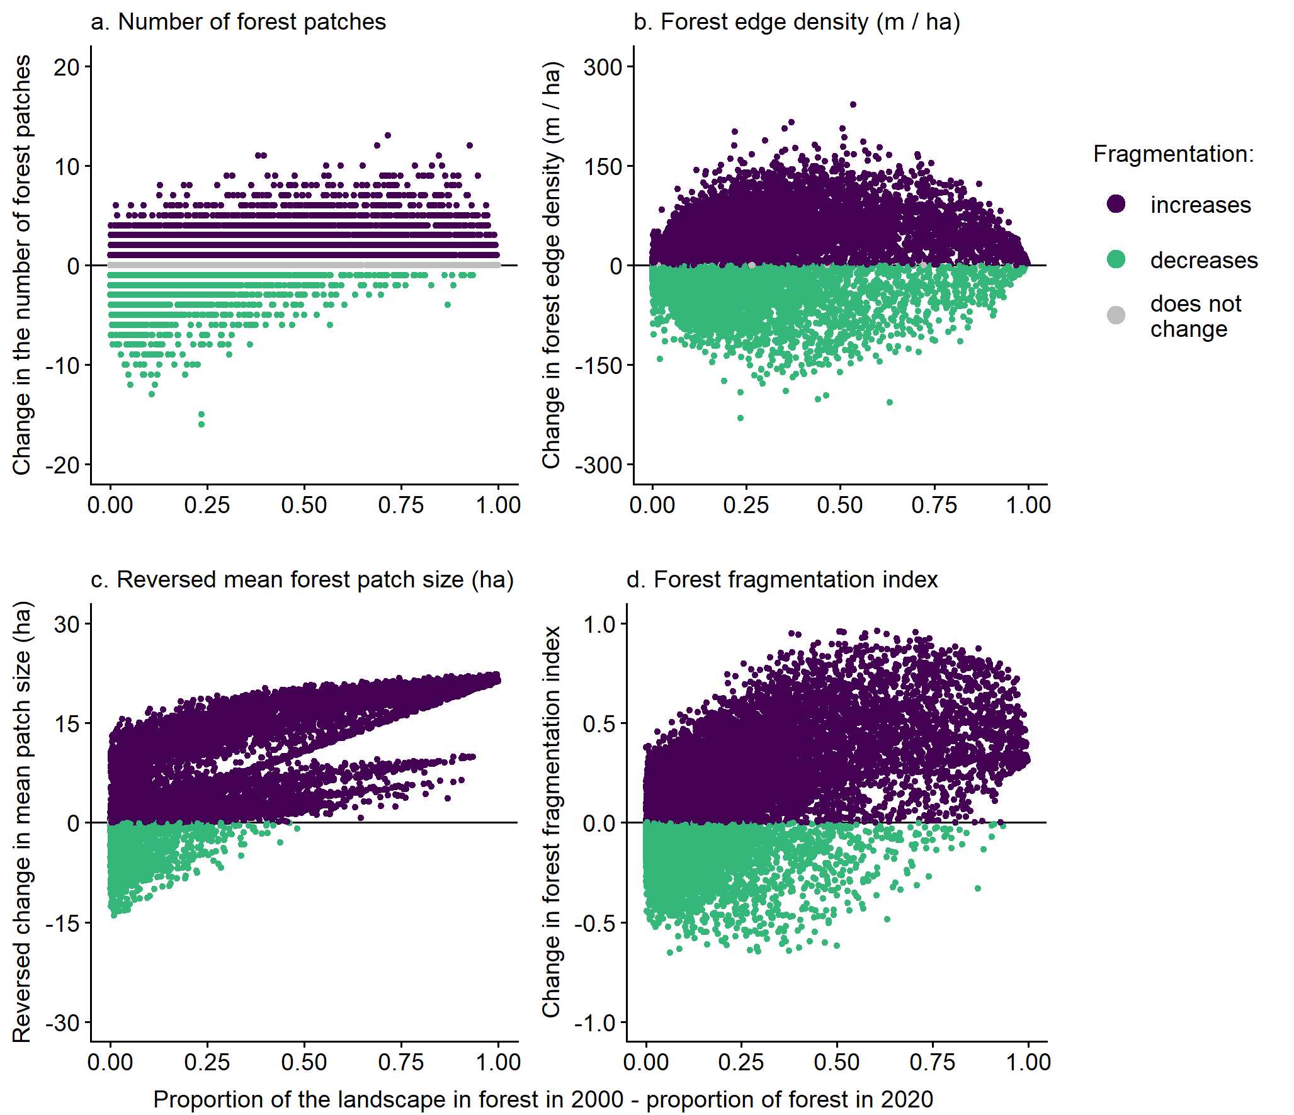
Fig. S4. Relationships between the magnitude of forest loss and the change in forest fragmentation from 2000 to 2020, for each of four measures of forest fragmentation. Forest loss was measured as the proportion of the landscape in forest in 2000 minus the proportion of the landscape in forest in 2020. An increase in fragmentation is indicated by (a) more forest patches, (b) higher forest edge density (meters of forest–non-forest edge per ha, including all patches in the landscape), (c) smaller mean forest patch sizes, and (d) higher forest fragmentation index values in 2020 than in 2000. We plot the reversed change in mean patch size, so that increased fragmentation is associated with positive values across all metrics. Results are for landscapes with a 0.25-km radius (n = 36,482); only landscapes that lost forest between 2000 and 2020 are included
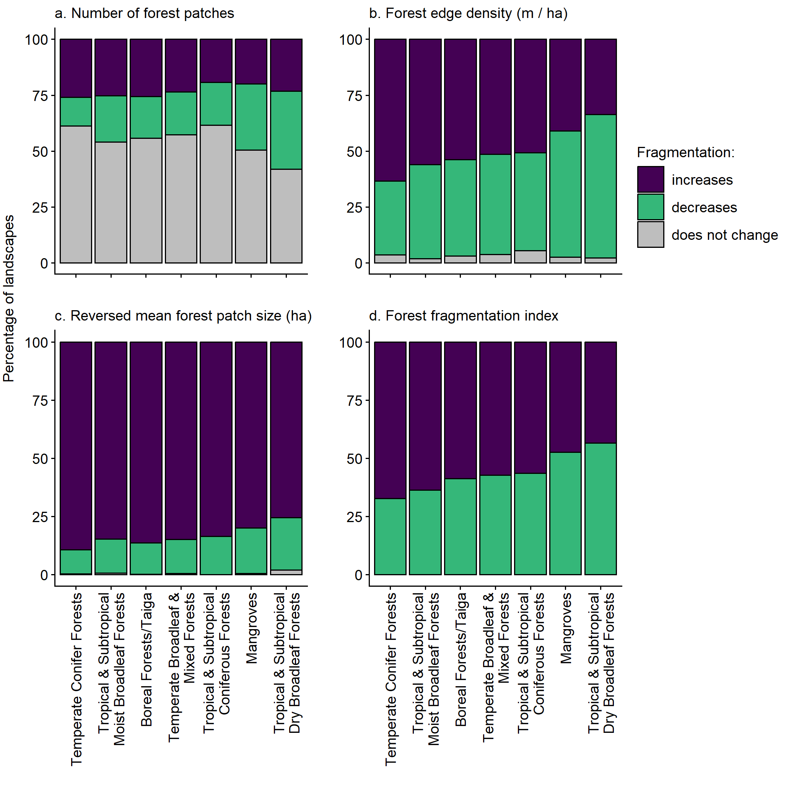
Fig. S5 Percentages of landscapes that became more fragmented, less fragmented, and showed no change in fragmentation associated with forest loss, in each of the seven forested biomes. Fragmentation was classified as increasing when there were (a) more forest patches, (b) higher forest edge density (meters of forest–non-forest edge per ha, including all patches in the landscape), (c) smaller mean forest patch sizes, and (d) higher forest fragmentation index values in 2020 than in 2000. Results are for landscapes with a 0.25-km radius (n = 36,482); only landscapes that lost forest between 2000 and 2020 are included
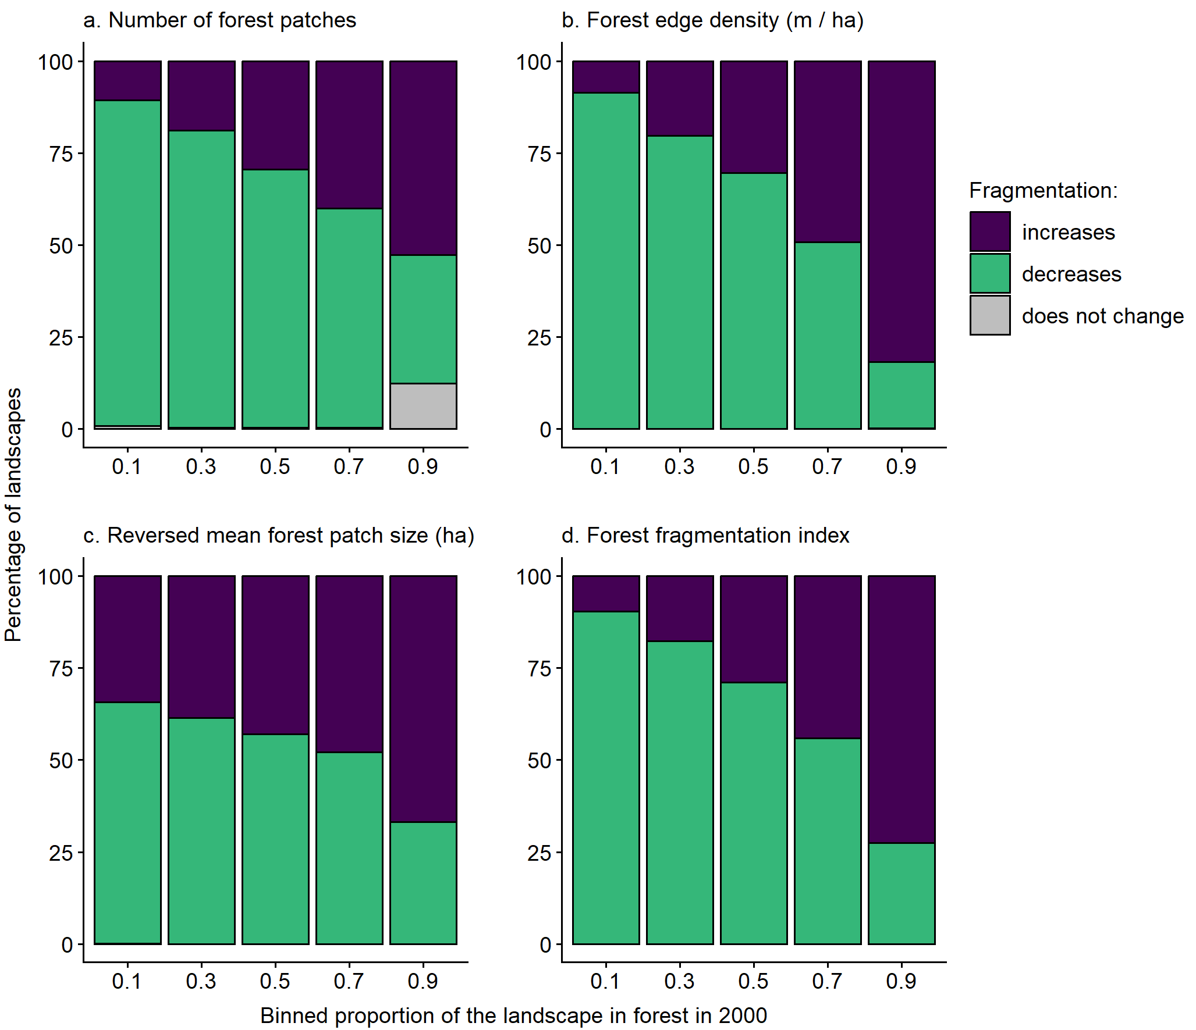
Fig. S6 Relationships between the proportion of the landscape in forest in 2000 and the percentages of landscapes that became more fragmented, less fragmented, and showed no change in fragmentation associated with forest loss. The proportion of the landscape in forest was binned into intervals of 0.2. Fragmentation was classified as increasing when there were (a) more forest patches, (b) higher forest edge density (meters of forest–non-forest edge per ha, including all patches in the landscape), (c) smaller mean forest patch sizes, and (d) higher forest fragmentation index values in 2020 than in 2000. Results are for landscapes with a 10-km radius (n = 84,635); only landscapes that lost forest between 2000 and 2020 are included
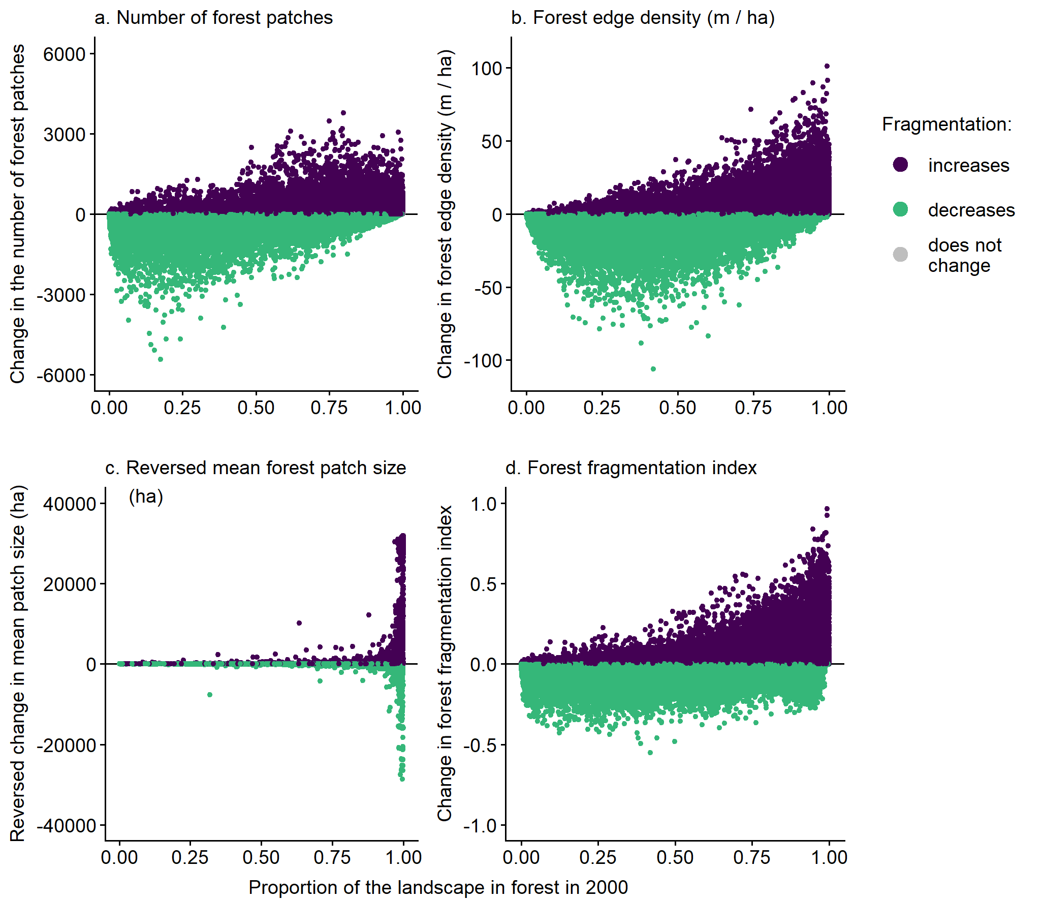
Fig. S7 Relationships between the proportion of the landscape in forest in 2000 and the change in forest fragmentation from 2000 to 2020, for each of four measures of forest fragmentation. An increase in fragmentation is indicated by (a) more forest patches, (b) higher forest edge density (meters of forest–non-forest edge per ha, including all patches in the landscape), (c) smaller mean forest patch sizes, and (d) higher forest fragmentation index values in 2020 than in 2000. We plot the reversed change in mean patch size, so that increased fragmentation is associated with positive values across all metrics. Results are for landscapes with a 10-km radius (n = 84,635); only landscapes that lost forest between 2000 and 2020 are included
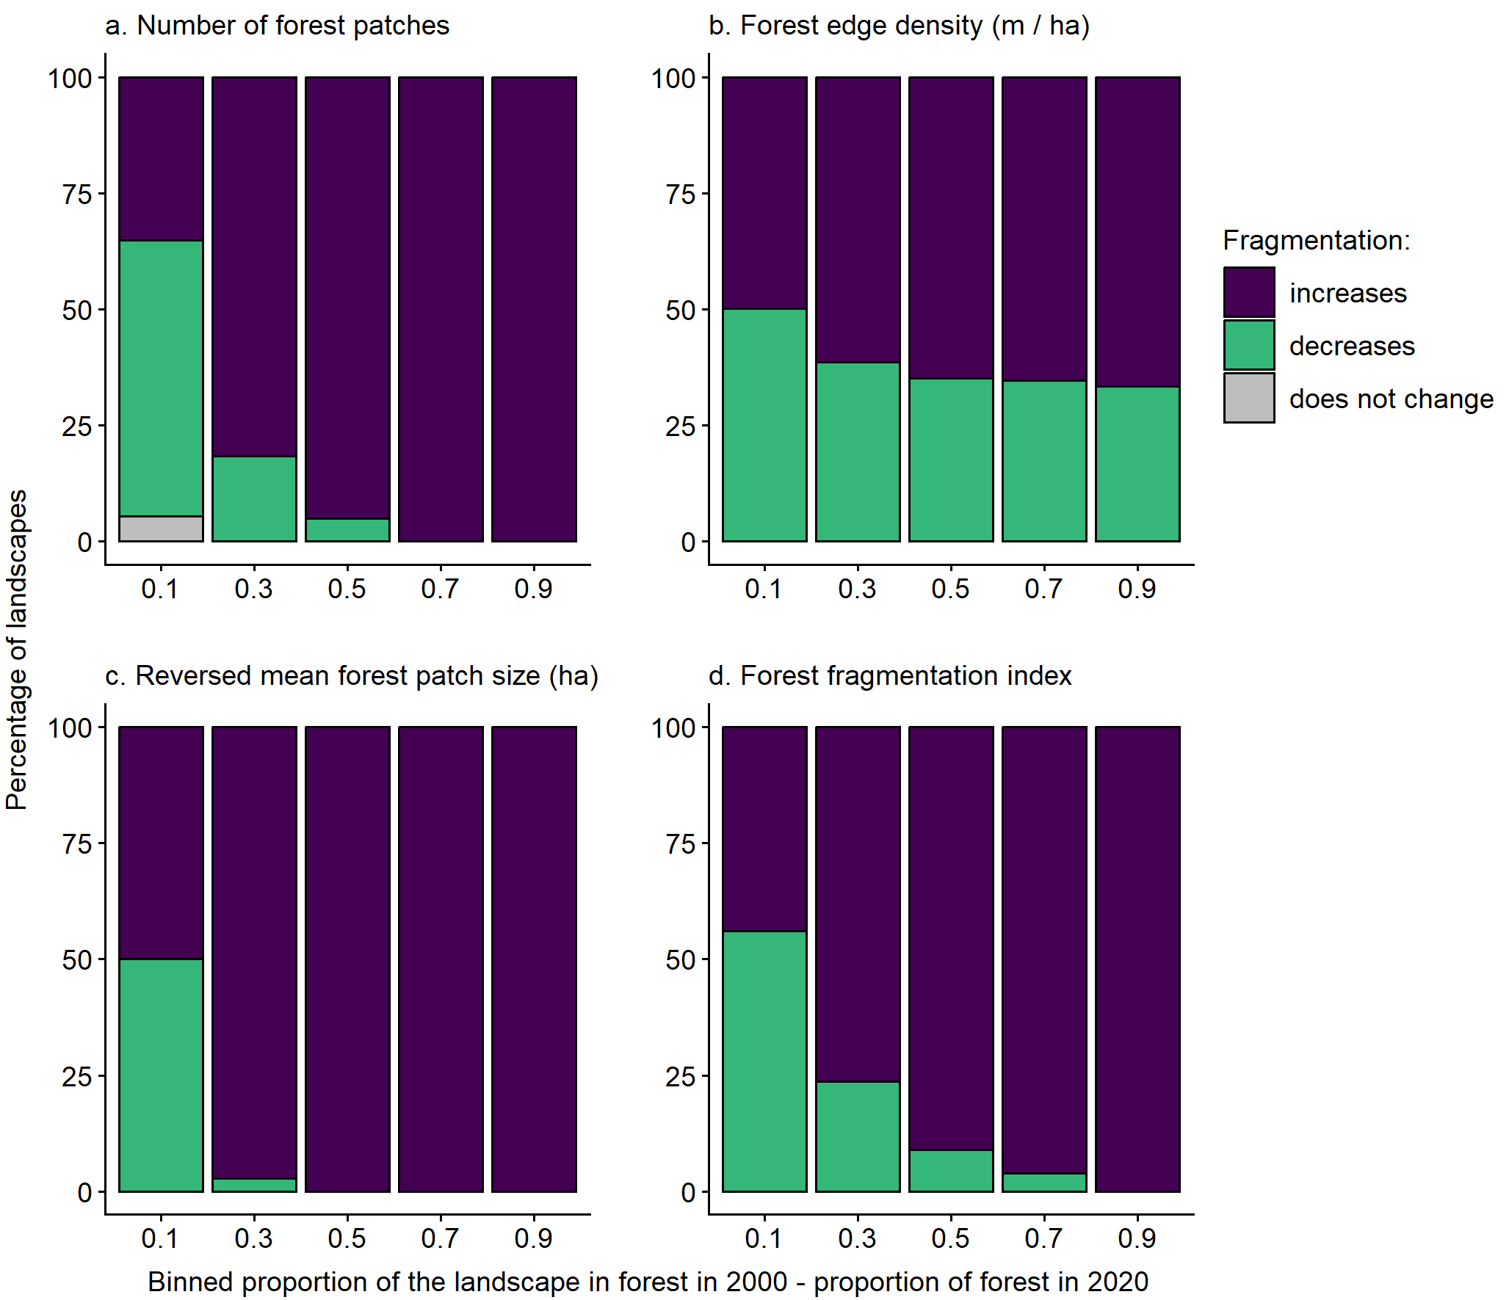
Fig. S8 Relationships between the magnitude of forest loss from 2000 and 2020 and the percentages of landscapes that became more fragmented, less fragmented, and showed no change in fragmentation associated with forest loss. Forest loss was binned into intervals of 0.2, where forest loss was the proportion of the landscape in forest in 2000 minus the proportion of the landscape in forest in 2020. Fragmentation was classified as increasing when there were (a) more forest patches, (b) higher forest edge density (meters of forest–non-forest edge per ha, including all patches in the landscape), (c) smaller mean forest patch sizes, and (d) higher forest fragmentation index values in 2020 than in 2000. Results are for landscapes with a 10-km radius (n = 84,635); only landscapes that lost forest between 2000 and 2020 are included
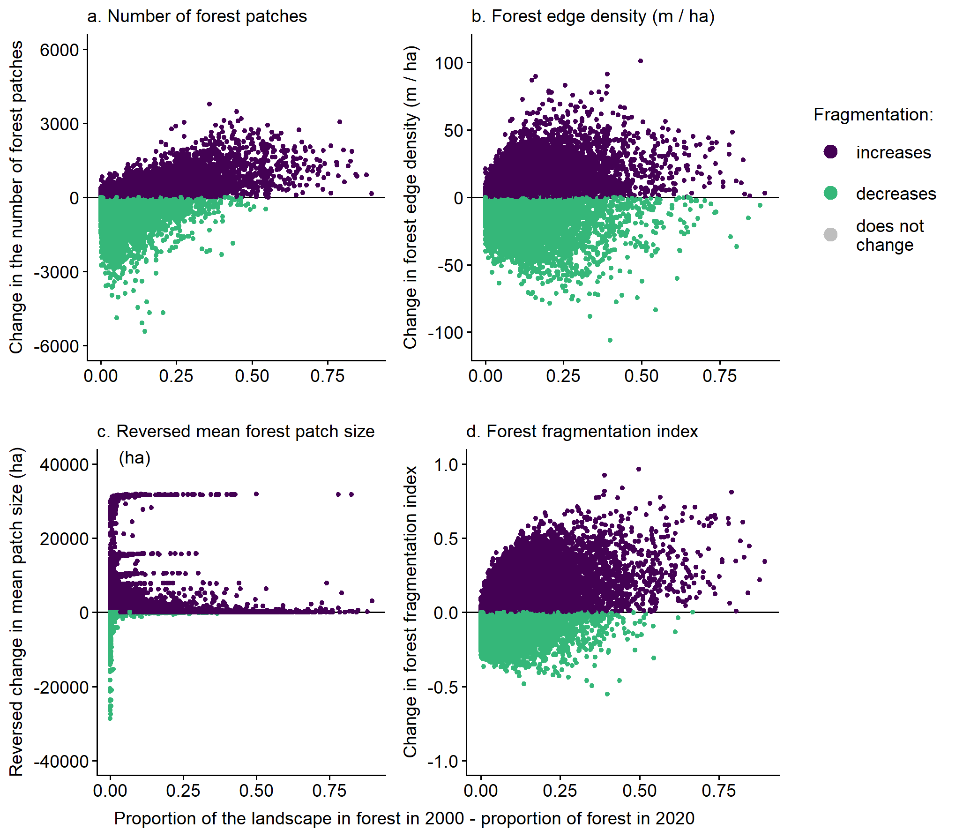
Fig. S9 Relationships between the magnitude of forest loss and the change in forest fragmentation from 2000 to 2020, for each of four measures of forest fragmentation. Forest loss was measured as the proportion of the landscape in forest in 2000 minus the proportion of the landscape in forest in 2020. An increase in fragmentation is indicated by (a) more forest patches, (b) higher forest edge density (meters of forest–non-forest edge per ha, including all patches in the landscape), (c) smaller mean forest patch sizes, and (d) higher forest fragmentation index values in 2020 than in 2000. We plot the reversed change in mean patch size, so that increased fragmentation is associated with positive values across all metrics. Results are for landscapes with a 10-km radius (n = 84,635); only landscapes that lost forest between 2000 and 2020 are included
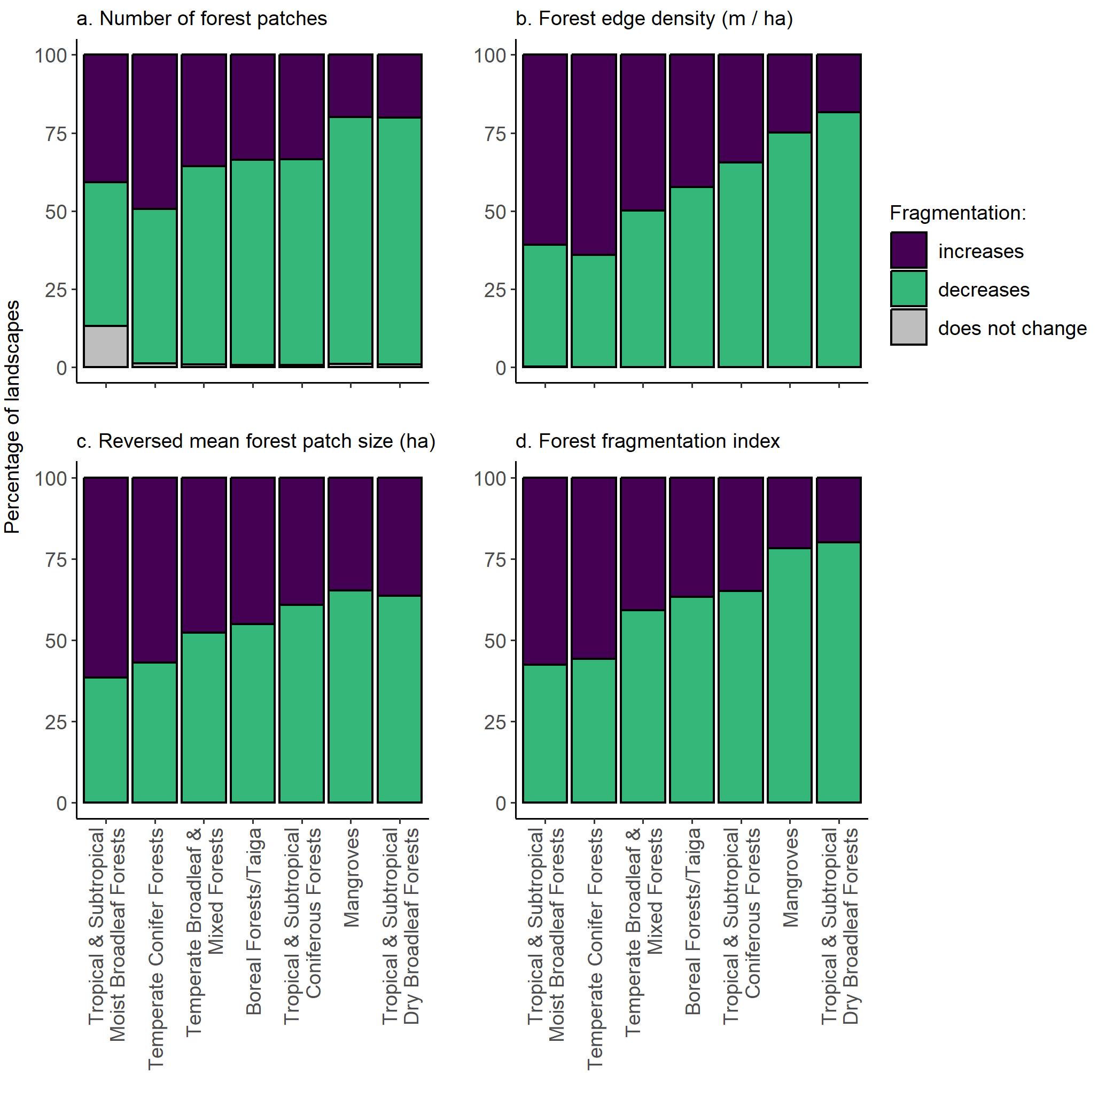
Fig. S10 Percentages of landscapes that became more fragmented, less fragmented, and showed no change in fragmentation associated with forest loss, in each of the seven forested biomes. Fragmentation was classified as increasing when there were (a) more forest patches, (b) higher forest edge density (meters of forest–non-forest edge per ha, including all patches in the landscape), (c) smaller mean forest patch sizes, and (d) higher forest fragmentation index values in 2020 than in 2000. Results are for landscapes with a 10-km radius (n = 84,635); only landscapes that lost forest between 2000 and 2020 are included

