Supplementary

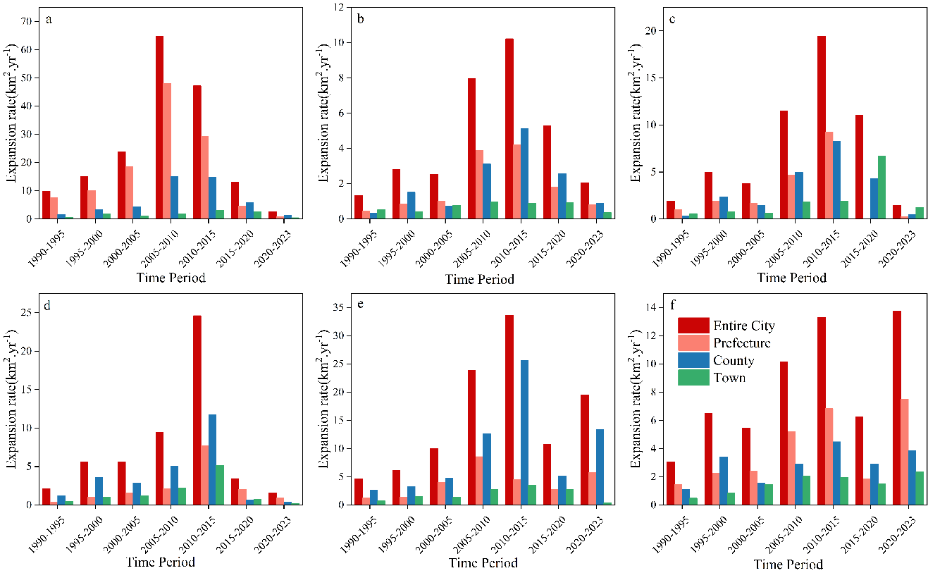
Figure S1 Changes in the rate of urban expansion at different administrative scales. a: KunMing, b: Chuxiong, c:Dali, d: Honghei, e: Qujing, f: Yuxi

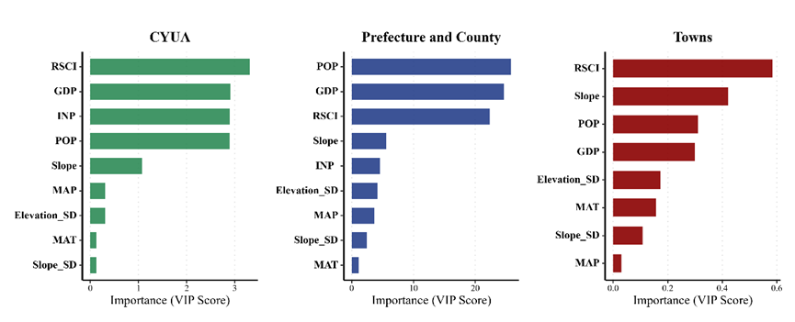
Figure S2. Robustness Check: Variable importance (VIP scores) derived from the PLS regression model, showing high consistency with the Random Forest results.

Table S1 Built-up land extraction accuracy
Year | PA | UA | OA | Kappa
1990 | 0.687 | 0.833 | 0.987 | 0.747
1991 | 0.656 | 0.808 | 0.986 | 0.717
1992 | 0.676 | 0.752 | 0.983 | 0.703
1993 | 0.774 | 0.807 | 0.989 | 0.785
1994 | 0.803 | 0.813 | 0.988 | 0.802
1995 | 0.793 | 0.798 | 0.986 | 0.788
1996 | 0.861 | 0.814 | 0.989 | 0.831
1997 | 0.791 | 0.775 | 0.986 | 0.776
1998 | 0.830 | 0.848 | 0.988 | 0.832
1999 | 0.778 | 0.795 | 0.985 | 0.778
2000 | 0.829 | 0.824 | 0.987 | 0.820
2001 | 0.735 | 0.835 | 0.983 | 0.773
2002 | 0.817 | 0.870 | 0.987 | 0.836
2003 | 0.864 | 0.828 | 0.988 | 0.840
2004 | 0.786 | 0.764 | 0.980 | 0.764
2005 | 0.791 | 0.839 | 0.982 | 0.805
2006 | 0.753 | 0.819 | 0.981 | 0.775
2007 | 0.792 | 0.812 | 0.974 | 0.788
2008 | 0.803 | 0.833 | 0.978 | 0.806
2009 | 0.857 | 0.867 | 0.982 | 0.852
2010 | 0.820 | 0.856 | 0.977 | 0.825
2011 | 0.783 | 0.845 | 0.972 | 0.798
2012 | 0.847 | 0.823 | 0.974 | 0.820
2013 | 0.874 | 0.864 | 0.973 | 0.854
2014 | 0.877 | 0.843 | 0.971 | 0.844
2015 | 0.859 | 0.853 | 0.971 | 0.839
2016 | 0.889 | 0.851 | 0.972 | 0.854
2017 | 0.893 | 0.840 | 0.973 | 0.851
2018 | 0.897 | 0.841 | 0.972 | 0.853
2019 | 0.925 | 0.826 | 0.975 | 0.859
2020 | 0.919 | 0.869 | 0.978 | 0.881
2021 | 0.925 | 0.843 | 0.975 | 0.868
2022 | 0.936 | 0.849 | 0.978 | 0.878
2023 | 0.927 | 0.853 | 0.977 | 0.876
PA: Producer’s accuracy, UA: User’s accuracy, OA: Overall accuracy

