- Supplemental materials
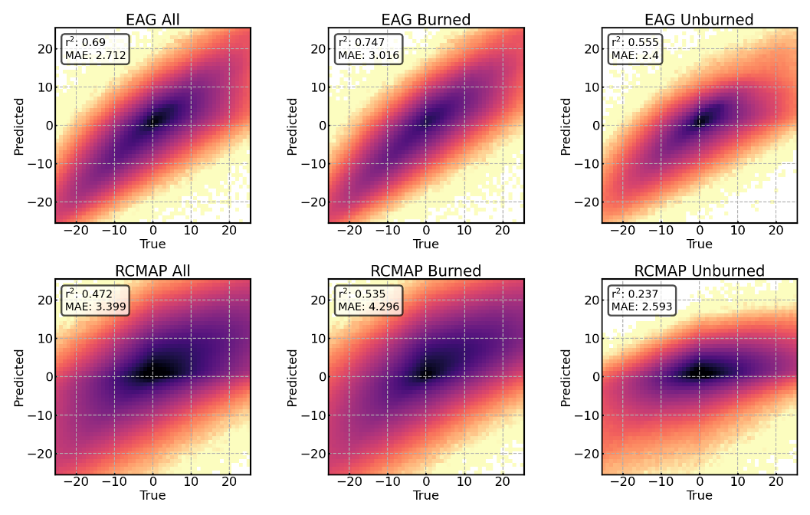
Fig. S1 Model accuracy for predicting the difference in invasive annual grass cover in each year post-fire compared to the year before fire in both burned and unburned points and in both the EAG (2016–2024) and RCMAP (1985–2024) datasets. Heatmaps display data density ranging from black (high) to tan (low)
Table S1 Permutation importance for model variables in short-term (left, EAG) and long-term (right, RCMAP) change in invasive annual grass cover models. Permutation importance values represent the increase in models mean absolute error (MAE) resulting from randomly permuting each predictor. Higher values indicate greater importance because shuffling that variable causes a larger degradation in model performance, whereas values near zero indicate little contribution to model accuracy
EAG |  | RCMAP
Feature | Permutation  importance | Feature | Permutation  importance
Invasive grass cover prior  to fire | 4.14 | Annual grass  cover prior to fire | 1.63
DEM | 0.98 | DEM | 0.93
Annual  Precipitation | 0.90 | Annual  Temperature | 0.80
Annual  Temperature | 0.65 | Annual  Precipitation | 0.67
Fire occurrence | 0.36 | Fire occurrence | 0.52
VegDRI spring  of fire year | 0.31 | Soil organic  matter | 0.37
VegDRI spring  prior to fire year | 0.30 | Years since last  burn | 0.20
VegDRI spring  after fire year | 0.25 | Available  Water Capacity | 0.18
PADR | 0.21 | silt | 0.17
slope | 0.18 | PADR | 0.16
Years since last burn | 0.18 | clay | 0.16
VegDRI fall  after fire year | 0.17 | slope | 0.14
VegDRI summer  after fire year | 0.17 | sand | 0.11
VegDRI summer  of fire year | 0.13 | aspect | 0.06
VegDRI summer  prior to fire year | 0.12
VegDRI fall  prior to fire year | 0.12
VegDRI fall  of fire year | 0.12
aspect | 0.06
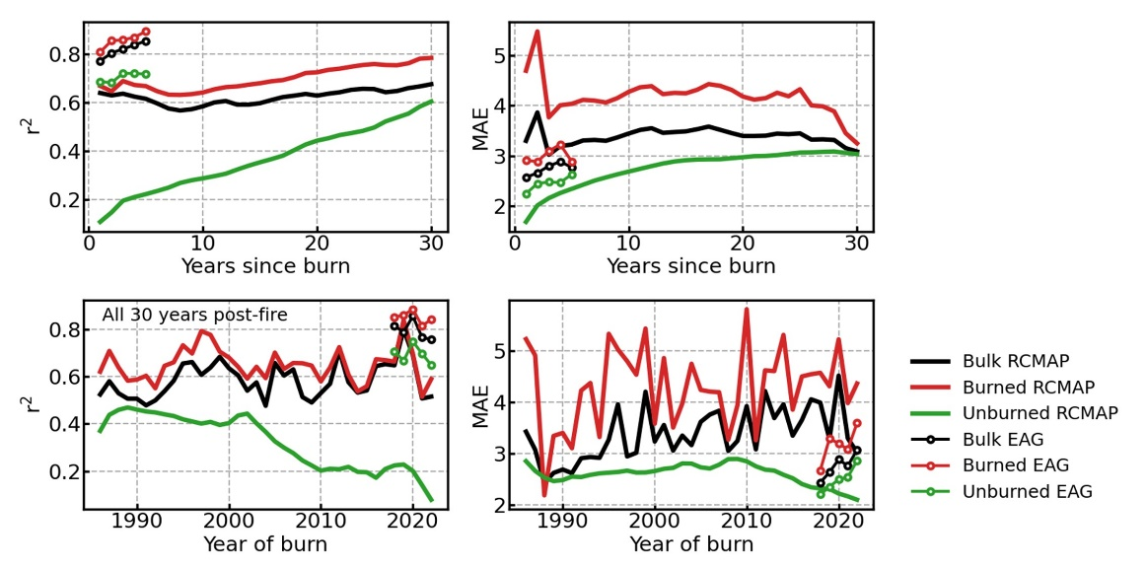
Fig. S2 Top) Model accuracy (r², left and MAE, right) by years since most recent burn. Bottom) Model accuracy by year of burn for 1986–2023. Unburned data were assigned a random burn year
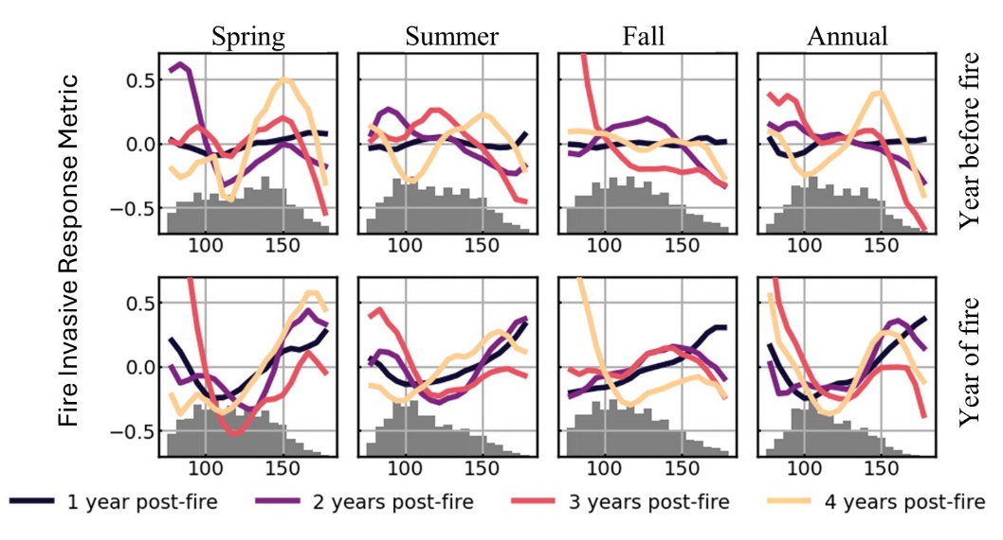
Fig. S3 Modeled Fire Invasive Response Metric (FIRM) for short-term (2016–2024) model by drought (VegDRI) occurring in spring, summer, fall, or entire year (annual) in the year before (top) and during (bottom) fire

