SUPPLEMENTARY INFORMATION
Multi-scale effects of termite mounds on bird communities in a human-modified African savanna landscape
Author names for publication: Patrick B. Newcombe*^{1,2}, R. Alex Wiebe^{1,3}, Fengyi Guo^{1,4,5}, David S. Wilcove^{1,6,7}
* Corresponding author: pbn21@cam.ac.uk
¹ Department of Ecology and Evolutionary Biology, Princeton University, Princeton, New Jersey, USA
² Department of Zoology, University of Cambridge, Cambridge, Cambridgeshire, UK
³ Department of Earth System Science, Stanford Doerr School of Sustainability, Stanford University, Palo Alto, California, USA
⁴ Cornell Lab of Ornithology, Cornell University, Ithaca, New York, USA
⁵ Cornell Atkinson Center for Sustainability, Cornell University, Ithaca, New York, USA
⁶ High Meadows Environmental Institute, Princeton University, Princeton, New Jersey, USA
⁷ Princeton School of Public and International Affairs, Princeton University, Princeton, New Jersey, USA

Supplementary Information 1
Caption: Extrapolated abundance-based rarefaction curves for each ecosystem and the entire landscape (that is, across all three ecosystems combined), built using the iNEXT package (Hsieh & Chao 2024). We used abundance values (i.e., the sum of all bird encounters across visits at a point, counting birds that moved between the mound and matrix in the same visit to a point only once) and extrapolated rarefaction curves to plateaus at 5,000 individuals in each ecosystem. Rarefaction curves for each ecosystem reached asymptotic species richness between 60 and 90 species, with total species richness of the landscape (i.e., across all three ecosystems) estimated to be 118 species. Savanna had the highest estimated species richness of the three ecosystems. 30 species were observed in all three ecosystems, and 34 species were observed in savanna or saline grasslands but not in agriculture. The numbers of species observed only in a single ecosystem were 22 for savanna, 19 for agriculture, and 15 for saline grasslands.
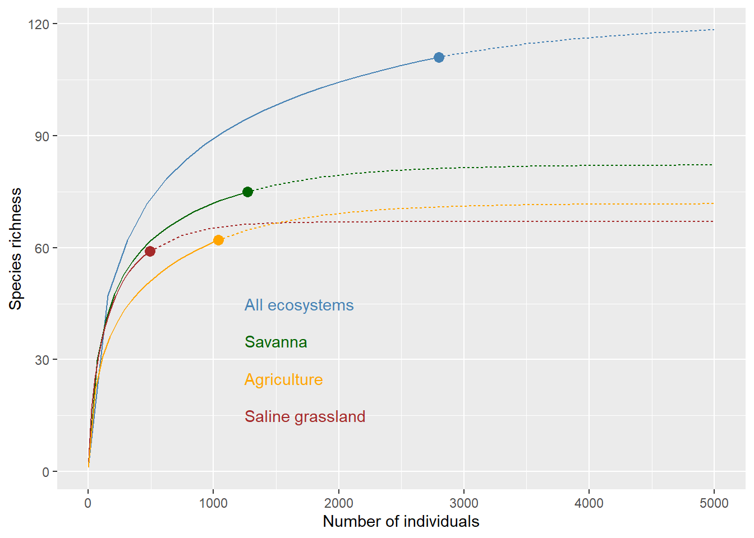

Supplementary Information 2
Caption: Rarefaction curves separated by mound (blue) and matrix (red) birds for savanna (a), agriculture (b), and saline grasslands (c). Ribbons represent standard error calculations by iNEXT. Curves generally begin plateauing before reaching 2000 individuals, and each curve’s slope begins to diminish. Sampling of birds on savanna mounds (a, blue) plateaus the least, potentially due to the large number of species that are associated with these mounds (see Figure 2a). Rarefaction curves are built using all individuals of any species observed on mounds or in the matrix, without regard to whether that species is significantly mound or matrix associated.
a.
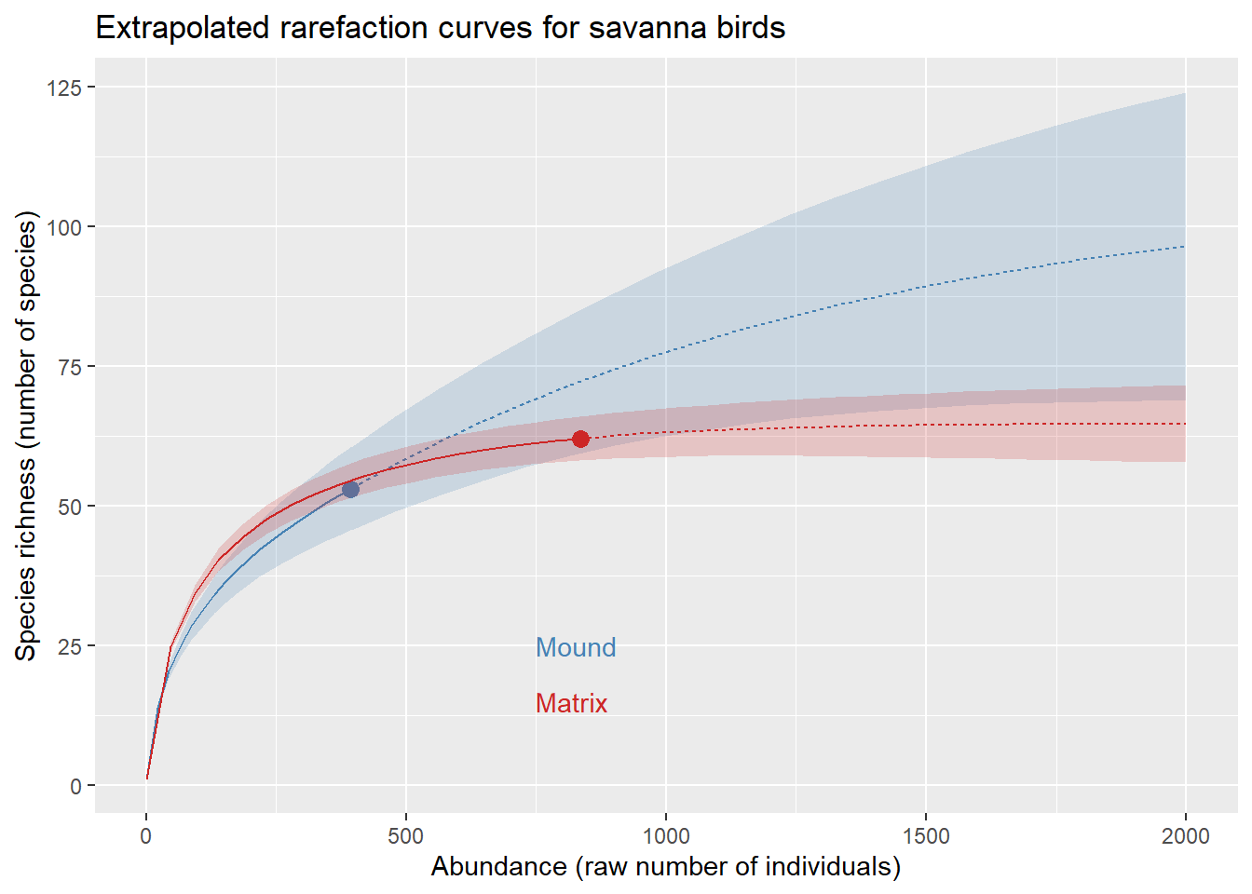
b.
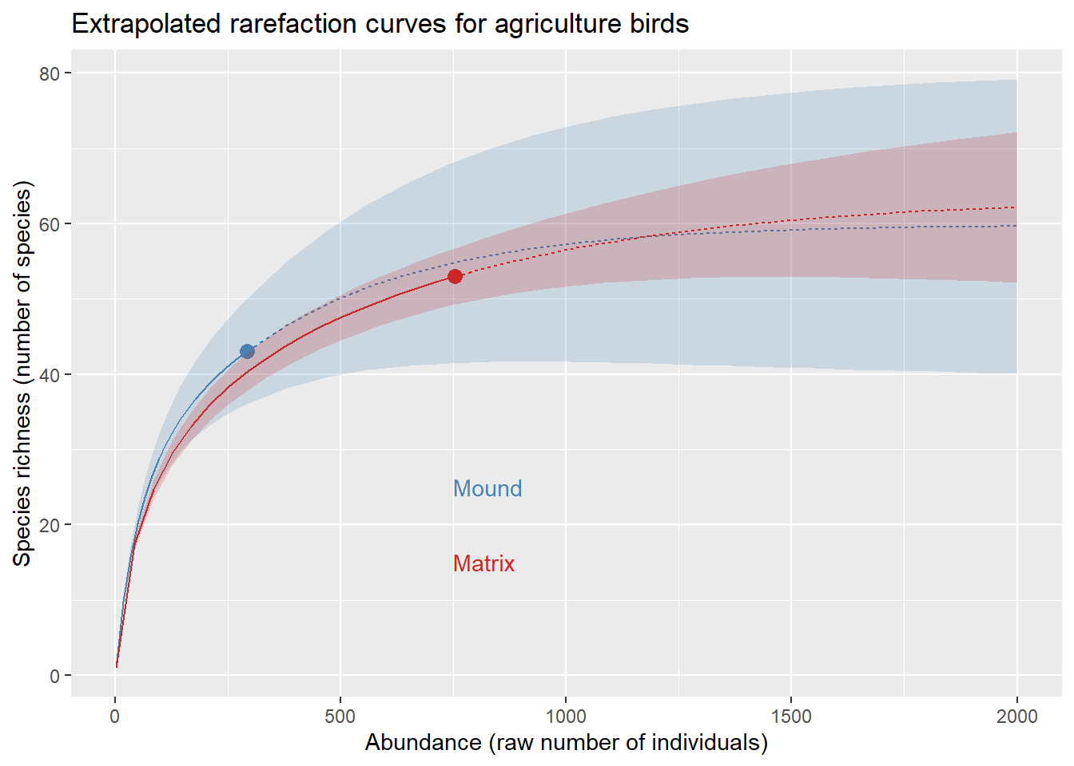
c.
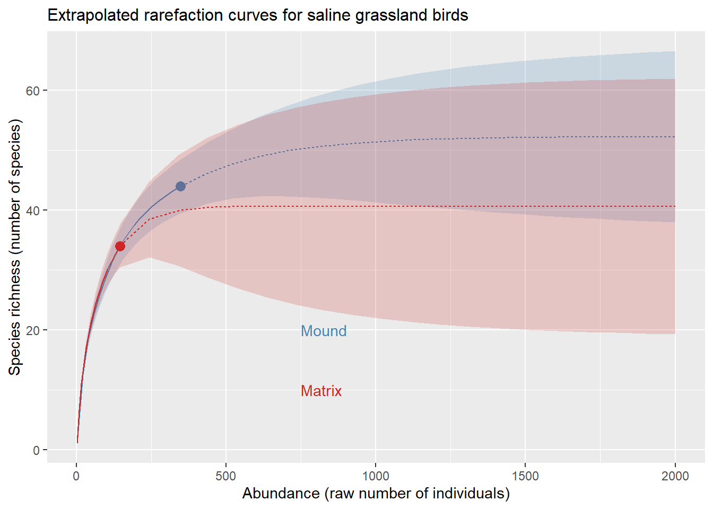

Supplementary Information 3
Caption: Species-specific patterns of mound association in savanna (a), agriculture (b), and saline grasslands (c). Significance values are interpreted using the mean of the difference of mound and matrix densities at each point where a species occurs. In a-c, species observed only on mounds or only in the matrix are represented with pink bars. This appendix corresponds to figure 1 (main), depicting full results from all three ecosystems rather than just savanna (as in Figure 1, a).
a.
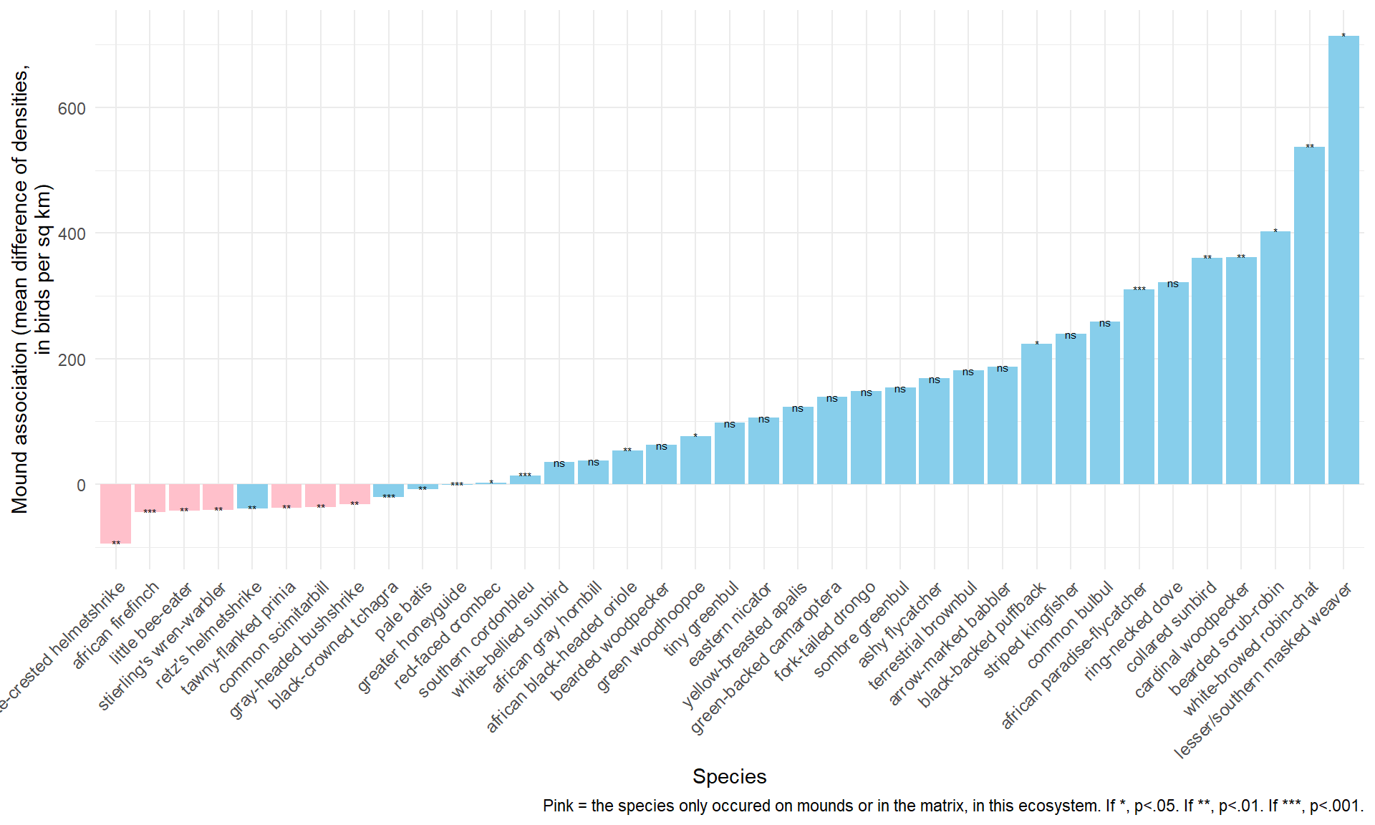
b. 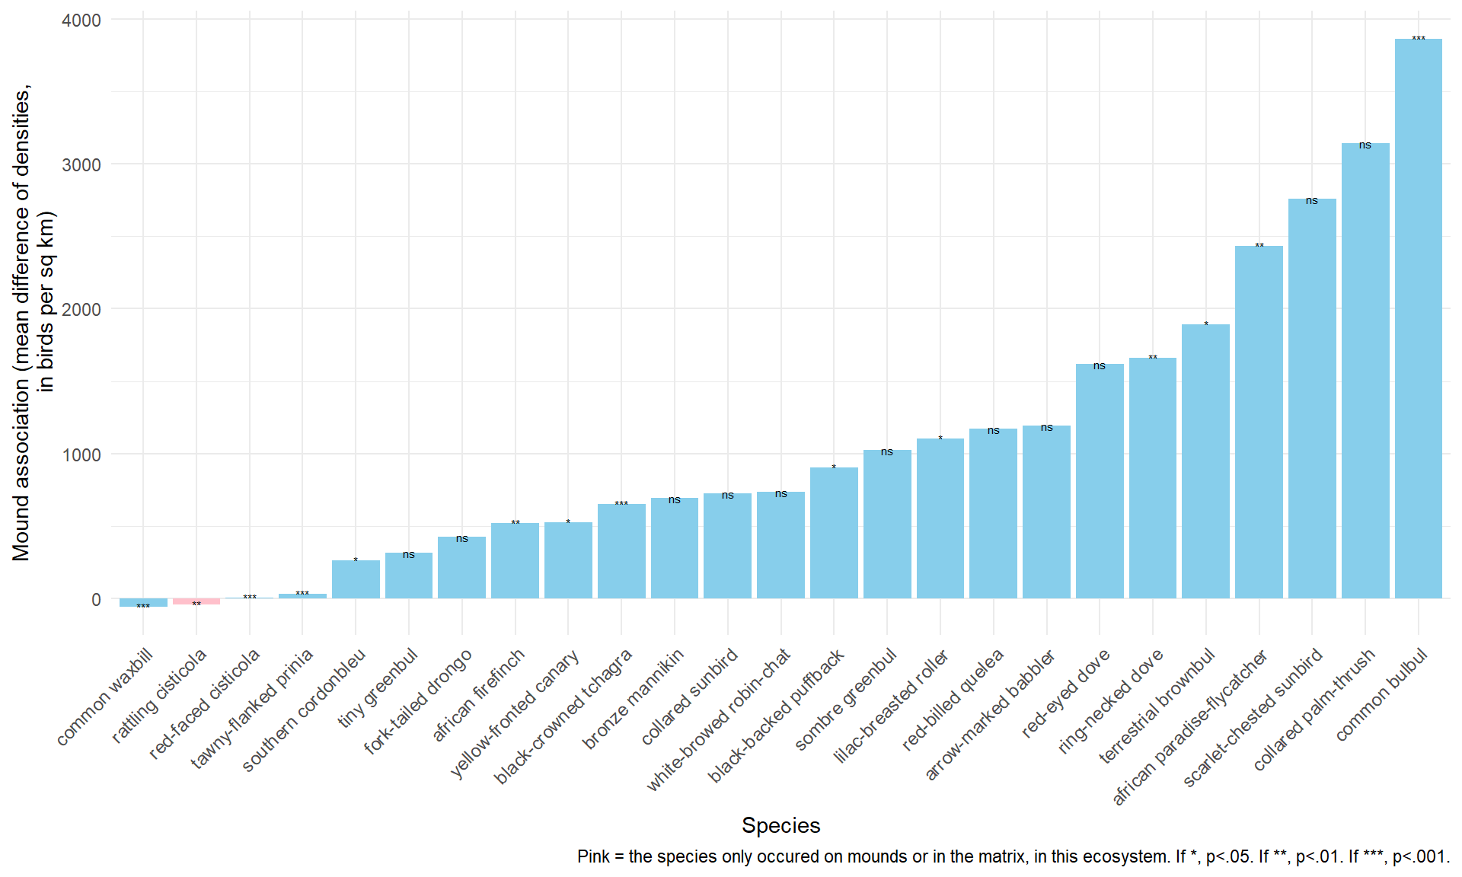
c. 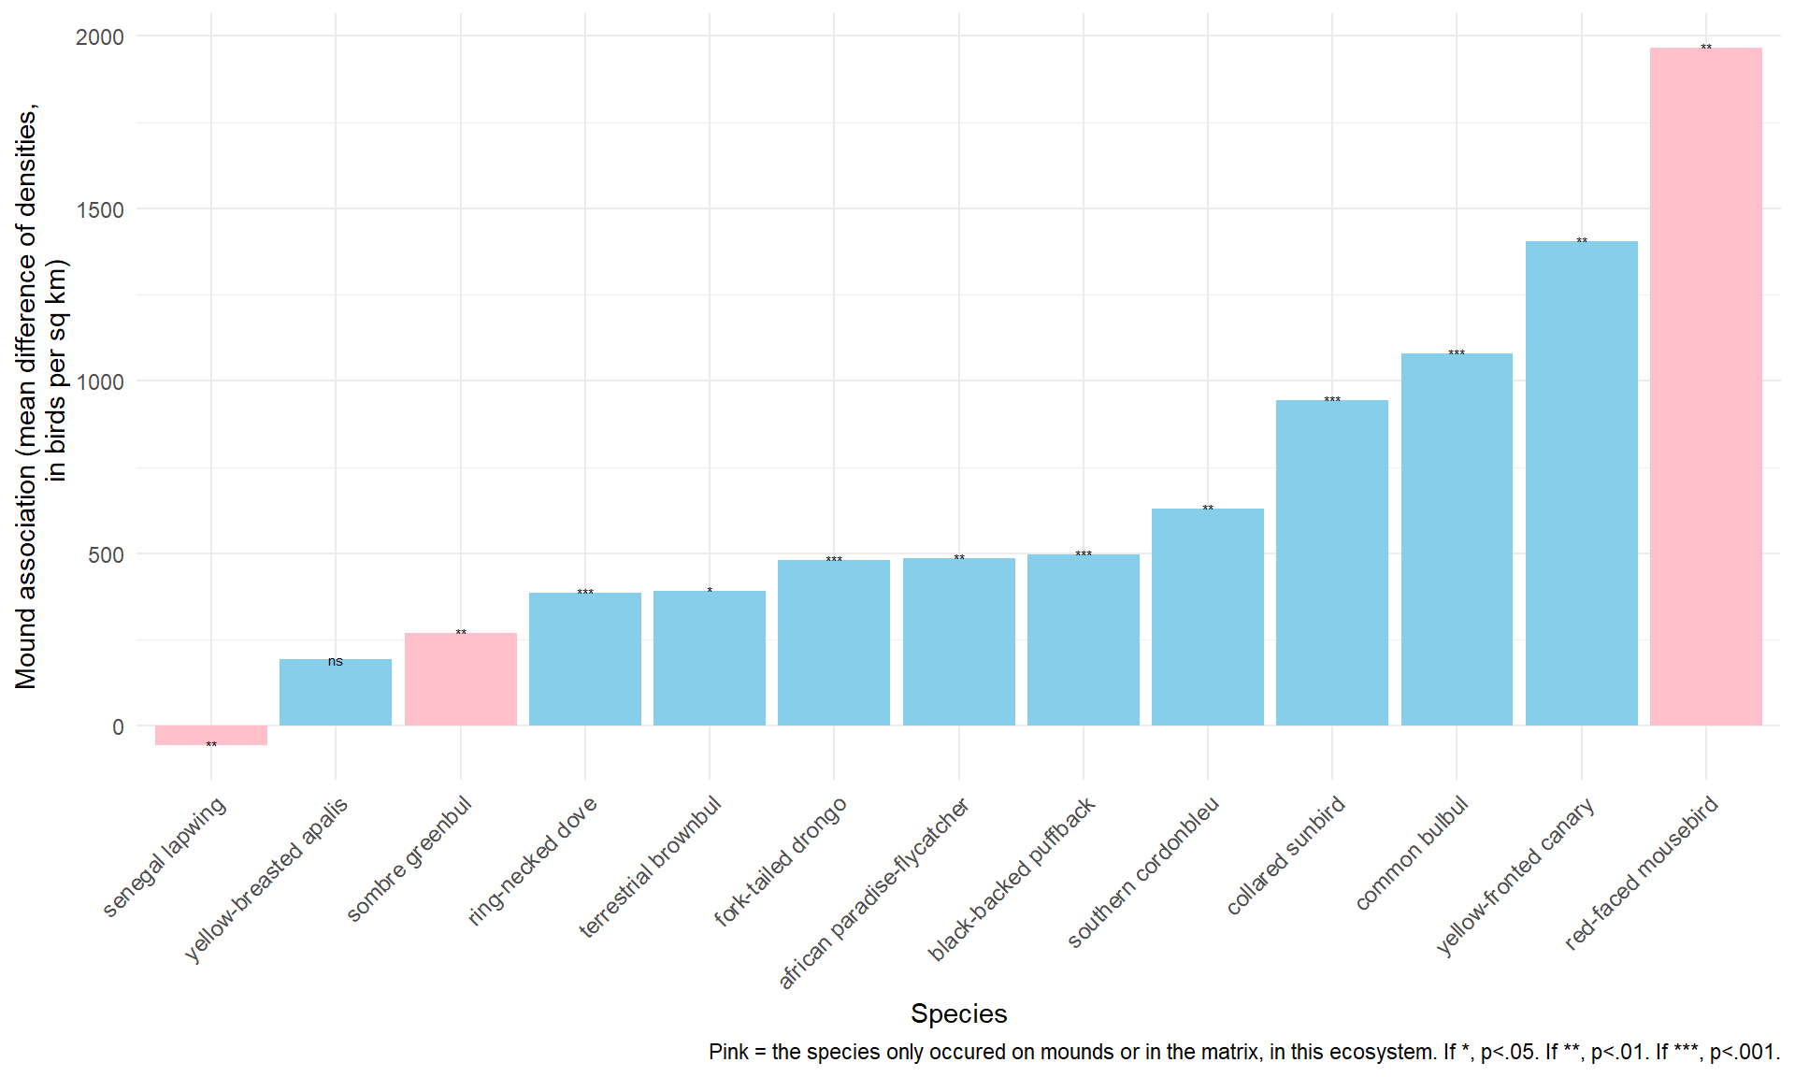

Supplementary Information 4
Caption: Raw values for species’ density on mounds, density in the matrix, and density difference (densities in individuals per km²), as well as p-values for comparisons of mound and matrix densities (rounded to the nearest thousandth), are reported for species represented in the graphs in Supplementary Information 3 (i.e., all bird species occurring at 5 or more points in an ecosystem), for savanna (a), agriculture (b), and saline grasslands (c). Species that retain significance under the Bonferroni-adjusted alpha threshold for their ecosystem are indicated by an asterisk (*).
a.
Species | Denser on Mound or Matrix |  | Mean Mound Density | Mean Matrix Density | Mean Density Difference | P-Value
Lesser/Southern Masked Weaver |  | mound | 741.9 | 27.3 | 714.6 | 0.035
White-browed Robin-Chat |  | mound | 543.3 | 6.3 | 537 | 0.010
Bearded Scrub-Robin |  | mound | 415.4 | 12.4 | 402.9 | 0.025
Cardinal Woodpecker |  | mound | 388.3 | 26.3 | 362 | 0.007
Collared Sunbird |  | mound | 387.9 | 27.3 | 360.6 | 0.006
Ring-necked Dove |  | mound | 346.9 | 25.8 | 321.1 | 0.091
African Paradise-Flycatcher* |  | mound | 338.9 | 28.1 | 310.7 | <0.001
Common Bulbul |  | mound | 301.8 | 42.6 | 259.3 | 0.131
Striped Kingfisher |  | mound | 255.4 | 15.7 | 239.7 | 0.400
Black-backed Puffback |  | mound | 256.2 | 33.2 | 223 | 0.014
Arrow-marked Babbler |  | mound | 214.8 | 28.3 | 186.5 | 0.056
Terrestrial Brownbul |  | mound | 216.1 | 34.8 | 181.3 | 0.249
Ashy Flycatcher |  | mound | 200.5 | 31.4 | 169.1 | 0.678
Sombre Greenbul |  | mound | 191.9 | 37.6 | 154.3 | 0.093
Fork-tailed Drongo |  | mound | 195.8 | 47.7 | 148.2 | 0.155
Green-backed Camaroptera |  | mound | 168.9 | 29.5 | 139.4 | 0.878
Yellow-breasted Apalis |  | mound | 150.5 | 27.1 | 123.3 | 0.638
Eastern Nicator |  | mound | 141.6 | 35.5 | 106.1 | 0.191
Tiny Greenbul |  | mound | 137.6 | 39.6 | 98 | 0.673
Green Woodhoopoe |  | mound | 123.4 | 47.4 | 76 | 0.025
Bearded Woodpecker |  | mound | 97.9 | 35.7 | 62.3 | 0.322
African Black-headed Oriole |  | mound | 89.2 | 36.2 | 53 | 0.006
African Gray Hornbill |  | mound | 65.7 | 27.6 | 38.1 | 0.124
White-bellied Sunbird |  | mound | 68.1 | 32.4 | 35.7 | 0.131
Southern Cordonbleu* |  | mound | 133.2 | 119.3 | 13.9 | <0.001
Red-faced Crombec |  | mound | 56.3 | 54.4 | 1.9 | 0.010
Greater Honeyguide* |  | matrix | 30 | 31.7 | -1.7 | <0.001
Pale Batis |  | matrix | 36.4 | 44.5 | -8 | 0.002
Black-crowned Tchagra* |  | matrix | 22 | 42.9 | -21 | <0.001
Gray-headed Bushshrike |  | matrix | 0 | 32.5 | -32.5 | 0.003
Common Scimitarbill |  | matrix | 0 | 36.9 | -36.9 | 0.007
Tawny-flanked Prinia |  | matrix | 0 | 38 | -38 | 0.008
Retz's Helmetshrike |  | matrix | 16.3 | 55.2 | -38.9 | 0.004
Stierling's Wren-Warbler* |  | matrix | 0 | 40.9 | -40.9 | 0.001
Little Bee-Eater |  | matrix | 0 | 42.6 | -42.6 | 0.003
African Firefinch* |  | matrix | 0 | 45 | -45 | <0.001
White-crested Helmetshrike |  | matrix | 0 | 95.2 | -95.2 | 0.007

b.
Species | Denser on Mound or Matrix | Mean Mound Density | Mean Matrix Density | Mean Density Difference | P-Value
Common Bulbul* | mound | 3931.5 | 69.8 | 3861.7 | <0.001
Collared Palm-Thrush | mound | 3166.7 | 25.1 | 3141.6 | 0.222
Scarlet-chested Sunbird | mound | 2814.8 | 52.5 | 2762.2 | 0.873
African Paradise-Flycatcher* | mound | 2451.8 | 19.5 | 2432.3 | 0.002
Terrestrial Brownbul | mound | 1902.4 | 10 | 1892.4 | 0.017
Ring-necked Dove | mound | 1675.7 | 14.1 | 1661.6 | 0.006
Red-eyed Dove | mound | 1629 | 11.9 | 1617.1 | 0.083
Arrow-marked Babbler | mound | 1252.3 | 60 | 1192.3 | 0.171
Red-billed Quelea | mound | 1193.8 | 24.2 | 1169.5 | 0.914
Lilac-breasted Roller | mound | 1153 | 47.9 | 1105.1 | 0.024
Sombre Greenbul | mound | 1058.6 | 34.3 | 1024.3 | 0.672
Black-backed Puffback | mound | 918.1 | 15.3 | 902.8 | 0.031
White-browed Robin-Chat | mound | 751.1 | 16.8 | 734.4 | 0.187
Collared Sunbird | mound | 743.7 | 20.1 | 723.6 | 0.375
Bronze Mannikin | mound | 863.7 | 168.5 | 695.2 | 0.798
Black-crowned Tchagra* | mound | 690.5 | 39.1 | 651.5 | <0.001
Yellow-fronted Canary | mound | 563.7 | 39.3 | 524.4 | 0.029
African Firefinch | mound | 550.9 | 32.4 | 518.5 | 0.002
Fork-tailed Drongo | mound | 448.8 | 22.2 | 426.6 | 0.863
Tiny Greenbul | mound | 339.2 | 23.4 | 315.8 | 0.817
Southern Cordonbleu | mound | 305.6 | 45.4 | 260.2 | 0.043
Tawny-flanked Prinia* | mound | 94.3 | 63.6 | 30.7 | <0.001
Red-faced Cisticola* | mound | 85.4 | 80.8 | 4.6 | <0.001
Rattling Cisticola | matrix | 0 | 42.6 | -42.6 | 0.007
Common Waxbill* | matrix | 144.3 | 203.7 | -59.4 | <0.001
c.
Species | Denser on Mound or Matrix | Mean Mound Density | Mean Matrix Density | Mean Density Difference | P-Value
Red-faced Mousebird* | mound | 1964.7 | 0 | 1964.7 | 0.003
Yellow-fronted Canary* | mound | 1421.8 | 18.2 | 1403.6 | 0.002
Common Bulbul* | mound | 1106.5 | 26.1 | 1080.4 | <0.001
Collared Sunbird* | mound | 949.1 | 3.8 | 945.3 | <0.001
Southern Cordonbleu* | mound | 634.8 | 6 | 628.8 | <0.001
Black-backed Puffback* | mound | 509.1 | 11.5 | 497.6 | <0.001
African Paradise-Flycatcher* | mound | 490.1 | 5.4 | 484.7 | 0.004
Fork-tailed Drongo* | mound | 502.8 | 23.3 | 479.5 | <0.001
Terrestrial Brownbul | mound | 396.3 | 5.4 | 390.8 | 0.0167
Ring-necked Dove* | mound | 398.2 | 13.4 | 384.8 | <0.001
Sombre Greenbul | mound | 268.8 | 0 | 268.8 | 0.007
Yellow-breasted Apalis | mound | 213.2 | 20.8 | 192.5 | 0.265
Senegal Lapwing* | matrix | 0 | 56.5 | -56.5 | 0.003

Supplementary Information 5
Caption. NMDS ordination plots for mound (a) and matrix (b) birds. Ellipses and colors represent agriculture vs. savanna ecosystem. Each point on a plot represents the composition of birds recorded at that sampling location (i.e., point count) that occurred on mounds (a) or in the matrix (b). The figures replicate Figure 5, except for their exclusion of saline grassland birds, to better highlight the differences in compositional similarity of birds occurring on mounds vs. in the matrix amidst conversion of savanna to agriculture. The stress values were 0.0938 for the mound plot and 0.2174 for the matrix plot.

a.
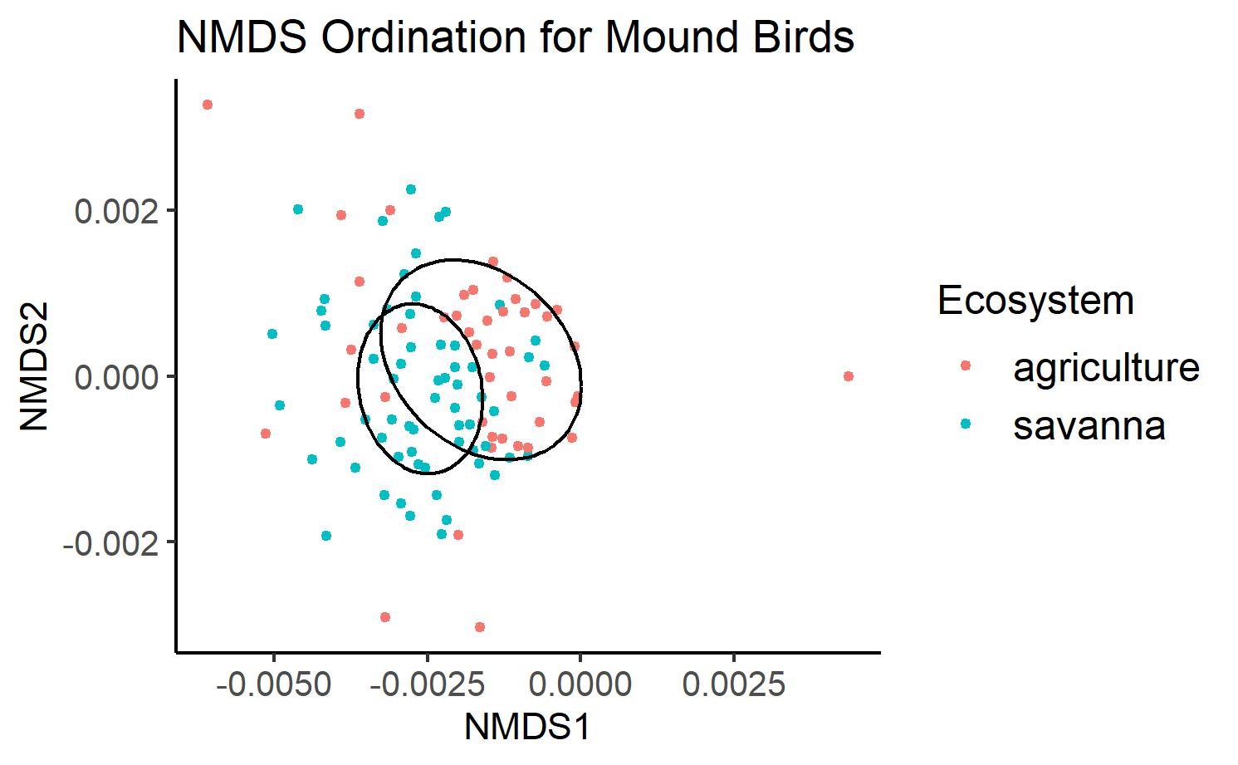
b.
