SUPPLEMENTARY DATA

Development of oral self-nanoemulsifying drug delivery system incorporated insulin-hydrophobic ion pairing complex

Jeong Hyeon Lee¹· Myung Kwan Chun²· Sang Hoon Joo ¹ and Kwon Yeon Weon^{*1}

¹ College of Pharmacy, Daegu Catholic University, Gyeongbuk 38430, Republic of Korea
² ODDSONBIO Co., Ltd., Gyeongsan, Gyeongbuk 38430, Republic of Korea

*Correspondence: Kwon Yeon Weon, weonky@cu.ac.kr, Tel.: +82-53-850-3616, FAX: +82-53-359-6726

Table S1. Droplet size and polydispersity index (PDI) values obtained from the I-optimal mixture design for INS-HIPC SNEDDS formulations (n = 3, mean ± standard deviation). INS, insulin; HIPC, hydrophobic ion pairing complex; SNEDDS, self-nanoemulsifying drug delivery system.
Run type |  | Weight ratios (w/w %) |  |  |  | Droplet size  (nm) |  | PDI
Run type |  | X₁: Capryol® 90 | X₂: Tween 80 | X₃: Transcutol® P
1 |  | 25.0 | 40.1 | 34.9 |  | 151.7 ± 1.58 |  | 0.445 ± 0.0070
2 |  | 8.9 | 70.0 | 21.2 |  | 11.2 ± 0.09 |  | 0.088 ± 0.0212
3 |  | 22.2 | 67.8 | 10.0 |  | 110.7 ± 0.95 |  | 0.318 ± 0.0033
4 |  | 14.7 | 40.3 | 45.0 |  | 108.4 ± 2.39 |  | 0.501 ± 0.0205
5 |  | 16.9 | 63.5 | 19.5 |  | 26.9 ± 0.14 |  | 0.450 ± 0.0041
6 |  | 15.0 | 55.5 | 29.5 |  | 28.4 ± 0.10 |  | 0.673 ± 0.0070
7 |  | 22.2 | 67.8 | 10.0 |  | 119.3 ± 0.65 |  | 0.298 ± 0.0021
8 |  | 15.0 | 55.5 | 29.5 |  | 35.4 ± 0.25 |  | 0.827 ± 0.0075
9 |  | 5.0 | 55.2 | 39.8 |  | 10.0 ± 0.19 |  | 0.112 ± 0.0230
10 |  | 25.0 | 30.0 | 45.0 |  | 154.9 ± 1.22 |  | 0.500 ± 0.0012
11 |  | 25.0 | 49.3 | 25.7 |  | 136.5 ± 0.12 |  | 0.292 ± 0.0033
12 |  | 25.0 | 56.6 | 18.4 |  | 133.4 ± 0.25 |  | 0.284 ± 0.0074
13 |  | 14.7 | 40.3 | 45.0 |  | 97.3 ± 0.13 |  | 0.436 ± 0.0036
14 |  | 14.0 | 48.3 | 37.7 |  | 30.8 ± 0.07 |  | 0.710 ± 0.0029
15 |  | 8.9 | 70.0 | 21.2 |  | 10.7 ± 0.07 |  | 0.096 ± 0.0137
16 |  | 5.0 | 64.1 | 30.9 |  | 9.9 ± 0.04 |  | 0.069 ± 0.0117
17 |  | 15.0 | 55.5 | 29.5 |  | 19.9 ± 0.06 |  | 0.355 ± 0.0062

Table S2. Individual transepithelial electrical resistance (TEER, Ω·cm²) values measured across Caco-2 cell monolayers before (0 h) and after (2 or 4 h) the in vitro permeability experiment following treatment with transport buffer, free insulin, or INS-HIPC SNEDDS formulations (n = 3 per condition). Treatments: transport buffer (control), free INS (200 μg/mL or 400 μg/mL), and INS-HIPC SNEDDS (200 μg/mL or 400 μg/mL). INS, insulin; HIPC, hydrophobic ion pairing complex; SNEDDS, self-nanoemulsifying drug delivery system.
Treatments | Dose  (μg/mL) | Incubation  time (h) | N | TEER before  (Ω·cm²) | TEER after  (Ω·cm²)
Transport  solution | - | 2 | 1 | 831.0 | 810.9
Transport  solution | - | 2 | 2 | 954.2 | 907.2
Transport  solution | - | 2 | 3 | 958.7 | 941.9
Transport  solution | - | 4 | 1 | 1024.8 | 999.0
Transport  solution | - | 4 | 2 | 963.2 | 952.0
Transport  solution | - | 4 | 3 | 974.4 | 967.7
Free INS | 200 | 2 | 1 | 965.4 | 961.0
Free INS | 200 | 2 | 2 | 913.9 | 888.2
Free INS | 200 | 2 | 3 | 864.6 | 809.8
Free INS | 200 | 4 | 1 | 1101.0 | 1017.0
Free INS | 200 | 4 | 2 | 920.6 | 912.8
Free INS | 200 | 4 | 3 | 1135.7 | 1115.5
Free INS | 400 | 2 | 1 | 1164.8 | 1137.9
Free INS | 400 | 2 | 2 | 965.4 | 955.4
Free INS | 400 | 2 | 3 | 1150.2 | 1140.2
Free INS | 400 | 4 | 1 | 949.8 | 961.0
Free INS | 400 | 4 | 2 | 948.6 | 925.1
Free INS | 400 | 4 | 3 | 873.6 | 864.6
INS-HIPC SNEDDS | 200 | 2 | 1 | 866.9 | 265.4
INS-HIPC SNEDDS | 200 | 2 | 2 | 925.1 | 264.3
INS-HIPC SNEDDS | 200 | 2 | 3 | 871.4 | 247.5
INS-HIPC SNEDDS | 200 | 4 | 1 | 880.3 | 172.5
INS-HIPC SNEDDS | 200 | 4 | 2 | 892.6 | 177.0
INS-HIPC SNEDDS | 200 | 4 | 3 | 909.4 | 166.9
INS-HIPC SNEDDS | 400 | 2 | 1 | 837.8 | 253.1
INS-HIPC SNEDDS | 400 | 2 | 2 | 801.9 | 249.8
INS-HIPC SNEDDS | 400 | 2 | 3 | 778.4 | 246.4
INS-HIPC SNEDDS | 400 | 4 | 1 | 877.0 | 160.2
INS-HIPC SNEDDS | 400 | 4 | 2 | 856.8 | 169.1
INS-HIPC SNEDDS | 400 | 4 | 3 | 855.7 | 172.5

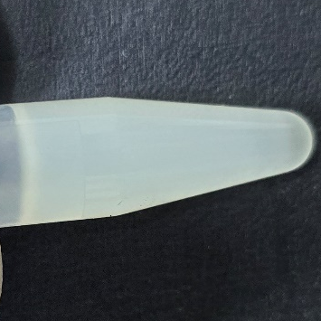
Figure S1. Appearance of INS-HIPC SNEDDS. The prepared INS-HIPC SNEDDS formulation with an INS-HIPC concentration of 1.3% (w/v), corresponding to an expected final insulin content of 1.0% (w/v), exhibiting a uniform, slightly opalescent, milky-white appearance. INS, insulin; HIPC, hydrophobic ion pairing complex; SNEDDS, self-nanoemulsifying drug delivery system.

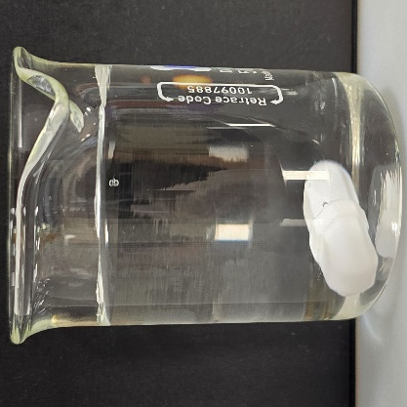
Figure S2. Self-emulsification behavior of INS-HIPC SNEDDS. A 100 µL aliquot of the formulation was introduced into 50 mL of purified water under continuous magnetic stirring at 80 rpm at room temperature, resulting in the rapid formation of a homogeneous and transparent nanoemulsion. INS, insulin; HIPC, hydrophobic ion pairing complex; SNEDDS, self-nanoemulsifying drug delivery system.

