Supplementary Material

Brain delivery of a Kv1.3-blocking peptide is not enhanced by conjugation to blood-brain barrier shuttle peptides

Dorothy C.C. Wai,†* Liam M. Koehn,§* Ethan Kreutzer,§ Pranav Runwal,§ Muhammad Umair Naseem,‡ Gyorgy Panyi,‡ David I. Finkelstein,# Joseph A. Nicolazzo,§,|| and Raymond S Norton†,#**

† Medicinal Chemistry, Monash Institute of Pharmaceutical Sciences, Monash University, Parkville, Victoria 3052, Australia
§ Drug Delivery, Disposition and Dynamics, Monash Institute of Pharmaceutical Sciences, Monash University, Parkville, Victoria 3052, Australia
‡ Department of Biophysics and Cell Biology, Faculty of Medicine, University of Debrecen, 4032 Debrecen, Hungary
# Parkinson’s Disease Laboratory, Florey Institute of Neuroscience and Mental Health, The University of Melbourne, Parkville, Victoria 3010, Australia
|| Centre for Drug Candidate Optimisation, Monash Institute of Pharmaceutical Sciences, Monash University, Parkville, Victoria 3052, Australia

*Authors contributed equally to the manuscript
**Correspondence to:
Raymond S. Norton, Medicinal Chemistry, Monash Institute of Pharmaceutical Sciences, Monash University, 381 Royal Parade, Parkville, Victoria 3052, Australia. Phone: (+61 3) 9903 9167. E-mail: ray.norton@monash.edu

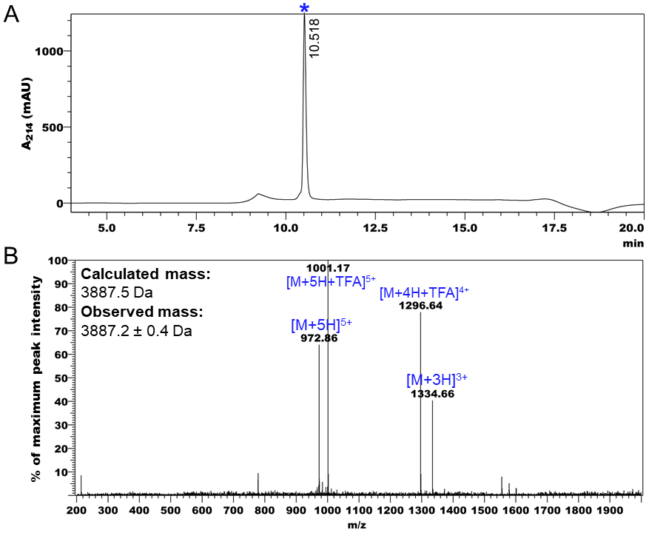

Fig S1. (A) Analytical liquid chromatography trace of KN₃-HsTX1[R14A] monitored at 214 nm. (B) Mass spectrum of KN₃-HsTX1[R14A] peak at 10.52 min, showing ions consistent with the calculated mass of the oxidized product. M, molecular ion; TFA, trifluoroacetic acid.

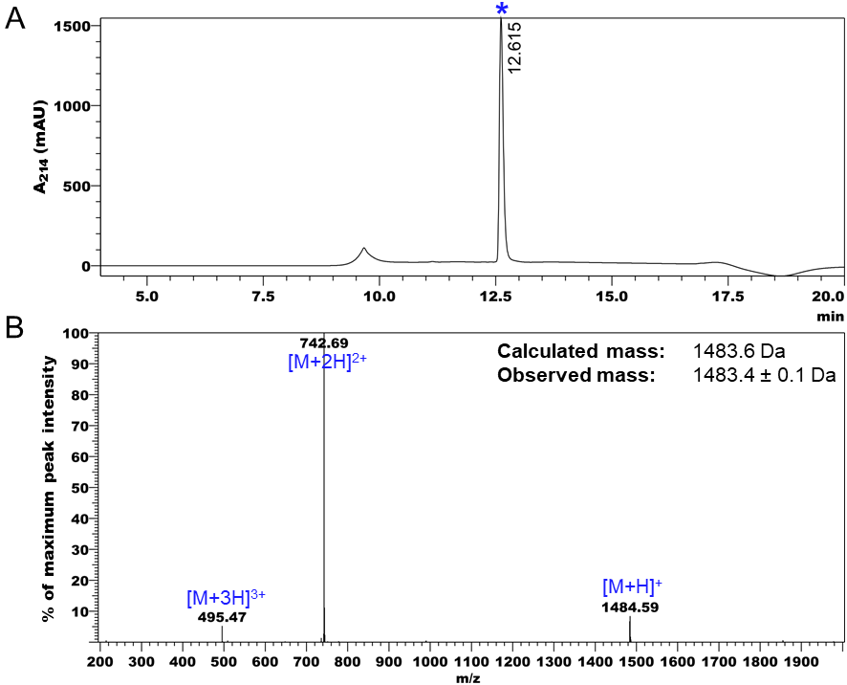
Fig S2. (A) Analytical liquid chromatography trace of Hex-MTf monitored at 214 nm. (B) Mass spectrum of Hex-MTf peak at 12.62 min, showing ions consistent with the calculated mass of the expected product. M, molecular ion; TFA, trifluoroacetic acid.

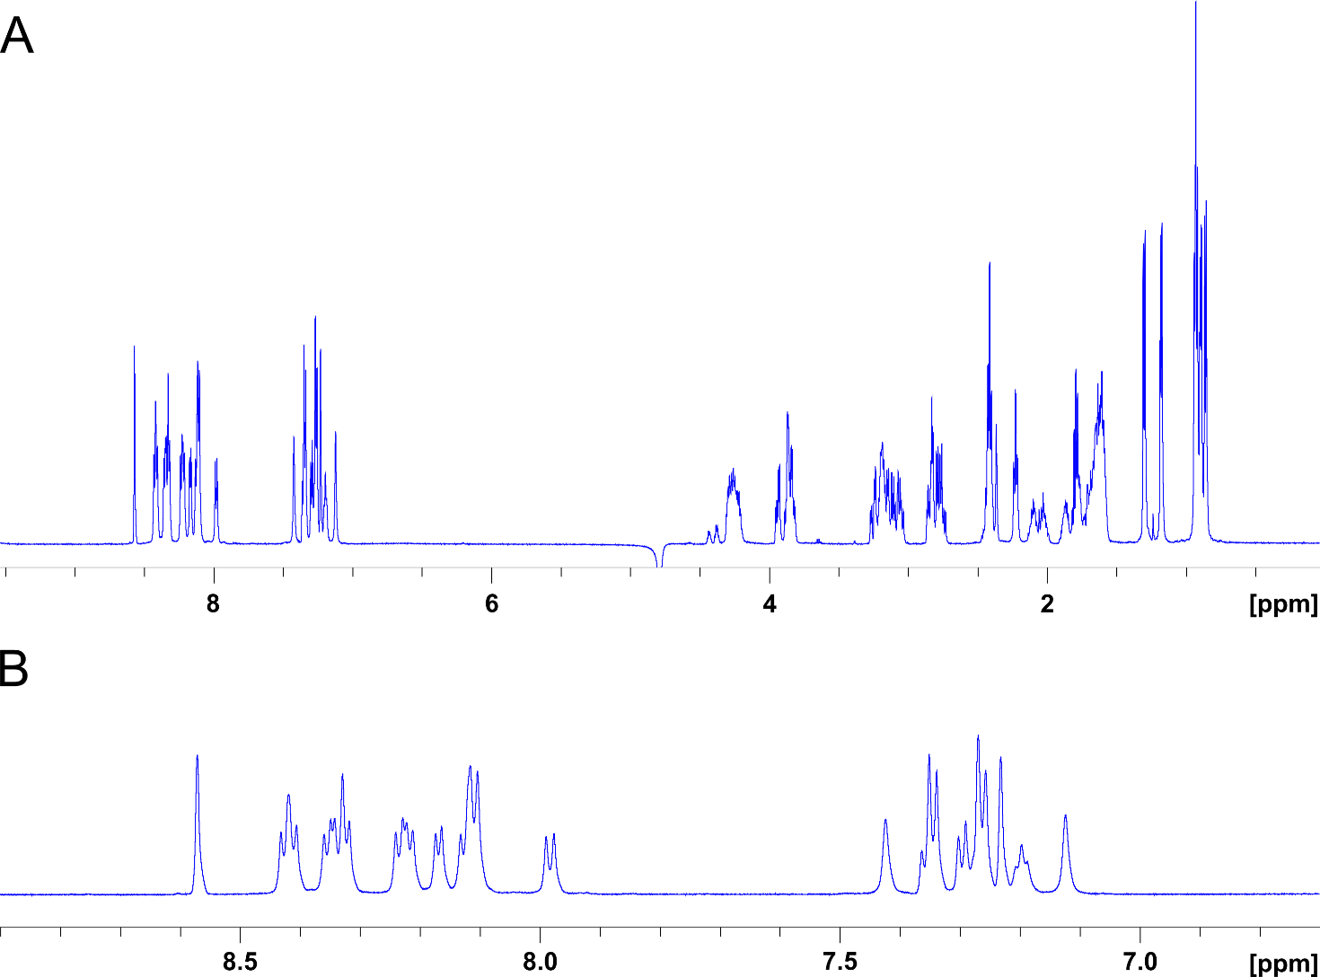

Fig S3. (A) One-dimensional ¹H NMR spectra of Hex-MTf acquired at 298 K in 95% H₂O/5% ²H₂O (pH 3.4). (B) Expanded amide-aromatic region of spectrum in (A).

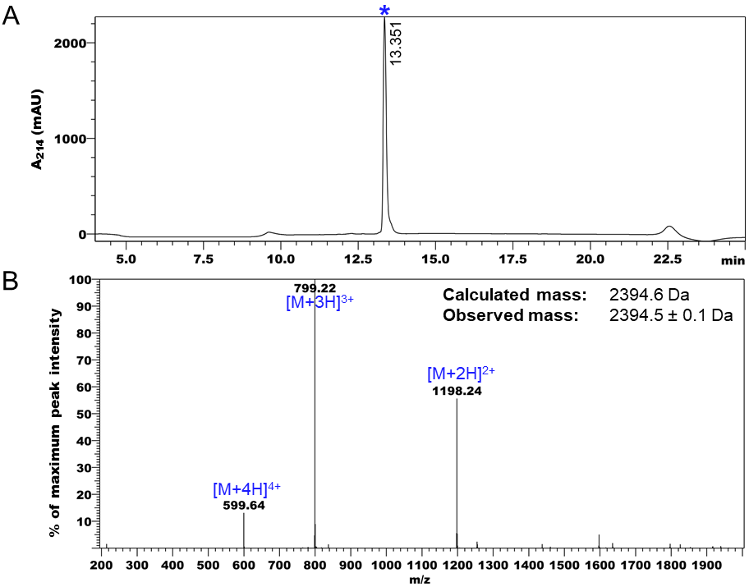
Fig S4. (A) Analytical liquid chromatography trace of Hex-Ang2 monitored at 214 nm. (B) Mass spectrum of Hex-Ang2 peak at 13.35 min, showing ions consistent with the calculated mass of the expected product. M, molecular ion; TFA, trifluoroacetic acid.

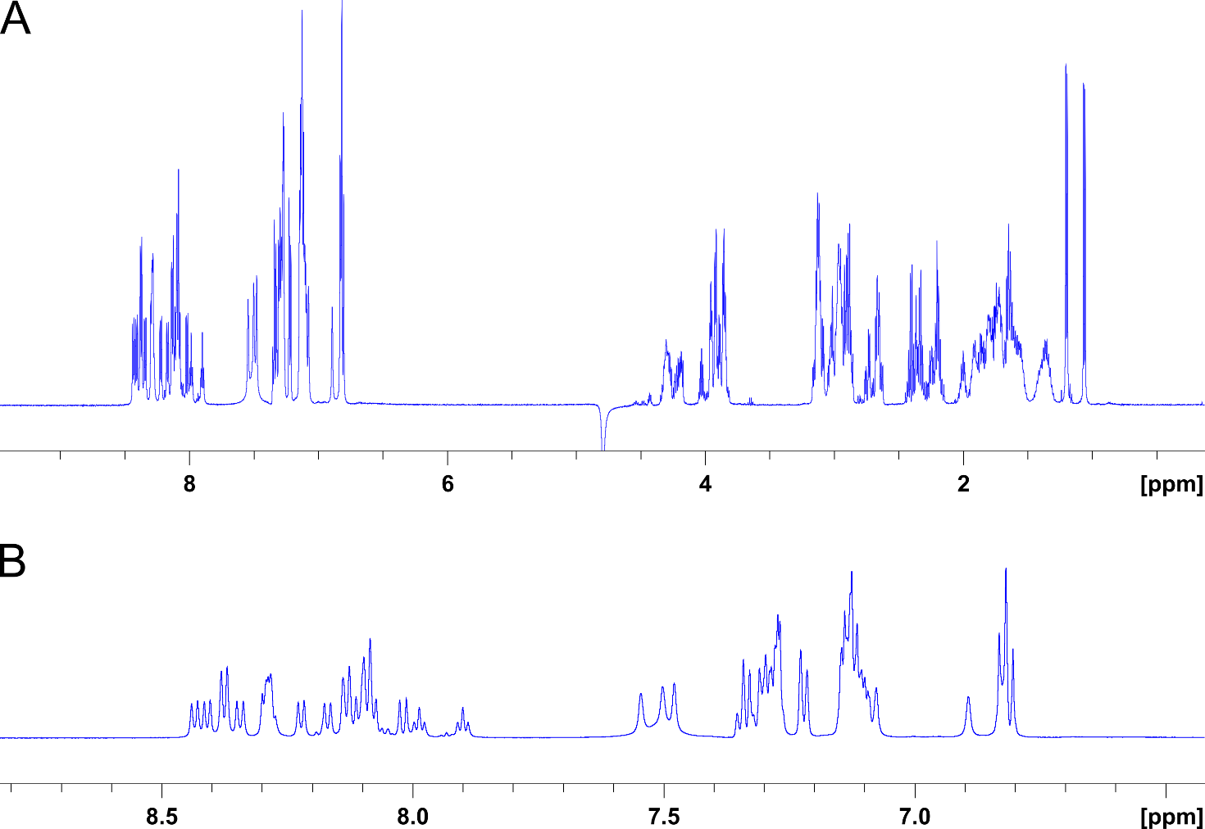

Fig S5. (A) One-dimensional ¹H NMR spectra of Hex-Ang2 acquired at 298 K in 95% H₂O/5% ²H₂O (pH 4.3). (B) Expanded amide-aromatic region of spectrum in (A).

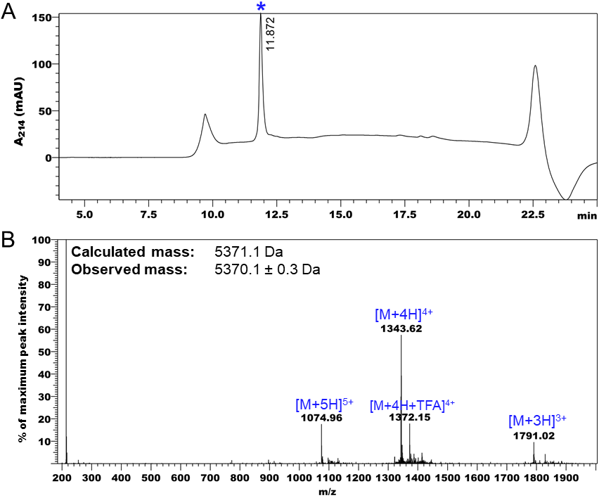

Fig S6. (A) Analytical liquid chromatography trace of MTf-HsTX1[R14A] monitored at 214 nm. (B) Mass spectrum of MTf-HsTX1[R14A] peak at 11.87 min, showing ions consistent with the calculated mass of the oxidized product.

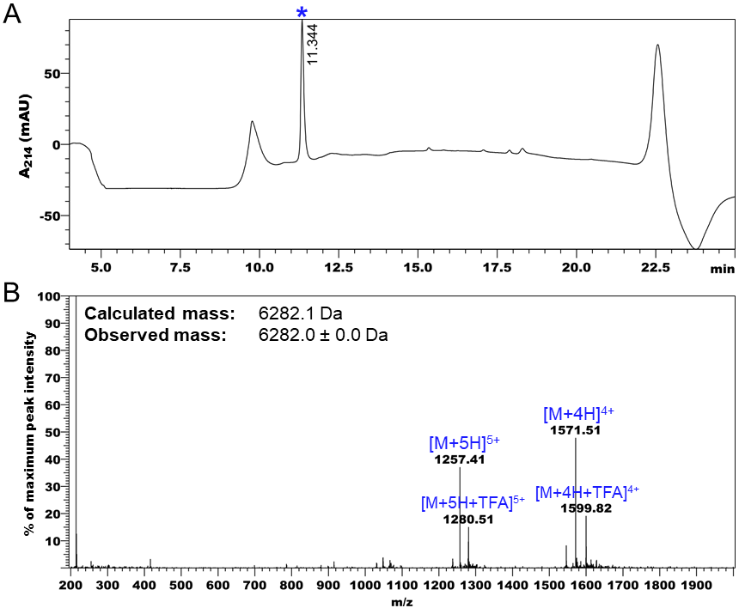

Fig S7. (A) Analytical liquid chromatography trace of Ang2-HsTX1[R14A] monitored at 214 nm. (B) Mass spectrum of Ang2-HsTX1[R14A] peak at 11.34 min, showing ions consistent with the calculated mass of the oxidized product. M, molecular ion; TFA, trifluoroacetic acid.

.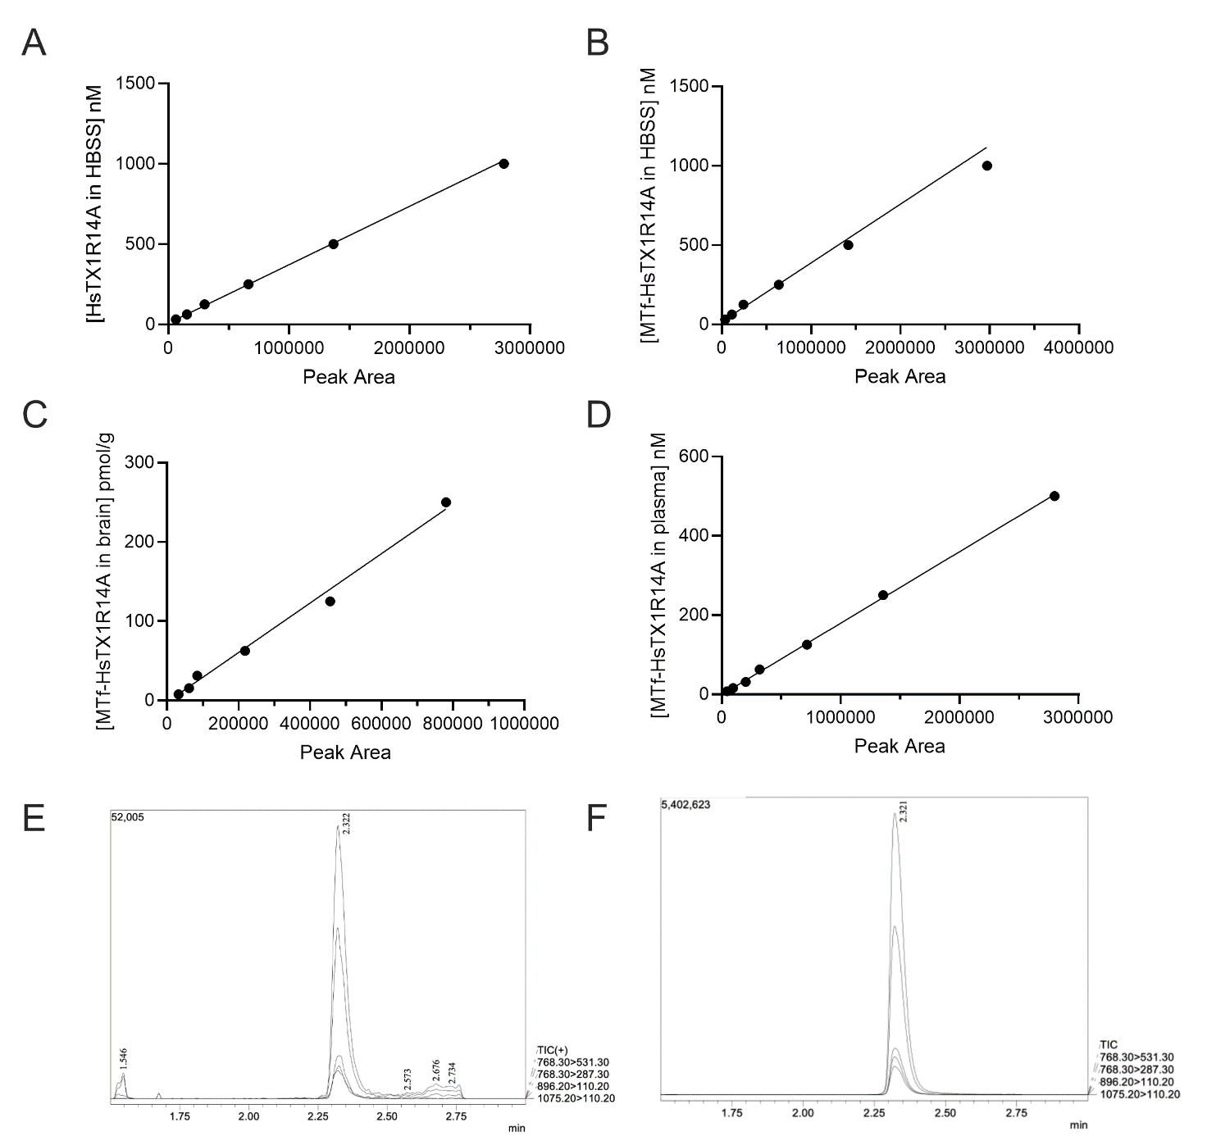

Fig S8. LC-MS/MS standard curves showing the linear ranges of (A) HsTX1[R14A] in HBSS, (B) MTf-HsTX1[R14A] in HBSS, (C) MTf-HsTX1[R14A] in brain, and (D) MTf-HsTX1[R14A] in plasma. Linear ranges are from precision and accuracy assessment and are an average of two measurements from one replicate. Lines are linear regression with 1/x or 1/x² weighting. Representative peaks of MTf-HsTX1[R14A] in plasma at (E) low (8 nM) and (F) high (500 nM) concentrations. Images are outputs from Shimadzu LabSolutions software. Value in top left corner is peak area (y-axis). Values above peaks indicate retention time (min; x-axis).

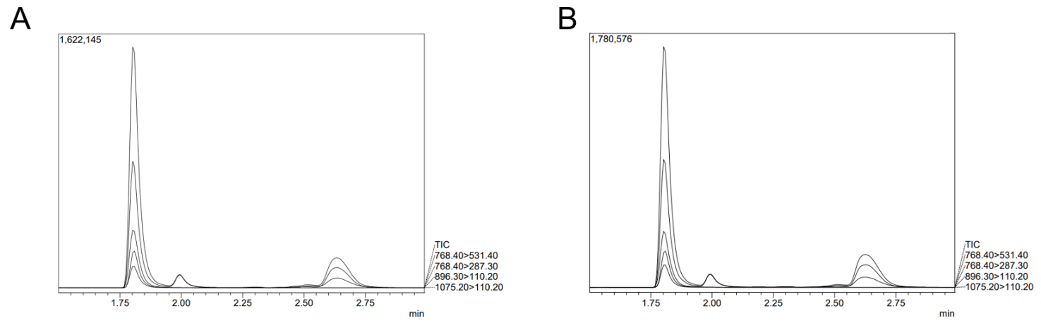

Fig S9. LC-MS/MS peaks of MTf-HsTX1[R14A] in plasma at 0 (A) and 120 (B) min in stability assay at 37 °C. Images are outputs from Shimadzu LabSolutions software. Value in top left corner is peak area (y-axis). Values on x-axis indicate retention times (min).
Table S1. LC-MS/MS conditions for HsTX1[R14A] and analogues.
Compound | Assay | Gradient (Mobile phase B %) | Quantifying transition | Qualifying transitions
HsTX1[R14A] | In vitro | 0.1-7.5 min: 5% B  0.75-2.25 min: 5-95% B  2.25-3 min: 95% B  3-3.75: 95-5% B  3.75-4.5: 5%B | 747.7-70.2 | 747.7-129.25  623.5-70.2  623.5-84.2
MTf-HsTX1[R14A] | In vitro | 0.1-0.75 min: 5% B  0.75-1 min: 5-50% B  1-2.25 min: 50-95% B  2.25-3 min: 95% B  3-3.75: 95-5% B  3.75-4.5: 5%B | 768.4-531.4 | 768.4-287.3  896.3-110.2  1075.2-110.2
MTf-HsTX1[R14A] | Mouse plasma | 0.1-0.75 min: 5% B  0.75-3 min: 5-95% B  3-4: 95% B  4-4.25: 95-5%B  4.25-6: 5%B | 768.4-531.4 | 768.4-287.3  896.3-110.2  1075.2-110.2
MTf-HsTX1[R14A] | Mouse brain | 0.1-0.75 min: 5% B  0.75-3 min: 5-95% B  3-4: 95% B  4-4.25: 95-5%B  4.25-6: 5%B | 768.4-531.4 | 768.4-287.3  896.3-110.2  1075.2-110.2
Ang2-HsTX1[R14A] | solvent | 0.1-0.75 min: 5% B  0.75-2.25 min: 5-95% B  2.25-3: 95% B  3-3.5: 95-5%B  3.5-4.25: 5%B | 898.5-136.2  1048-136.3  786.35-636.1  786.35-120.3

Table S2 Comparison of peak areas between HsTX1[R14A] and analogues during assay development.
Compound | Concentration | Transition | Peak Area
HsTX1[R14A] | 1200 ng/mL | 623.25>70.20 | 140908
 |  | 623.25>84.20 | 94522
 |  | 747.70>70.20 | 276611
 |  | 747.70>129.25 | 128529
MTf-HsTX1[R14A] | 1200 ng/mL | 768.40>287.30 | 16522
 |  | 768.40>531.40 | 25829
 |  | 896.30>110.20 | 182456
 |  | 1075.20>110.20 | 48872
Ang2-HsTX1[R14A] | 11000 ng/mL | 786.35>120.30 | 6300
 |  | 786.35>636.10 | 717
 |  | 898.50>136.20 | 25844
 |  | 1048.00>136.30 | 26829

