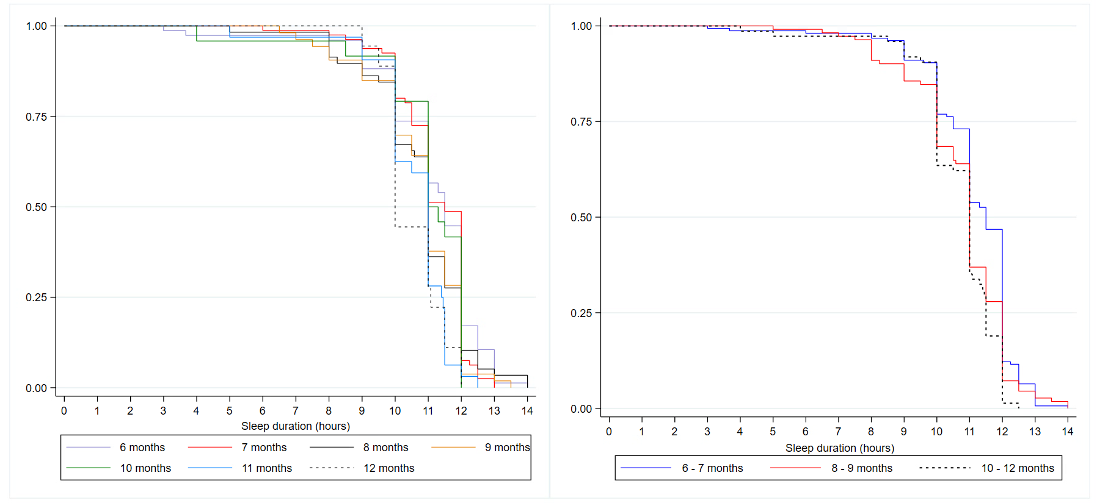
Fig S1 Kaplan-Meier plot showing nighttime sleep duration of infants in all age groups (left panel) and three age groups 8right panel). A drop in the curve indicates the time infants woke up (that is, the end of the nighttime sleep duration)

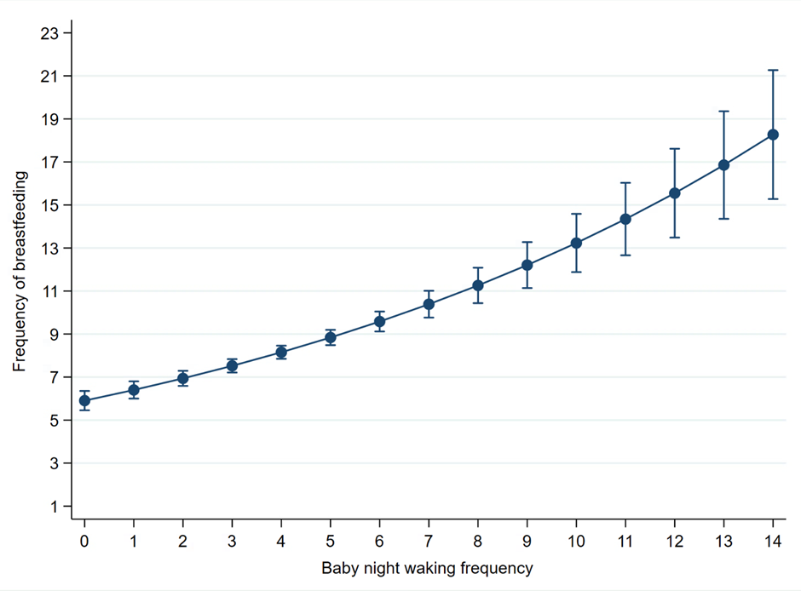
Figure 2 S. Marginsplot showing the association between baby night-waking frequency and night breastfeeding frequency

