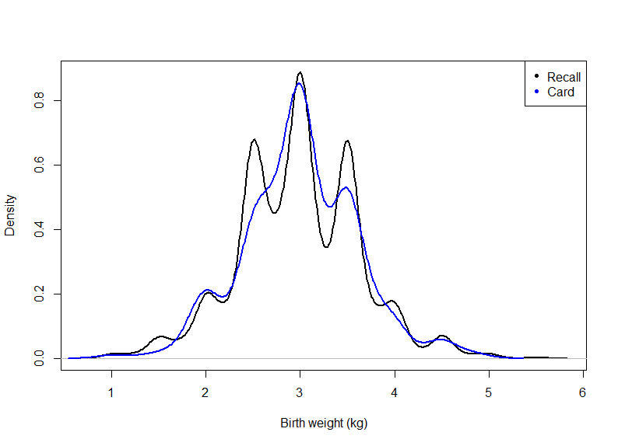
Figure S1. Density plot of birthweight by source of birthweight.
Table S1. Distribution of smoothed birthweight data.
 | Categories | %
Smoothed birthweight | <2.5 kg | 19.1
 | ≥2.5 kg | 80.9

Table S2. Mean smoothed birthweight by mothers’ perceived infant size at birth.
 | Smoothed birth weight
Perceived baby size | Mean | SE | p-value
Very large | 3.79 | 0.0774 | <0.001
Larger than average | 3.54 | 0.0245 | <0.001
Average | 3.00 | 0.0098 | <0.001
Smaller than average | 2.40 | 0.0243 | <0.001
Very small | 1.85 | 0.0529 | <0.001
SE: standard error
Table S3. Accuracy of mothers’ perceived infant birth size to predict low birthweight.
 | Smoothed birthweight
 | <2.5 kg | ≥2.5 kg | Total (%)
Perceived birth size
Small | 476 (10.2%) | 359 (7.7%) | 835 (17.9)
Normal or above | 416 (8.9%) | 3422 (73.2%) | 3838 (82.1)
Total (%) | 892 (19.1%) | 3781 (80.9%) | 4673
Indicator accuracy
Sensitivity | 53.4
PPV | 57.0
Specificity | 90.5
NPV | 89.2
Agreement
Concordant | 83.4
Overestimate | 7.7
Underestimate | 8.9
Kappa (95% CI) | 0.45 (0.41-0.49)

Table S4. Accuracy of mothers’ perceived infant birth size to predict low birthweight using smoothed data (five class).
 | Smoothed birthweight (five classes)
Birth size (five classes) | Very small | Smaller than average | Average | Larger than average | Very large | Total
Very small | 47 | 43 | 17 | 1 | 0 | 107
Smaller than average | 75 | 251 | 384 | 14 | 4 | 727
Average | 9 | 260 | 2591 | 244 | 38 | 3142
Larger than average | 1 | 11 | 345 | 186 | 69 | 612
Very large | 0 | 0 | 41 | 20 | 23 | 84
Total | 131 | 565 | 3378 | 464 | 134 | 4673
Agreement
Concordant |  |  | 66.3
Overestimate |  |  | 16.3
Underestimate |  |  | 17.4
Kappa (95% CI) |  |  | 0.30 (0.27-0.33)

Table S5. Associations between different factors and mothers’ reported infant size and smoothed birthweight agreement.
Variables | Birth size and birthweight (smoothed) agreement  (Base: Concordance)
 | Overestimate | Underestimate
 | AOR (95% CI) | AOR (95% CI)
Sex
Male | 1.00 | 1.00
Female | 1.20 (1.01, 1.43) | 0.95 (0.79, 1.14)
Early marriage
No | 1.00 | 1.00
Yes | 1.24 (1.03, 1.49) | 1.05 (0.86, 1.27)
Mother’s education
Pre-primary or none | 1.00 | 1.00
Primary | 0.92 (0.56, 1.52) | 1.06 (0.64, 1.76)
Secondary | 0.76 (0.48, 1.21) | 0.91 (0.57, 1.44)
Higher secondary or upper | 0.61 (0.38, 0.99) | 1.03 (0.64, 1.66)
Place of delivery
Health facility | 1.00 | 1.00
Home | 1.22 (0.88, 1.68) | 0.81 (0.57, 1.17)
Mother’s media exposure
No | 1.00 | 1.00
Yes | 0.81 (0.66, 1.00) | 0.86 (0.70, 1.05)
AOR: adjusted odds ratio; CI: confidence interval.

