Do Happy People Shop More? A Replication-Extension Field Study on Spending
Online Appendix
Supplementary Analyses
In more support of our findings, we subjected the data to additional analyses by re-conducting the tests in the manuscript using transformed measures of spending. The results are qualitatively unchanged: the coefficient of happiness was significant on log-transformed spending, β = 0.183, 95% CI = [0.071, 0.296], p = .002; square root-transformed spending, β = 0.330, 95% CI = [0.224, 0.437], p < .001, and inverse-transformed spending, β = -0.242, 95% CI = [-0.353, -0.130], p < .001. In Figure A1, we illustrate the pattern between happiness and each measure of spending: raw, log, square root, and inverse.
Figure A1. Scatterplots between Happiness and Spending (Raw and Transformed)
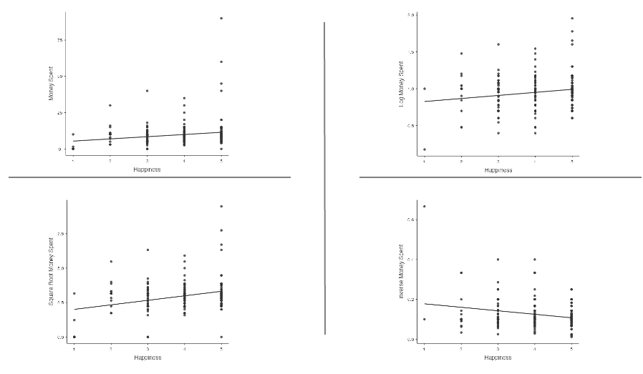
The significant patterns for the transformed spending measures held for both robustness checks in the manuscript: when we removed 13 spend-thrifty participants who spent 1 SD over the mean spending amount, and when we analyzed only small purchases—under $5 (see Table A1). In addition, a non-parametric test (Spearman’s rho test) between happiness and each measure of spending was significant: raw spending, ρ = 0.200, p < .001; log-transformed spending, ρ = 0.130, p = .026; square root-transformed spending, ρ = 0.200, p < .001, and inverse-transformed spending, ρ = -0.130, p = .026.
Table A1. Robustness Checks on Transformed Measures of Spending
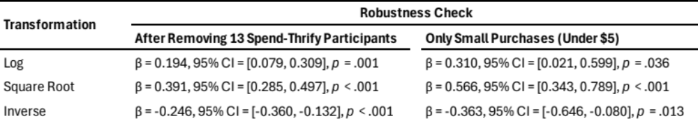
Article Comprehension Study
We conducted a study by polling participants’ interpretations of an article published in the Wall Street Journal on the effects of sadness on spending, entitled: “How Do You Keep The Public Shopping? Just Make People Sad.” We asked 316 participants on Amazon Mechanical Turk (MTurk) to read the article in full and to respond (“yes” or “no”) to one of two questions based on their understanding of the piece: “Does sadness increase shopping?” or “Does happiness decrease shopping?” To the question on sadness-increasing-shopping, 94.8% (147/155) of participants correctly answered “yes.” To the question on happiness-decreasing-shopping, a large number of participants, 82.6% (133/161), also answered “yes”—an answer that does not follow from the article. These results show that participants incorrectly inferred that happy people spend less when they are led to believe that sad people spend more.

