Supplementary Table 1：PCR primer sequence number
HLA-B | Forward Primer | CAGTTCGTGAGGTTCGACAG | Reverse Primer | CAGCCGTACATGCTCTGGA
CSK | Forward Primer | CTGTACGCGCCTCATTAAACC | Reverse Primer | CAGCATCACGTCTCCGAACTC
PPIL1 | Forward Primer | TGAGTTGGCTCGTCGAGGTTA | Reverse Primer | GCCATAGATAGATGCACCACC
BEX1 | Forward Primer | CAGCATGGAAAATGCCAACCA | Reverse Primer | ATGATGGTCATGGTGAGGGG
CAPG | Forward Primer | CAACATCCTGGAACGCAACA | Reverse Primer | AGCAGTTCAAGGGCAAATGG
GANAB | Forward Primer | TGGGGATTACCCTTGCTGTG | Reverse Primer | CCGTATGCTTCTCTGTCGCT
IGLL1 | Forward Primer | CGTGGTAACCCATGGCCTG | Reverse Primer | ATGAACATTCTGCAGGGGCC
PTMA | Forward Primer | GGAGGCTGACAATGAGGTAGA | Reverse Primer | TGGTATCGACATCGTCATCCT
PDXP | Forward Primer | CTGGAGACCGACATCCTCTTT | Reverse Primer | TTCTAGGCGGGAGACTCCTG
CRTC3 | Forward Primer | AGTTTCAGCCGTCATTTCACC | Reverse Primer | AGCACTACCATCAAATTGTCGC
BTBD6 | Forward Primer | GCCATGTTCTACGGAGACCTG | Reverse Primer | TCTTAGCAGCGTACAGAGTGG
SERTAD2 | Forward Primer | TGTCCCACATCTACCTCCACA | Reverse Primer | CTTGAGGACCGTCGAGTTTCT
AP5B1 | Forward Primer | TGCCTGCGAGAGCTAGAGAG | Reverse Primer | TGGGGAGACCTTATCCGTGAG
ABHD2 | Forward Primer | CATGCTGGAGACTCCCGAAC | Reverse Primer | CAAACACCGGACGATCACGTA
FYB1 | Forward Primer | GGATGTCTCAGTCAATAGCCG | Reverse Primer | GGTTCCTTGTCAGGCTTTTCC
GAPDH | Forward Primer | TGCACCACCAACTGCTTAG | Reverse Primer | GATGCAGGGATGATGTTC
Supplementary Table 2：shRNA Sequence
FYB1-sh1 | CCGGCCAAATGTTGACCTGACGAAACTCGAGTTTCGTCAGGTCAACATTTGGTTTTTTGAATT
FYB1-sh2 | CCGGGCTTCAAGCAAGGAGAGCAAACTCGAGTTTGCTCTCCTTGCTTGAAGCTTTTTTGAATT
FYB1-sh3 | CCGGGCCATCTCTTCACAGTGTAAACTCGAGTTTACACTGTGAAGAGATGGCTTTTTTGAATT
CAPG-sh1 | CCGGGCATTTCACAAGACCTCCACACTCGAGTGTGGAGGTCTTGTGAAATGCTTTTTGAATT
CAPG-sh2 | CCGGGCTGATATCTGATGACTGCTTCTCGAGAAGCAGTCATCAGATATCAGCTTTTTGAATT
CAPG-sh3 | CCGGGAGTCCCATCTTCAAGCAATTCTCGAGAATTGCTTGAAGATGGGACTCTTTTTGAATT
Supplementary Figure 1
Differential expression plot of CAPG
Analysis of the RNA-seq dataset (GSE183385) revealed significant downregulation of CAPG after knocking down ADAP.
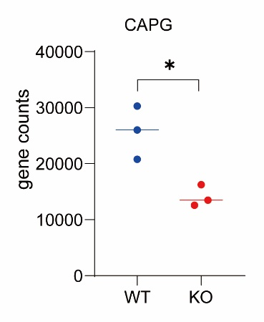
Supplementary Figure 2
FYB1 and CAPG gene expression between normal and cancer cell lines.
(A-B) The expression levels of FYB1 and CAPG in GSE149237.
(C-D) The protein expression levels of FYB1 and CAPG between CD34+ HSPC and cancer cell lines.
(E-F) The mRNA levels of FYB1 and CAPG between CD34+ HSPC and cancer cell lines.
