Human umbilical cord mesenchymal stem cells improve bone marrow hematopoiesis through regulation of bone marrow adipose tissue

Molecular and Cellular Biochemistry

Jingyi Feng^{1,2}, Miao Zhang², Huanying Ren¹, Yan Ren¹, Zhuanghui Hao², Sicheng Bian³, Jiangxia Cui¹, Shuo Li², Jing Xu⁴, Muteb Muyey Daniel², Fanggang Ren¹, Zhifang Xu¹, Yanhong Tan¹, Xiuhua Chen¹, Yaofang Zhang¹, Jianmei Chang¹, Hongwei Wang^{1,2,}*

¹Institute of Hematology, Second Hospital of Shanxi Medical University, Taiyuan 030001, People's Republic of China.
²The Second Clinical Medical College, Shanxi Medical University, Taiyuan 030001, People's Republic of China.
³Department of Medicine, The MetroHealth System, Case Western Reserve University, Ohio 44109, United States.
⁴Department of Medical Cell Biology and Genetics, Shanxi Medical University, Taiyuan 030001, People's Republic of China.

*Correspondence: Hongwei Wang, PhD, Institute of Hematology, The Second Hospital of Shanxi Medical University, Taiyuan 030001, People's Republic of China. Tel: +86 0351 3365807; Email: wanghw68@hotmail.com

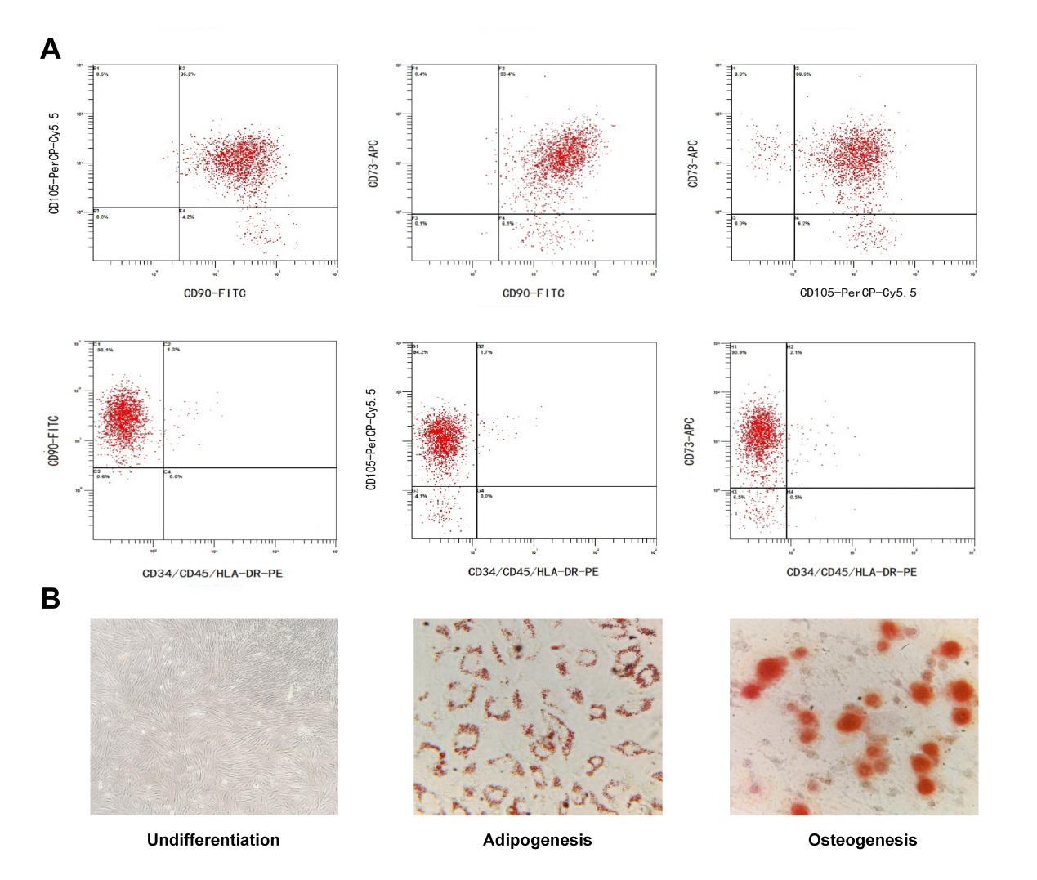
Figure S1: The characteristic of human umbilical cord mesenchymal stem cells.
A. The flow cytometry results showed that most of the hucMSCs we used expressed CD90, CD73 and CD105, but not CD34, CD45 and HLA-DR.
B. The morphology of hucMSCs (4×). And the results of Oil red O staining (40×) and Alizarin red S staining (40×) showed that the hucMSCs we used are capable of differentiating into adipocytes and osteoblasts.

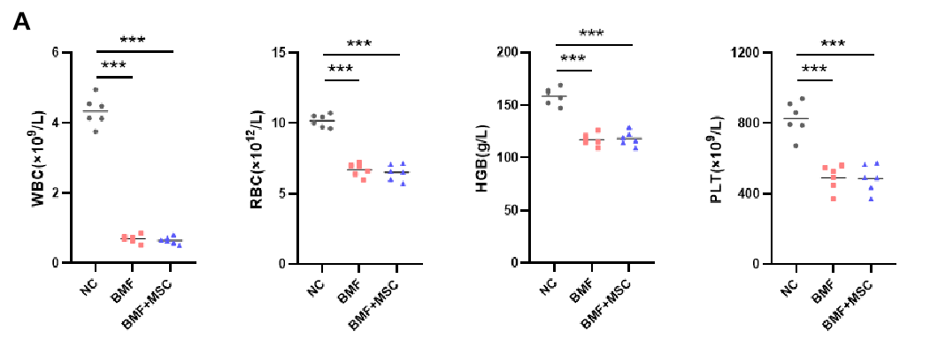
Figure S2: Analysis of peripheral blood cell counts in mouse models.
A. WBC, RBC, HGB, and PLT counts on day 9 of the chemotherapy-induced BMF mouse model.

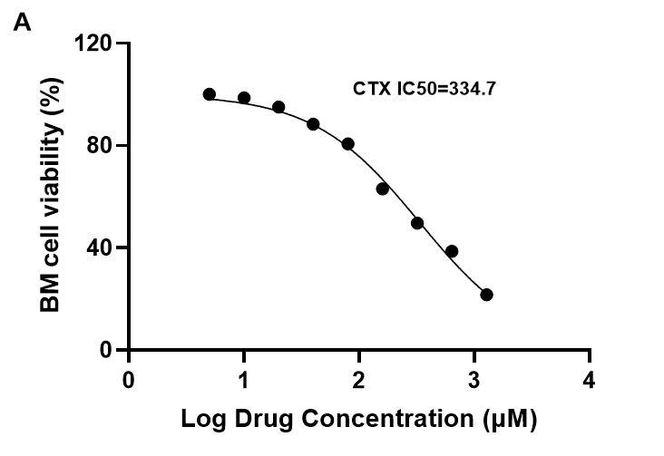
Figure S3: Establishment of chemotherapeutic drug concentrations for in vitro intervention in mouse BM cells.
A. CTX and BUS were administered in a 4:1 ratio, based on the in vitro experimental dosing regimen, with CTX dosage serving as the reference for gradient concentration experiments. The half-maximal inhibitory concentration (IC50) values were calculated by assessing cell viability through cell counting.

Table S1. Antibodies used for identification of hucMSCs
Antibody | Company
PE Mouse Anti-Human CD34 | BD Pharmingen
PE Mouse Anti-Human CD45 | BD Pharmingen
PE Mouse Anti-Human HLA-DR | BD Pharmingen
APC Mouse anti-Human CD73 | BD Pharmingen
FITC Mouse Anti-Human CD90 | BD Pharmingen
PerCP-Cy5.5 Mouse anti-Human CD105 | BD Pharmingen

Table S2. Primers used for qRT-PCR
Gene | Forward primer (5’ - 3’) | Reverse primer (5’ - 3’)
PPARG | TTTCAAGGGTGCCAGTTTCG | CATCTTTATTCATCAGGGAGGC
CEBPA | CAAGAACAGCAACGAGTACCG | GTCACTGGTCAACTCCAGCAC
CEBPB | CTTCAGCCCCTACCTGGAG | GGAGAGGAAGTCGTGGTGC
FABP4 | AAGGTGAAGAGCATCATAACCCT | TCACGCCTTTCATAACACATTCC
FASN | GGAGGTGGTGATAGCCGGTAT | TGGGTAATCCATAGAGCCCAG
ACC1 | GATGAACCATCTCCGTTGGC | GACCCAATTATGAATCGGGAGTG
NRF2 | CAGCCATGACTGATTTAAGCAG | CAGCTGCTTGTTTTCGGTATTA
HO1 | TCCTTGTACCATATCTACACGG | GAGACGCTT TACATAGTGCTGT
NQO1 | GAAGACATCATTCAACTACGCC | GAGATGACTCGGAAGGATACTG
SOD1 | AAGGGAGATGTTACAACTCAGG | GCTCAGGTTTGTCCAGAAAATG
GAPDH | ATGGTGAAGGTCGGTGTG | AACTTGCCGTGGGTAGAG

Table S3. Antibodies used for Western blot
Antibody | Species drived from | Company | Dilution
PPARgamma(C26H12) | Rabbit mAb | Cell Signaling Technology | 1/1000
Anti-C/EBPα | Rabbit pAb | Wanleibio | 1/500
Anti-FABP4 | Rabbit pAb | Proteintech | 1/1000
Anti-C/EBPβ | Rabbit pAb | Wanleibio | 1/500
Fatty Acid Synthase (C20G5) | Rabbit mAb | Cell Signaling Technology | 1/1000
Jak2 (D2E12) | Rabbit mAb | Cell Signaling Technology | 1/1000
Phospho-Jak2 (Tyr1007/1008) (C80C3) | Rabbit mAb | Cell Signaling Technology | 1/1000
Stat3 (D3Z2G) | Rabbit mAb | Cell Signaling Technology | 1/1000
Phospho-Stat3 (Tyr705) (D3A7) | Rabbit mAb | Cell Signaling Technology | 1/1000
Anti-NRF2 | Rabbit pAb | Wanleibio | 1/500
Anti-HO-1 | Rabbit pAb | Wanleibio | 1/500
Anti-NQO1 | Rabbit pAb | Wanleibio | 1/500
SOD1(24): sc-101523 | Mouse mAb | Santa Cruz Biotechnology | 1/1000
GAPDH | Rabbit pAb | Proteintech | 1/5000
HRP-conjugated Affinipure | Goat Anti-Rabbit IgG(H+L) | Proteintech | 1/5000
HRP-conjugated Affinipure | Goat Anti-Mouse IgG(H+L) | Proteintech | 1/5000

Table S4: Antibodies used for assessing BM primitive cells and BM cell differentiation
Antibody | Company
Anti-mouse Lineage V450 | BD Pharmingen
Anti-mouse Sca-1 PE | BD Pharmingen
Anti-mouse C-kit PerCP-eFluor710 | eBioscience
Anti-mouse CD41 PerCP-Vio700 | Miltenyi Biotec
Anti-mouse Gr-1 FITC | Miltenyi Biotec
Anti-mouse mac-1 PE | BD Pharmingen
Anti-mouse Ter119 VioBlue | Miltenyi Biotec
Anti-mouse B220 APC-Cy7 | BD Pharmingen
Anti-mouse CD3 BV510 | BD Pharmingen

