GPR55 senses lactate to sustain motility in prostate cancer cells

Giovanna Sgrignani¹*, Marta Iozzo¹*, Lara Di Leonardo¹, Elisa Pardella¹, Erica Pranzini¹, Giulia Gangarossa¹, Giuseppina Comito¹, Luigi Ippolito¹**, Elisa Giannoni^{@1}, Paola Chiarugi^{@1}

¹ Department of Experimental and Clinical Biomedical Sciences, “Mario Serio”. University of Florence, Viale Morgagni 50, 50134, Florence, Italy

*Equal contribution as first authors
@Equal contribution as last authors
**Corresponding author: L. Ippolito, luigi.ippolito@unifi.it
Supplementary Material
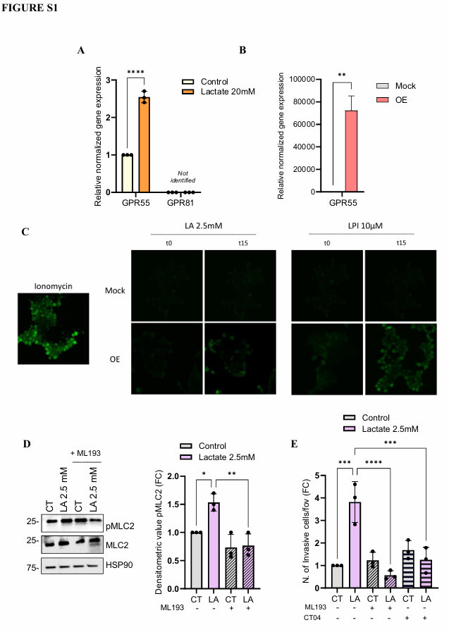
Supplementary Fig. 1
Lactate promotes GPR55 activation and RhoA-dependent invasiveness in PC3 cells. A) RT-PCR analysis for the GPR55 and GPR81 in DU145 cells treated as figure 1A. B) RT-PCR analysis for GPR55 in HEK293T cells transfected with GPR55-expressing plasmid versus mock-transfected controls. C) Representative confocal images showing the levels of intracellular calcium flux assessed after stimulation with lactate (2.5 mM) or LPI (10 µM) in GPR55-OE and mock-transfected HEK293T cells. Ionomycin (5 µM) was reported as positive control (magnification 40×; time = 0 and 15 min post-stimulation). D) Total protein lysates from PC3 cells, treated with 2.5 mM lactate for 15 min ± ML193 (5 µM) were subjected to WB analysis of pMLC2 and total MLC2. HSP90 was used as housekeeping protein. E) 5x10⁴ PC3 cells, treated with 2.5 mM lactate for 48 hours and administered with CT04 (1 µg/mL) or ML193 (5 µM) were allowed to invade through matrigel-coated transwell chambers for 16h. All data are represented as the mean ± SEM of n=3 experiments. Two-way ANOVA following Sidak’s multiple comparisons (A); One-way ANOVA following Tukey’s corrected (B, D, E). * p<0.05; ** p<0.01; ***p<0.001; **** p<0.0001

