Optimization of RNP-CRISPR for High-Efficiency Gene Editing in Mouse Intestinal Organoids
Xiya Cao^{1, 7}, Youyuan He^{2, 7}, Haozhe Guo^{1, 7}, Xiaoya Cao³, Dan Zhang¹, Yuxuan Lai², Weihua Yang⁴, Zixuan Ma⁵, Xinghua Yu^{6,} *, Liren Wang^{1,} *, Dali Li^{1, 8,} *& Zhiyang Zeng^{3, 1, 8,} *
Supplementary information
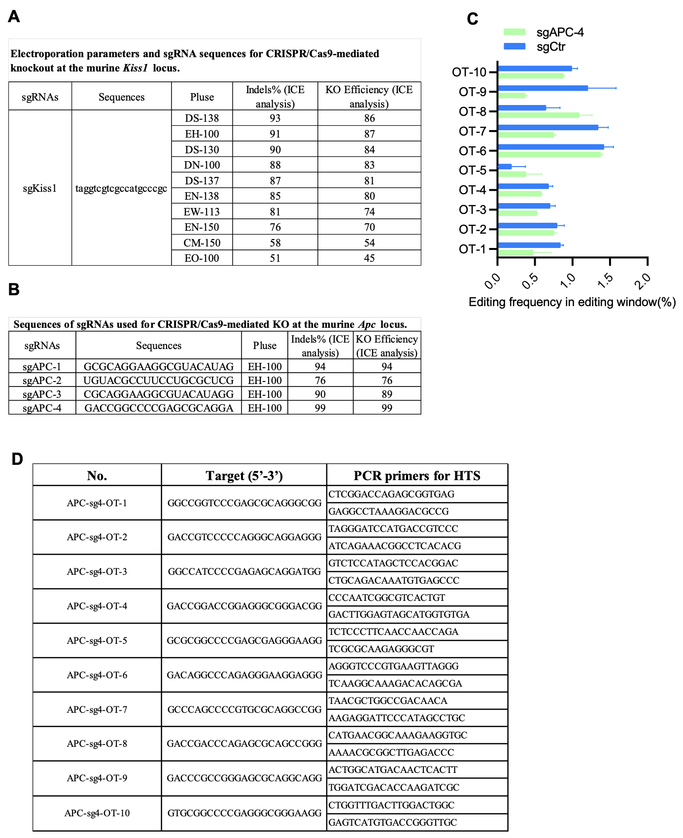
Fig. S1

Fig. S1 sgRNA sequences, electroporation parameters, and off-target analysis for RNP-CRISPR editing in mouse intestinal organoids.
A Electroporation parameters and sgRNA sequences for Kiss1 knockout optimization. The table lists the ten tested 4D-Nucleofector™ pulse codes, the sgRNA sequence targeting the murine Kiss1 locus, and the corresponding gene editing outcomes (indel percentage and knockout efficiency) as determined by ICE analysis. B Sequences and editing efficiency of sgRNAs targeting the murine Apc locus. The table shows the four designed sgRNA sequences (sgAPC-1 to sgAPC-4), the electroporation program used (EH-100), and the resulting indel and knockout efficiencies from ICE analysis. C Validation of on-target specificity for sgAPC-4. Next-generation sequencing (NGS) analysis of editing efficiency at the 10 top-ranked in silico predicted off-target sites for sgAPC-4. No significant indel activity was detected at any off-target locus (n=3 independent experiments). Data are presented as mean ± SD. D List of predicted off-target sites and validation primers. The genomic coordinates, sequences, and PCR primers used to amplify the 10 potential off-target sites analyzed in (C) are provided.

