Supplementary figures
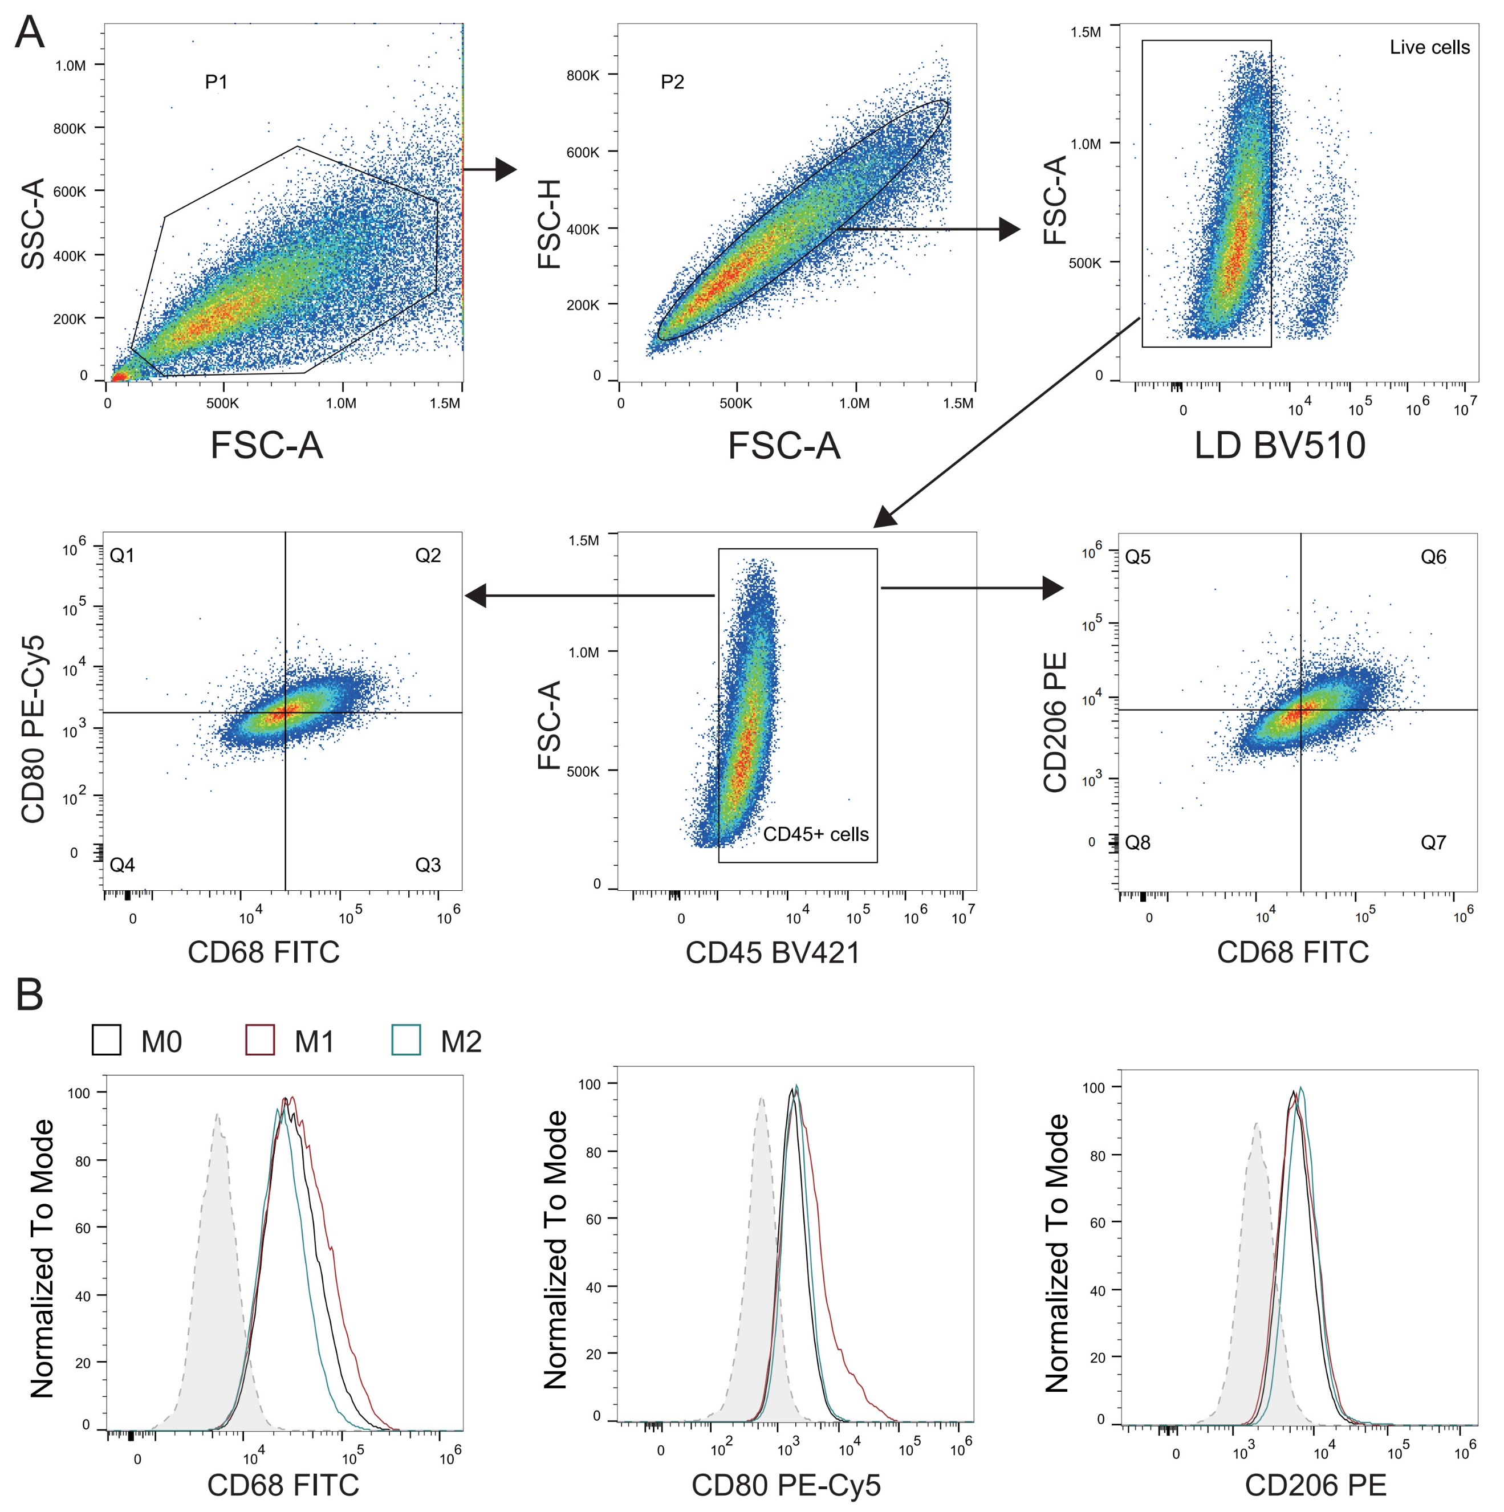
Fig. S1 Flow cytometry analysis of THP-1-derived macrophages. (A) Gating strategy for analysis of macrophage markers, including CD68, CD80 and CD206. (B) Histogram of CD68, CD80 and CD206 in THP-1-derived macrophages.

Fig. S2 Pharmacologic inhibition of IGF1R in THP-1-derived macrophages downregulated the expression of polarization markers. Relative mRNA expression of IFNγR2 (A), CD68 (B), CD80 (C) and CD206 (D) in THP-1-derived M0 macrophage treated with or without 1μM BMS-754807 for 24 h. Data are presented as mean ± SD (n=3). The error bars represent the standard deviation. Statistical analysis was performed using Student’s t-test. *P<0.05, **P<0.01, ***P<0.001.
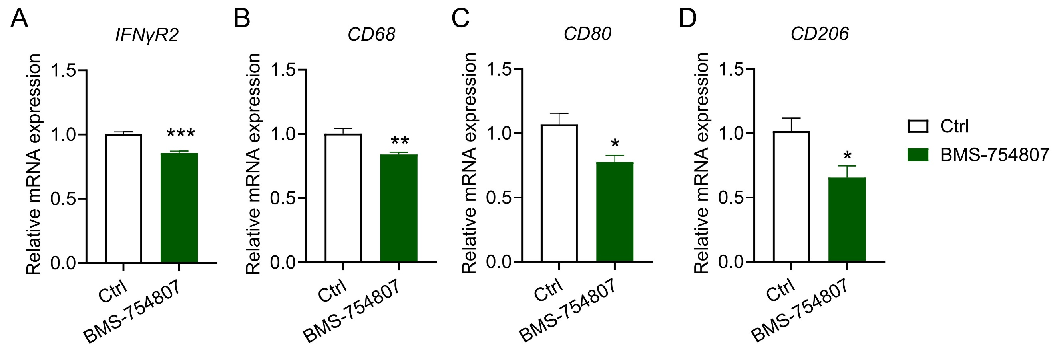

Fig. S3 Gene expression of ECM related genes in THP-1-derived TAMs and A375 cells pre-co-cultured with TAMs. (A) Gene expression of ECM related genes in THP-1-derived TAMs. (B) Gene expression of ECM related genes in A375 cells pre-co-cultured with TAMs. All data are derived from the transcriptome analysis of TAMs and A375 cells. Data are presented as mean ± SD (n=3). The error bars represent the standard deviation. Statistical analysis was performed using Student’s t-test. *P<0.05, **P<0.01, ***P<0.001.
