Supplementary material

Hyaluronan Fragments Modulate Inflammation in Preeclampsia: A Focus on Th17/Treg Balance

Mariana Romao-Veiga¹ ORCID 0000-0002-8990-0237; Vanessa Rocha Ribeiro-Vasques² ORCID 0000-0001-7629-7689; Patrícia Braga da Silva¹ ORCID 0000-0003-2997-2789; Gabriela de Oliveira Franco¹ ORCID 0000-0001-9461-6479; Larissa Ragozo Cardoso de Oliveira² ORCID 0000-0002-9407-1496; José Carlos Peraçoli¹ ORCID 0000-0002-3273-3001; Maria Terezinha Serrão Peraçoli^{1,2} ORCID 0000-0002-0936-9512.

¹Department of Gynecology and Obstetrics, Botucatu Medical School, Sao Paulo State University-UNESP, Botucatu, Sao Paulo, Brazil
²Department of Genetics, Microbiology and Immunology, Institute of Biosciences, Sao Paulo State University-UNESP, Botucatu, Sao Paulo, Brazil

Correspondence should be addressed to Mariana Romao Veiga.
*Corresponding author at Botucatu Medical School, Sao Paulo State University, Unesp - Sao Paulo State University, Botucatu, Sao Paulo, Brazil.
CEP 18618-689 Phone: 55 14 3880 0431
Email address: romao.veiga@unesp.br

Flow cytometry gate strategy

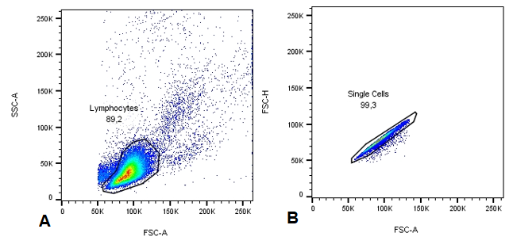
Supplementary Fig. S1. Representative dot plots for phenotypic strategy analysis of CD4⁺ T cells by flow cytometry. (A) Gate lymphocytes were based on the size and granularity of the cell population. (B) Gate singlets were based on single cell analysis.

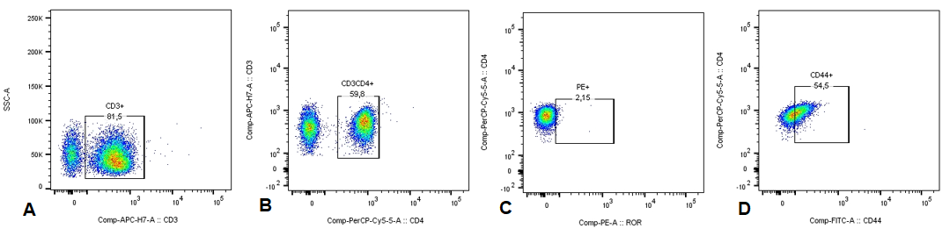
Supplementary Fig. S2. Representative dot plots for phenotypic strategy analysis of Th lymphocytes by flow cytometry. (A) Gate CD3⁺ represents the selection of positive cells for this marker. (B) Gate CD4⁺ represents the selection of positive cells for this marker. (C) Gate for cell population were transcription factors T-bet and RORγt, and intracellular cytokines TNF and IL-17 were analyzed. (D) Gate CD44⁺ represents the selection of positive cells for this marker.

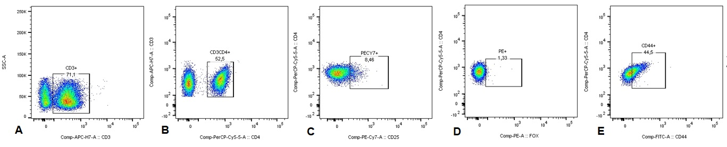
Supplementary Fig. S3. Representative dot plots for phenotypic strategy analysis of Th lymphocytes by flow cytometry. (A) Gate CD3⁺ represents the selection of positive cells for this marker. (B) Gate CD4⁺ represents the selection of positive cells for this marker. (C) Gate CD25⁺ cell population. (D) Gate for transcription factor FoxP3 or intracellular cytokine IL-10 positive cells. (E) Gate CD44⁺ represents the selection of positive cells for this marker.

Cell viability after hyaluronan (HA) exposure
Cell viability was assessed after 24 h of culture by flow cytometry using an Annexin V/propidium iodide (PI) assay (Thermo Fisher). Cell viability was not significantly affected by exposure to low molecular weight - LMW-HA (Fig S3) or high molecular weight - HMW-HA (Fig S4) compared with the unstimulated control culture.

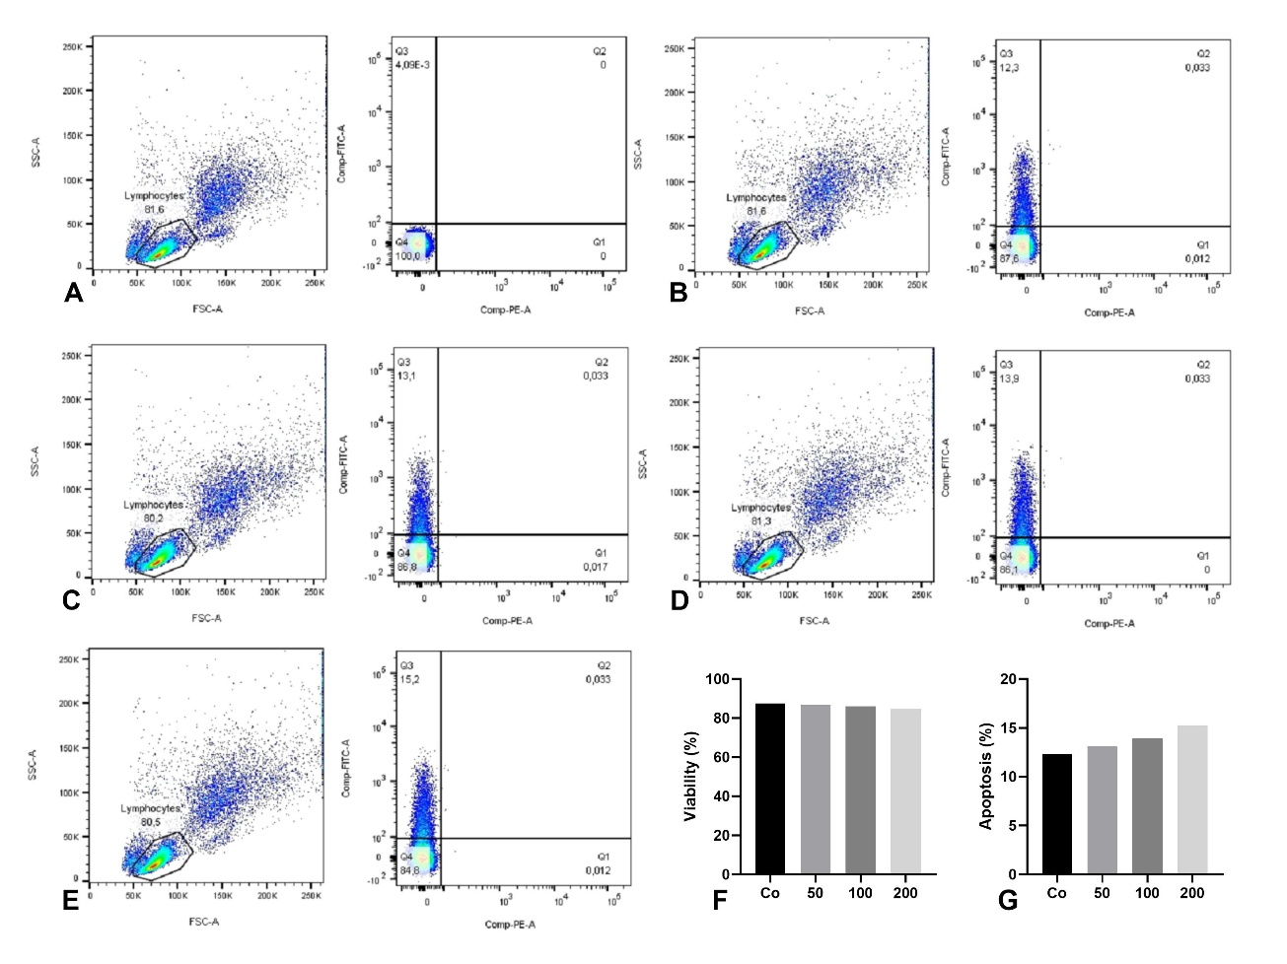
Fig S4. Lymphocyte viability after treatment with different concentrations of LMW-HA. (A) Unstained live control; (B) Untreated lymphocyte control (Co); (C) LMW-HA at a concentration of 50 ng/mL; (D) LMW-HA at a concentration of 100 ng/mL; (E) LMW-HA at a concentration of 200 ng/mL; Graphs F and G represent, respectively, the percentages of lymphocytes viability (F) and apoptosis (G) after cell incubation with different concentrations of LMW-HA.

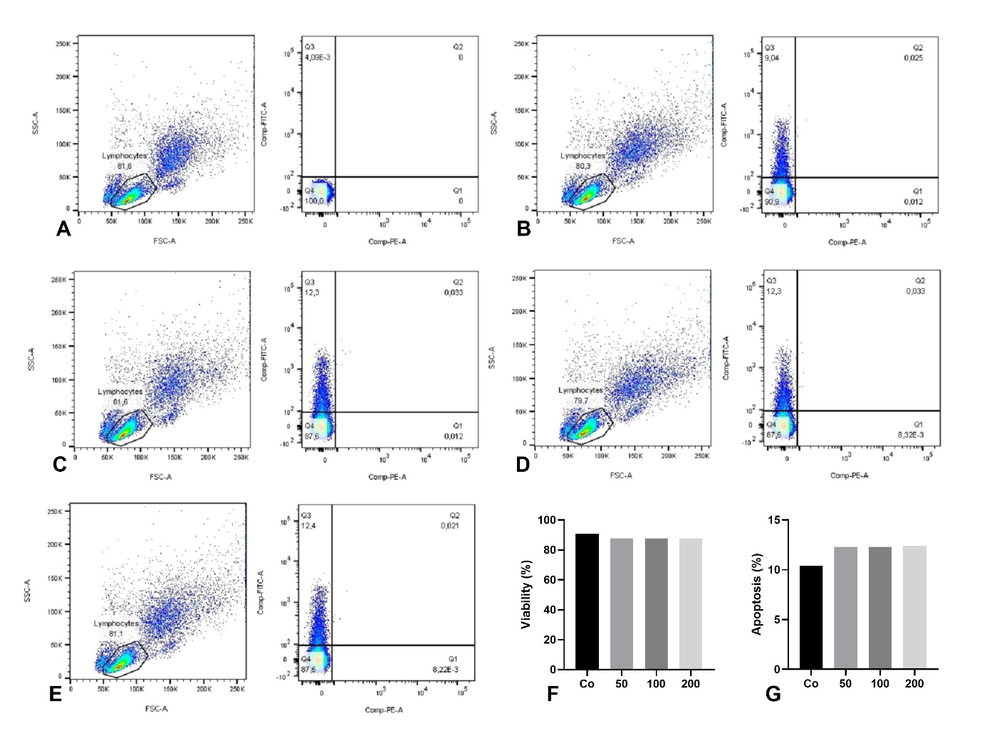
Fig S5. Lymphocyte viability after treatment with different concentrations of HMW-HA . (A) Unstained live control; (B) Untreated lymphocyte control (Co); (C) HMW-HA at a concentration of 50 ng/mL; (D) HMW-HA at a concentration of 100 ng/mL; (E) HMW-HA at a concentration of 200 ng/mL. Graphs F and G represent, respectively, the percentages of lymphocytes viability (F) and apoptosis (G) after cell incubation with different concentrations of HMW-HA.

