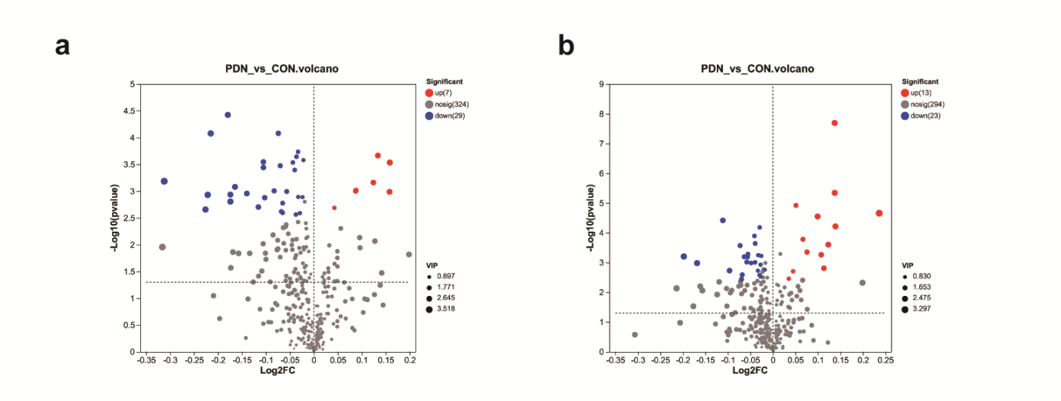
Supplement Figure 1. Volcano plot of hydrophilic metabolites in both positive and negative ion mode.
a: Positive ion mode of hydrophilic substances; b: Negative ion mode of hydrophilic substances.
Every datum on this graphical tableau aligns with a metabolite, where the red unveils the significantly upregulated entities, the blue unveils the significantly downregulated counterparts, and the grey unveils those metabolites that remain non-significantly different from the normal group. The classification is based on a VIP > 1 and a significance level of false discovery rate < 0.05.

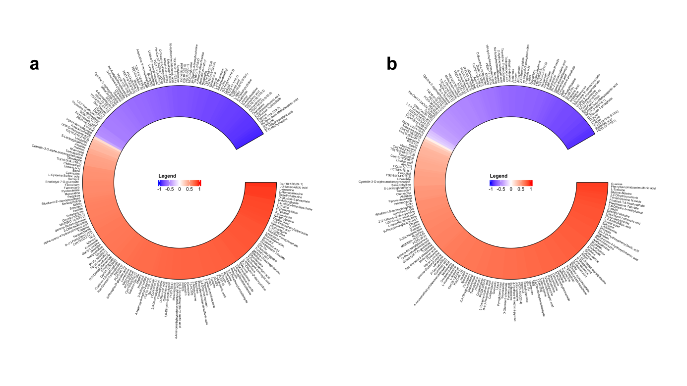
Supplement Figure 2. Correlation analysis results between all differential metabolites and the PWT and PWL.
a: Correlation between differential metabolites and the PWT; b: Correlation between differential metabolites and PWL.
Red indicates a positive correlation between metabolites and pain behavior, and purple indicates a negative correlation between metabolites and pain behavior; the deeper the color, the stronger the correlation.

