Mitigation and Adaptation Strategies for Global Change

Supplementary materials

Challenges and opportunities for restoration of high-elevation Andean peatlands in Ecuador

Tab. S1. Raw data matrix used for the negative binomial regression model to analyze the elevation (field data), human population density (2010 National Census Data), precipitation, and mountain range (Eastern or Western branch of the cordillera), on the concentration of signs of human activities on Ecuadorian páramo peatlands. For details, please see text.
Site | Mountain Range | Total disturbance | Population Density  (hab/km²) | Annual Precipitation  (mm) | Elevation (m)
1 | Western | 4.5 | 22.9 | 1908 | 3987
2 | Western | 8 | 22.9 | 2105 | 4061
3 | Western | 8 | 22.9 | 2105 | 4059
4 | Western | 8 | 22.9 | 2226 | 3928
5 | Eastern | 4.5 | 2.3 | 1755 | 3300
6 | Eastern | 4.5 | 49.9 | 1161 | 3070
7 | Eastern | 3 | 74.0 | 1195 | 3092
8 | Western | 14 | 51.9 | 1462 | 3278
9 | Western | 2.5 | 51.9 | 1510 | 3386
10 | Eastern | 0 | 25.2 | 1726 | 3233
11 | Eastern | 0 | 25.2 | 1719 | 3288
12 | Eastern | 0.5 | 25.2 | 1719 | 3214
13 | Eastern | 0 | 49.9 | 1560 | 3183
14 | Eastern | 6 | 25.2 | 1636 | 3306
15 | Eastern | 0 | 12.3 | 1323 | 3128
16 | Eastern | 0 | 12.3 | 1263 | 3124
17 | Eastern | 12.5 | 32.1 | 1011 | 2927
18 | Eastern | 0.5 | 10.9 | 1330 | 3325
19 | Eastern | 0.5 | 10.9 | 1330 | 3317
20 | Eastern | 0.5 | 10.9 | 1154 | 3117
21 | Eastern | 0.5 | 10.9 | 1352 | 3302
22 | Eastern | 0.5 | 10.9 | 1223 | 3190
23 | Eastern | 0 | 10.9 | 1112 | 3021
24 | Western | 3.5 | 51.6 | 1633 | 3812
25 | Western | 5 | 26.0 | 1623 | 3805
26 | Western | 3.5 | 51.6 | 1682 | 3782
27 | Western | 3.5 | 51.6 | 1653 | 3781
28 | Western | 0 | 39.4 | 1973 | 3818
29 | Western | 0 | 39.4 | 2045 | 3940
30 | Western | 3.5 | 39.4 | 2064 | 3901
31 | Western | 3.5 | 39.4 | 2068 | 3939
32 | Western | 0 | 39.4 | 2068 | 3956
33 | Western | 3 | 39.4 | 2060 | 3970
34 | Western | 3.5 | 39.4 | 2036 | 3807
35 | Western | 3 | 39.4 | 2068 | 3972
36 | Western | 3 | 39.4 | 2060 | 3978
37 | Western | 4.5 | 39.4 | 2036 | 3811
38 | Western | 0 | 39.4 | 2036 | 3816
39 | Western | 3.5 | 39.4 | 2060 | 3979
40 | Western | 3.5 | 4.1 | 2105 | 3406
41 | Western | 6.5 | 4.1 | 2083 | 3854
42 | Western | 5 | 4.1 | 2083 | 3979
43 | Western | 1 | 4.1 | 2105 | 3904
44 | Western | 3.5 | 106.6 | 2096 | 4235
45 | Western | 3.5 | 106.6 | 2117 | 4239
46 | Western | 11 | 12.4 | 2218 | 4121
47 | Eastern | 8 | 149.0 | 1249 | 3400
48 | Eastern | 14 | 70.4 | 1442 | 3264
49 | Western | 0 | 147.5 | 1493 | 3804
50 | Western | 3.5 | 21.5 | 1921 | 3903
51 | Western | 5 | 21.5 | 2013 | 3904
52 | Western | 4.5 | 22.9 | 1402 | 3687
53 | Western | 6 | 138.5 | 1459 | 3612
54 | Western | 5 | 22.9 | 1739 | 3544
55 | Western | 3 | 22.9 | 2096 | 3813
56 | Western | 1.5 | 13.2 | 1674 | 3980
57 | Western | 1.5 | 13.2 | 1696 | 4143
58 | Western | 5 | 8.3 | 1812 | 3766
59 | Western | 8 | 35.0 | 1391 | 4026
60 | Western | 12.5 | 84.5 | 1386 | 4114
61 | Western | 3 | 84.5 | 1386 | 4080
62 | Western | 8 | 84.5 | 1351 | 3864
63 | Western | 8 | 84.5 | 1319 | 3869
64 | Western | 3.5 | 12.7 | 2441 | 4051
65 | Western | 6.5 | 12.7 | 2509 | 4067
66 | Western | 3.5 | 12.7 | 2577 | 4110
67 | Western | 6.5 | 12.7 | 2577 | 4116
68 | Eastern | 8 | 371.3 | 2742 | 3850
69 | Eastern | 6 | 3.0 | 2965 | 3468
70 | Eastern | 3 | 371.3 | 2708 | 3996
71 | Eastern | 6 | 371.3 | 2597 | 3873
72 | Eastern | 3 | 371.3 | 2173 | 3749
73 | Western | 8 | 100.2 | 1713 | 3855
74 | Eastern | 3.5 | 371.3 | 2601 | 3940
75 | Western | 3.5 | 51.7 | 1828 | 3956
76 | Western | 6.5 | 51.7 | 1875 | 3843
77 | Western | 3.5 | 37.1 | 2595 | 3978
78 | Western | 6.5 | 37.1 | 2461 | 3937
79 | Western | 8 | 37.1 | 2112 | 3681
80 | Western | 2 | 18.5 | 2244 | 3976
81 | Eastern | 1.5 | 84.5 | 1471 | 3304
82 | Eastern | 1 | 24.0 | 1472 | 3439
83 | Eastern | 1 | 24.0 | 1487 | 3477
84 | Eastern | 1.5 | 24.0 | 1497 | 3413
85 | Eastern | 2.5 | 5.6 | 1495 | 3395
86 | Western | 2.5 | 29.5 | 1647 | 3460
87 | Western | 1.5 | 20.4 | 1692 | 3641
88 | Western | 0.5 | 44.4 | 1654 | 3721
89 | Western | 2.5 | 44.4 | 1654 | 3611
90 | Eastern | 5 | 1.8 | 2808 | 3992
91 | Eastern | 3.5 | 1.8 | 2808 | 4023
92 | Eastern | 3 | 1.8 | 2808 | 3997
93 | Eastern | 3 | 1.8 | 2782 | 3983
94 | Eastern | 3 | 1.8 | 2706 | 4029
95 | Eastern | 3.5 | 2.9 | 2250 | 3983
96 | Eastern | 3.5 | 2.9 | 2250 | 3982
97 | Eastern | 3.5 | 2.9 | 2236 | 3979
98 | Eastern | 3.5 | 2.9 | 2302 | 3710
99 | Eastern | 4.5 | 11.6 | 3447 | 3582
100 | Eastern | 5 | 0.7 | 2221 | 3821
101 | Eastern | 3.5 | 36.6 | 1873 | 4059
102 | Eastern | 3.5 | 36.6 | 2022 | 3938
103 | Eastern | 5.5 | 36.6 | 1686 | 3767
104 | Eastern | 8 | 36.6 | 1729 | 3771
105 | Eastern | 3 | 0.7 | 2179 | 3853
106 | Eastern | 3 | 0.7 | 2196 | 3917
107 | Eastern | 7.5 | 0.7 | 2045 | 3422
108 | Eastern | 8 | 0.7 | 2159 | 3770
109 | Eastern | 3.5 | 0.7 | 2104 | 3652
110 | Eastern | 8 | 0.7 | 2109 | 3623
111 | Eastern | 5 | 0.7 | 2162 | 3728
112 | Eastern | 0 | 48.8 | 2118 | 3846
113 | Eastern | 1 | 48.8 | 2109 | 3767
114 | Eastern | 4 | 48.8 | 2118 | 3719
115 | Eastern | 7.5 | 48.8 | 2094 | 3724
116 | Eastern | 1 | 132.9 | 1729 | 3884
117 | Eastern | 3.5 | 132.9 | 1865 | 4090
118 | Eastern | 3.5 | 132.9 | 1865 | 4154
119 | Eastern | 3.5 | 132.9 | 1859 | 4254
120 | Eastern | 1.5 | 132.9 | 1908 | 4426
121 | Eastern | 3.5 | 17.2 | 1859 | 3955
122 | Eastern | 1.5 | 17.2 | 1807 | 3826
123 | Eastern | 1 | 17.2 | 1713 | 3690
124 | Eastern | 1.5 | 17.2 | 1669 | 3612
125 | Eastern | 1 | 17.2 | 1599 | 3480
126 | Western | 8 | 28.8 | 1723 | 4019
127 | Western | 5 | 28.8 | 1309 | 4346
128 | Western | 8 | 28.8 | 1368 | 4236
129 | Western | 3.5 | 28.8 | 1342 | 4272
130 | Western | 3.5 | 28.8 | 2078 | 4184
131 | Western | 14 | 28.8 | 1481 | 4040
132 | Western | 14 | 68.9 | 1282 | 3785
133 | Western | 8 | 68.9 | 1278 | 3858
134 | Western | 14 | 45.0 | 1276 | 3728
135 | Western | 14 | 45.0 | 1238 | 3798
136 | Western | 14 | 28.8 | 1368 | 3998
137 | Western | 14 | 28.8 | 1364 | 3915
138 | Western | 11 | 28.8 | 1393 | 3998
139 | Western | 4.5 | 28.8 | 1377 | 3865
140 | Western | 3.5 | 28.8 | 1694 | 3780
141 | Western | 3 | 28.8 | 1729 | 3890
142 | Western | 5 | 133.8 | 1328 | 3756
143 | Western | 5 | 133.8 | 1401 | 3856
144 | Western | 5 | 22.9 | 1468 | 4006
145 | Western | 3 | 22.9 | 1780 | 4025
146 | Western | 3 | 22.9 | 1482 | 3949
147 | Western | 3.5 | 22.9 | 1513 | 3978
148 | Western | 5 | 22.9 | 1592 | 4155
149 | Western | 5 | 22.9 | 1592 | 4152
150 | Western | 3 | 22.9 | 1616 | 3985
151 | Western | 5 | 22.9 | 1530 | 4007
152 | Eastern | 3.5 | 21.9 | 3780 | 3674
153 | Eastern | 3.5 | 21.9 | 3695 | 3657
154 | Eastern | 1.5 | 11.6 | 3559 | 3673
155 | Eastern | 2.5 | 11.6 | 3612 | 3632
156 | Eastern | 3.5 | 2.9 | 2257 | 3872
157 | Eastern | 3.5 | 11.6 | 2854 | 3691
158 | Eastern | 1.5 | 11.6 | 2440 | 3948
159 | Eastern | 1.5 | 11.6 | 3350 | 3589
160 | Eastern | 1.5 | 11.6 | 2892 | 3667
161 | Eastern | 1.5 | 11.6 | 2630 | 3929
162 | Eastern | 6.5 | 11.6 | 2546 | 3898
163 | Eastern | 5 | 11.6 | 2918 | 3621

Tab. S2. Percentage of sampled peatlands that exhibited each type of sign of human activities on the Easter and Western Andes of Ecuador. The number of peatlands samples was 85 and 78 for the Western and Eastern cordilleras, respectively. The total corresponds to the average and standard error of the impact index calculated for each mountain range (for details please see text).

 | % of peatlands
Type of activity | Western | Eastern
Garbage | 80.0 | 64.1
Impacts on surrounding slopes (e.g. roads, fire scars, agriculture) | 88.2 | 80.8
Infrastructure (e.g. houses, fences, water management infrastructure) | 44.7 | 17.9
Cattle | 80.0 | 55.1
Drainage | 32.9 | 24.4
Agriculture/Pastures | 11.8 | 3.8
Total | 5.2 ± 3.6 | 3.3 ± 2.7

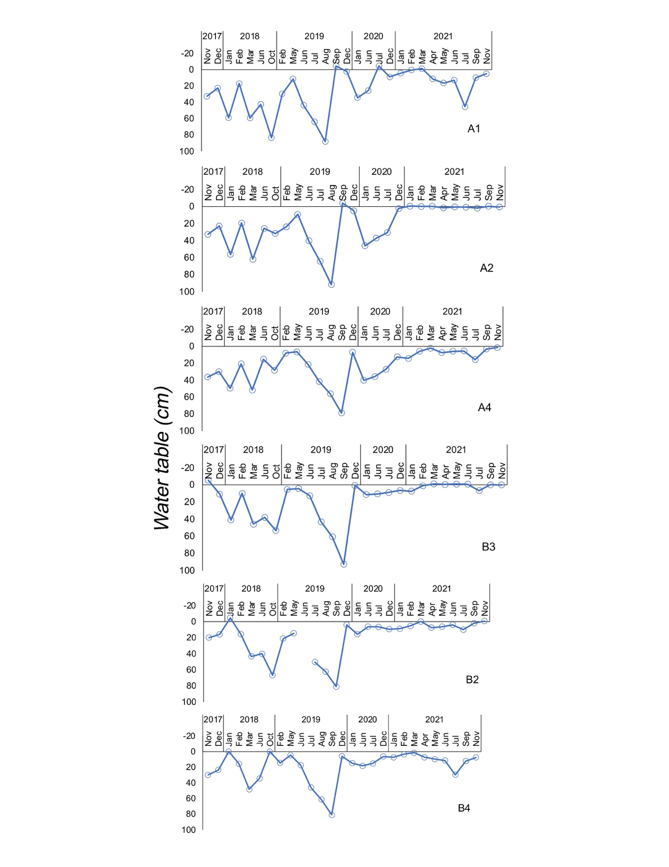
Fig. S1.

Fig S1. Trends of water table depth in six wells located thoughout the Chaklana peatland. Hydrological restoration activities were implemented between November 2017 and February 2018. For details please see text.

