Climate change and cocoyam (Colocasia esculenta (L.) Schott) production: Assessing impacts and potential adaptation strategies in Zimbabwe

Supplementary materials
SI1: Detailed description of the 8 soil classes used in the modelling of cocoyam suitability in Zimbabwe. The table describes the genesis and the distribution of the soils.
Soil Group | Genesis | Occurrence and distribution
Lithosol | Have not had adequate time to develop beyond their present depth either because of climatic conditions or other environmental factors. | May occur extensively on flat areas especially in areas underlain by rock which is relatively resistant to weathering such as southern part of Zimbabwe. In higher rainfall areas, lithosols are associated with broken or hilly terrain where the relatively high rate of erosion is partly responsible for the shallowness.
Regosol | Mostly developed from Kalahari sands. Soils are poor in nutrients and nutrients are supplied by extensive groundwater below the sands. Vegetation consists of fairly closed woodland in some areas whereas in others, it is thick thorny bush. | Extensive in the western part of the country from around Nyamandlovu just north of Bulawayo to Victoria Falls including parts of Hwange, Lupane, Nkayi and some parts of Gokwe and the belt extends into Botswana.
Vertisol | Major occurrences developed from jurrassic basalt. Major occurrences in low rainfall areas. Relative aridity of the areas result in limited weathering and leaching of weathering products. Also found in the higher rainfall areas as part of soil catenas where soils developed from mafic parent materials. Soils occupy lowerslope positions where there is accumulation of leached weathering products. | Major areas of vertisols are associated with basalt and mudstone formations. Chisumbanje has the most extensive area of vertisols with an area of about 40,000 ha which extends into Mozambique. Other areas include parts of Gokwe and the Zambezi valley.
Siallitic | Main features determining their occurrence are climate and topography. Predominant in low rainfall areas hence are relatively unleached with high base status. Like vertisols in high rainfall areas, they are also found as part of soil catenas where soils are developed from mafic parent materials. Soils occupy lower to mid-slope positions where there is accumulation of leached weathering products. | Predominant in the Save-Limpopo and south and south-east low veldt, semi-arid south and south west and in the Zambezi Valley. Also common along river valleys, where they are irrigated.
Fersiallitic | Consists of moderately leached soils with kaolinite the dominant mineral and some 2:1 lattice clays and appreciable amounts of free sesquioxides. Some reserve of weatherable minerals is present in most fersiallitic soils. In low rainfall areas fersiallitics are generally limited to siliceous parent material and become confined to mafic parent materials as rainfall increases. | These are the most extensive soil group in Zimbabwe. Agriculturally they are the most important in the country because of the widespread occurrence and diverse uses to which they are put.
Paraferrallitic | Derived in situ from relatively highly leached granite parent material. Clay mineralogy is dominated by mostly kandites and substantial amounts of sesquioxides. In the previous classification, this soil order generally occurred in areas with rainfall ranging from 900 mm to 1,250 mm per annum. | Found in association with granite rock. Occurred on upland positions on the catena on the central plateau at relatively high altitudes. Most extensive belt occurs just outside Harare, eastward through Epworth, Marondera, Headlands into Rusape with long wide belt extending south-west through Hwedza to the Range (Chivhu) eastward again to Buhera.
Orthoferrallitic | Very deep, freely draining soils resulting from deep weathering of underlying rock, followed by intense leaching of bases, accelerated by high rainfall in the areas where they occur. Represents soils that have undergone different degrees of weathering by different pathways and variations appear to be a function of annual rainfall and parent material. Soils generally have relatively high clay content which is inert because of high amounts of kandites and sesquioxides. | Occurs in areas with annual rainfall greater than 1,000 mm per annum. Major areas are the Eastern Highlands, Bikita-Ndanga Highlands in the south-east of the country and isolated highland areas with locally high rainfall such as around Mvurwi, Marondera and Headlands.
Sodic | The soil group includes weakly and strongly sodic soils as well as saline-sodic soils with a lower exchangeable sodium percentage limit of 9. The main factor responsible for formation of this group is parent materials relatively rich in sodium-releasing weatherable minerals, the most important being sandstones, mudstones, grits and conglomerates of Karoo age and younger gneisses and granites of the basement complex. | Extensive areas coincided with areas of lowest rainfall in the Zambezi and Limpopo-Save Valleys.  Also occurred in scattered localized small patches where mean annual rainfall was below 800 mm. Distribution is affected by parent material rich in sodium-releasing feldspars.
Source: (Nyamapfene, 1991; Thompson & Purves, 1978)

SI2: Model calibration for the Maxent model using the Enmeval functions. Performance metrics for parameter settings regarding regularization multiplier (RMs) used for creating the final models of cocoyam suitability in Zimbabwe. The legend shows the used feature classes (FCs) are individual and combinations of L, LQ, H, LQH, LQHP, LQHPT; where L=linear, Q=quadratic, H=hinge, P=product and T=threshold), which resulted in a total of in 768 models with the 8 predictor sets/variables. The tests are based on delta.AICc (a), meanAUC (b), mean.AUC.DIFF(c) and mean.ORmin (d). The delta.AICc is the AUC corrected for small samples sizes that shows the change in AUC with the regularization parameter and reflects both model goodness-of-fit and complexity. The model with the lowest delta.AICc value is the best model. The meanAUC is threshold-independent metric based on predicted values for the test points averaged over k iterations. Higher values reflect a better model. The mean.ORmin shows the average of the omission rate, a threshold-dependent metric that indicates the proportion of test sample points with suitability values lower than that associated with the lowest-ranking training point. Values for this should be closer to zero for best models. Here we see that the Maxent default regularization parameter is not the best for modelling suitability of cocoyam in Zimbabwe.
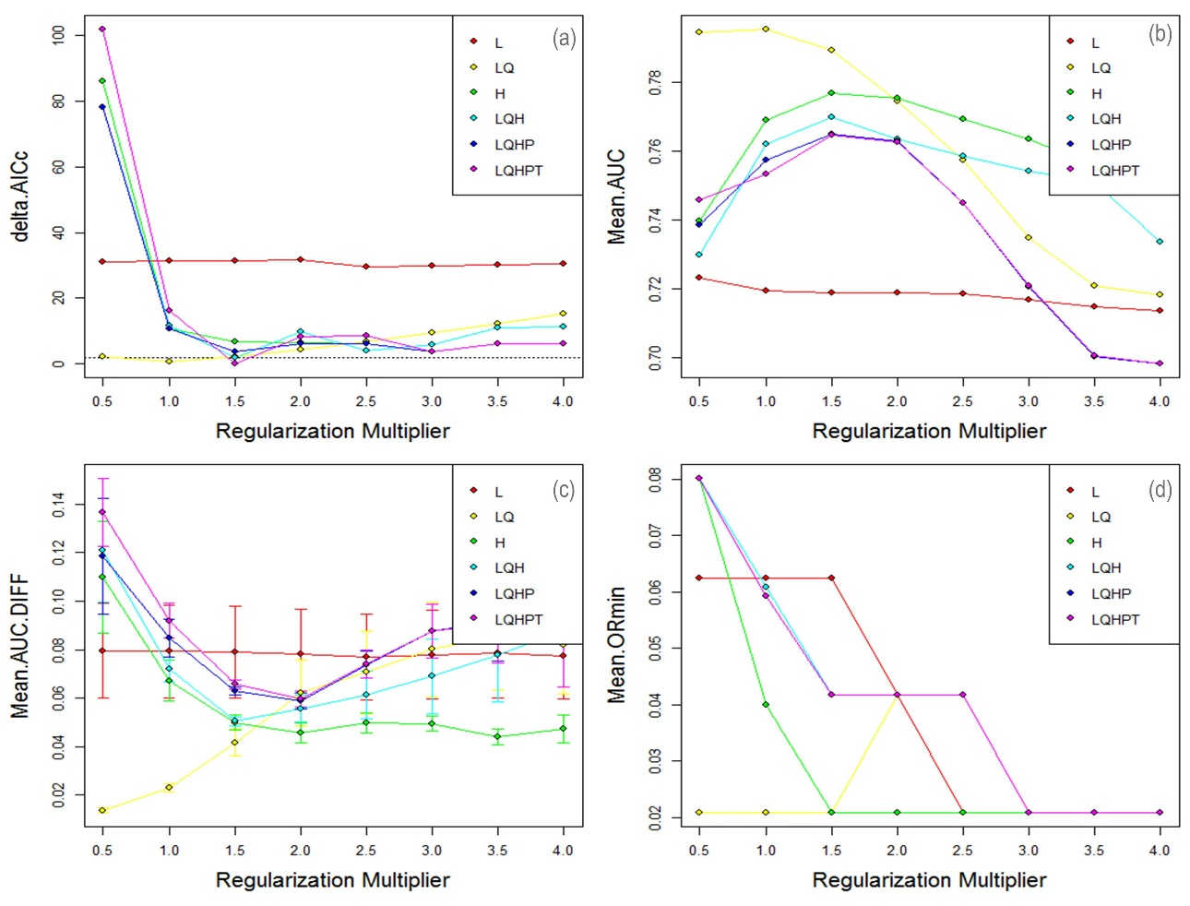

SI3: Model accuracy assessment of the Maxent model used for suitability assessment of cocoyam. The black line shows the null model. The results showed that the prediction was systematic and far different from the random prediction.
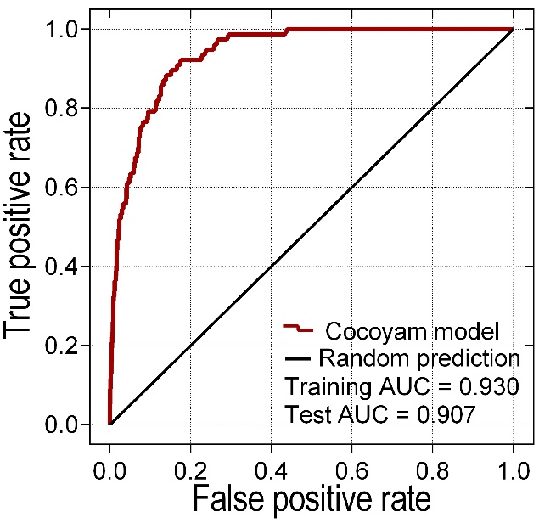

SI4: Response curves of cocoyam to the bioclimatic, topographic and soil factors used in the modelling. The response curves are for (a) mean annual temperature (Bio1), (b) temperature seasonality (Bio4), (c) mean temperature of wettest quarter (Bio8), (d) total annual precipitation (Bio12), (e) seasonality of precipitation (Bio15), (f) precipitation of wettest quarter (Bio16), (g) elevation and (h) soil type (listed according to the order in SI1).
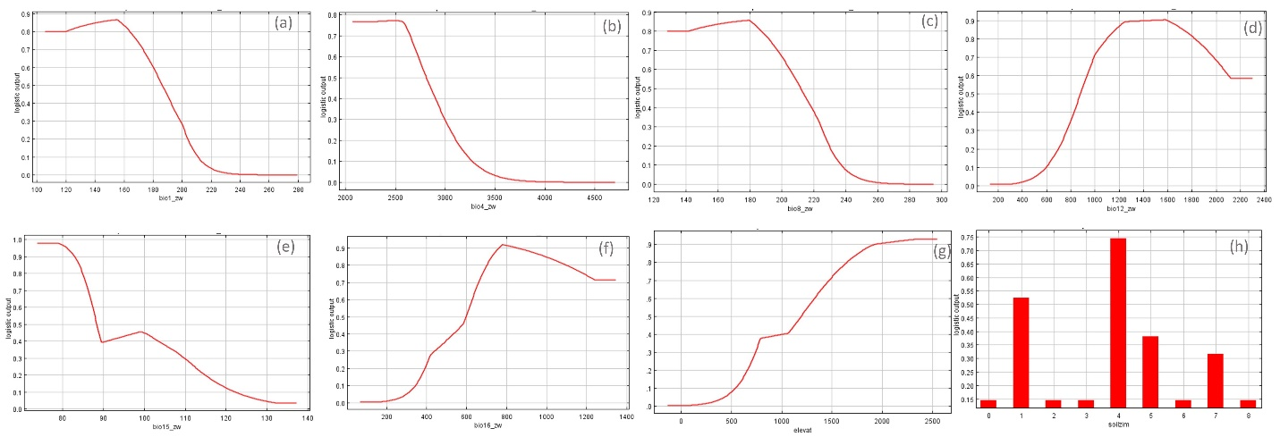

SI5: Changes in bioclimatic variables under different scenarios and GCMs by 2050 and 2070 for sampling points that were used in the modelling. The Tables shows the difference between the future projection and the current as additional information to Table 2.
 |  | 2050:RC26 |  |  |  | 2050:RC45 |  |  |  | 2050:RC60 |  |  |  | 2050:RC85
 |  | CCSM4 | HADGEM | MIROC5 | Mean | CCSM4 | HADGEM | MIROC5 | Mean | CCSM4 | HADGEM | MIROC5 | Mean | CCSM4 | HADGEM | MIROC5 | Mean
2050 | Bio1 | 1.1 | 1.9 | 1.6 | 1.6 | 1.5 | 2.3 | 1.9 | 1.9 | 1.4 | 2.3 | 1.7 | 1.8 | 2.1 | 3.1 | 2.3 | 2.5
 | Bio12 | 27.5 | -57.5 | -41.3 | -23.8 | 8.9 | 20.2 | -51.2 | -7.4 | 35.5 | 54.5 | -72.9 | 5.7 | 97.3 | -41.2 | -68.4 | -4.1
 | Bio15 | 5.6 | 11.6 | 6.2 | 7.8 | 1.4 | 13.1 | 6.6 | 7.0 | 5.8 | 12.3 | 6.3 | 8.1 | 6.4 | 16.7 | 4.2 | 9.1
 | Bio16 | 34.7 | 17.3 | -1.7 | 16.8 | 1.5 | 77.8 | 3.3 | 27.5 | 33.4 | 94.4 | -20.8 | 35.7 | 84.6 | 51.6 | -26.5 | 36.6
 | Bio4 | 72.1 | 63.5 | 154.4 | 96.7 | 93.0 | 23.2 | 143.0 | 86.4 | 12.8 | 43.5 | 116.6 | 57.6 | 112.7 | 15.0 | 169.2 | 99.0
 | Bio8 | 1.0 | 1.8 | 1.5 | 1.4 | 1.5 | 2.1 | 1.7 | 1.7 | 1.3 | 2.0 | 1.4 | 1.5 | 2.0 | 2.7 | 2.2 | 2.3
 |  | 2070:RC26 |  |  |  | 2070:RC45 |  |  |  | 2070:RC60 |  |  |  | 2070:RC85
 |  | CCSM4 | HADGEM | MIROC5 | Mean | CCSM4 | HADGEM | MIROC5 | Mean | CCSM4 | HADGEM | MIROC5 | Mean | CCSM4 | HADGEM | MIROC5 | Mean
2070 | Bio1 | 1.0 | 2.0 | 1.8 | 1.6 | 1.8 | 2.9 | 2.2 | 2.3 | 1.9 | 3.2 | 2.2 | 2.4 | 3.2 | 4.6 | 3.4 | 3.7
 | Bio12 | 15.7 | -27.2 | -67.2 | -26.3 | 51.2 | -54.7 | -48.1 | -17.2 | 34.1 | 99.1 | -84.5 | 16.2 | 63.5 | -78.2 | -63.8 | -26.2
 | Bio15 | 5.1 | 16.6 | 7.4 | 9.7 | 5.5 | 14.6 | 5.5 | 8.5 | 2.9 | 17.5 | 4.4 | 8.3 | 5.0 | 21.8 | 6.0 | 10.9
 | Bio16 | 27.5 | 60.1 | -11.2 | 25.5 | 46.8 | 78.2 | -7.7 | 39.1 | 28.9 | 157.0 | -36.5 | 49.8 | 56.0 | 49.0 | -22.7 | 27.4
 | Bio4 | 144.6 | 71.1 | 187.8 | 134.5 | 104.5 | 116.1 | 135.8 | 118.8 | 105.2 | 68.5 | 166.6 | 113.4 | 132.5 | 243.4 | 129.9 | 168.6
 | Bio8 | 1.0 | 1.7 | 1.8 | 1.5 | 1.7 | 2.6 | 1.9 | 2.1 | 1.8 | 2.8 | 2.2 | 2.3 | 3.0 | 4.3 | 3.1 | 3.5

SI6: Modelled area (km2) and percentage change in suitability for cocoyam in Zimbabwe by 2050 and 2070 and four projected climatic scenarios (RCP26, RCP45, RCP60 and RCP85). The change in suitability is the difference between the current and future scenarios.
 | Area suitable (km2) |  |  |  |  |  | Change in suitability (%)
District | Now | RCP26 | RCP45 | RCP60 | RCP85 |  | Now | RCP26 | RCP45 | RCP60 | RCP85
Bikita | 590 | 172 | 101 | 94 | 10 |  | 10.9 | -7.7 | -9.0 | -9.2 | -10.7
Chikomba | 208 | 45 | 179 | 241 | 1 |  | 3.1 | -2.4 | -0.4 | 0.5 | -3.1
Chimanimani | 2288 | 2026 | 1951 | 1840 | 1459 |  | 65.8 | -7.6 | -9.7 | -12.9 | -23.8
Chipinge | 1578 | 1608 | 1506 | 1395 | 1187 |  | 28.8 | 0.5 | -1.3 | -3.3 | -7.1
Makoni | 3519 | 2830 | 2430 | 2432 | 1346 |  | 43.5 | -8.5 | -13.5 | -13.5 | -26.9
Marondera | 988 | 480 | 436 | 245 | 1 |  | 27.6 | -14.2 | -15.4 | -20.8 | -27.6
Masvingo | 587 | 149 | 53 | 71 | 1 |  | 8.1 | -6.1 | -7.4 | -7.1 | -8.1
Murehwa | 409 | 283 | 172 | 121 | 1 |  | 11.2 | -3.5 | -6.5 | -7.9 | -11.2
Mutare | 901 | 669 | 493 | 361 | 159 |  | 15.2 | -3.9 | -6.9 | -9.1 | -12.5
Mutasa | 1757 | 1451 | 1403 | 1546 | 840 |  | 66.7 | -11.6 | -13.4 | -8.0 | -34.8
Nyanga | 2400 | 2060 | 1852 | 1472 | 973 |  | 40.3 | -5.7 | -9.2 | -15.6 | -24.0
Wedza | 535 | 444 | 269 | 190 | 1 |  | 20.2 | -3.4 | -10.0 | -13.0 | -20.1
Zaka | 724 | 124 | 80 | 75 | 0 |  | 22.2 | -18.4 | -19.7 | -19.9 | -22.2
Bikita | 590 | 122 | 44 | 37 | 0 |  | 10.9 | -8.6 | -10.1 | -10.2 | -10.9
Chikomba | 208 | 120 | 29 | 4 | 0 |  | 3.1 | -1.3 | -2.7 | -3.0 | -3.1
Chimanimani | 2288 | 1721 | 1466 | 1346 | 565 |  | 65.8 | -16.3 | -23.6 | -27.1 | -49.5
Chipinge | 1578 | 1453 | 1073 | 1001 | 301 |  | 28.8 | -2.3 | -9.2 | -10.5 | -23.3
Makoni | 3519 | 2243 | 1975 | 1597 | 52 |  | 43.5 | -15.8 | -19.1 | -23.8 | -42.9
Marondera | 988 | 248 | 140 | 56 | 0 |  | 27.6 | -20.7 | -23.7 | -26.0 | -27.6
Masvingo | 587 | 147 | 7 | 4 | 0 |  | 8.1 | -6.1 | -8.0 | -8.1 | -8.1
Murehwa | 409 | 99 | 17 | 26 | 0 |  | 11.2 | -8.5 | -10.7 | -10.5 | -11.2
Mutare | 901 | 475 | 239 | 260 | 25 |  | 15.2 | -7.2 | -11.2 | -10.8 | -14.8
Mutasa | 1757 | 1258 | 1203 | 981 | 306 |  | 66.7 | -18.9 | -21.0 | -29.4 | -55.1
Nyanga | 2400 | 1870 | 1394 | 1277 | 219 |  | 40.3 | -8.9 | -16.9 | -18.9 | -36.6
Wedza | 535 | 172 | 30 | 13 | 0 |  | 20.2 | -13.7 | -19.0 | -19.7 | -20.2
Zaka | 724 | 122 | 8 | 2 | 0 |  | 22.2 | -18.4 | -21.9 | -22.1 | -22.2

