SUPPLEMENTARY MATERIAL
Farming system change under different climate scenarios and its impact on food security: an analytical framework to inform adaptation policy in developing countries

Journal: Mitigation and Adaptation Strategies for Global Change

- The farming system typology for Mozambique
Farming systems (FS) were derived based on a set of 42 computed variables (Table S1), representing farmers’ individual productive decisions regarding agricultural land use/cover, livestock density and composition, use of yield-raising (e.g. fertilizer) and labour-saving (e.g. mechanical or animal traction) inputs. Therefore, different FS reflect different combinations of farmers’ productive decisions.
Data for the classification of farms by FS for Mozambique were extracted from the latest agricultural census to date, referring to the 2009/2010 agricultural season (INE, 2011). Only small and medium farms were included in the analysis – accounting for about 99% of total farms in Mozambique (INE, 2011) – therefore, subject to a specific survey in national agricultural censuses. Data was analysed at the farm-level, including a usable sample of 27,805 farms, which represents about 1% of total small and medium farms in the country, corresponding to a fixed sample of 10 households/farms in each enumeration area defined by the agricultural census, in all districts (third administrative division) (see INE, 2011 for more details). A farm refers to all parcels of land managed by the same household.
FS were identified based on a farm-level Principal Components Analysis (PCA) firstly performed on a correlation matrix of the 42 farm characterization variables (Table S1) for dimension reduction. Principal components (PCs) with eigenvalues greater than 1 (Kaiser’s criteria) were selected to enter a Hierarchical Cluster Analysis (HCA), from which a set of 16 clusters were selected based on dendrogram analysis and experts’ knowledge, representing the main FS in Mozambique – see Table 1 in original paper.

Table S1. Summary of the variables considered for the classification of farms by FS (n=27,805)
Variables |  |  | Description (crops/livestock)
Land use/cover | Annual Crops (proportion of total arable area) | Maize
Land use/cover | Annual Crops (proportion of total arable area) | Rice
Land use/cover | Annual Crops (proportion of total arable area) | Sorghum+ (includes Millet)
Land use/cover | Annual Crops (proportion of total arable area) | Cassava
Land use/cover | Annual Crops (proportion of total arable area) | Sweet Potato
Land use/cover | Annual Crops (proportion of total arable area) | Cowpea
Land use/cover | Annual Crops (proportion of total arable area) | Beans
Land use/cover | Annual Crops (proportion of total arable area) | Groundnut
Land use/cover | Annual Crops (proportion of total arable area) | Sesame
Land use/cover | Annual Crops (proportion of total arable area) | Cotton
Land use/cover | Annual Crops (proportion of total arable area) | Tobacco
Land use/cover | Annual Crops (proportion of total arable area) | Hort1 (Pumpkin, Watermelon and Okra)
Land use/cover | Annual Crops (proportion of total arable area) | Hort2 (Tomato, Kale, Onion, Potato, Lettuce and Cabbage)
Land use/cover | Annual Crops (proportion of total arable area) | Hort3 (Cucumber, Yam, Green beans, Garlic, Carrot, Pepper and Eggplant)
Land use/cover | Annual Crops (proportion of total arable area) | Other annual crops (e.g. peas, sunflower, soy, sugarcane, wheat, ginger)
Land use/cover | Permanent Crops (PERM) (proportion of total fruit tree stems) | Mango
Land use/cover |  | Cashew
Land use/cover |  | Coconut
Land use/cover |  | Citrus (Orange, Lemon, Tangerine and Grapefruit)
Land use/cover |  | Other Fruits (Papaya, Maçanica, Mafurra, Guava, Avocado, Jambalão, Peach, Litchi and Apple)
Land use/cover | Proportion of equivalent arable area with permanent crops^{(a)}
Livestock Variables | Livestock (proportion in total standard livestock units) | Bovine
Livestock Variables | Livestock (proportion in total standard livestock units) | Goats
Livestock Variables | Livestock (proportion in total standard livestock units) | Swine
Livestock Variables | Livestock (proportion in total standard livestock units) | Small Livestock (Chickens, Ducks, Bush chicken, Turkeys, Rabbits and Geese)
Livestock Variables | Livestock (proportion in total standard livestock units) | Sheep
Livestock Variables | Livestock density (number of standard livestock units per hectare of arable area)
Output Diversification | Gross Product ^{(b)} (proportion of total output, i.e. Total Gross Product –TGP ^{(c)}) | Annual Basic Food Crops (STAPLES)
Output Diversification |  | Horticultural Crops (HORT)
Output Diversification |  | Cash Crops (CASH)
Output Diversification |  | Cashew
Output Diversification |  | Coconut
Output Diversification |  | Livestock
Output Diversification | Economic Intensity [output (MZN) per hectare of arable area]
Yield-raising input intensity (proportion of arable area) |  | Irrigation
Yield-raising input intensity (proportion of arable area) |  | Pesticide
Yield-raising input intensity (proportion of arable area) |  | Fertilizer
Yield-raising input intensity (proportion of arable area) |  | Manure
Labour and labour-saving inputs | Labour productivity – output (MZN) per labour unit ^{(d)}
Labour and labour-saving inputs | Labour intensity – labour units per hectare of arable area
Labour and labour-saving inputs | Bovine traction use: 1 – yes; 0 – otherwise
Labour and labour-saving inputs | Tractors use indicator: 1 – yes; 0 – otherwise
^{(a)} Total arable area with permanent crops was computed based on the average area per fruit tree stem (Rehm and Espig, 1991) and the number of fruit tree stems (extracted from CAP database).
^{(b)} The Gross Product (GP) for crops was computed based on data from CAP 2009-2010, i.e. the harvested amount and the median price for each crop (in the national currency, Metical – MZN). Conversions to kilograms (kg) were made, when necessary, based on the conversion parameters from the Ministry of Agriculture and Food Security and the National Statistical Institute. When conversion factors were not available, and when applicable, land productivity was used to estimate farm production. Conversion factors for horticultural crops and fruits were not available, therefore it was assumed that the gross product was equal to sales (MZN). For livestock, the GP was computed based on livestock outputs, i.e. slaughtered, and live animals sold and offered. The average price was computed based on the purchase and sale price (of meat and live animals) – extracted from CAP.
^{(c)} TGP refers to the total output of the farm, including crops (annual and permanent) and livestock.
^{(d)} Labour units correspond to the sum of all units of labour employed in agriculture and livestock activity, including: i) family labour (weighted in 100% for those who had agricultural as their main activity, and 25% as their secondary activity); ii) full-time workers (assumed to dedicate 100% of their time to agricultural activity); and iii) temporary workers (assumed to spend 10% of their time).

The spatial distribution of each FS was represented at the district level (the third administrative level), based on the percentage of Total Agricultural Area (TAA) of each farming system in each district. For better representativeness and understanding of the spatial distribution of all farming systems in the country, a second HCA was performed at the district level based on the share of each farming systems’ area in the TAA of the district (Fig. S1). Each cluster represents a geographic area, i.e. a zone (representing a set of districts) with a similar composition of farming systems (Fig. S1).

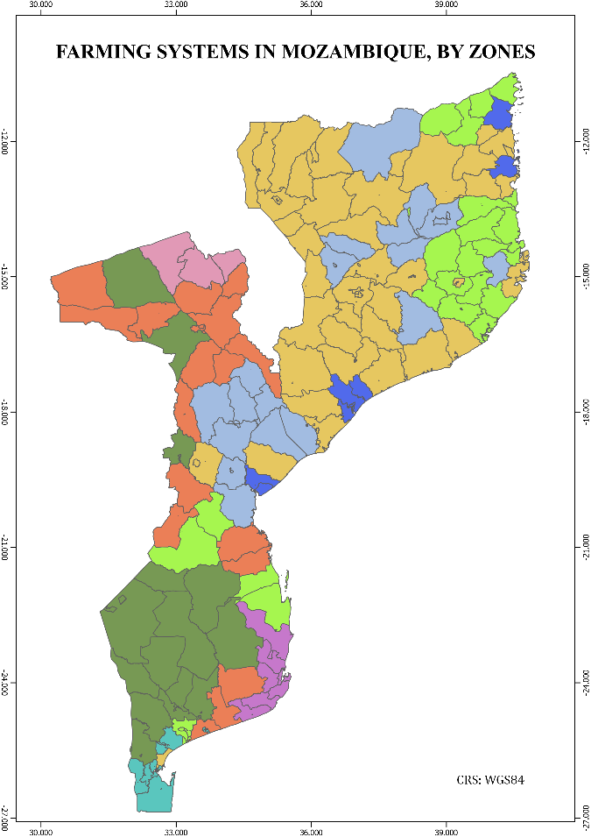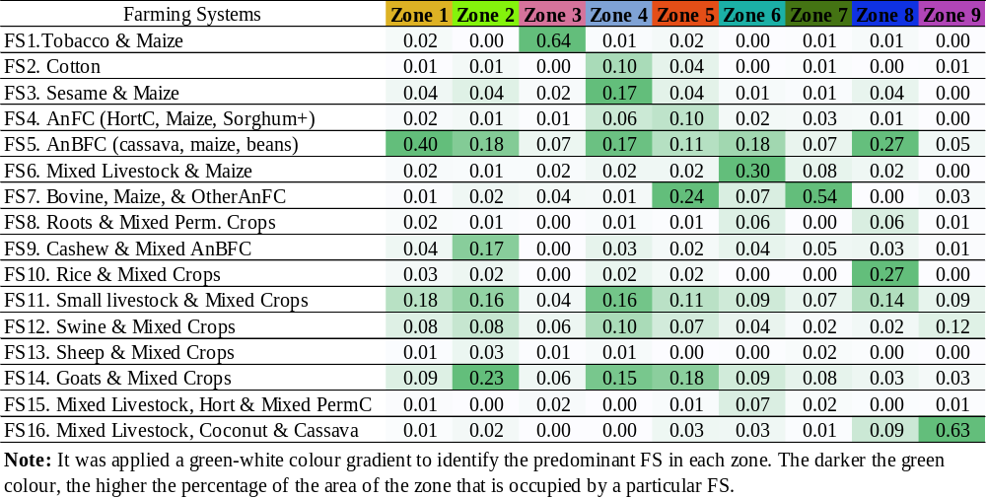
Fig. S1 Spatial distribution of FS in Mozambique by zones. The table refers to the percentage of the area of each zone (which represents a set of districts) that is occupied by each FS.
- Biophysical and socioeconomic drivers of farming system choice
The Random Forest Model was used to identify the main drivers of FS choice in Mozambique, based on the FS typology. A set of biophysical and socioeconomic variables (Table S2) were used as independent variables, and the set of 16 selected clusters, representing the main farming systems in Mozambique, as the dependent categorical variable.
Biophysical data included climate variables, such as rainfall, temperature, and aridity. Climate types (Fig. 3, in the original paper) were classified based on the aridity index (AI), using the following parameters: Hyper-arid if AI < 0.05; Arid if 0.05 ≤ AI < 0.2; Semi-arid if 0.2 ≤ AI < 0.5; and, Dry Subhumid if 0.5 ≤ AI < 0.65 (Cherlet et al., 2018). Other biophysical variables included the proportion of the administrative post area in diverse slope and soil fertility classes, and the proportion of the farm area located in lower zones. Slope classes – representing smooth (<5%) and steep (>10%) slopes – were computed from a slope map extracted from the 30 meters Digital Elevation Model (DEM) from Shuttle Radar Topography Mission (SRTM) for Mozambique, obtained at RCMRD GeoPortal (2015) (Table S2). For soil fertility, areas with intermediate to high and very high fertility were merged into a single class: areas with high soil fertility. Spatial data on soil types and soil fertility were provided in person by the Agricultural Research Institute of Mozambique (IIAM).
Context socioeconomic data included population density, road density, market integration and household/farm structural variables (Table 2 in original paper). Population – referring to the Population and Housing Census 2007 – and administrative post area data were obtained from the National Statistics Institute. Road density was computed based on road length data extracted from the RCMRD GeoPortal (see Table S2). Data extracted from maps was computed at the administrative post level (fourth administrative division) and data extracted from the agricultural census at the farm-level.
Market integration as defined in this paper, i.e. as the proportion of output sold, is subject to change over a short period of time, as it is very sensitive to the context and shocks that may have occurred in the period for which the data was collected. Market integration was used as a proxy of access to markets, based on the assumption that the proportion of output sold in a particular farm was made possible because the farmer had access to the resources that enabled this level of market integration, e.g. accessible markets, associated value chains, among others.
The analysis included a sample of 26,421 farms. Farms belonging to the same administrative post were assigned the same value for these variables. Farms with missing biophysical and socioeconomic data at the administrative post level were excluded from the analysis.
Table S2. Computation of biophysical and socioeconomic drivers
 | Variable | Variable name | Unit | Formula | Var. Code |  | Name of the variable to extract |  | Unit |  | Source of data
BIOPHYSICAL | MINTEMP | Average minimum temperature in the coldest month | ºC | MIN (Average minimum temperature of month i) | tmin (i) |  | Average minimum temperature of month I (i = 1,…,12) |  | ºc |  | WorldClim (average period 1970-2000)
BIOPHYSICAL | AVGTEMP | Average annual temperature | ºC | Ʃ monthly average temperature_{i} /12 | tavg_month |  | Monthly average temperature I (i = 1,…,12) |  | ºc |  | WorldClim (average period 1970-2000)
BIOPHYSICAL | RAINFALL | Average annual rainfall | mm | Ʃ pr (i) | pr (i) |  | Rainfall of month i (i = 1,…,12) |  | mm |  | WorldClim (average period 1970-2000)
BIOPHYSICAL | ARIDITYINDEX | Index of aridity |  | RAINFALL/PET | RAINFALL | Average annual rainfall |  | mm |  | WorldClim
 |  |  |  |  | PET | Potential evapotranspiration - computed based on the Thornthwaite method (Pascual-Ferrer & Candela, 2015) |  | mm
BIOPHYSICAL | SLOPE5 | Proportion of administrative post area with smooth slopes (<5%) | % | ASlope (i)/PAarea | ASlope (i) | Total area with slope of class (i) |  | m² |  | Slope map extracted from the DEM (Digital Elevation Model) SRTM30m Mozambique obtained at RCMRD GeoPortal (2015)
BIOPHYSICAL | SLOPE10 | Proportion of administrative post area with steep slopes (>10%) | % | ASlope (i)/PAarea | PAarea | PAdm total area |  | m²
BIOPHYSICAL | HIGHFERT | Proportion of administrative post area with high fertility | % | AFertil (f)/PAarea | AFertil (f) | Area with soil fertility of class f |  | m² |  | soil fertility chart from IIAM
 |  |  |  |  | PAarea | PAdm total area |  | m²
BIOPHYSICAL | LOWAREA | Proportion of farm area in lower areas | % | (ALow/FArea)*100 | ALow | Total area in lower areas (all parcels) |  | ha |  | Agricultural Census (CAP 2009/10)
 |  |  |  |  | FArea | Farm area (all parcels) |  | ha

 | Variable | Variable name | Unit | Formula | Var. Code |  | Name of the variable to extract |  | Unit |  | Source of data
SOCIEOCONOMIC | POPDENS | Population density | inhabitants/km² | POP/APA | POP |  | Population by administrative post |  | inhabitants |  | National Statistical Institute (INE)
 |  |  |  |  | APA |  | Administrative post area |  | km²
SOCIEOCONOMIC | ROADDENS | Road density | km/km² | RoadExtPA/PAarea |  | RoadExtPA |  | Road extent by PAdm (Ʃ of the road length) |  | km |  | (RCMRD GeoPortal, 2015)
 |  |  |  |  |  | PAarea |  | PAdm total area |  | m²
SOCIEOCONOMIC | HOUSEHOLD | Household size | N |  |  |  |  |  |  |  |  | CAP
SOCIEOCONOMIC | FARMSIZE | Farm size | ha | FArea | FArea |  | Farm area (all parcels) |  | ha |  | CAP
SOCIEOCONOMIC | WOMEN | Proportion of farm area managed by women | % | (AWom/FArea)*100 | AWom |  | Farm area managed by women (all parcels) |  | ha
 |  |  |  |  | FArea |  | Farm area (all parcels) |  | ha
SOCIEOCONOMIC | MARKET | Market integration | % | (TSale/TGP)*100 | TSale |  | Total farm sales:  TSale = CropSale + LivSale |  | MZN
 |  |  |  |  |  |  | CropSale - total farm crop sales
 |  |  |  |  |  |  | LivSale - total livestock sales
 |  |  |  |  | TGP |  | Total Gross Product:  TGP = GPC + GPLiv
 |  |  |  |  |  |  | GPC - Total Crop GP
 |  |  |  |  |  |  | GPLiv - Total Livestock GP
SOCIEOCONOMIC | PAIDWORK | Proportion of paid work in total labor unit | % | (FTWork+TWork)/LU | FTWork |  | Total full-time workers used in farming (agriculture and livestock) |  | N
 |  |  |  |  | TWork |  | Total temporary workers used in farming |  | N
 |  |  |  |  | LU |  | Labor Unit: LU = FamWork+FTWork+Twork |  | N
 |  |  |  |  |  |  | FamWork - family workers

References
Cherlet, M. et al. (2018) World Atlas of Desertification: Rethinking land degradation and sustainable land management. 3rd Ed. Luxembourg: Publication Office of the European Union. doi: 10.2760/9205.
INE (2011) Censo Agro-pecuário 2009-2010: Resultados Definitivos - Moçambique. Maputo.
RCMRD GeoPortal (2015) Mozambique SRTM 30 Meters. Available at: http://geoportal.rcmrd.org/layers/servir%3Amozambique_srtm30meters (Accessed: 30 June 2020).
Rehm, S. and Espig, G. (1991) The Cultivated plants of tropics and subtropics. Cultivation, economic value, utilization. Verlag Josef Margraf

