Supplementary Materials
Table S1. Model diagnostics for selecting the optimal number of topics in the topic modeling analysis. Metrics include exclusiveness, semantic coherence, held-out likelihood and residuals for models with 4 to 24 topics.
Number of topics | Held-Out Likelihood | Semantic Coherence | Residuals | Lower Bound
4 | -7.8558 | -175.0450 | 222.8878 | -3435205
5 | -7.8546 | -181.8260 | 218.9444 | -3433411
6 | -7.9095 | -197.1889 | 244.8200 | -3454456
7 | -7.9013 | -196.7596 | 233.8795 | -3447650
8 | -7.8920 | -200.5649 | 225.9738 | -3444071
9 | -7.8651 | -196.9281 | 215.6367 | -3428425
10 | -7.8799 | -209.8663 | 218.0585 | -3434300
11 | -7.8910 | -221.5348 | 222.9555 | -3439758
12 | -7.8432 | -208.4334 | 202.5237 | -3413891
13 | -7.7948 | -211.8103 | 184.9769 | -3397784
14 | -7.7938 | -215.3811 | 179.2515 | -3392995
15 | -7.8122 | -226.7371 | 188.9347 | -3400640
16 | -7.7773 | -221.2157 | 177.1778 | -3386911
17 | -7.7845 | -219.0168 | 180.0832 | -3391036
18 | -7.7788 | -226.3036 | 176.7317 | -3385472
19 | -7.7629 | -217.9297 | 170.7598 | -3381250
20 | -7.7716 | -237.5450 | 168.3081 | -3381756
21 | -7.7291 | -232.4187 | 165.1946 | -3365318
22 | -7.7676 | -233.8032 | 171.1027 | -3376411
23 | -7.7248 | -235.0402 | 166.6359 | -3364470
24 | -7.7125 | -231.0188 | 161.6593 | -3356585

Table S2. Distribution of tweets across German states (‘Bundeslӓnder’)
State | Tweets | Tweets share | Population | Population share
North Rhine-Westphalia | 10,351 | 18.1% | 18,139,116 | 21.5%
Berlin | 9,282 | 16.2% | 3,755,251 | 4.5%
Bavaria | 6,279 | 11.0% | 13,369,393 | 15.8%
Hesse | 4,223 | 7.4% | 6,391,360 | 7.6%
Baden-Wurttemberg | 3,859 | 6.8% | 11,280,257 | 13.4%
Hamburg | 3,569 | 6.2% | 1,892,122 | 2.2%
Lower Saxony | 3,348 | 5.9% | 8,140,242 | 9.6%
Saxony | 1,753 | 3.1% | 4,086,152 | 4.8%
Rhineland-Palatinate | 1632 | 2.9% | 4,159,150 | 4.9%
Schleswig-Holstein | 1055 | 1.8% | 2,953,270 | 3.5%
Brandenburg | 737 | 1.3% | 2,573,135 | 3.1%
Bremen | 573 | 1.0% | 684,864 | 0.8%
Thuringia | 558 | 1.0% | 2,126,846 | 2.5%
Saxony-Anhalt | 545 | 1.0% | 2,186,643 | 2.6%
Saarland | 405 | 0.7% | 992,666 | 1.2%
Mecklenburg-Vorpommern | 306 | 0.5% | 1,628,378 | 1.9%
no spatial data | 8670 | 15.2%
Population as of 20 June 2023; source: Population by nationaly and federal states - German Federal Statistical Office (destatis.de) https://www.destatis.de/EN/Themes/Society-Environment/Population/Current-Population/Tables/population-by-laender.html
Table S3. Sentiment scores and categories across topics, seasons and time
 | Sentiment score | % positive | % neutral | % negative
Total | 0.092 | 37.0 | 43.5 | 19.5
Topic
Topic 1: Global heat waves and mortality | 0.057 | 29.1 | 53.4 | 17.4
Topic 2: Local impact of climate change | 0.126 | 41.1 | 41.3 | 17.6
Topic 3: Heat health impacts | 0.045 | 33.8 | 41.7 | 24.5
Topic 4: Storm risk | 0.018 | 30.9 | 41.8 | 27.3
Topic 5: Temperature records and warnings | 0.130 | 40.4 | 44.2 | 15.5
Topic 6: Heat and fire risk | 0.139 | 43.9 | 38.2 | 17.9
Topic 7: Heat as a nuisance | 0.128 | 42.4 | 38.5 | 19.1
Topic 8: European droughts | 0.088 | 37.0 | 43.0 | 20.0
Topic 9: Local heat adaptation and advice | 0.158 | 49.3 | 30.1 | 20.6
Season
spring | 0.003 | 27.73 | 46.74 | 25.53
summer | 0.102 | 38.16 | 42.88 | 18.96
autumn | 0.054 | 32.05 | 46.66 | 21.30
winter | 0.011 | 26.50 | 49.92 | 23.58
Time
before 2018 | 0.064 | 30.15 | 52.41 | 17.44
2018 and after | 0.099 | 38.82 | 41.07 | 20.11

Table S4. Number of tweets per topic per year and per season (summer [Sum] vs. other seasons [Oth] which included spring, autumn and winter)
Topic | 2013 |  | 2014 |  |  | 2015 |  |  | 2016 |  | 2017 |  |  | 2018 |  |  | 2019 |  |  | 2020 |  | 2021 |  |  | 2022 |  |  | Total
Topic | Sum | Oth |  | Sum | Oth |  | Sum | Oth | Sum | Oth | Sum | Oth | Sum |  | Oth | Sum |  | Oth | Sum |  | Oth |  | Sum | Oth |  | Sum | Oth | Total
1 | 1805 | 470 |  | 688 | 318 |  | 3651 | 422 | 1015 | 302 | 808 | 370 | 0 |  | 374 | 2 |  | 426 | 0 |  | 685 |  | 8 | 469 |  | 0 | 504 | 12317
2 | 12 | 1 |  | 6 | 2 |  | 373 | 0 | 18 | 0 | 46 | 3 | 3368 |  | 137 | 2570 |  | 77 | 803 |  | 63 |  | 560 | 42 |  | 3215 | 230 | 11526
3 | 9 | 0 |  | 3 | 1 |  | 405 | 55 | 4 | 0 | 20 | 2 | 1754 |  | 142 | 1222 |  | 79 | 317 |  | 60 |  | 235 | 31 |  | 1543 | 491 | 6373
4 | 2 | 0 |  | 6 | 0 |  | 168 | 1 | 17 | 0 | 39 | 0 | 1109 |  | 65 | 1210 |  | 30 | 664 |  | 55 |  | 1048 | 35 |  | 1428 | 139 | 6016
5 | 12 | 0 |  | 15 | 0 |  | 257 | 0 | 46 | 0 | 63 | 0 | 969 |  | 44 | 1661 |  | 28 | 716 |  | 43 |  | 343 | 14 |  | 1439 | 42 | 5692
6 | 2 | 0 |  | 5 | 0 |  | 108 | 0 | 10 | 1 | 30 | 0 | 805 |  | 36 | 902 |  | 13 | 567 |  | 35 |  | 882 | 19 |  | 1771 | 91 | 5277
7 | 14 | 0 |  | 15 | 0 |  | 171 | 0 | 39 | 0 | 45 | 0 | 1096 |  | 59 | 1042 |  | 41 | 417 |  | 76 |  | 277 | 37 |  | 1148 | 118 | 4595
8 | 0 | 0 |  | 0 | 0 |  | 61 | 0 | 0 | 0 | 19 | 0 | 1000 |  | 39 | 430 |  | 8 | 228 |  | 14 |  | 216 | 5 |  | 1125 | 53 | 3198
9 | 0 | 0 |  | 8 | 0 |  | 93 | 0 | 6 | 0 | 6 | 0 | 433 |  | 22 | 466 |  | 9 | 204 |  | 19 |  | 108 | 7 |  | 708 | 62 | 2151
Total | 1856 | 471 |  | 746 | 321 |  | 5287 | 478 | 1155 | 303 | 1076 | 375 | 10534 |  | 918 | 9505 |  | 711 | 3916 |  | 1050 |  | 3677 | 659 |  | 12377 | 1730 | 57145
Topic 1: Global heat waves and mortality; Topic 2: Local impact of climate change; Topic 3: Heat health impacts; Topic 4: Storm risk; Topic 5: Temperature records and warnings; Topic 6: Heat and fire risk; Topic 7: Heat as a nuisance; Topic 8: European droughts; Topic 9: Local heat adaptation and advice
Figure S1. The 50 most important words per topic for the 9-topic and 5-topic model, with the keywords used to define each topic highlighted in bold
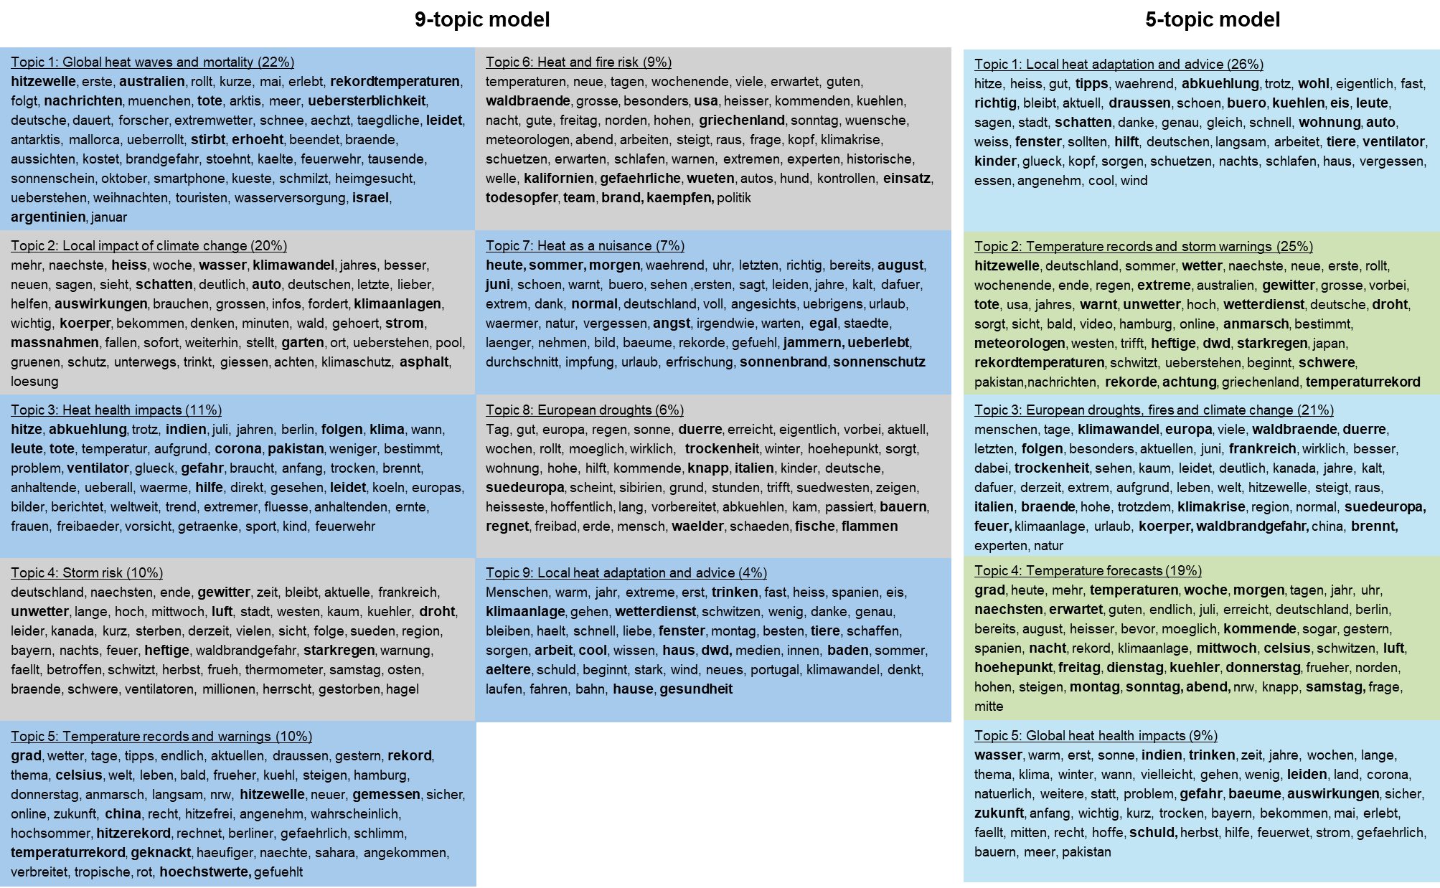
Figure S2. Comparison of topic alignment between the 9-topic model (left) and the 5-topic model (right). The Sankey diagram illustrates how topics from the more granular 9-topic model map onto the broader 5-topic model, highlighting overlaps and differences in topic composition.
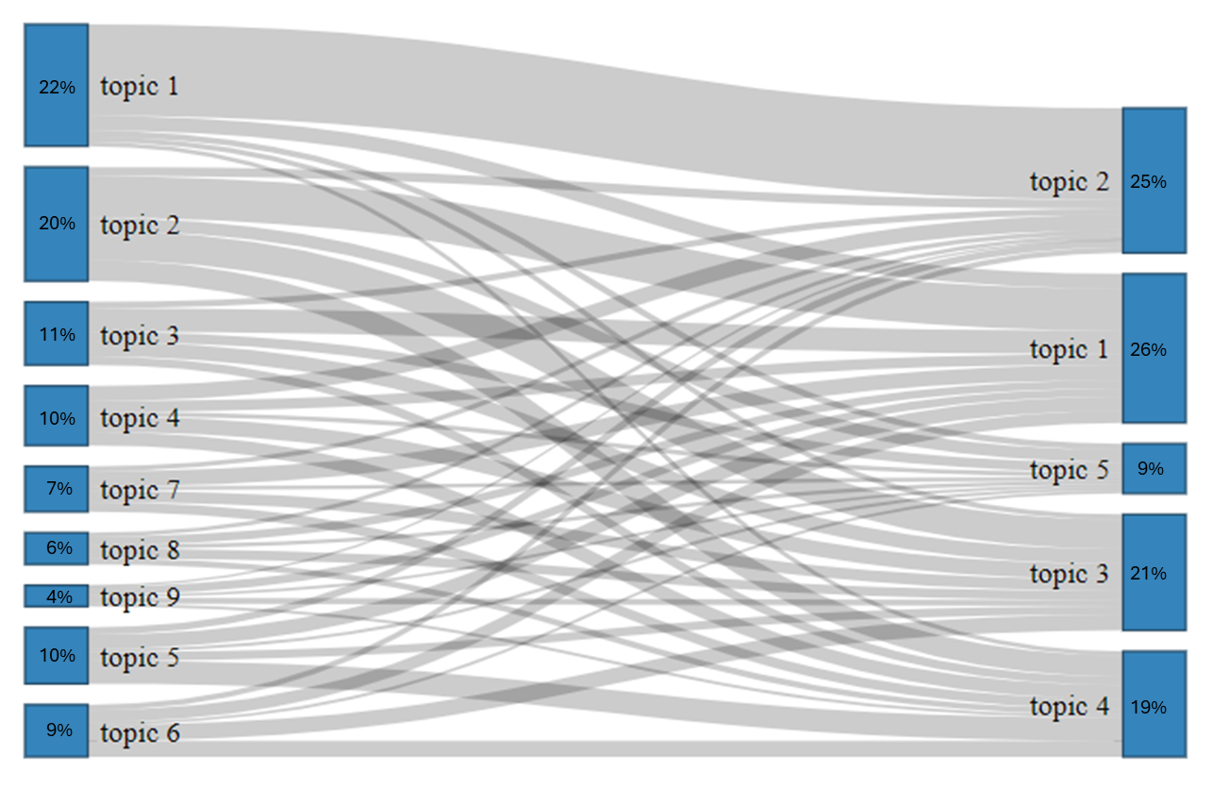
Figure S3. Correlations between topics, showing that only one pair was correlated: topics 7 & 9
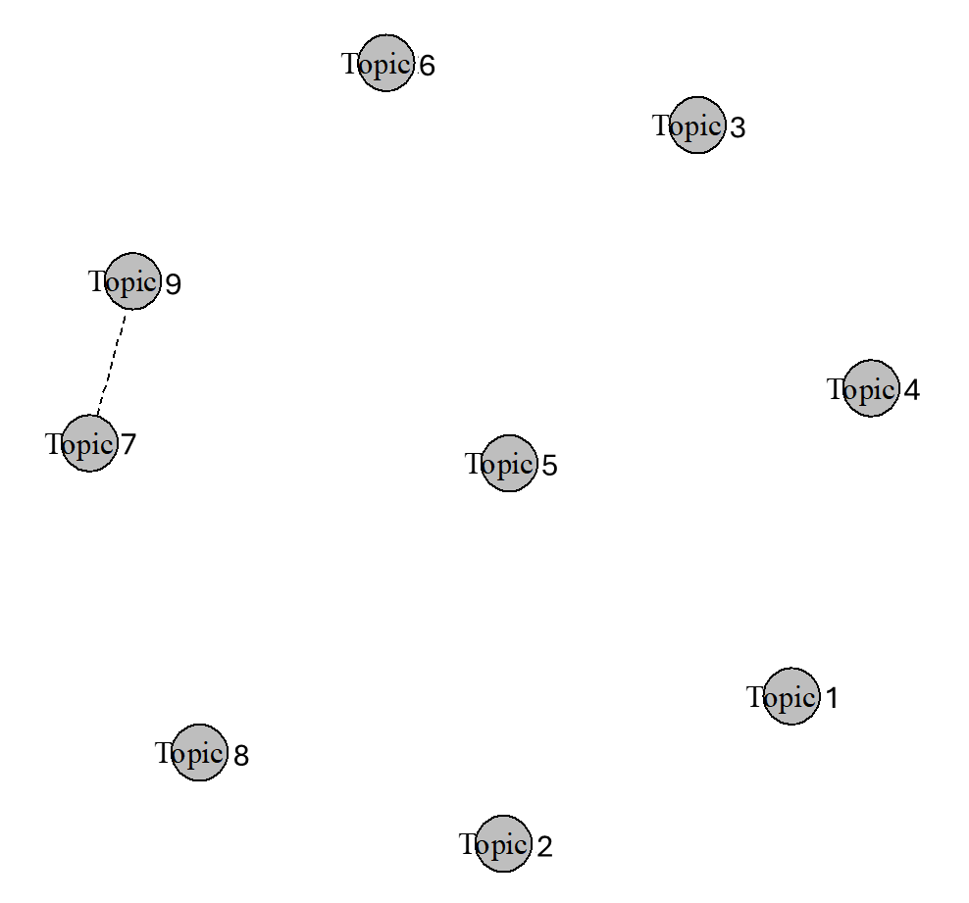
Topic 1: Global heat waves and mortality; Topic 2: Local impact of climate change; Topic 3: Heat health impacts; Topic 4: Storm risk; Topic 5: Temperature records and warnings; Topic 6: Heat and fire risk; Topic 7: Heat as a nuisance; Topic 8: European droughts; Topic 9: Local heat adaptation and advice

