Supplementary Information: Climate ambition explained: key indicators and net-zero target projections using machine learning

Contents
Supplementary Information: Climate ambition explained: key indicators and net-zero target projections using machine learning 1
Supplementary Text 1. Overview of cumulative per capita emissions 2
Choice of the target variable 2
Supplementary Text 2. Overview of all Indicators 5
Supplementary Text 3. Methods 8
Backward Elimination using Variance Inflation Factor 8
Clustering of countries 8
Decision tree: XGBoost 9
SHapley Additive exPlanations (SHAP) 9
Linear Regression 10
Supplementary Text 4 Clustering Results 11
Supplementary Text 5. Correlation Analysis 13
Supplementary Text 6 Model performance 16
Supplementary Text 7 Sensitivity analysis 20
Supplementary Text 8 Interaction Effects & Non-Linearity 24
Supplementary Text 9 Absolute SHAP values indicate the absolute impact of each indicator on national emissions phase-out ambition 27
Supplementary Text 10. Impact of different indicators on the predictive outcome of the XGBoost model 28
Supplementary Text 11. Overview of Global Net-Zero Targets 35
References 43

Supplementary Text 1. Overview of cumulative per capita emissions
Table S.1: Cumulative per capita emissions (tCO₂eq/capita, in natural logarithmic scale) of the countries analysed. The dataset contains 74 countries, each with a net-zero target year listed in ClimateWatch (2025). Czechia, Poland, and Bulgaria do not have a net-zero target, but they were included under the assumption of following the EU 2050 net-zero target.
Country | Cumulative per capita emissions (tCO₂eq/capita, log) | Country | Cumulative per capita emissions (tCO₂eq/capita, log) | Country | Cumulative per capita emissions (tCO₂eq/capita, log)
Andorra | 4.52 | Micronesia (Federated States) | 3.18 | Malta | 4.11
United Arab Emirates | 6.03 | United Kingdom | 4.42 | Malaysia | 5.23
Argentina | 4.89 | Georgia | 5.00 | Nigeria | 2.81
Australia | 5.43 | Ghana | 3.06 | Netherlands | 4.96
Austria | 4.30 | Gambia | 2.21 | Norway | 4.57
Belgium | 4.92 | Greece | 4.76 | New Zealand | 5.32
Bulgaria | 4.85 | Croatia | 4.42 | Oman | 5.87
Brazil | 4.75 | Haiti | 2.89 | Peru | 4.44
Barbados | 4.68 | Hungary | 4.57 | Poland | 5.08
Canada | 5.36 | Indonesia | 5.13 | Portugal | 4.88
Switzerland | 4.14 | India | 4.51 | Russian Federation | 5.75
Chile | 4.87 | Ireland | 5.19 | Saudi Arabia | 5.97
China | 6.04 | Israel | 4.74 | Slovakia | 5.05
Colombia | 4.23 | Italy | 4.71 | Slovenia | 4.57
Costa Rica | 3.47 | Japan | 5.11 | Sweden | 1.92
Cyprus | 4.51 | Kazakhstan | 5.56 | Thailand | 5.01
Czech Republic | 5.19 | Cambodia | 4.36 | Tunisia | 4.13
Germany | 4.78 | South Korea | 5.34 | Turkey | 4.96
Dominica | 3.54 | Kuwait | 6.73 | Ukraine | 5.56
Denmark | 4.54 | Lebanon | 4.67 | United States | 5.32
Spain | 4.40 | Liberia | 2.45 | Vietnam | 4.49
Estonia | 5.29 | Lithuania | 4.57 | South Africa | 4.89
Ethiopia | 2.68 | Luxembourg | 5.12
EU27 | 4.72 | Latvia | 4.92
Finland | 4.18 | Maldives | 4.32
France | 4.51 | Marshall Islands | 3.86

Choice of the target variable
By accurately defining a target variable, this research aims to provide a comprehensive understanding of factors driving climate ambition. It identifies four potential target variables related to net-zero ambition: percentage reduction in emissions, absolute reduction speed, a multi-output model combining NDC and a net-zero target, and cumulative per capita emissions, considering NDCs. Fig. S.1 illustrates these approaches with hypothetical trajectories that distinguish between the NDC target and the net-zero target.
- Reduction percentage: This straightforward approach measures the reduction percentage from a base year to net-zero. However, it assumes that reducing high emissions to zero is as ambitious as reducing low emissions to zero within the same timeframe. Given emissions in base year E_{base}, Y_{NZ} as net-zero year and Y_{base} as base year, reduction rate R can be represented by: R = E_{base} /(Y_{NZ} − Y_{base)}
- Absolute reduction speed: This approach measures the average reduction speed of per capita emissions from a base year to net-zero. While straightforward, it assumes a constant reduction speed and may not account for the last remaining emissions being harder to abate. Moreover, the base year influences the ambition: if the NDC is taken as the base year, countries that increase per capita emissions until 2030 appear more ambitious because of the larger reduction speed. Given the per capita emissions in base year EPC_{base}, reduction speed S can be represented by: S = EPC_{base} / (Y_{NZ} − Y_{base)}
- Multi-output model: This experimental approach formulates two target variables: the reduction speed from the latest available emissions data to the 2030 NDC target and from the NDC target to net-zero. The potential benefit of this approach lies in leveraging the interdependencies between these targets for enhanced predictive accuracy. However, it is not preferred in this research due to the substantial complexity and the significant amount of detailed supplementary information required, which is currently unavailable.
- Cumulative per capita emissions: This approach considers the cumulative per capita emissions from the most recent data to the net-zero year, incorporating NDCs. It addresses the equity principles of capability and responsibility (Robiou du Pont et al. 2017), highlighting differences in cumulative per capita emissions contributions, per capita emissions levels and mitigation capabilities. The cumulative emissions per capita are calculated by the sum of per capita emissions over the period (Y_{NZ} − Y_{base}):
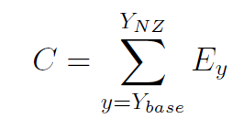 (1)
The cumulative per capita emissions is the most comprehensive and equitable target variable as it offers a balanced and fair measure of climate ambition.
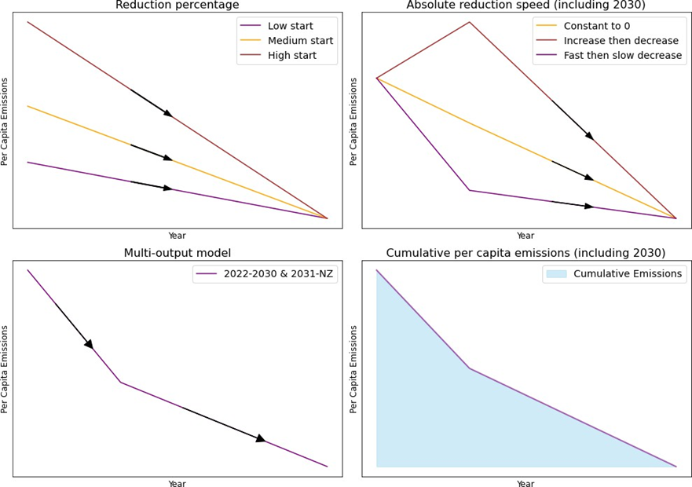
Fig. S.1 Illustration of the possible approaches of defining the target variable. The upper left figure shows the reduction rate as a percentage from a start year to a net-zero year. It shows that the initial value does not matter as a 10 per cent reduction per year makes any initial value go to zero after 10 years. The upper right shows the absolute reduction rate, taken from some base point to net-zero. The lower left represents a multi-output target that takes as target variable multiple reduction rates. The lower right shows a total area taken as target variable, that represents the cumulative per capita emissions from a base year until net-zero, taking into account a midpoint, in this case the 2030 NDC target. Note that these trajectories are hypothetical and do not represent actual trajectories of countries.

Supplementary Text 2. Overview of all Indicators

Table S.2: Total List of Indicators used to characterise determinants of net-zero targets (Trend Not Included).
Indicator | Unit | Literature Sources that uses this indicator | Data sources (links)
Emissions
Per capita GHG emissions | tons/capita | (van Soest et al. 2021) | World Development Indicators | DataBank (worldbank.org)
Non-CO₂ emissions per capita | tons/capita | (van Soest et al. 2021) | World Development Indicators | DataBank (worldbank.org)
GHG growth | annual % | (van Soest et al. 2021; Nascimento and Höhne 2023) | World Development Indicators | DataBank (worldbank.org)
Total hard-to-abate emissions (agricultural, building, industrial processes and transport) | tons/capita | (van Soest et al. 2021) | World Development Indicators | DataBank (worldbank.org)
Energy systems
Renewable energy share | % of total final energy consumption | (Fragkos et al. 2018; Stephenson et al. 2021; Peters et al. 2017; Lamb and Minx 2020; Le Quéré et al. 2019; Steves and Teytelboym 2013; Nascimento et al. 2022) | Glossary | DataBank (worldbank.org)
Renewable electricity share | % of total electricity output | (Fragkos et al. 2018; Stephenson et al. 2021; Peters et al. 2017; Lamb and Minx 2020; Le Quéré et al. 2019; Steves and Teytelboym 2013; Nascimento et al. 2022) | Renewable electricity share of total electricity output (%) | Indicator Profile | Prosperity Data360 (worldbank.org)
Energy intensity | MJ/$2017 PPP GDP | (Fragkos et al. 2018; Le Quéré et al. 2019; Peters et al. 2017) | Energy intensity level of primary energy (MJ/$2017 PPP GDP) - OECD members | Data (worldbank.org)
Oil and Gas Rents | % of GDP | (Lamb and Minx 2020; Lachapelle and Paterson 2018; Muttitt and Kartha 2020; Dioha and Kumar 2020; Nascimento et al. 2024). | WorldBank (gas)  WorldBank (oil)
Coal rents | % of GDP | (Lamb and Minx 2020; Lachapelle and Paterson 2018; Muttitt and Kartha 2020; Dioha and Kumar 2020; Nascimento et al. 2024). | World Development Indicators | DataBank (worldbank.org)
Land use
Forest area | % of land area | (van Soest et al. 2021; Brutschin et al. 2021) | World Development Indicators | DataBank (worldbank.org)
Annual deforestation | % of change | (van Soest et al. 2021; Brutschin et al. 2021) | IDA Results Measurement System, Tier I Database – WDI | DataBank (worldbank.org)
Agricultural land | % of land area | (van Soest et al. 2021; Brutschin et al. 2021) | World Development Indicators | DataBank (worldbank.org)
Population density | people/sq. km of land area | (Dioha and Kumar 2020; van Soest et al. 2021) | Countries by Population Density | Countries by Density 2024 (worldpopulationreview.com)
Average supply of protein of animal origin | g/capita/day | (Brutschin et al. 2021) | Average supply of protein of animal origin (g/cap/day) | Indicator Profile | Prosperity Data360 (worldbank.org)
Institutional and Governance
GDP per capita | constant 2015 US$ | (e.g.Lachapelle and Paterson 2018; Muttitt and Kartha 2020; Dioha and Kumar 2020; Lamb and Minx 2020; Nascimento et al. 2024) | WordBank  WorldBank (for GDP)  WorldBank (per capita)
Electoral Democracy | categorical index | (Lamb and Minx 2020) | The V-Dem Dataset – V-Dem
Control of Corruption | continuous index | (Averchenkova and Bassi 2016) | Home | Worldwide Governance Indicators (worldbank.org)
Political Stability and Absence of Violence/Terrorism | continuous index | (Averchenkova and Bassi 2016; Lamb and Minx 2020) | Home | Worldwide Governance Indicators (worldbank.org)
Regulatory Quality | continuous index | (Averchenkova and Bassi 2016; Lamb and Minx 2020) | Home | Worldwide Governance Indicators (worldbank.org)
Voice and Accountability* | continuous index | (Averchenkova and Bassi 2016; Steves and Teytelboym 2013) | Home | Worldwide Governance Indicators (worldbank.org)
Press Freedom Index | continuous index | RSF (2024) (Steves and Teytelboym 2013) | Index | RSF
Climate Change Risk Index | INFORM Risk Index | INFORM (Inform—Global 2024) | IMF Adaptation  EU DRMKC
* Voice and accountability captures perceptions of the extent to which a country's citizens are able to participate in selecting their government, as well as freedom of expression, freedom of association, and a free media

Table S.3: List of Indicators that have been eliminated to characterise determinants of net-zero targets, and the reasons for omission. If the data for at least 15% of the countries were missing or showed gaps, then we excluded the indicator as too sparse. For VIF, we excluded indicators by iteratively removing the single indicator with the highest VIF until the maximum VIF < 10, after first imputing missing values to make VIF computable.
Indicators that have been eliminated | Unit | Reason for omission | Literature Source | Data sources
Access to electricity | % of population | Uninformative (very few outliers) | (Dioha and Kumar 2020) | Access to electricity (% of population) | Data (worldbank.org)
Adopted Policies | total | Too sparse | (Nascimento et al. 2022)
Fossil-fuel pre-tax subsidies | USD per capita | Too sparse | (Lamb and Minx 2020) | Fossil-fuel pre-tax subsidies (consumption and production) USD per capita | Indicator Profile | Prosperity Data360 (worldbank.org)
Government Effectiveness | continuous index | Eliminated by VIF | (Averchenkova and Bassi 2016; Lamb and Minx 2020) | Home | Worldwide Governance Indicators (worldbank.org)
Human Development Index (HDI) |  | Eliminated through the VIF as it correlates highly with GDP per capita | (Dioha and Kumar 2020; Lamb and Minx 2020) | Human Development Index | Human Development Reports (undp.org)
Population | total | Uninformative |  | Population, total | Data (worldbank.org)
Poverty headcount ratio at national poverty lines | % of population | Too sparse | (Dioha and Kumar 2020) | Poverty headcount ratio at national poverty lines (% of population) | Data (worldbank.org)
PPP GDP | constant 2017 international $ | Too similar to GDP |  | GDP per capita, PPP (constant 2017 international $) | Indicator Profile | Prosperity Data360 (worldbank.org)
Rule of Law | continuous index | Eliminated by VIF | (Averchenkova and Bassi 2016; Lamb and Minx 2020; Steves and Teytelboym 2013) | Home | Worldwide Governance Indicators (worldbank.org)
Trade in environmental goods | % of total exports | Too sparse |  | Trade in environmental goods as share of total exports | Indicator Profile | Prosperity Data360 (worldbank.org)
Total environmental tax revenue | % of GDP | Too sparse |  | Total environmental tax revenue (% of GDP) | Indicator Profile | Prosperity Data360 (worldbank.org)
Total sovereign green bonds issuance | billion US$ | Too sparse | (Dioha and Kumar 2020) | Total sovereign green bonds issuance (billion US$) | Indicator Profile | Prosperity Data360 (worldbank.org)
Unemployment rate | % of population | Too sparse | (Dioha and Kumar 2020) | Unemployment (%) | World Bank Gender Data Portal
WGI sum | continuous index | Eliminated by VIF |  | Home | Worldwide Governance Indicators (worldbank.org)

Supplementary Text 3. Methods

Backward Elimination using Variance Inflation Factor
Despite XGBoost's ability to handle multicollinearity, we use backward elimination using the Variance Inflation Factor (VIF) to prevent the model from arbitrarily selecting indicators. The VIF of an indicator is a factor by which the variance of the indicator increases due to the correlation between the other indicators. VIFs of indicators can vary widely as they depend on the partial correlation of the indicator with all other indicators (Marquardt 1970), .which makes it a good measure of multicollinearity. Backward elimination iteratively removes indicators with the highest VIF until a threshold is met. This process eliminates collinearity that interferes with predictive accuracy and model interpretation (O’brien 2007). In such a setup, only the indicators with the highest multicollinearity are removed, giving the model versatility by using as many non-multicollinear indicators as possible. The rule of thumb is to set this threshold between four and ten (O’brien 2007), and here ten is used.

Clustering of countries
Stratifying countries when training machine-learning models helps stabilise the models. This study explores six types of country groups. First, we group countries based on income, region, the clusters defined in Lamb and Minx (2020) and Nascimento and Höhne (2023). We also use two clustering algorithms (K-means and HDBSCAN) to identify new clusters based on the determinants discussed in Supplementary Text 1. The grouping approaches are summarised below:
- Income-based clustering: Countries were grouped according to their income level as defined by the World Bank.
- Region-based clustering: Countries were clustered according to geographical regions.
- Research by Lamb and Minx (2020): Countries have been clustered according to political economy constraints.
- Research by Nascimento and Höhne (2023): Countries have been clustered based on historical GDP and emissions levels.
K-Means clustering is a non-hierarchical algorithm known for its simplicity, fast convergence, and effectiveness (Arthur and Vassilvitskii 2006; Feng et al. 2023). It has been used in climate research to cluster countries based on similarities in indicator values (Nascimento et al. 2024 ; Lamb and Minx 2020). The goal of this centroid-based algorithm is based on a pre-determined K to minimise the sum of the squared distances between each point and the nearest centroid (Arthur and Vassilvitskii 2006). The elbow method is an example of a way to determine the value of K, but research often sets a threshold for the minimum explained variance that should be achieved (e.g., Lamb and Minx 2020). K-means has limitations, such as difficulties in dealing with non-spherical clusters, clusters of different sizes, and the presence of outliers (Carrasco and Hernandez-del-Valle 2023).

Decision tree: XGBoost
XGBoost (Chen and Guestrin 2016) is a decision tree-based model that uses gradient boosting. Gradient boosting methods use a set of weak learners that iteratively optimise the loss function of the previous tree. XGBoost can achieve very high prediction accuracy, matching or exceeding that of other machine-learning models such as neural networks (Giannakas et al. 2021). It does not require the strict assumptions of linear regression, such as linearity, homoscedasticity and normality of residuals. Additionally, it is relevant for the dataset used, as it can handle categorical features without any need for preprocessing. XGBoost can manage non-linearity, interactions between indicators, and it can be more robust to multicollinearity and heteroskedasticity. This flexibility often results in improved predictive performance, especially in complex datasets where linear relationships do not adequately capture the underlying patterns.
There are many other notable benefits of XGBoost. Climate research often deals with missing data. By design, sparsity awareness enables imputation for the algorithm, which greatly improves (predictive) performance (Aydin and Ozturk 2021; Zhang et al. 2020; Rusdah and Murfi 2020). While boosting algorithms are inherently sensitive to overfitting (especially for noisy data), XGBoost has both L1 (Lasso) and L2 (Ridge) regularisation, among others. Having both a differentiable convex loss function and a complexity penalty improves the generalisability of the model (Chen and Guestrin 2016).

SHapley Additive exPlanations (SHAP)
In tree-based machine-learning models, SHapley Additive exPlanations (SHAP) values enhance interpretability by explaining why a model makes specific predictions. Based on game theory, SHAP assigns an importance value to each indicator for a prediction across all possible coalitions. It calculates the average marginal contribution of each indicator, measuring local interaction effects and understanding the model's global structure by combining local explanations (Lundberg et al. 2020; Lundberg and Lee 2017). SHAP values, calculated as marginal contributions, are independent of the indicator scale, rendering them valuable for interpreting models with indicators that have different units or scales. This calculation entails assessing the change in prediction output when an indicator is included in a subset in comparison to when it is not, thereby providing a normalised measure of each indicator’s impact on the prediction.
In the development of tree-based models, SHAP values play an essential role in improving model interpretability. They provide a robust measure of indicator importance that adheres to three key properties: local accuracy, missingness, and consistency (Lundberg et al. 2020; Lundberg and Lee 2017). Interaction values capture local interaction effects, enabling the emergence of patterns that may otherwise have been overlooked. The utilisation of SHAP in this research strikes a balance between model accuracy and interpretability, providing clear insights into the rationale behind specific model decisions. This is of paramount importance in practical applications where an understanding of the underlying decision-making process is as crucial as the decision outcome itself.

Linear Regression
Linear regression is often used in climate research. Our research compares the results obtained with linear regressions with those of XGBoost to see the difference in model performance. A full explanation of all the assumptions involved in linear regression was given by Poole and O'Farrell (1971). Multiple linear regression relies on several key assumptions which, if violated, can lead to biased or inefficient estimates. These assumptions include the absence of measurement error in the variables, linearity between the dependent and independent variables, zero mean of the disturbance term, constant variance (homoscedasticity) and no serial correlation (autocorrelation). In addition, the independent variables should not be perfectly collinear.

Supplementary Text 4 Clustering Results
Eight clustering types were compared using MSE and R² metrics. To determine the best clustering strategy, an 85% cumulative variance threshold, as used in Lamb and Minx (2020), was applied for Principal Component Analysis to facilitate a comparison of country stratification by K-means clustering, yet the best performing K-means clustering was achieved using all dimensions.
Each clustering type was evaluated over 15 model runs (models), with average performance metrics presented in Table S.4. The performance was evaluated on the test set, in other words, an out-of-sample fit. The clustering type with the lowest summed rank was identified as the most informative stratification strategy. The K-Means clustering method yielded the best results, where the number of clusters, five, was subjectively chosen as it effectively differentiated distinct groups of countries and performed well in the subsequent analysis.
Table S.4 Performance Metrics for Different Clustering Types. MSE and R² of the test set are used to evaluate clustering performance. The summed rank combines ranks of MSE and R² to provide an overall performance metric.
Clustering Type | MSE | R² | Ranking
Income Clusters | 0.340 (6) | 0.649 (1) | 7
Regional Clusters | 0.402 (8) | 0.562 (3) | 11
Lamb Clusters | 0.297 (4) | 0.529 (6) | 10
Lamb Clusters Completed | 0.279 (1) | 0.531 (5) | 6
Nascimento Clusters | 0.343 (7) | 0.504 (7) | 14
Nascimento Clusters Completed | 0.292 (3) | 0.560 (4) | 7
K-Means Clusters | 0.281 (2) | 0.563 (2) | 4
HDBSCAN Clusters | 0.323 (5) | 0.500 (8) | 13

Table S.5: Clustering of countries based on feasibility and credibility characteristics based on the K-Means clustering method.
Hard-to-Abate economies | Balanced economies | Coal Dependent Economies | Fossil-fuel exporting States | Low-emitting economies
Australia  Bulgaria  Czechia  Colombia  Poland  Russian Federation  United States of America | Andorra  Austria  Belgium  Barbados  Canada  Chile  Costa Rica  Cyprus  Germany  Denmark  Spain  Estonia  European Union  Finland  France  United Kingdom  Georgia  Greece  Croatia  Hungary  Israel  Italy  Ireland  Luxembourg  Japan  South Korea  Lithuania  Latvia  Malta  Netherlands  Norway  New Zealand  Portugal  Slovakia  Slovenia  Sweden  Tunisia  Switzerland | China Indonesia India Kazakhstan South Africa  Ukraine  Vietnam | Kuwait  Oman  Saudi Arabia  United Arab Emirates | Argentina  Brazil  Cambodia  Dominica  Ethiopia  Gambia  Ghana  Haiti  Lebanon  Liberia  Malaysia  Maldives  Marshall Islands  Micronesia  Nigeria  Peru  Thailand  Turkey

Supplementary Text 5. Correlation Analysis
The initial Spearman correlation matrix, which includes the indicators analysed before backward elimination using VIF was implemented, reveals some exceptionally strong relationships, both positive and negative, among the variables under consideration. In particular, correlations as high as 0.97 suggest that certain pairs of indicators move almost in tandem, possibly indicating redundancy or the presence of underlying factors that strongly influence both variables. On the contrary, a correlation of -0.81 indicates a strong inverse relationship, implying that as one indicator increases, the other tends to decrease significantly.
Strong positive correlations could reflect direct relationships between indicators, such as economic welfare metrics such as GDP per capita and HDI that are often closely linked. In the context of emissions phase-out ambitions, these correlations can indicate a group of indicators that share a common thread in influencing climate policy. However, strongly negative correlations may point to trade-offs or balancing factors in national policies. For example, more economically developed countries (high GDP per capita) might be better prepared for the impact of climate change (INFORM Risk Index). Before applying backward elimination, the presence of high correlation coefficients necessitates scrutiny for multicollinearity, which could inflate the variance of coefficients. Fig. S.2 shows the Spearman correlation matrix before eliminating highly correlated indicators.
The backward elimination process using the Variance Inflation Factor (VIF) has effectively reduced multicollinearity, thus ensuring a more stable and interpretable set of indicators for the subsequent XGBoost regression analysis. Shown visually in Fig. S.3, WGI sum (World Governance Indicators), Rule of Law, Government Effectiveness and HDI are eliminated from the set of indicators. It provides confidence that the indicators chosen for the XGBoost model are likely to be relevant and not merely artefacts of collinear relationships. However, Fig. S.3 also shows that significantly collinear relationships still exist. Therefore, the effectiveness of backward elimination using VIF is questioned in high-dimensional space; especially given the ability of machine-learning models to regularise. Although these models might arbitrarily choose either indicators which is collinear, hierarchical clustering using Euclidean space might point to indicator redundancy, thereby achieving the desired result.

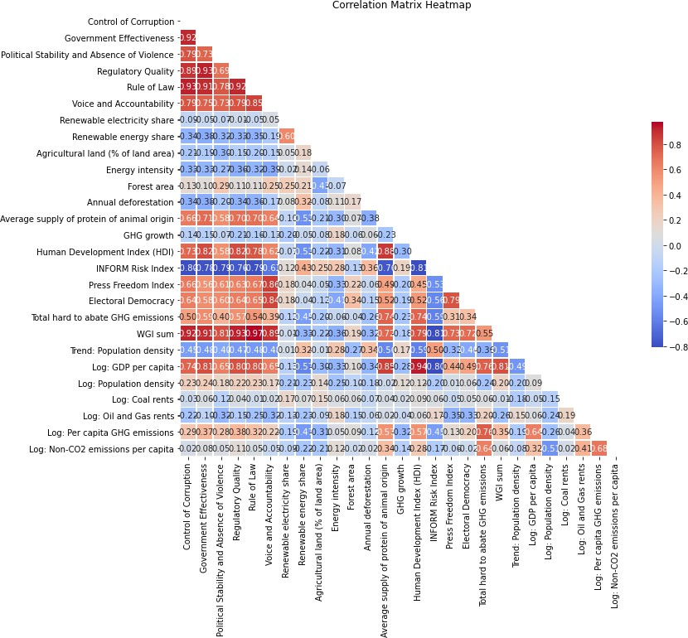
Fig. S.2: Pre-elimination matrix. The pre-elimination matrix includes all indicators, highlighting the initial correlations with values as high as 0.97 and as low as -0.81, indicating potential multicollinearity issues. This matrix gives an initial understanding of the interrelationships of the data. The high correlation underscores the need for elimination of certain indicators using VIF.

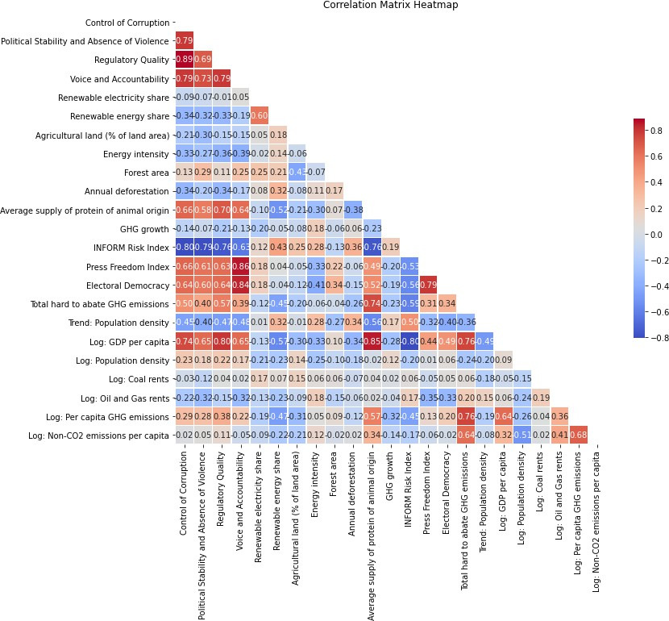
Fig. S.3: Post-elimination matrix Note that the limit of the colourscale are updated to adjust to the new high and low value of the interval. The post-elimination matrix shows reduced correlations with the highest at 0.89 and the lowest at -0.80, demonstrating the limited effect of the VIF method in reducing correlation, despite eliminating the most significant variance inflation.

Supplementary Text 6 Model performance
XGBoost is a tree-based machine learning algorithm that can be tailored to specific problems, but it includes many hyperparameters that significantly impact the model's performance. Key hyperparameters consist of regularization terms such as λ (Ridge), α (Lasso), γ (pruning), and the learning rate η. The minimum child weight sets the minimum sum of instance weights needed to create new nodes, ensuring the statistical reliability of these nodes. While γ addresses the quality of data splits in relation to the loss function, the minimum child weight emphasizes the robustness of the data supporting the nodes. Increasing the number of trees K may lead to overfitting. By imposing a bound on the maximum depth of a tree, the minimum child weight, and through subsampling by column (indicator) and subsampling by row (country), this overfitting can be mitigated.
The maximum depth (max depth) of a tree sets a limit on how many nodes deep a tree can grow. Limiting the depth of each tree is a straightforward way to prevent the model from becoming overly complex and overfitting, especially on datasets with many indicators. Subsampling by column (by tree) and row introduces randomness, similar to bootstrapping in random forests. It reduces variance, increases model robustness, and prevents overfitting by using only a subset of available data for each tree, thereby it improves the model’s generalizability and mitigates overfitting.
Each hyperparameter plays a critical role in the performance of the model. The hyperparameter optimisation process was performed using efficient hyperparameter optimisation, which efficiently navigates the complex hyperparameter space of the XGBoost model. Fourfold cross-validation was used in the training process to find the lowest RMSE. The optimal search space for hyperparameter optimisation was found iteratively by analysing the RMSE in a large search space over 200 trials, and narrowing down the hyperparameters to those areas where the RMSE was lowest. During each model run, 200 iterations were used to find the optimal set of hyperparameters. This set was then used in the final model. This process has been repeated 200 times (200 model runs). The x-axes of Fig. S.4 show the range of each hyperparameter in the final search space. The plots of this figure show the values that the hyperparameters took during these 200 trials.
In the final search space, the maximum depth of a tree and the minimum child weight both minimised the RMSE, if set at three, both of which help to prevent extreme overfitting. Throughout the final 200 trials, the learning rate η indicates a cautious approach to updating the model, which reduces the risk of overfitting but slows down the convergence of the model.

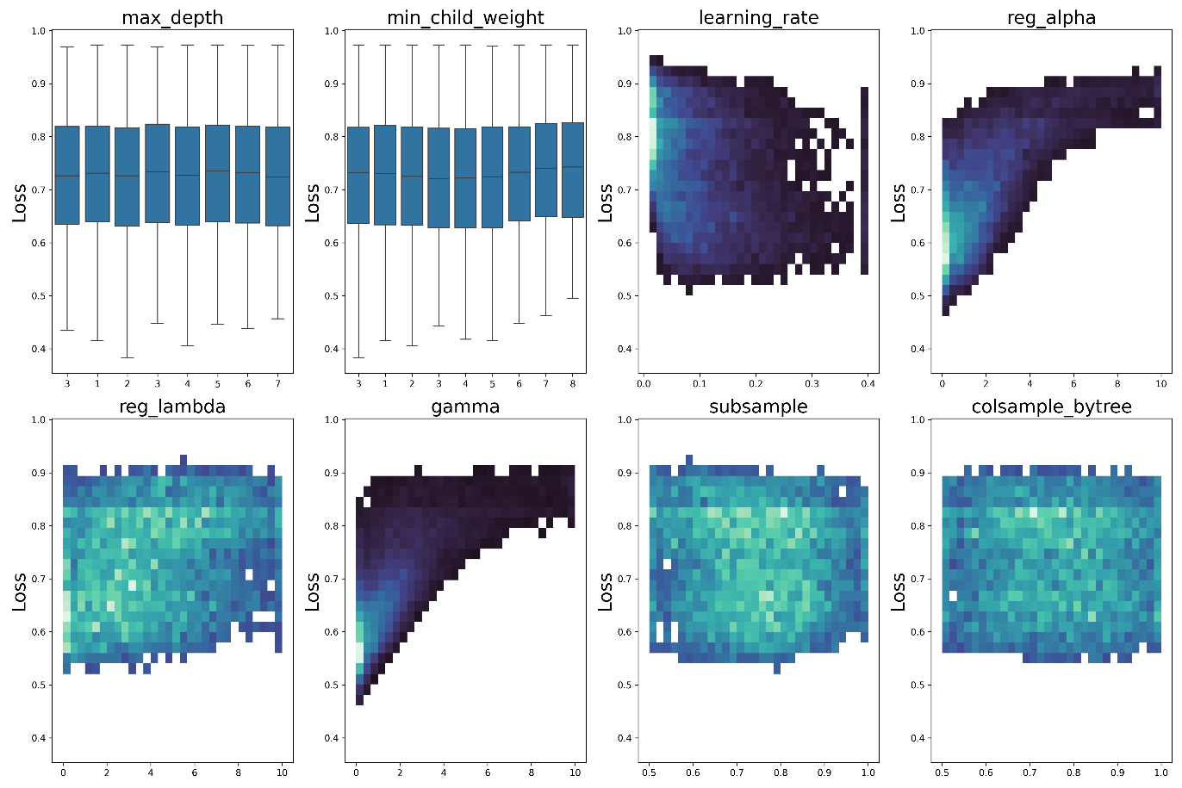
Fig. S.4 Impact of Various Hyperparameters on Validation Loss. This figure provides a detailed view of how different hyperparameters influence the model’s validation loss. Each subplot showcases the relationship between a specific hyperparameter and the validation loss, highlighting the areas within the search space that contributed to lower loss values.
The convergence analysis shown in Fig. S.5, illustrates the slow convergence of the validation loss, stabilising over 200 evaluations across the 200 trials. This visualisation helps to understand the stability and efficiency of the hyperparameter optimisation process. The pruning regularisation by γ is low, as the lowest RMSE was achieved with small values of γ during search space refinement. The L1 regularisation (α) is relatively small, limiting the reduction in the total number of leaves across all trees, while the L2 regularisation (λ) imposes a range of weak and strong penalties. The wide range suggests significant variability in the regularisation, which is reflected in the variability of performance metrics across models and consequently their generalisability. Finally, subsampling both rows and columns introduces variability in the randomness of tree construction, preventing overfitting. Overall, narrowing the search space could improve the robustness of the models, thereby increasing their generalisability. Obviously, this research serves as an initial exploration of the domain space.
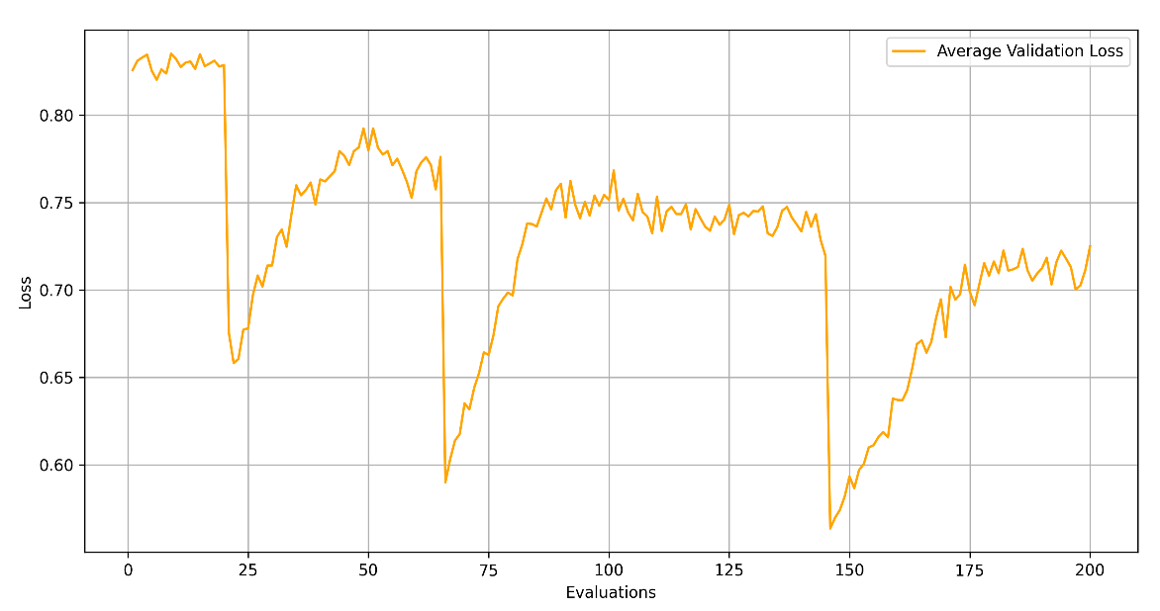
Fig. S.5. Validation Loss Over Evaluations for 200 trials. The figure illustrates the convergence of the validation loss throughout the 200 trials of hyperparameter optimisation. Each point represents an evaluation, with the x-axis indicating the number of evaluations and the y-axis representing the validation loss. The overall trend shows a gradual reduction in validation loss due to a low learning rate. This pattern suggests that the search space was efficiently narrowed down to regions with lower MSE, thereby improving model performance and stability.
Fig. S.5 reflects the hyperparameter search process over 200 trials. Fig S.6 reflects the average train and test MSE per boosting round, averaged over 200 model runs. Its shows the mean square error (MSE) for both the training and test sets—and particularly the difference between the two—was evaluated over multiple trials. This difference becomes more pronounced after more than 200 boosting runs, indicating overfitting. Therefore, we use 100 boosting rounds to ensure optimal performance and minimize overfitting.
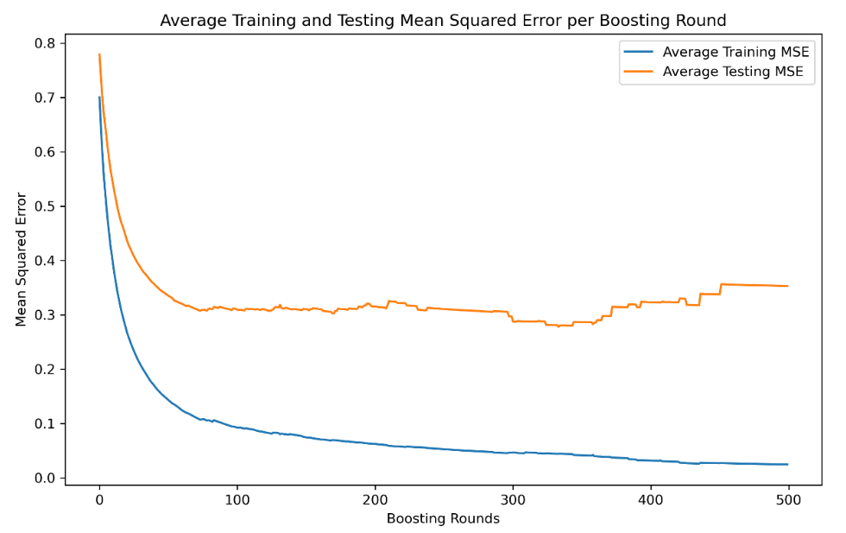
Fig. S.6. The model's performance, measured by mean square error (MSE) for both the training and test sets—and particularly the difference between the two—was evaluated over multiple boosting rounds and averaged over all model runs.
For the final 200 model runs, Table S.6 (below) shows a summary statistics of the hyperparameters, by reporting the parameters such as the mean, average, 25th percentile, and 75th percentile.
Table S.6: A summary statistics of the final estimates of Hyperparameters on Validation Loss based on 200 model runs, by reporting mean, standard deviation, and 25th- 75th percentile ranges and minimum and maximum ranges.
Indicators | Average | Stan-dard Devia-tion | Median | 25th Percen- tile | 75th Percen- tile | Mini-mum | Maxi-mum
learning_rate | 0.20 | 0.08 | 0.20 | 0.13 | 0.26 | 0.04 | 0.40
reg_alpha (α) | 0.52 | 0.35 | 0.40 | 0.09 | 0.79 | 0.00 | 2.53
reg_lambda (λ) | 4.37 | 2.80 | 4.09 | 1.96 | 6.53 | 0.00 | 9.98
Gamma (γ) | 0.21 | 0.26 | 0.11 | 0.02 | 0.30 | 0.00 | 1.66
subsample | 0.73 | 0.14 | 0.72 | 0.63 | 0.83 | 0.50 | 1.00
colsample_bytree | 0.76 | 0.12 | 0.75 | 0.63 | 0.87 | 0.50 | 1.00

Supplementary Text 7 Sensitivity analysis
200 Runs:
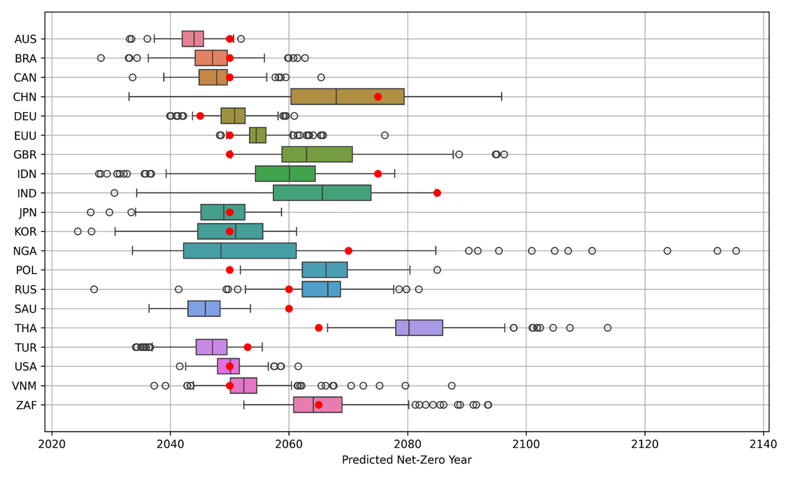
100 runs:
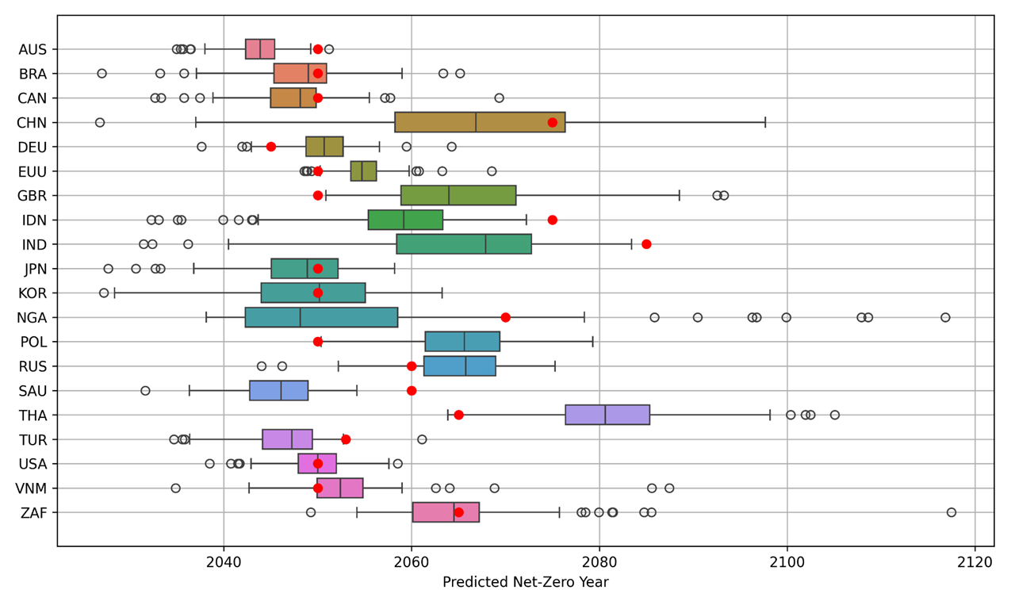
Fig. S.7 Projected net-zero targets against actual net-zero targets for 100 and 200 runs. Red dots mark the actual net-zero target years. This figure presents a box plot of the projected net-zero years for the largest emitting countries with a net-zero target. Each box plot represents the spread of projected net-zero years across 200 model runs for each country. The boxes show the interquartile range (IQR) with the vertical line inside each box indicating the median. Outliers are depicted as individual points beyond the whiskers.
50 Runs:
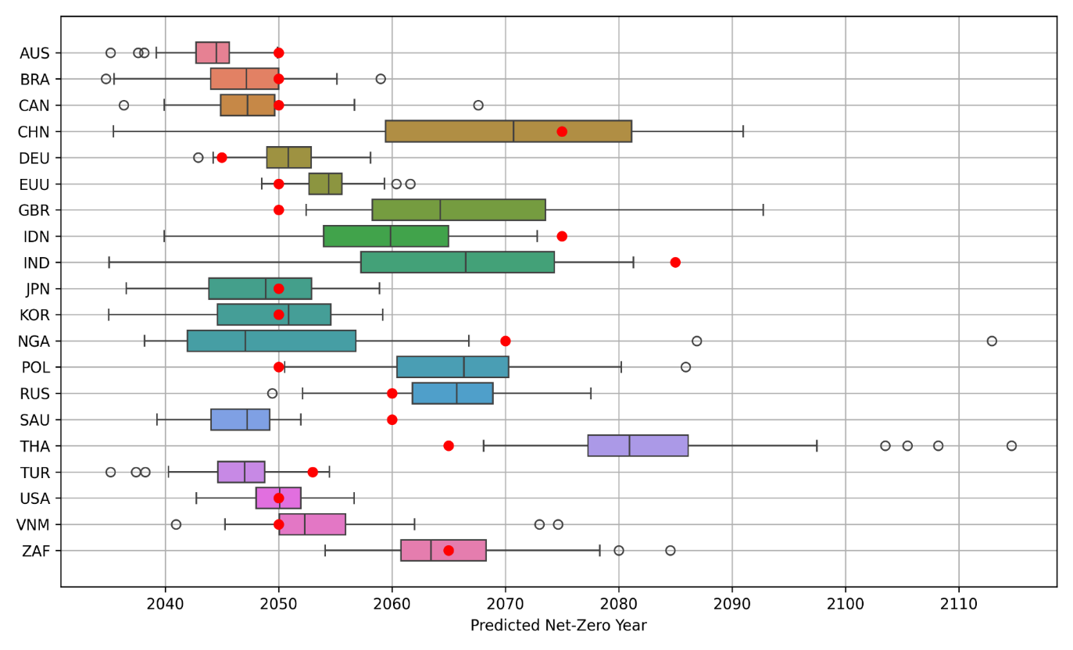
20 runs:
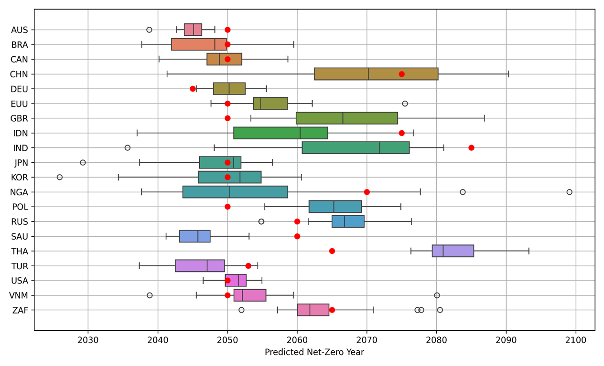

10 Runs:
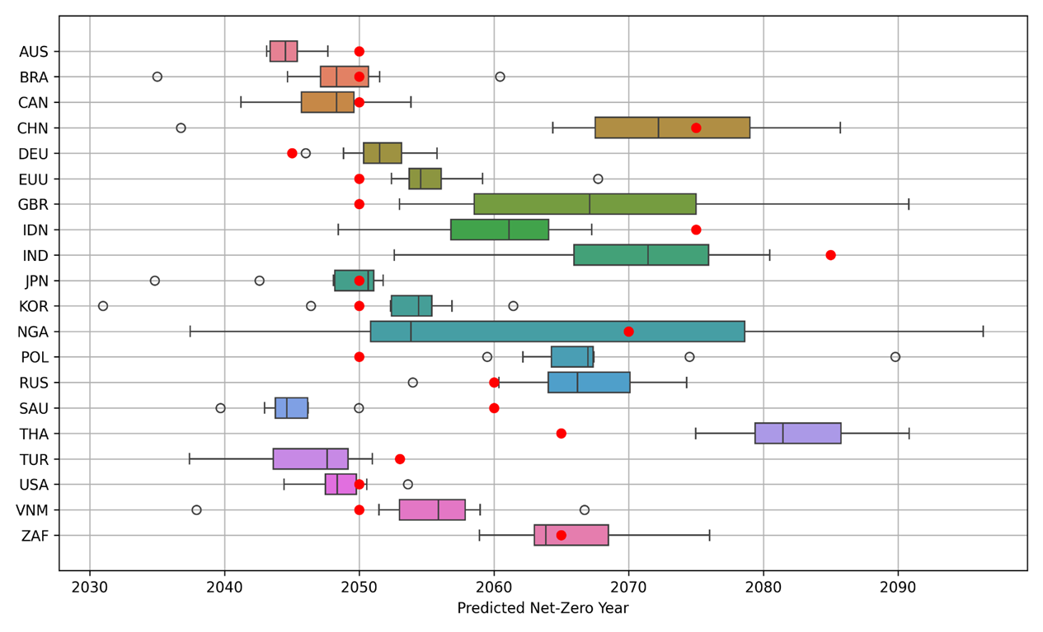
Fig. S.8 Projected net-zero targets against actual net-zero targets for 10, 20 and 50 runs. Red dots mark the actual net-zero target years. This figure presents a box plot of the projected net-zero years for the largest emitting countries with a net-zero target. Each box plot represents the spread of projected net-zero years across 200 model runs for each country. The boxes show the interquartile range (IQR) with the vertical line inside each box indicating the median. Outliers are depicted as individual points beyond the whiskers.
Table S.7 Summary Statistics for XGBoost (based on the full data of all features) for different number of model runs, i.e. : 200, 100, 20 and 10.
Statistic | MSE | MAE | R² | RMSE | MSE | MAE | R² | RMSE
Number model runs | 200 |  |  |  | 100
Average | 0.30 | 0.40 | 0.62 | 0.65 | 0.30 | 0.40 | 0.63 | 0.66
Std Dev | 0.16 | 0.09 | 0.15 | 0.14 | 0.18 | 0.10 | 0.23 | 0.19
Median | 0.26 | 0.40 | 0.66 | 0.68 | 0.26 | 0.38 | 0.67 | 0.67
25th percentile | 0.19 | 0.35 | 0.55 | 0.58 | 0.18 | 0.33 | 0.54 | 0.58
75th percentile | 0.37 | 0.46 | 0.73 | 0.75 | 0.39 | 0.45 | 0.74 | 0.76
Min | 0.06 | 0.20 | -0.18 | -0.14 | 0.09 | 0.24 | -0.17 | -0.01
Max | 0.94 | 0.75 | 0.89 | 0.90 | 0.80 | 0.65 | 0.84 | 0.86
Number model runs | 10 |  |  |  | 20
Average | 0.21 | 0.35 | 0.72 | 0.73 | 0.20 | 0.35 | 0.70 | 0.70
Std Dev | 0.09 | 0.08 | 0.08 | 0.08 | 0.07 | 0.07 | 0.11 | 0.11
Median | 0.17 | 0.33 | 0.71 | 0.72 | 0.20 | 0.35 | 0.73 | 0.76
25th percentile | 0.14 | 0.29 | 0.68 | 0.69 | 0.14 | 0.30 | 0.62 | 0.63
75th percentile | 0.31 | 0.42 | 0.75 | 0.76 | 0.25 | 0.41 | 0.77 | 0.78
Min | 0.08 | 0.23 | 0.61 | 0.61 | 0.09 | 0.25 | 0.44 | 0.44
Max | 0.33 | 0.47 | 0.87 | 0.87 | 0.33 | 0.47 | 0.83 | 0.83

Supplementary Text 8 Interaction Effects & Non-Linearity
Apart from the local explanations, interaction values capture local interaction effects such that patterns can arise that may otherwise have been missed (Lundberg et al., 2020). Dependence plots illustrate the marginal effect of a single indicator on the projected outcome and capture interaction effects between indicators. Total hard-to-abate GHG emissions follow an asymptotic path, indicating that the effect is significant for countries with low emissions, but becomes negligible beyond a certain point. The Average supply of protein of animal origin shows a parabolic relationship, increasing emissions up to about 50 grams, after which the effect turns negative. This suggests that meat consumption increases emissions to a point, beyond which it decreases them. The results hint that Voice and Accountability might have an effect on this, but the interaction is inconclusive.
The interaction strength can be computed using SHAP interaction values, which capture how the presence of one indicator changes the contribution of another indicator to the projection. Interaction effects are most prominent between Energy intensity and Per capita GHG emissions. High per capita GHG emissions amplify the effect of high energy intensity, particularly at moderate to high levels of energy intensity. Additionally, Voice and Accountability interacts with Non-CO₂ emissions per capita, where higher emissions are related to an accentuated effect of Voice and Accountability on cumulative emissions, particularly at the lower range of the latter.

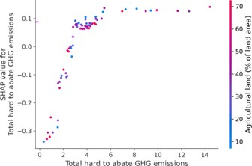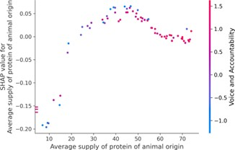
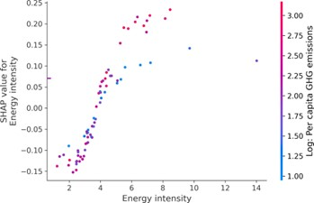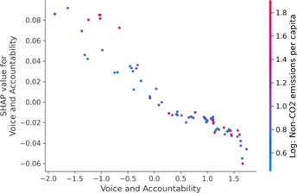
Fig. S.9: Dependence plots, showing the non-linear progression of and interaction effects between indicators. (a) Dependence plot of Total hard-to-abate GHG emissions. (b) Dependence plot of Average supply of protein of animal origin. (c) Dependence plot of Energy intensity and (d) Dependence plot of Voice and Accountability. Each subplot illustrates the marginal contribution of an indicator throughout the range of the indicator. The colours represent the value of the indicator that exhibits the largest interaction effect with the primary indicator, shown on the right.

Supplementary Text 9 Absolute SHAP values indicate the absolute impact of each indicator on national emissions phase-out ambition

Table S.8: Stability of SHAP outcomes across all countries, such as by reporting mean, standard deviation, and 25th - 75th percentile ranges
Indicators | Average | Median | 25th Percen- tile | 75th Percen- tile | Mini-mum | Maxi-mum | Stan-dard Devia-tion
Log: Per capita GHG emissions | 0.19 | 0.17 | 0.08 | 0.24 | 0.00 | 0.45 | 0.15
Renewable energy share | 0.16 | 0.12 | 0.07 | 0.14 | 0.01 | 0.59 | 0.16
Total hard to abate GHG | 0.10 | 0.08 | 0.07 | 0.12 | 0.00 | 0.30 | 0.08
Log: Non-CO₂ per capita | 0.10 | 0.11 | 0.08 | 0.13 | 0.00 | 0.16 | 0.03
Energy intensity | 0.09 | 0.08 | 0.06 | 0.12 | 0.01 | 0.18 | 0.04
Log: Oil and Gas rents | 0.06 | 0.06 | 0.02 | 0.09 | 0.00 | 0.12 | 0.04
Press Freedom Index | 0.05 | 0.03 | 0.02 | 0.07 | 0.01 | 0.11 | 0.03
Log: Coal rents | 0.04 | 0.03 | 0.03 | 0.05 | 0.01 | 0.10 | 0.02
Supply protein animal | 0.03 | 0.02 | 0.01 | 0.04 | 0.00 | 0.13 | 0.02
Voice and Accountability | 0.03 | 0.02 | 0.02 | 0.03 | 0.00 | 0.08 | 0.03
Annual deforestation | 0.02 | 0.01 | 0.00 | 0.03 | 0.00 | 0.06 | 0.02
Renewable electricity share | 0.01 | 0.01 | 0.01 | 0.02 | 0.00 | 0.03 | 0.01
Log: GDP per capita | 0.01 | 0.01 | 0.01 | 0.01 | 0.01 | 0.04 | 0.01
Electoral Democracy | 0.01 | 0.01 | 0.01 | 0.01 | 0.01 | 0.04 | 0.01
Regulatory Quality | 0.01 | 0.01 | 0.00 | 0.01 | 0.00 | 0.04 | 0.01
GHG growth | 0.01 | 0.01 | 0.00 | 0.02 | 0.00 | 0.03 | 0.01

Supplementary Text 10. Impact of different indicators on the predictive outcome of the XGBoost model
This section provides a comprehensive view of SHAP values for individual countries’ predictions, showing the variability and distribution of each indicator’s impact. It provide a nuanced understanding of the model's predictions and are critical for identifying outlier countries with unique circumstances. Low values are generally associated with a lower target variable value. For example, lower Per capita GHG emissions imply lower cumulative per capita emissions. For some indicators it is just the opposite. For example, high Renewable energy share and Press freedom index correlate with lower projected cumulative per capita emissions, implying that high values for these indicators lead to lower cumulative per capita emissions. Fig. S.7 shows the largest spread for indicators Per capita GHG emissions and Renewable energy share, which globally have the largest impact on the model.
The level of granularity in Fig. S.7 helps detect nuances in how different countries’ ambitions are influenced by specific factors. Local SHAP values provide a nuanced understanding of model predictions, crucial for identifying outlier countries with unique circumstances, as illustrated by the waterfall plot figures for many major emitting countries For example, Iran's energy intensity and press freedom index are highly influential, while it ranks only fourth and eighth globally.
Argentina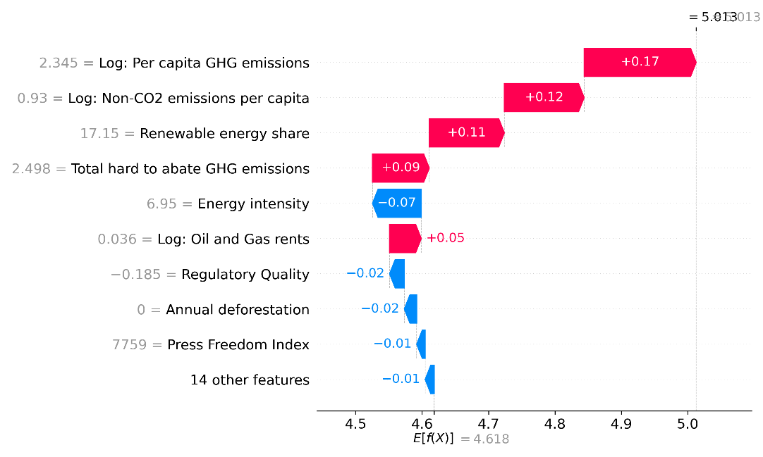
Australia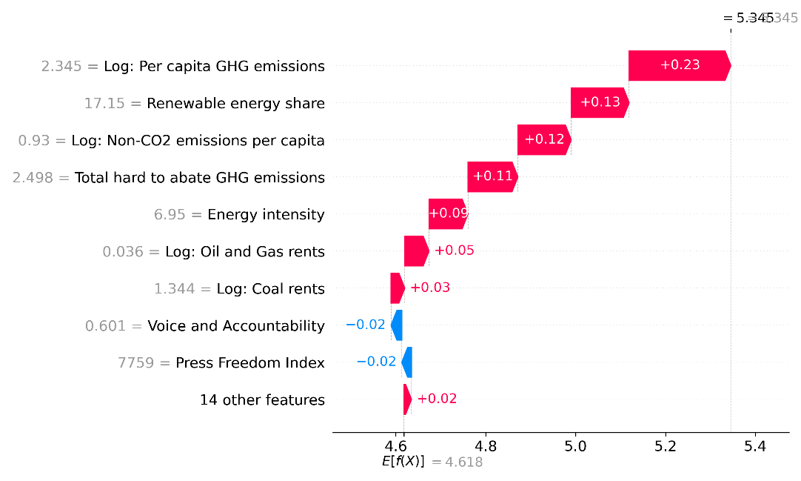
Brazil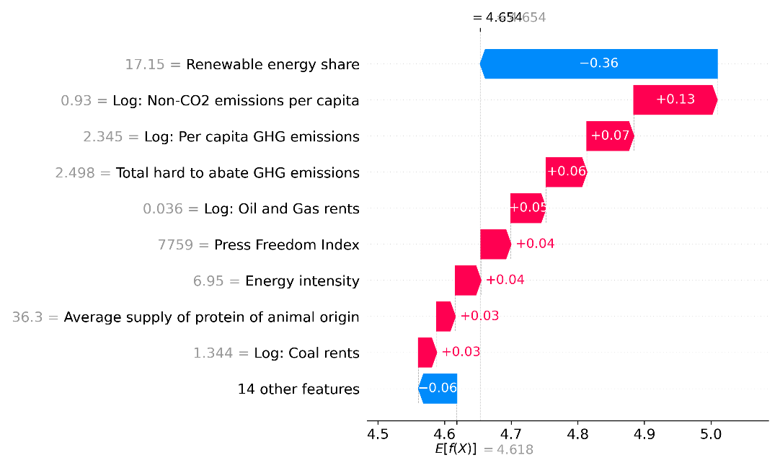
Canada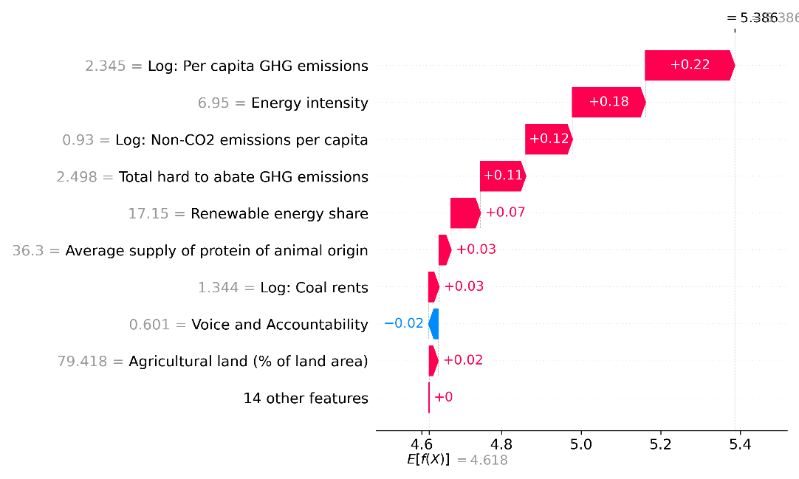
China 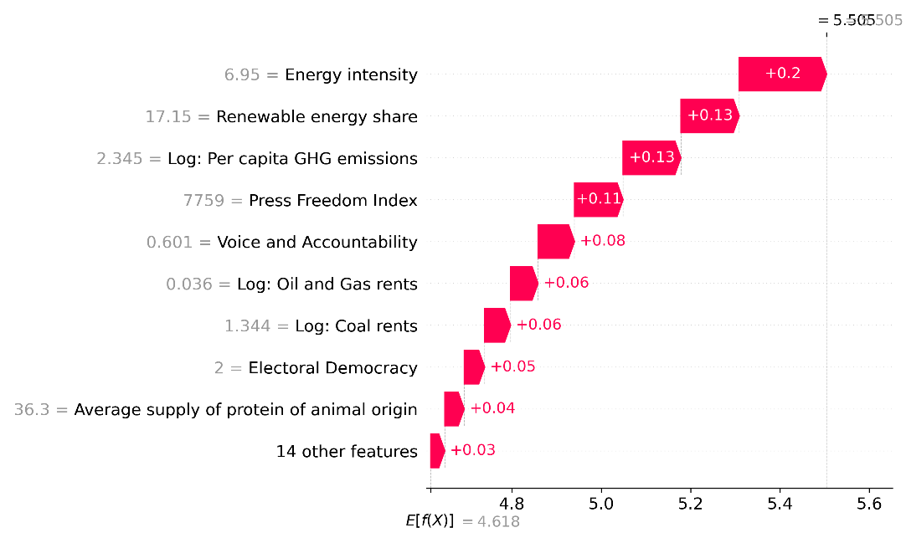
EU-27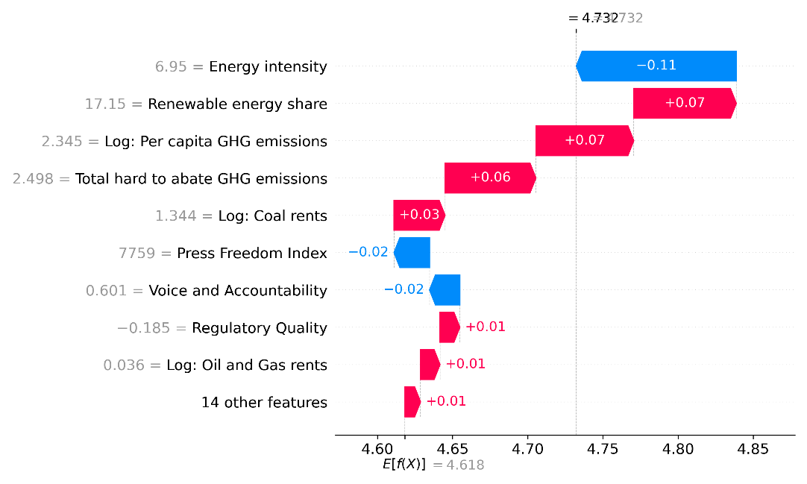
India: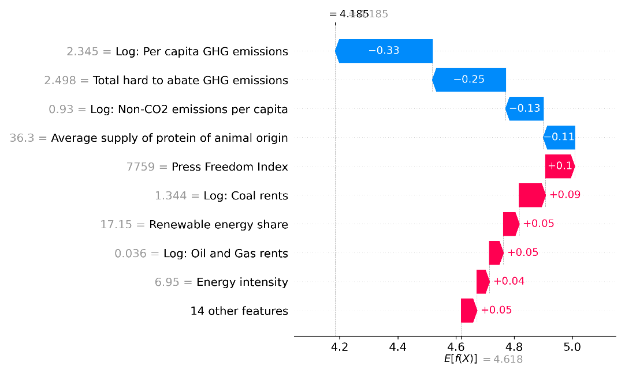
Indonesia: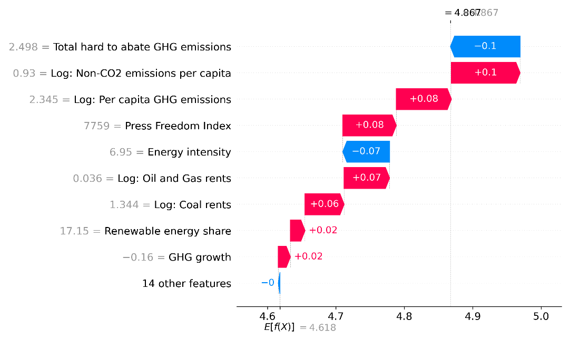
Iran: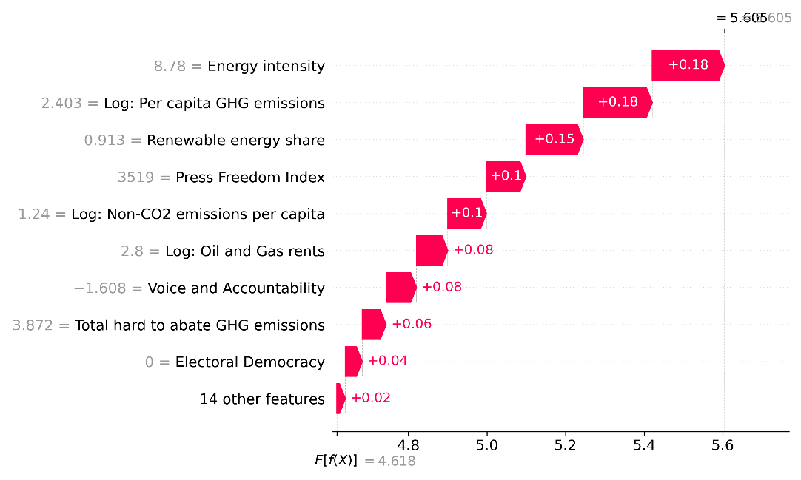
Japan: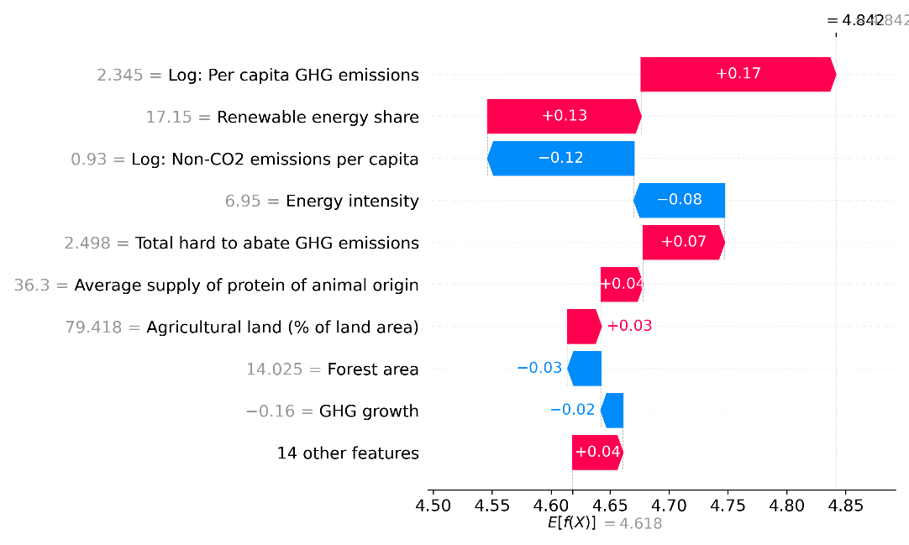
Mexico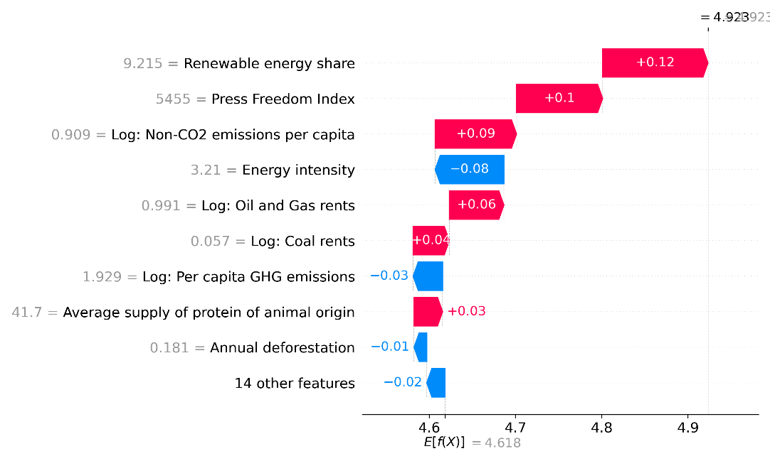
South-Korea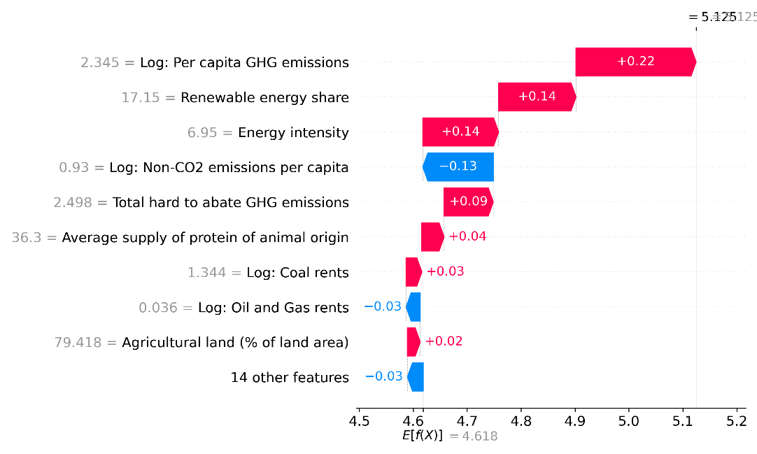
Russian Federation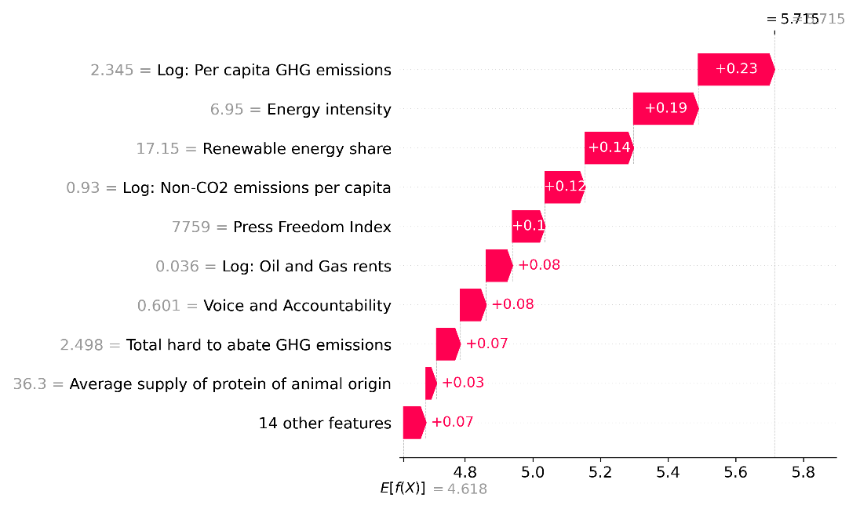

Saudi-Arabia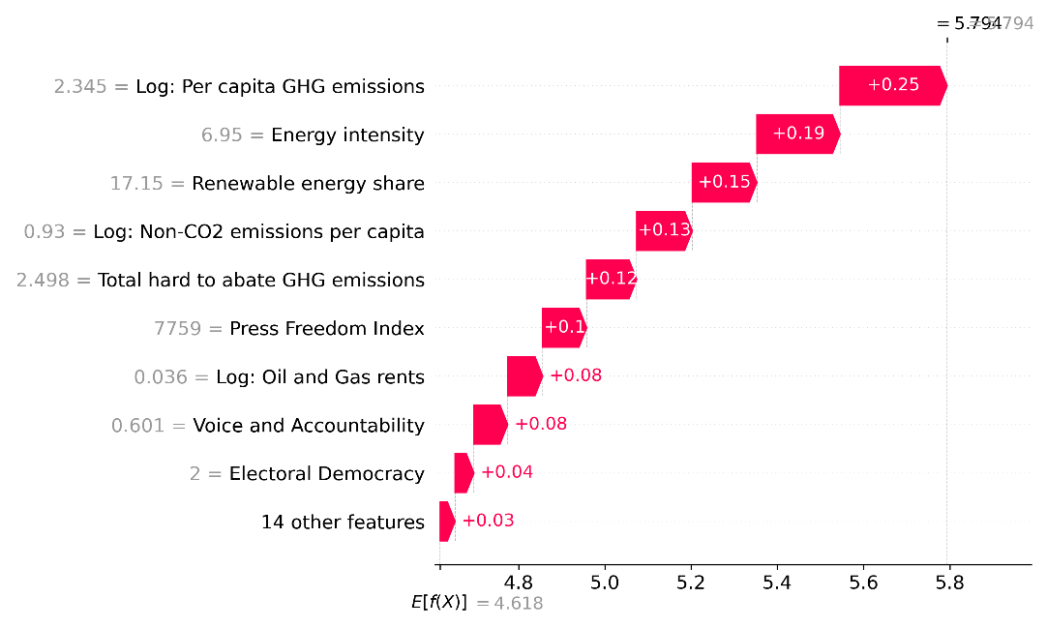
South Africa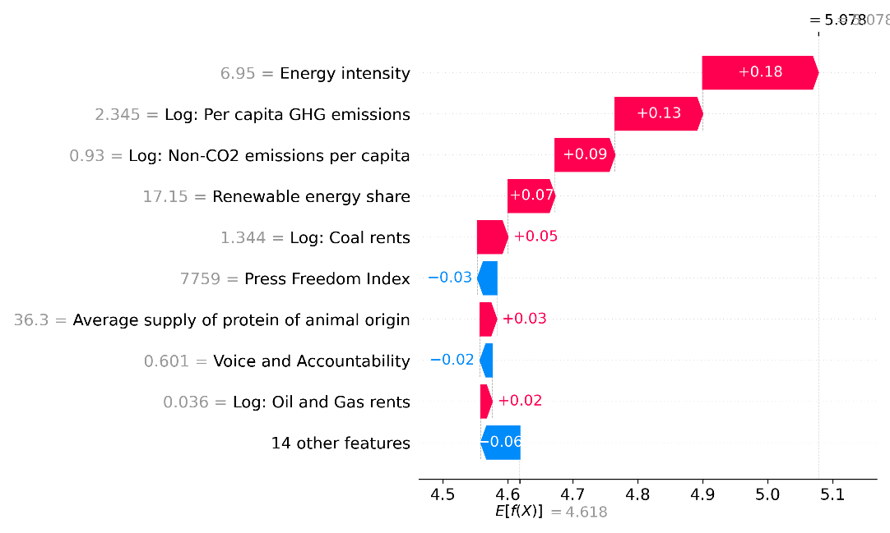
Türkiye 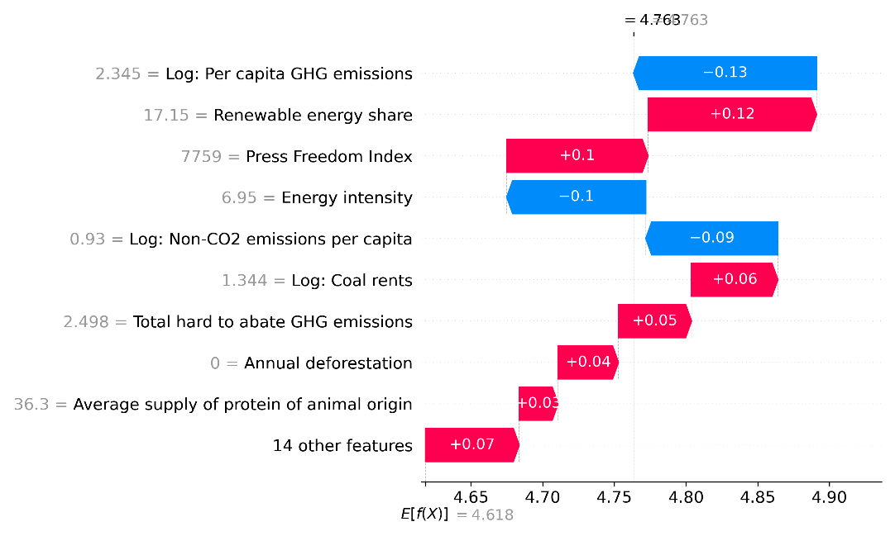
United States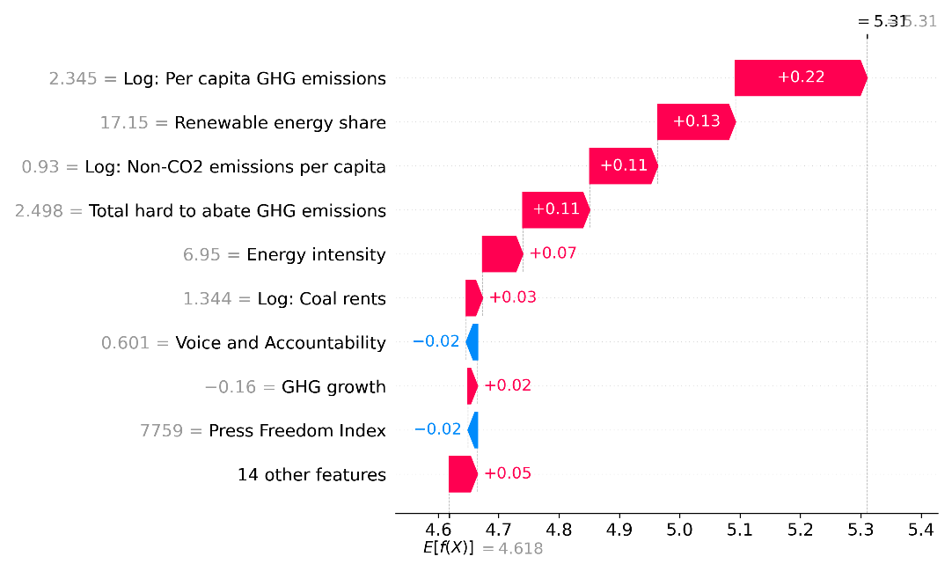
Fig. S.10 Individual waterfall plots for all major emitting countries, illustrating the local impact of different indicators on the predictive outcome of the XGBoost model. Iran and Mexico are shown as they are the highest emitting countries without a net-zero target. Each subplot illustrates the contribution of different indicators to the XGBoost model’s predictive outcome, reflecting the interplay of local and global importance and the implications of regularisation in model learning. The left numbers represent the actual indicator value; arrows and accompanying numbers represent SHAP values. The plot starts from the mean target variable value for all countries at the bottom, ending with the specific country’s value at the top. Top indicators have the largest local prediction effect, highlighting marginal contribution diversity of indicators between countries.

Supplementary Text 11. Overview of Global Net-Zero Targets
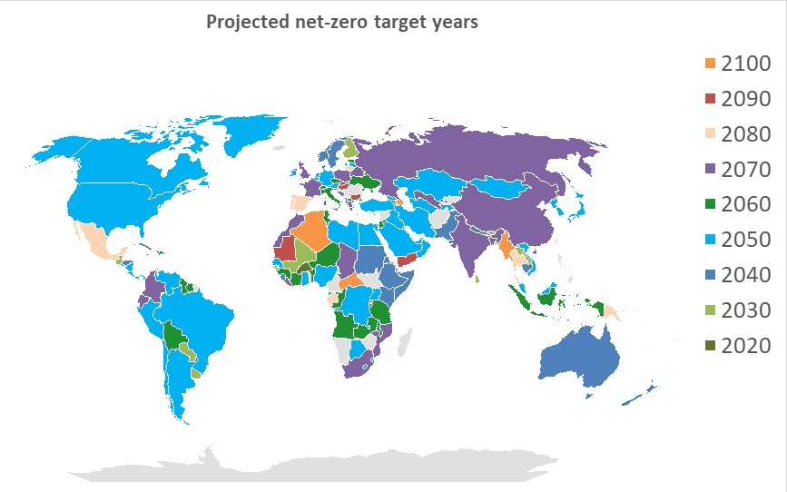
Fig. S.11 Overview of the mean net-zero target years projected by all 200 model runs

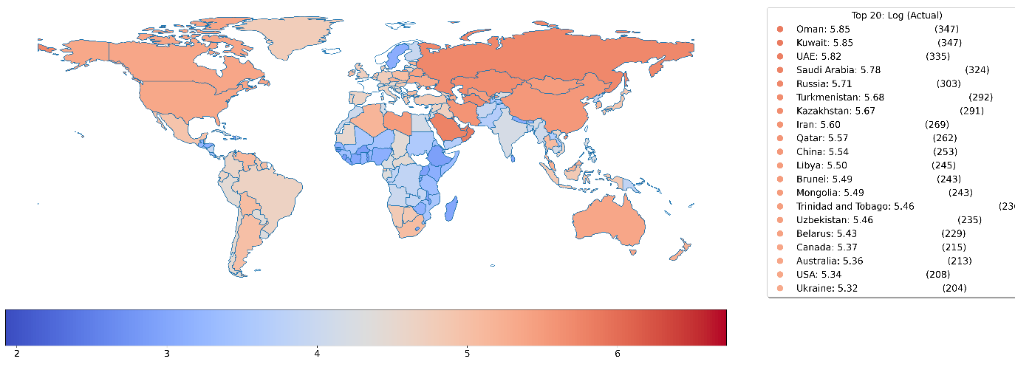
Fig. S.12: Projected cumulative per capita emissions of countries in the dataset.

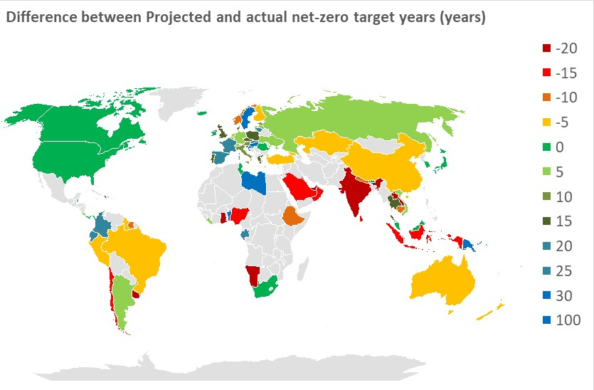

Fig. S.13: Difference between projected and adopted net-zero target years (rounded to the nearest five years, maximum 100 years) for countries with net-zero targets. Negative values (red) indicate that projected net-zero target years are earlier than the adopted target years. Positive values (green and blue) indicate that projected net-zero target years are later than the adopted target years. Countries without net-zero target years are shown in grey.

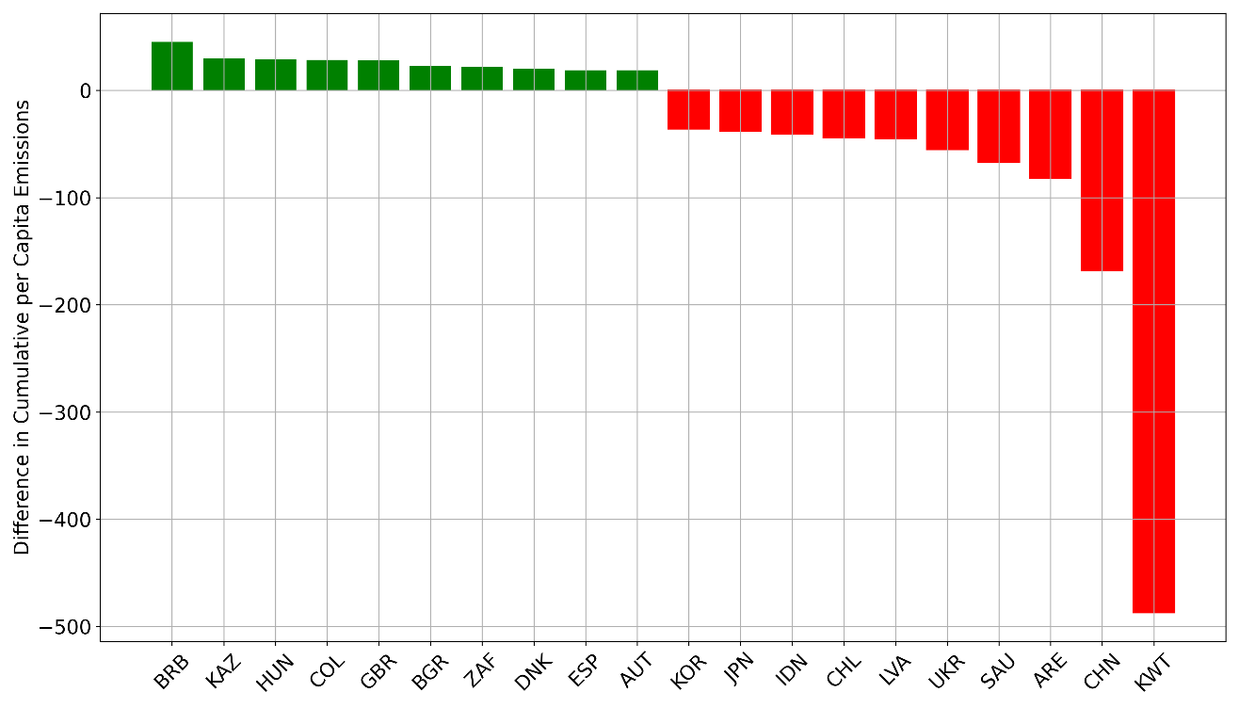

Fig. S.14: Top ten and bottom ten countries by difference in cumulative per capita emissions between actual and projected value. The negative values indicate a negative difference in the projected cumulative per capita emissions based on the actual and projected net-zero target year. For example, for Kuwait, the actual net-zero target is 2060 for CO₂ coverage. Therefore, for all GHG coverage, the net-zero target is assumed to be 15 years later, in 2075. The projected net-zero target was 2041. Given the high per capita emissions, this leads to a high negative difference estimate. For the United Kingdom, there is an positive value, as the actual and projected net-zero year is 2050 and 2066, respectively.

Table S.9: Projected Net-Zero Target Years by Country
Country Name | Year | Country Name | Year | Country Name | Year | Country Name | Year
Afghanistan | 2137 | Egypt | 2050 | Libya | 2051 | San Marino
Albania | 2042 | El Salvador | 2047 | Liechtenstein | 2037 | Sao Tome and Principe | 2065
Algeria | 2099 | Equatorial Guinea | 2046 | Lithuania | 2077 | Saudi Arabia | 2046
American Samoa | 2022 | Eritrea | 2041 | Luxembourg | 2046 | Senegal | 2050
Andorra | 2052 | Estonia | 2061 | Macao |  | Serbia and Montenegro
Angola | 2063 | Ethiopia | 2042 | Macedonia | 2061 | Seychelles | 2036
Anguilla |  | Faeroe Islands |  | Madagascar |  | Sierra Leone | 2039
Argentina | 2053 | Falklands Islands. |  | Malawi | 2060 | Singapore
Armenia | 2040 | Fiji |  | Malaysia | 2048 | Slovakia | 2092
Aruba | 2038 | Finland | 2028 | Maldives | 2040 | Slovenia | 2072
Australia | 2044 | France | 2070 | Mali | 2033 | Solomon Islands
Austria | 2051 | French Guyana |  | Malta | 2068 | Somalia | 2039
Azerbaijan | 2101 | French Polynesia |  | Marshall Islands | 2050 | South Africa | 2066
Bahamas | 2031 | Gabon | 2076 | Martinique |  | Spain | 2076
Bahrain | 2043 | Gambia | 2070 | Mauritania | 2088 | Sri Lanka | 2034
Bangladesh | 2072 | Georgia | 2046 | Mauritius | 2049 | St. Helena
Barbados | 2052 | Germany | 2051 | Mexico | 2080 | St. Kitts & Nevis | 2036
Belarus | 2076 | Ghana | 2052 | Micronesia | 2082 | St. Lucia | 2039
Belgium | 2054 | Gibraltar |  | Moldova | 2135 | St. Pierre
Belize | 2082 | Greece | 2067 | Monaco |  | St. Vincent | 2036
Benin | 2060 | Greenland | 2022 | Mongolia | 2047 | Sudan | 2038
Bermuda | 2022 | Grenada | 2151 | Montserrat |  | Suriname | 2054
Bhutan | 2029 | Guadeloupe |  | Morocco | 2071 | Swaziland | 2049
Bolivia | 2055 | Guatemala | 2032 | Mozambique | 2067 | Sweden | 2163
Bosnia and Herzegovina | 2039 | Guinea | 2056 | Myanmar | 2096 | Switzerland | 2055
Botswana | 2053 | Guinea-Bissau | 2033 | Namibia | 2004 | Syria | 2121
Brazil | 2047 | Guyana | 2061 | Nauru | 2039 | Taiwan
Brunei | 2028 | Haiti | 2050 | Nepal | 2037 | Tajikistan | 2054
Bulgaria | 2088 | Honduras | 2035 | Netherlands | 2055 | Tanzania | 2060
Burkina Faso | 2021 | Hong Kong, China | 2080 | Netherlands Antilles |  | Thailand | 2082
Burundi | 2036 | Hungary | 2087 | New Zealand | 2044 | Timor-Leste
Cambodia | 2041 | Iceland |  | Nicaragua | 2049 | Togo | 2015
Cameroon | 2133 | India | 2066 | Niger | 2061 | Tokelau
Canada | 2048 | Indonesia | 2059 | Nigeria | 2054 | Tonga | 2061
Cape Verde | 2067 | Iran | 2046 | Niue |  | Trinidad Tobago | 2026
Cayman Islands |  | Iraq | 2045 | Norway | 2039 | Tunisia | 2064
Colombia | 2069 | Ireland | 2048 | Oman | 2050 | Turkey | 2047
Comoros | 3345 | Israel | 2054 | Pakistan | 2042 | Turkmenistan | 2045
Congo, Democratic Republic | 2049 | Italy | 2060 | Palau | 2023 | Tuvalu | 2057
Congo, Republic | 2057 | Jamaica | 2030 | Panama | 2050 | Uganda | 2048
Cook Islands |  | Japan | 2049 | Papua New Guinea | 2087 | Ukraine | 2063
Costa Rica | 2054 | Jordan | 2063 | Paraguay | 2028 | UAE | 2047
Cote d' Ivoire | 2064 | Kazakhstan | 2054 | Peru | 2046 | UK | 2065
Croatia | 2081 | Kenya | 2035 | Philippines | 2182 | United States | 2050
Cuba | 2038 | Kiribati | 2249 | Pitcairn |  | Uruguay | 2028
Cyprus | 2061 | North Korea | 2047 | Poland | 2066 | Uzbekistan | 2065
Czech Republic | 2063 | South Korea | 2049 | Portugal | 2080 | Vanuatu | 2095
Denmark | 2058 | Kuwait | 2041 | Puerto Rico |  | Vatican City
Djibouti | 2069 | Kyrgyzstan | 2192 | Qatar | 2021 | Venezuela | 2049
Dominica | 2049 | Laos | 2029 | Reunion |  | Vietnam | 2053
Dominican Republic | 2057 | Latvia | 2053 | Romania |  | Yemen | 2097
Colombia | 2069 | Lebanon | 2046 | Russian Federation | 2065 | Zambia | 2059
Comoros | 3345 | Lesotho | 2051 | Rwanda | 2093 | Zimbabwe
Ecuador | 2071 | Liberia | 2068 | Samoa | 2069 | EU27 | 2055
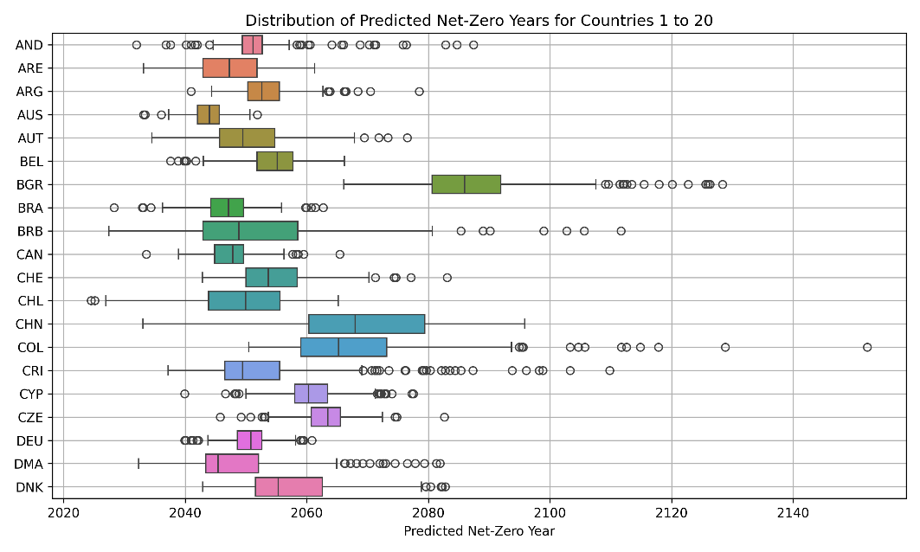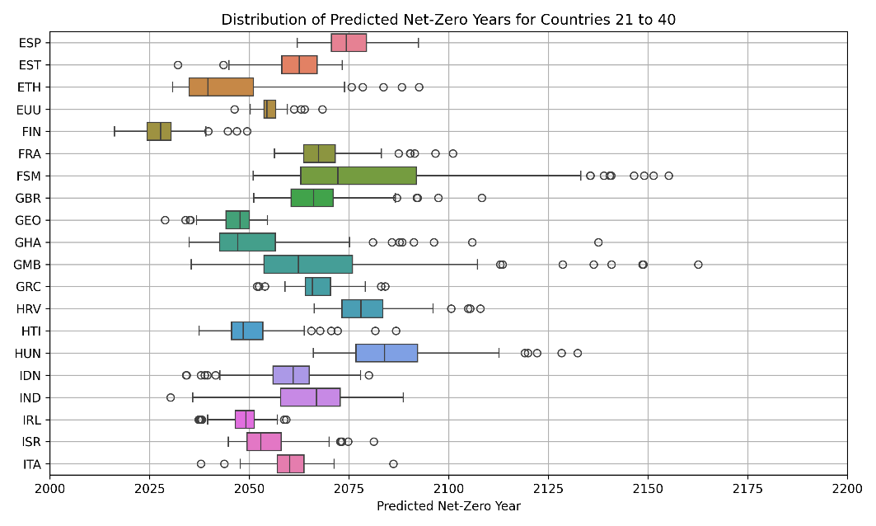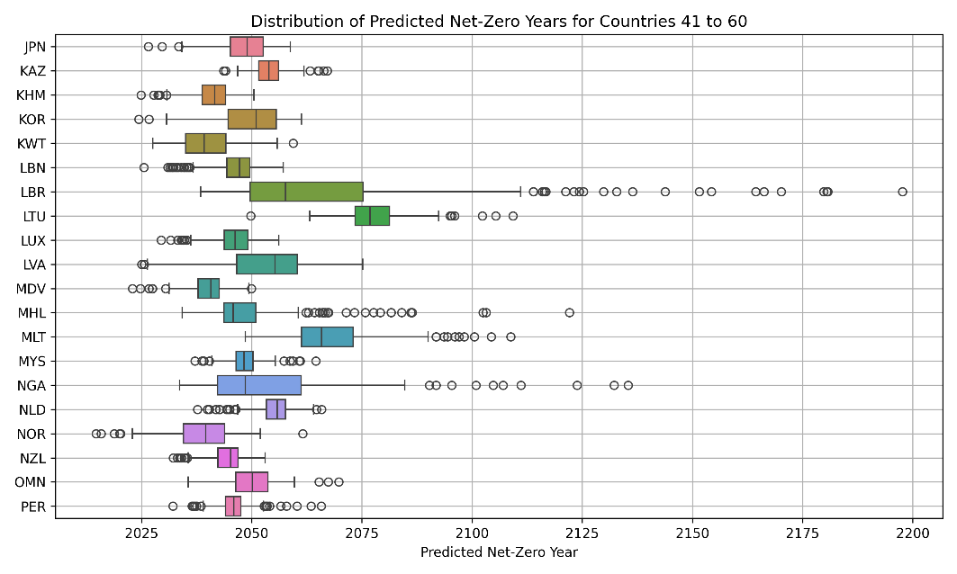
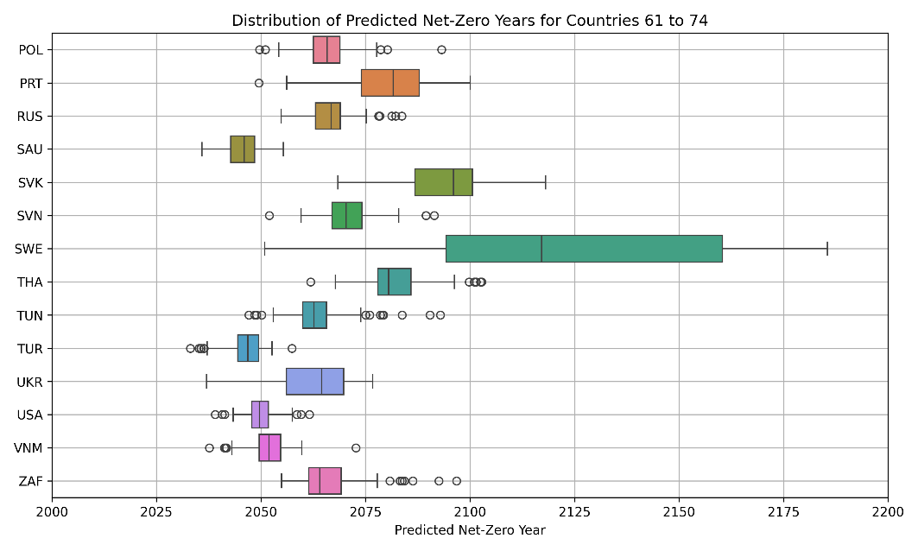
Fig. S.11. Overview of the mean net-zero target years projected by all 200 model runs for the 74 selected countries. This figure presents a box plot of the projected net-zero years. Each box plot represents the spread of projected net-zero years across 200 model runs for each country. The boxes show the interquartile range (IQR) with the vertical line inside each box indicating the median. Outliers are depicted as individual points beyond the whiskers.

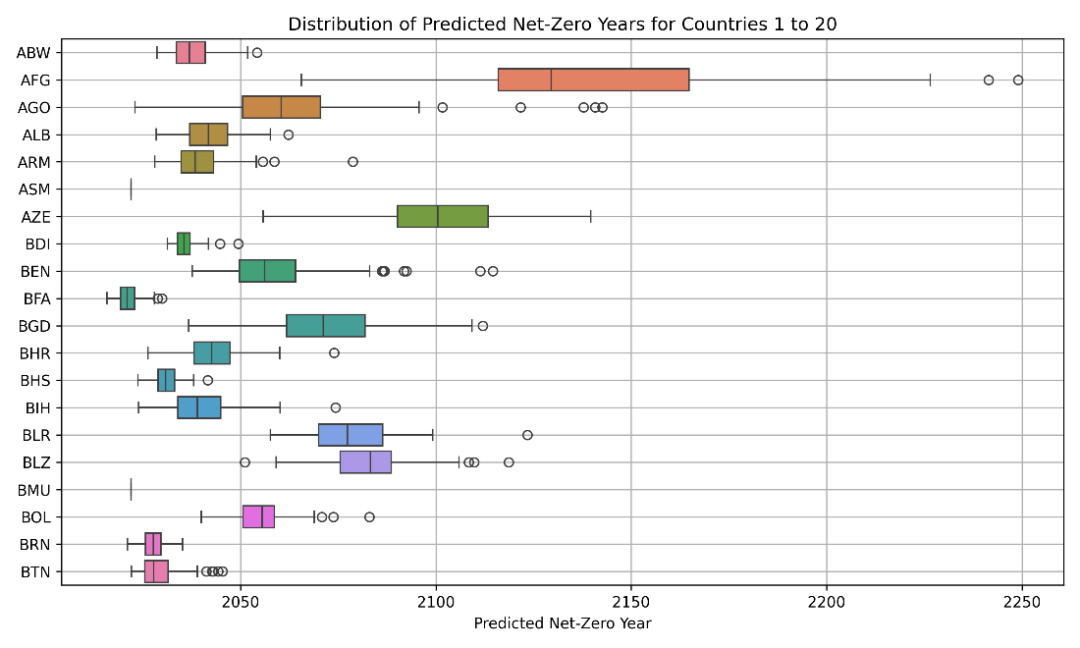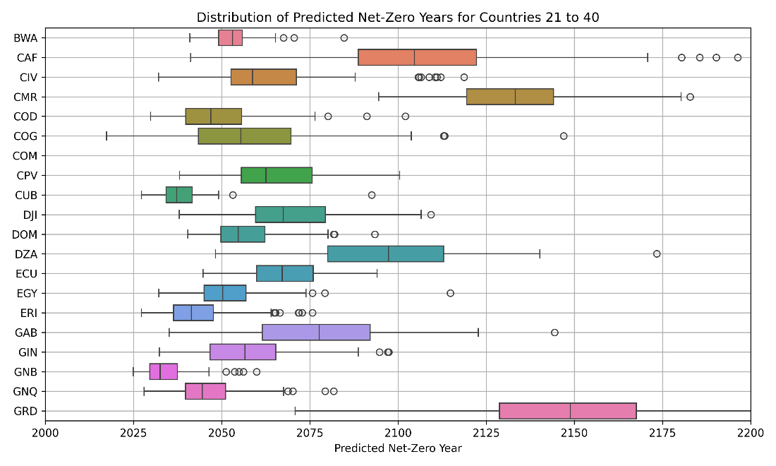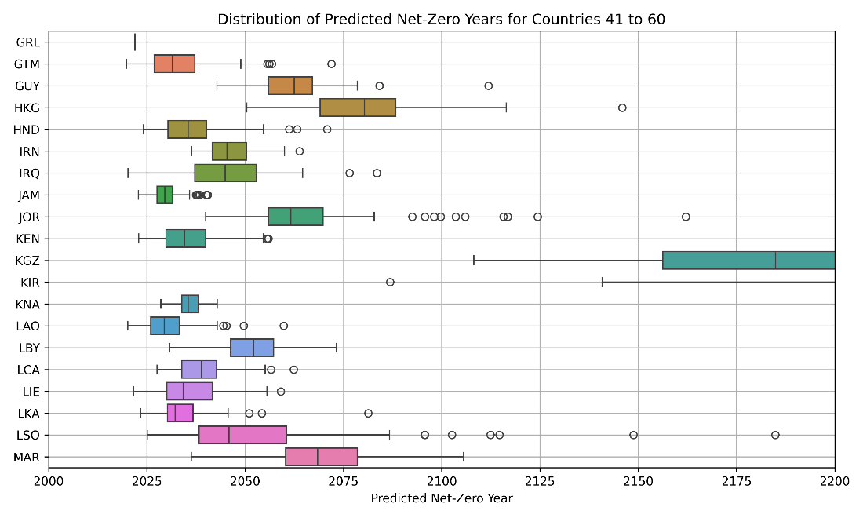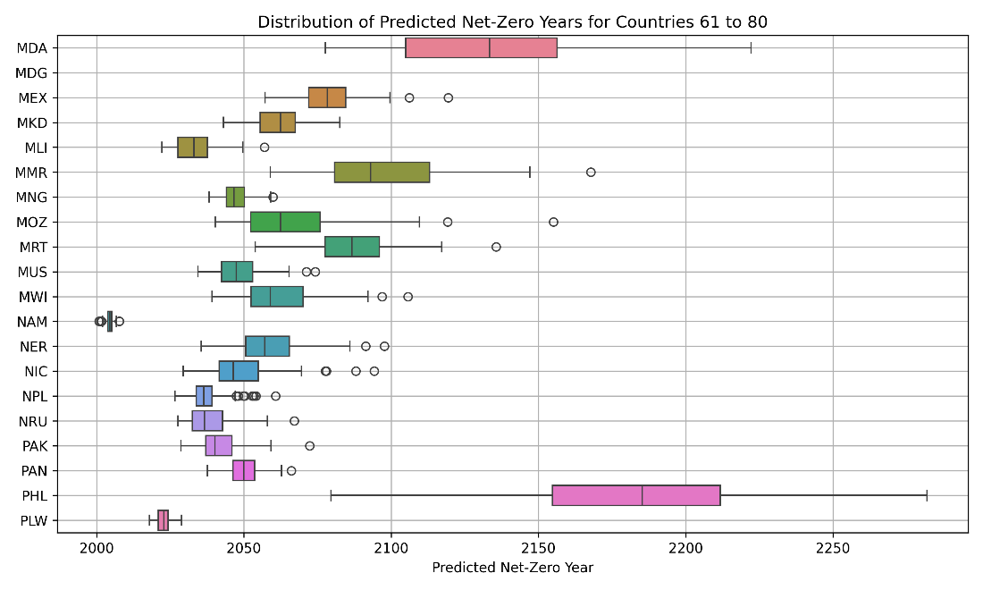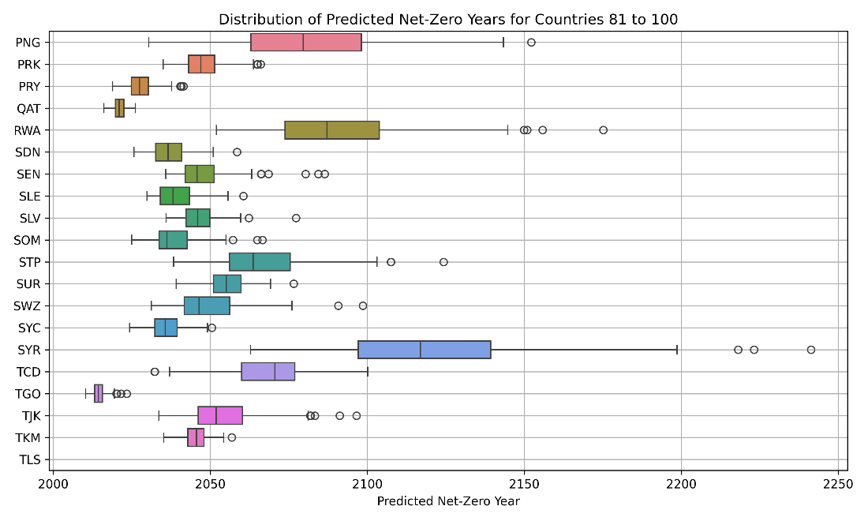
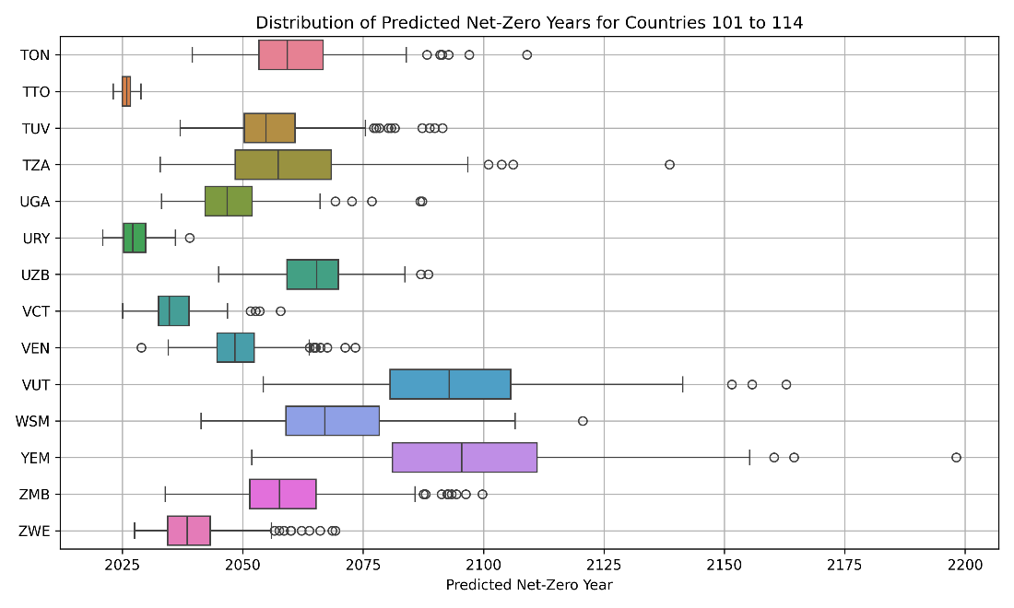
Fig. S.12. Overview of the mean net-zero target years projected by all 200 model runs for the 114 remaining countries. This figure presents a box plot of the projected net-zero years. Each box plot represents the spread of projected net-zero years across 200 model runs for each country. The boxes show the interquartile range (IQR) with the vertical line inside each box indicating the median. Outliers are depicted as individual points beyond the whiskers.

References
Arthur, D., and S. Vassilvitskii. (2006). k-means++: The advantages of careful seeding. Stanford, https://www.rama.mahidol.ac.th/ceb/sites/default/files/public/pdf/journal_club/2023/shap.pdf.pdf.
Averchenkova, A., and S. Bassi. (2016). Beyond the targets: assessing the political credibility of pledges for the Paris Agreement. Centre for Climate Change Economics and Policy and Grantham Research, London United Kingdom, https://eprints.lse.ac.uk/65670/1/Averchenkova-and-Bassi-2016.pdf.
Aydin, Z. E., and Z. K. Ozturk. (2021). "Performance analysis of XGBoost classifier with missing data." Manchester Journal of Artificial Intelligence and Applied Sciences (MJAIAS) 2 (02):2021.
Brutschin, E., S. Pianta, M. Tavoni, K. Riahi, V. Bosetti, G. Marangoni, and B. J. Van Ruijven. (2021). "A multidimensional feasibility evaluation of low-carbon scenarios." Environmental Research Letters 16 (6):064069. https://dx.doi.org/10.1088/1748-9326/abf0ce.
Campello, R. J. G. B., D. Moulavi, and J. Sander, eds. (2013). Density-Based Clustering Based on Hierarchical Density Estimates. Edited by Jian Pei, Vincent S. Tseng, Longbing Cao, Hiroshi Motoda and Guandong Xu, Advances in Knowledge Discovery and Data Mining. Berlin, Heidelberg, https://doi.org/10.1007/978-3-642-37456-2_14: Springer Berlin Heidelberg.
Campello, R. J. G. B., D. Moulavi, A. Zimek, and J. Sander. (2015). "Hierarchical density estimates for data clustering, visualization, and outlier detection." ACM Transactions on Knowledge Discovery from Data (TKDD) 10 (1):1–51.
Carrasco, C. A., and A. Hernandez-del-Valle. (2023). "Energy intensity, economic structure, and capital goods imports in upper-middle income countries: Insights from HDBSCAN clustering." Journal of Environmental Management 339:117840. https://doi.org/10.1016/j.jenvman.2023.117840.
Chen, T., and C. Guestrin. (2016). "XGBoost: A Scalable Tree Boosting System." Proceedings of the 22nd ACM SIGKDD International Conference on Knowledge Discovery and Data Mining, San Francisco, California, USA.
Dioha, M. O., and A. Kumar. (2020). "Exploring the energy system impacts of Nigeria's Nationally Determined Contributions and low-carbon transition to mid-century." Energy Policy 144:111703. https://doi.org/10.1016/j.enpol.2020.111703.
Feng, R., X. Xu, Z.-T. Yu, and Q. Lin. (2023). "A machine-learning assisted multi-cluster assessment for decarbonization in the chemical fiber industry toward net-zero: A case study in a Chinese province." Journal of Cleaner Production 425:138965. https://doi.org/10.1016/j.jclepro.2023.138965.
Fragkos, P., K. Fragkiadakis, L. Paroussos, R. Pierfederici, S. S. Vishwanathan, A. C. Köberle, G. Iyer, C.-M. He, and K. Oshiro. (2018). "Coupling national and global models to explore policy impacts of NDCs." Energy Policy 118:462–473. https://doi.org/10.1016/j.enpol.2018.04.002.
Giannakas, F., C. Troussas, A. Krouska, C. Sgouropoulou, and I. Voyiatzis. (2021) of Conference. "Xgboost and deep neural network comparison: The case of teams’ performance." 2021.
Inform—Global, I. (2024). Open-Source Risk Assessment for Humanitarian Crises and Disasters, https://drmkc.jrc.ec.europa.eu/inform-index.
Lachapelle, E., and M. Paterson. (2018). "Drivers of national climate policy." Climate Policy 13 (5):547–571. https://doi.org/10.1080/14693062.2013.811333.
Lamb, W. F., and J. C. Minx. (2020). "The political economy of national climate policy: Architectures of constraint and a typology of countries." Energy Research & Social Science 64:101429. https://doi.org/10.1016/j.erss.2020.101429.
Le Quéré, C., J. I. Korsbakken, C. Wilson, J. Tosun, R. Andrew, R. J. Andres, J. G. Canadell, A. Jordan, G. P. Peters, and D. P. van Vuuren. (2019). "Drivers of declining CO2 emissions in 18 developed economies." Nature Climate Change 9 (3):213–217. https://doi.org/10.1038/s41558-019-0419-7.
Lentzakis, A. F., R. Seshadri, A. Akkinepally, V.-A. Vu, and M. Ben-Akiva. (2020). "Hierarchical density-based clustering methods for tolling zone definition and their impact on distance-based toll optimization." Transportation Research Part C: Emerging Technologies 118:102685. https://doi.org/10.1016/j.trc.2020.102685.
Lundberg, S. M., G. Erion, H. Chen, A. DeGrave, J. M. Prutkin, B. Nair, R. Katz, J. Himmelfarb, N. Bansal, and S.-I. Lee. (2020). "From local explanations to global understanding with explainable AI for trees." Nature machine intelligence 2 (1):56–67. https://doi.org/10.1038/s42256-019-0138-9.
Lundberg, S. M., and S.-I. Lee. (2017). "A unified approach to interpreting model predictions." Advances in neural information processing systems 30.
Marquardt, D. W. (1970). "Generalized inverses, ridge regression, biased linear estimation, and nonlinear estimation." Technometrics 12 (3):591–612. https://doi.org/10.2307/1267205.
McInnes, L., J. Healy, and S. Astels. (2017). "hdbscan: Hierarchical density based clustering." J. Open Source Softw. 2 (11):205. https://web.archive.org/web/20180721125619id_/https://www.theoj.org/joss-papers/joss.00205/10.21105.joss.00205.pdf.
Muttitt, G., and S. Kartha. (2020). "Equity, climate justice and fossil fuel extraction: principles for a managed phase out." Climate Policy 20 (8):1024–1042. https://doi.org/10.1080/14693062.2020.1763900.
Nascimento, L., M. den Elzen, T. Kuramochi, S. Woollands, I. Dafnomilis, M. Moisio, M. Roelfsema, N. Forsell, and Z. Araujo Gutierrez. (2024). "Comparing the Sequence of Climate Change Mitigation Targets and Policies in Major Emitting Economies." Journal of Comparative Policy Analysis: Research and Practice 26 (3-4):233–250. https://doi.org/10.1080/13876988.2023.2255151.
Nascimento, L., and N. Höhne. (2023). "Expanding climate policy adoption improves national mitigation efforts." Npj Climate Action 2 (1):12. https://doi.org/10.1038/s44168-023-00043-8.
Nascimento, L., T. Kuramochi, G. Iacobuta, M. den Elzen, H. Fekete, M. Weishaupt, H. L. van Soest, M. Roelfsema, G. D. Vivero-Serrano, S. Lui, F. Hans, M. Jose de Villafranca Casas, and N. Höhne. (2022). "Twenty years of climate policy: G20 coverage and gaps." Climate Policy 22 (2):158–174. https://doi.org/10.1080/14693062.2021.1993776.
O’brien, R. M. (2007). "A caution regarding rules of thumb for variance inflation factors." Quality & quantity 41:673–690.
Peters, G. P., R. M. Andrew, J. G. Canadell, S. Fuss, R. B. Jackson, J. I. Korsbakken, C. Le Quéré, and N. Nakicenovic. (2017). "Key indicators to track current progress and future ambition of the Paris Agreement." Nature Climate Change 7 (2):118. https://doi.org/10.1038/nclimate3202.
Poole, M. A., and P. N. O'Farrell. (1971). "The assumptions of the linear regression model." Transactions of the Institute of British Geographers:145–158.
Robiou du Pont, Y., L. Jeffery, J. Gutschow, J. Rogelj, P. Christoff, and M. Meinshausen. (2017). "Equitable mitigation to achieve the Paris Agreement goals." Nature Clim. Change 7 (1):38–43. http://dx.doi.org/10.1038/nclimate3186.
RSF. (2024). RSF's World Press Freedom Index, https://rsf.org/en/index.
Rusdah, D. A., and H. Murfi. (2020). "XGBoost in handling missing values for life insurance risk prediction." SN Applied Sciences 2 (8):1336.
Schubert, E., J. Sander, M. Ester, H. P. Kriegel, and X. Xu. (2017). "DBSCAN revisited, revisited: why and how you should (still) use DBSCAN." ACM Transactions on Database Systems (TODS) 42 (3):1–21. https://doi.org/10.1145/3068335.
Stephenson, J. R., B. K. Sovacool, and T. H. J. Inderberg. (2021). "Energy cultures and national decarbonisation pathways." Renewable and Sustainable Energy Reviews 137:110592. https://doi.org/10.1016/j.rser.2020.110592.
Steves, F., and A. Teytelboym. (2013). "Political economy of climate change policy." Smith School Working Paper Series, SSEE Working Paper 13-02, https://www.smithschool.ox.ac.uk/sites/default/files/2022-03/Political-Economy-of-Climate-Change-Policy.pdf.
Stewart, G., and M. Al-Khassaweneh. (2022). "An implementation of the HDBSCAN* clustering algorithm." Applied Sciences 12 (5):2405. https://doi.org/10.3390/app12052405.
van Soest, H. L., M. G. J. den Elzen, and D. P. van Vuuren. (2021). "Net-zero emission targets for major emitting countries consistent with the Paris Agreement." Nature communications 12, 2140, (https://doi.org/10.1038/s41467-021-22294-x). https://doi.org/10.1038/s41467-021-22294-x.
WRI. (2025). Climate Watch NDC Tracker. Washington DC, USA: World Resource Institute, https://www.climatewatchdata.org/ndc-tracker , Accessed October 7, 2025. .
Zhang, X., C. Yan, C. Gao, B. A. Malin, and Y. Chen. (2020). "Predicting missing values in medical data via XGBoost regression." Journal of healthcare informatics research 4:383–394. https://doi.org/10.1007/s41666-020-00077-1.

A linear path from 2022 emissions to net-zero was assumed for EU countries, while the 2030 NDC emission value was used for non-EU countries. This differentiation reflects the EU’s collective NDC target and distinguishes between peaked and non-peaked non-EU countries. Linear paths were assumed to avoid complexity in the assumption.

