Online Resources
Online resource 1 Farming practices during the study
 | Inganneva | Särkelä
2019 | fertilization with Ecolan Agra 350 kg ha⁻¹ (28 kg N ha⁻¹), valves installed and P. arundinacea sown in June | valves installed in October, game field
2020 | first harvest in July (mainly for prevention of weed growth) | levelling off the field surface in May,  4.6.2020 sowing grass under the game field, NK1 fertilization 25 kg ha⁻¹ (6.75 kg N ha⁻¹)
2021 | 3.6.2021 fertilization with solid manure 15 t ha⁻¹ (c. 180 kg Ntotal / 25.5 kg Nsoluble ha⁻¹)  26.7.2021 cutting | 3.7.2021 cutting  16.7.2021 harvest
2022 | yield was left in the field in order to test spring harvest next year (only biomass samples were taken) | 3.6.2022 fertilization with NK 21-18 114,5 kg ha⁻¹ (24 kg N ha⁻¹)  16.7.2022 cutting  23.7.2022 harvest
2023 | harvest at the end April | 17.7.2023 harvest

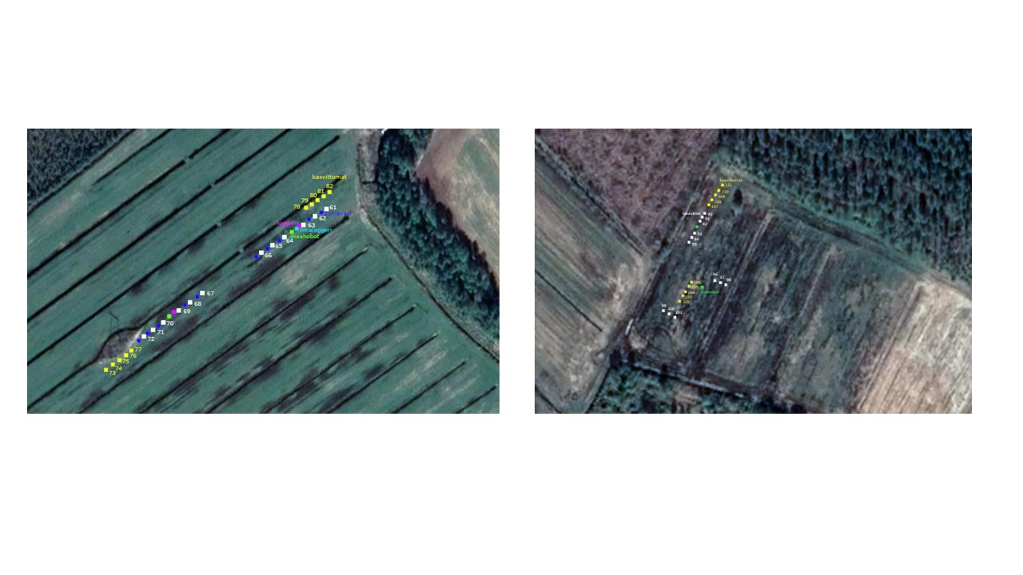
Online Resource 2 The position of collars and environment data loggers at study fields: Inganneva (left), Särkelä (right)
Online Resource 3 Ecosystem model details. Mean value and standard error of 6 models
GP | Field | Treatment | Amax |  | k |  | R2 |  | n
 | Inganneva | raised WT | 8.6 | 1.4 | 701 | 204 | 0.74 | 0.04 | 41.5 | 0.3
 |  | control | 6.0 | 0.7 | 365 | 57 | 0.72 | 0.03 | 42.8 | 0.8
 | Särkelä | control | 6.4 | 0.7 | 341 | 68 | 0.91 | 0.02 | 40.2 | 0.8
 |  | raised WT | 7.5 | 1.1 | 598 | 188 | 0.89 | 0.03 | 39.2 | 0.3
ER | Field | Treatment | R0s |  | R0p |  | Es |  | R2 |  | n
 | Inganneva | raised WT | 0.76 | 0.06 | 0.20 | 0.04 | 154 | 8 | 0.49 | 0.04 | 33.3 | 0.3
 |  | control | 0.92 | 0.06 | 0.25 | 0.04 | 168 | 7 | 0.60 | 0.02 | 33.8 | 0.2
 | Särkelä | control | 0.54 | 0.05 | 0.44 | 0.05 | 212 | 7 | 0.73 | 0.02 | 31.5 | 0.2
 |  | raised WT | 0.52 | 0.06 | 0.53 | 0.08 | 196 | 17 | 0.75 | 0.01 | 31.8 | 0.2

Online Resource 4 Bare soil model details. Mean value and standard error of 5 models
Soil respiration | Field | Treatment | R0s |  | Es |  | R2 |  | n
 | Inganneva | control | 0.51 | 0.02 | 319 | 22 | 0.63 | 0.08 | 17 | 0.5
 |  | raised WT | 0.27 | 0.03 | 290 | 30 | 0.63 | 0.10 | 17 | 0.3
 | Särkelä | control | 0.41 | 0.03 | 408 | 31 | 0.67 | 0.05 | 15 | 0.2
 |  | raised WT | 0.26 | 0.01 | 442 | 29 | 0.43 | 0.04 | 15 | 0.4

Online resources 5 Statistical results of Inganneva study site
Inganneva
CH₄, mg m⁻² h⁻¹
Effect | Degrees of freedom | F value | p value
Treatment | 1, 10.8 | 15.39 | 0.002
Period | 11, 27.4 | 2.10 | 0.056
Treatment x period | 11, 23.7 | 1.38 | 0.245

 | Control |  |  | Raised WT
Period | Treatment mean | 95% lower limit | 95% upper limit | Treatment mean | 95% lower limit | 95% upper limit
1 | 0.050 | -0.121 | 0.221 | 0.001 | -0.171 | 0.174
2 | 0.023 | -0.150 | 0.197 | -0.005 | -0.178 | 0.169
3 | 0.981 | 0.588 | 1.375 | 0.213 | -0.180 | 0.606
4 | 0.112 | -0.102 | 0.325 | -0.011 | -0.224 | 0.203
5 | -0.058 | -0.231 | 0.116 | -0.029 | -0.203 | 0.144
6 | -0.040 | -0.253 | 0.174 | 0.008 | -0.205 | 0.222
7 | 0.115 | -0.059 | 0.288 | 0.034 | -0.140 | 0.207
8 | -0.004 | -0.218 | 0.209 | -0.023 | -0.236 | 0.191
9 | -0.033 | -0.206 | 0.141 | -0.018 | -0.191 | 0.156
10 | -0.033 | -0.207 | 0.141 | -0.012 | -0.185 | 0.162
11 | -0.001 | -0.151 | 0.148 | -0.009 | -0.159 | 0.141
12 | 0.193 | 0.057 | 0.329 | 0.038 | -0.098 | 0.173
Periods when treatments differed significantly (p ≤ 0.05) are shown in bold.

N₂O, µg m⁻² h⁻¹
Effect | Degrees of freedom | F value | p value
Treatment | 1, 39.43 | 0.00 | 0.997
Period | 11, 28.81 | 1.16 | 0.354
Treatment x period | 11, 31.7 | 0.35 | 0.968

 | Control |  |  | Raised WT
Period | Treatment mean | 95% lower limit | 95% upper limit | Treatment mean | 95% lower limit | 95% upper limit
1 | 78.71 | 33.62 | 123.80 | 47.54 | 2.482 | 92.59
2 | 5.041 | -32.03 | 42.11 | 5.963 | -31.13 | 43.05
3 | -0.062 | -28.75 | 28.63 | 0.387 | -28.34 | 29.12
4 | 25.94 | -23.40 | 75.29 | 51.64 | 2.287 | 100.98
5 | 19.10 | -18.42 | 56.61 | 21.00 | -16.63 | 58.62
6 | 4.632 | -41.10 | 50.36 | 9.526 | -36.63 | 55.68
7 | -0.004 | -37.75 | 37.74 | 0.549 | -36.79 | 37.89
8 | 2.041 | -44.00 | 48.08 | 7.245 | -38.24 | 52.73
9 | 3.688 | -33.59 | 40.97 | 1.550 | -36.03 | 39.13
10 | 6.945 | -30.23 | 44.12 | 4.486 | -32.73 | 41.70
11 | 0.219 | -32.30 | 32.73 | -4.485 | -36.99 | 28.02
12 | -1.030 | -29.72 | 27.66 | -0.355 | -29.05 | 28.34

Soil CO₂, mg m⁻² h⁻¹
Effect | Degrees of freedom | F value | p value
Treatment | 1, 93.09 | 16.33 | 0.0001
Period | 9, 260 | 2.36 | 0.0141
Treatment x period | 9, 260 | 1.20 | 0.2974
Soil temperature at the depth of 5 cm | 1, 260 | 16.42 | <0.0001

 | Control |  |  | Raised WT
Period | Treatment mean | 95% lower limit | 95% upper limit | Treatment mean | 95% lower limit | 95% upper limit
1 | 827.0 | 387.1 | 1267.0 | 623.8 | 302.4 | 945.2
2 | 432.7 | 8.284 | 857.1 | 441.3 | 13.60 | 869.0
3 | 1385.2 | 875.6 | 1894.7 | 653.6 | 140.3 | 1167.0
4 | 1119.7 | 765.8 | 1473.7 | 364.7 | 10.88 | 718.4
5 | 696.0 | 334.9 | 1057.2 | 501.8 | 137.0 | 866.6
6 | 392.6 | 45.514 | 739.6 | 264.8 | -86.62 | 616.2
7 | 488.0 | 82.23 | 893.8 | 23.18 | -377.5 | 423.9
8 | 1002.8 | 640.7 | 1364.9 | 408.5 | 47.61 | 769.4
9 | 760.1 | 400.3 | 1119.8 | 443.0 | 81.93 | 804.1
10 | 803.7 | 348.2 | 1259.1 | 229.0 | 253.9 | 1155.7
Periods when treatments differed significantly (p ≤ 0.05) are shown in bold.

WT, cm
Effect | Degrees of freedom | F value | p value
Treatment | 1, 19.44 | 28.49 | <0.0001
Period | 11, 30.4 | 2.74 | 0.0138
Treatment x period | 11, 31.85 | 6.86 | <0.0001

 | Control |  |  | Raised WT
Period | Treatment mean | 95% lower limit | 95% upper limit | Treatment mean | 95% lower limit | 95% upper limit
1 | -75.5 | -94.8 | -56.2 | -61.5 | -80.9 | -42.2
2 | -38.9 | -61.4 | -16.4 | -34.2 | -56.7 | -11.7
3 | -18.2 | -33.8 | -2.6 | -20.5 | -36.1 | -4.9
4 | -50.1 | -76.9 | -23.3 | -38.7 | -65.5 | -11.8
5 | -72.7 | -94.8 | -50.6 | -49.3 | -71.5 | -27.2
6 | -75.3 | -102.1 | -48.5 | -38.7 | -65.5 | -11.9
7 | -28.5 | -47.5 | -9.5 | -29.6 | -48.6 | -10.6
8 | -60.3 | -87.5 | -33.0 | -54.9 | -82.1 | -27.7
9 | -62.7 | -84.6 | -40.7 | -58.2 | -80.2 | -36.3
10 | -62.1 | -84.0 | -40.1 | -50.0 | -71.9 | -28.1
11 | -42.7 | -61.7 | -23.7 | -40.6 | -59.6 | -21.6
12 | -39.2 | -54.8 | -23.7 | -37.8 | -53.3 | -22.2

Online resources 6, Statistical results of Särkelä study site

Särkelä
CH₄, mg m⁻² h⁻¹
Effect | Degrees of freedom | F value | p value
Treatment | 1, 5.723 | 23.61 | 0.003
Period | 14, 20.98 | 2.63 | 0.022
Treatment x period | 14, 19.29 | 1.37 | 0.258

 | Control |  |  | Raised WT
Period | Treatment mean | 95% lower limit | 95% upper limit | Treatment mean | 95% lower limit | 95% upper limit
1 | 0.181 | -2.549 | 2.912 | 2.016 | -1.451 | 5.483
2 | 0.170 | -0.222 | 0.563 | 0.856 | 0.460 | 1.252
3 | 0.133 | -0.186 | 0.452 | 0.685 | 0.364 | 1.005
4 | 0.223 | -0.201 | 0.646 | 1.126 | 0.426 | 1.826
5 | -0.009 | -0.220 | 0.202 | 0.169 | -0.049 | 0.386
6 | -0.061 | -0.269 | 0.148 | 0.070 | -0.139 | 0.280
7 | 0.017 | -0.165 | 0.198 | 0.107 | -0.074 | 0.289
8 | -0.004 | -0.258 | 0.250 | 0.041 | -0.214 | 0.295
9 | -0.035 | -0.243 | 0.174 | 0.015 | -0.193 | 0.224
10 | -0.017 | -0.271 | 0.237 | 0.090 | -0.164 | 0.344
11 | -0.037 | -0.291 | 0.217 | 0.023 | -0.231 | 0.277
12 | -0.013 | -0.195 | 0.168 | 0.061 | -0.122 | 0.244
13 | 0.013 | -0.195 | 0.222 | 0.190 | -0.019 | 0.398
14 | 0.007 | -0.202 | 0.215 | 0.080 | -0.128 | 0.289
15 | 0.011 | -0.197 | 0.220 | 0.144 | -0.064 | 0.353
Periods when treatments differed significantly (p ≤ 0.05) are shown in bold.

N₂O, µg m⁻² h⁻¹
Effect | Degrees of freedom | F value | p value
Treatment | 1, 68.12 | 0.09 | 0.769
Period | 14, 40.02 | 0.52 | 0.907
Treatment x period | 14, 39.46 | 0.67 | 0.793

 | Control |  |  | Raised WT
Period | Treatment mean | 95% lower limit | 95% upper limit | Treatment mean | 95% lower limit | 95% upper limit
1 | 848.4 | -52.11 | 1748.8 | 110.5 | -791.5 | 1012.5
2 | 164.1 | -10.78 | 339.0 | 53.75 | -123.6 | 231.1
3 | 5.207 | -146.8 | 157.2 | 2.791 | -147.7 | 153.2
4 | 46.76 | -172.2 | 265.7 | 10.81 | -208.1 | 229.8
5 | 30.42 | -174.8 | 235.6 | 258.6 | 45.82 | 471.3
6 | 6.178 | -355.6 | 367.9 | 270.5 | -96.97 | 638.0
7 | 29.74 | -122.2 | 181.7 | 60.04 | -90.40 | 210.5
8 | 101.0 | -113.3 | 315.3 | 105.6 | -104.3 | 315.5
9 | 16.70 | -163.9 | 197.3 | 53.36 | -128.9 | 235.6
10 | 51.84 | -180.9 | 284.6 | 73.99 | -140.3 | 288.3
11 | 12.22 | -229.7 | 254.1 | 22.97 | -202.2 | 248.2
12 | 3.426 | -178.3 | 185.1 | 105.8 | -54.68 | 266.3
13 | 12.51 | -160.0 | 185.0 | 22.63 | -149.9 | 195.2
14 | 7.917 | -177.5 | 193.3 | 170.3 | -6.277 | 346.8
15 | 14.72 | -278.3 | 307.7 | 301.9 | 29.85 | 573.9

Soil CO₂, mg m⁻² h⁻¹
Effect | Degrees of freedom | F value | p value
Treatment | 1, 24.19 | 3.35 | 0.0797
Period | 9, 127.6 | 4.10 | 0.0001
Treatment x period | 9, 21.96 | 1.49 | 0.2114
Soil temperature at the depth of 5 cm | 1, 134.6 | 7.10 | 0.0086

 | Control |  |  | Raised WT
Period | Treatment mean | 95% lower limit | 95% upper limit | Treatment mean | 95% lower limit | 95% upper limit
1 | 276.7 | -83.71 | 637.2 | 308.1 | -54.24 | 670.5
2 | 1147.5 | 817.9 | 1477.1 | 1283.8 | 954.8 | 1612.7
3 | 480.0 | 171.4 | 788.7 | 442.8 | 134.9 | 750.7
4 | 306.0 | -80.56 | 692.6 | 394.7 | 10.54 | 778.9
5 | 441.6 | 148.4 | 734.7 | 424.0 | 132.6 | 715.3
6 | 645.9 | 365.7 | 926.1 | 262.2 | -17.15 | 541.5
7 | 684.9 | 363.6 | 1006.2 | 304.8 | -16.58 | 626.3
8 | 367.5 | 21.53 | 713.6 | 323.0 | -26.77 | 672.7
9 | 256.1 | -34.06 | 546.3 | 156.4 | -135.5 | 448.4
10 | 665.8 | 327.7 | 1003.9 | 307.5 | -26.84 | 641.9
Periods when treatments differed significantly (p ≤ 0.05) are shown in bold.

WT, cm
Effect | Degrees of freedom | F value | p value
Treatment | 1, 6.119 | 22.10 | 0.003
Period | 13, 21.31 | 1.52 | 0.188
Treatment x period | 13, 19.62 | 3.16 | 0.011

 | Control |  |  | Raised WT
Period | Treatment mean | 95% lower limit | 95% upper limit | Treatment mean | 95% lower limit | 95% upper limit
1 | -23.6 | -48.2 | 1.0 | -8.8 | -33.4 | 15.8
2 | -40.1 | -64.6 | -15.5 | -17.0 | -41.5 | 7.5
3 | 3.4 | -38.6 | 45.4 | 11.2 | -30.8 | 53.2
4 | -49.9 | -79.7 | -20.1 | -55.2 | -85.0 | -25.3
5 | -61.8 | -86.2 | -37.4 | -54.4 | -78.8 | -30.1
6 | -41.5 | -65.8 | -17.1 | -37.6 | -62.0 | -13.3
7 | -21.6 | -63.6 | 20.4 | -15.0 | -57.0 | 27.0
8 | -33.7 | -63.5 | -3.9 | -25.0 | -54.8 | 4.8
9 | -60.1 | -84.5 | -35.8 | -48.6 | -72.9 | -24.2
10 | -30.7 | -61.6 | 0.3 | -26.8 | -57.8 | 4.1
11 | -53.0 | -83.2 | -22.8 | -29.5 | -59.7 | 0.7
12 | -32.0 | -53.3 | -10.7 | -18.9 | -40.3 | 2.4
13
14 | -31.3 | -55.7 | -7.0 | -22.7 | -47.0 | 1.7
15 | -57.7 | -82.0 | -33.3 | -39.3 | -63.6 | -14.9
Periods when treatments differed significantly (p ≤ 0.05) are shown in bold.

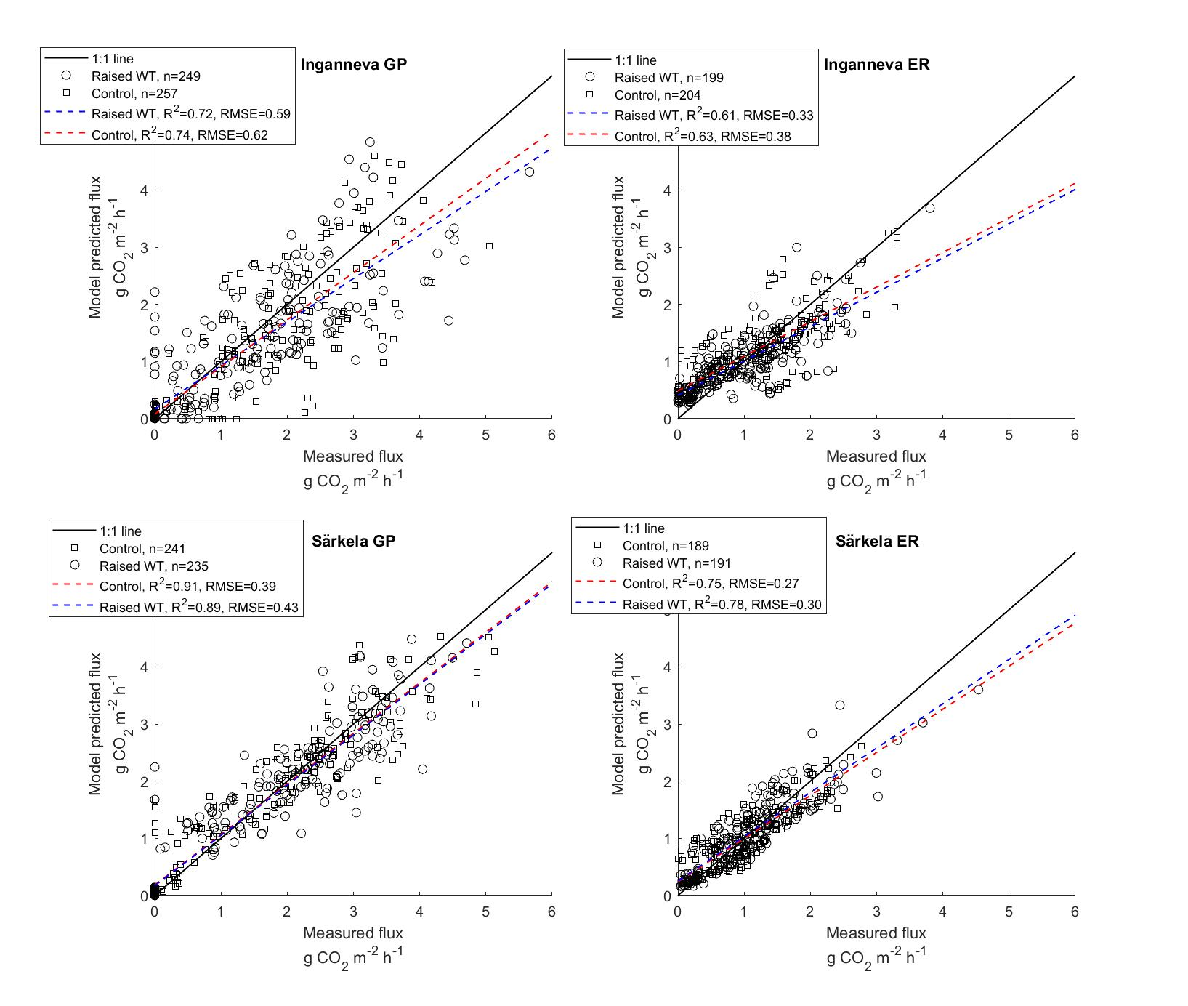

Online Resource 7 The correlation between modelled and observed gross photosynthesis (GP) and ecosystem respiration (ER) rates in both treatments at Inganneva and Särkelä study sites

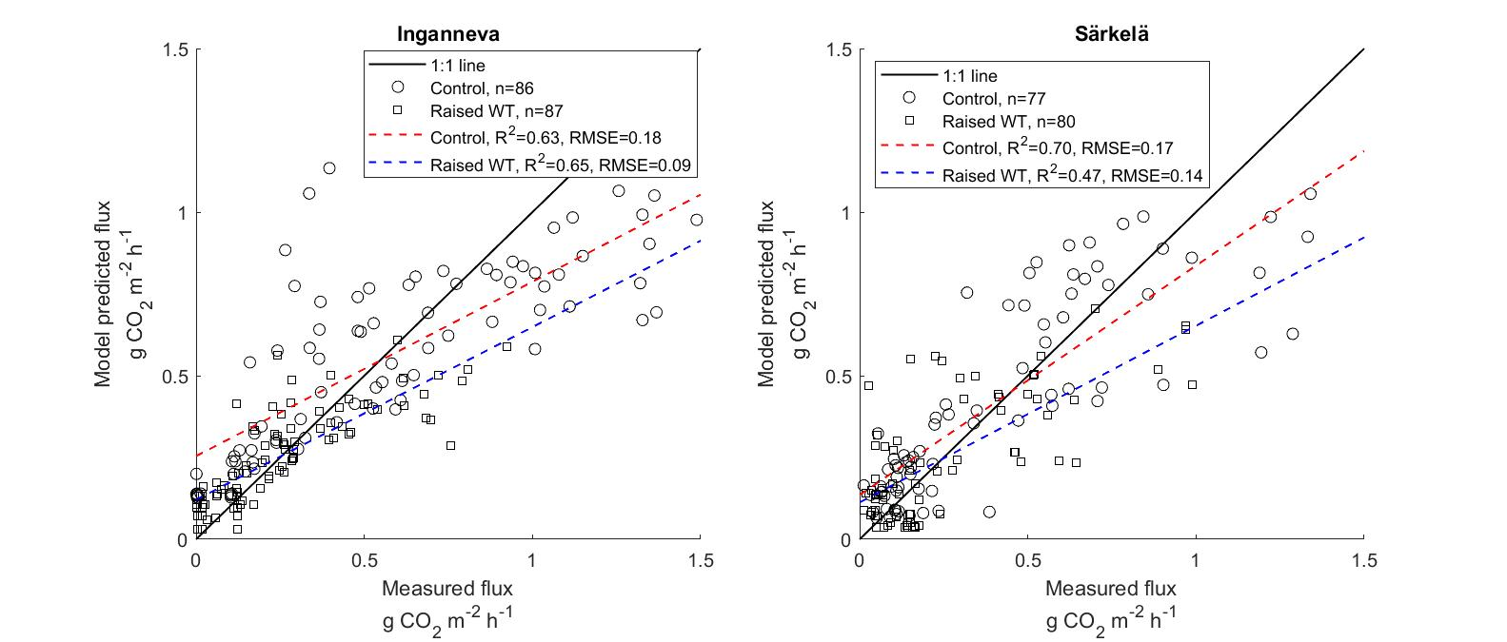

Online Resource 8 The correlation between modelled and observed soil respiration rates in both treatments at Inganneva and Särkelä study sites

