Investigation of the cytotoxicity of bioinspired coumarin analogues towards human breast cancer cells

Leonidas Gkionis^{1,§}, Eleni Kavetsou^{2,§}, Alexandros Kalospyros², Dimitris Manousakis², Miguel Garzon sanz¹, Sam Butterworth^{1,3}, Anastasia Detsi^{2,*} and Annalisa Tirella^{1,3,*}

¹Division of Pharmacy and Optometry, Faculty of Biology, Medicine and Health, University of Manchester, Manchester Academic Health Science Centre, Oxford Road, Manchester M13 9PL, United Kingdom
²Laboratory of Organic Chemistry, School of Chemical Engineering, National Technical University of Athens, Heroon Polytechniou 9, Zografou Campus, GR 15780, Athens, Greece
³NorthWest Centre for Advanced Drug Delivery (NoWCADD), Faculty of Biology, Medicine and Health, University of Manchester, Oxford Road, Manchester, M13 9PT, United Kingdom
§Co-first authors
*Corresponding authors: annalisa.tirella@manchester.ac.uk, adetsi@chemeng.ntua.gr

Supporting information
¹H-NMR and ¹³C-NMR spectra for Compounds 3a-5

7-hydroxy-4-propyl-2H-chromen-2-one (3a)
¹H NMR
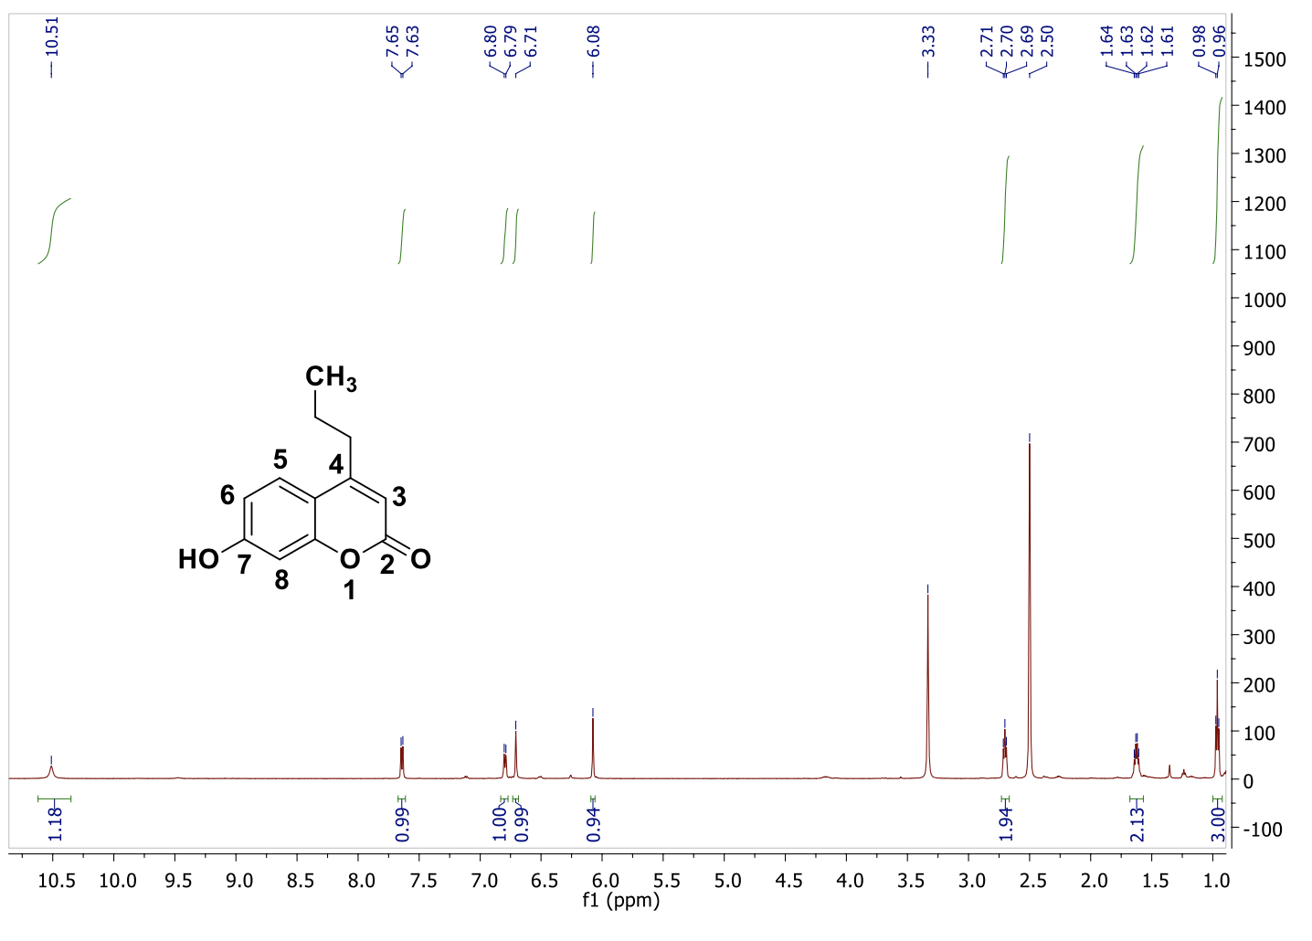

5,7-dihydroxy-4-methyl-2H-chromen-2-one (3b)
¹H NMR
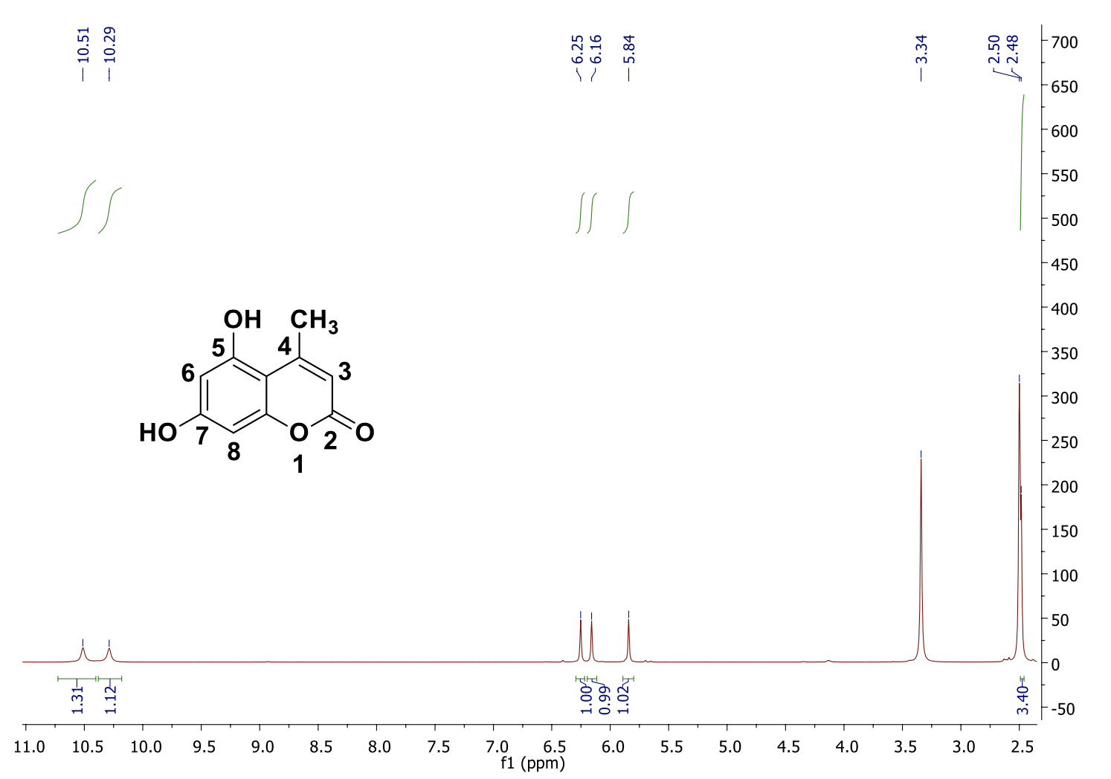

7-prenyloxy-4-methyl-2H-chromen-2-one (4a)
¹H NMR
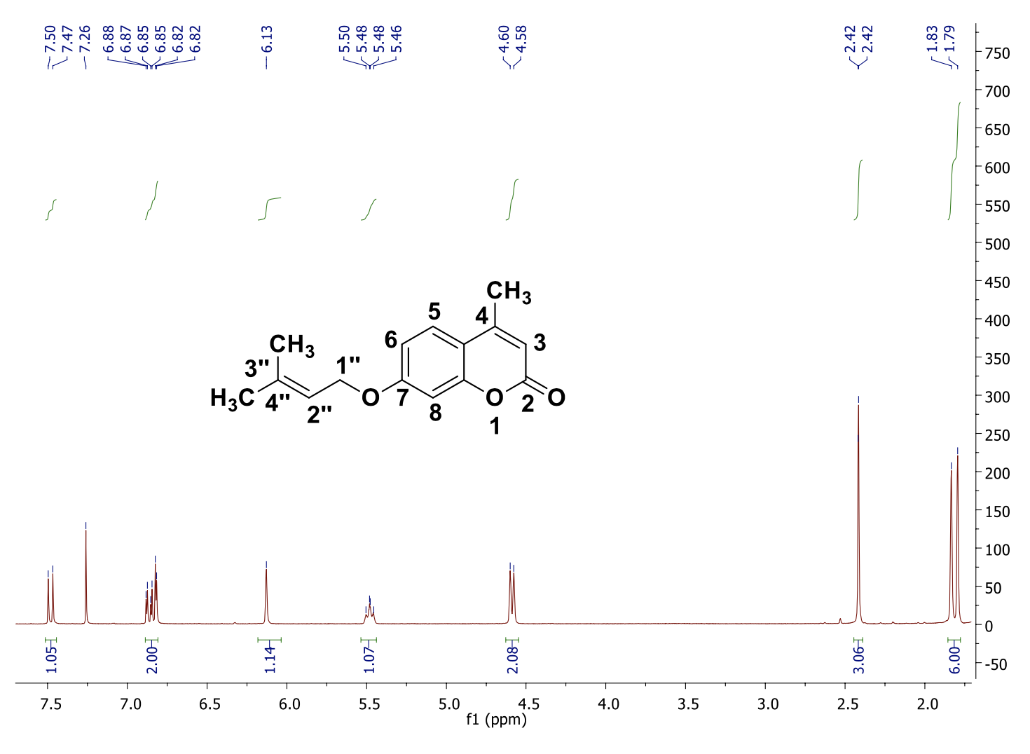

7-geranyloxy-4-methyl-2H-chromen-2-one (4b)
¹H NMR
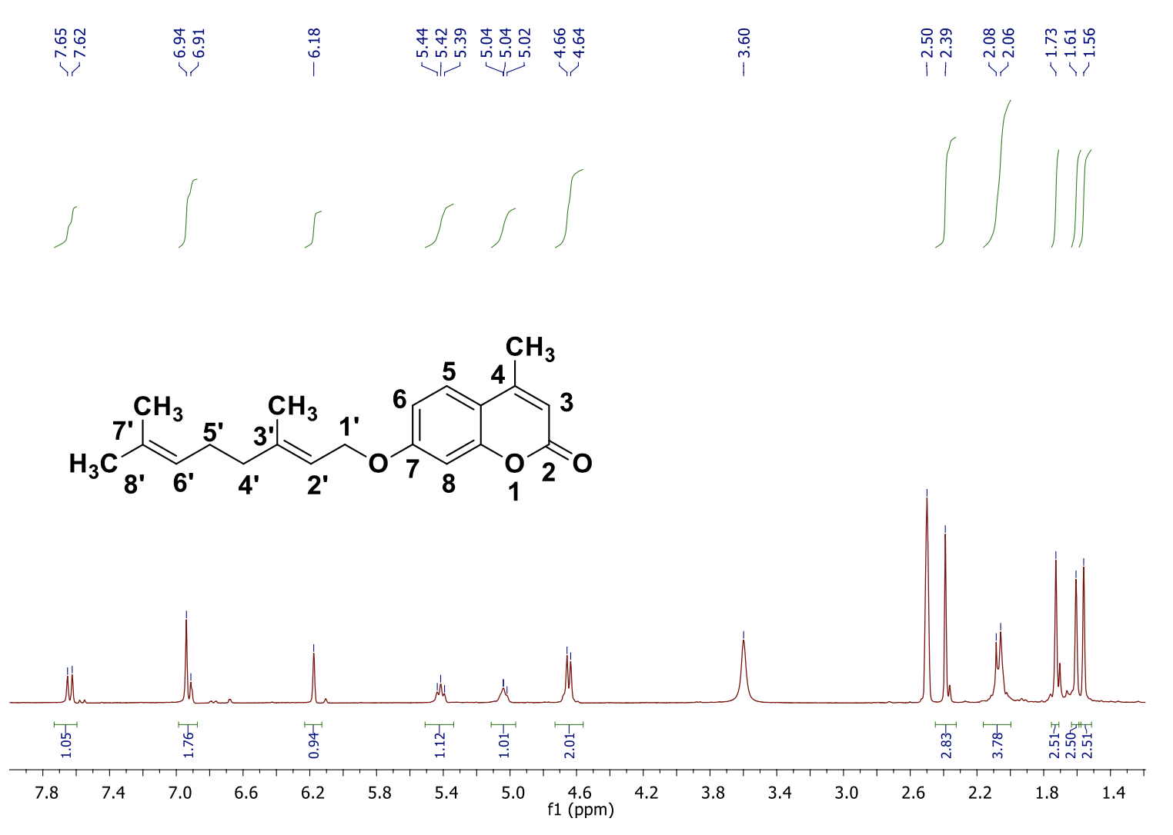

7-farnesyloxy-4-methyl-2H-chromen-2-one (4c)
¹H NMR
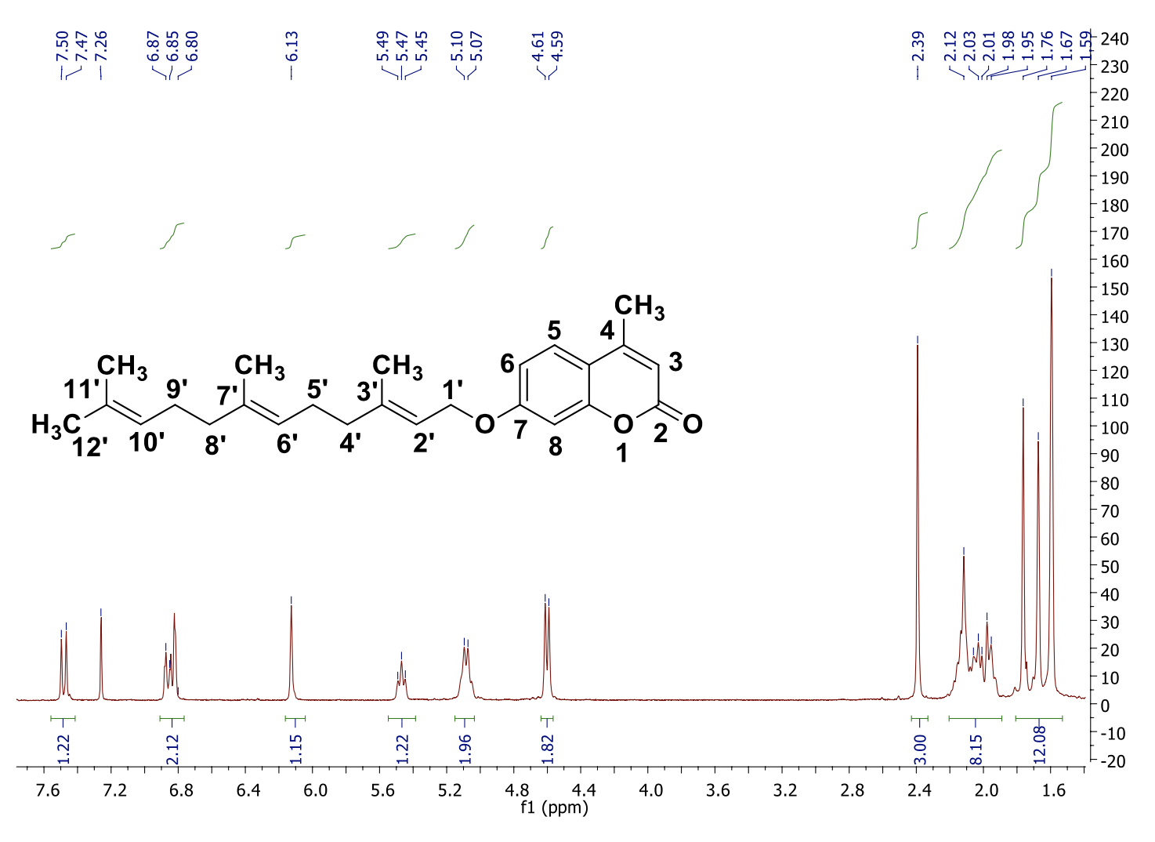

¹³C NMR
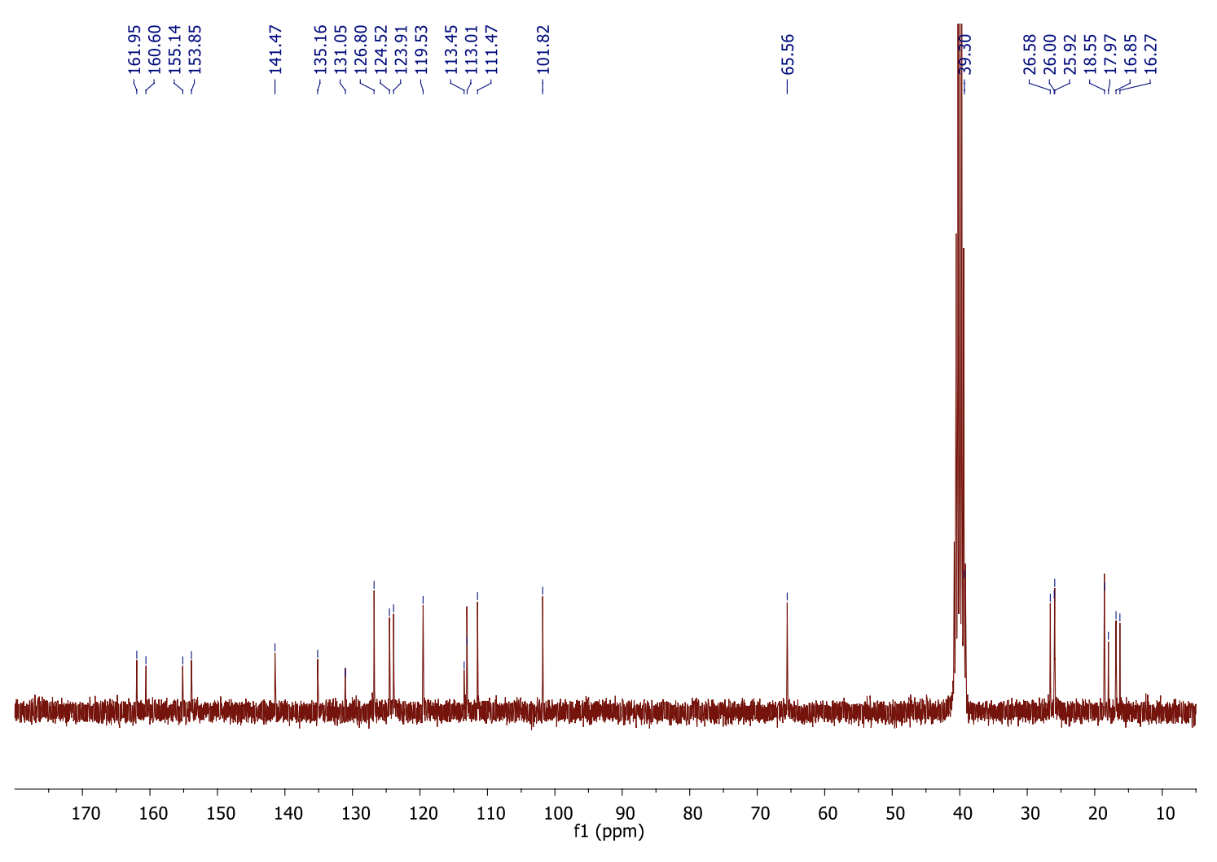
7-prenyloxy-4-propyl-2H-chromen-2-one (4e)
¹H NMR
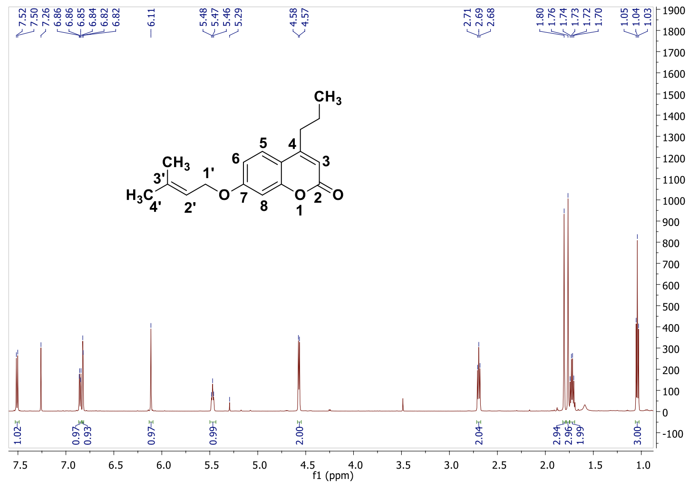

¹³C NMR
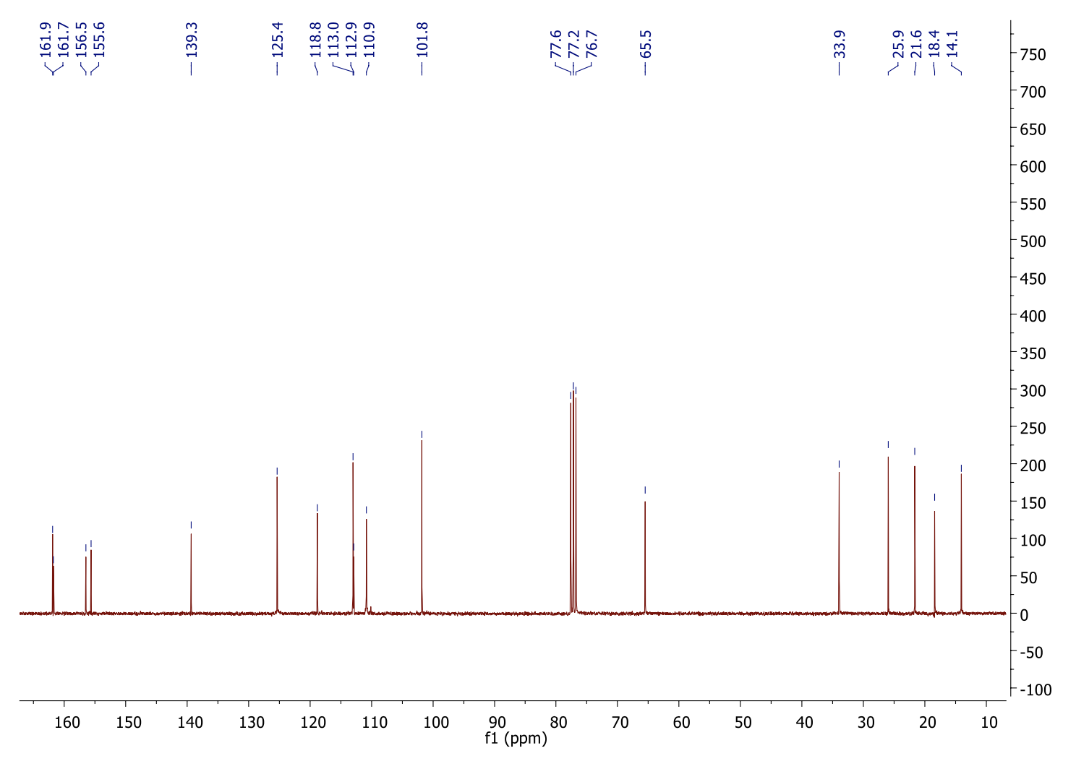
7-octyloxy-4-propyl-2H-chromen-2-one (4f)
¹H NMR
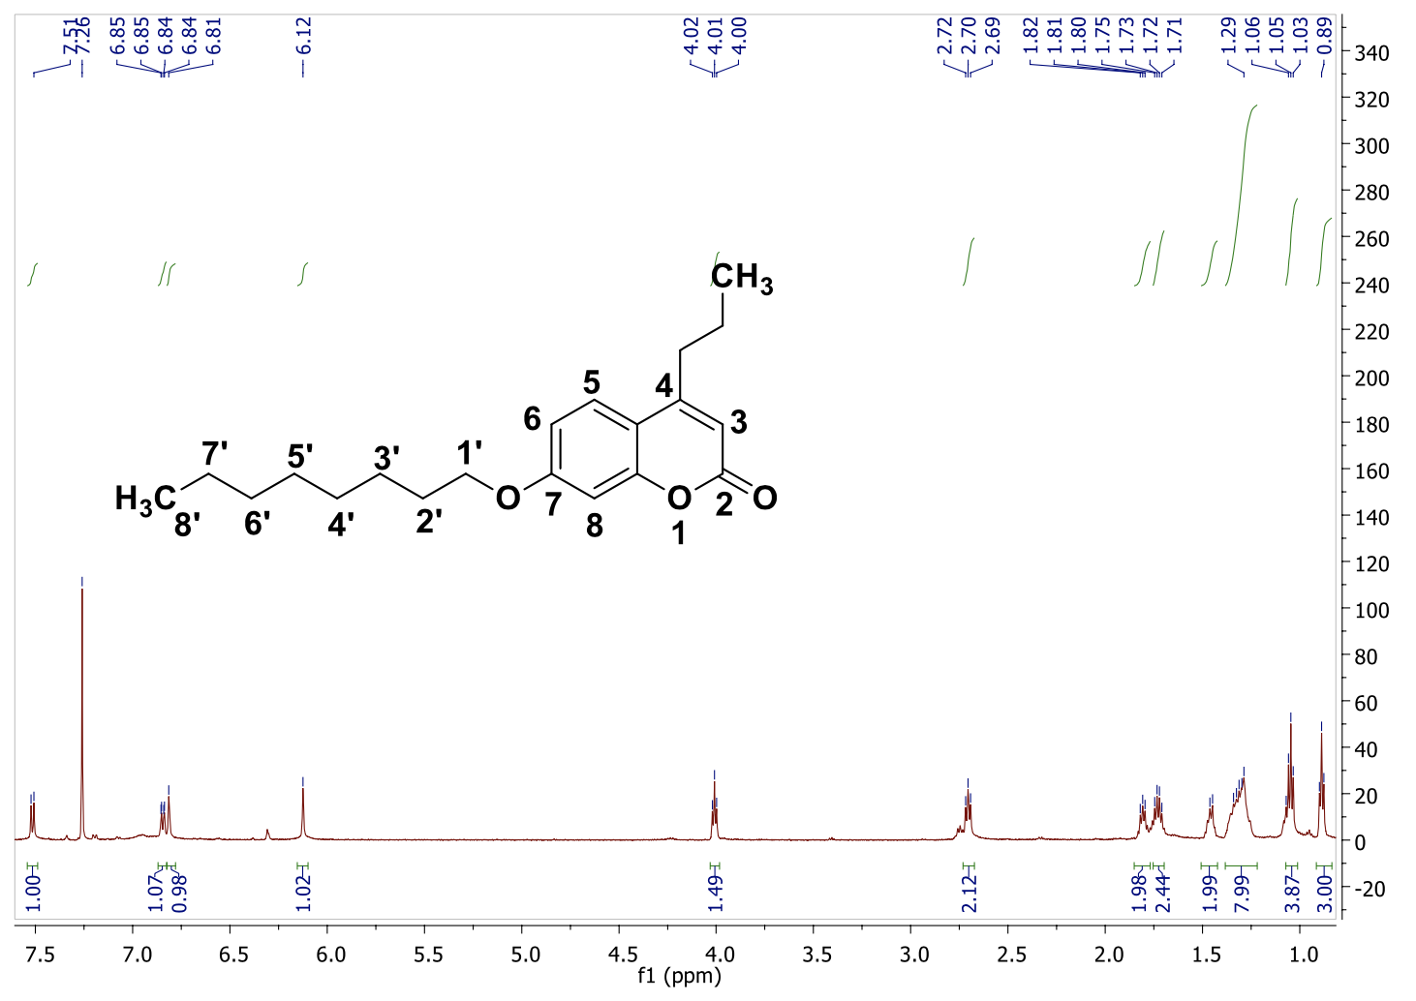

¹³C NMR
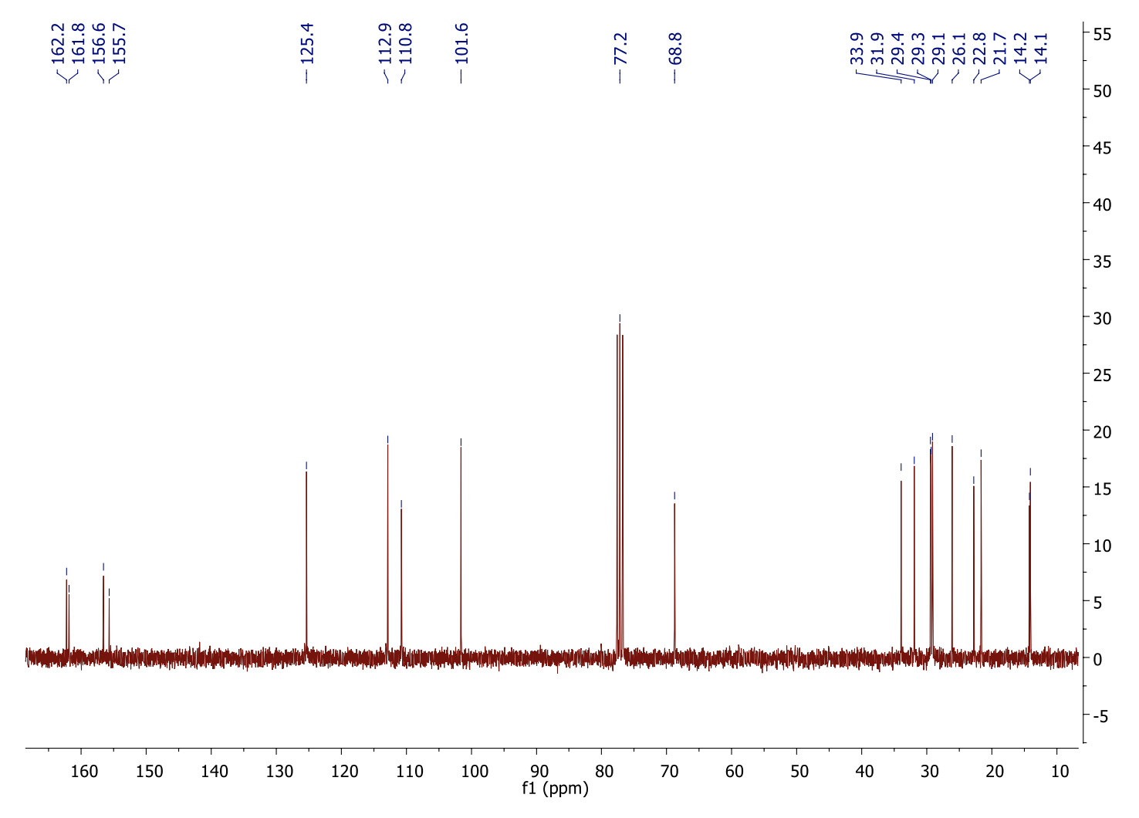
5,7-diprenyloxy-4-methyl-2H-chromen-2-one (4g)
¹H NMR
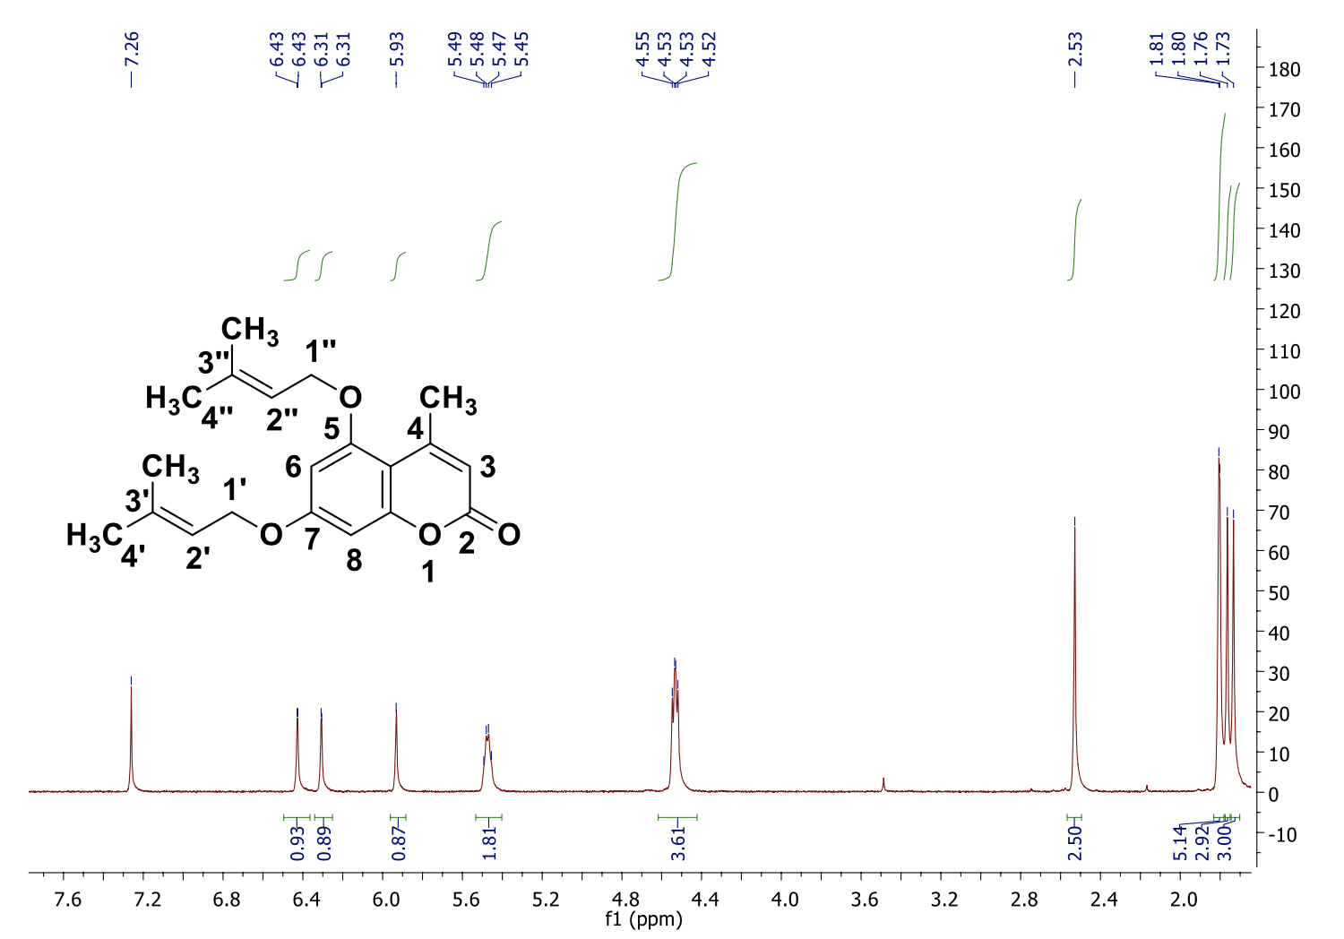

¹³C NMR
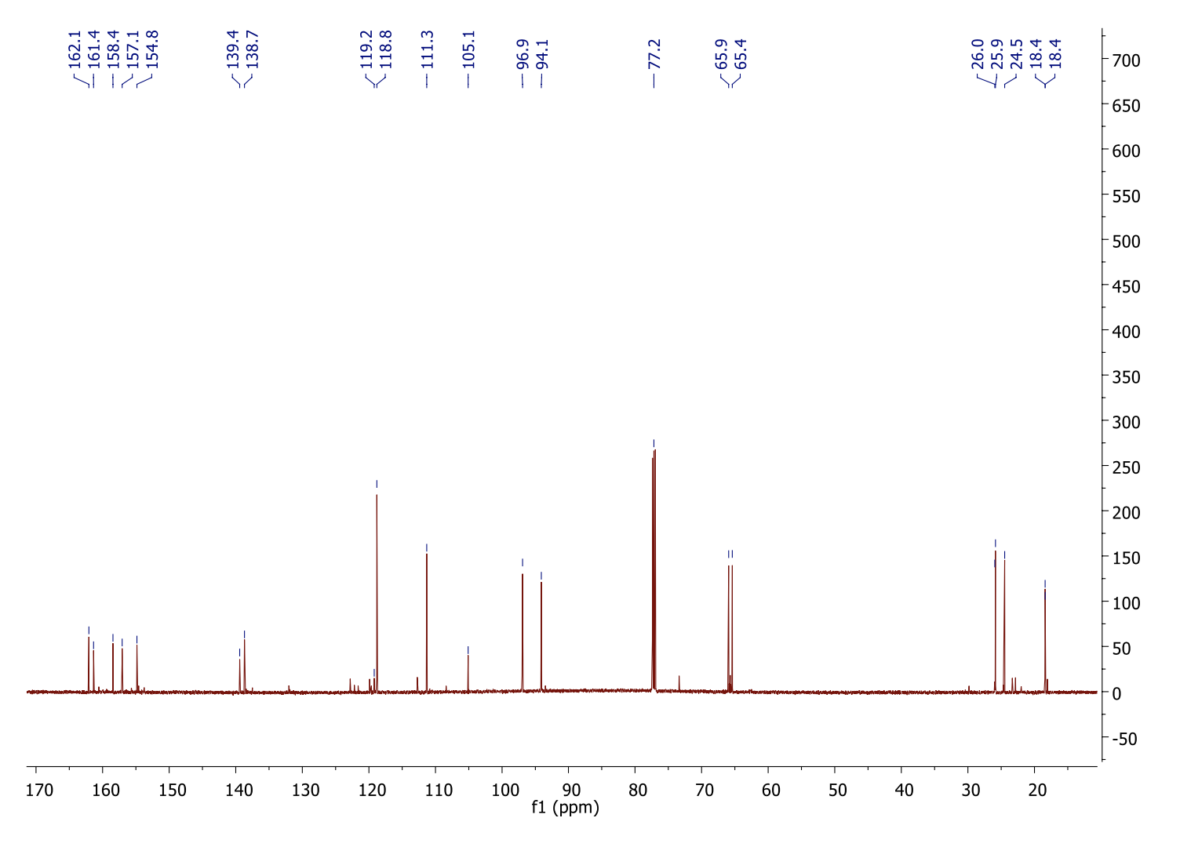

5,7-diprenyloxy-4-propyl-2H-chromen-2-one (4h)
¹H NMR
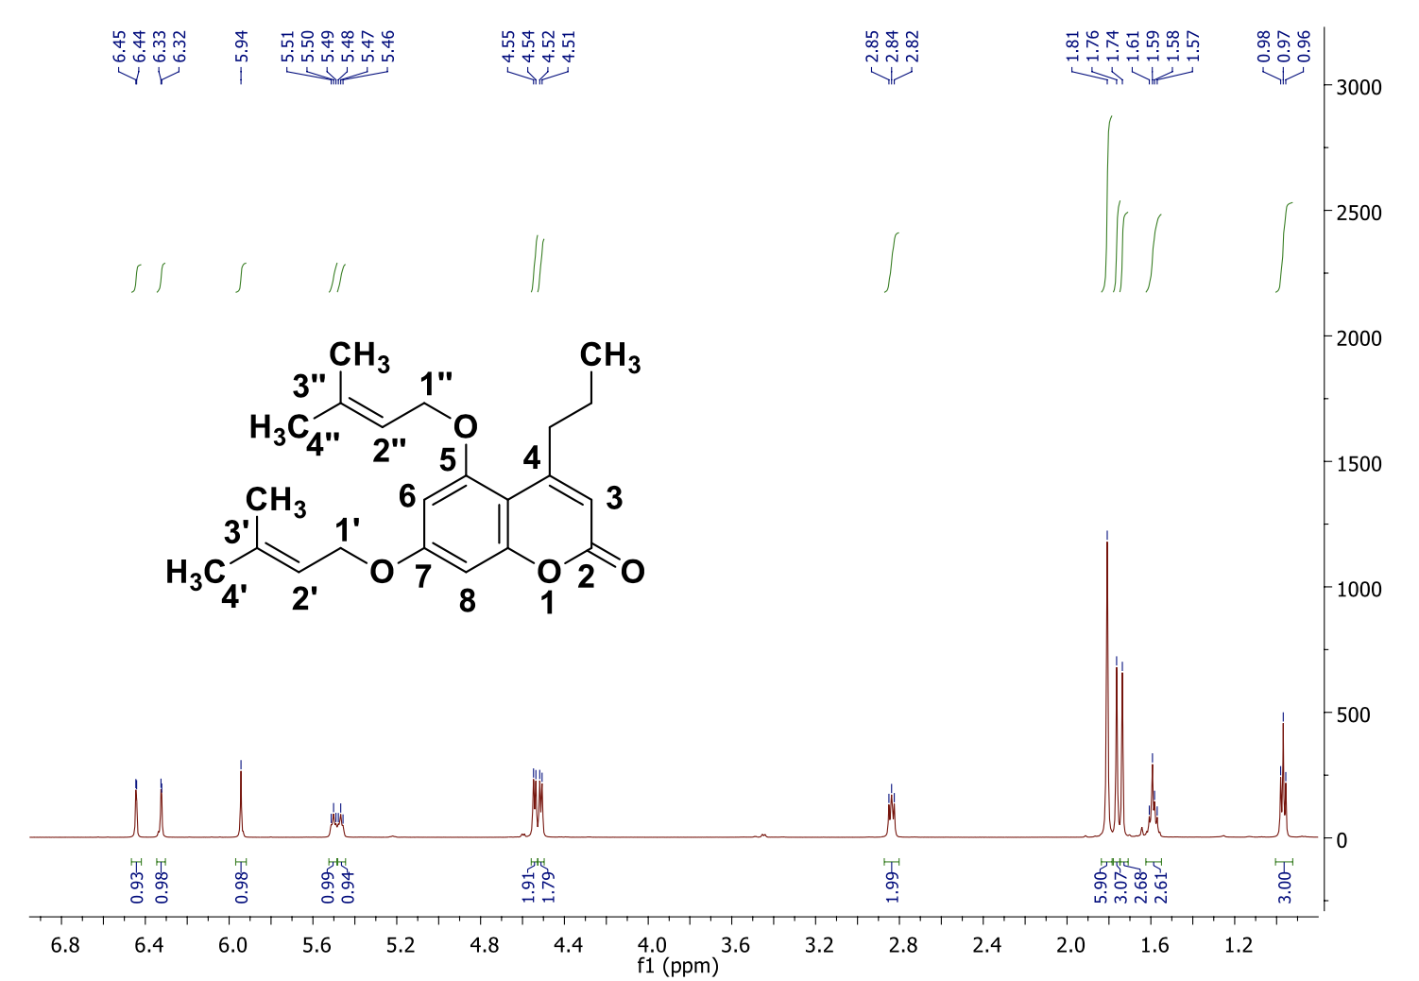

¹³C NMR
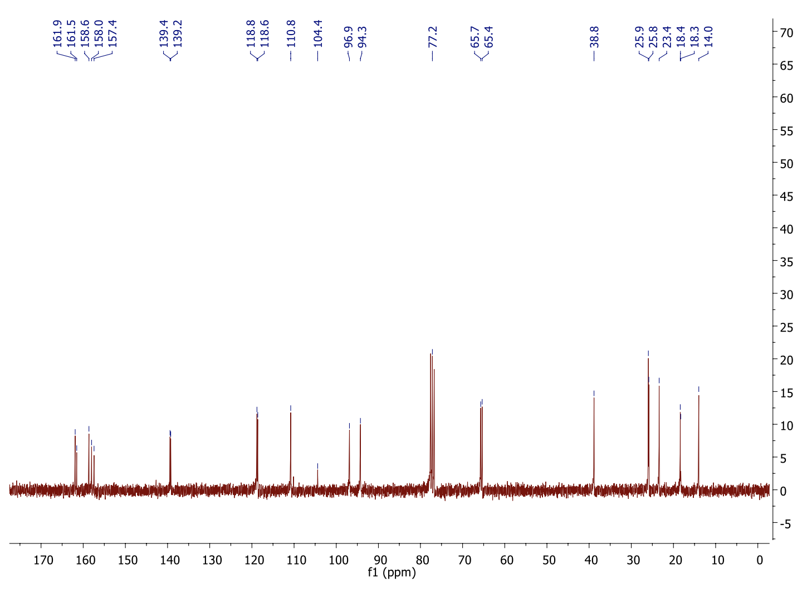
5,7-digeranyloxy-4-propyl-2H-chromen-2-one (4i)
¹H NMR
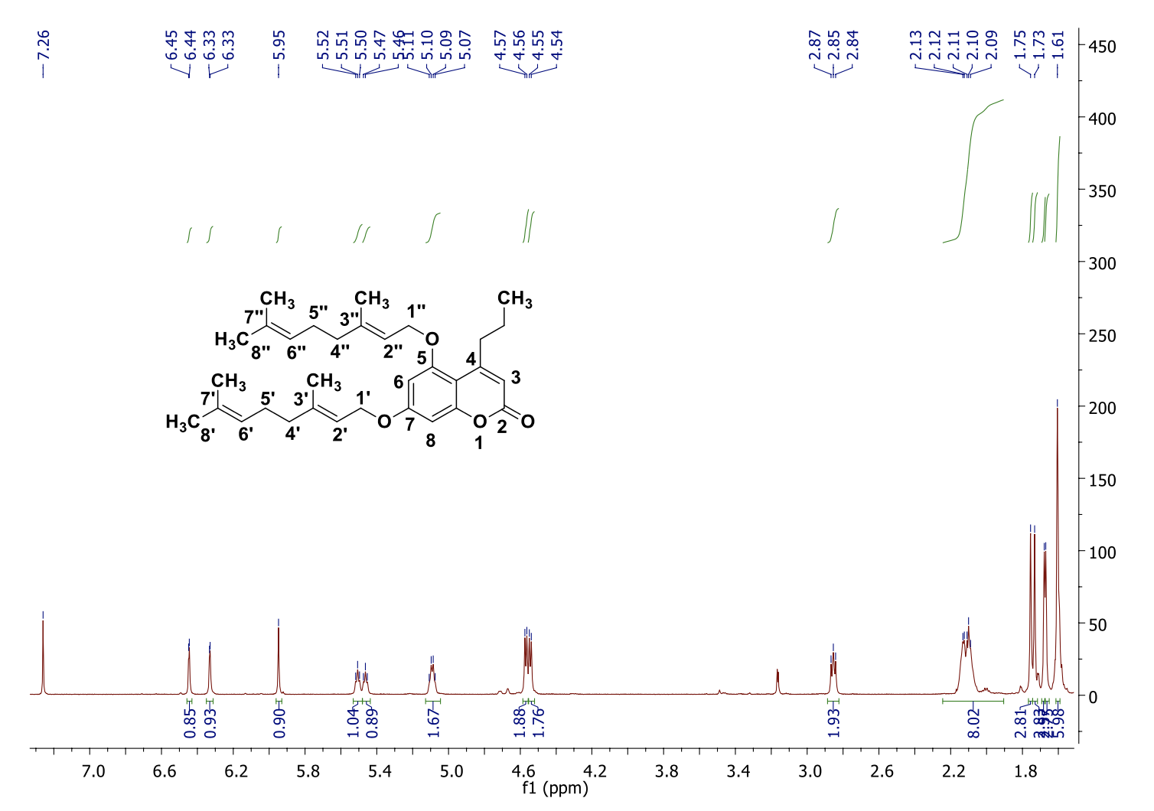

¹³C NMR
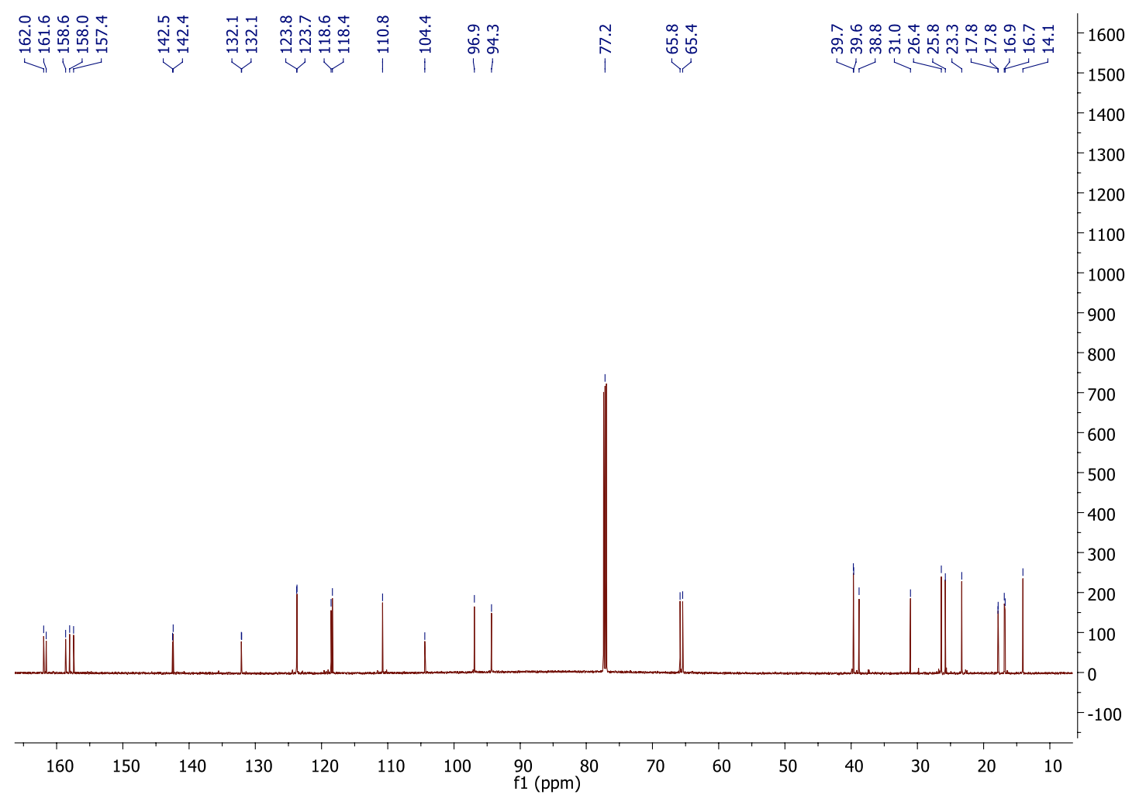

7-prenyloxy-2H-chromen-2-one (4j)
¹H NMR
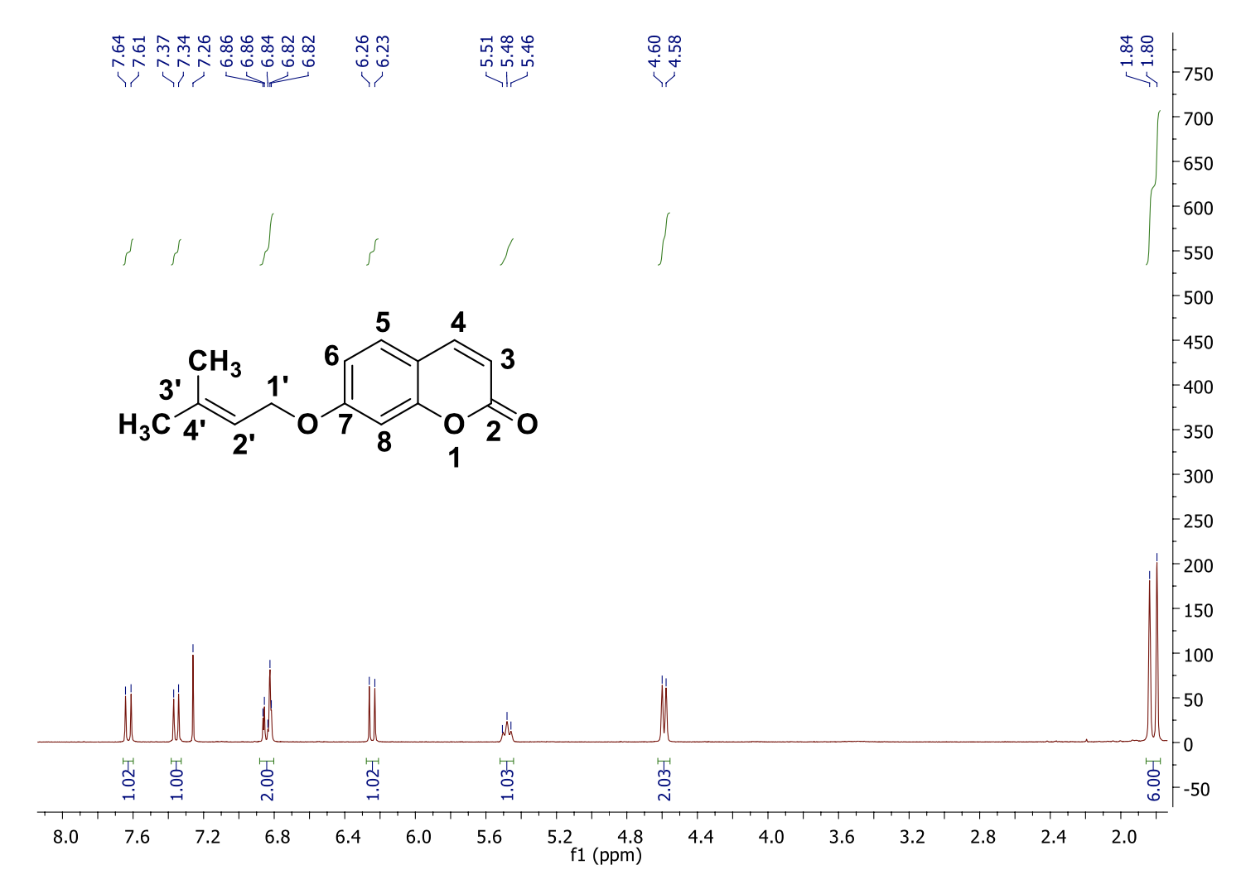

7-geranyloxy-2H-chromen-2-one (Auraptene) (4k)
¹H NMR
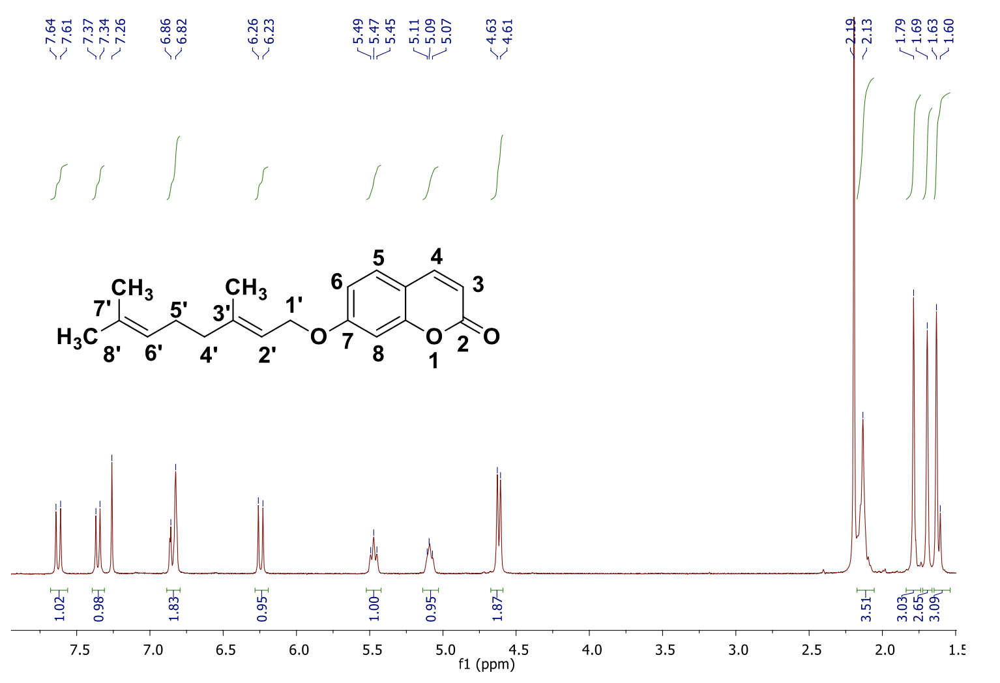

7-farnesyloxy- coumarin (Umbelliprenin) (4l)
¹H NMR
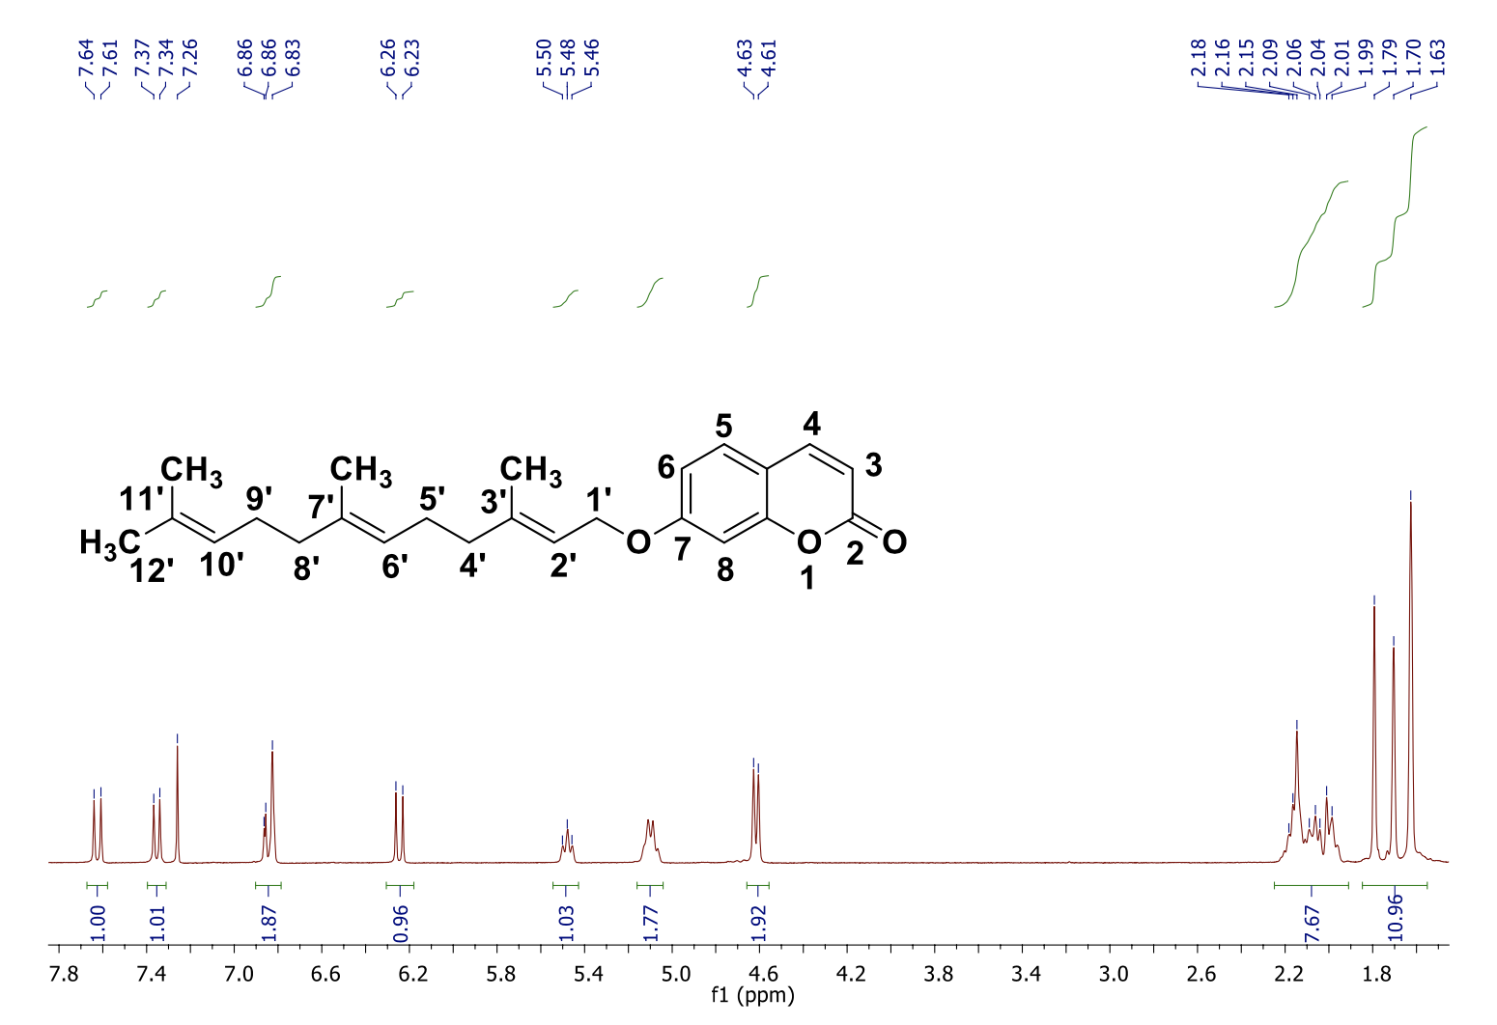

7-geranylgeranyloxy-coumarin (4m)
¹H NMR
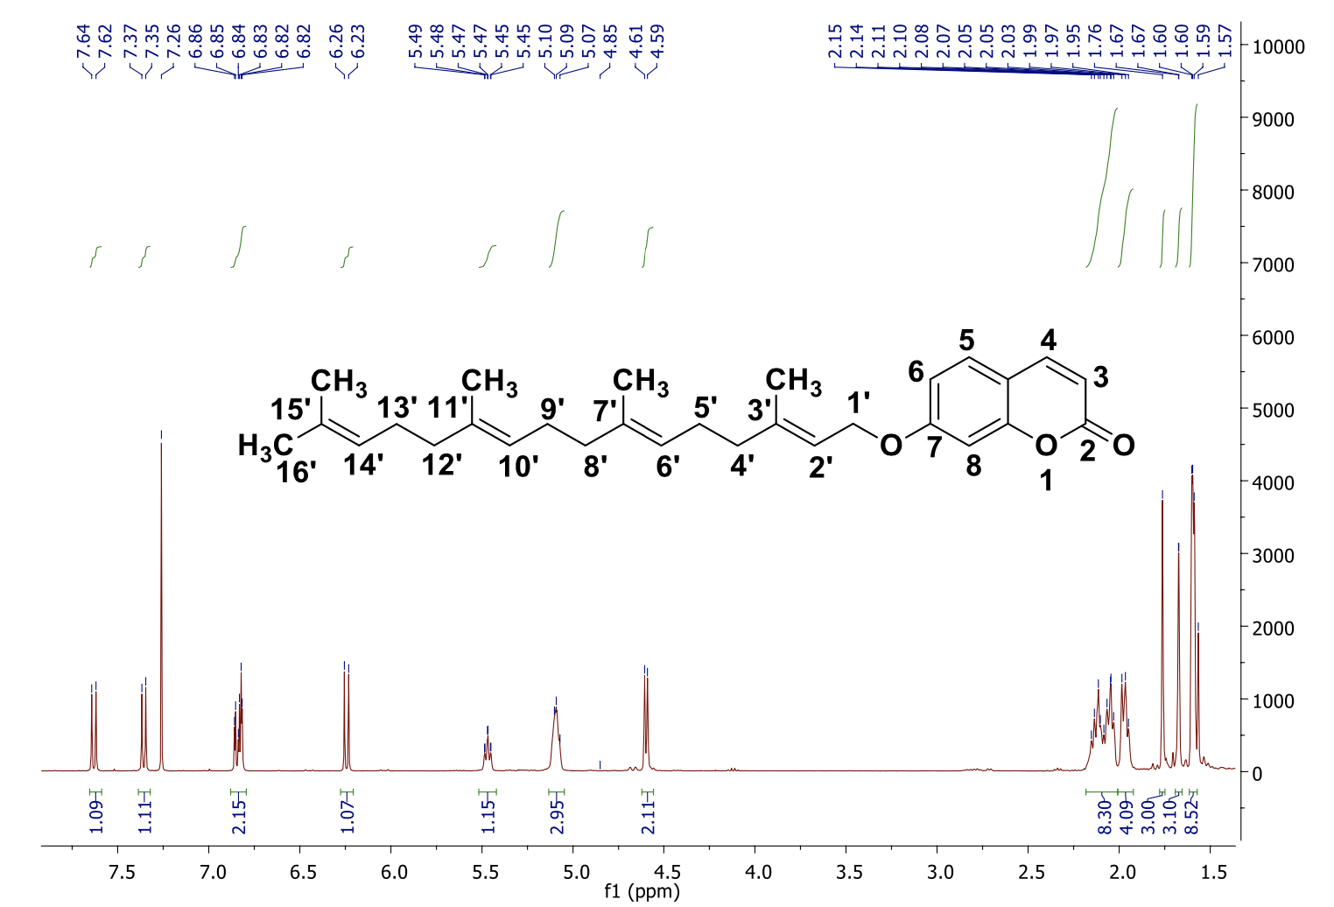

5,7-diacetyloxy-4-methyl-2H-chromen-2-one (5)
¹H NMR
