Mono- and diacylated imidazolidine-2-thione derivatives: synthesis, antiproliferative activity and computational studies
Anna Scarsi ^{1,†}, Marco Ponassi ², Chiara Brullo ¹, Camillo Rosano ² and Andrea Spallarossa ^{1,}*

¹ Department of Pharmacy, University of Genova, viale Benedetto XV, 3, 16132, Genova, Italy; anna.scarsi@iit.it (A.S.); chiara.brullo@unige.it (C.B.).
² Proteomics and Mass Spectrometry Unit, IRCCS Ospedale Policlinico San Martino, Largo R. Benzi 10, 16132, Genova, Italy; marco.ponassi@hsanmartino.it (M.P.); camillo.rosano@hsanmartino.it (C.R.).
† Current address: IIT, Via Morego, 30, 16163 Genova, Italy
* Correspondence: andrea.spallarossa@unige.it

Index
Fig. S1 ¹H NMR (400 MHz, DMSO-D₆) of compound 2a
Fig. S2 ¹³C NMR (101 MHz, DMSO-D₆) of compound 2a
Fig. S3 ¹H NMR (400 MHz, DMSO-D₆) of compound 2b
Fig. S4 ¹³C NMR (101 MHz, DMSO-D₆) of compound 2b
Fig. S5 ¹H NMR (400 MHz, DMSO-D₆) of compound 2c
Fig. S6 ¹³C NMR (101 MHz, DMSO-D₆) of compound 2c
Fig. S7 ¹H NMR (400 MHz, DMSO-D₆) of compound 2d
Fig. S8 ¹³C NMR (101 MHz, DMSO-D₆) of compound 2d
Fig. S9 ¹H NMR (400 MHz, DMSO-D₆) of compound 2e
Fig. S10 ¹H NMR (400 MHz, DMSO-D₆) of compound 2f
Fig. S11 ¹H NMR (400 MHz, DMSO-D₆) of compound 2g
Fig. S12 ¹H NMR (200 MHz, DMSO-D₆) of compound 2h
Fig. S13 ¹H NMR (400 MHz, DMSO-D₆) of compound 2j
Fig. S14 ¹³C NMR (101 MHz, DMSO-D₆) of compound 2j
Fig. S15 ¹H NMR (400 MHz, CDCl₃) of compound 3i
Fig. S16 ¹H NMR (200 MHz, CDCl₃) of compound 3k
Fig. S17 ¹H NMR (400 MHz, DMSO-D₆) of compound 3l
Fig. S18 ¹³C NMR (101 MHz, DMSO-D₆) of compound 3l
Fig. S19¹H NMR (400 MHz, CDCl₃) of compound 4
Fig. S20 ¹³C NMR (101 MHz, CDCl₃) of compound 4
Fig. S21 ¹H NMR (300 MHz, CDCl₃) of compound 5
Fig. S22 ¹H NMR (400 MHz, DMSO-D₆) of compound 6
Fig. S23 ¹H NMR (200 MHz, CDCl₃) of compound 7
Fig. S24 ¹H NMR (400 MHz, CDCl₃) of compound 8
Fig. S25 ¹³C NMR (101 MHz, CDCl₃) of compound 8
Fig. S26 ¹H NMR (400 MHz, CDCl₃) of compound 9
Fig. S27 ¹³C NMR (101 MHz, CDCl₃) of compound 9
Fig. S28 ¹H NMR (400 MHz, CDCl₃) of compound 10
Fig. S29 ¹³C NMR (101 MHz, CDCl₃) of compound 10
Fig. S30 Partial charge distribution of benzoyl chloride (A), 4-chlorobenzoyl chloride (B), 4-anisoyl chloride (C) and their corresponding intermediates II (D-F).

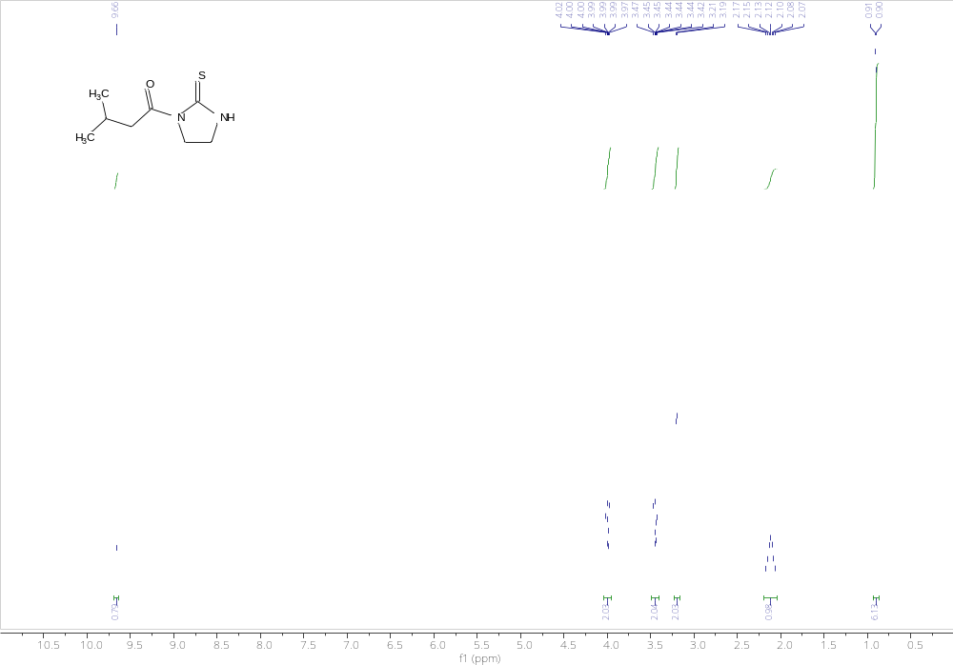
Fig. S1 ¹H NMR (400 MHz, DMSO-D₆) of compound 2a

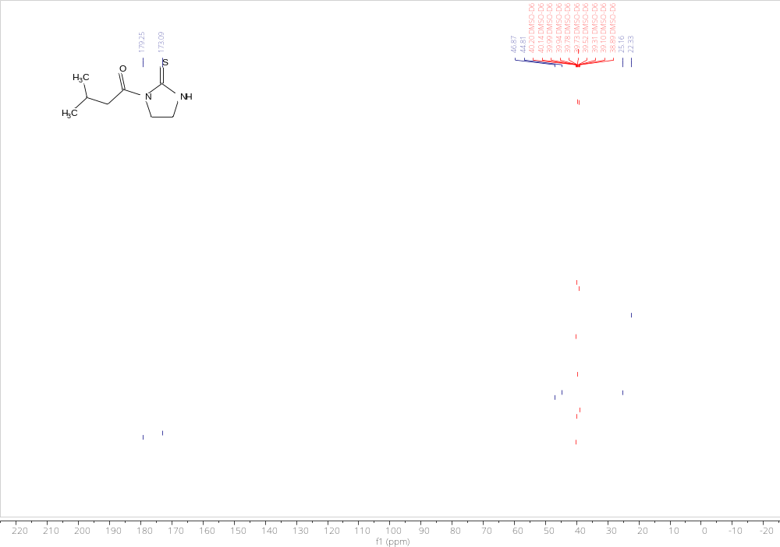
Fig. S2 ¹³C NMR (101 MHz, DMSO-D₆) of compound 2a
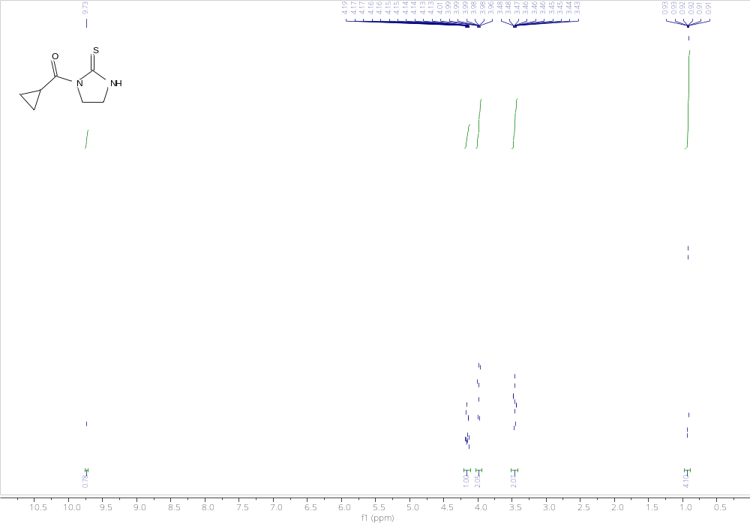
Fig. S3 ¹H NMR (400 MHz, DMSO-D₆) of compound 2b

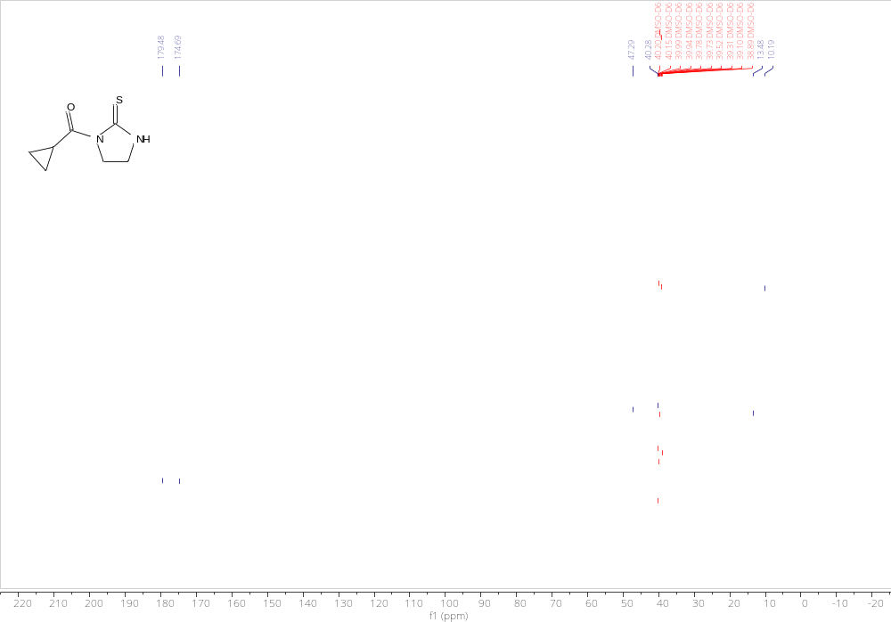
Fig. S4 ¹³C NMR (101 MHz, DMSO-D₆) of compound 2b
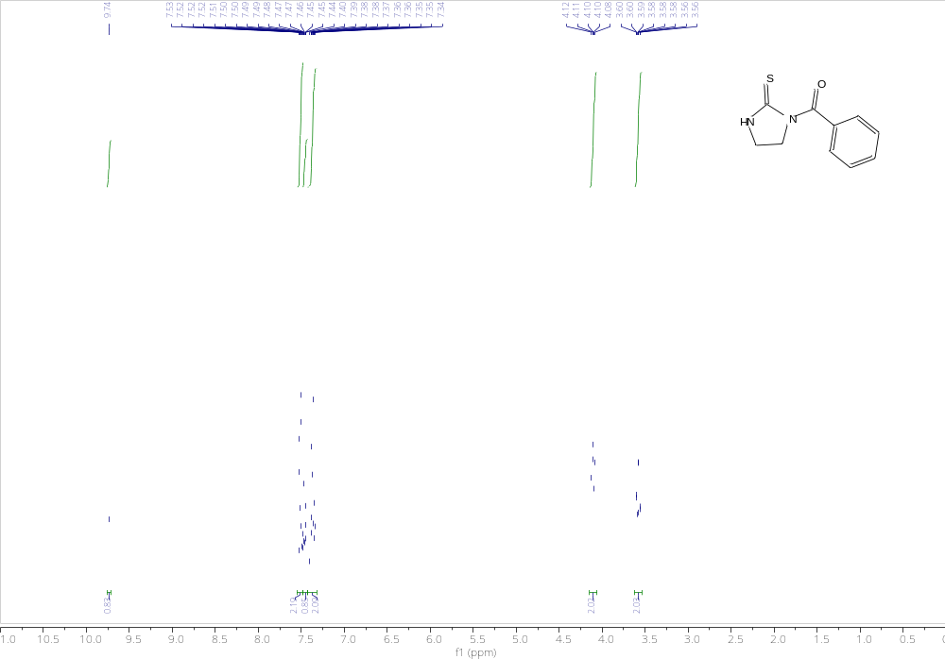
Fig. S5 ¹H NMR (400 MHz, DMSO-D₆) of compound 2c

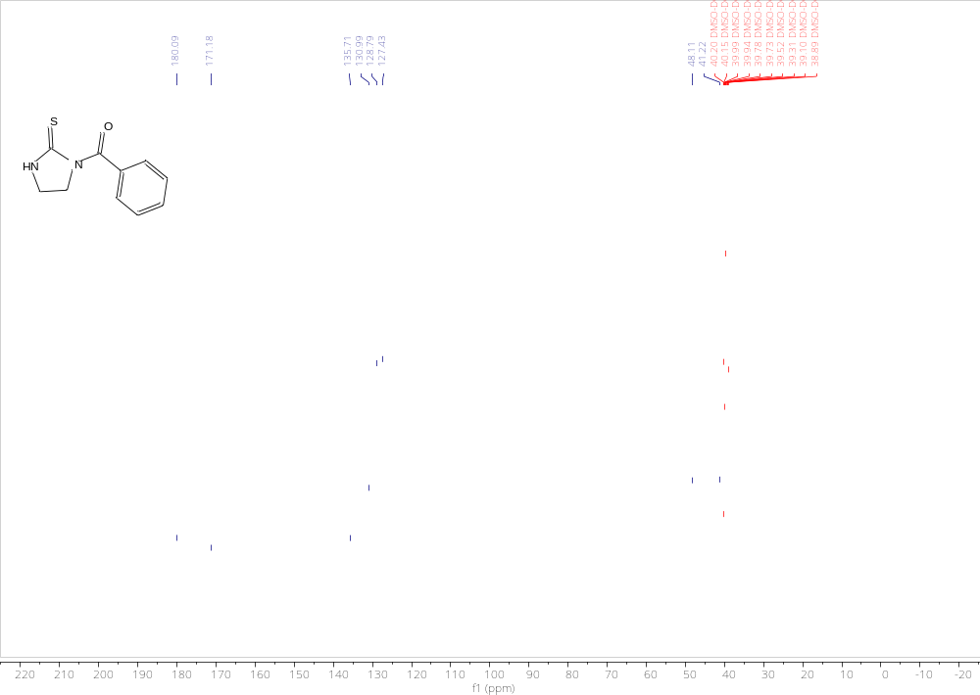
Fig. S6 ¹³C NMR (101 MHz, DMSO-D₆) of compound 2c

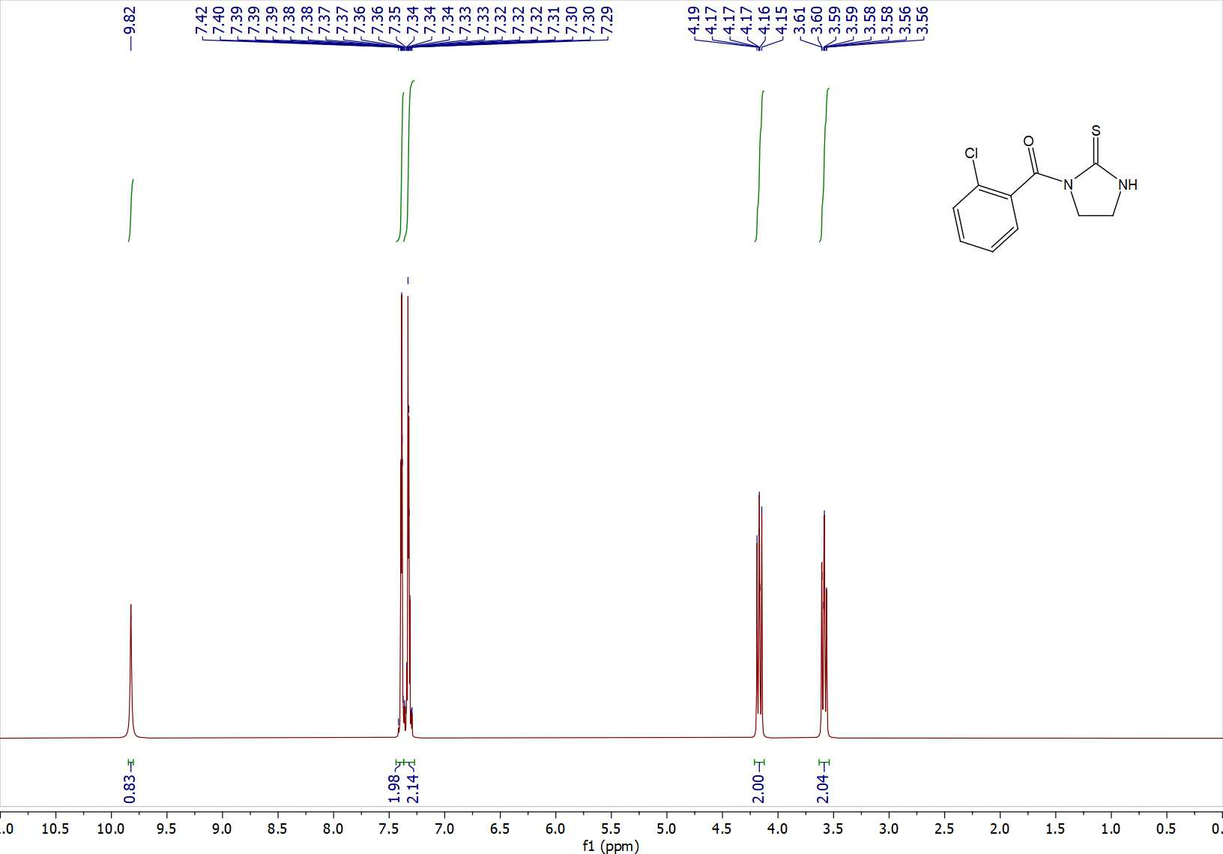
Fig. S7 ¹H NMR (400 MHz, DMSO-D₆) of compound 2d

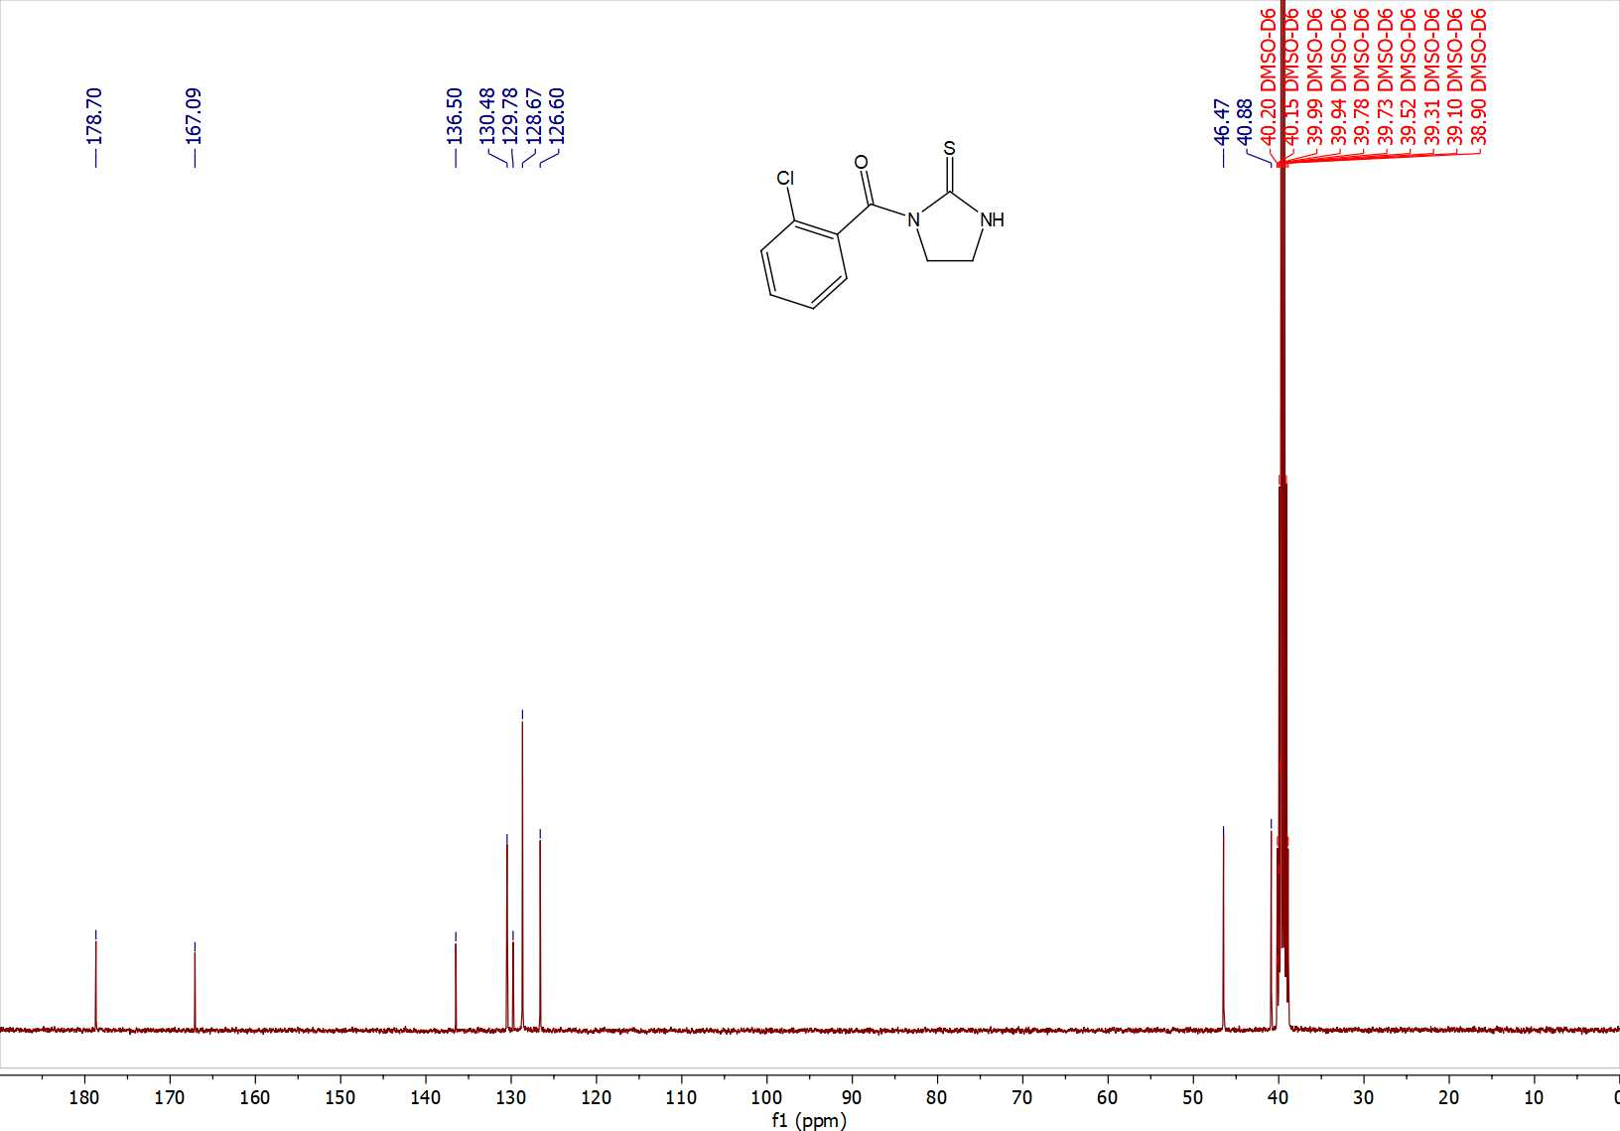
Fig. S8 ¹³C NMR (101 MHz, DMSO-D₆) of compound 2d
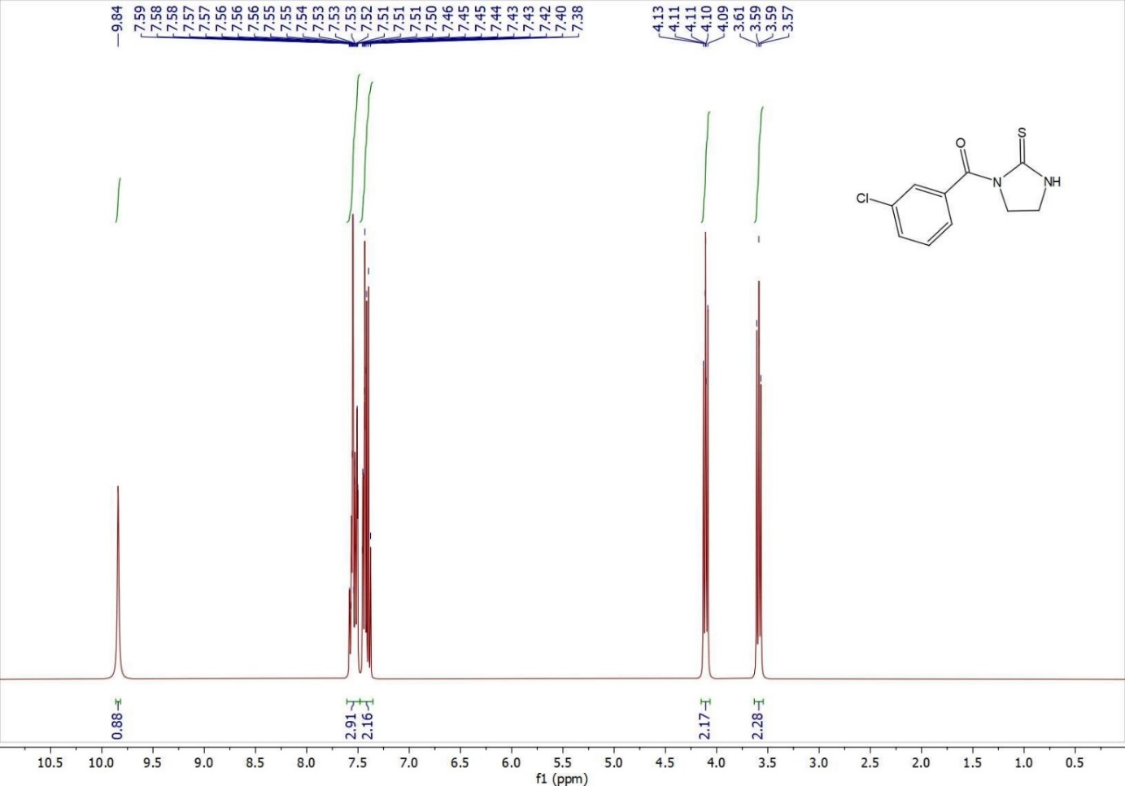
Fig. S9 ¹H NMR (400 MHz, d₆-DMSO) of compound 2e

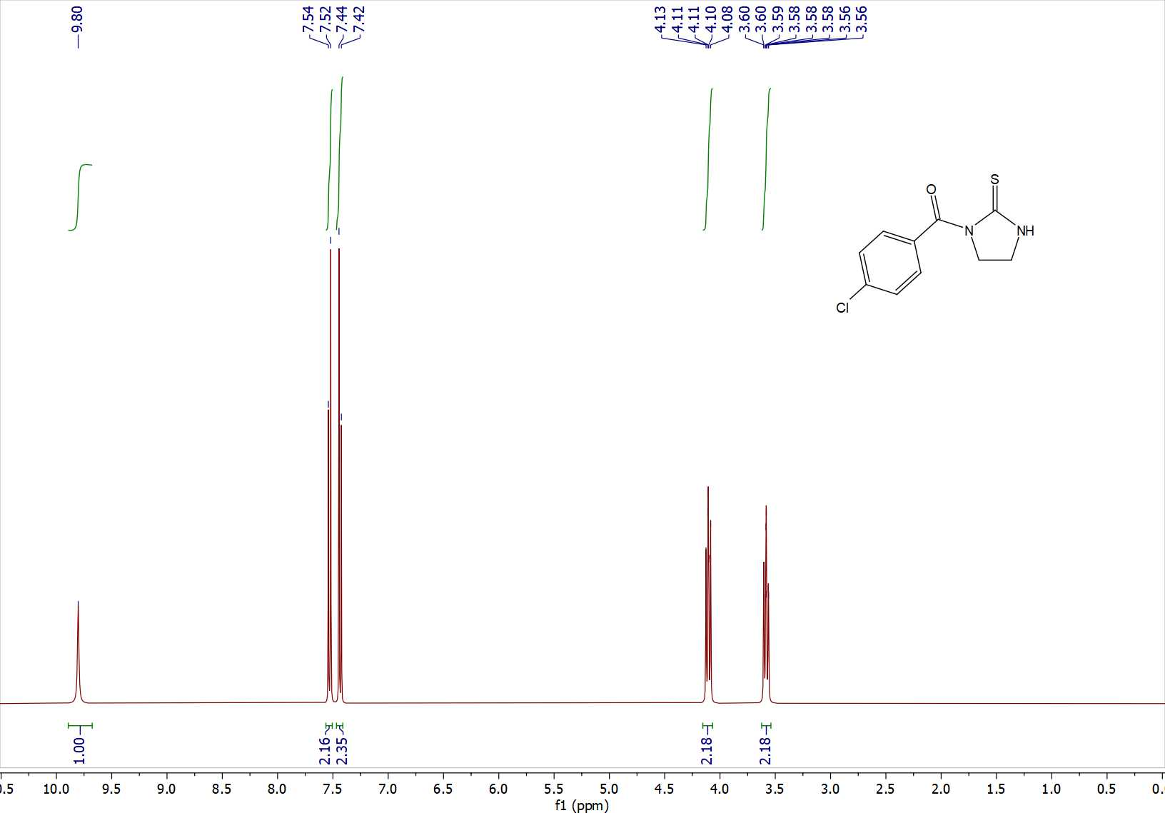
Fig. S10 ¹H NMR (400 MHz, d₆-DMSO) of compound 2f
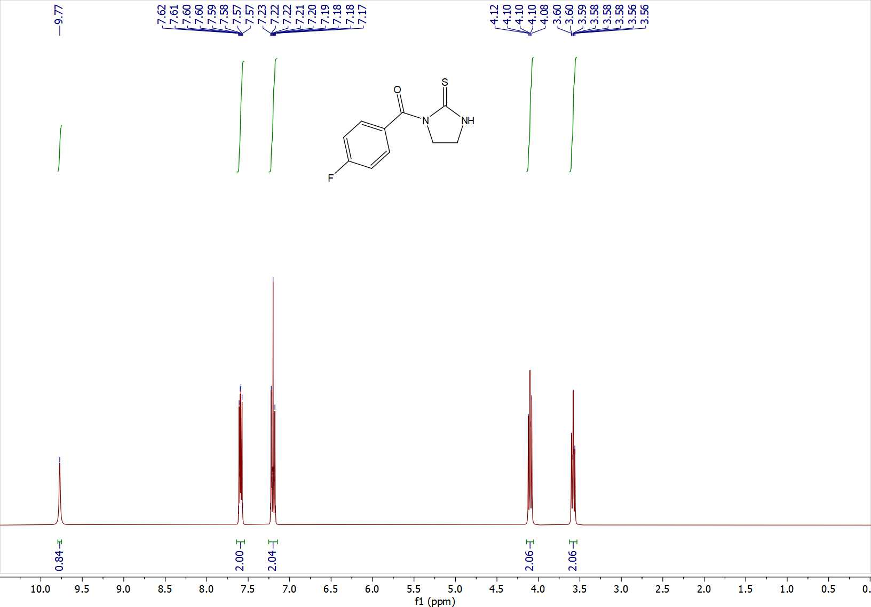
Fig. S11 ¹H NMR (400 MHz, d₆-DMSO) of compound 2g

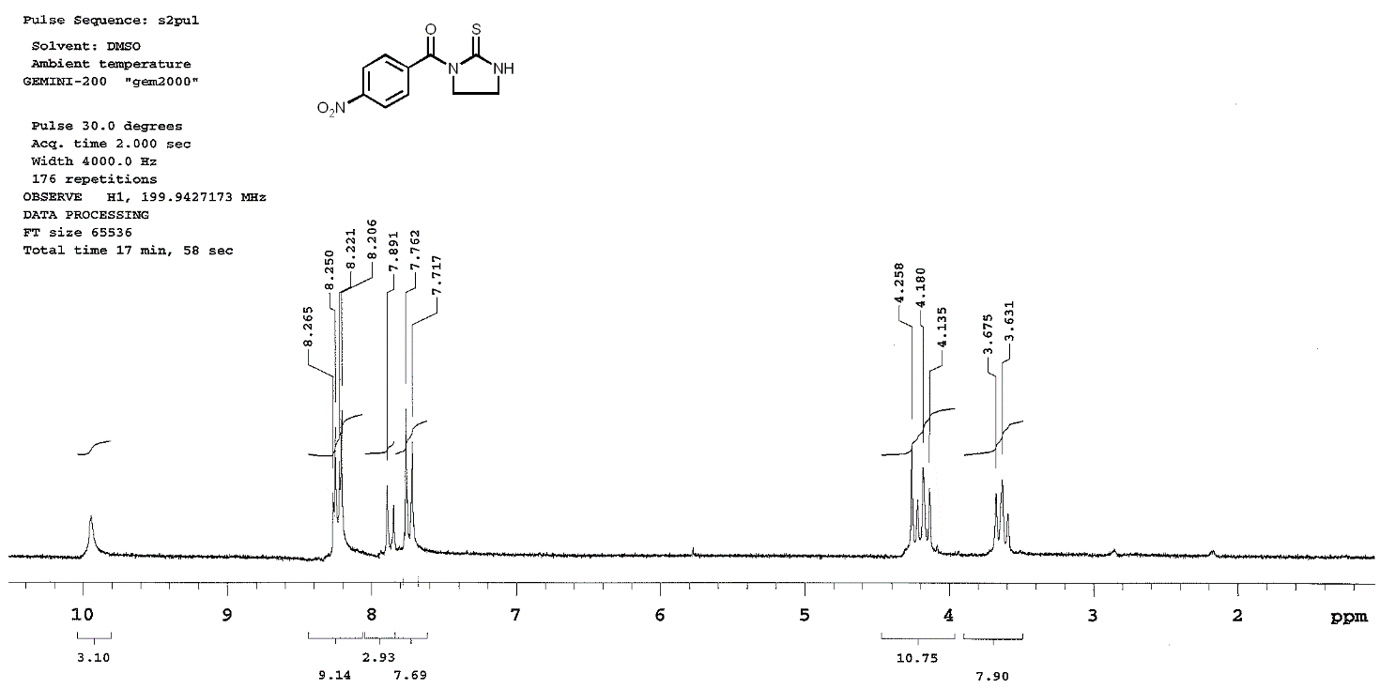
Fig. S12 ¹H NMR (200 MHz, d₆-DMSO) of compound 2h

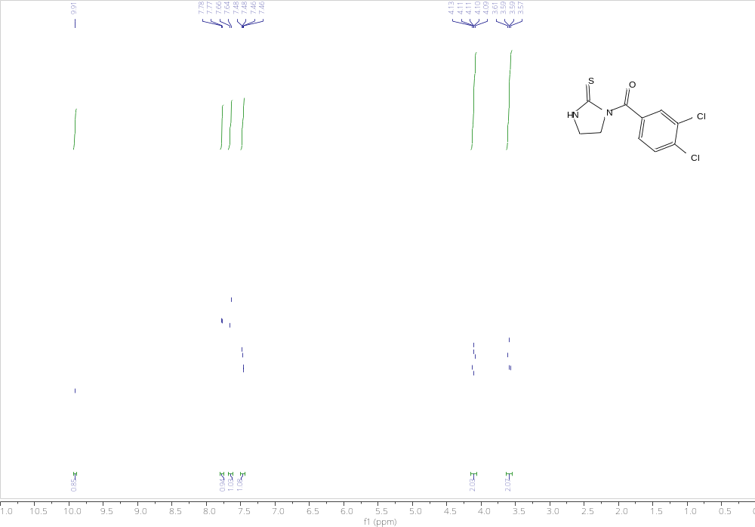
Fig. S13 ¹H NMR (400 MHz, d₆-DMSO) of compound 2j

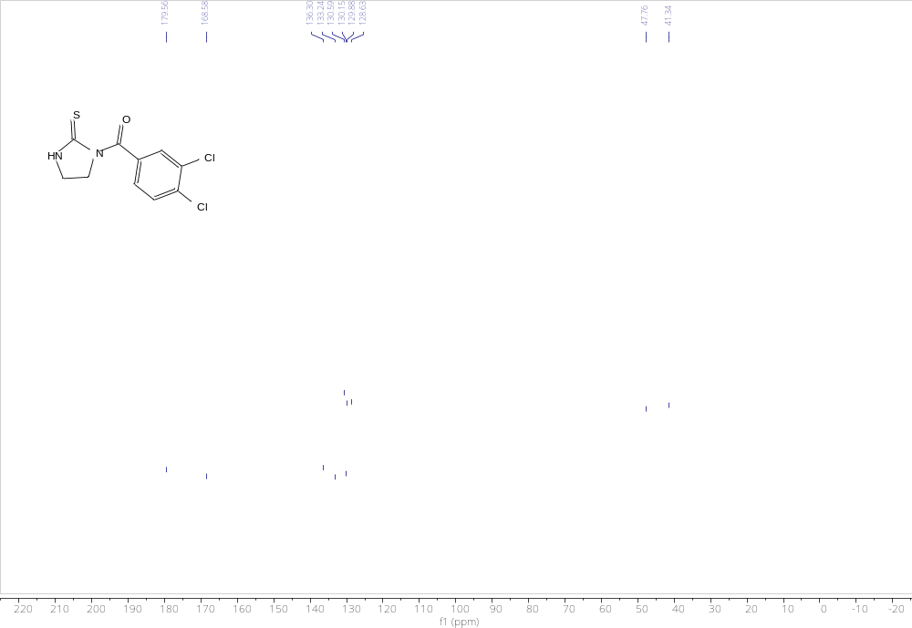
Fig. S14 ¹³C NMR (101 MHz, DMSO-D₆) of compound 2j
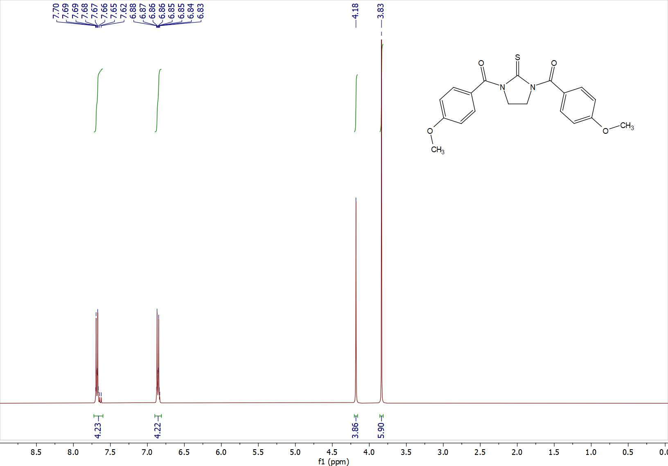
Fig. S15 ¹H NMR (400 MHz, CDCl₃) of compound 3i

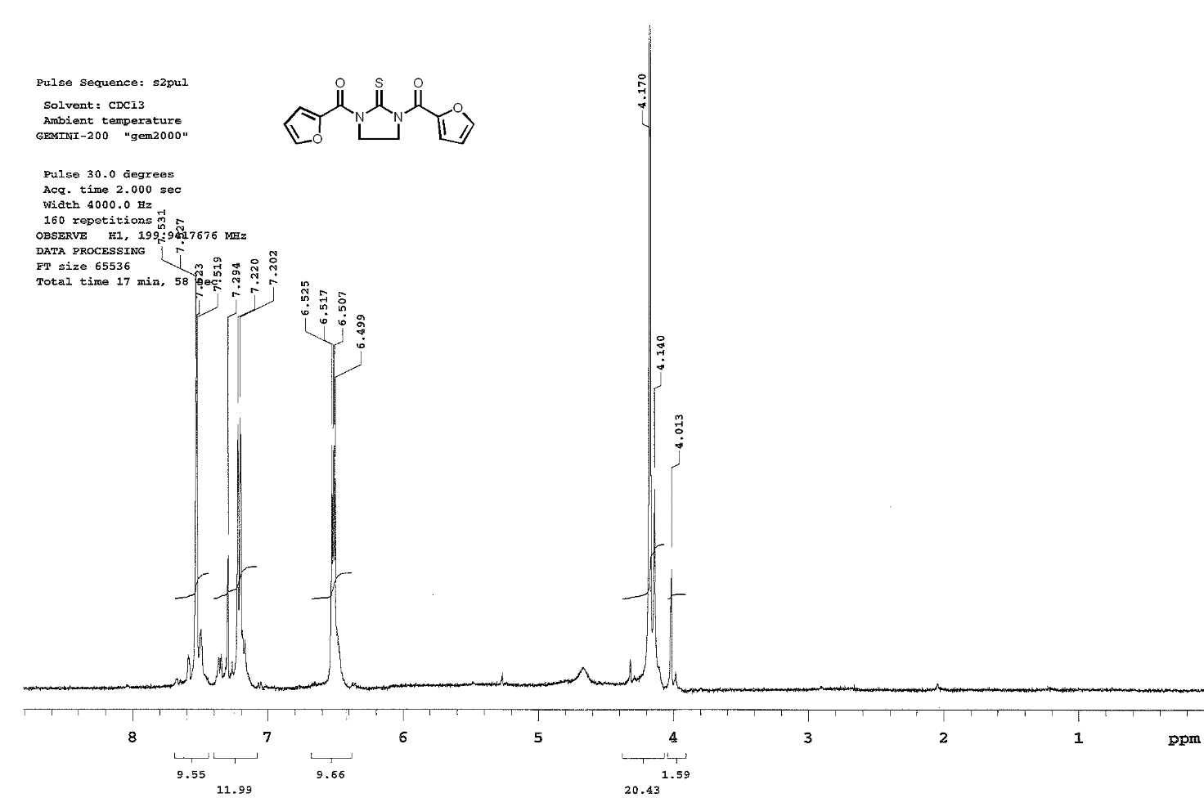
Fig. S16 ¹H NMR (200 MHz, CDCl₃) of compound 3k

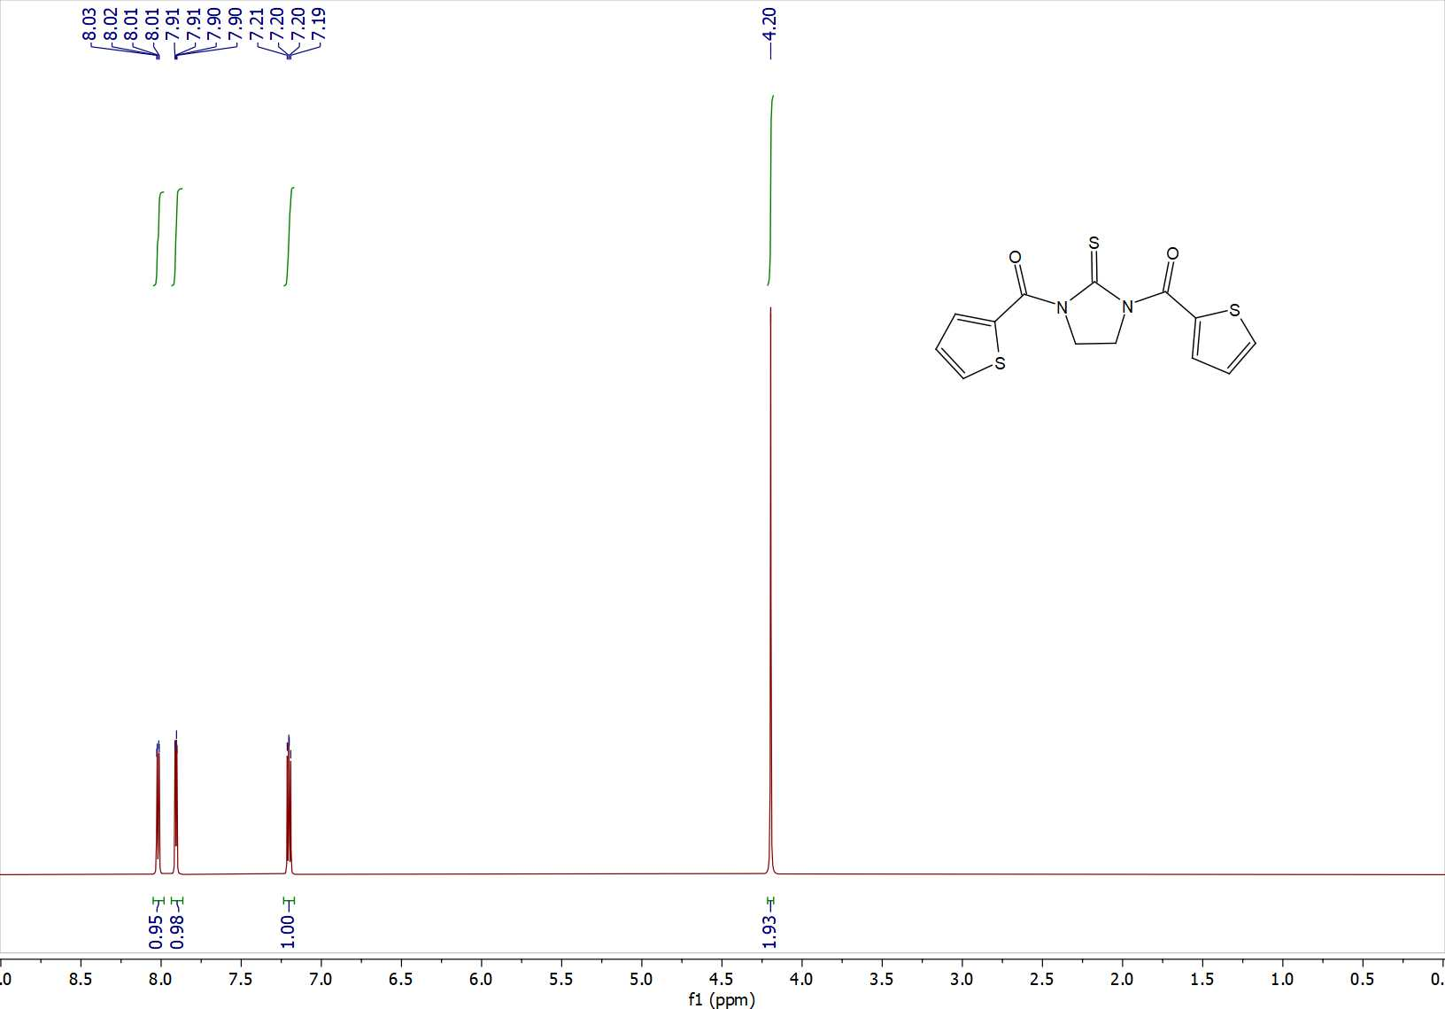
Fig. S17 ¹H NMR (400 MHz, DMSO-D6) of compound 3l
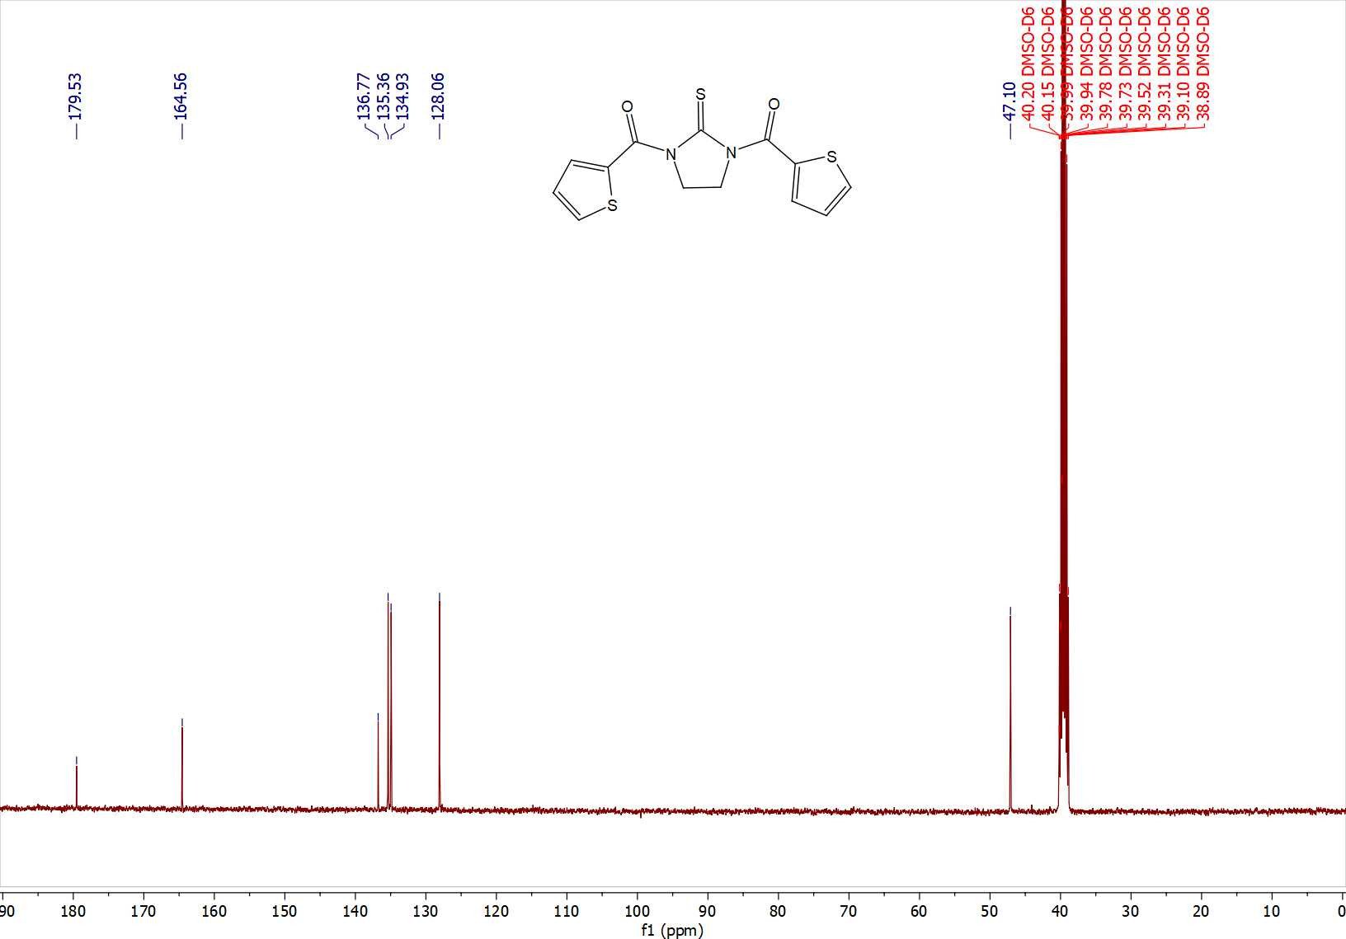
Fig. S18 ¹³C NMR (101 MHz, DMSO-D6) of compound 3l

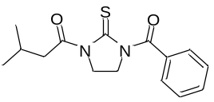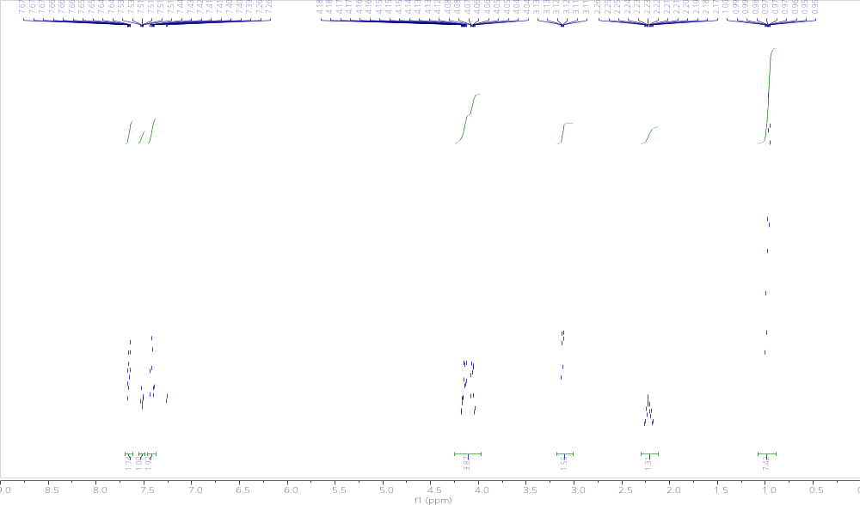
Fig. S19 ¹H NMR (400 MHz, CDCl₃) of compound 4
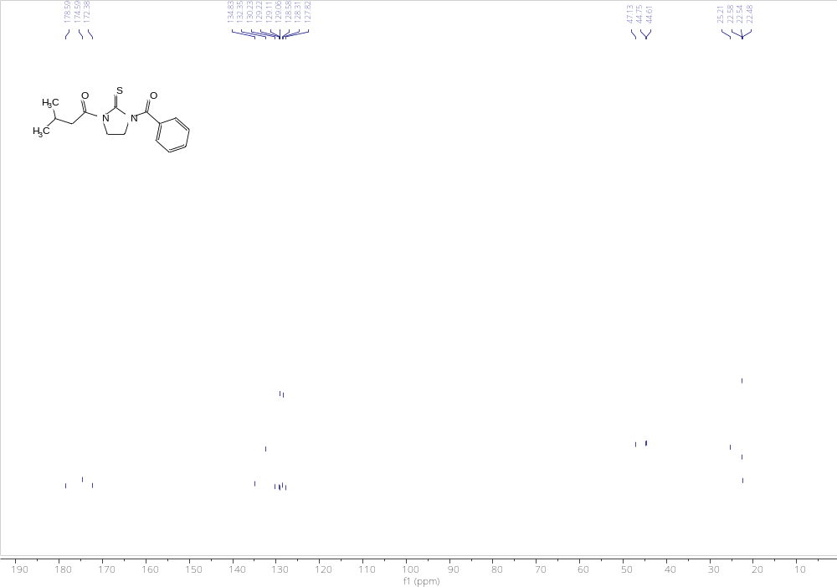
Fig. S20 ¹³C NMR (101 MHz, CDCl₃) of compound 4
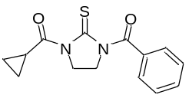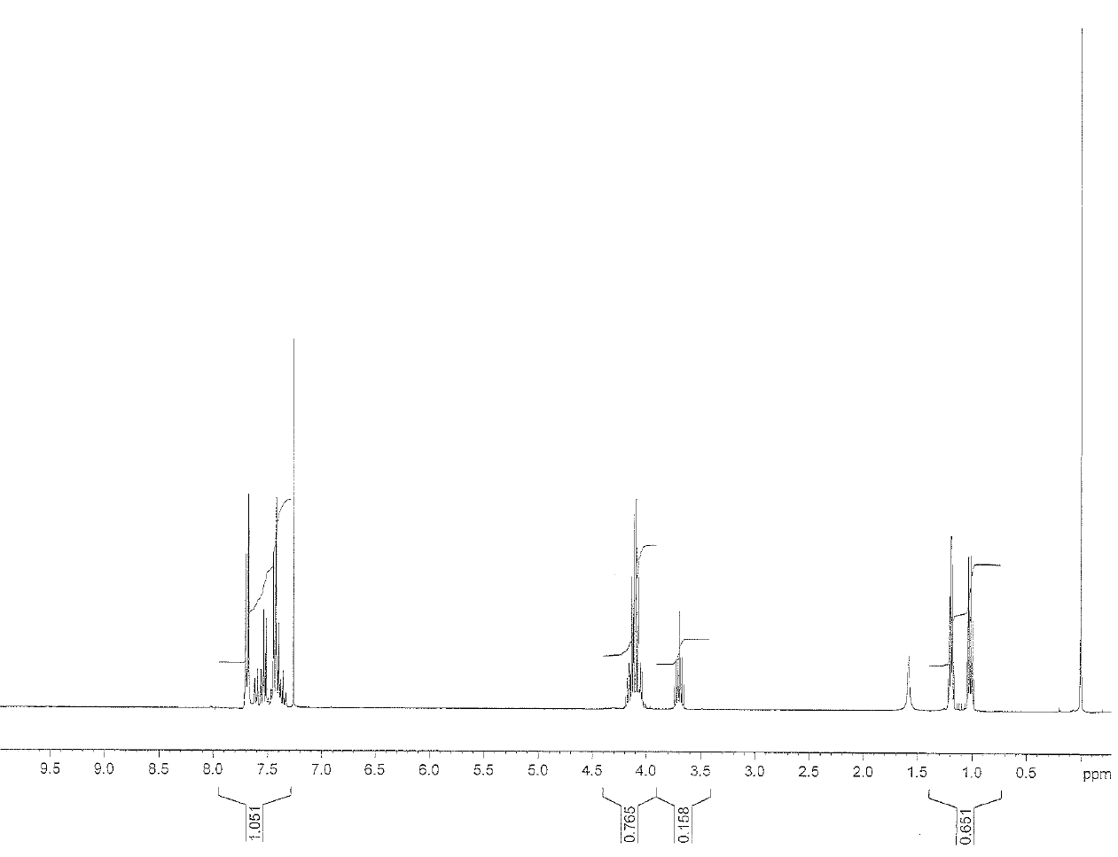
Fig. S21 ¹H NMR (300 MHz, CDCl₃) of compound 5
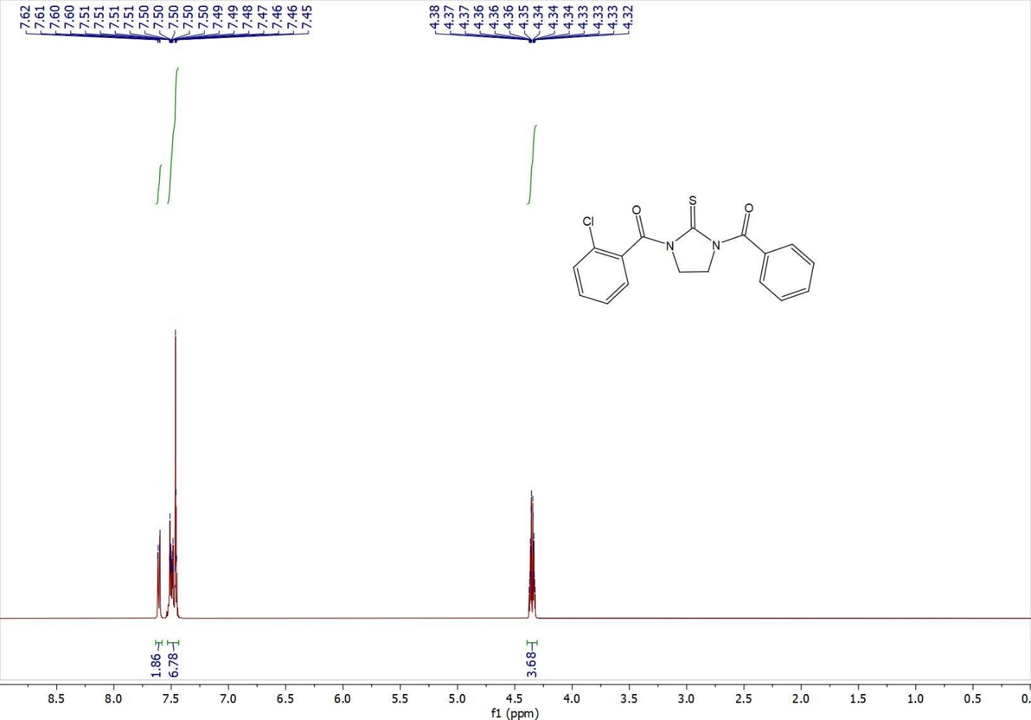
Fig. S22 ¹H NMR (400 MHz, DMSO-D6) of compound 6
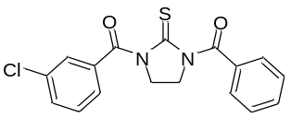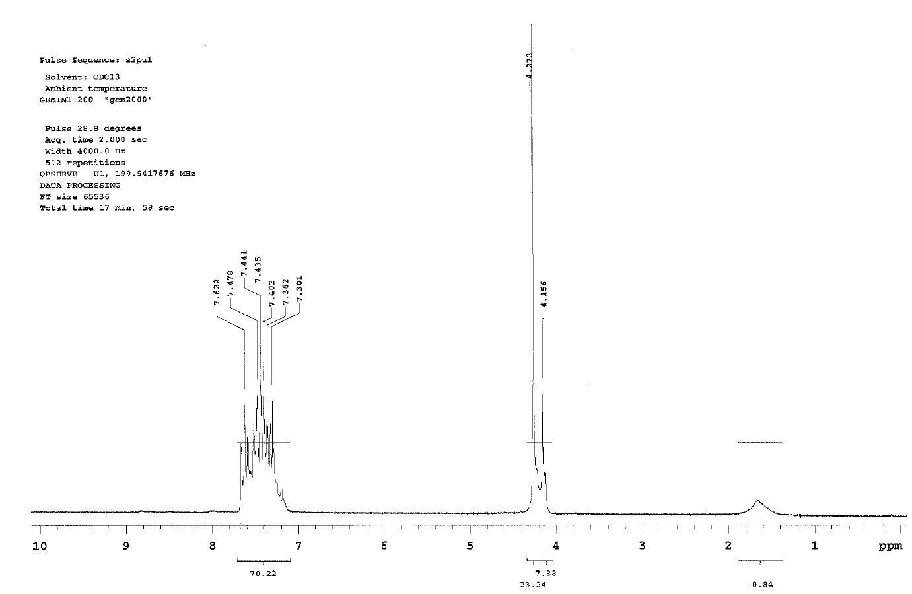
Fig. S23 ¹H NMR (200 MHz, CDCl₃) of compound 7

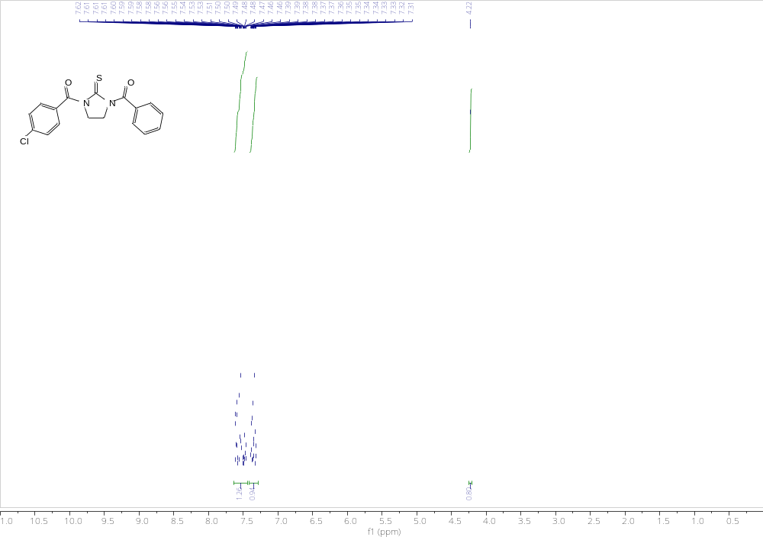
Fig. S24 ¹H NMR (400 MHz, CDCl₃) of compound 8
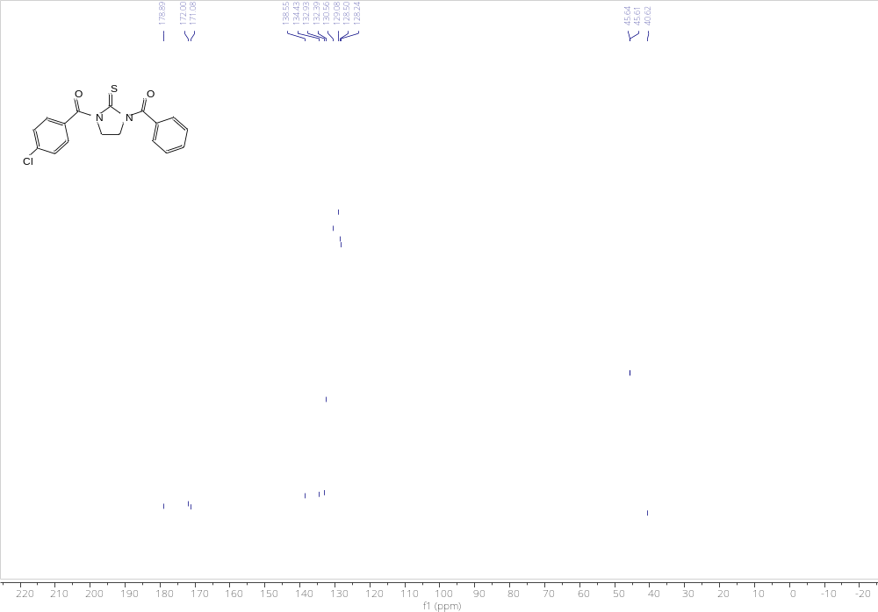 Fig. S25 ¹³C NMR (101 MHz, CDCl₃) of compound 8

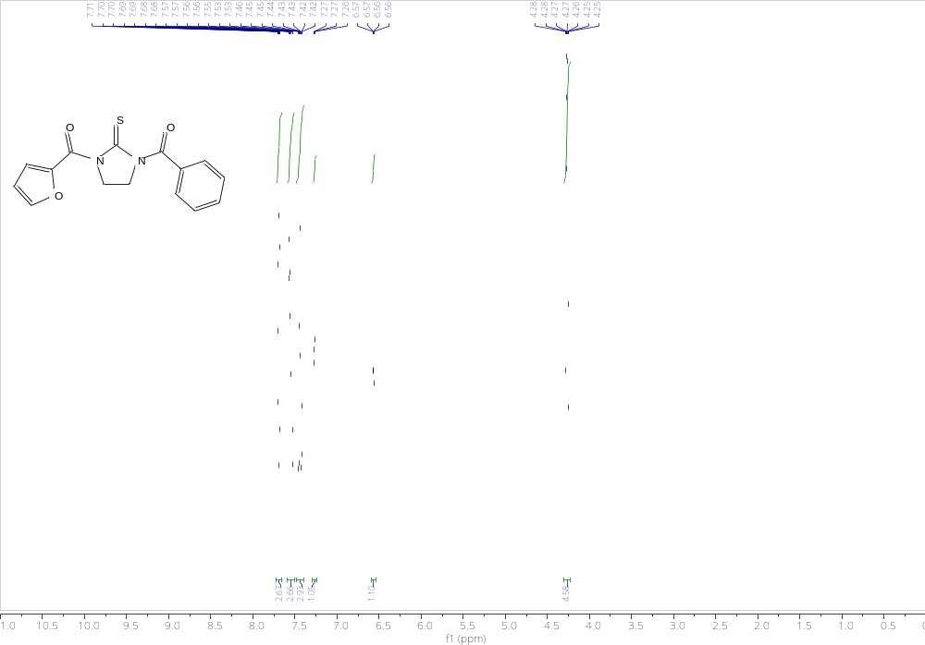
Fig. S26 ¹H NMR (400 MHz, CDCl₃) of compound 9
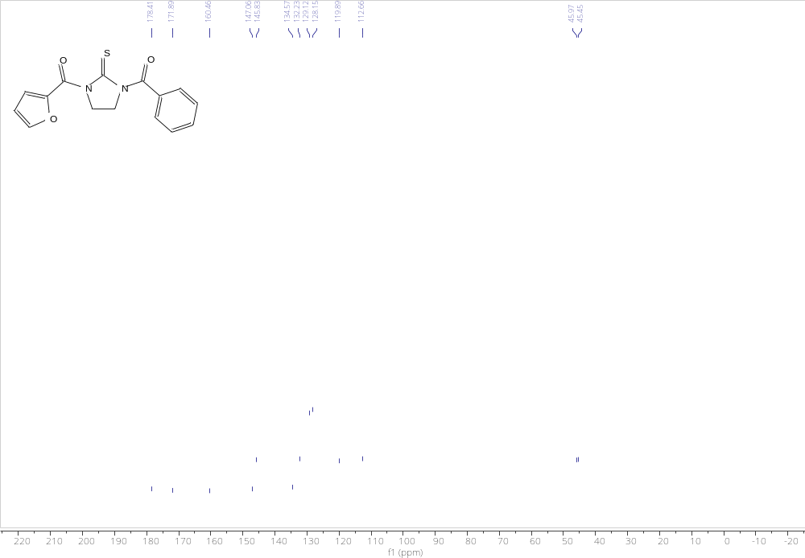
Fig. S27 ¹³C NMR (101 MHz, CDCl₃) of compound 9

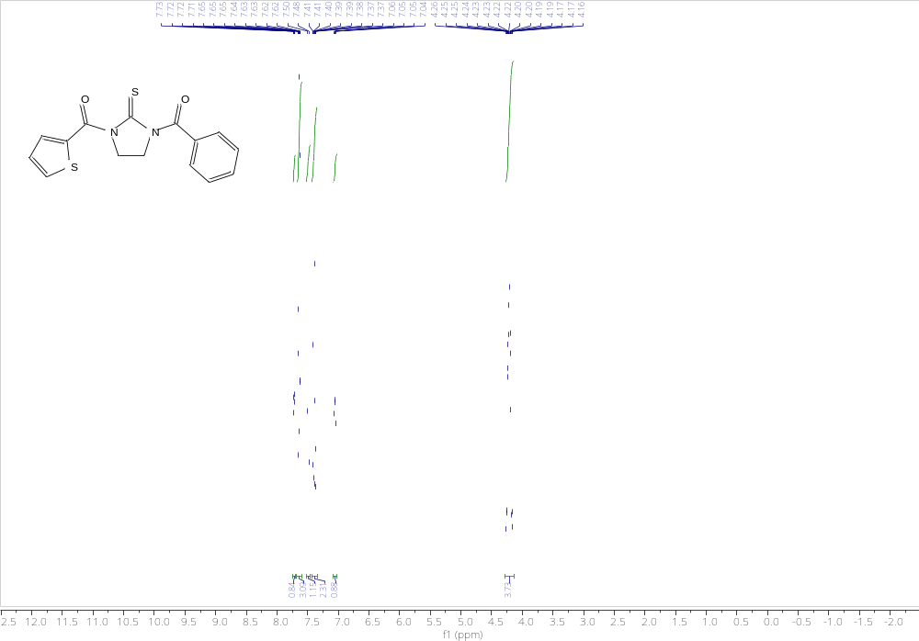
Fig. S28 ¹H NMR (400 MHz, CDCl₃) of compound 10
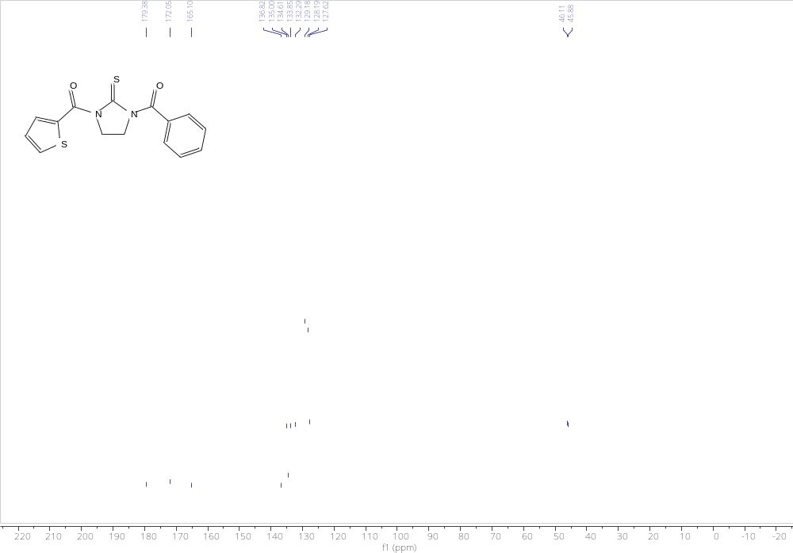
Fig. S29 ¹³C NMR (101 MHz, CDCl₃) of compound 10

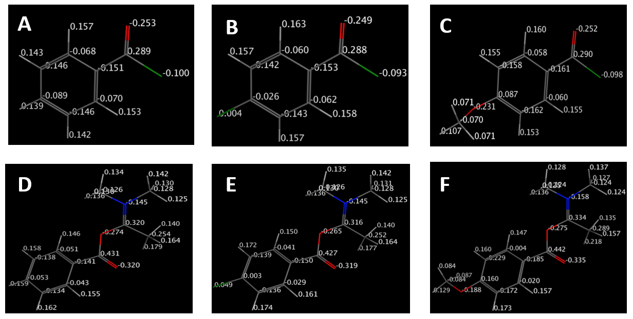
Fig. S30 Partial charge distribution of benzoyl chloride (A), 4-chlorobenzoyl chloride (B), 4-anisoyl chloride (C) and their corresponding intermediates II (D-F).

