Supplementary introduction
The kinase domain is a conserved region from 150-408, with two lobes, N-lobe and C- lobe. The N-lobe has four subdomains (I-IV), and the C-lobe has six subdomains (VI- XI); the subdomain V connects the N-lobe to the C-lobe [1].
- Subdomain I contain an ATP-binding glycine-rich loop with the GKGTFG motif (Gly 157, Lys 158, Gly 159, Thr 160, Phe 161, Gly 162), which connects the two β-strands.
- Subdomain II has Lys 179 that interacts with the phosphates of ATP.
- Subdomain III is an α-helix that connects to many parts of the kinase, and its orientation is critical for activity. In Akt1 active conformation, DFG-in conformation is seen; therefore, glutamate (Glu 179) of Subdomain III will form a salt bridge with lysine (Lys 179) of Subdomain II.
- Subdomain IV contains a β-strand and contributes to the core structure of the small lobe.
- Subdomain V contains a hydrophobic β-strand in the N-lobe and an α-helix in the C-lobe. Additionally, the sequence connecting these two secondary structures contributes residues to the ATP binding pocket and to peptide substrate binding.
- Subdomain VIa contains long α-helix which is parallel the α-helix of subdomain IX. Subdomain VIb contains the catalytic loop with the conserved motif YRDLKLEN (Tyr 272, Arg 273, Asp 274, Leu 275, Lys 276, Leu 277, Glu 278, Asn 279). The Asp 274 of this motif is the catalytic base that accepts the hydrogen removed from the hydroxyl group being phosphorylated.
- Subdomain VII contains an Mg-binding loop with the DFG motif (Asp 292, Phe 293, Gly 294), which links the two β-strands. The Aspartate in this motif chelates an Mg2+ ion that bridges the gamma and beta phosphate of ATP and positions the gamma phosphate for transfer to the substrate.
- Subdomain VIII contains the APE motif (Ala 317, Pro 318, Glu 319). The arginine in Subdomain XI and the glutamate in APE motif form a salt bridge that is essential for the formation of the stable kinase core and acts as a crucial step for the movement of the activation loop. The Akt1 has pThr 308 (phosphothreonine) eight residues upstream of the APE motif, which forms an ionic bond with the arginine in the YRDLKLEN motif (Tyr 272, Arg 273, Asp 274, Leu 275, Lys 276, Leu 277, Glu 278, Asn 279) of the catalytic loop and helps to position it for catalysis. The loop region between Thr 308 and the APE motif is known as the P+1 loop.
- Subdomain IX contains a hydrophobic α-helix with an invariant aspartate residue.
- Subdomain X and Subdomain XI contain three alpha helices forming the kinase core, which binds substrate proteins.
The AGC-kinase C terminal domain present at the C terminal of Akt1 consists of 71 amino acids (409-480). It possesses phosphorylation on its C-terminus (pSer 473) and constitutive phosphorylation at Thr 450, essential for active conformation stability [2]. Due to the interaction between PH domain-kinase domain, Akt1 remains in the autoinhibited conformation. On phosphorylation of Ser 473, it interacts with kinase domain N-lobe (Gln 218) and the PH–kinase linker (Arg 144) to activate Akt1. Phosphorylation of Ser 477 and Thr 479 also activates Akt1 by relieving PH domain-mediated autoinhibition [2].
Table S1: List of the Active and Inactive sets of ligands used to build 2D QSAR models.
Sr.No. | Name | Structure
Active ligands
 | Chlorogenic acid | 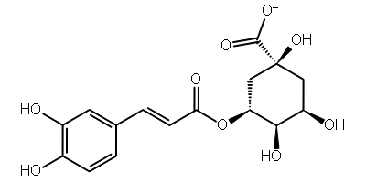
 | Baicalin | 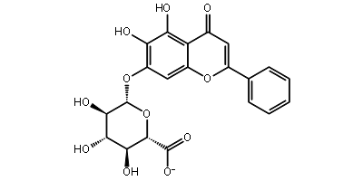
 | Puerarin | 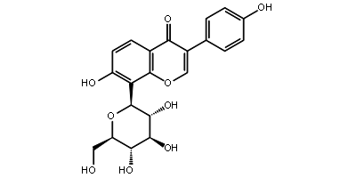
 | Inositol 1,3,4,5-tetrakisphosphate | 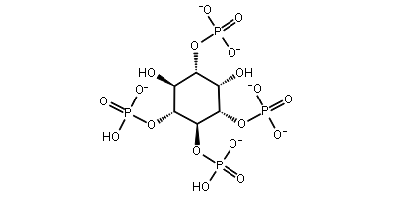
 | SC79 | 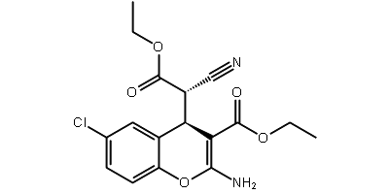
 | Kaempferol 3-O-glucuronide | 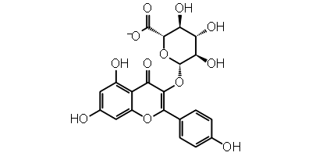
 | Quercetin 3-O-glucuronide | 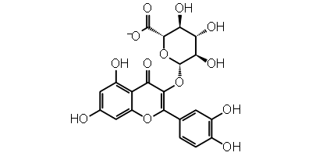
Inactive ligands
 | SC1 | 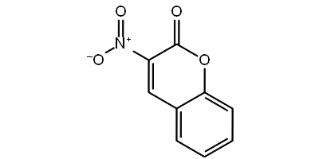
 | SC2 | 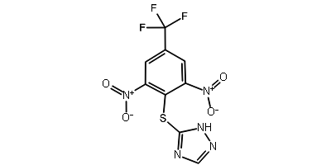
 | SC3 | 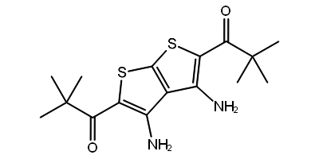
 | SC4 | 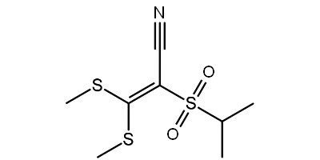
 | SC5 | 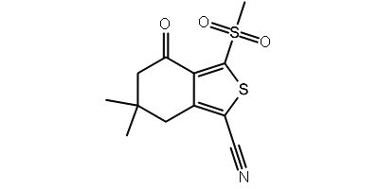
 | SC7 | 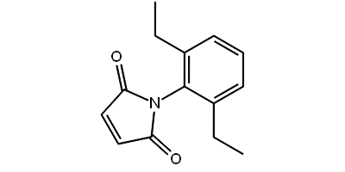
 | SC8 | 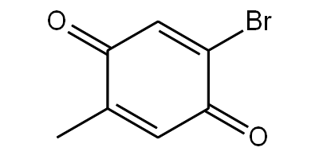
 | SC9 | 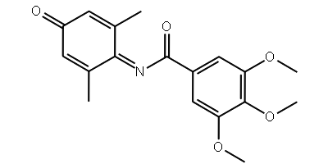
 | SC10 | 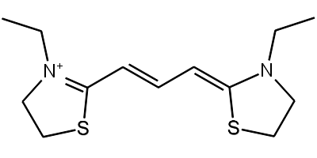
 | SC11 | 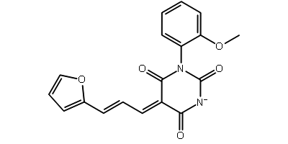
 | SC12 | 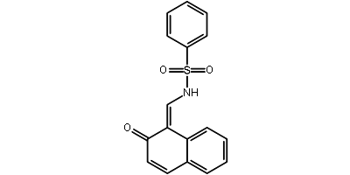
 | SC13 | 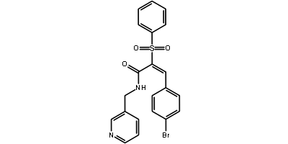
 | SC14 | 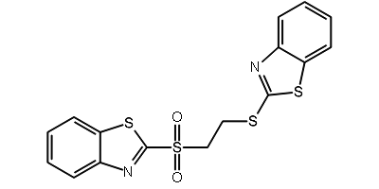
 | SC15 | 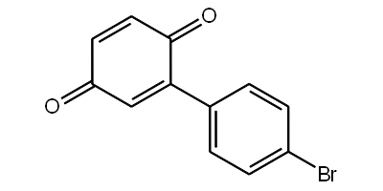
 | SC16 | 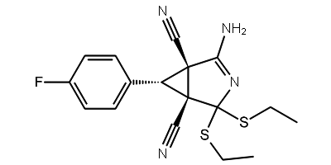
 | SC17 | 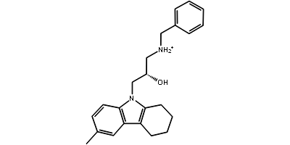
 | SC18 | 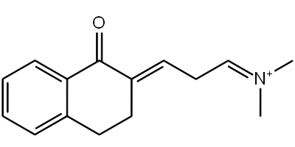
 | SC19 | 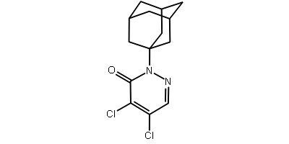
 | SC20 | 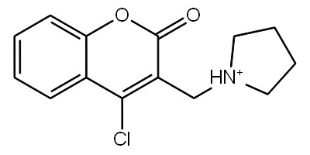
 | SC21 | 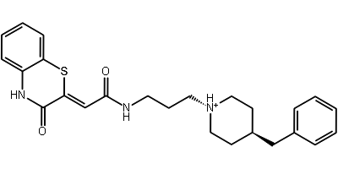
 | SC22 | 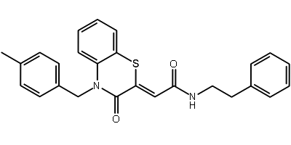
 | SC23 | 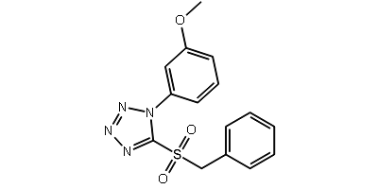
 | SC24 | 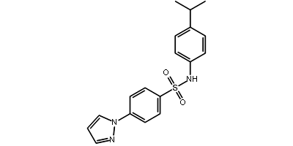
 | SC25 | 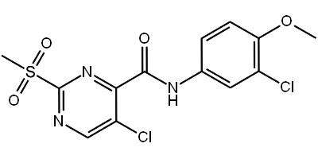
 | SC26 | 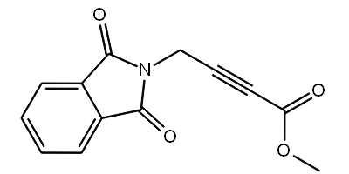
 | SC27 | 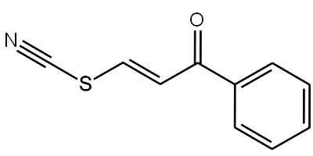
 | SC28 | 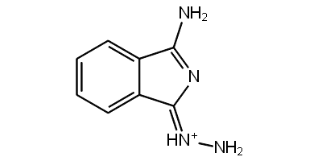
 | SC30 | 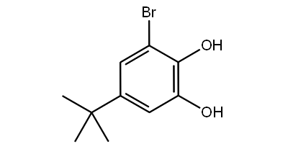

Table S2: List of ten multiple ligand-based pharmacophore models generated with Phase hypo score, BEDROC score, and matches it shows with known activators.

Hypothesis | Phase Hypo Score | EF1% | BEDROC160.9 | Matches
AAAD_3 | 1.17 | 71.93 | 0.81 | 4 of 4
AAAD_5 | 1.17 | 71.93 | 0.85 | 4 of 4
AAAD_9 | 1.17 | 86.31 | 0.79 | 4 of 4
AAAD_6 | 1.14 | 71.93 | 0.84 | 4 of 4
AAAD_8 | 1.14 | 86.31 | 0.9 | 4 of 4
AAAD_7 | 1.11 | 71.93 | 0.7 | 4 of 4
AAAD_2 | 1.1 | 71.93 | 0.8 | 4 of 4
AAAD_1 | 1.07 | 57.54 | 0.74 | 4 of 4
AADD_1 | 1.06 | 71.93 | 0.83 | 4 of 4
AAAD_4 | 1.05 | 71.93 | 0.75 | 4 of 4

Table S3: Fingerprint based 2D QSAR Models in which database molecules were screened: green right tick represent as active molecules and red X mark represent Inactive
Code assigned | Atom pair |  |  |  |  |  |  |  |  |  |  |  |  |  |  | Atom triplets |  | Dendritic
Code assigned | 1B | 1C | 1K | 1P | 1Q | BC | BK | BP | BQ | CK | CP | CQ | KP | KQ | PQ | 1K | 1Q | 1B | 1C | 1K | 1P | 1Q | BC | BK | BP | BQ | CK | CP | CQ | KP | KQ | PQ
109586 |  |  |  |  |  |  |  |  |  |  |  |  |  |  |  |  |  |  |  |  |  |  |  |  |  |  |  |  |  |  |  | 
115183 |  |  |  |  |  |  |  |  |  |  |  |  |  |  |  |  |  |  |  |  |  |  |  |  |  |  |  |  |  |  |  | 
125036 |  |  |  |  |  |  |  |  |  |  |  |  |  |  |  |  |  |  |  |  |  |  |  |  |  |  |  |  |  |  |  | 
142354 |  |  |  |  |  |  |  |  |  |  |  |  |  |  |  |  |  |  |  |  |  |  |  |  |  |  |  |  |  |  |  | 
197105 |  |  |  |  |  |  |  |  |  |  |  |  |  |  |  |  |  |  |  |  |  |  |  |  |  |  |  |  |  |  |  | 
253878 |  |  |  |  |  |  |  |  |  |  |  |  |  |  |  |  |  |  |  |  |  |  |  |  |  |  |  |  |  |  |  | 
256085 |  |  |  |  |  |  |  |  |  |  |  |  |  |  |  |  |  |  |  |  |  |  |  |  |  |  |  |  |  |  |  | 
108535 |  |  |  |  |  |  |  |  |  |  | X |  |  |  |  |  |  |  |  |  |  |  |  |  |  |  |  |  |  |  |  | 
261126 |  |  |  |  |  |  |  |  |  |  |  |  |  |  |  |  |  |  |  |  |  |  |  |  |  |  |  |  |  |  |  | 
122155 |  |  |  |  |  |  |  |  |  |  |  |  |  |  |  | X | X |  |  |  |  |  |  |  |  |  |  |  |  |  |  | 
123435 |  |  |  |  |  |  |  |  |  |  |  |  |  |  |  | X | X |  |  |  |  |  |  |  |  |  |  |  |  |  |  | 
125037 |  |  |  |  |  |  |  |  |  |  |  |  |  |  |  | X | X |  |  |  |  |  |  |  |  |  |  |  |  |  |  | 
126004 |  |  |  |  |  |  |  |  |  |  |  |  |  |  |  | X | X |  |  |  |  |  |  |  |  |  |  |  |  |  |  | 
129318 |  |  |  |  |  |  |  |  |  |  |  |  |  |  |  | X | X |  |  |  |  |  |  |  |  |  |  |  |  |  |  | 
129323 |  |  |  |  |  |  |  |  |  |  |  |  |  |  |  | X | X |  |  |  |  |  |  |  |  |  |  |  |  |  |  | 
130971 |  |  |  |  |  |  |  |  |  |  |  |  |  |  |  | X | X |  |  |  |  |  |  |  |  |  |  |  |  |  |  | 
130985 |  |  |  |  |  |  |  |  |  |  |  |  |  |  |  | X | X |  |  |  |  |  |  |  |  |  |  |  |  |  |  | 
132665 |  |  |  |  |  |  |  |  |  |  |  |  |  |  |  | X | X |  |  |  |  |  |  |  |  |  |  |  |  |  |  | 
133079 |  |  |  |  |  |  |  |  |  |  |  |  |  |  |  | X | X |  |  |  |  |  |  |  |  |  |  |  |  |  |  | 
133584 |  |  |  |  |  |  |  |  |  |  |  |  |  |  |  | X | X |  |  |  |  |  |  |  |  |  |  |  |  |  |  | 
135489 |  |  |  |  |  |  |  |  |  |  |  |  |  |  |  | X | X |  |  |  |  |  |  |  |  |  |  |  |  |  |  | 
136530 |  |  |  |  |  |  |  |  |  |  |  |  |  |  |  | X | X |  |  |  |  |  |  |  |  |  |  |  |  |  |  | 
136532 |  |  |  |  |  |  |  |  |  |  |  |  |  |  |  | X | X |  |  |  |  |  |  |  |  |  |  |  |  |  |  | 
136540 |  |  |  |  |  |  |  |  |  |  |  |  |  |  |  | X | X |  |  |  |  |  |  |  |  |  |  |  |  |  |  | 
139882 |  |  |  |  |  |  |  |  |  |  |  |  |  |  |  | X | X |  |  |  |  |  |  |  |  |  |  |  |  |  |  | 

Code assigned | Molprint 2D |  |  |  |  |  |  |  |  |  |  |  |  |  |  | linear |  |  |  |  |  |  |  |  |  |  |  |  |  |  | Radial
Code assigned | 1B | 1C | 1K | 1P | 1Q | BC | BK | BP | BQ | CK | CP | CQ | KP | KQ | PQ | 1B | 1C | 1K | 1P | 1Q | BC | BK | BP | BQ | CK | CP | CQ | KP | KQ | PQ | 1B | 1K | 1P | 1Q | BK | BP | BQ | KP | KQ | PQ
109586 |  |  |  |  |  |  |  |  |  |  |  |  |  |  |  |  |  |  |  |  |  |  |  |  |  |  |  |  |  |  |  |  |  |  |  |  |  |  |  | 
115183 |  |  |  |  |  |  |  |  |  |  |  |  |  |  |  |  |  |  |  |  |  |  |  |  |  |  |  |  |  |  |  |  |  |  |  |  |  |  |  | 
125036 |  |  |  |  |  |  |  |  |  |  |  |  |  |  |  |  |  |  |  |  |  |  |  |  |  |  |  |  |  |  |  |  |  |  |  |  |  |  |  | 
142354 |  |  |  |  |  |  |  |  |  |  |  |  |  |  |  |  |  |  |  |  |  |  |  |  |  |  |  |  |  |  |  |  |  |  |  |  |  |  |  | 
197105 |  |  |  |  |  |  |  |  |  |  |  |  |  |  |  |  |  |  |  |  |  |  |  |  |  |  |  |  |  |  |  |  |  |  |  |  |  |  |  | 
253878 |  |  |  |  |  |  |  |  |  |  |  |  |  |  |  |  |  |  |  |  |  |  |  |  |  |  |  |  |  |  |  |  |  |  |  |  |  |  |  | 
256085 |  |  |  |  |  |  |  |  |  |  |  |  |  |  |  |  |  |  |  |  |  |  |  |  |  |  |  |  |  |  |  |  |  |  |  |  |  |  |  | 
108535 |  |  |  |  |  |  |  |  |  |  |  |  |  |  |  |  |  |  |  |  |  |  |  |  |  |  |  |  |  |  |  |  |  |  |  |  |  |  |  | 
261126 |  |  |  |  |  |  |  |  |  |  |  |  |  |  |  |  |  |  |  |  |  |  |  |  |  |  |  |  |  |  |  |  |  |  |  | X |  |  |  | 
122155 |  |  |  |  |  |  |  |  |  |  |  |  |  |  |  |  |  |  |  |  |  |  |  |  |  |  |  |  |  |  |  |  |  |  |  |  |  |  |  | 
123435 |  |  |  |  |  |  |  |  |  |  |  |  |  |  |  |  |  |  |  |  |  |  |  |  |  |  |  |  |  |  |  |  |  |  |  |  |  |  |  | 
125037 |  |  |  |  |  |  |  |  |  |  |  |  |  |  |  |  |  |  |  |  |  |  |  |  |  |  |  |  |  |  |  |  |  |  |  |  |  |  |  | 
126004 |  |  |  |  |  |  |  |  |  |  |  |  |  |  |  |  |  |  |  |  |  |  |  |  |  |  |  |  |  |  |  |  |  |  |  | X |  |  |  | 
129318 |  |  |  |  |  |  |  |  |  |  |  |  |  |  |  |  |  |  |  |  |  |  |  |  |  |  |  |  |  |  |  |  |  |  |  |  |  |  |  | 
129323 |  |  |  |  |  |  |  |  |  |  |  |  |  |  |  |  |  |  |  |  |  |  |  |  |  |  |  |  |  |  |  |  |  |  |  |  |  |  |  | 
130971 |  |  |  |  |  |  |  |  |  |  |  |  |  |  |  |  |  |  |  |  |  |  |  |  |  |  |  |  |  |  |  |  |  |  |  |  |  |  |  | 
130985 |  |  |  |  |  |  |  |  |  |  |  |  |  |  |  |  |  |  |  |  |  |  |  |  |  |  |  |  |  |  |  |  |  |  |  |  |  |  |  | 
132665 |  |  |  |  |  |  |  |  |  |  |  |  |  |  |  |  |  |  |  |  |  |  |  |  |  |  |  |  |  |  |  |  |  |  |  |  |  |  |  | 
133079 |  |  |  |  |  |  |  |  |  |  |  |  |  |  |  |  |  |  |  |  |  |  |  |  |  |  |  |  |  |  |  |  |  |  |  |  |  |  |  | 
133584 |  |  |  |  |  |  |  |  |  |  |  |  |  |  |  |  |  |  |  |  |  |  |  |  |  |  |  |  |  |  |  |  |  |  |  |  |  |  |  | 
135489 |  |  |  |  |  |  |  |  |  |  |  |  |  |  |  |  |  |  |  |  |  |  |  |  |  |  |  |  |  |  |  |  |  |  |  |  |  |  |  | 
136530 |  |  |  |  |  |  |  |  |  |  |  |  |  |  |  |  |  |  |  |  |  |  |  |  |  |  |  |  |  |  |  |  |  |  |  |  |  |  |  | 
136532 |  |  |  |  |  |  |  |  |  |  |  |  |  |  |  |  |  |  |  |  |  |  |  |  |  |  |  |  |  |  |  |  |  |  |  |  |  |  |  | 
136540 |  |  |  |  |  |  |  |  |  |  |  |  |  |  |  |  |  |  |  |  |  |  |  |  |  |  |  |  |  |  |  |  |  |  |  |  |  |  |  | 
139882 |  |  |  |  |  |  |  |  |  |  |  |  |  |  |  |  |  |  |  |  |  |  |  |  |  |  |  |  |  |  |  |  |  |  |  |  |  |  |  | 

Code assigned | Topological
Code assigned | 1B | 1C | 1K | 1P | 1Q | BC | BK | BP | BQ | CK | CP | CQ | KP | KQ | PQ
109586 |  |  |  |  |  |  |  |  |  |  |  |  |  |  | 
115183 |  |  |  |  |  |  |  |  |  |  |  |  |  |  | 
125036 |  |  |  |  |  |  |  |  |  |  |  |  |  |  | 
142354 |  |  |  |  |  |  |  |  |  |  |  |  |  |  | 
197105 |  |  |  |  |  |  |  |  |  |  |  |  |  |  | 
253878 |  |  |  |  |  |  |  |  |  |  |  |  |  |  | 
256085 |  |  |  |  |  |  |  |  |  |  |  |  |  |  | 
108535 |  |  |  |  |  |  |  |  |  |  |  |  |  |  | 
261126 |  |  |  |  |  |  |  |  |  |  |  |  |  |  | 
122155 |  |  |  |  |  |  |  |  |  |  |  |  |  |  | 
123435 |  |  |  |  |  |  |  |  |  |  |  |  |  |  | 
125037 |  |  |  |  |  |  |  |  |  |  |  |  |  |  | 
126004 |  |  |  |  |  |  |  |  |  |  |  |  |  |  | 
129318 |  |  |  |  |  |  |  |  |  |  |  |  |  |  | 
129323 |  |  |  |  |  |  |  |  |  |  |  |  |  |  | 
130971 |  |  |  |  |  |  |  |  |  |  |  |  |  |  | 
130985 |  |  |  |  |  |  |  |  |  |  |  |  |  |  | 
132665 |  |  |  |  |  |  |  |  |  |  |  |  |  |  | 
133079 |  |  |  |  |  |  |  |  |  |  |  |  |  |  | 
133584 |  |  |  |  |  |  |  |  |  |  |  |  |  |  | 
135489 |  |  |  |  |  |  |  |  |  |  |  |  |  |  | 
136530 |  |  |  |  |  |  |  |  |  |  |  |  |  |  | 
136532 |  |  |  |  |  |  |  |  |  |  |  |  |  |  | 
136540 |  |  |  |  |  |  |  |  |  |  |  |  |  |  | 
139882 |  |  |  |  |  |  |  |  |  |  |  |  |  |  | 

Table S4: 2D interaction diagrams of the known Akt activators with a summary of docking score, glide energy, and all non-bonding interactions
Sr.No. | Title | Docking Score  (kcal/mol) | MMGBSA dg-bind  (kcal/mol) | 2D Interaction diagram | Non-bonding interactions
 | Kaempferol 3-glucuronide | -6.829 | -38.24 | 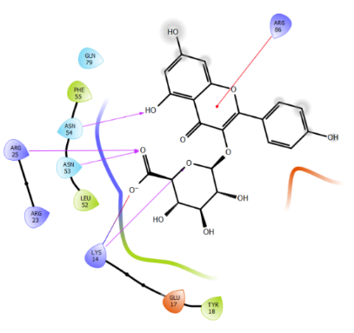 | H-bond: Lys 14, Arg 25, Asn 54, Arg 53  Salt bridge: Lys 14  Pi cation interaction: Arg 86  Charged negative: Glu 17  Charged positive: Arg 23  Polar: Gln 79  Hydrophobic: Tyr 18, Leu 52, Phe 55
 | Baicalin | -6.664 | -38.78 | 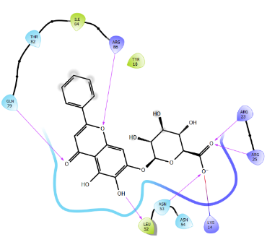 | H-bond: Arg 25, Arg 23, Asn 53, Leu 52, Gln 79, Arg 86  Salt bridge: Lys 14  Polar: Thr 82, Asn 54  Hydrophobic: Tyr 18, Ile 84
 | Puerarin | -5.63 | -33.31 | 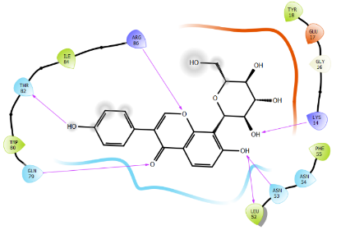 | H-bond: Lys 14, Asn 53, Leu 52, Gln 79, Thr 82, Arg 86  Charged negative: Gln 17  Polar: Asn 54  Hydrophobic: Tyr 18, Phe 55, Trp 80, Ile 84, Gly 16
 | Quercetin 3-O-glucuronide | -5.602 | -40.96 | 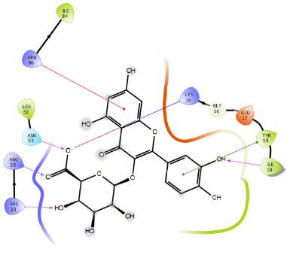 | H-bond: Ile 19, Arg 23, Arg 25, Asn 53  Salt bridge: Lys 14  Pi-Pi interaction: Tyr 18  Pi cation interaction: Arg 86  Charged negative: Glu 17  Hydrophobic: Gly 16, Leu 52, Ile 84
 | SC79 | -2.355 | -26.38 | 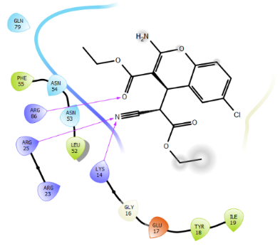 | H-bond: Lys 14, Arg 25, Arg 86  Charged negative: Glu 17  Charged positive: Arg 23  Polar: Gln 79, Asn 54, Asn 53  Hydrophobic: Gly 16, Ile 19, Tyr 18, Leu 52, Phe 55

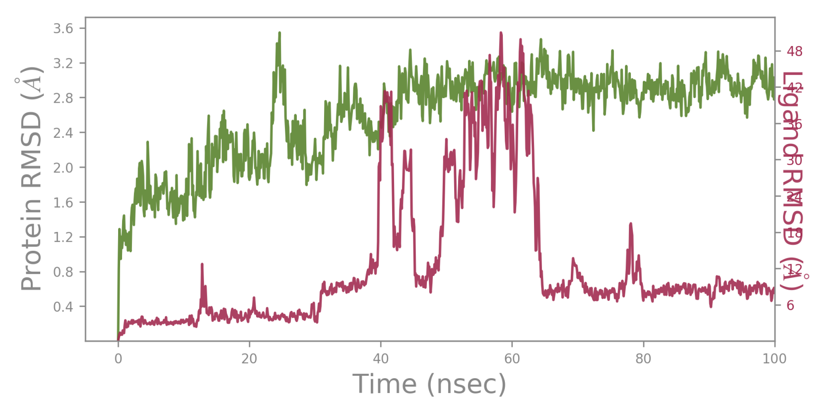  197105 | 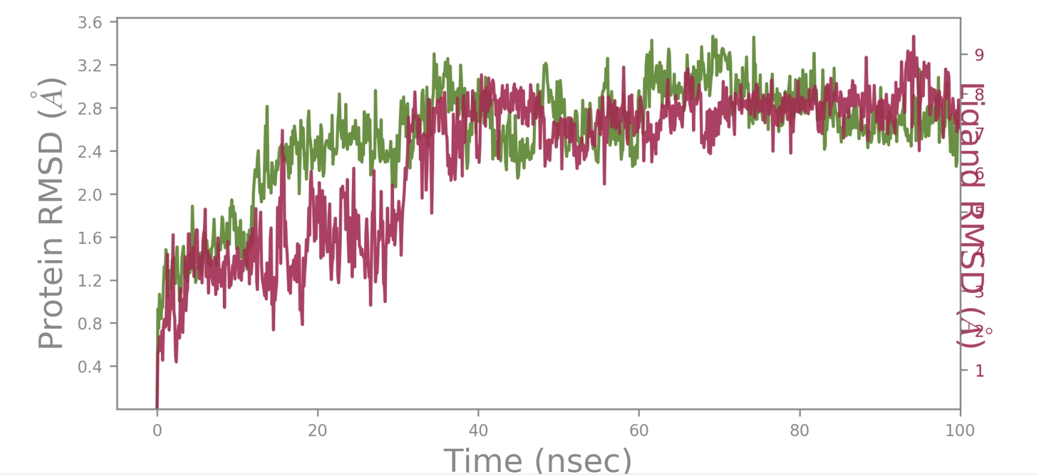  253878
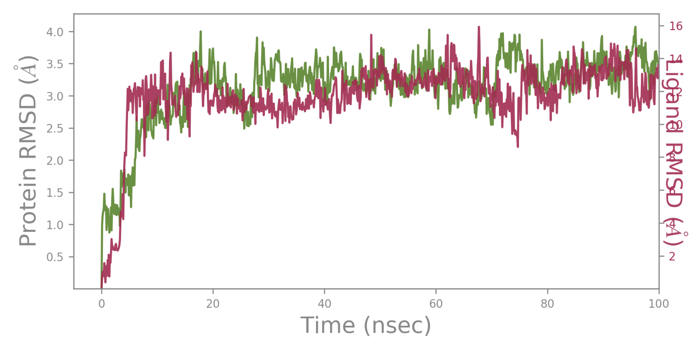  256085 | 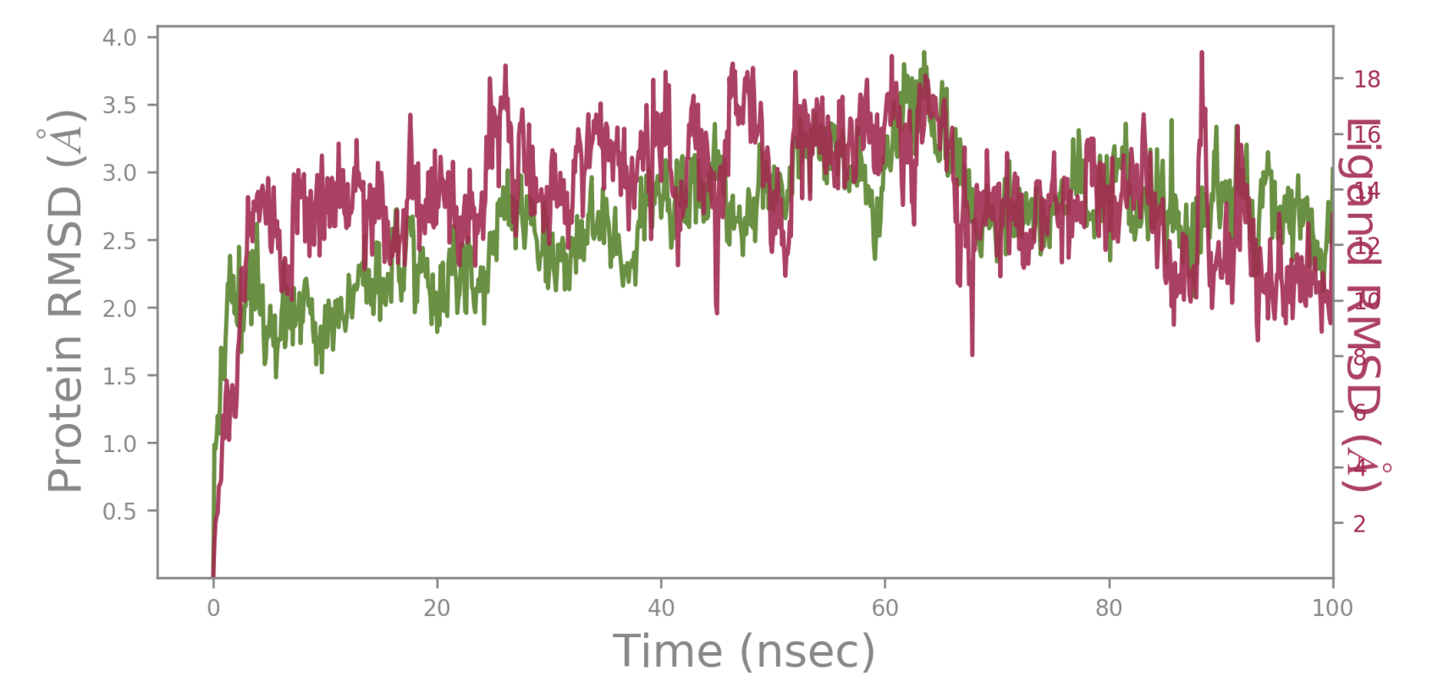  102479045

Figure 1S: RMSD plots of protein and ligand complex after MD simulation for 100 ns

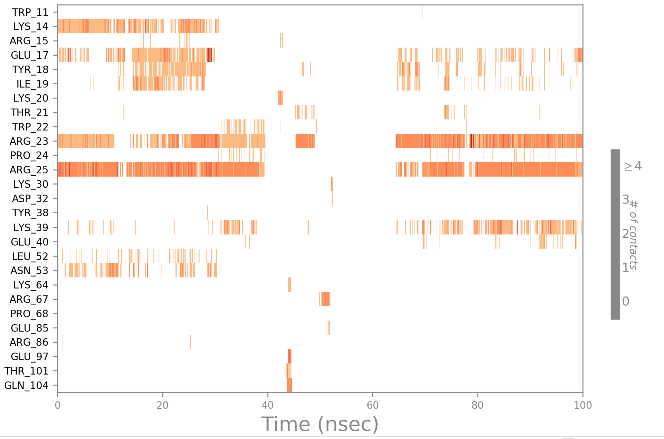 | 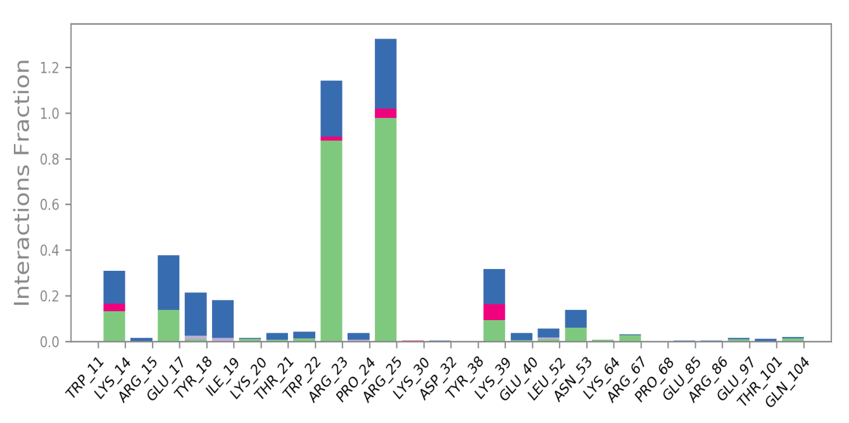
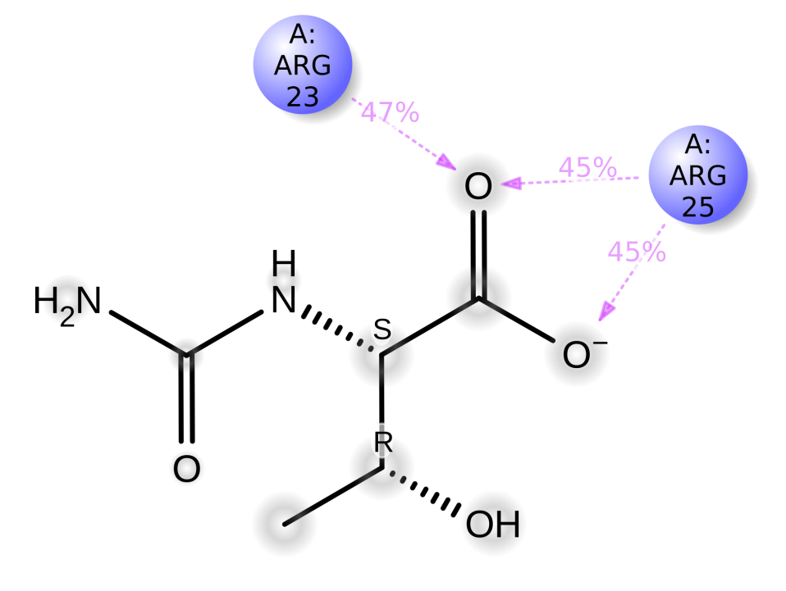
197105

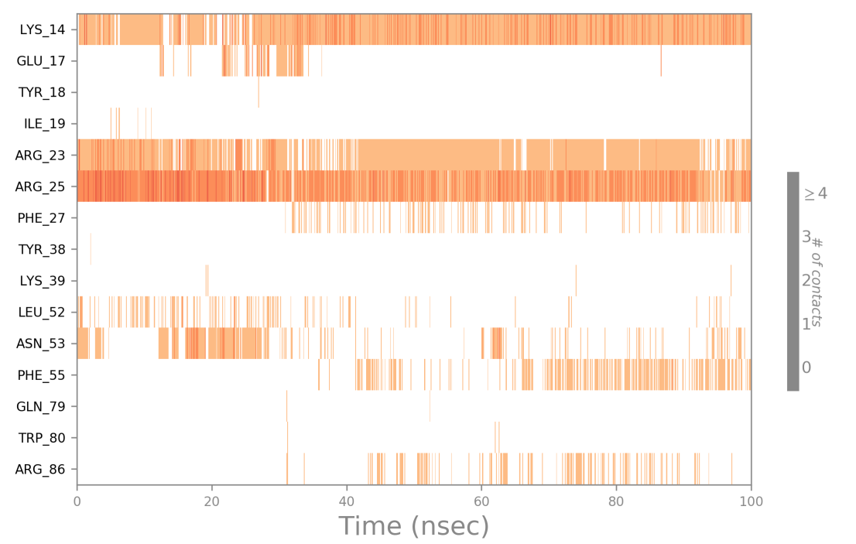 | 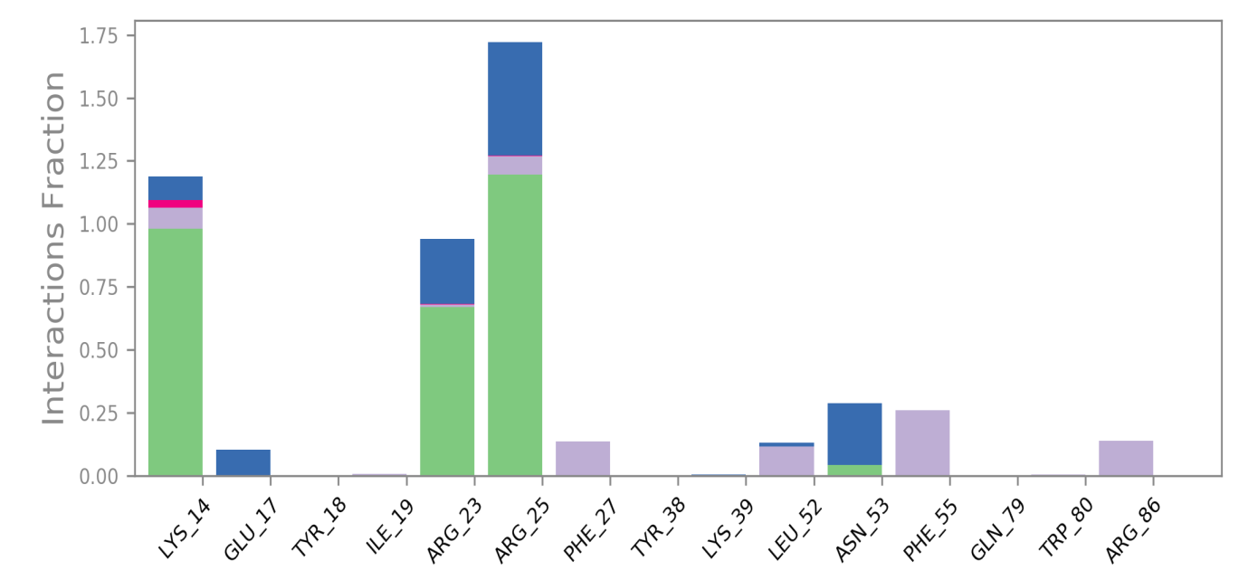
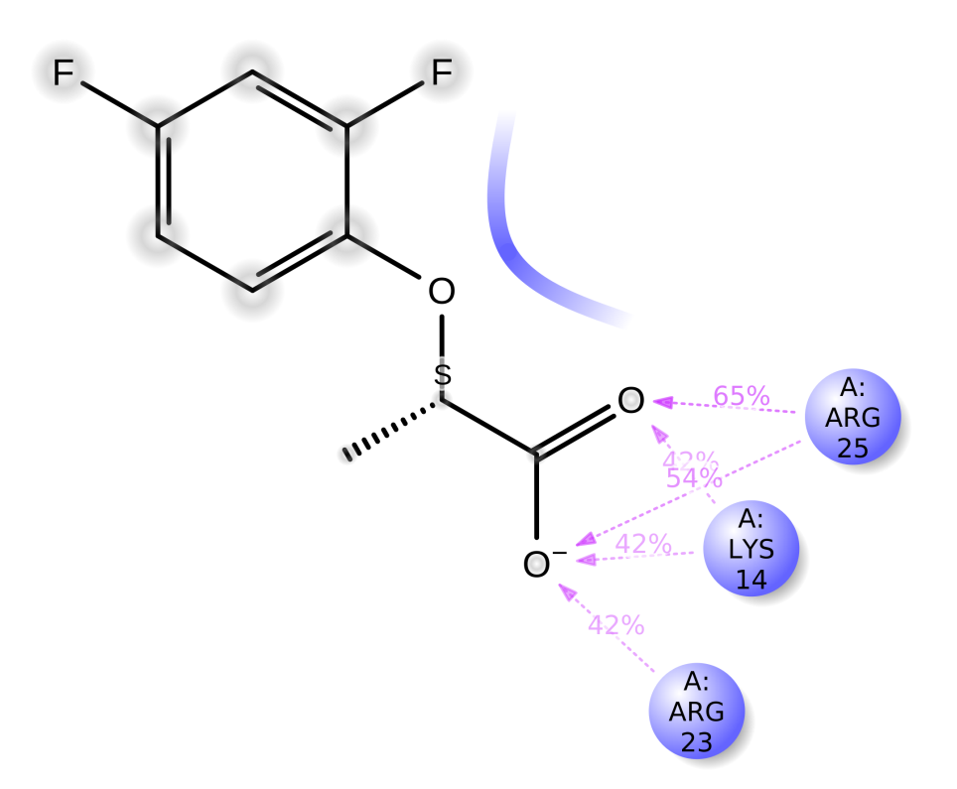
253878

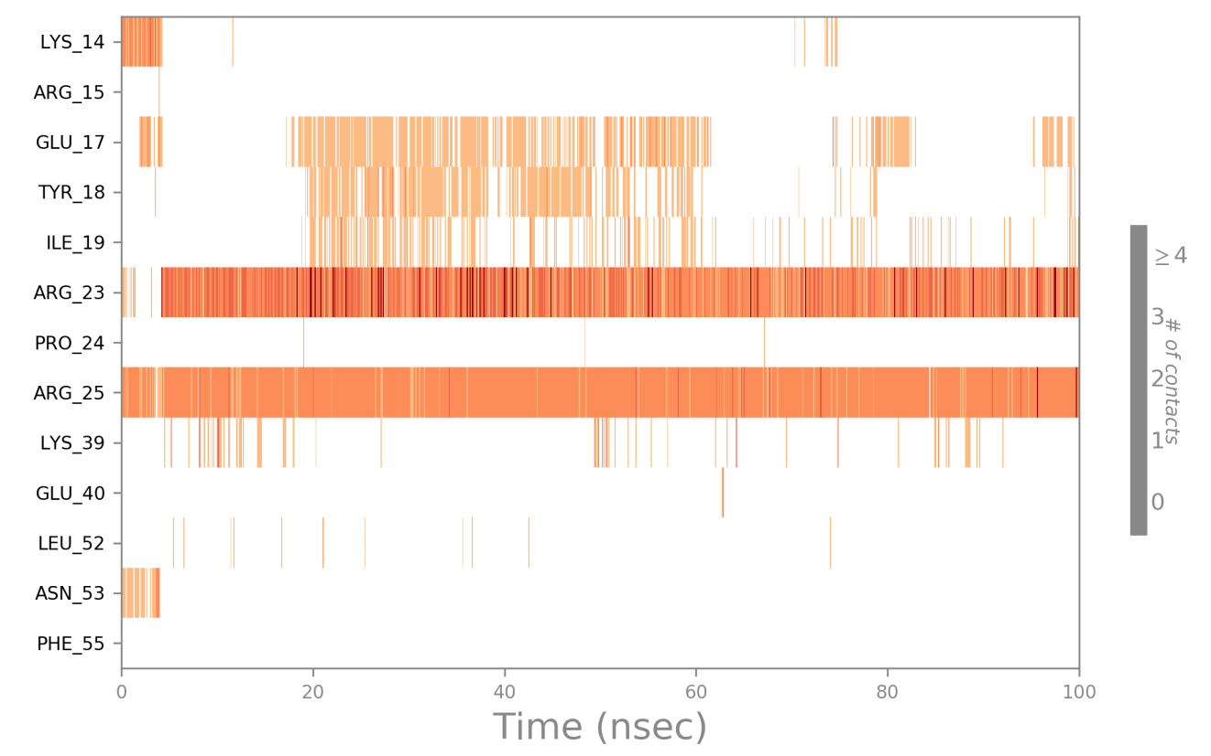 | 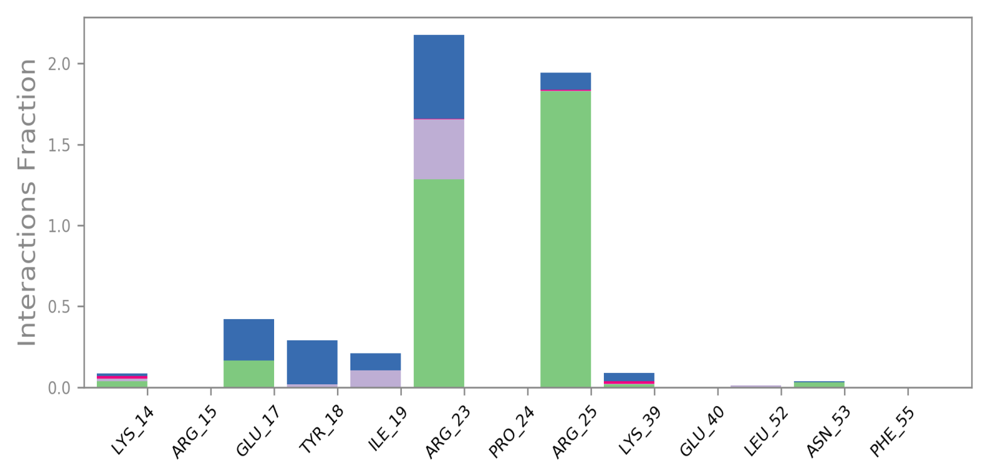
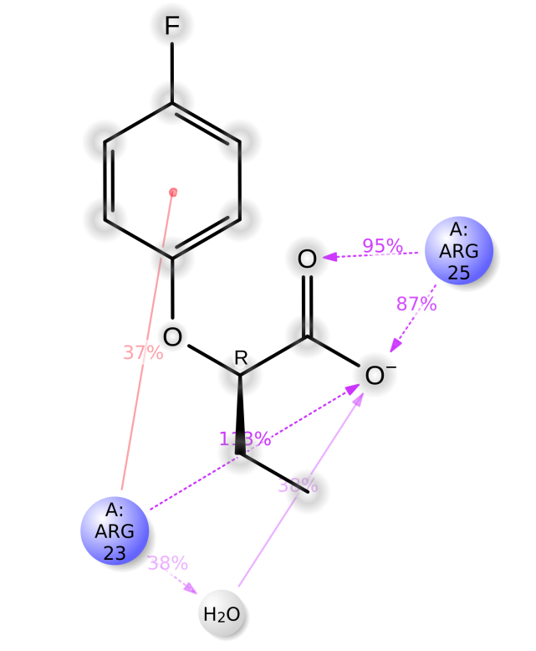
256085

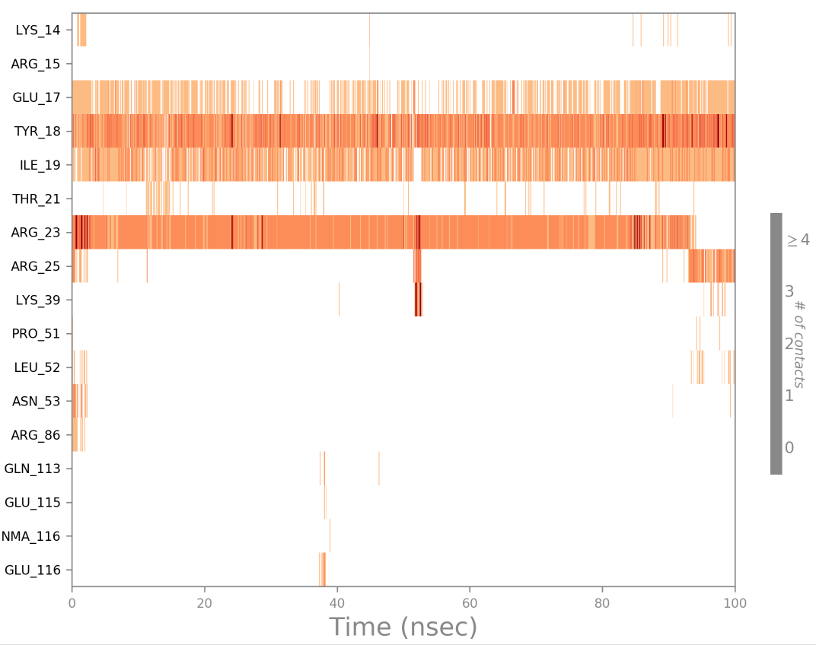 | 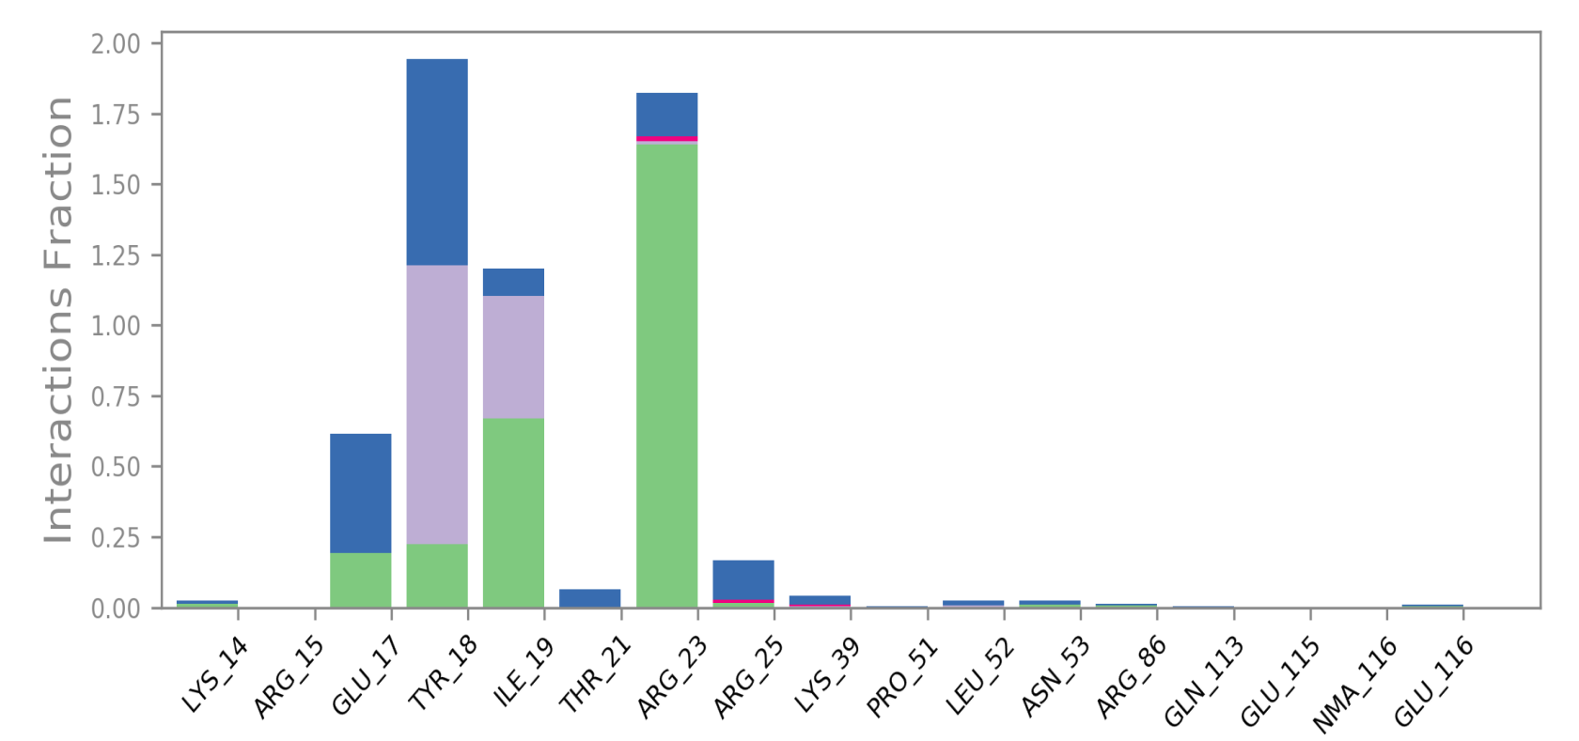
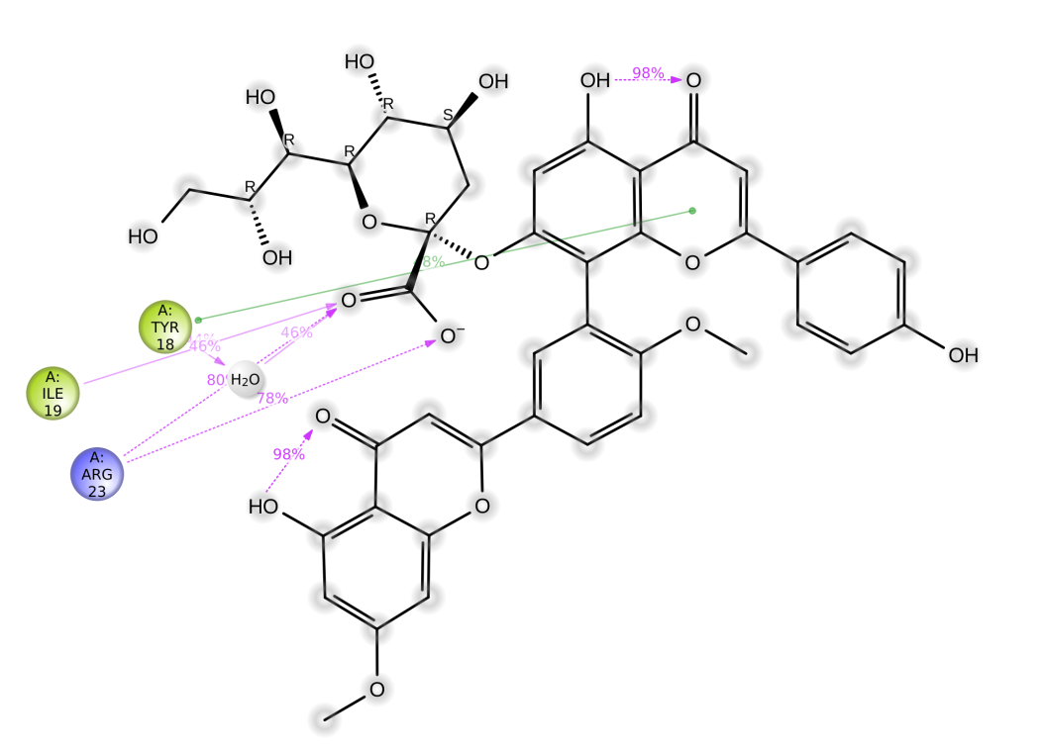
102479045

Figure 2S: 2D interaction diagram, protein–ligand contacts and timeline representation of the interactions for 100 ns MD simulation in which green represents H-bonds, pink represents an Ionic bond, blue represents a water bridge, and grey represents hydrophobic interaction.
References
1. Harmon A, Harel M, Herraez A (2016) Eukaryotic Protein Kinase Catalytic Domain. https://proteopedia.org/wiki/index.php/Eukaryotic_Protein_Kinase_Catalytic_Domain. Accessed 5 Jun 2023
2. Cole PA, Chu N, Salguero AL, Bae H (2019) AKTivation mechanisms. Curr Opin Struct Biol 59:47–53. https://doi.org/10.1016/j.sbi.2019.02.004

