Supplementary Information

Microwave-assisted enzymatic synthesis of geraniol esters in solvent-free systems: Optimization of the reaction parameters, purification and characterization of the products, and biocatalyst reuse

Valentina Venturi¹, Francesco Presini², Claudio Trapella², Olga Bortolini¹, Pier Paolo Giovannini², Lindomar Alberto Lerin²*

¹ Department of Environment and Prevention Sciences, University of Ferrara – UNIFE, Via Luigi Borsari, 46, 44121 – Ferrara – Italy
² Department of Chemical, Pharmaceutical and Agricultural Sciences, University of Ferrara – UNIFE, Via Luigi Borsari, 46, 44121, Ferrara – Italy
* Corresponding author: Lindomar Alberto Lerin, lrnldm@unife.it

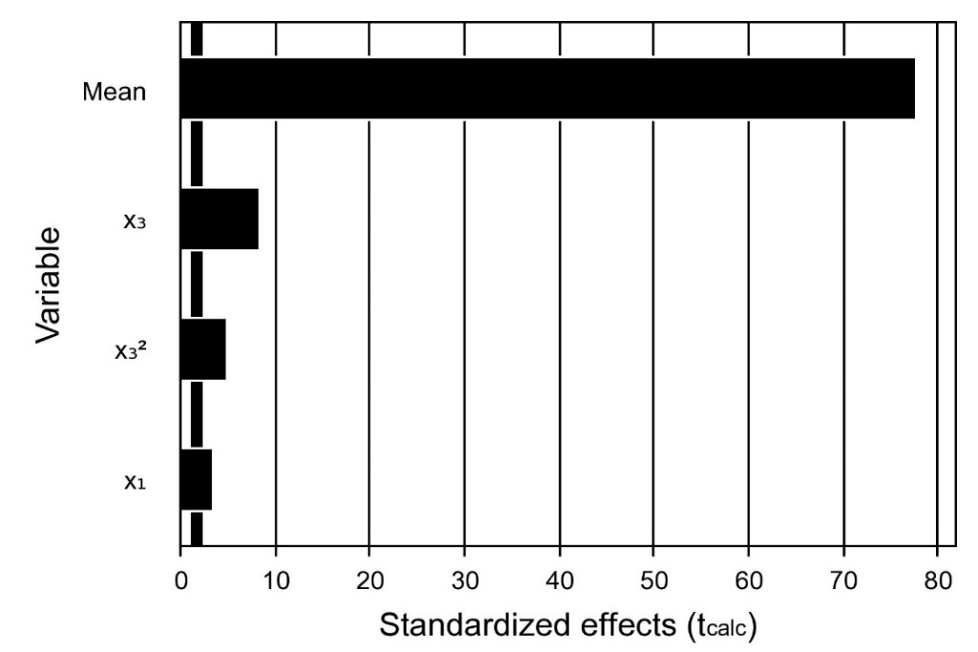 (a)
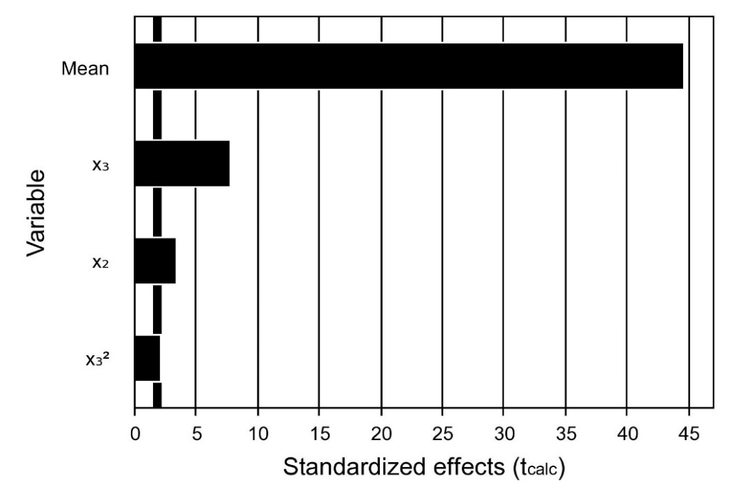 (b)
Figure S1 - Pareto chart with the significant effects of the independent variables studied on the microwave-assisted enzymatic synthesis of geranyl acetoacetate (GAcAc) in a solvent-free system with (a) and without (b) the removal of co-produced methanol (p<0.1). Where X₁ is the molar ratio, X₂ is temperature, and X₃ is the enzyme amount. Experimental data and conditions are shown in Table 1.
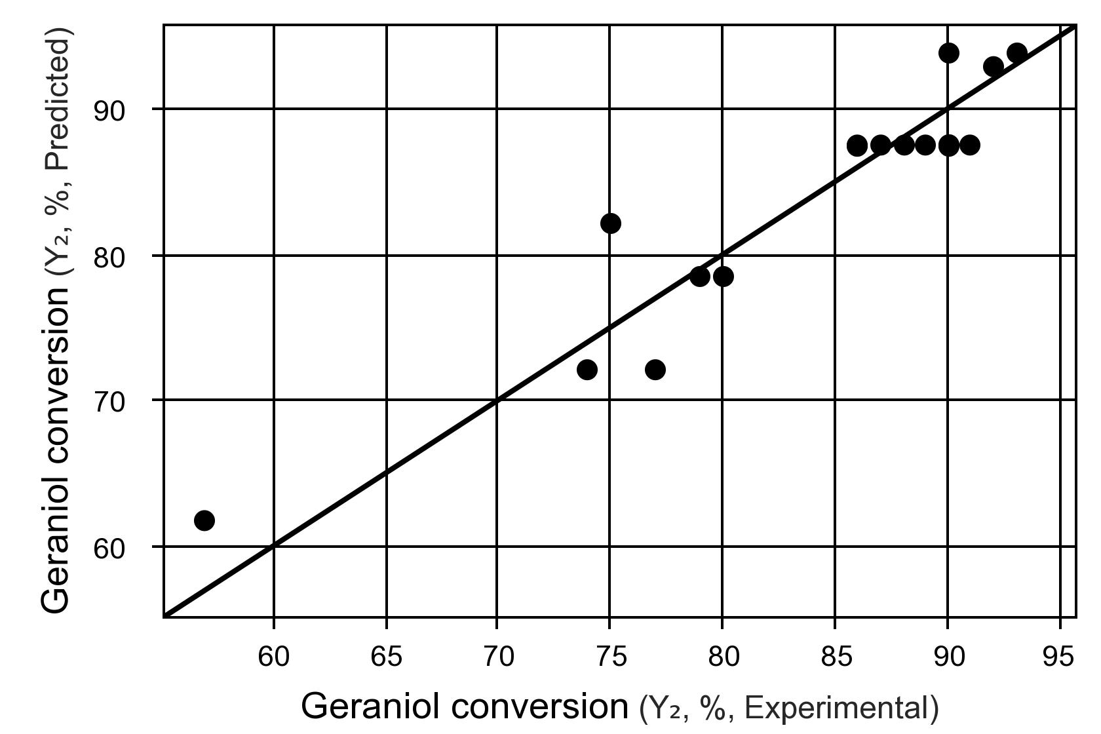 (a)
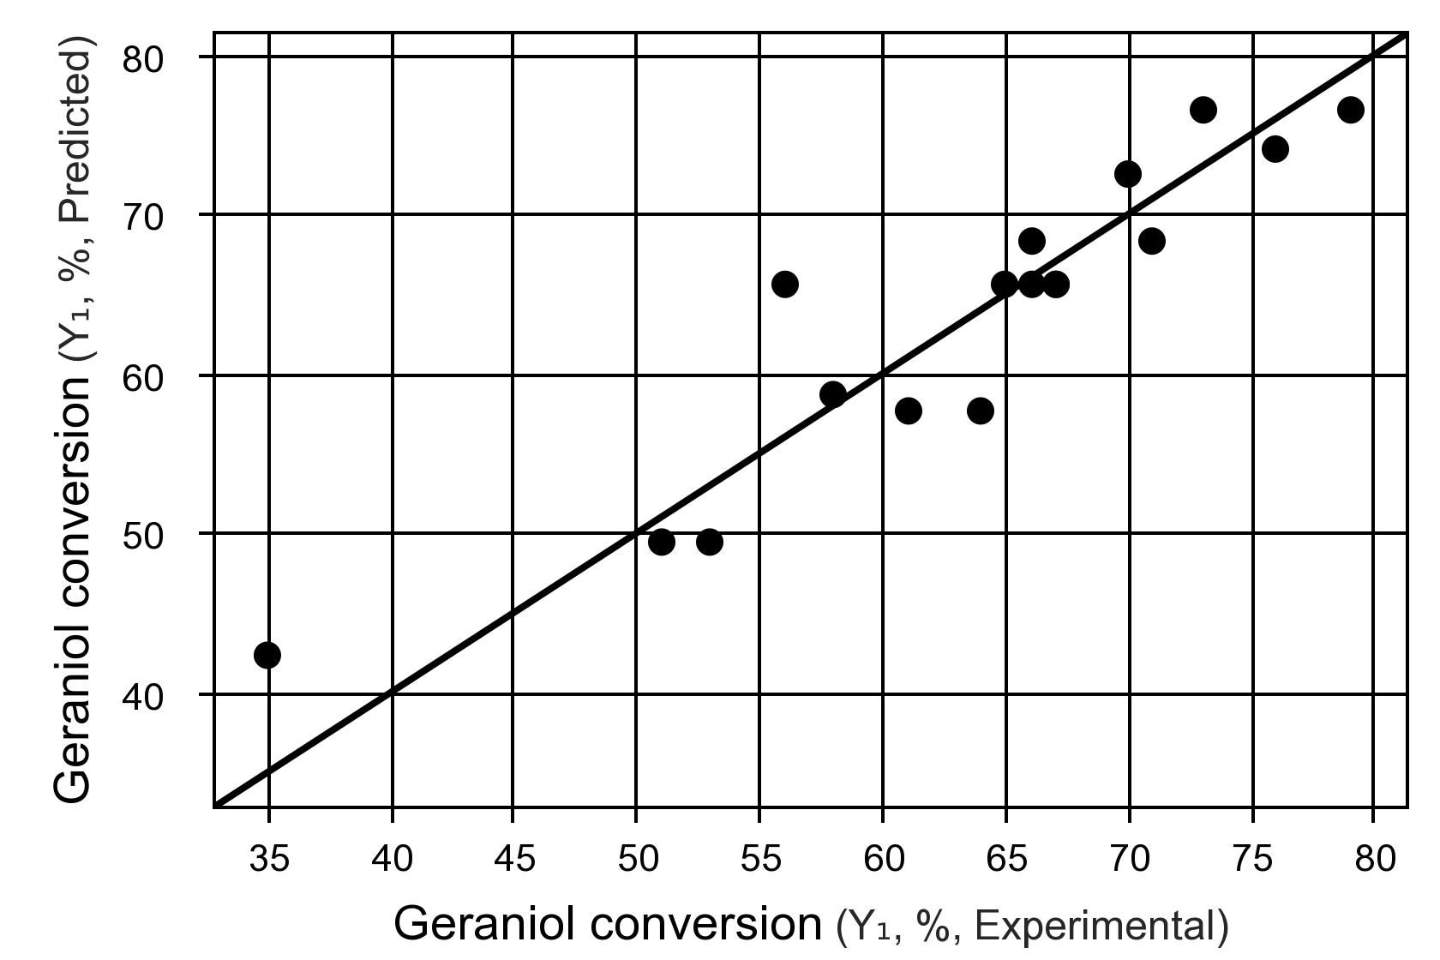 (b)
Figure S2 - Experimental versus predicted geraniol conversion for microwave-assisted enzymatic synthesis of GAcAc with (a) and without (b) removal of the co-produced methanol.

Table S1 - Analysis of variance (ANOVA) of the estimated model for the optimization of microwave-assisted enzymatic synthesis of GAcAc with the removal of co-produced methanol.
Variation source | Sum of square | Degrees of  freedom | Mean square | F_{calc} | P-value
Regression | 1207.57 | 3 | 402.52 | 34.54 | 0.000001
Residuals | 151.47 | 13 | 11.65
Lack of Fit | 149.47 | 11 | 13.58 | 13.58 | 0.0704
Pure Error | 2.00 | 2 | 1.00
Total | 1359.05 | 16
Regression coefficient: R² = 0.89; F_{0.90; 3; 13} = 2.56

Table S2 - Analysis of variance (ANOVA) of the estimated model for optimizing microwave-assisted enzymatic synthesis of GAcAc without removing co-produced methanol.
Variation source | Sum of square | Degrees of  freedom | Mean square | F_{calc} | P-value
Regression | 1537.73 | 3 | 512.57 | 25.78 | 0.00001
Residuals | 258.38 | 13 | 19.87
Lack of Fit | 256.38 | 11 | 23.30 | 23.30 | 0.04183
Pure Error | 2.00 | 2 | 1.00
Total | 1796.11 | 16
Regression coefficient: R² = 0.86; F_{0.90; 3; 13} = 2.56

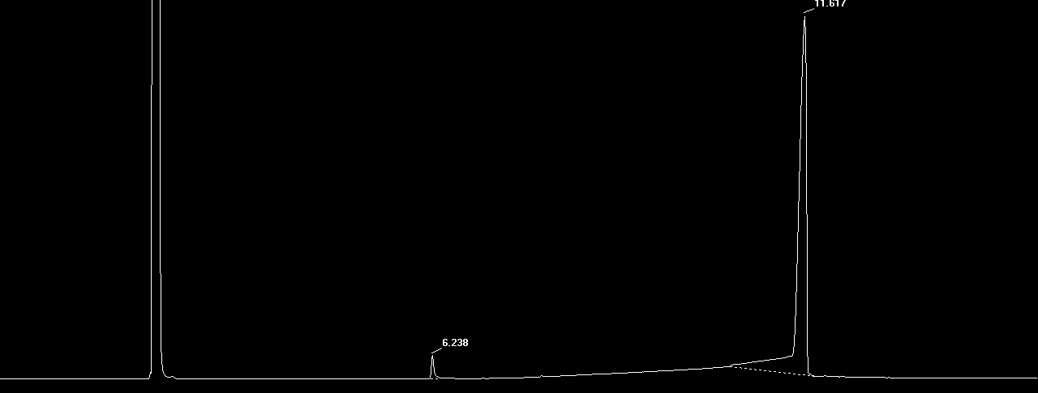
Figure S3 - Typical gas-chromatogram of GAcAc after removal of the excess methyl acetoacetate by vacuum distillation (rotary evaporator, 70°C, 10 mbar). Retention time: ethyl acetate 2.94 min, geraniol 6.2 min and GAcAc 11.6 min.

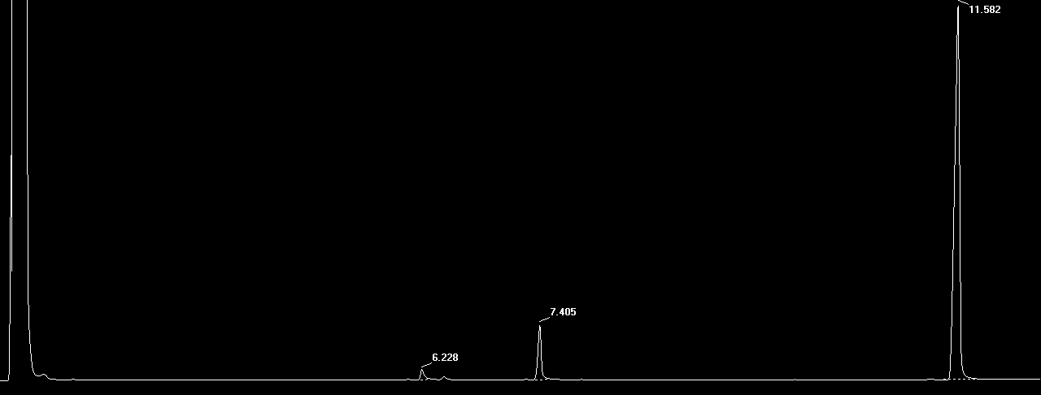
Figure S4 - Typical gas-chromatogram of geranyl (R)-3-hydroxybutyrate (G-3HB) after removal of the excess of methyl (R)-3-hydroxybutyrate by vacuum distillation (rotary evaporator,70°C, 200 rmp, and 10 mbar). Retention time: ethyl acetate 2.94 min, geraniol 6.2 min, 4-methoxy-4-oxobutan-2-yl 3-hydroxy butanoate 7.4 min (see ¹H-NMR spectra in Figure S13), and G-3HB 11.5 min.

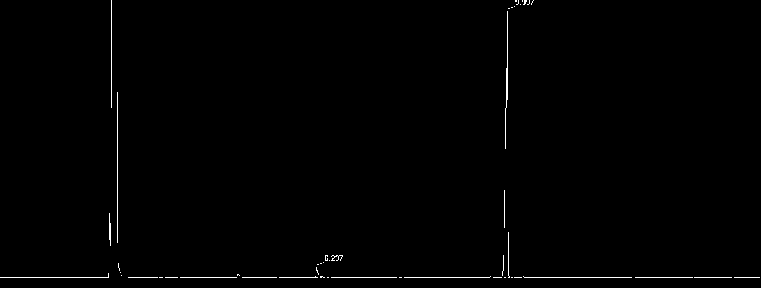
Figure S5 - Typical gas-chromatogram of geranyl butyrate (GB) after removal of the excess ethyl butyrate by vacuum distillation (rotary evaporator, 70°C, 200 rmp, and 10 mbar). Retention time: ethyl acetate 2.94 min, geraniol 6.2 min, and GB 9.9 min.

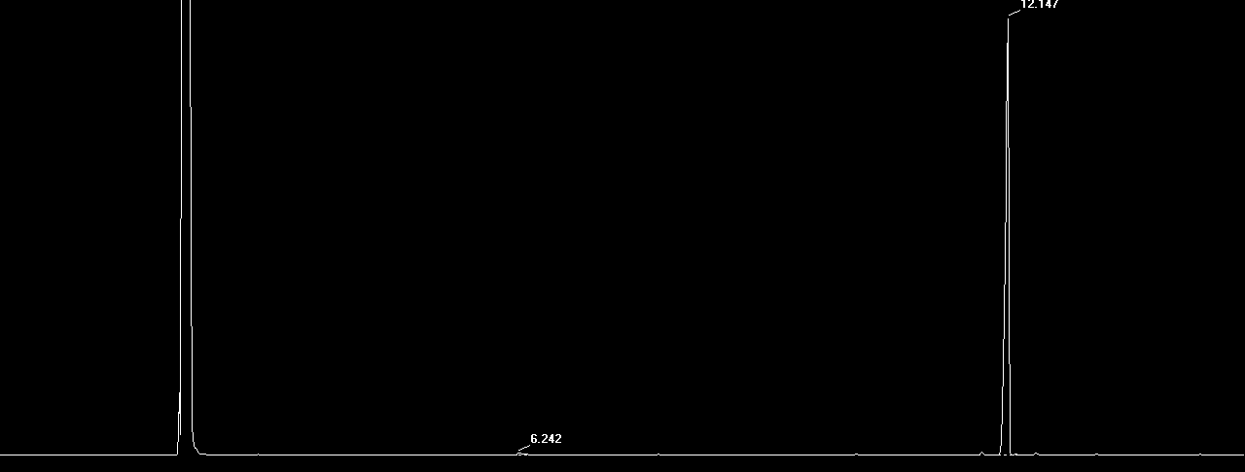
Figure S6 - Typical gas-chromatogram of geranyl hexanoate (GH) after removal of the excess of methyl hexanoate by vacuum distillation (rotary evaporator, 70°C, 200 rmp, 10 mbar). Retention time: ethyl acetate 2.94 min, geraniol 6.2 min, and GH 12.1 min.

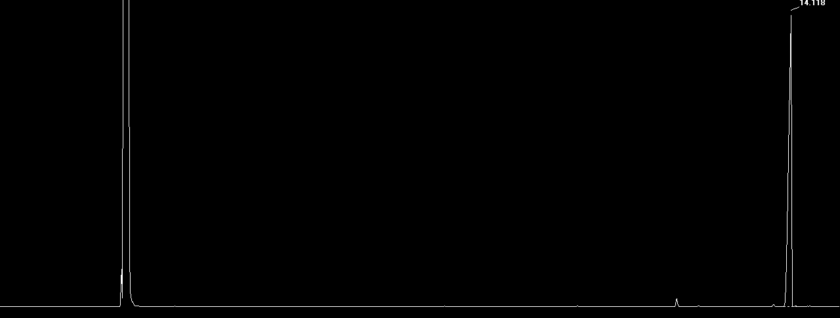
Figure S7 - Typical gas-chromatogram of geranyl octanoate (GO) after removal of the excess of methyl octanoate by vacuum distillation (rotary evaporator, 70°C, 200 rmp, and 10 mbar vacuum). Retention time: ethyl acetate 2.94 min and GO 14.1 min.

Figure S8 - ¹H- and ¹³C-NMR spectra of geranyl acetoacetate using CDCl₃ at 400 MHz.

Figure S9 - ¹H- and ¹³C-NMR spectra of geranyl (R)-3-hydroxybutyrate using CDCl₃ at 400 MHz.

Figure S10 - ¹H- and ¹³C-NMR spectra of geranyl butyrate using CDCl₃ at 400 MHz.

Figure S11 - ¹H- and ¹³C-NMR spectra of geranyl hexanoate using CDCl₃ at 400 MHz.

Figure S12 - ¹H- and ¹³C-NMR spectra of geranyl octanoate using CDCl₃ at 400 MHz.

Figure S13 - ¹H-NMR spectra of 4-methoxy-4-oxobutan-2-yl 3-hydroxy butanoate using CDCl₃ at 400 MHz: δ 5.37-5.28 (m, 1H), 4.23-4.14 (m, 1H), 3.69 (s, 3H), 3.01 (d, J = 3.6 Hz, 1H), 2.64 (dd, J = 15.6, 7.8 Hz, 1H), 2.53 (dd, J = 15.6, 5.3 Hz, 1H), 2.46 (dd, J = 15.9, 3.5 Hz, 1H), 2.39 (dd, J = 16.0, 8.5 Hz, 1H), 1.32 (d, J = 6.4 Hz, 3H), 1.22 (d, J = 6.3 Hz, 3H).

