Design and Synthesis of New Quinazolinone Derivatives: Investigation of Antimicrobial and Biofilm Inhibition Effects
Rasha Mohamed Hassan ^{1*, a}, Heba Yehia ^{2, a} , Mohammed F. El-Behairy ³, Aida Abdel- Sattar El-Azzouny ¹, Mohamed Nabil Aboul-Enein ^{1*}

¹Medicinal and Pharmaceutical Chemistry Department, Pharmaceutical and Drug Industries Research Institute, National Research Centre (ID: 60014618), P.O. 12622, Dokki, Giza, Egypt.
² Chemistry of Natural and Microbial Products Department, Pharmaceutical and Drug Industries Research Institute, National Research Centre (ID: 60014618), P.O. 12622, Dokki, Giza, Egypt.
³ Department of Organic and Medicinal Chemistry, Faculty of Pharmacy, University of Sadat City, Sadat City 32897, Egypt.
* Correspondence:
Rasha Mohamed Hassan, Medicinal and Pharmaceutical Chemistry Department, Pharmaceutical and Drug Industries Research Institute, National Research Centre, P.O. 12622 Dokki, Giza, Egypt. e-mail: rashahassan_pharma@yahoo.ca
Mohamed Nabil Aboul-Enein, Medicinal and Pharmaceutical Chemistry Department, Pharmaceutical and Drug Industries Research Institute, National Research Centre, P.O. 12622 Dokki, Giza, Egypt. e-mail: mnaboulenein@yahoo.com
ª Co-first authors.

Spectral data of intermediate and target compounds

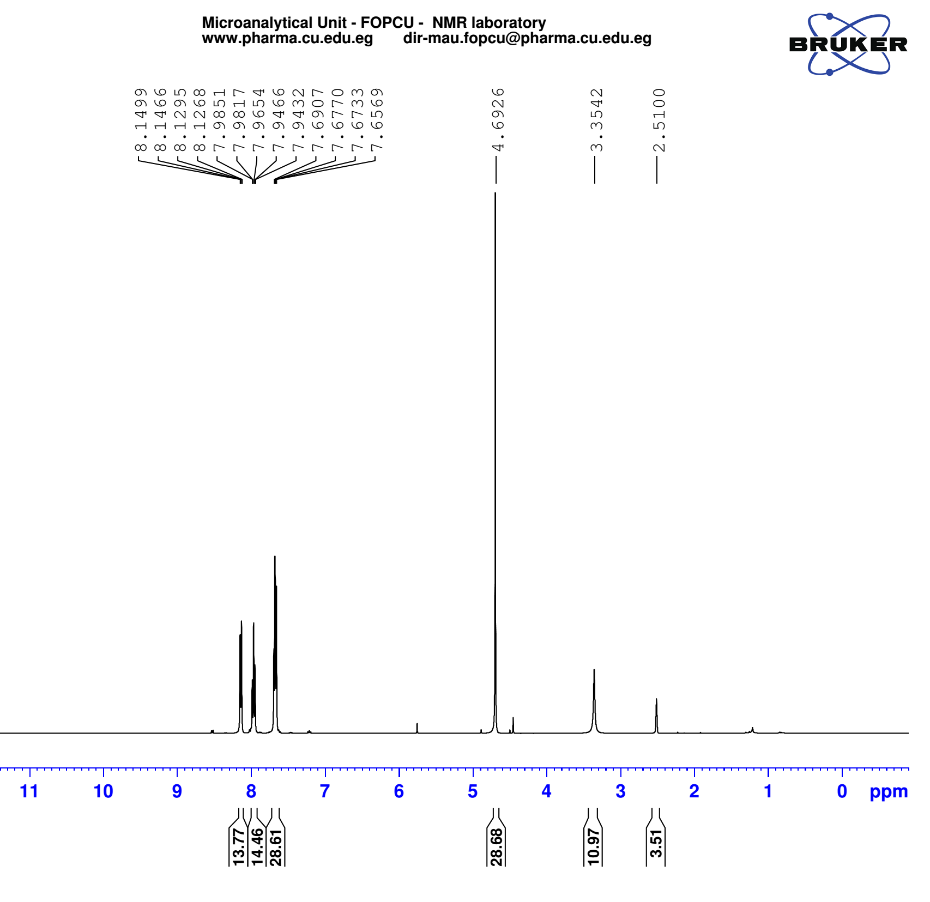
¹H-NMR spectrum of compound 7
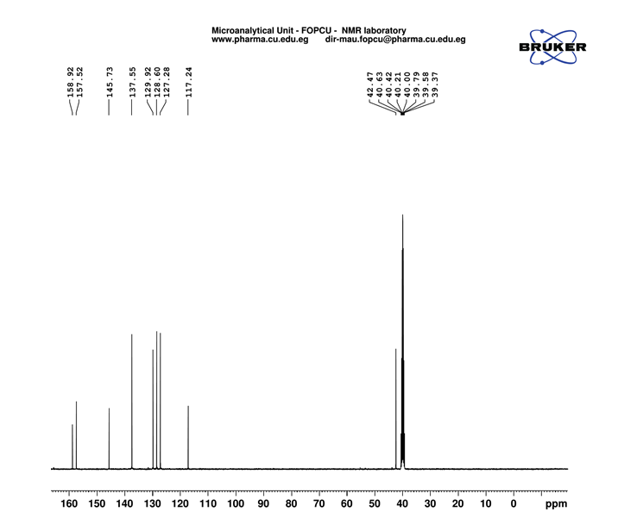

¹³C-NMR spectrum of compound 7

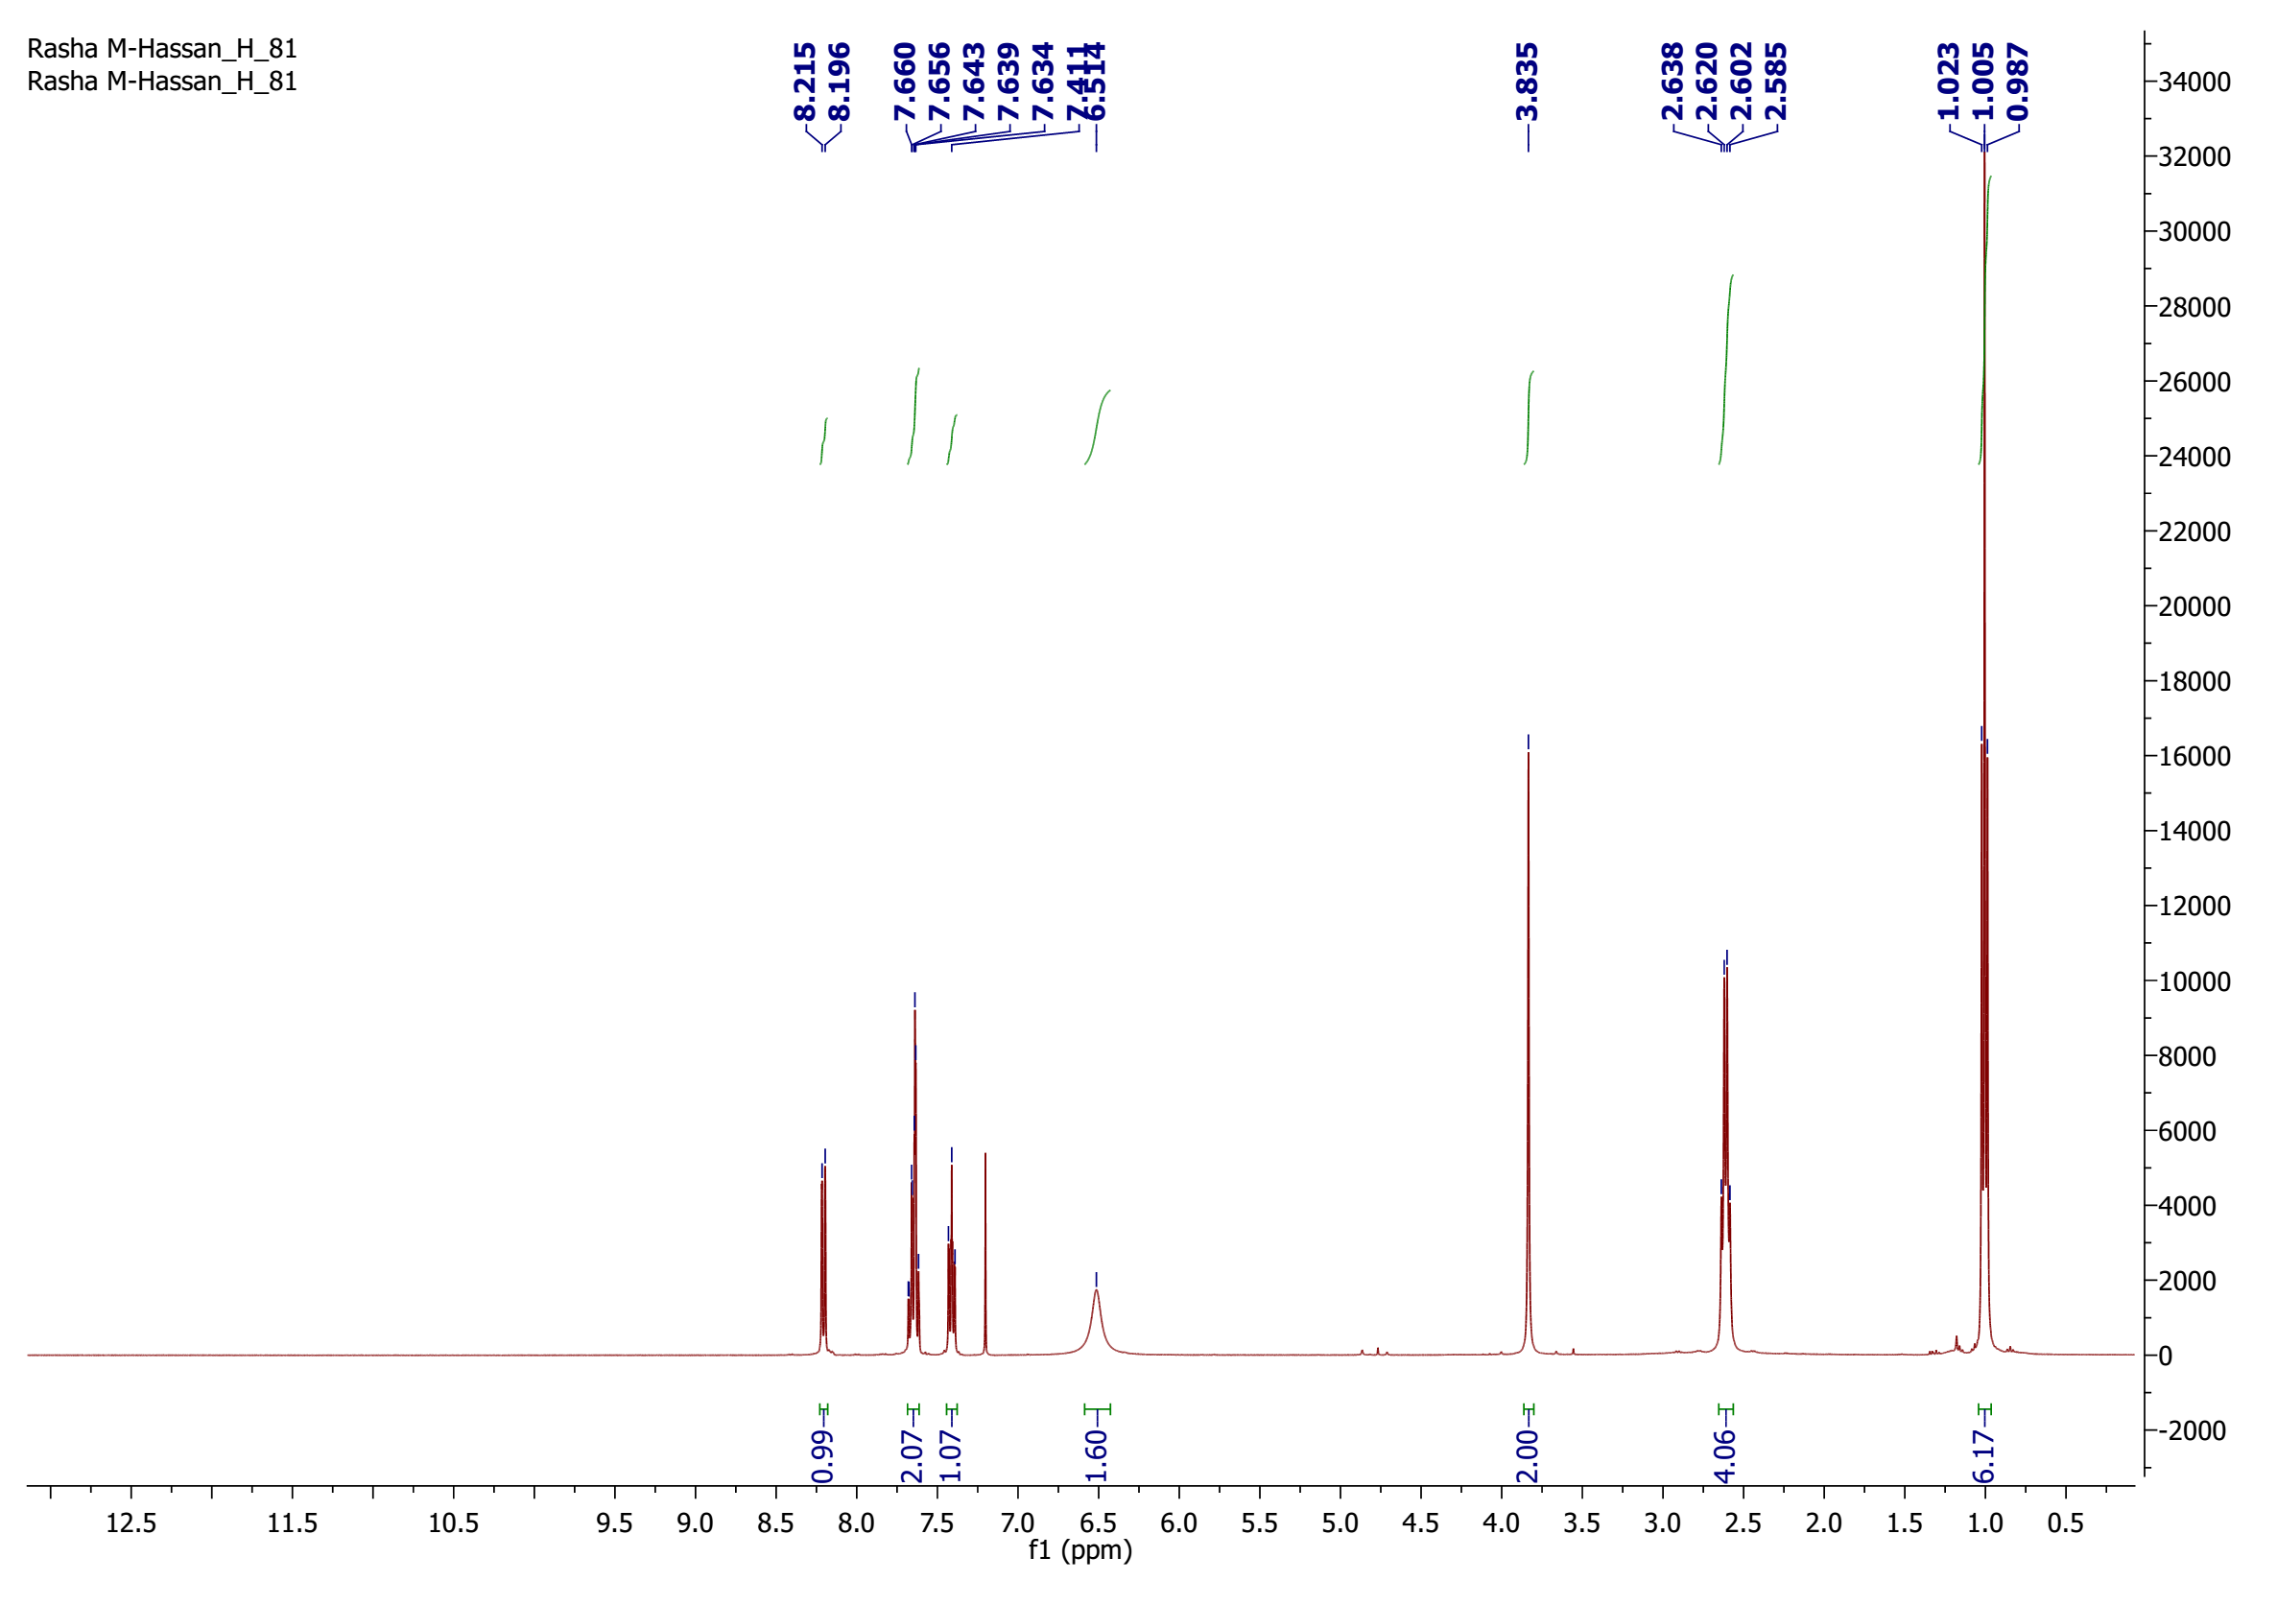
¹H-NMR spectrum of compound 5a

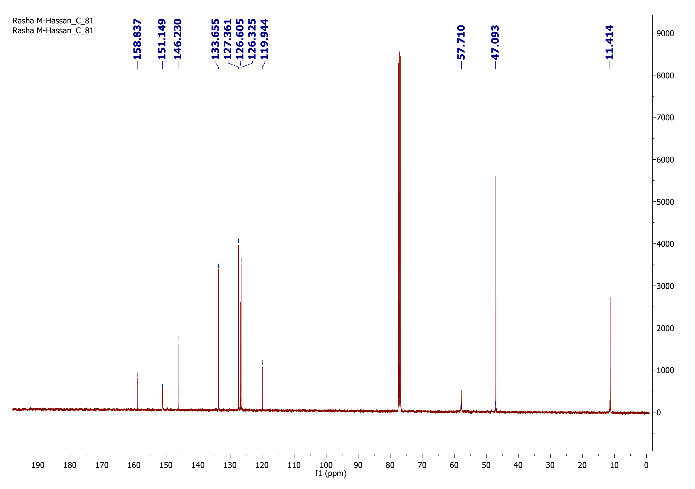
¹³C-NMR spectrum of compound 5a

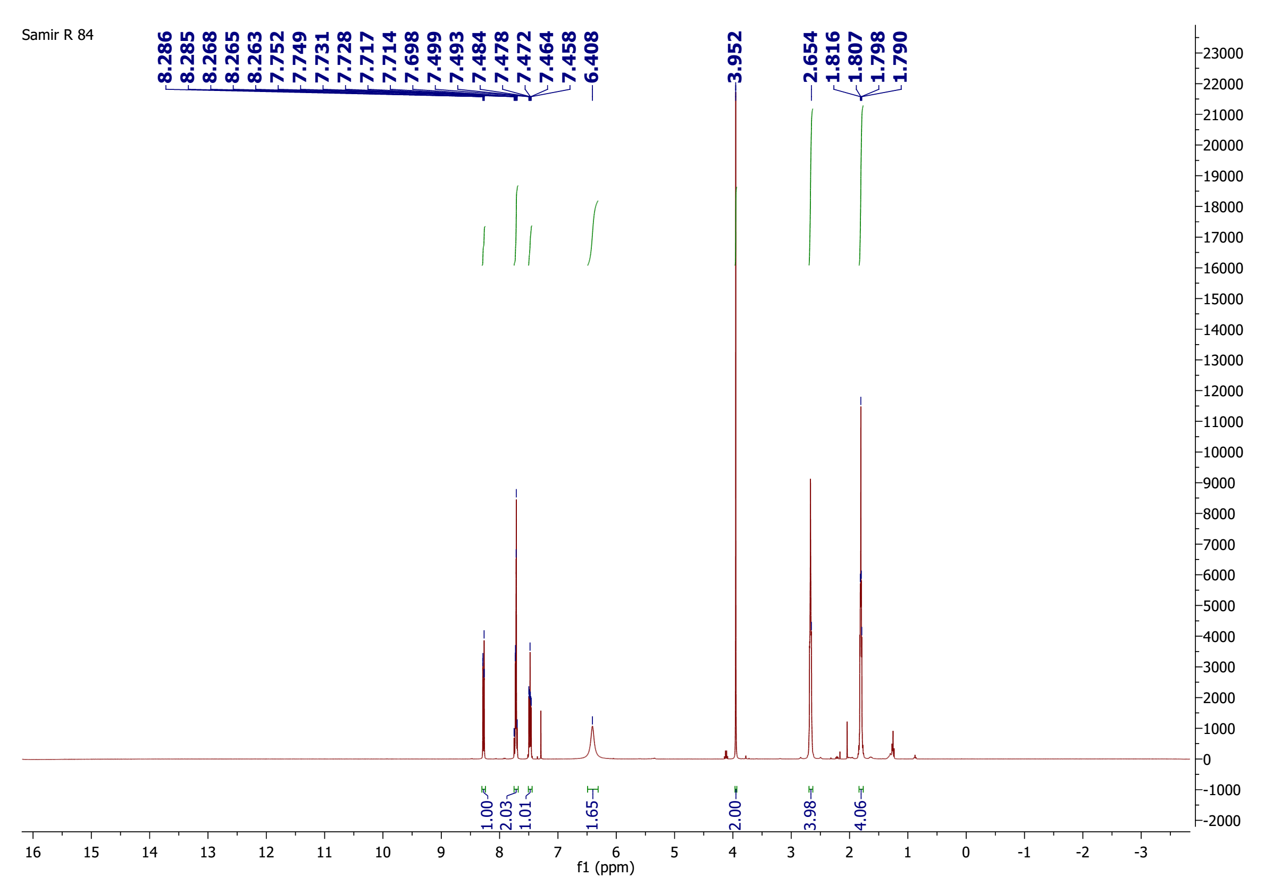
¹H-NMR spectrum of compound 5b

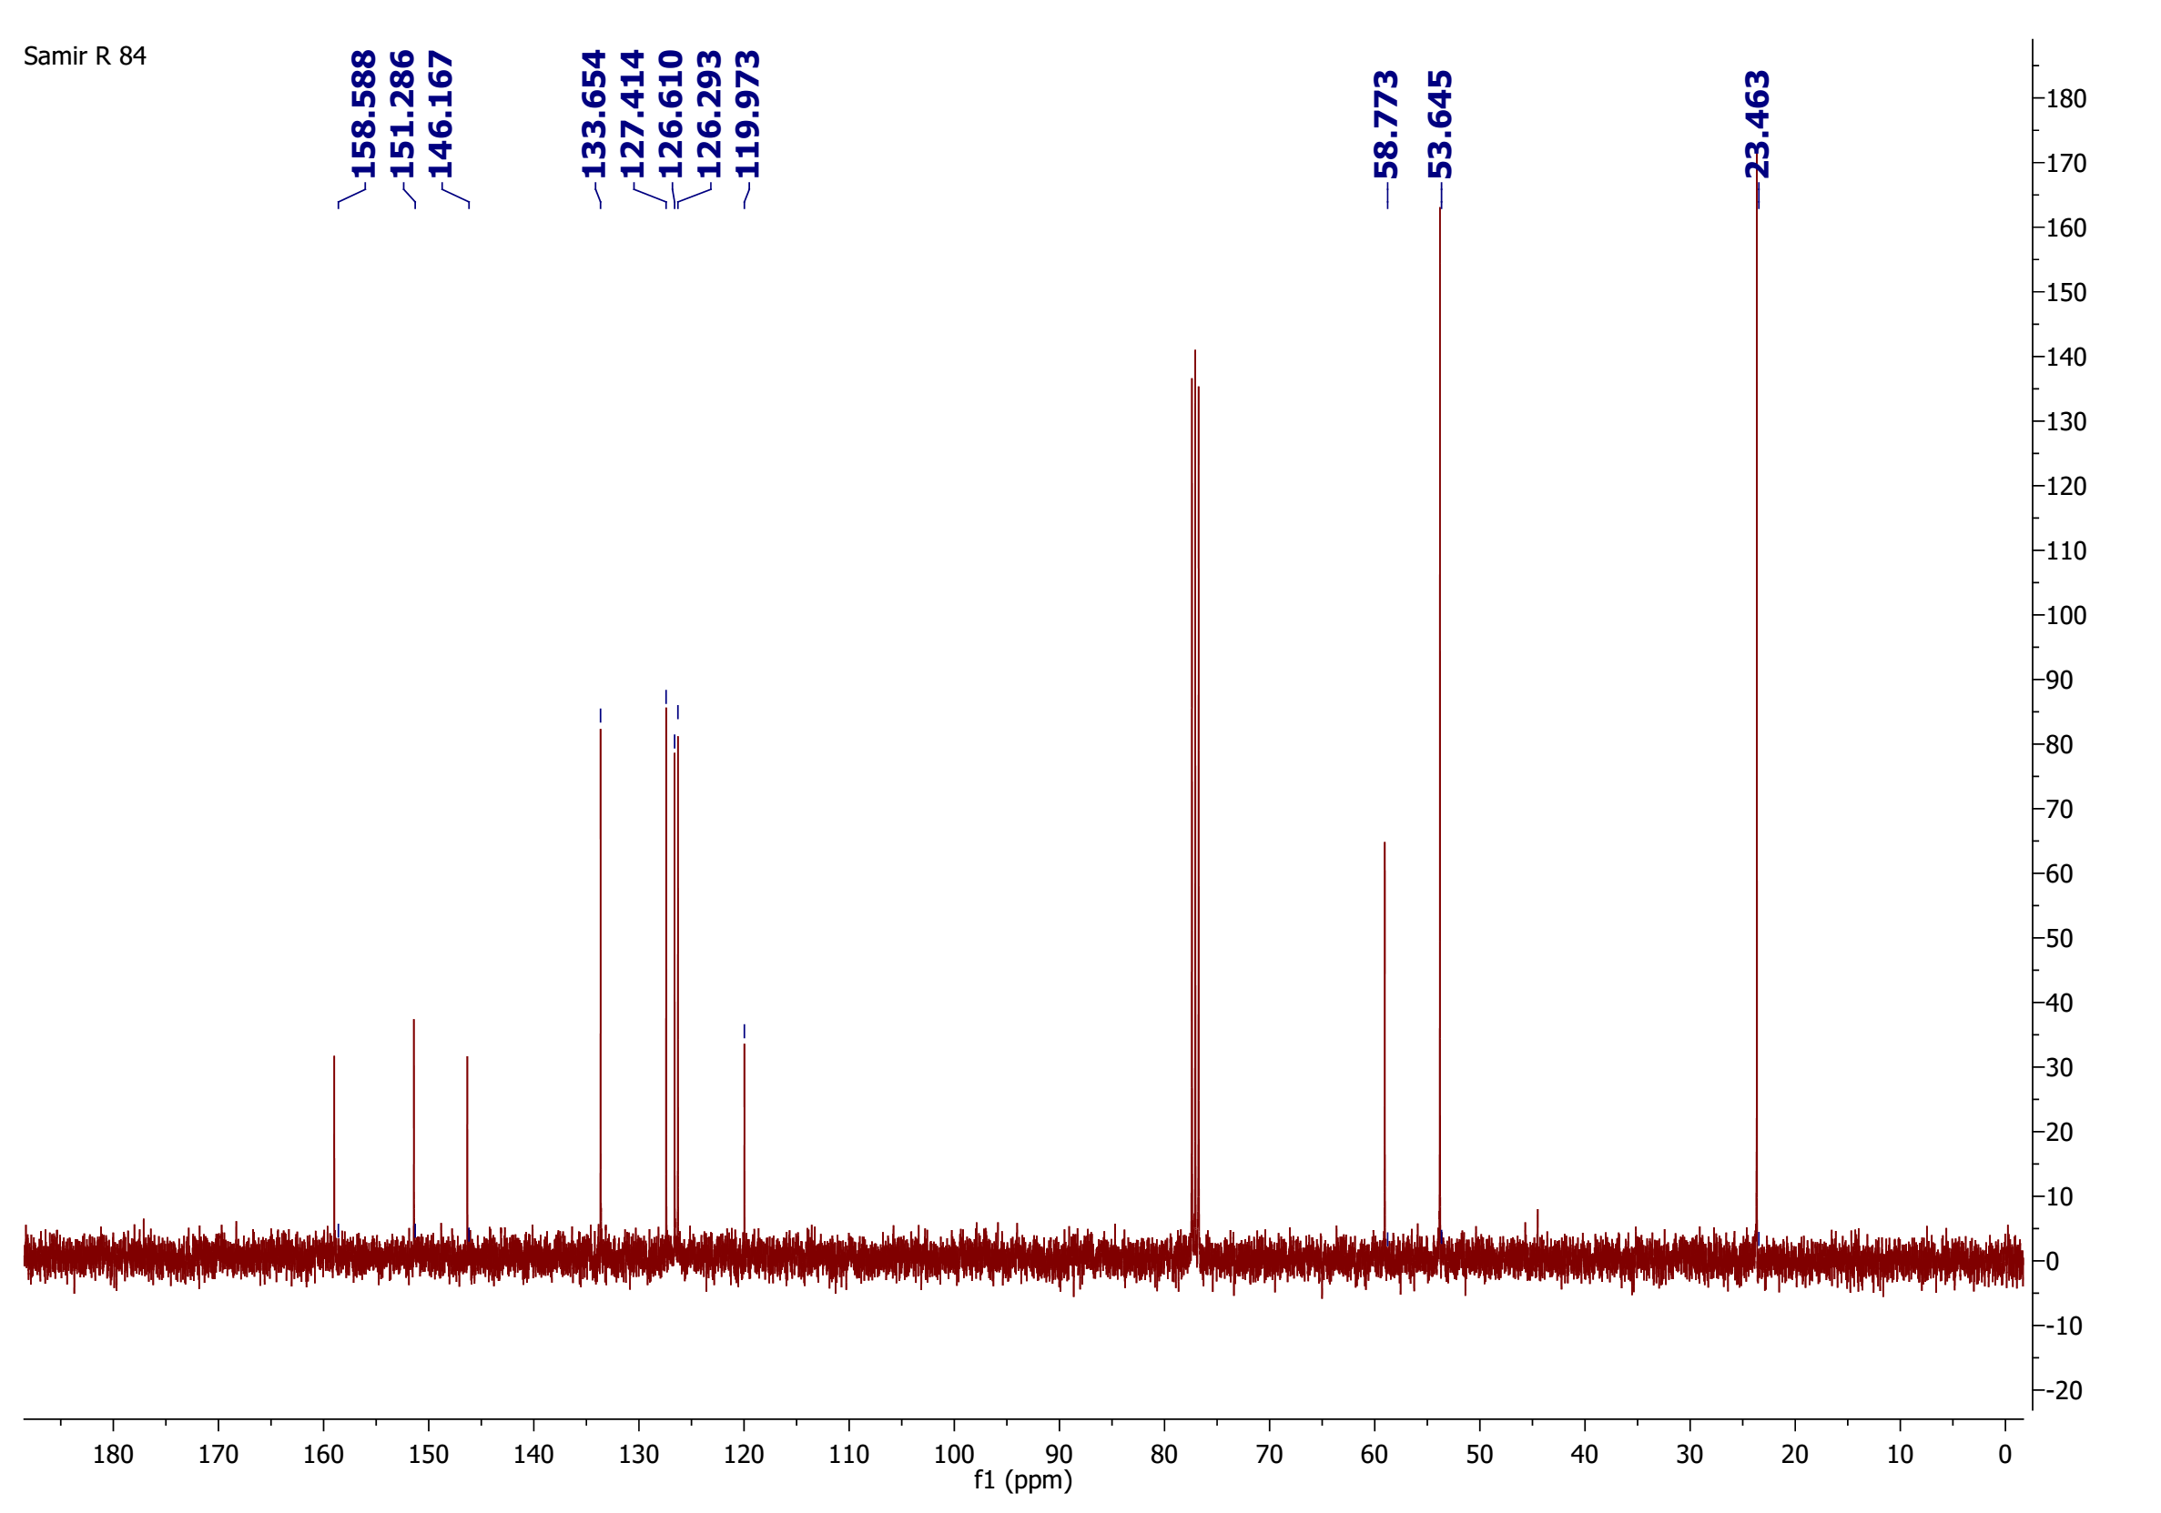

¹³C-NMR spectrum of compound 5b

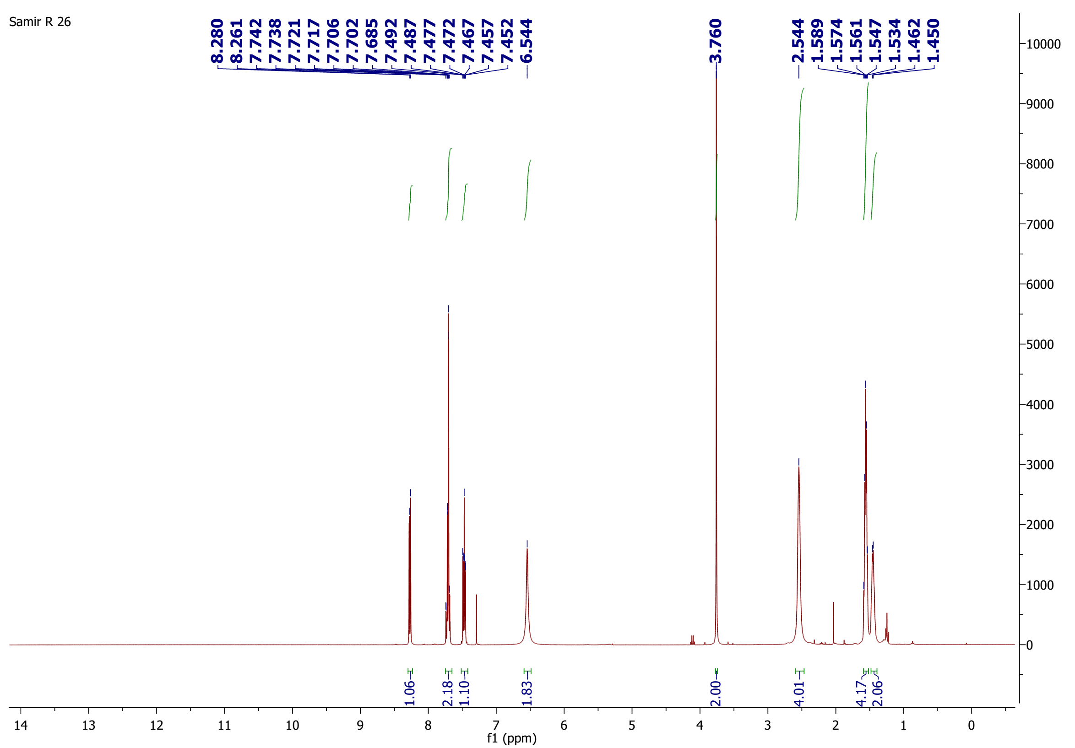
¹H-NMR spectrum of compound 5c

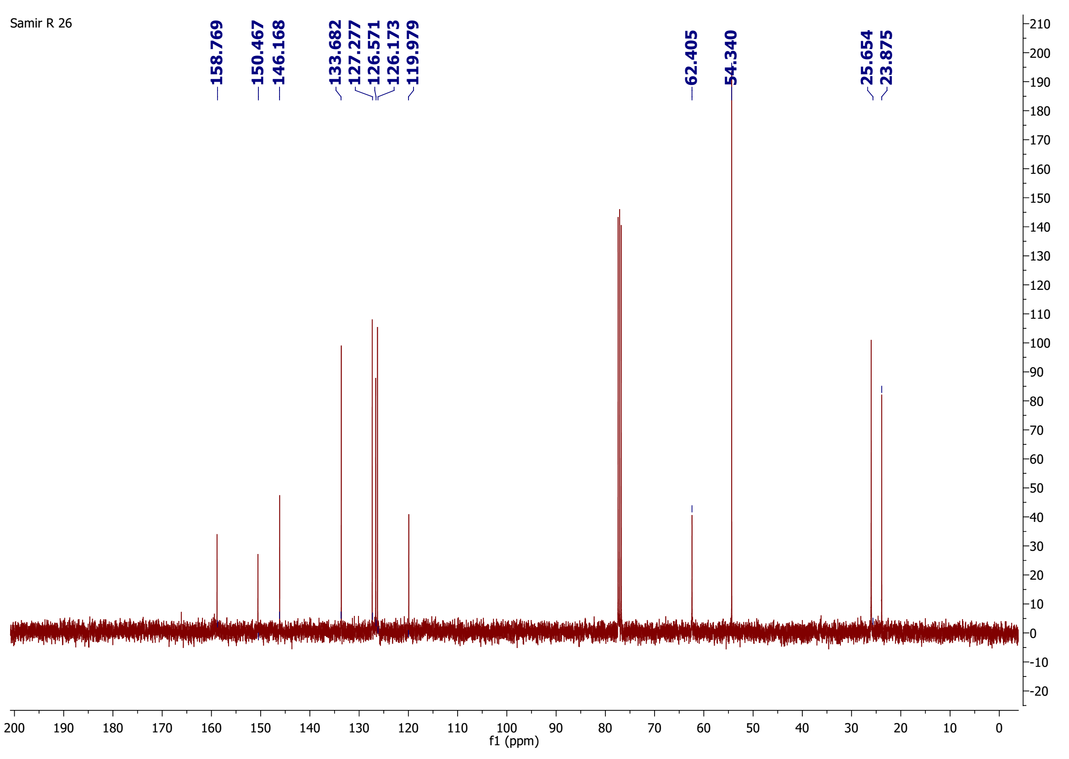
¹³C-NMR spectrum of compound 5c

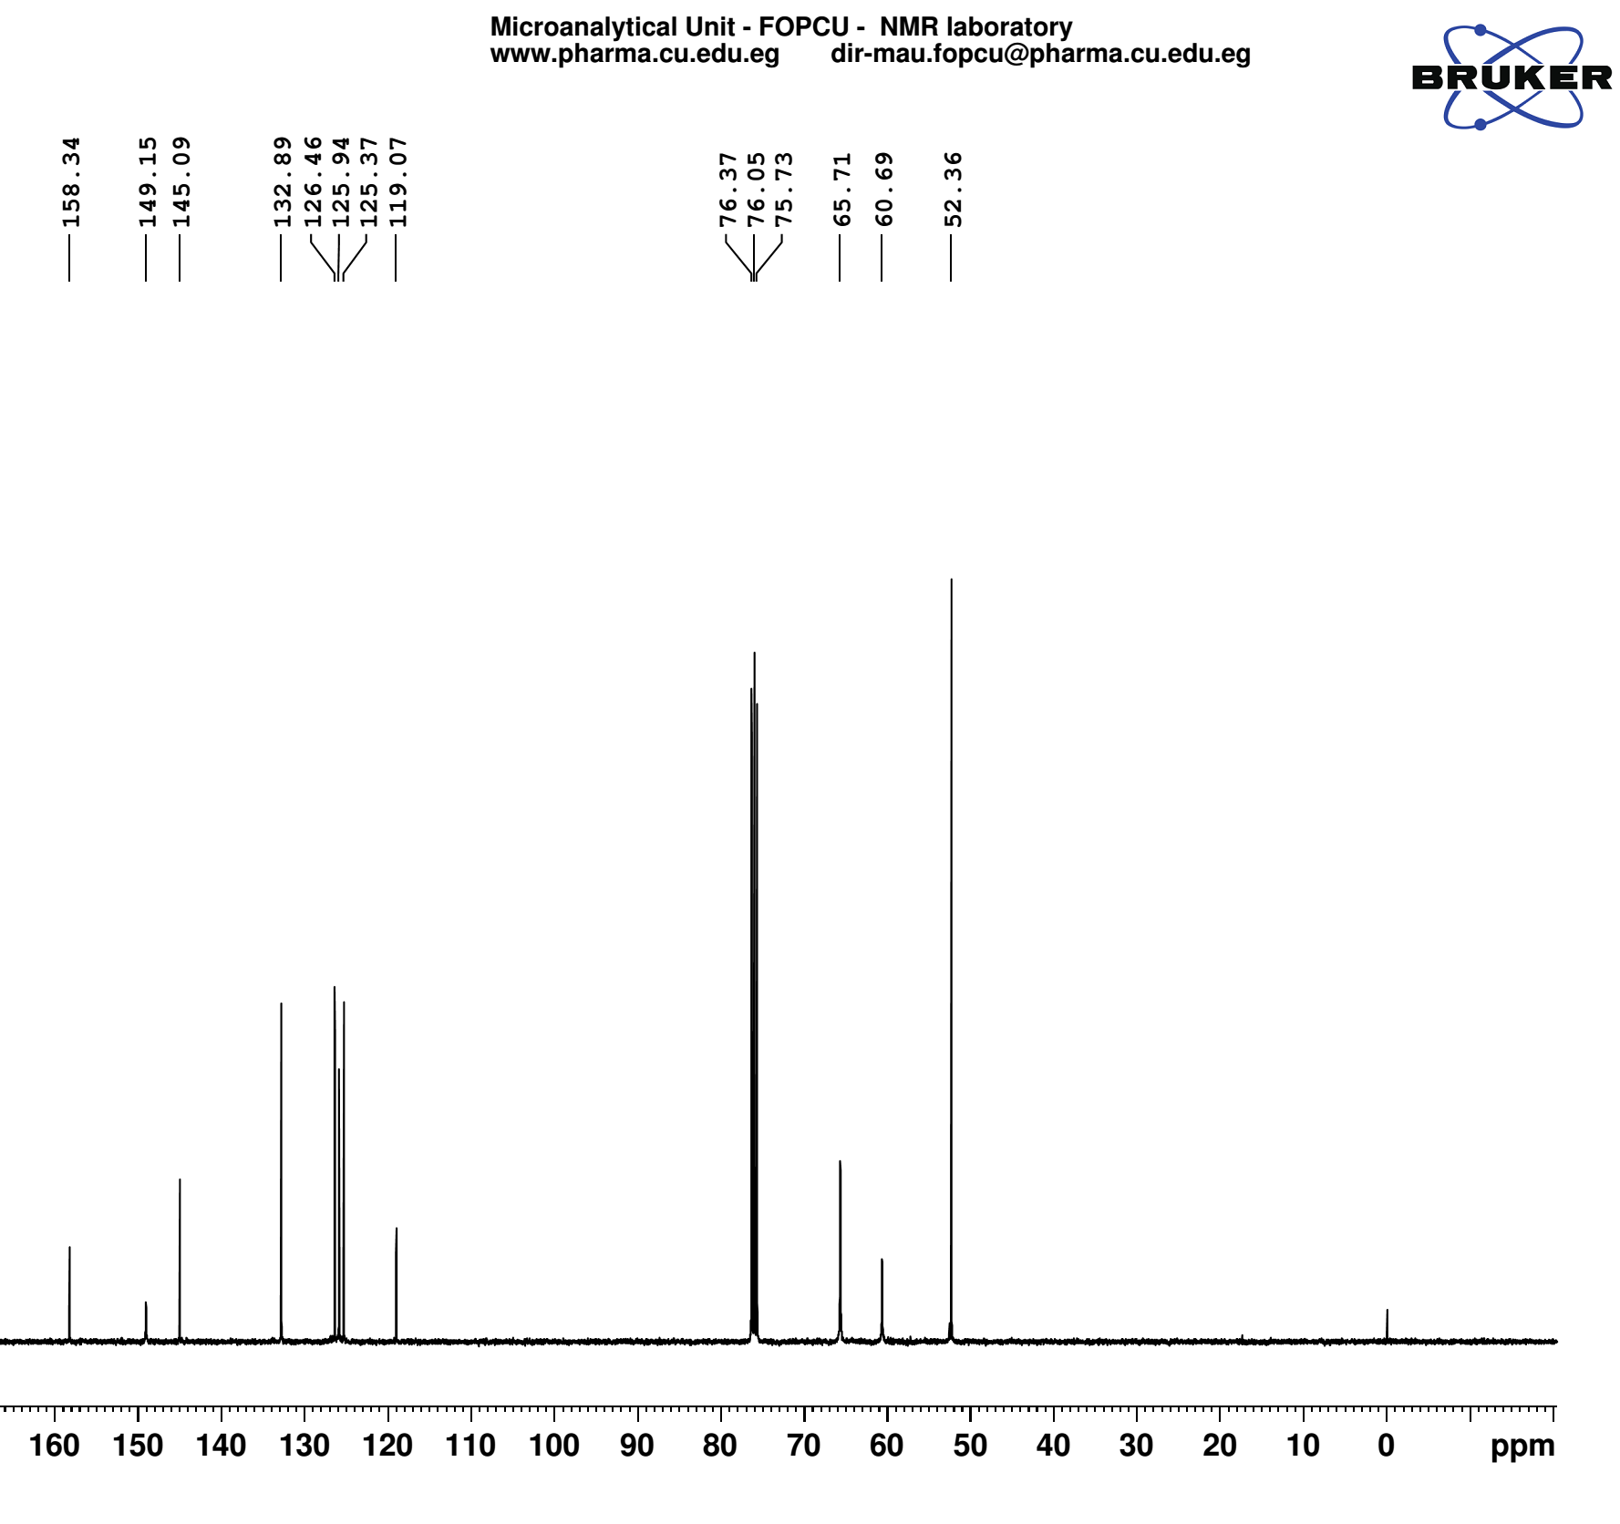
¹³C-NMR spectrum of compound 5d

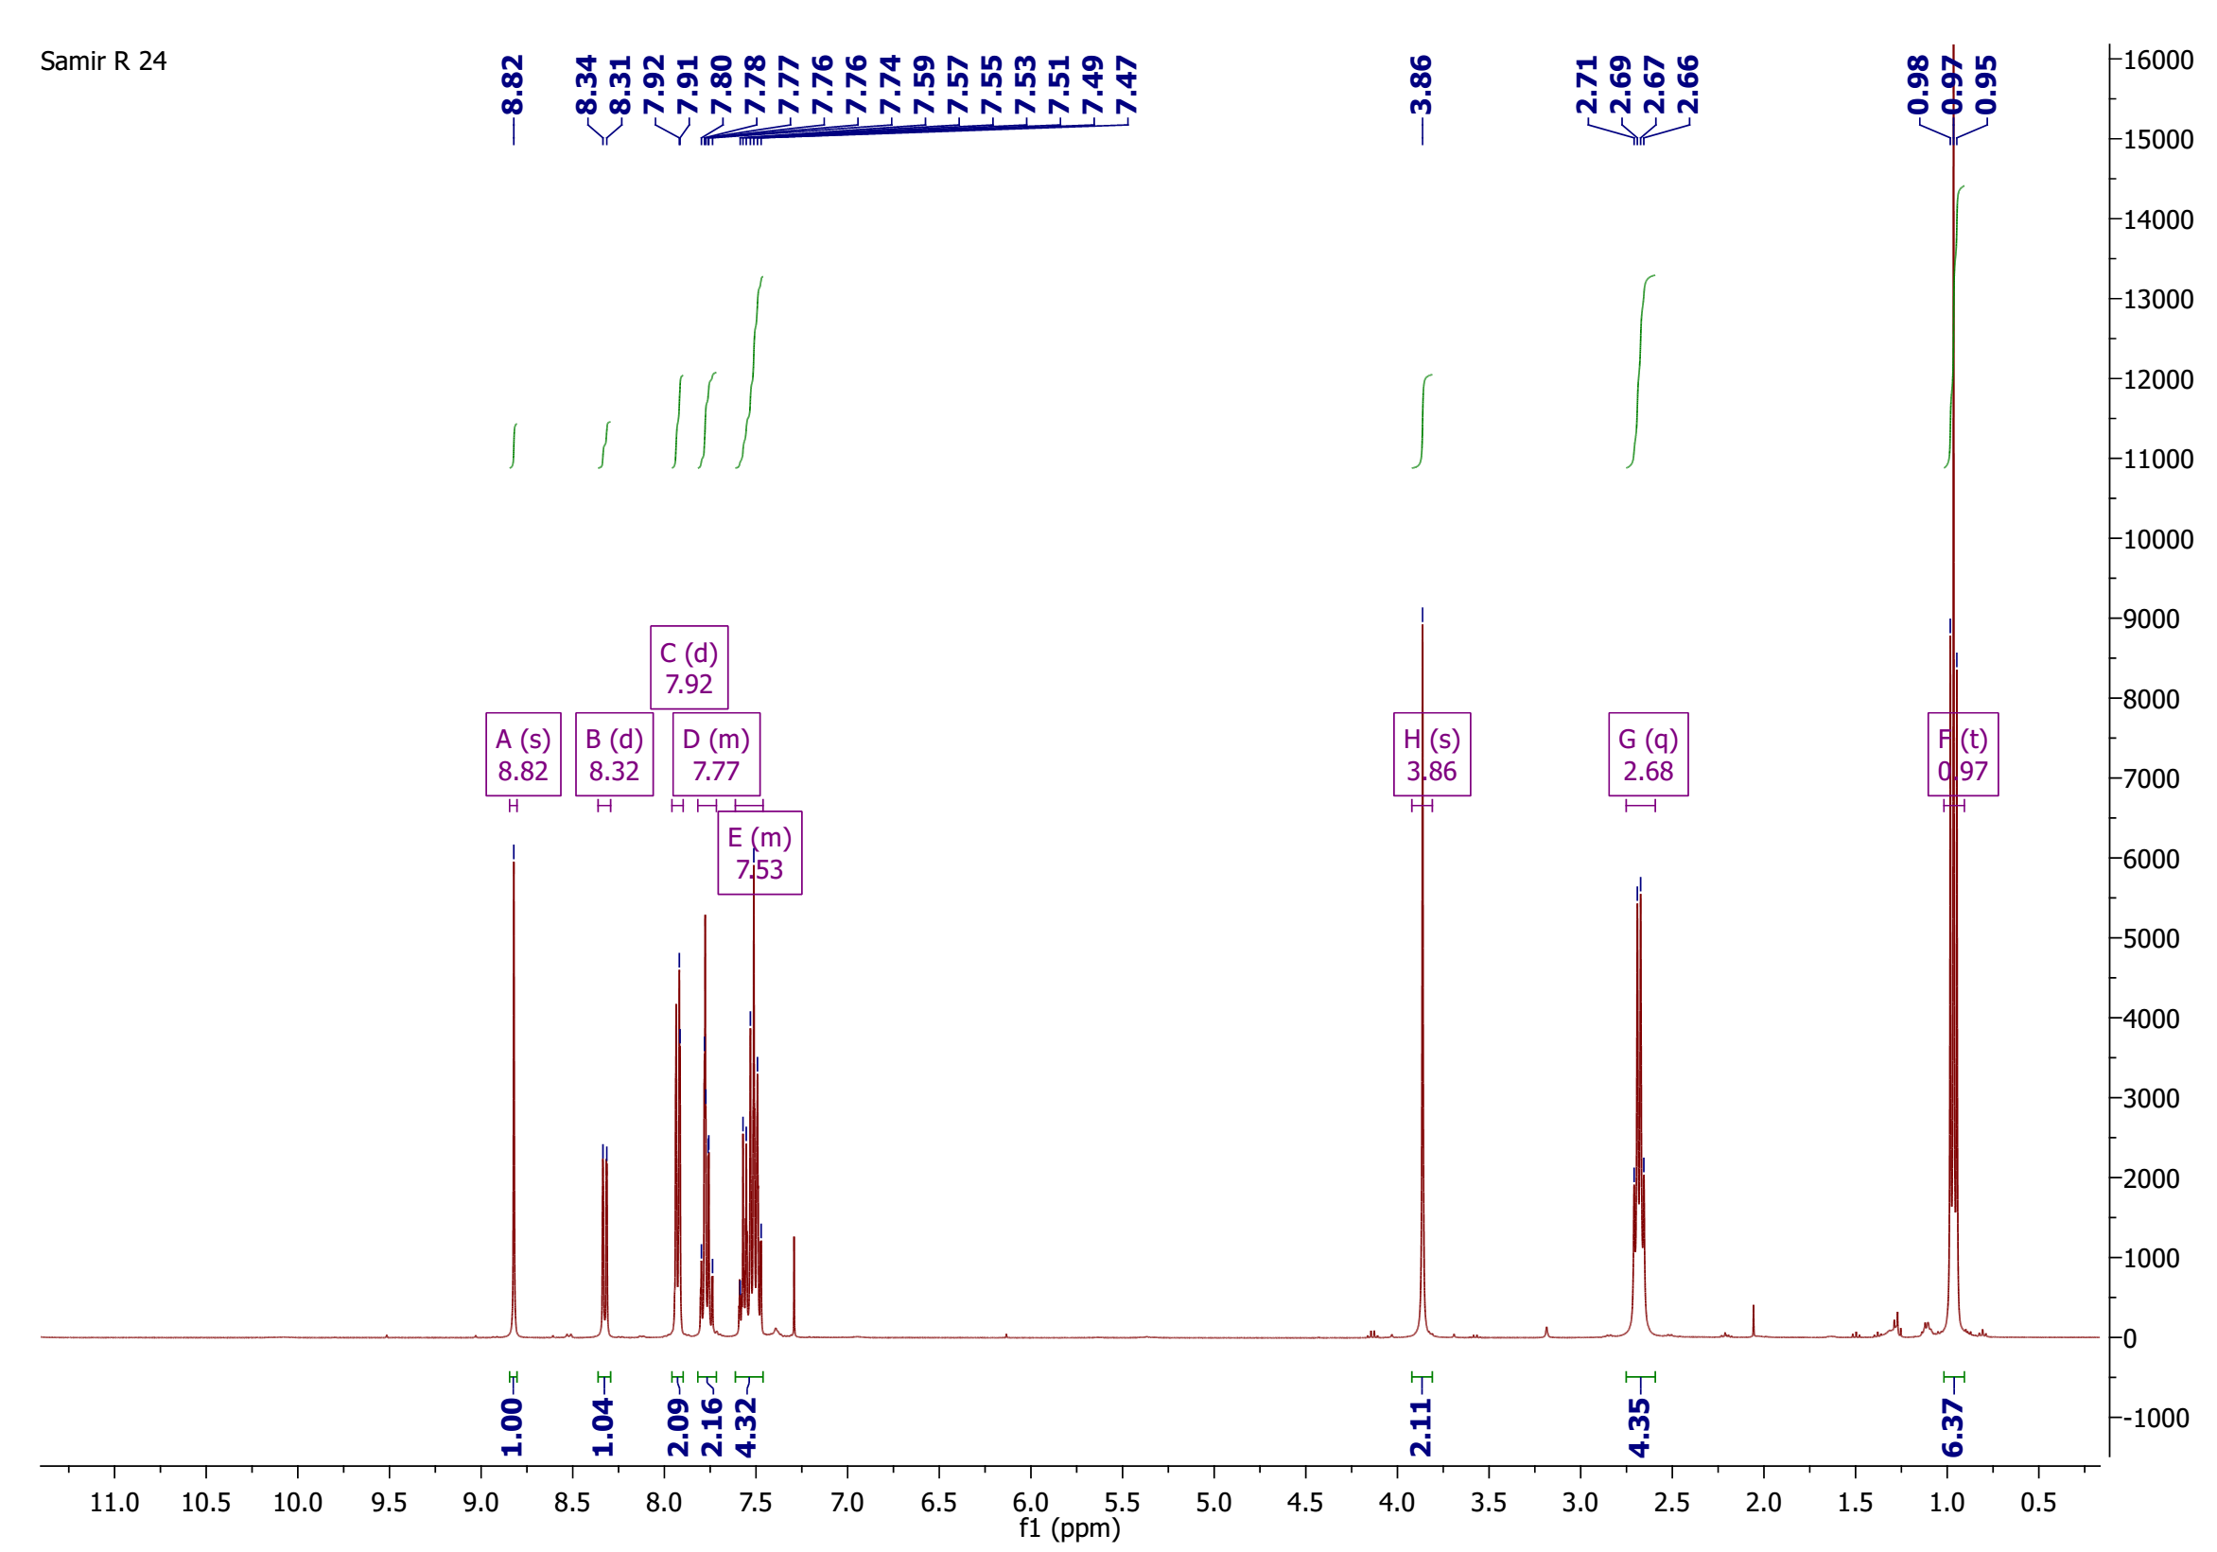
¹H-NMR spectrum of compound 9

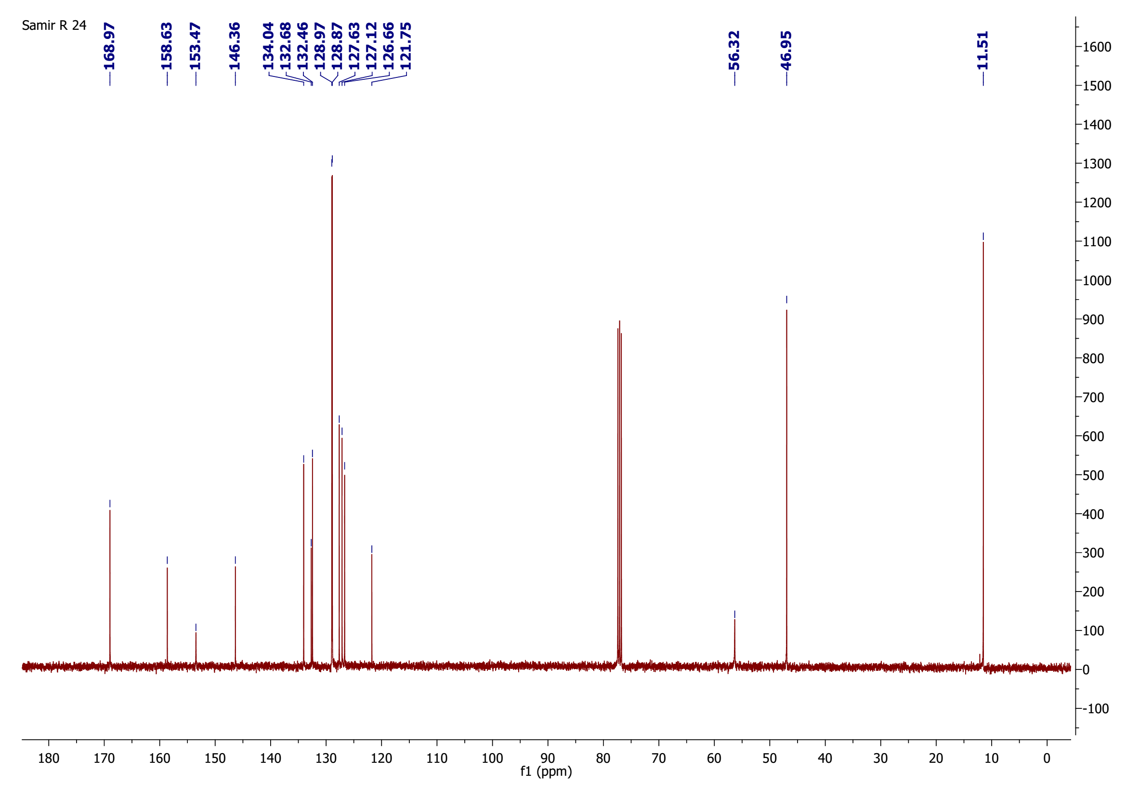

¹³C-NMR spectrum of compound 9

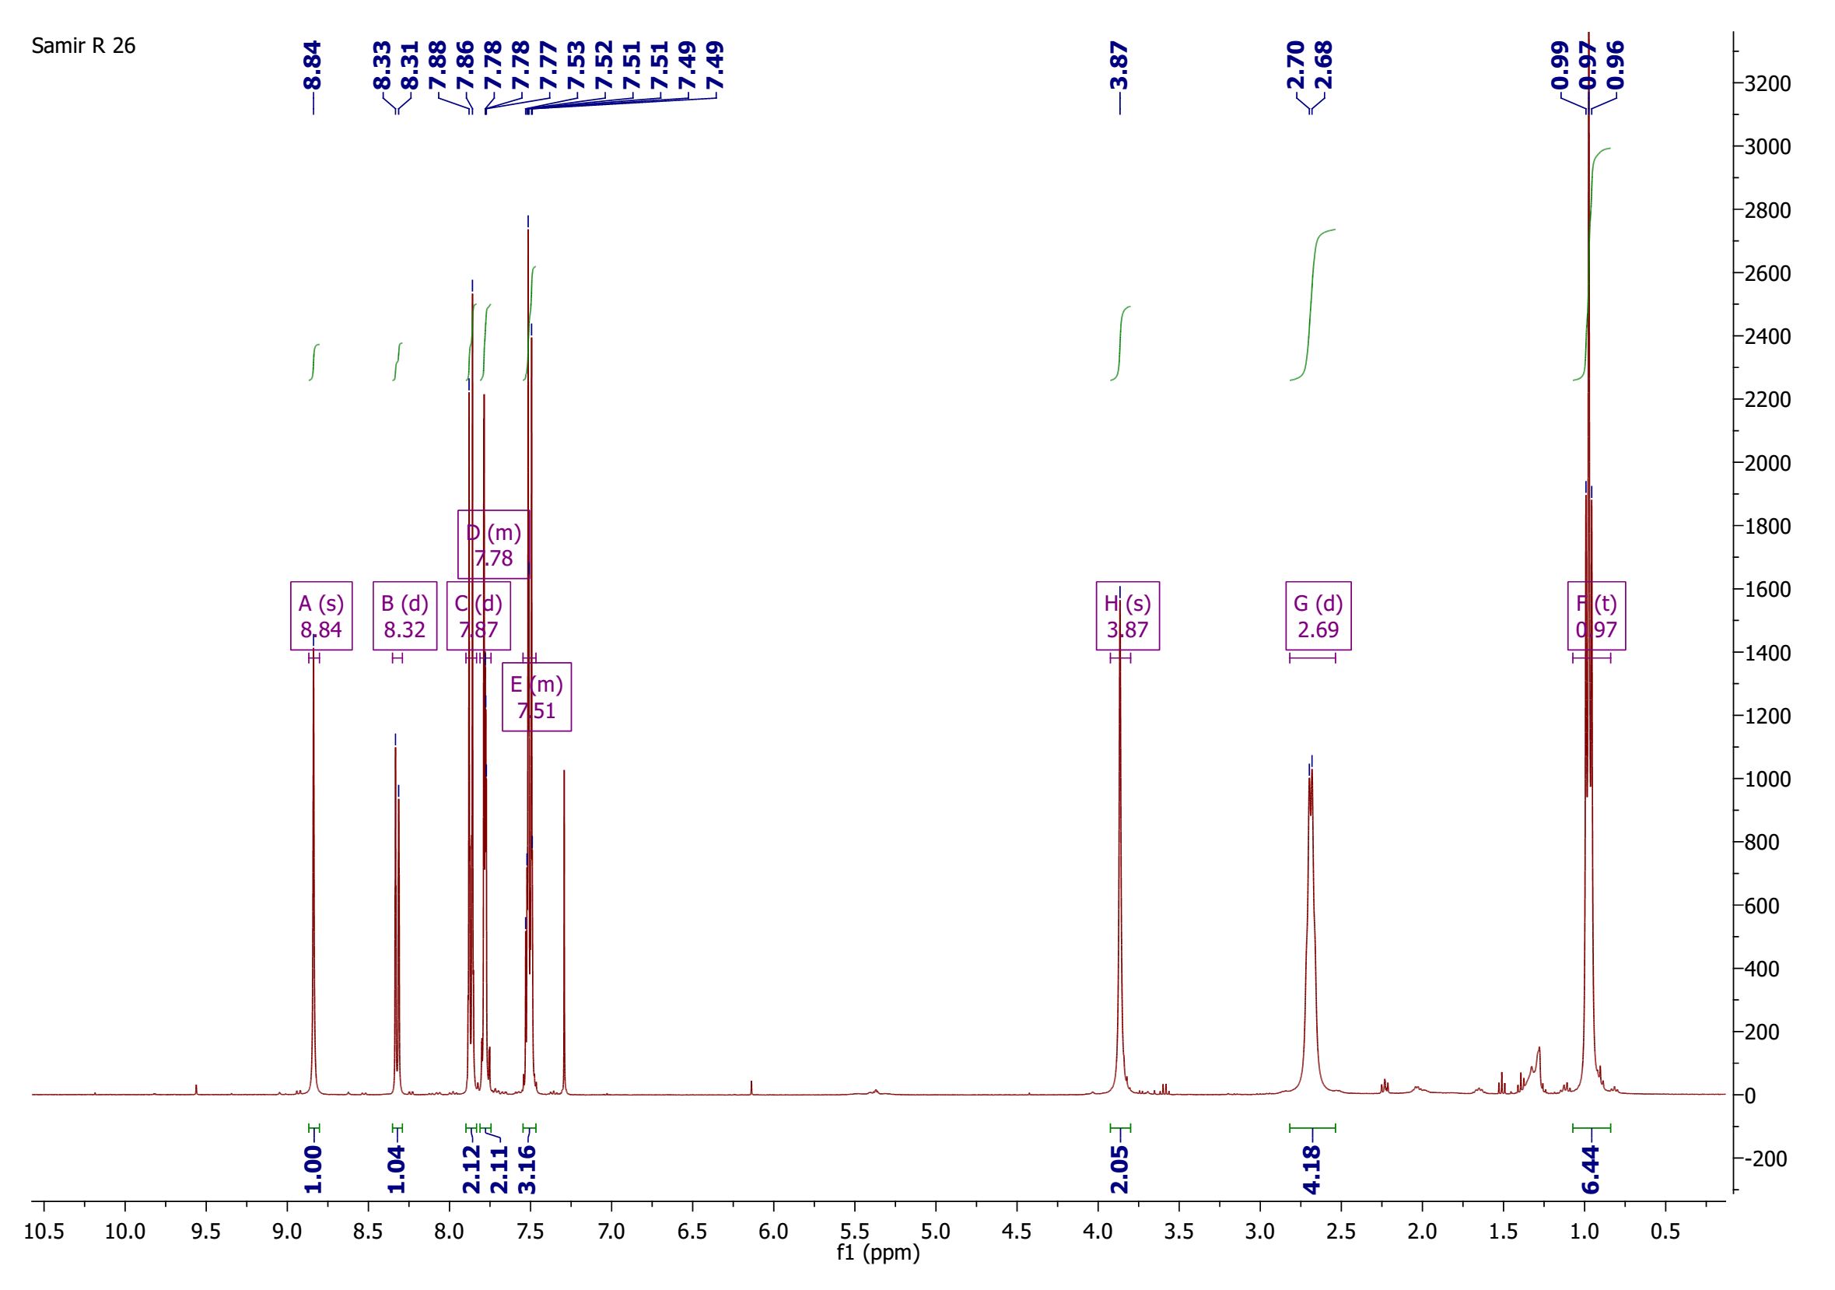
¹H-NMR spectrum of compound 10

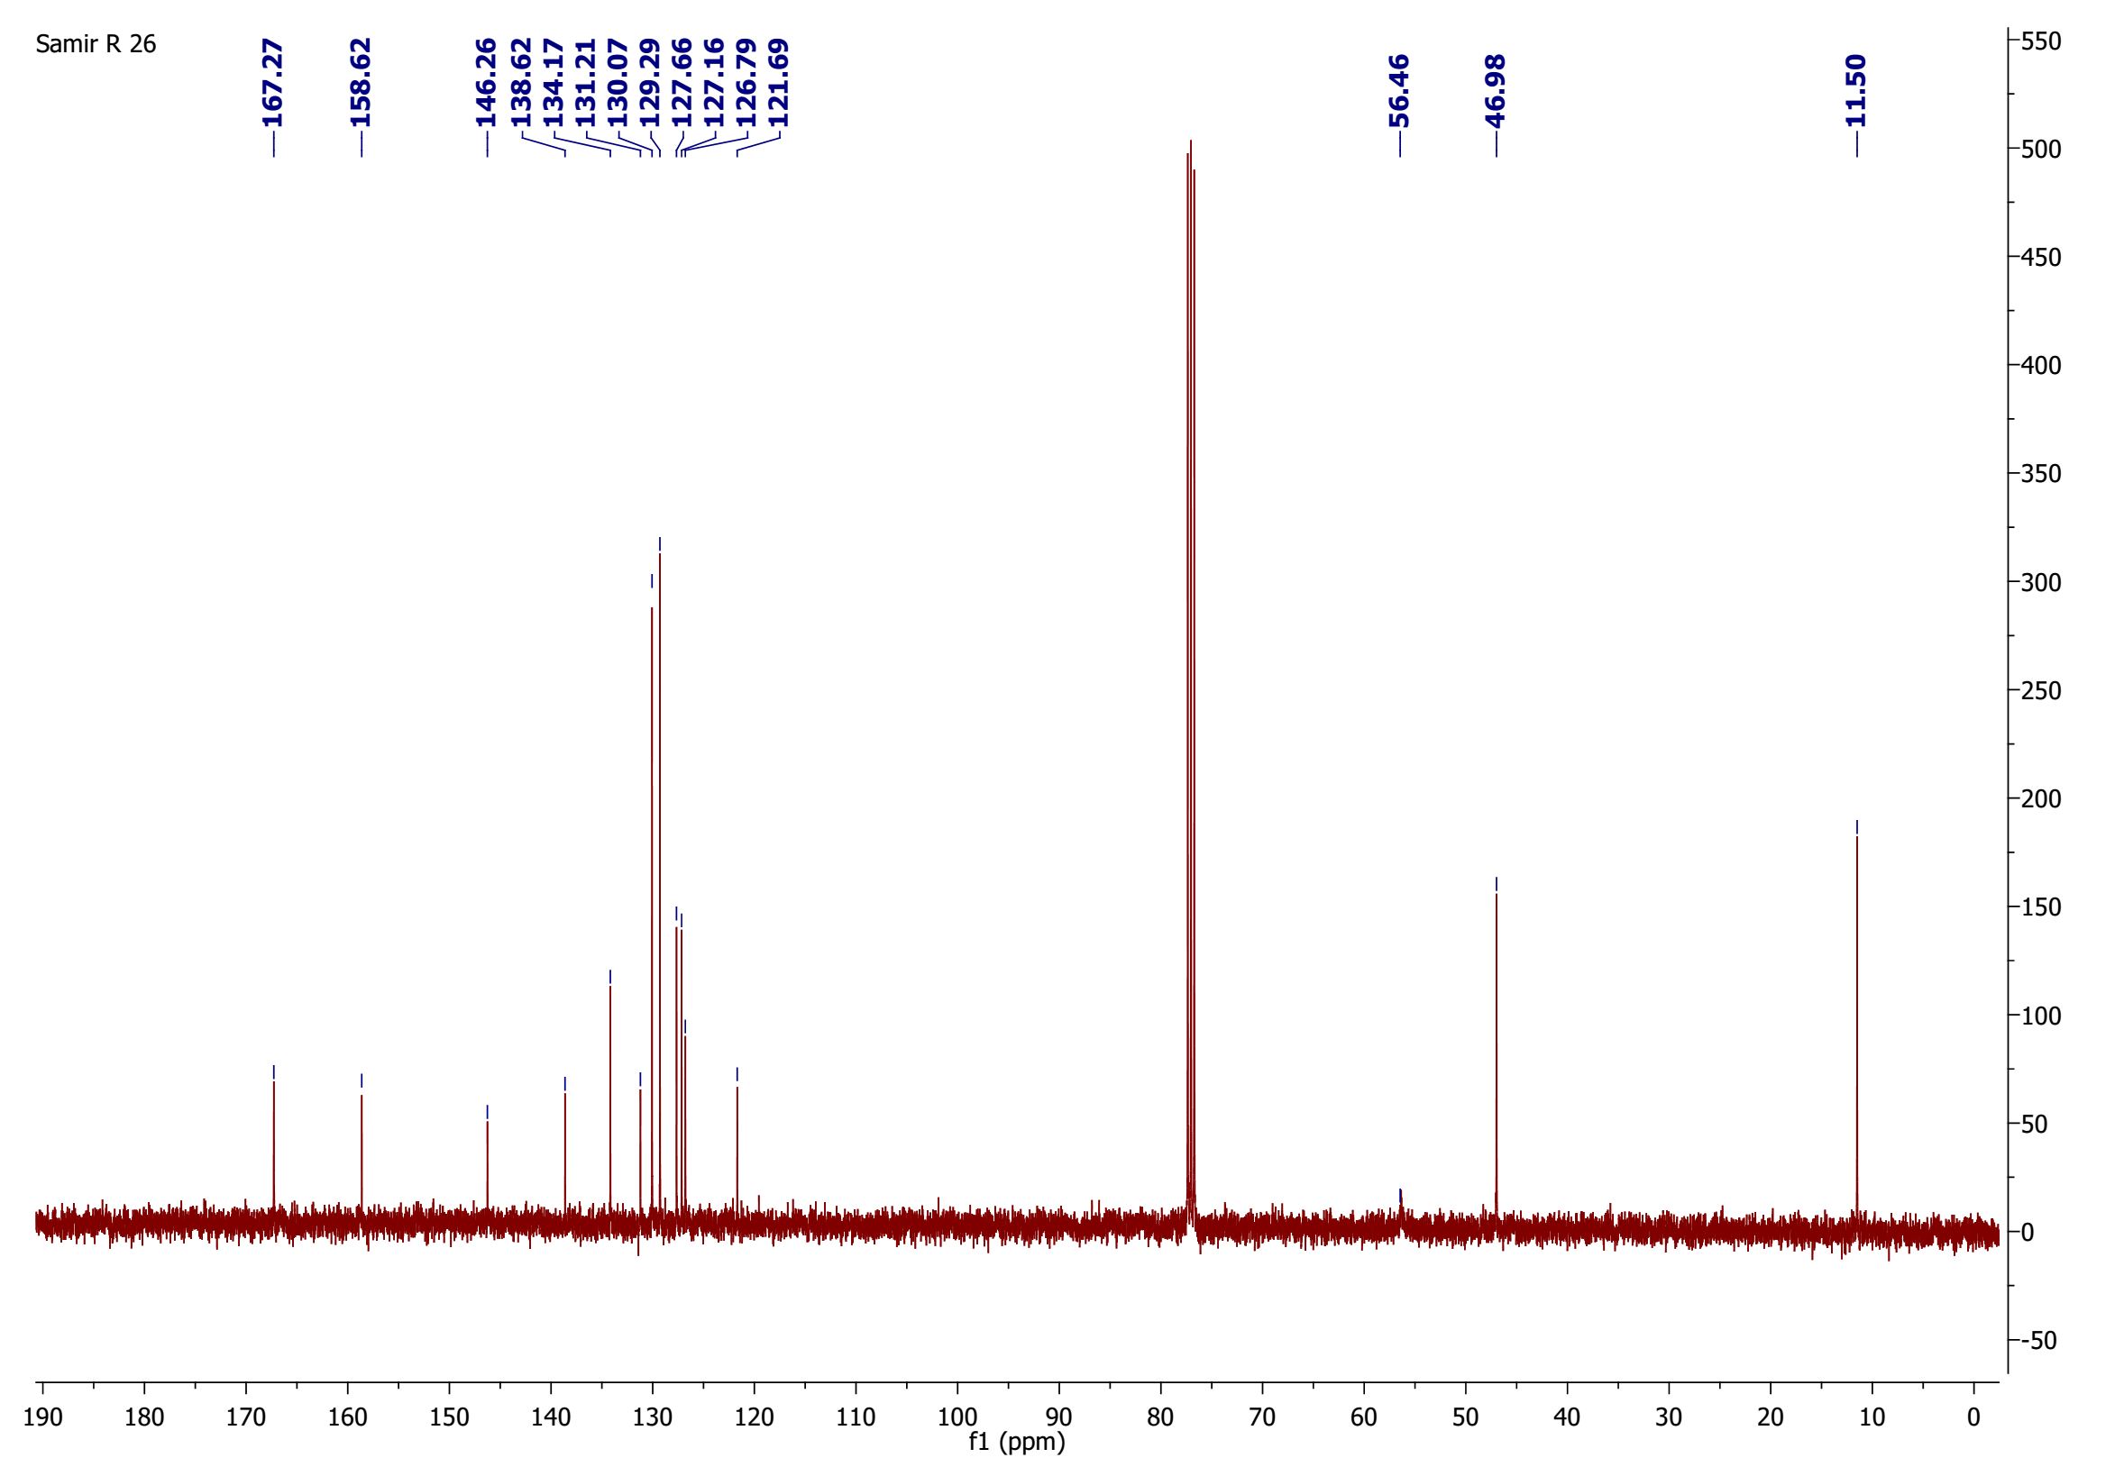

¹³C-NMR spectrum of compound 10

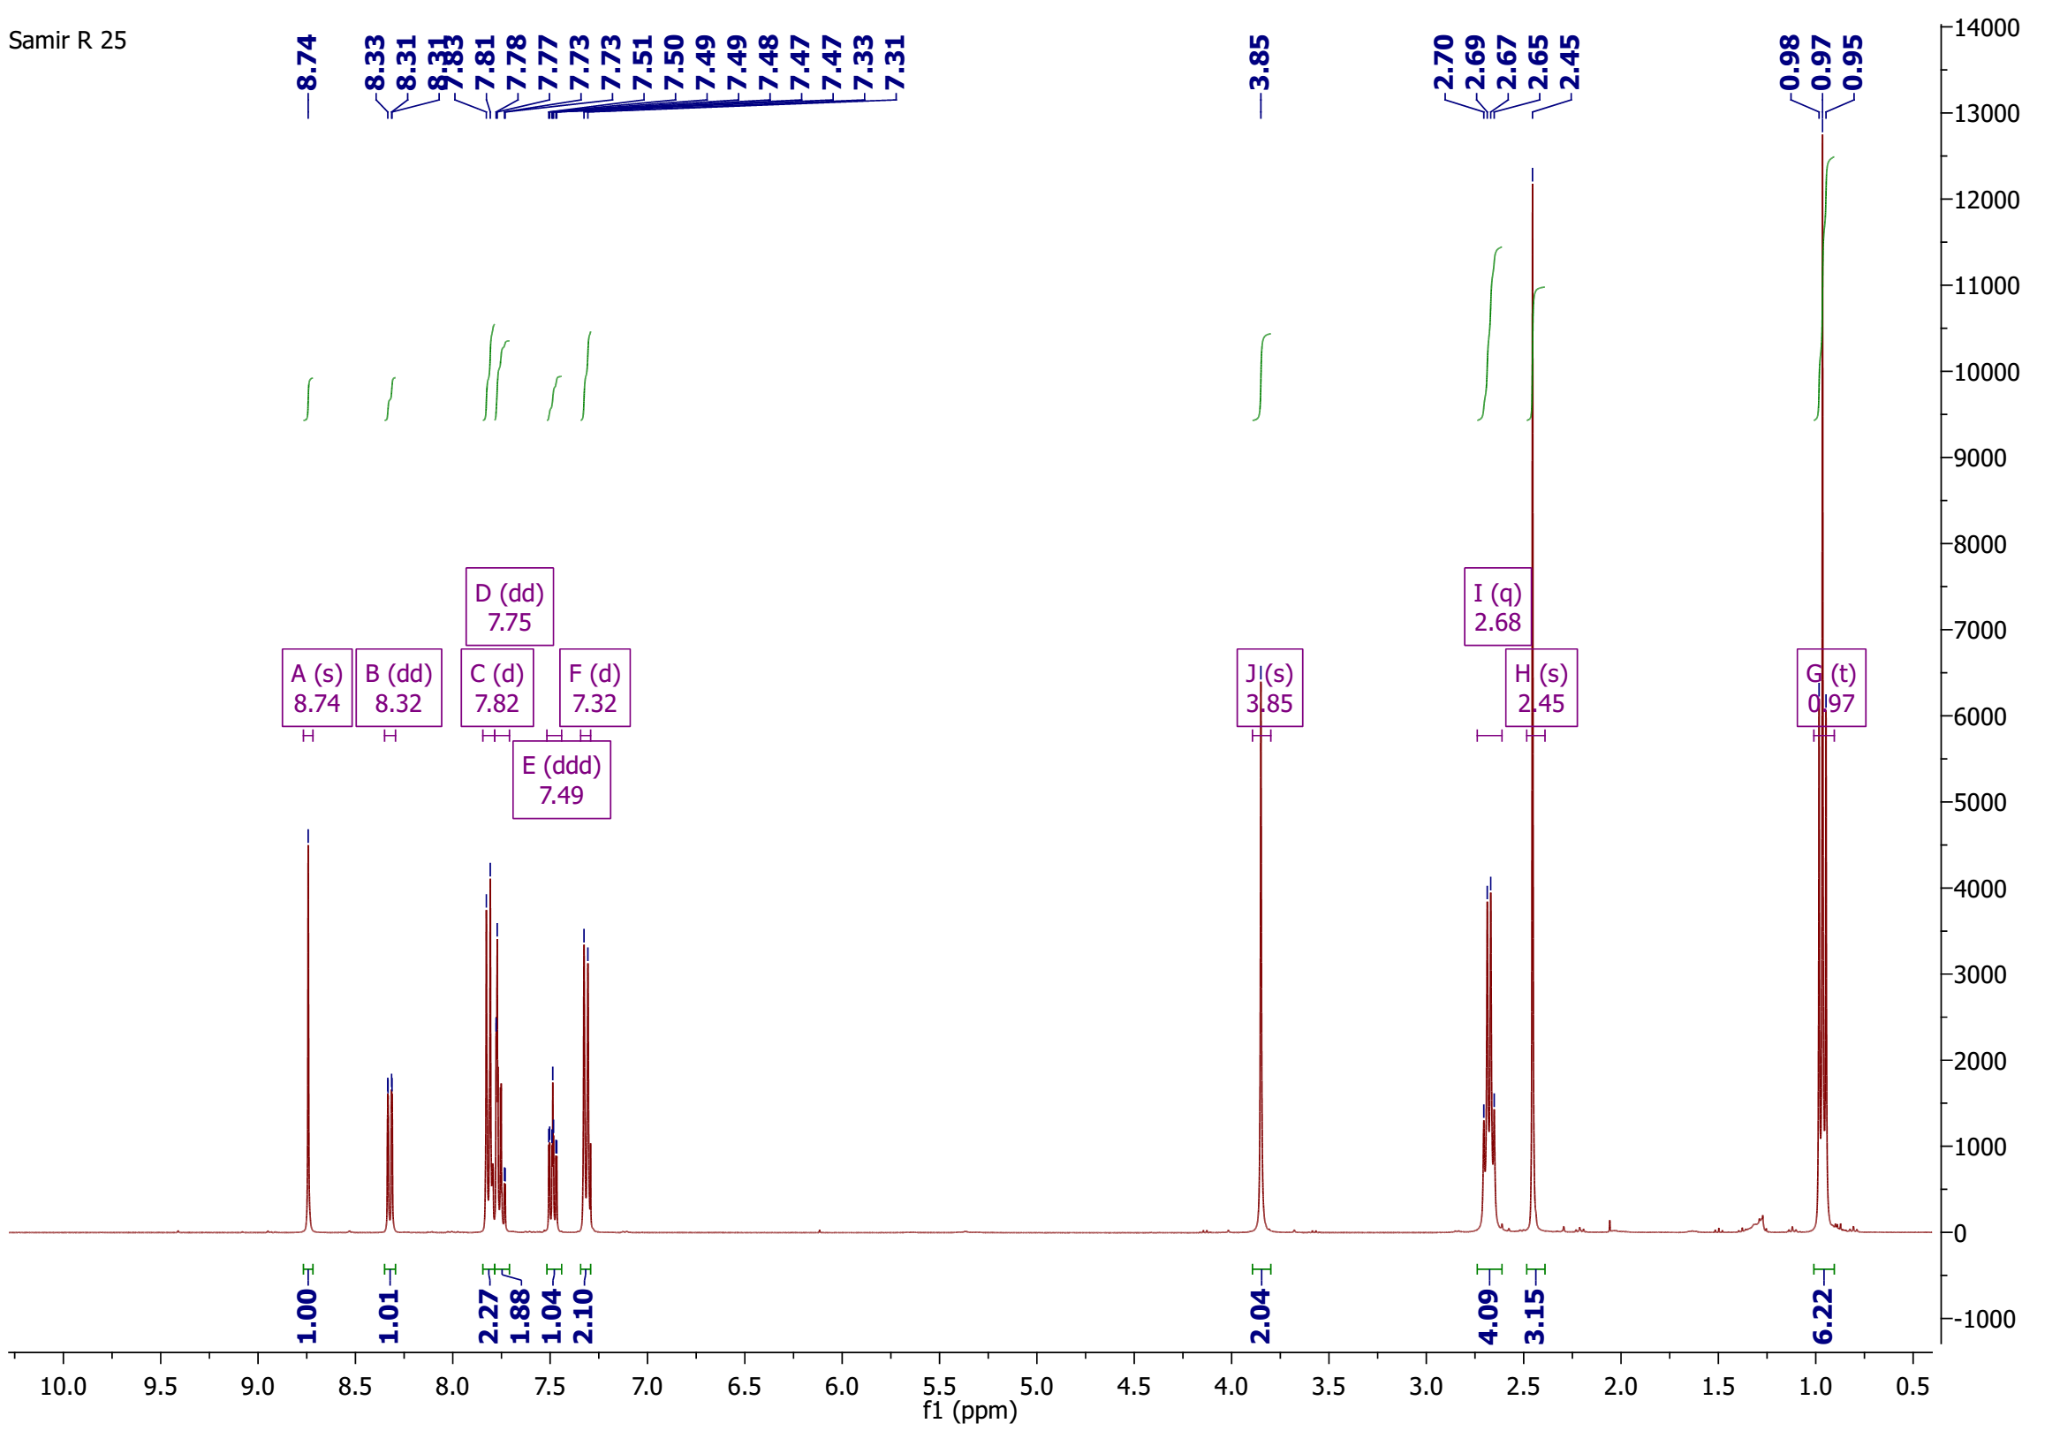
¹H-NMR spectrum of compound 11

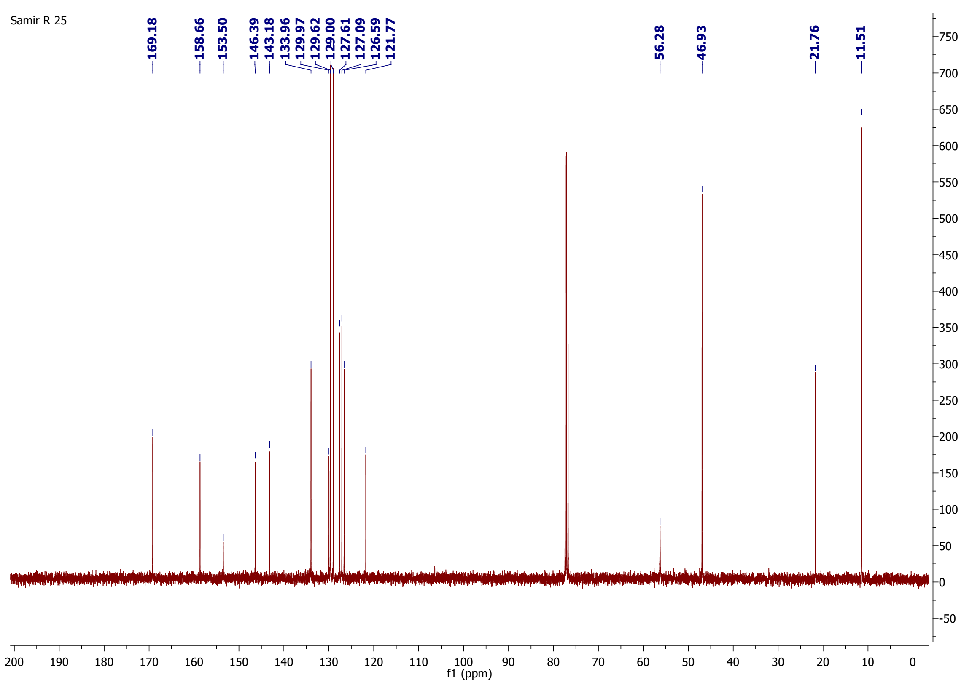
¹³C-NMR spectrum of compound 11

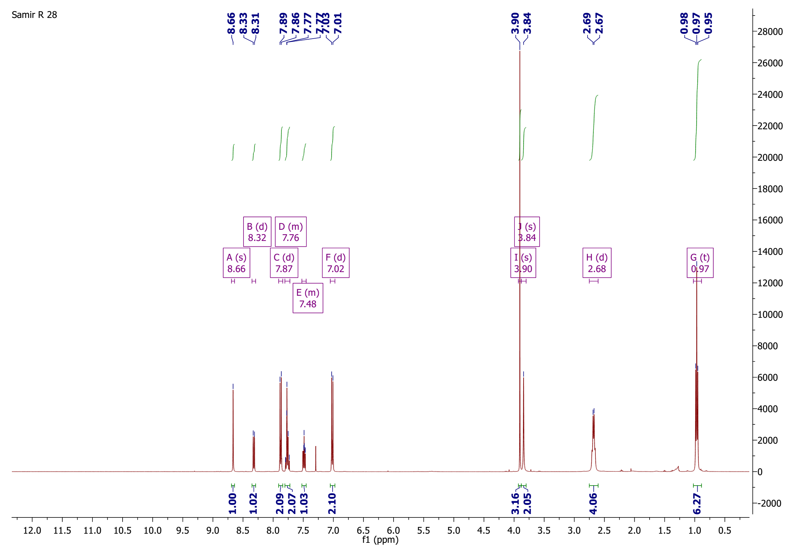
¹H-NMR spectrum of compound 12

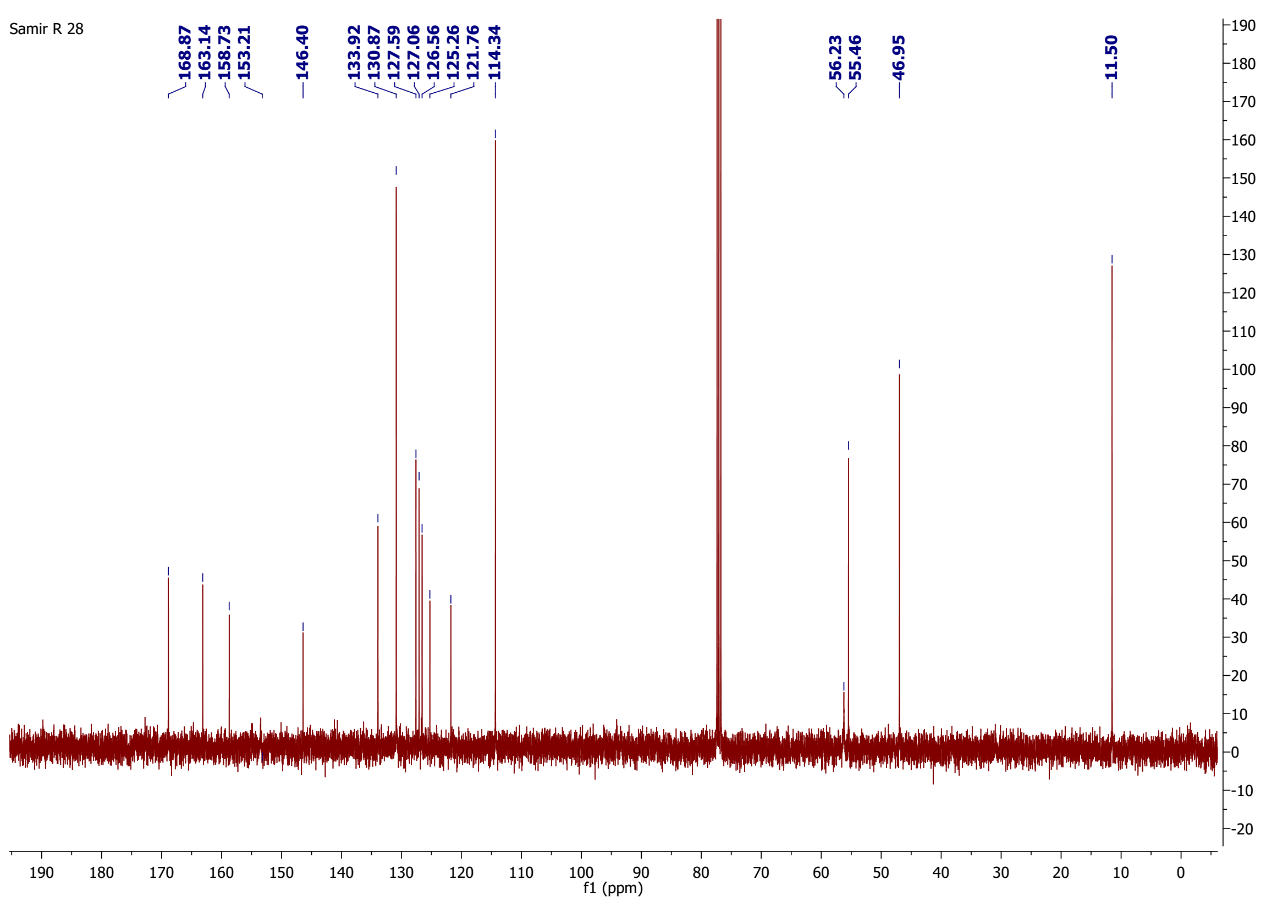
¹³C-NMR spectrum of compound 12

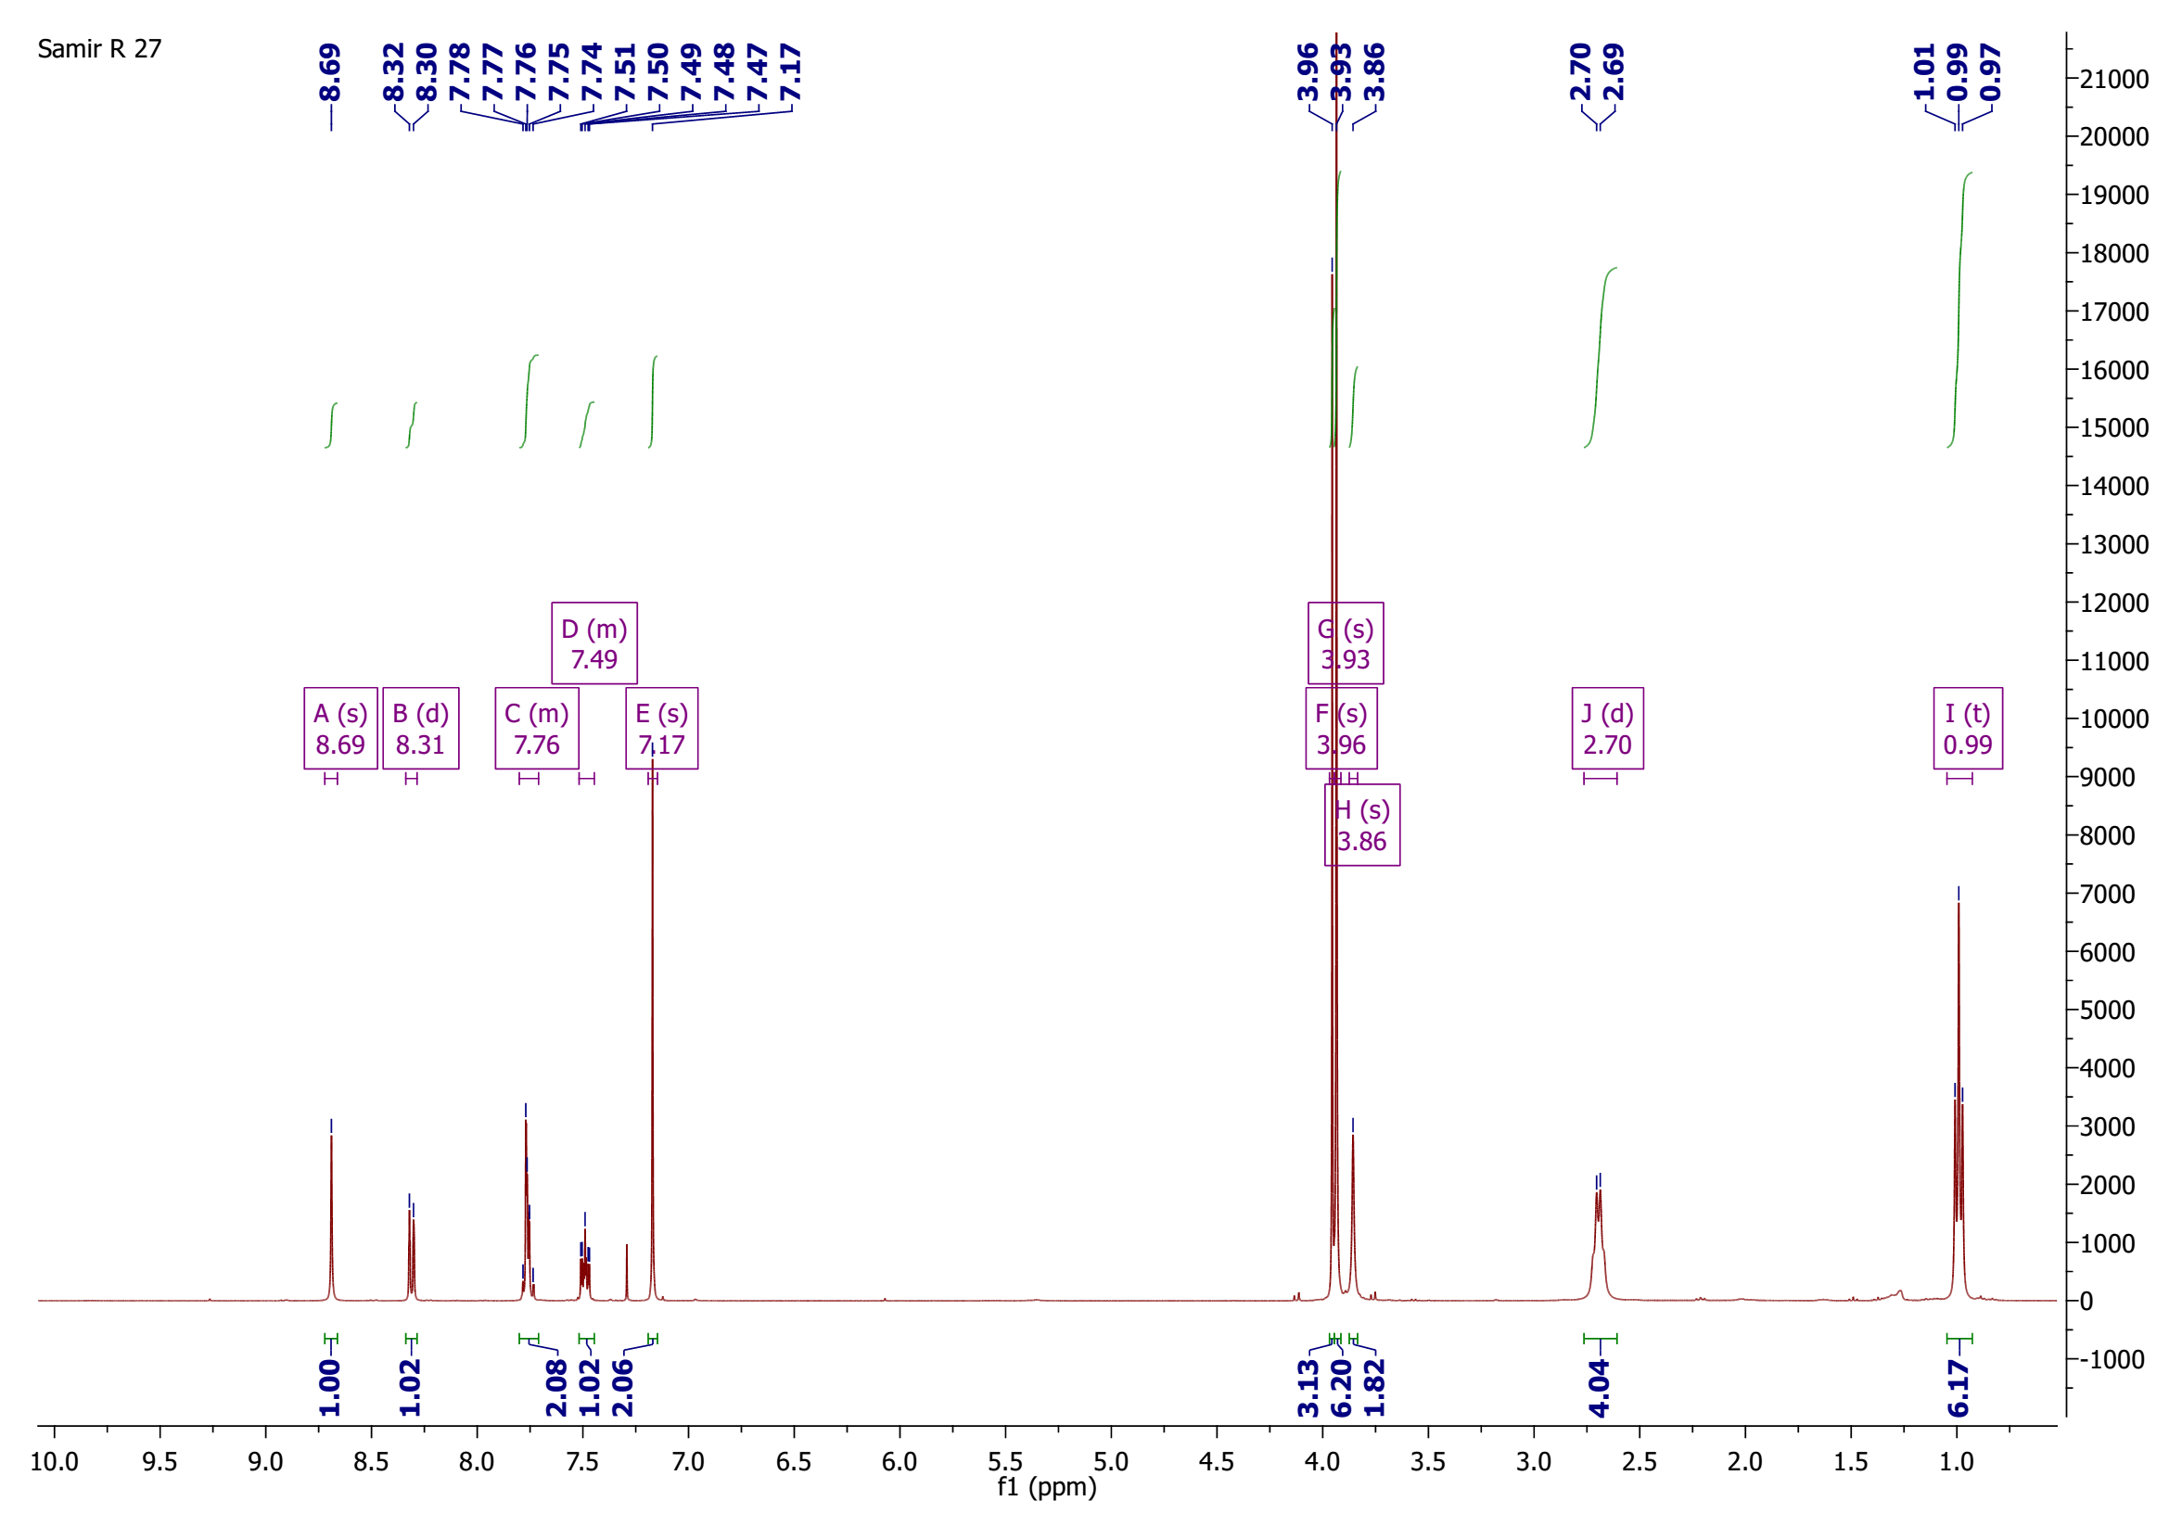
¹H-NMR spectrum of compound 13

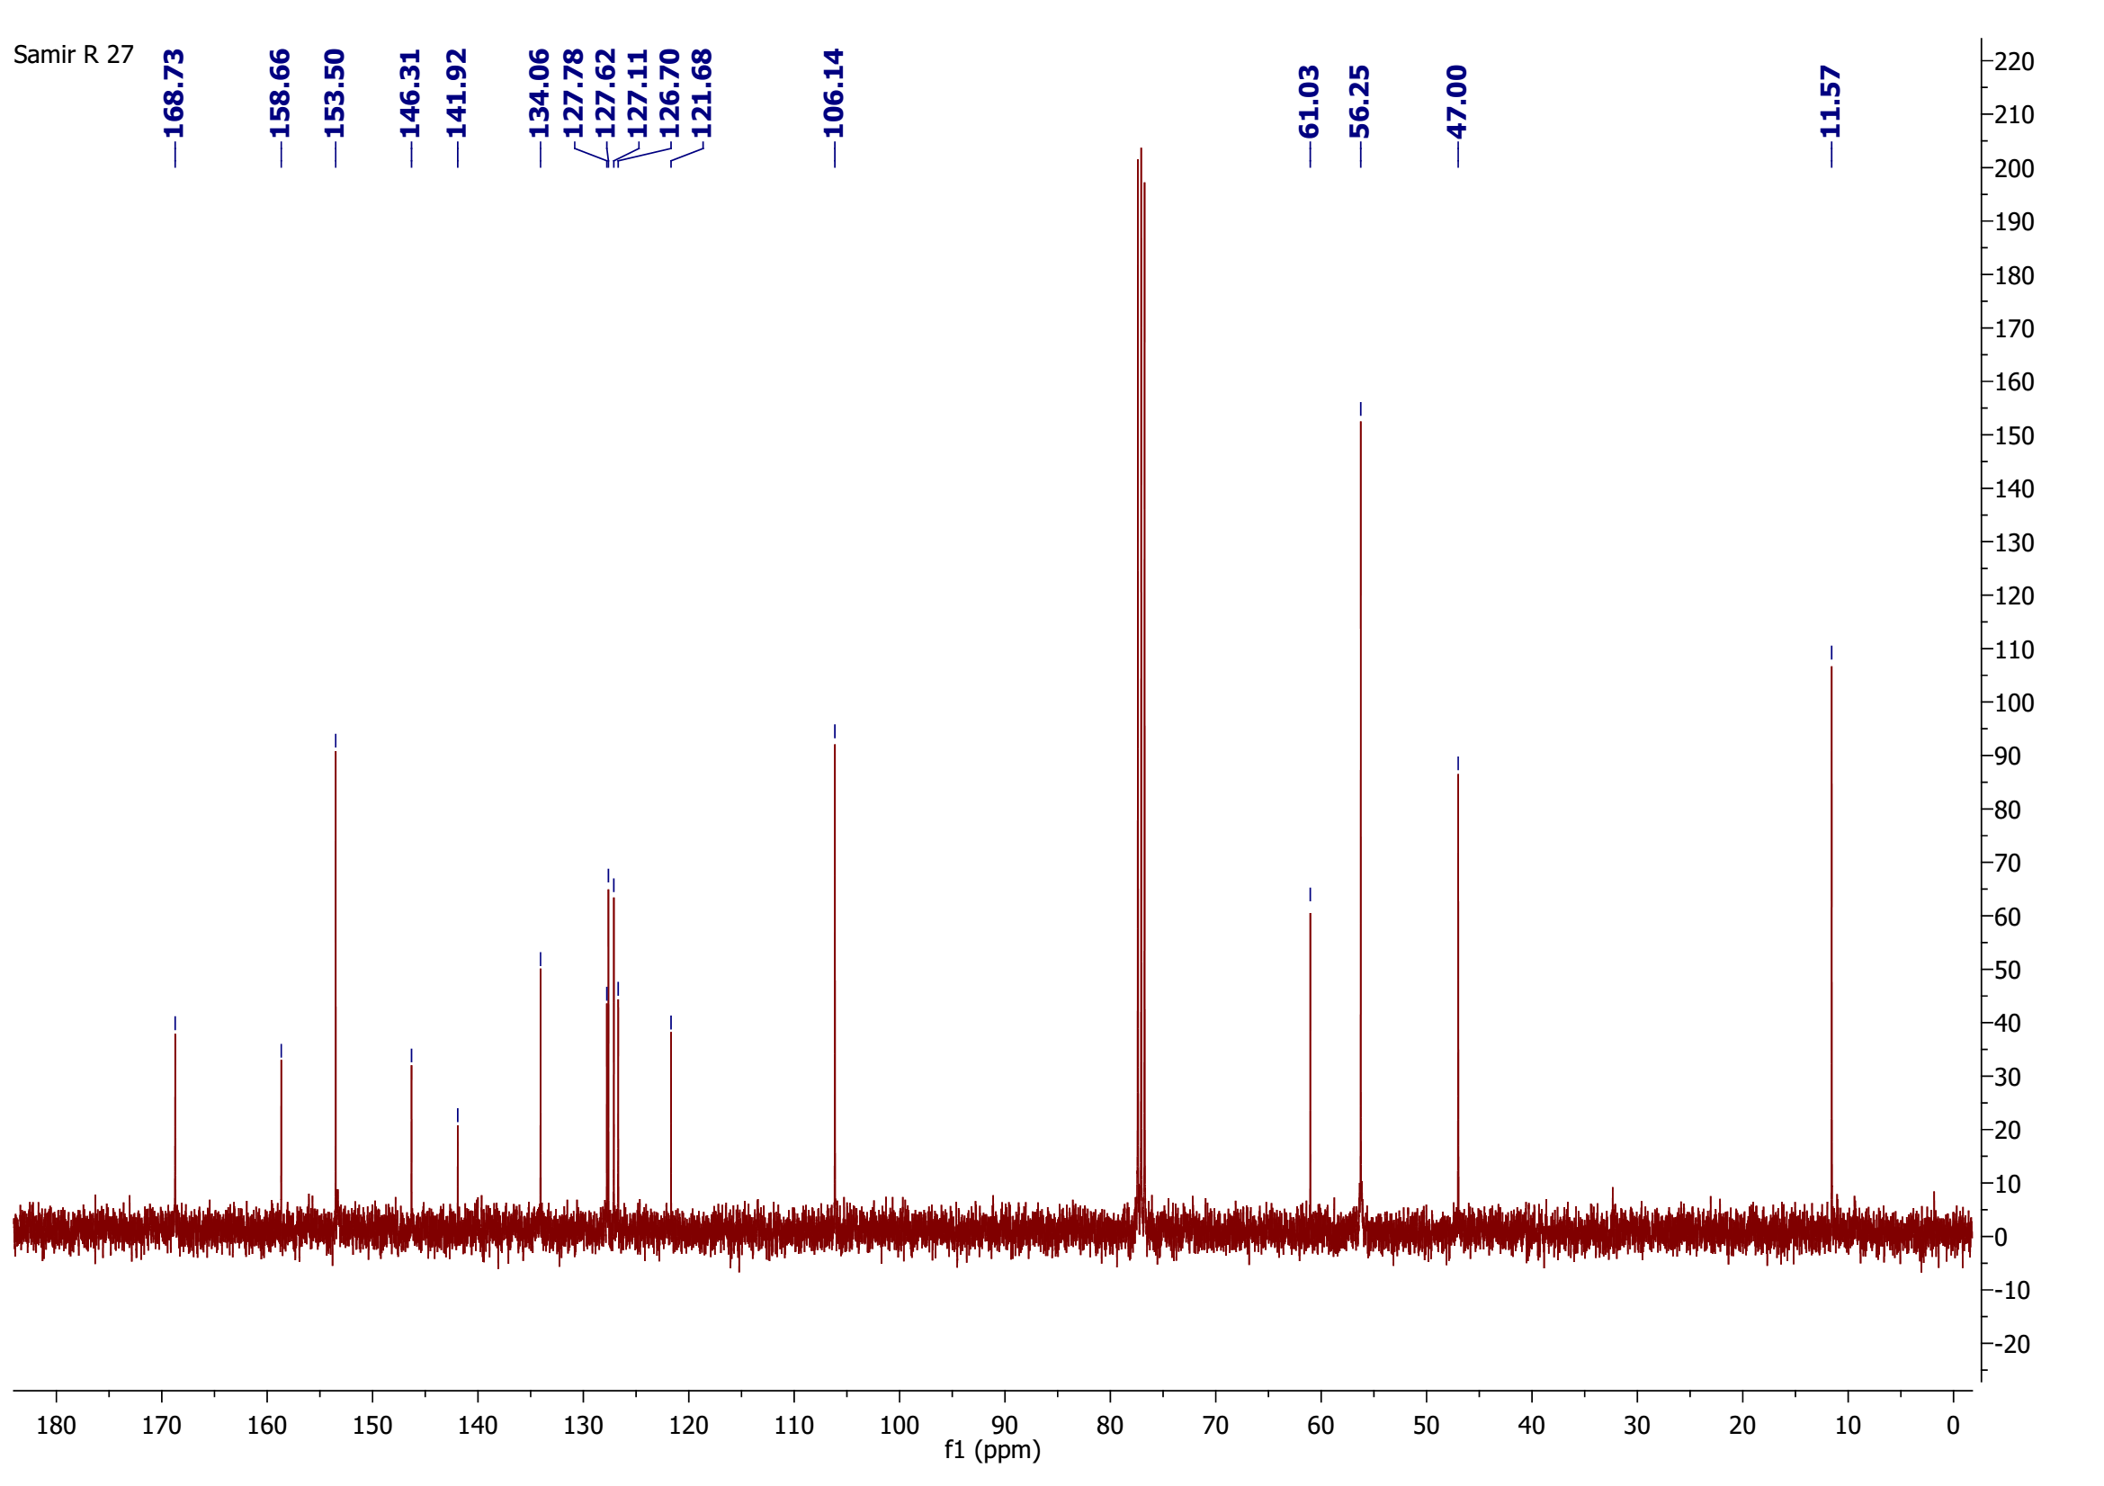
¹³C-NMR spectrum of compound 13

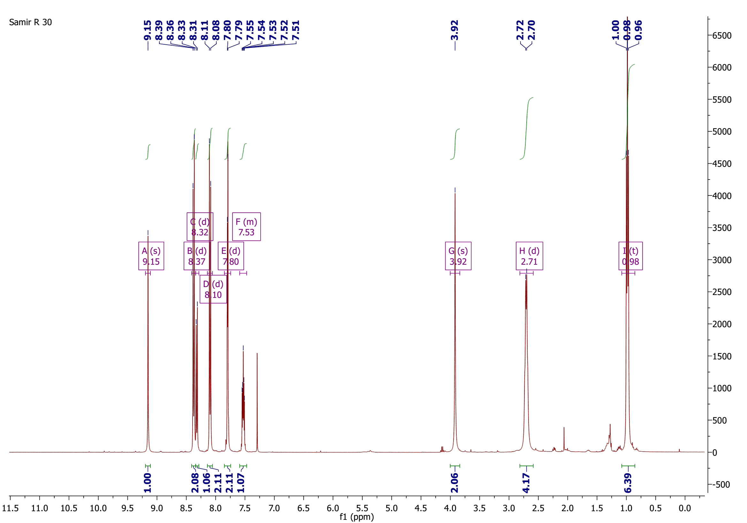
¹H-NMR spectrum of compound 14

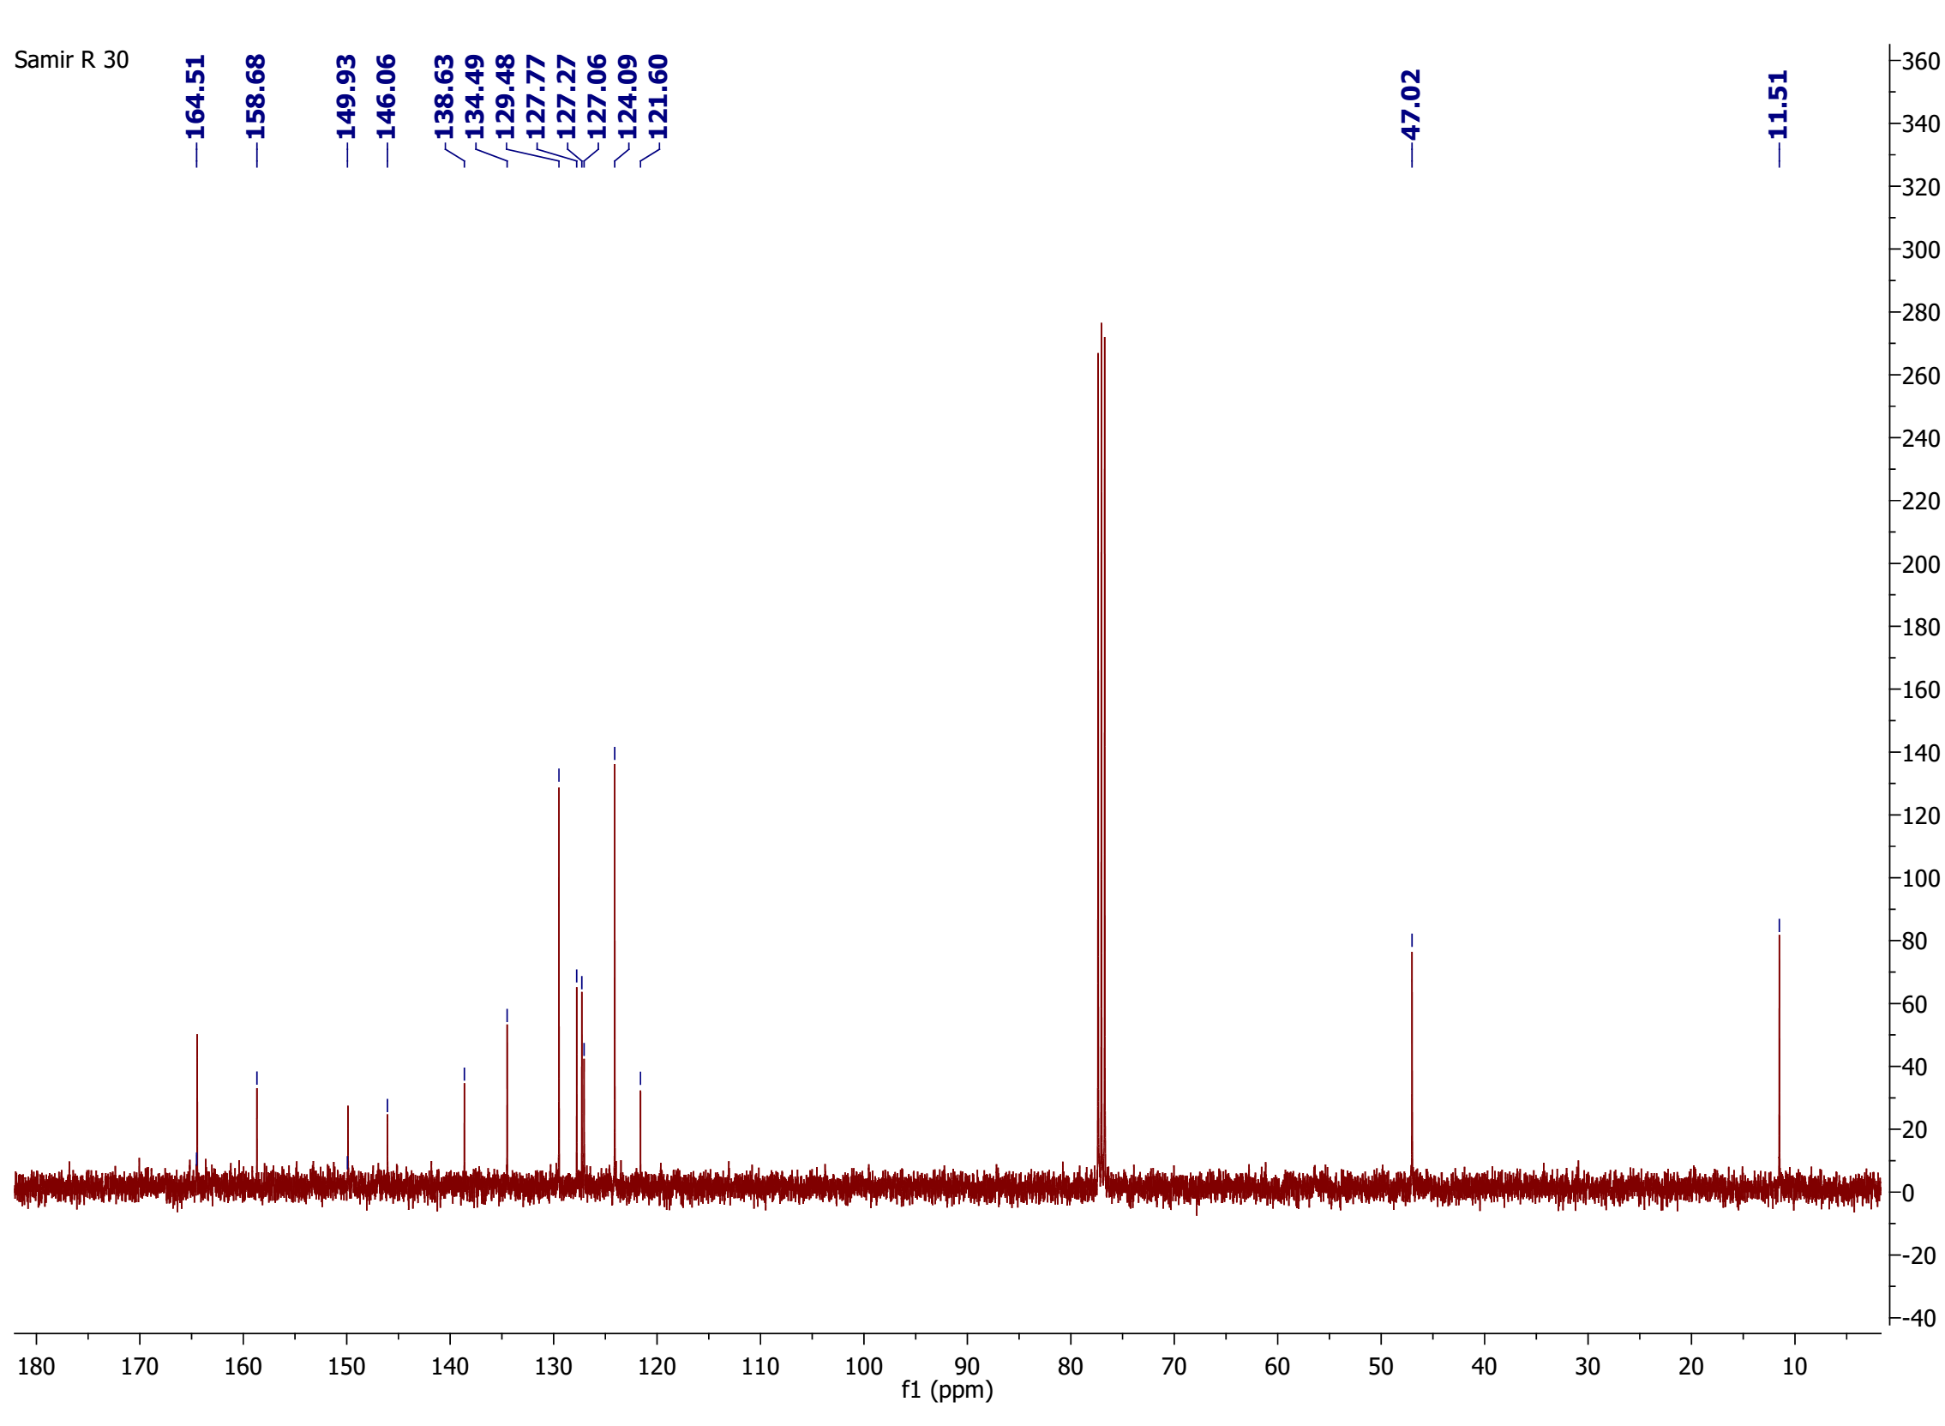
¹³C-NMR spectrum of compound 14

¹H-NMR spectrum of compound 15

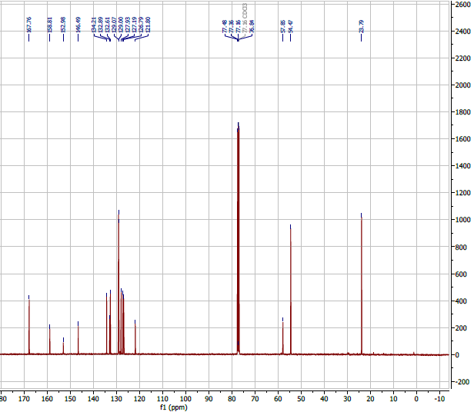
¹³C-NMR spectrum of compound 15

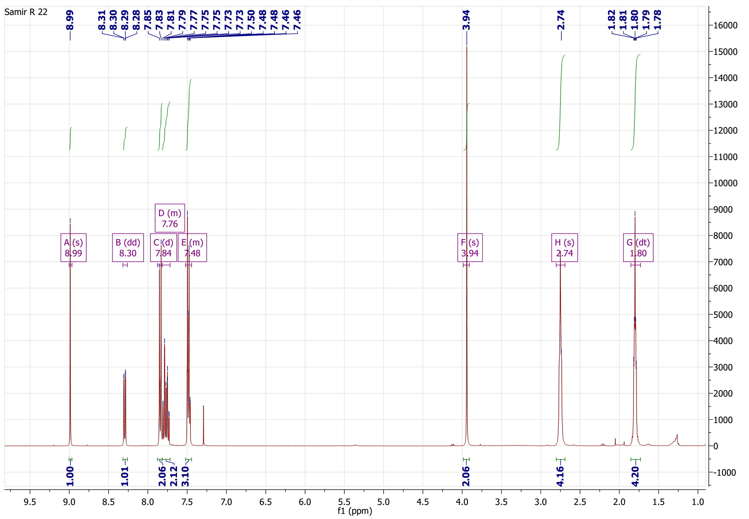
¹H-NMR spectrum of compound 16

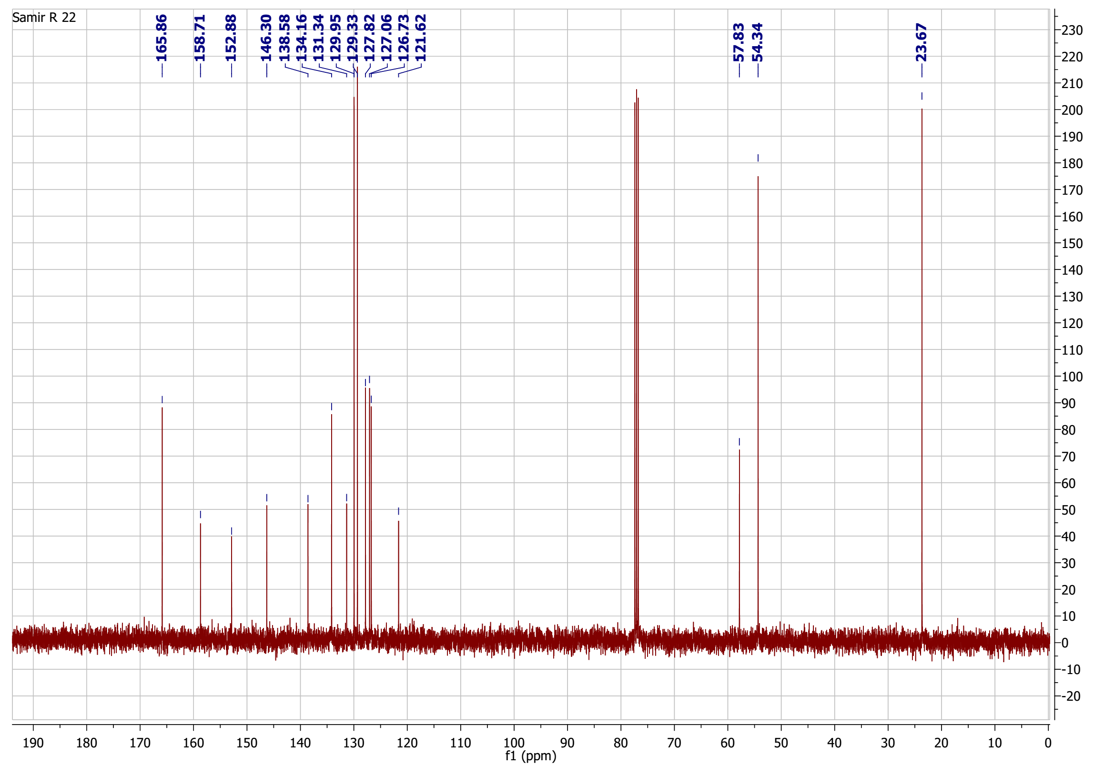
¹³C-NMR spectrum of compound 16

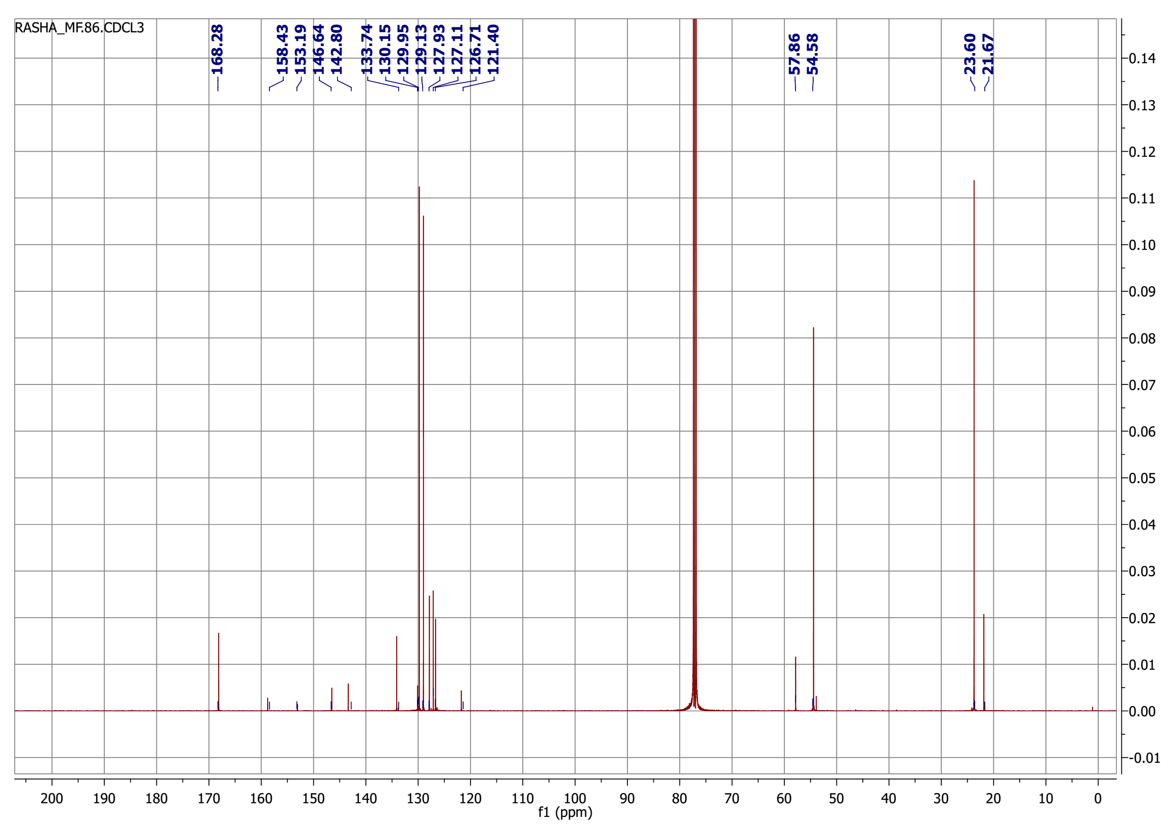
¹³C-NMR spectrum of compound 17

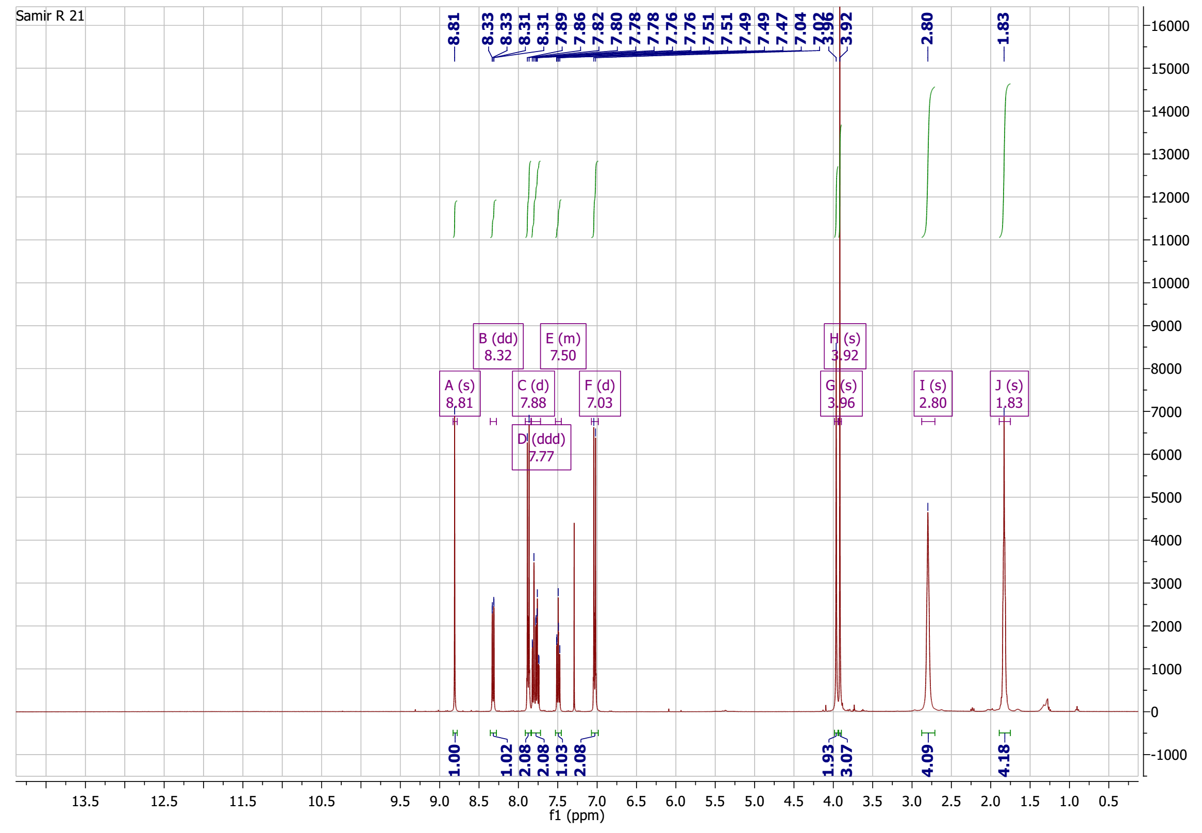
¹H-NMR spectrum of compound 18

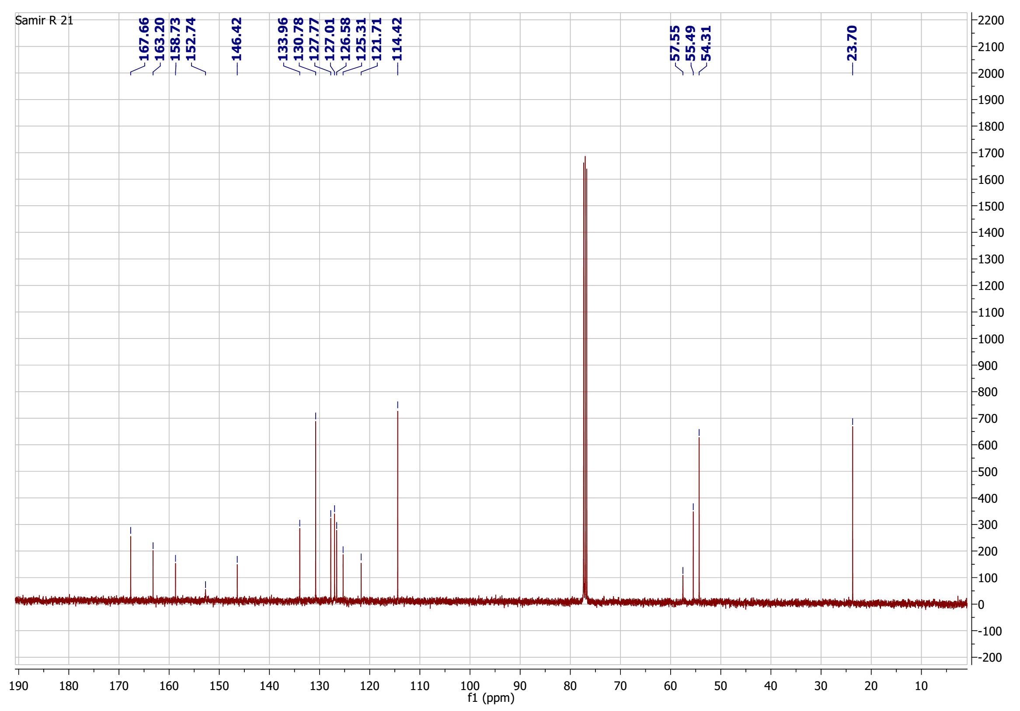
¹³C-NMR spectrum of compound 18

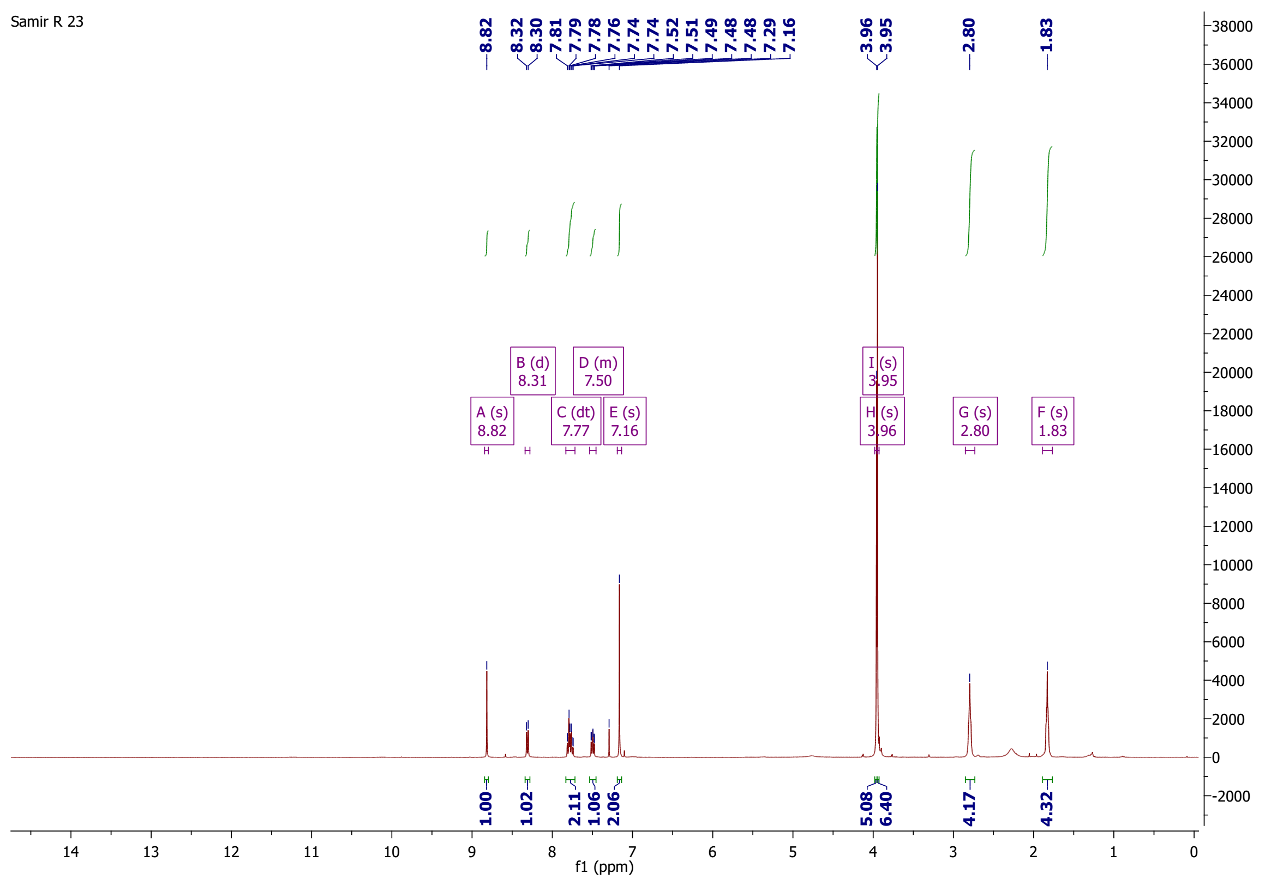
¹H-NMR spectrum of compound 19

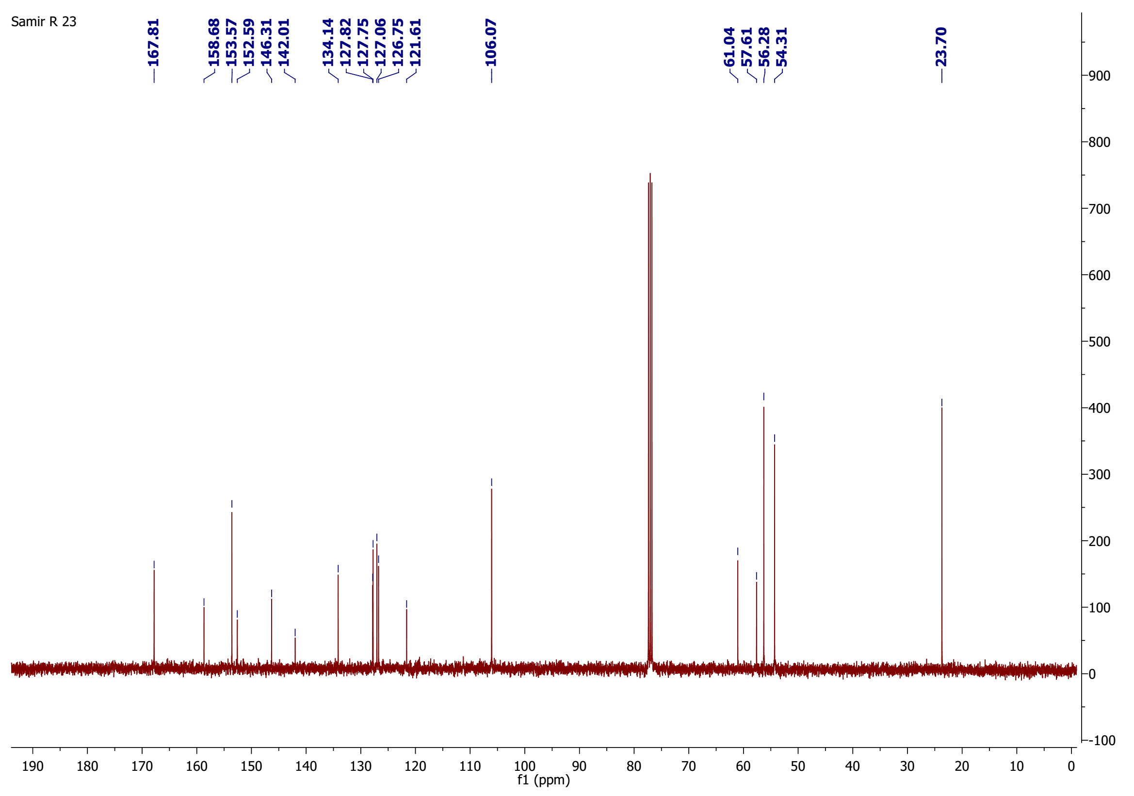
¹³C-NMR spectrum of compound 19

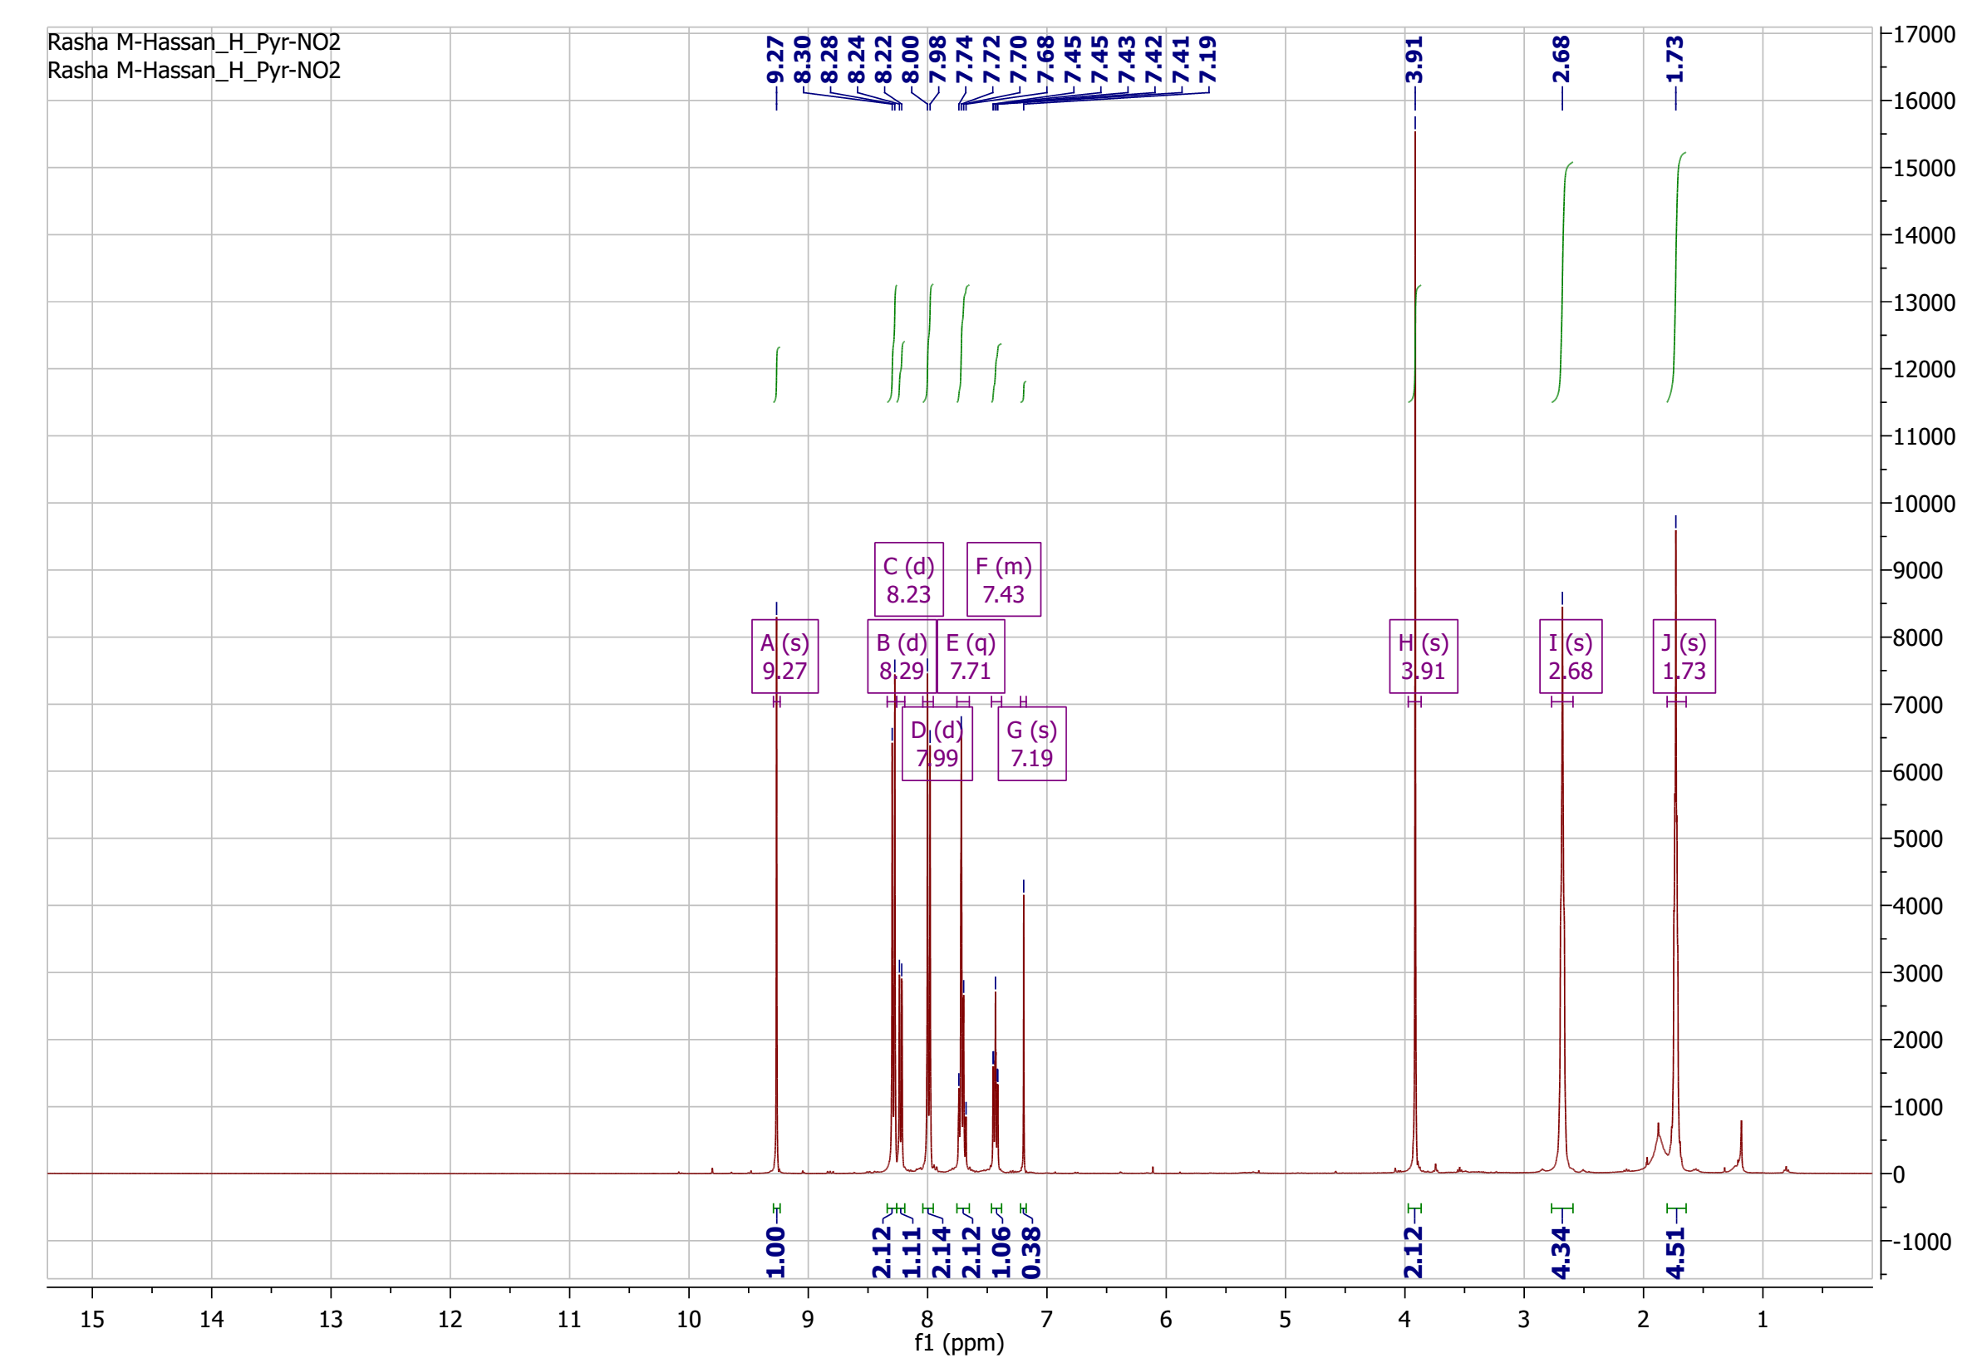
¹H-NMR spectrum of compound 20

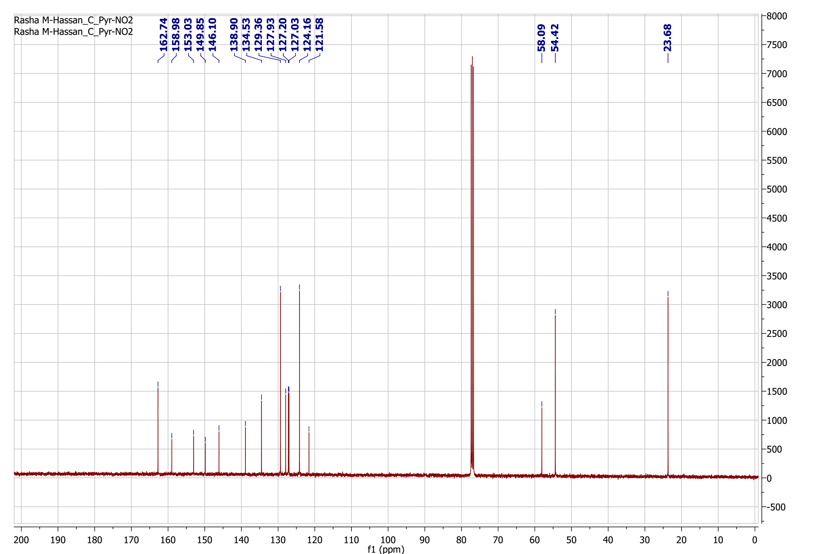

¹³C-NMR spectrum of compound 20

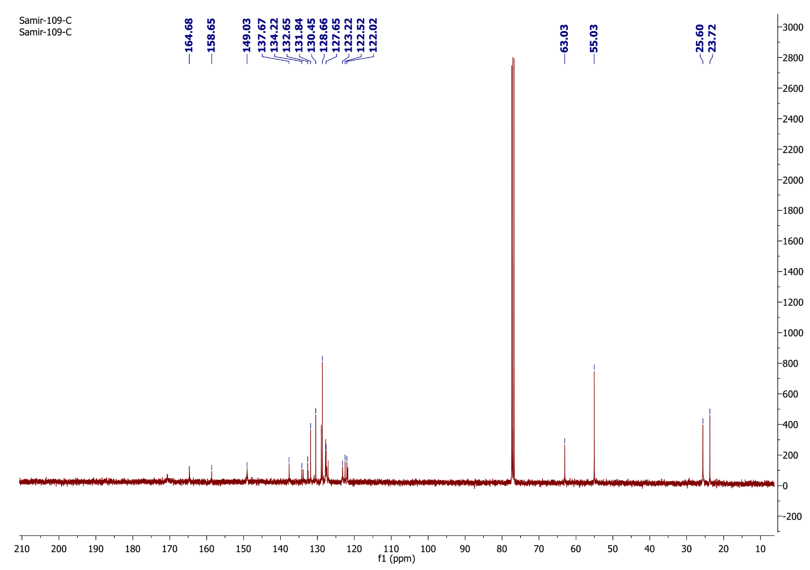
¹³C-NMR spectrum of compound 21

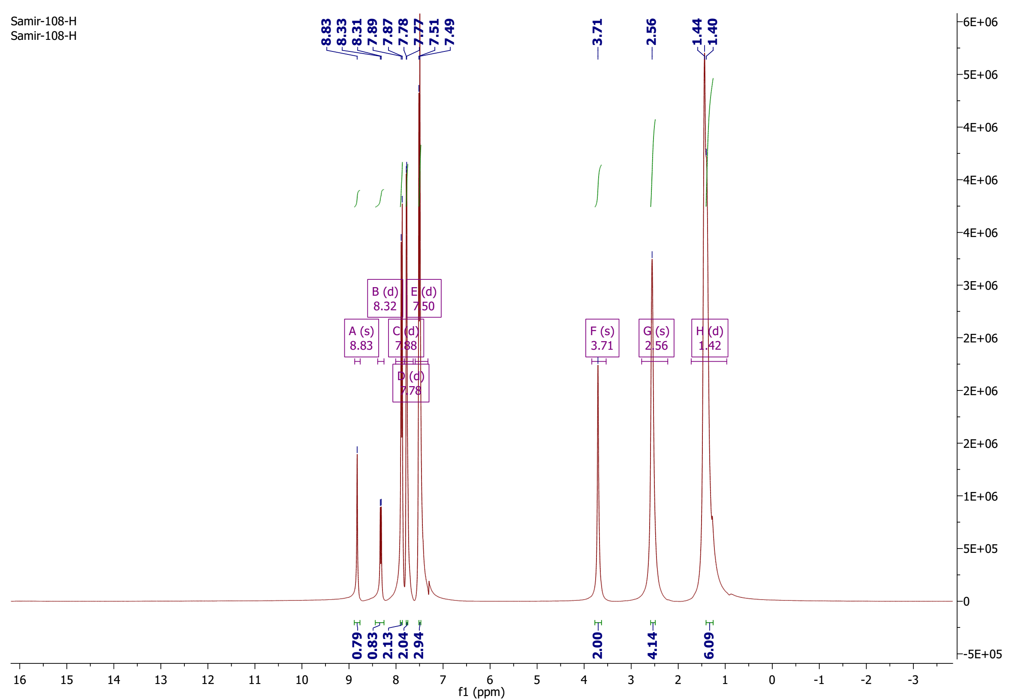

¹H-NMR spectrum of compound 22

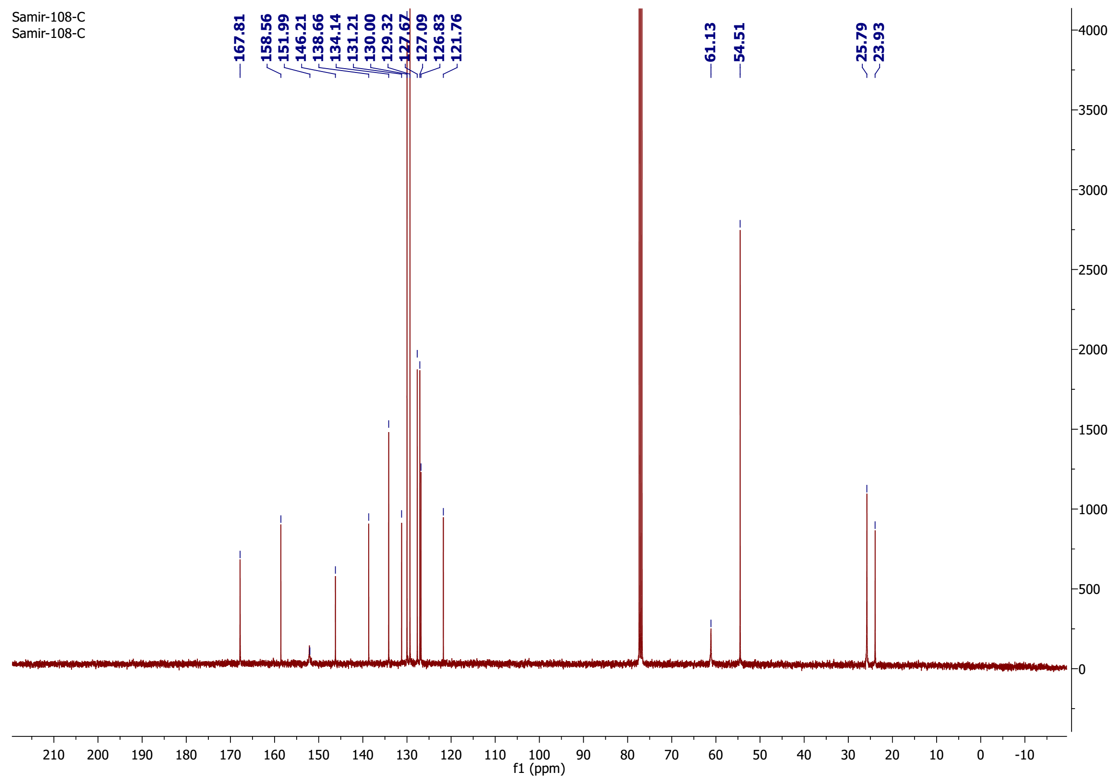

¹³C-NMR spectrum of compound 22

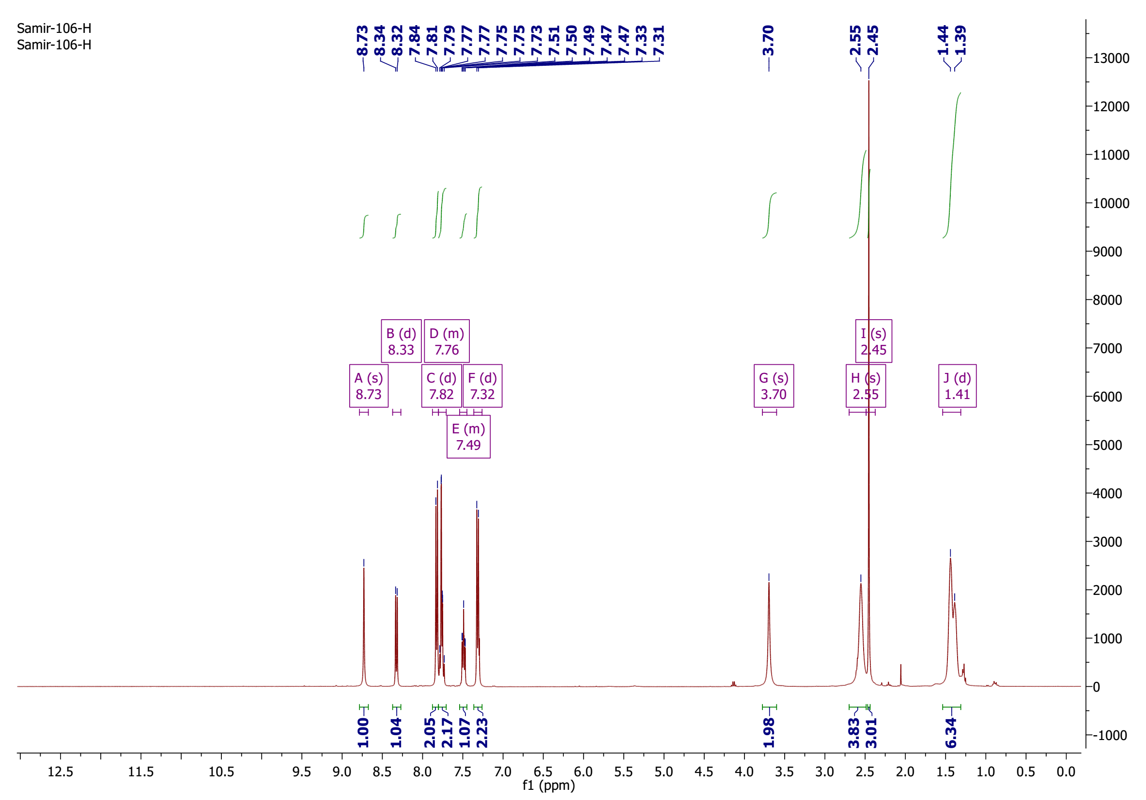

¹H-NMR spectrum of compound 23

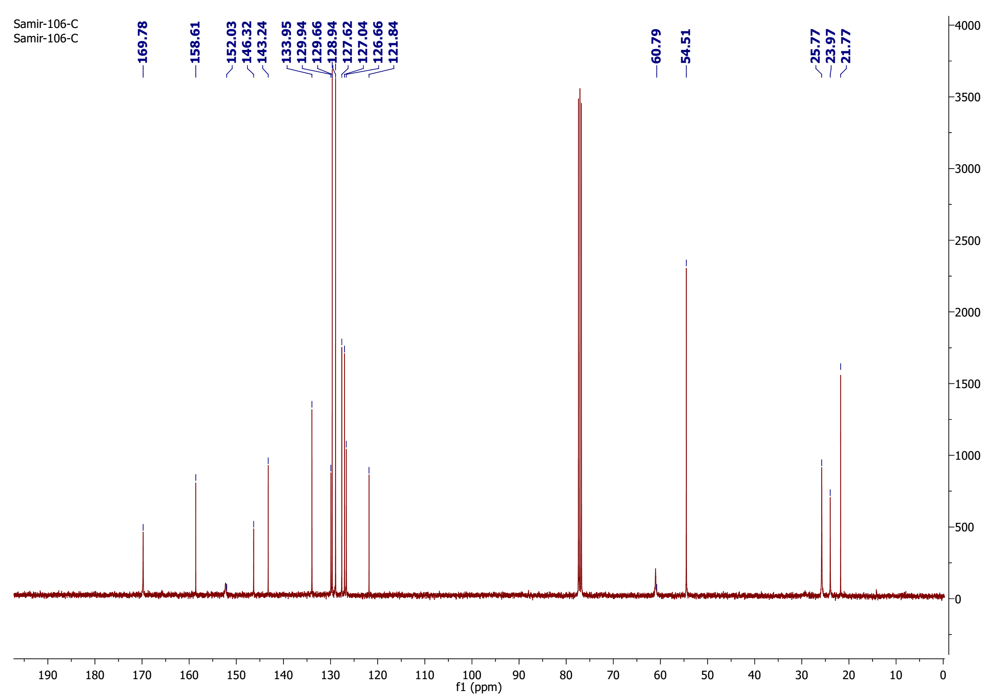
¹³C-NMR spectrum of compound 23

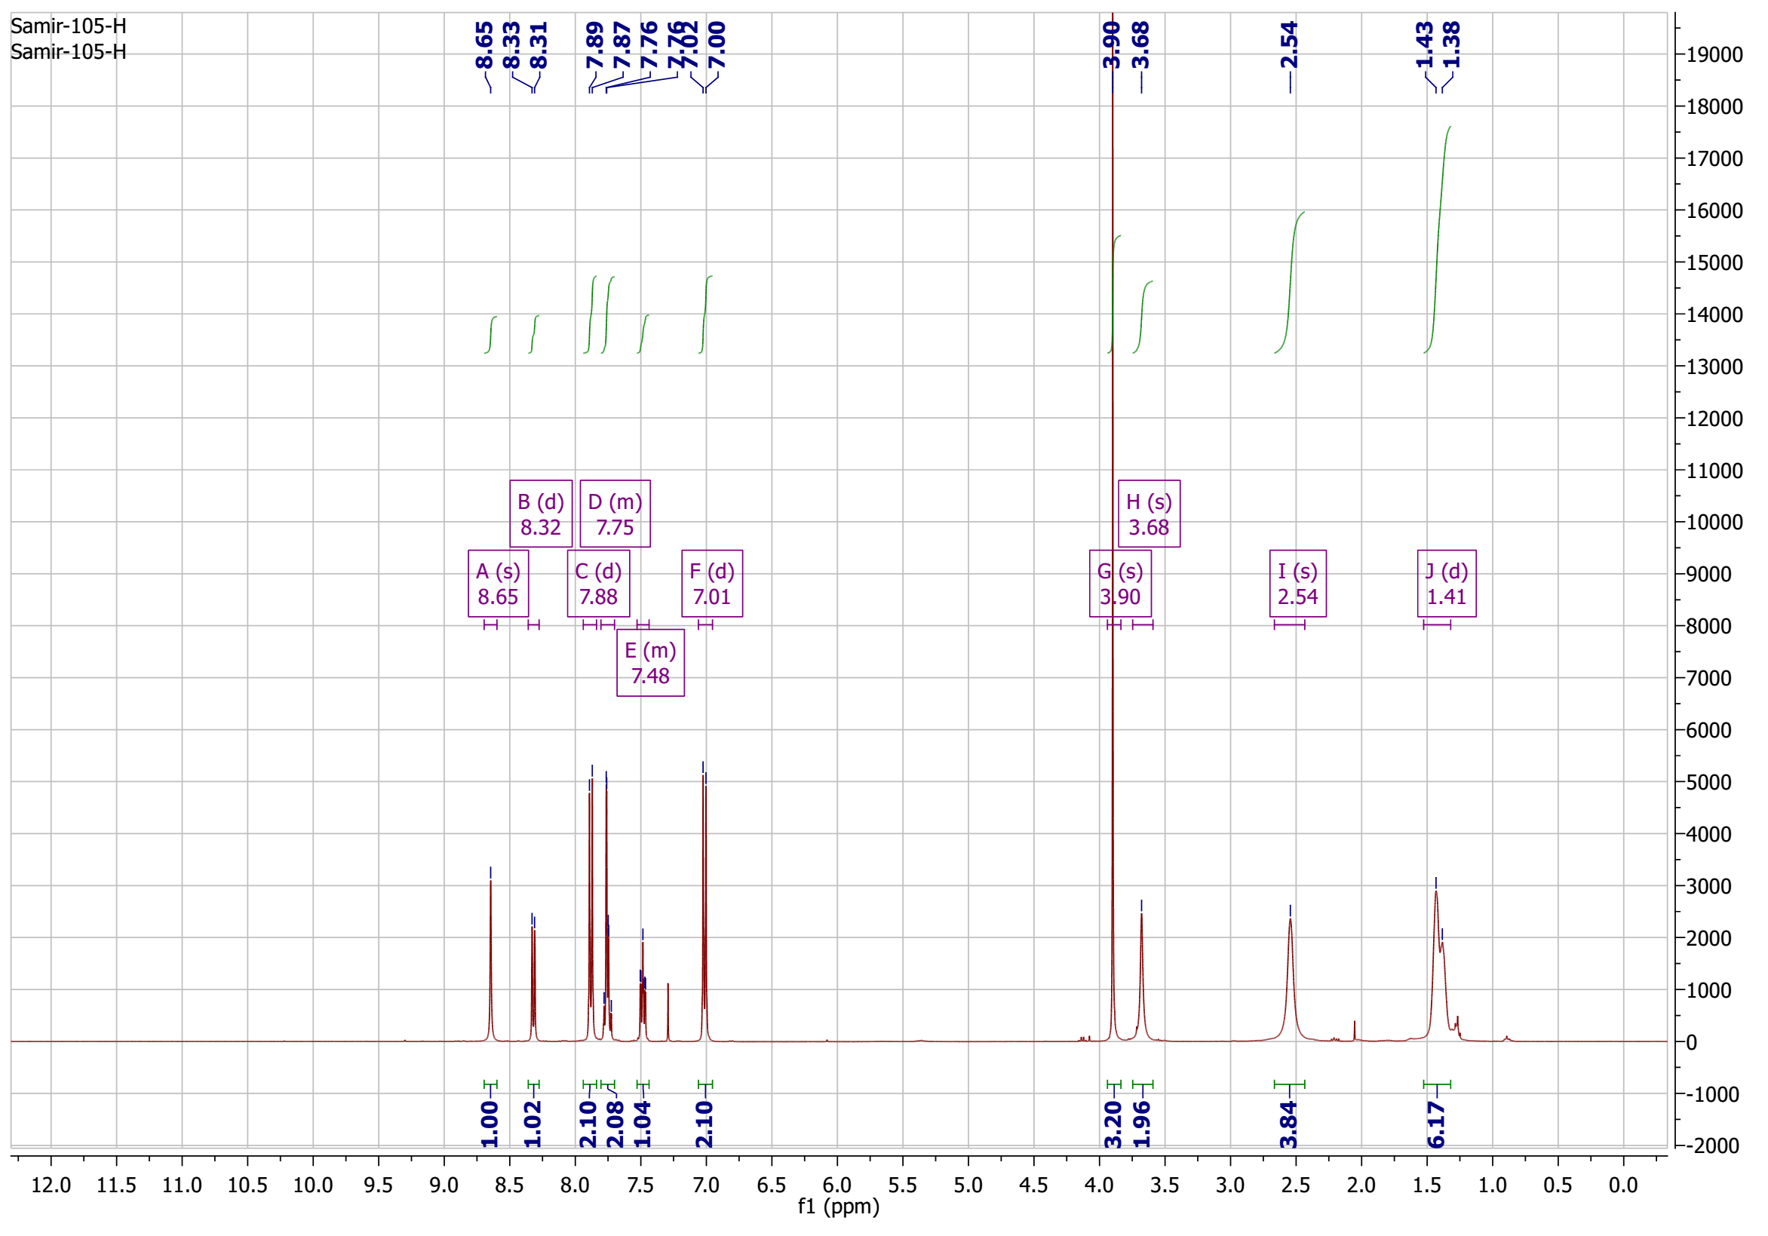

¹H-NMR spectrum of compound 24

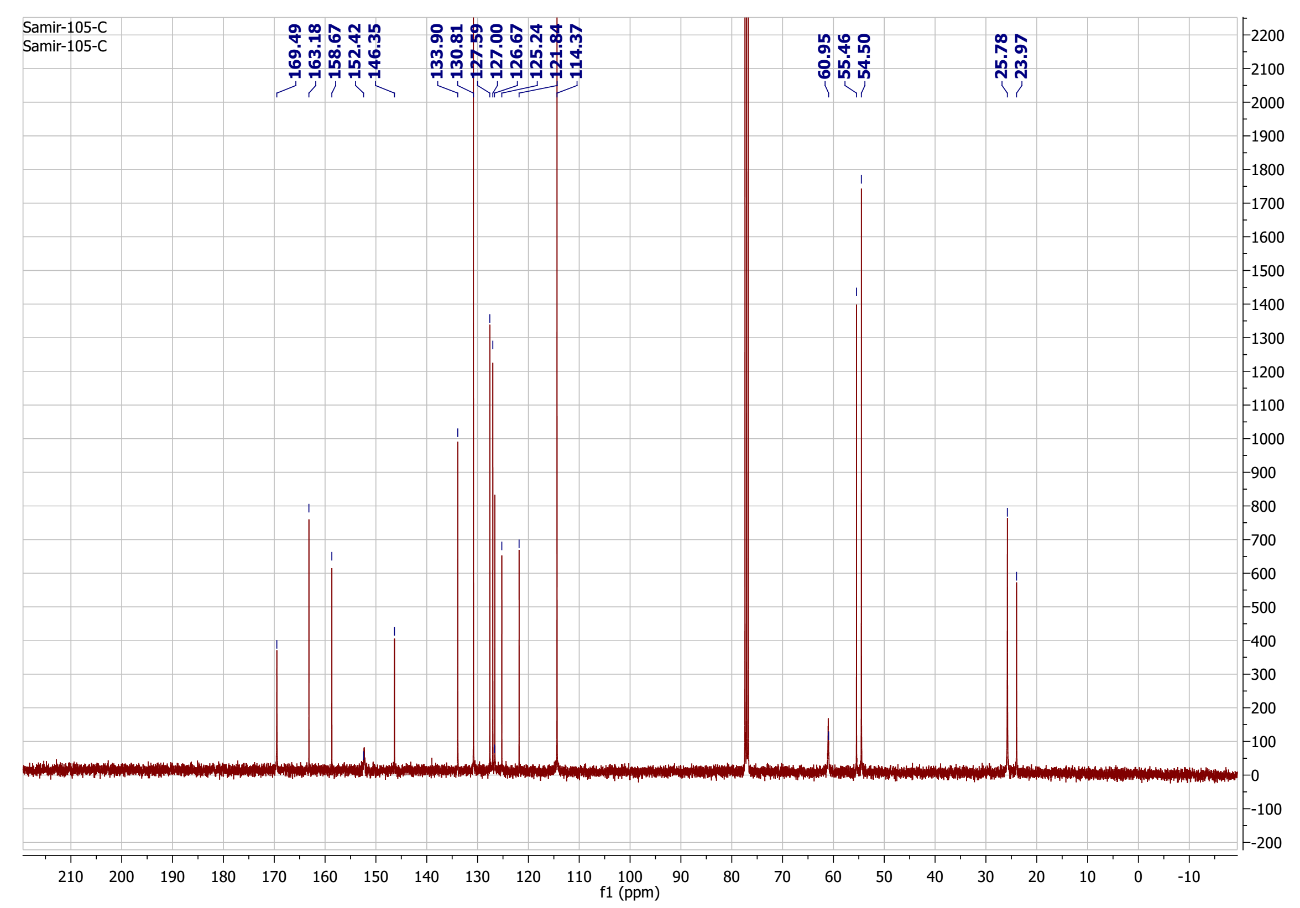
¹³C-NMR spectrum of compound 24

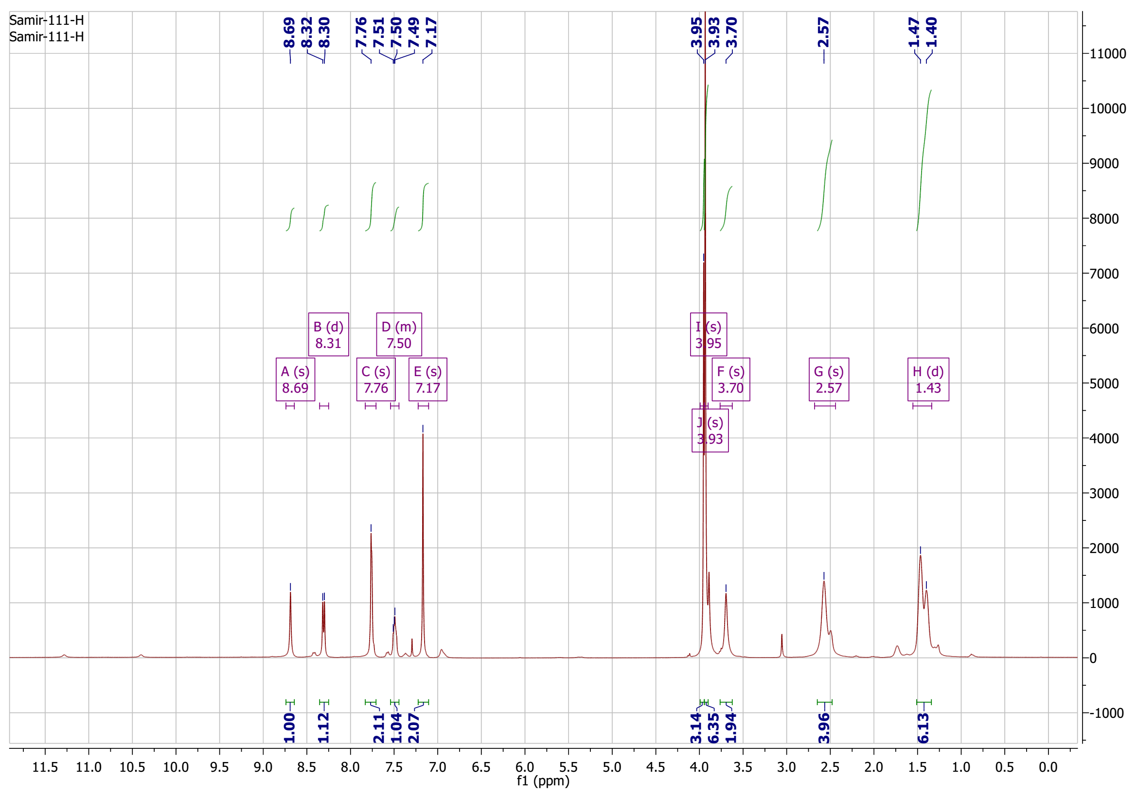
¹H-NMR spectrum of compound 25

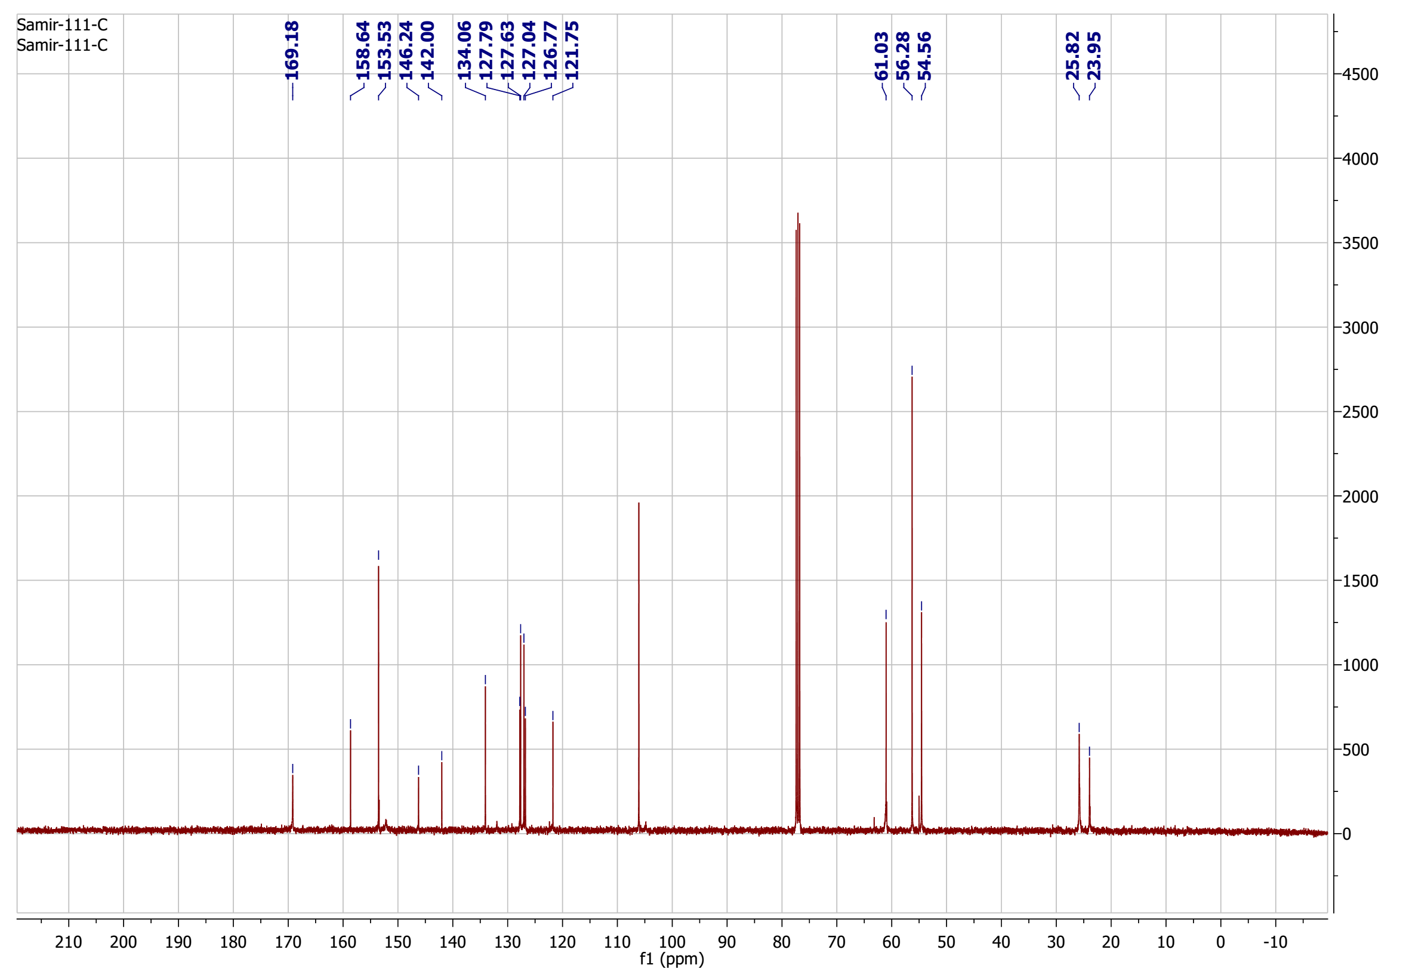
¹³C-NMR spectrum of compound 25

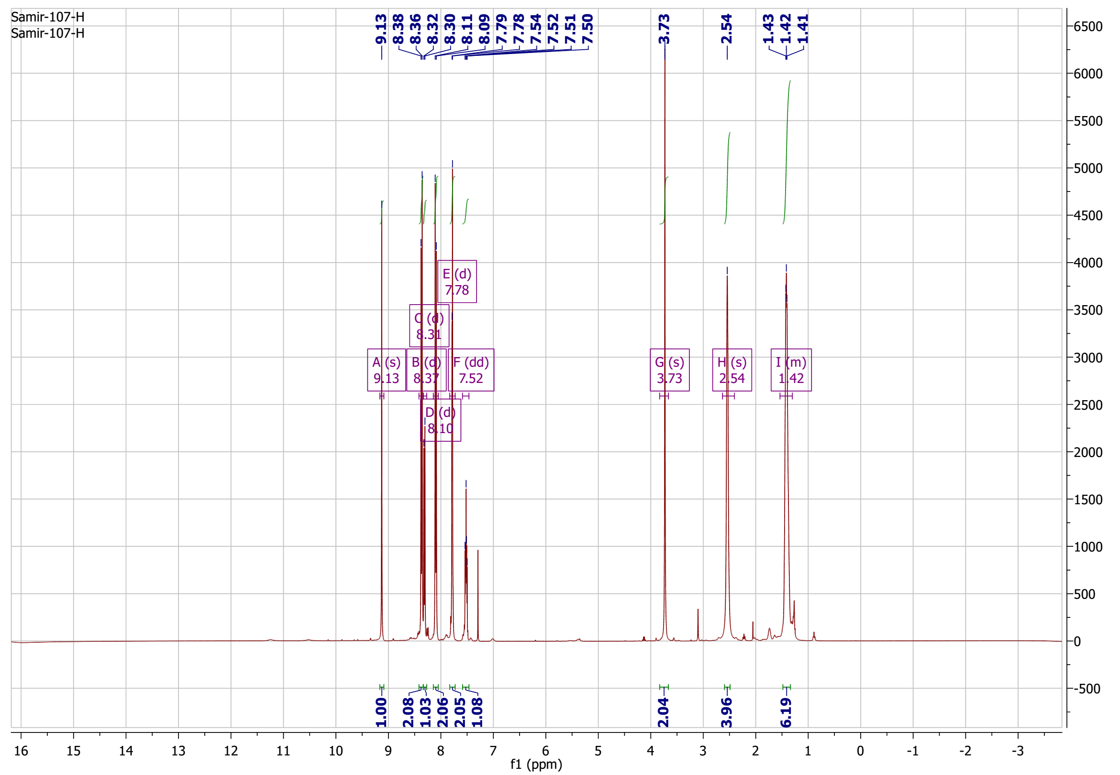
¹H-NMR spectrum of compound 26

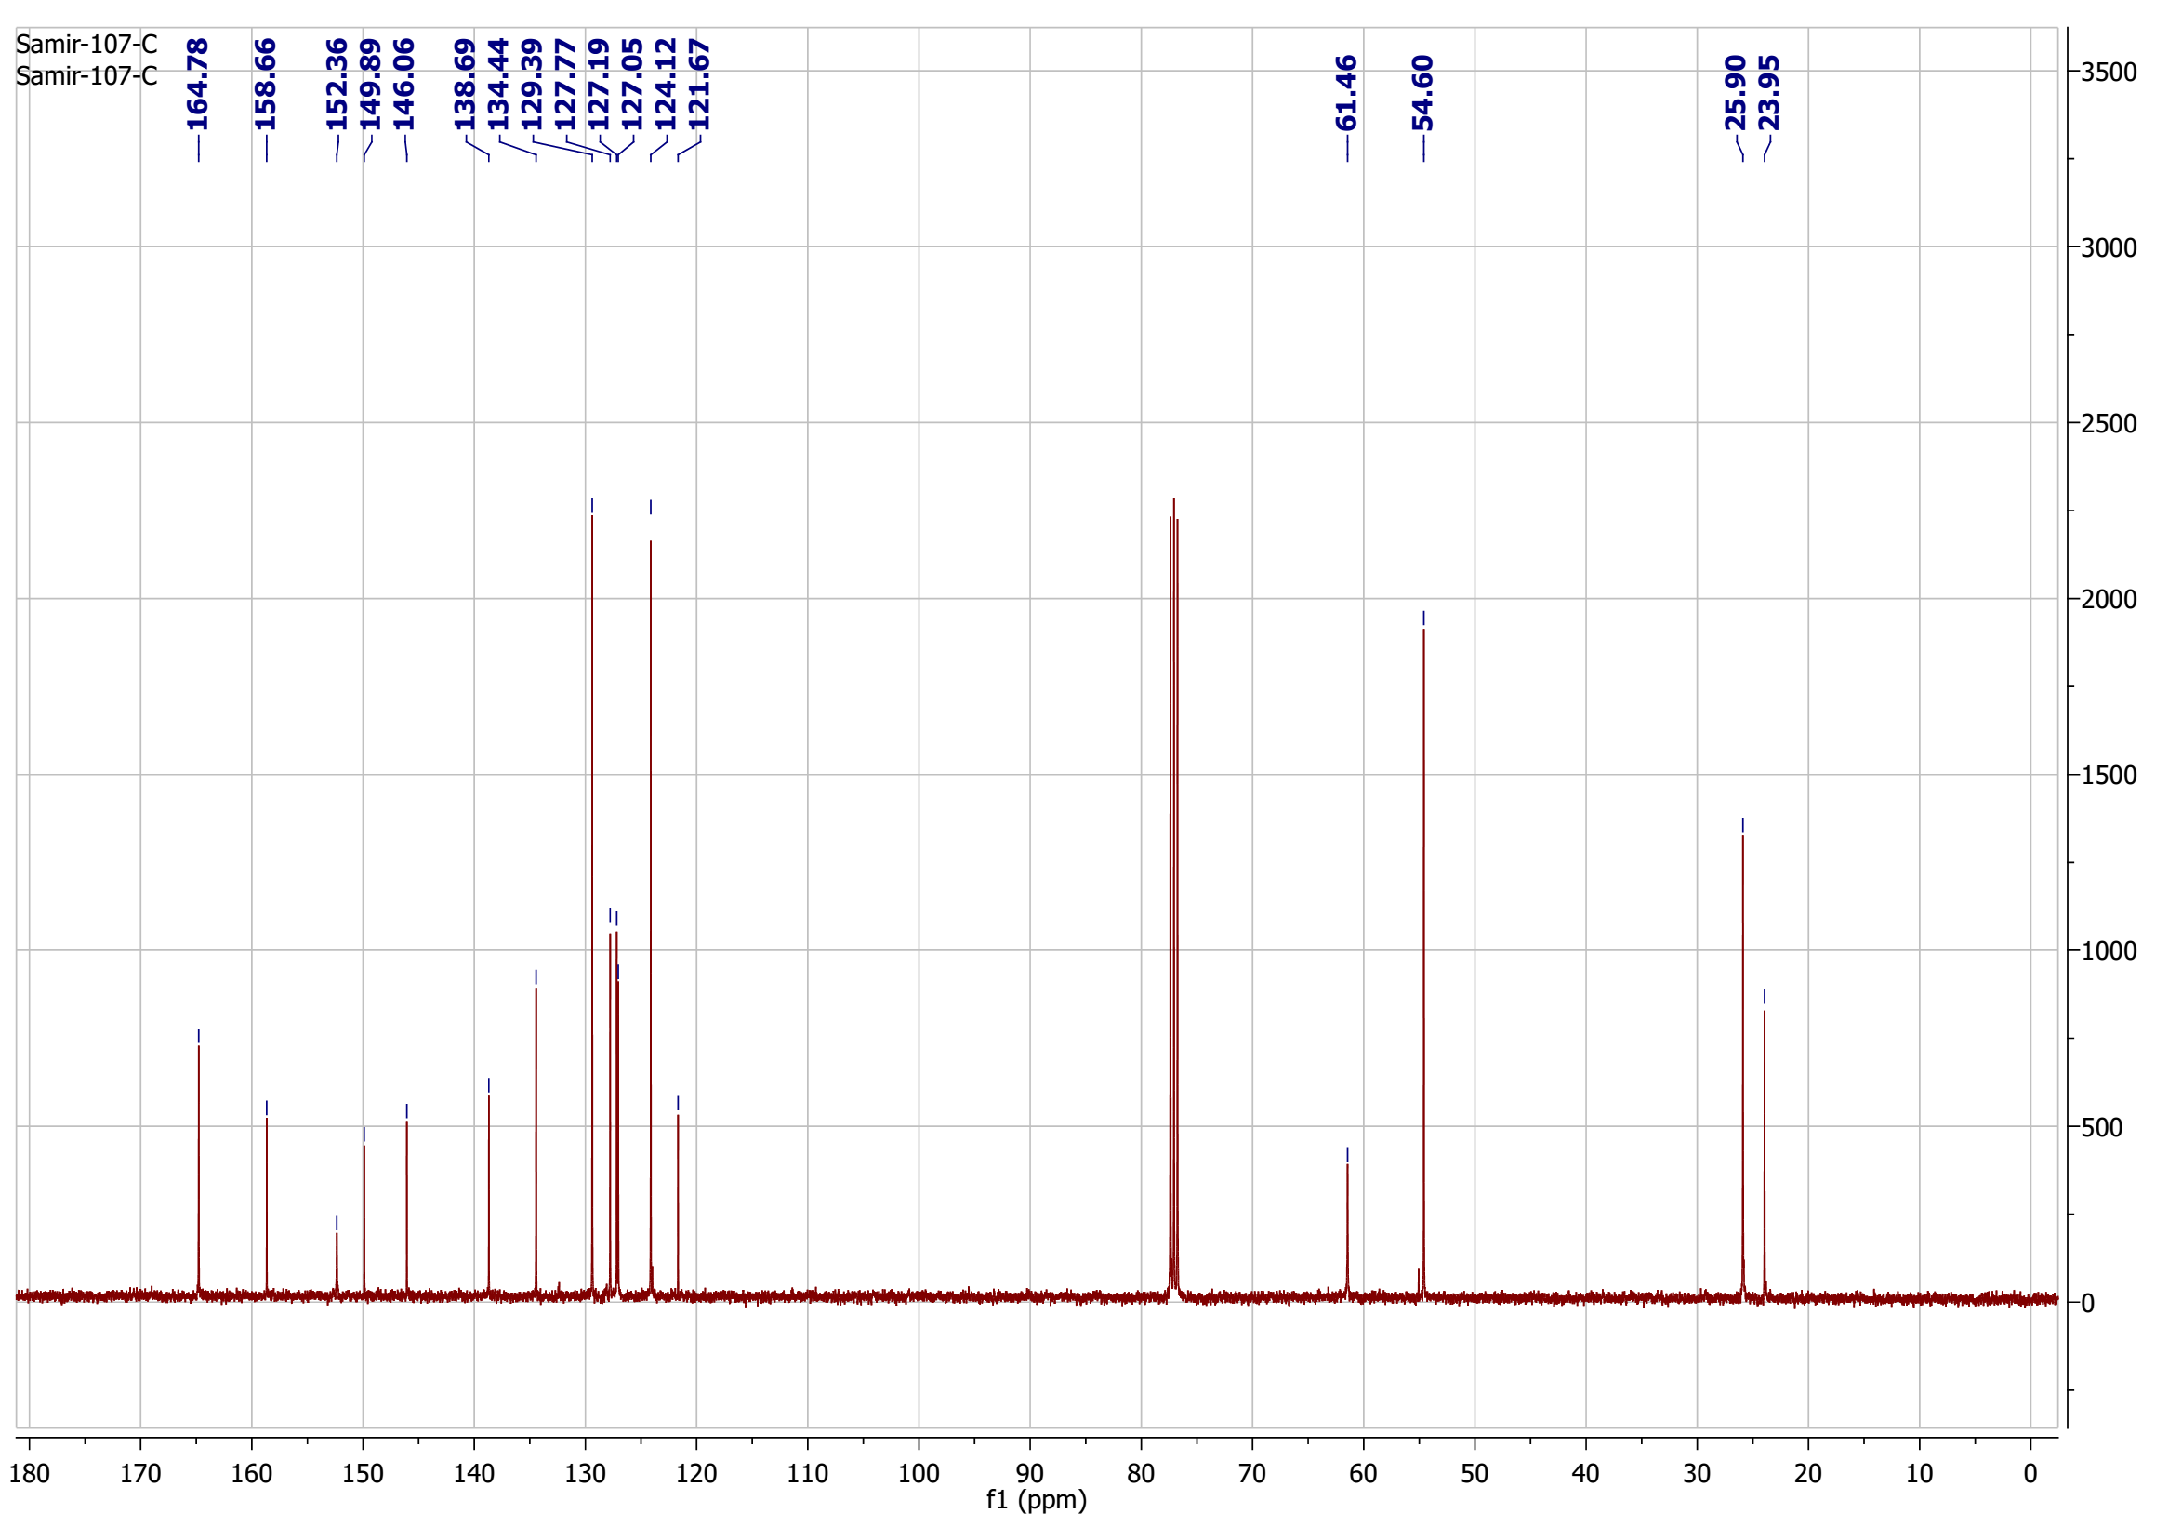
¹³C-NMR spectrum of compound 26

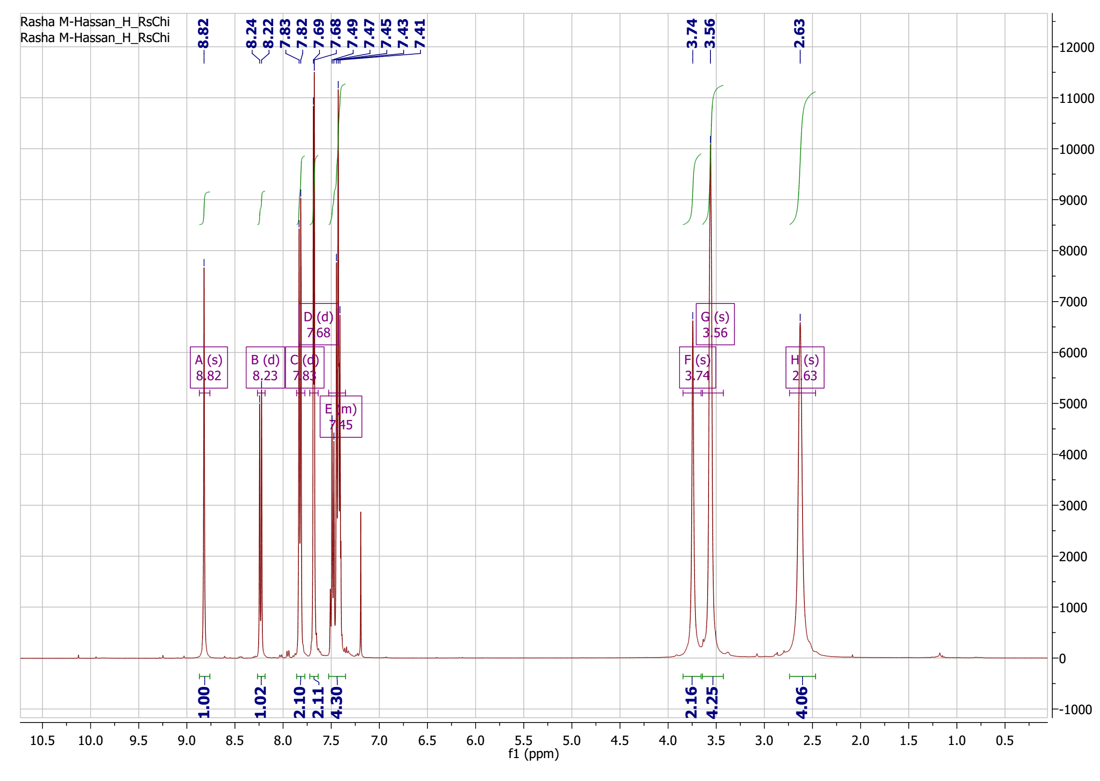
¹H-NMR spectrum of compound 27

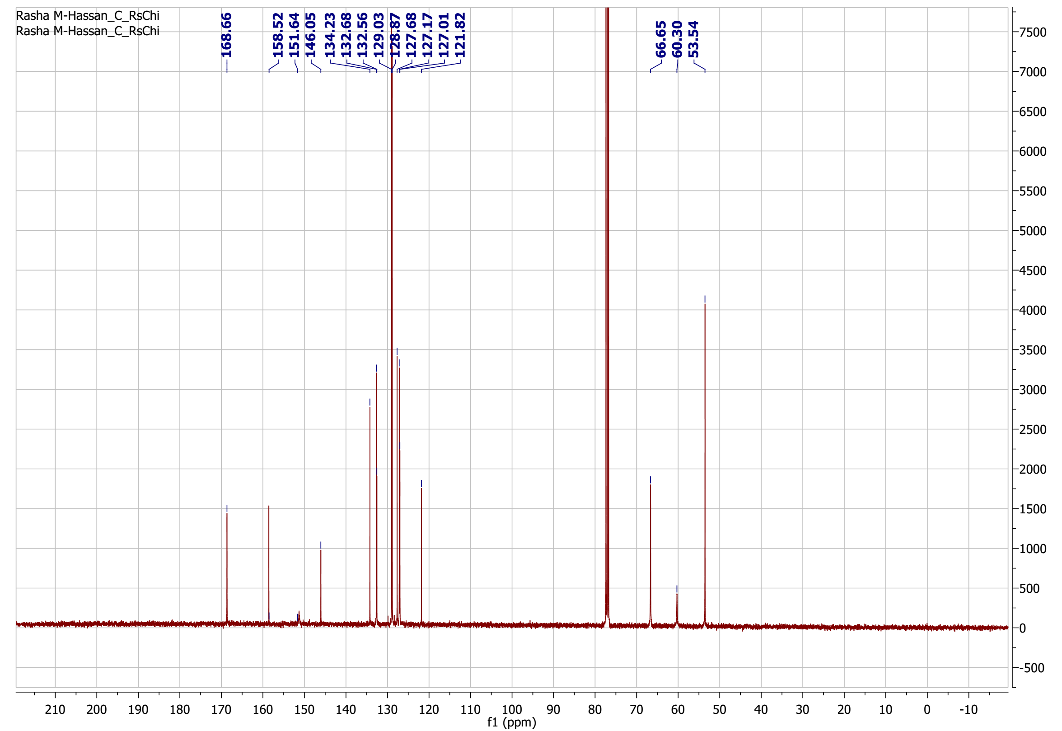
¹³C-NMR spectrum of compound 27

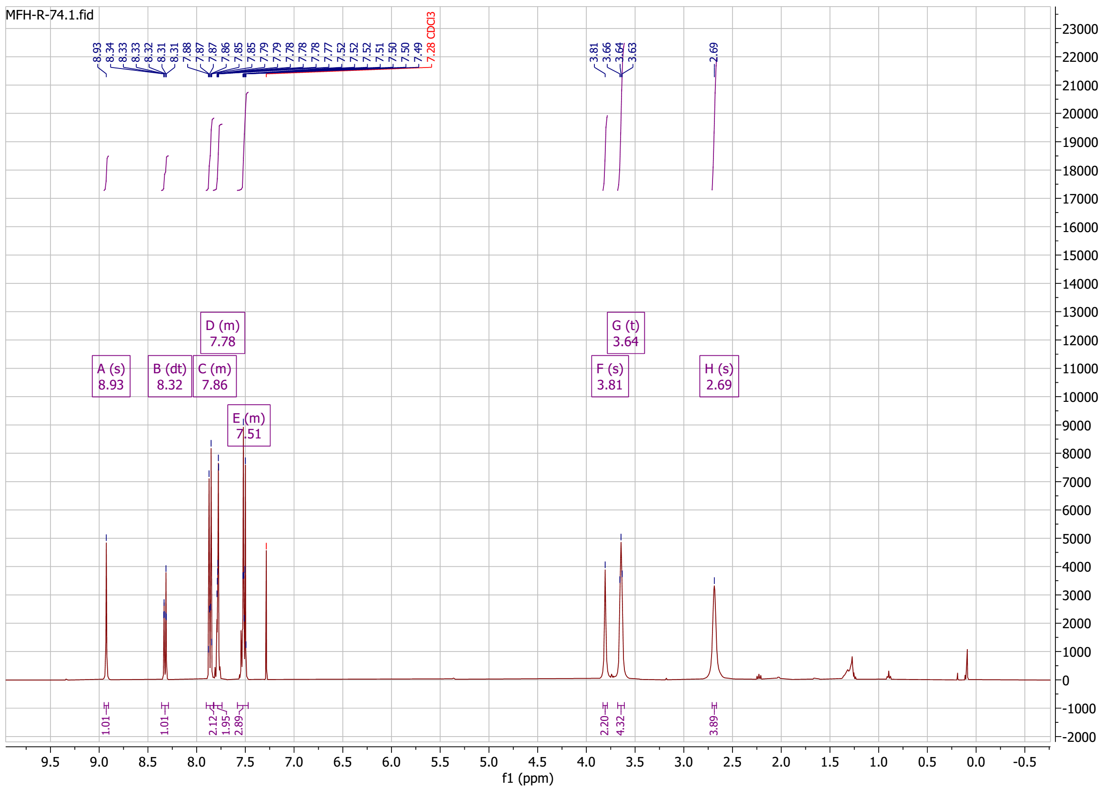
¹H-NMR spectrum of compound 28

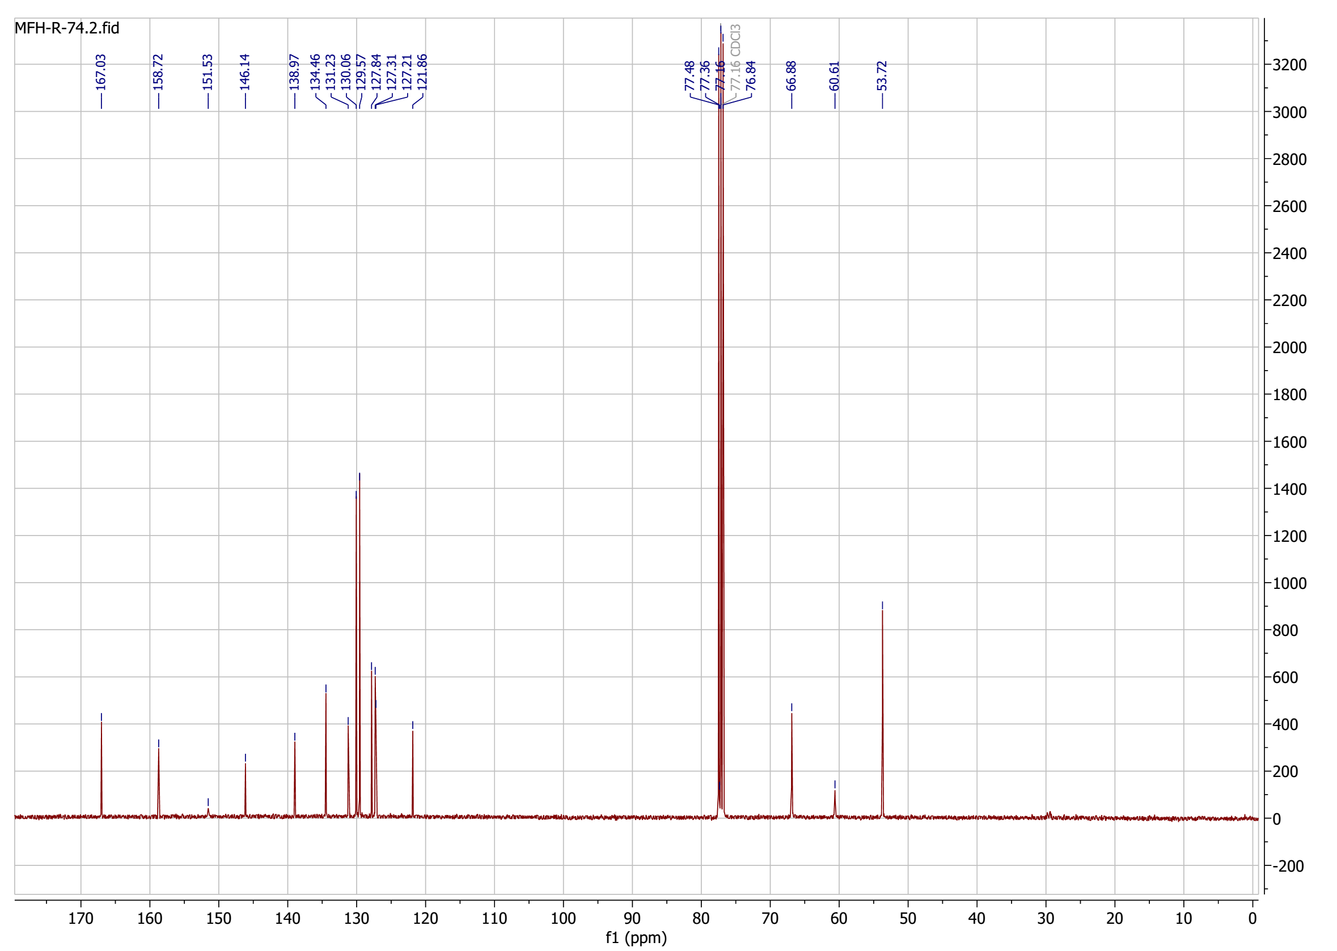
¹³C-NMR spectrum of compound 28

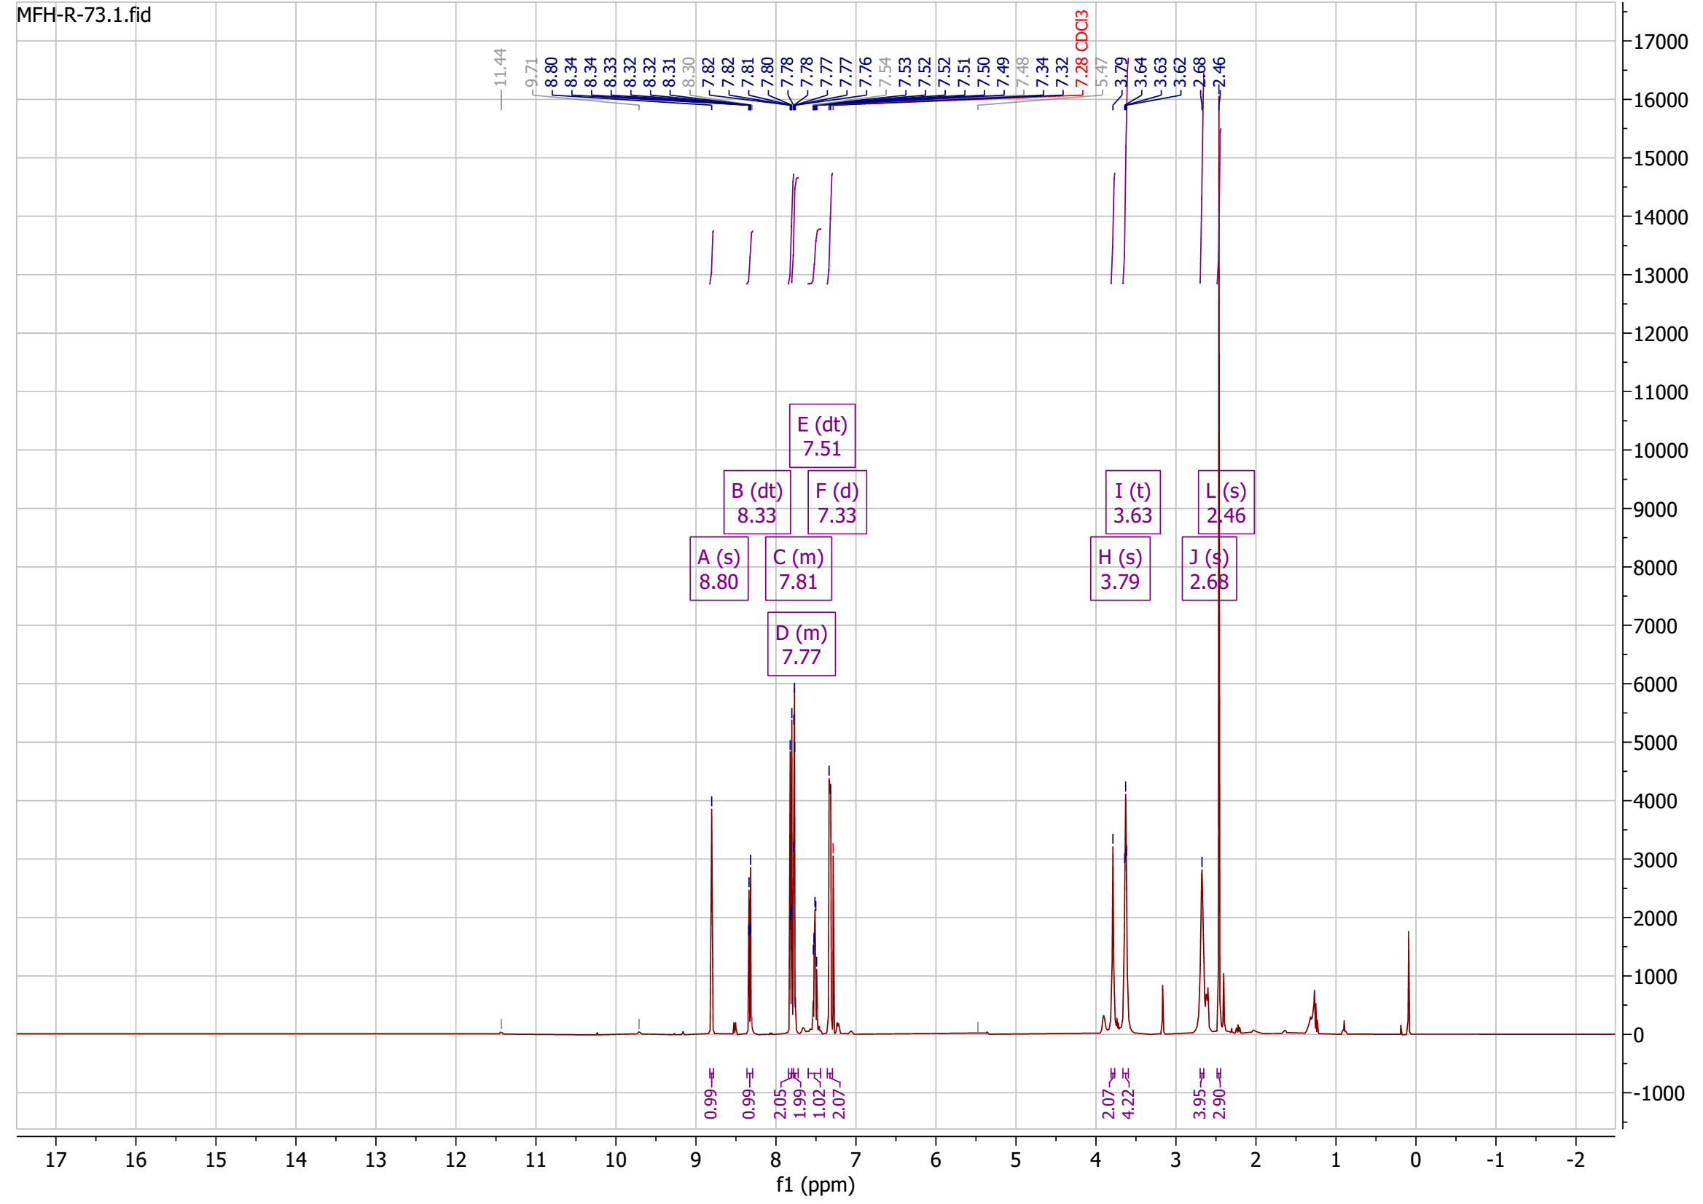
¹H-NMR spectrum of compound 29

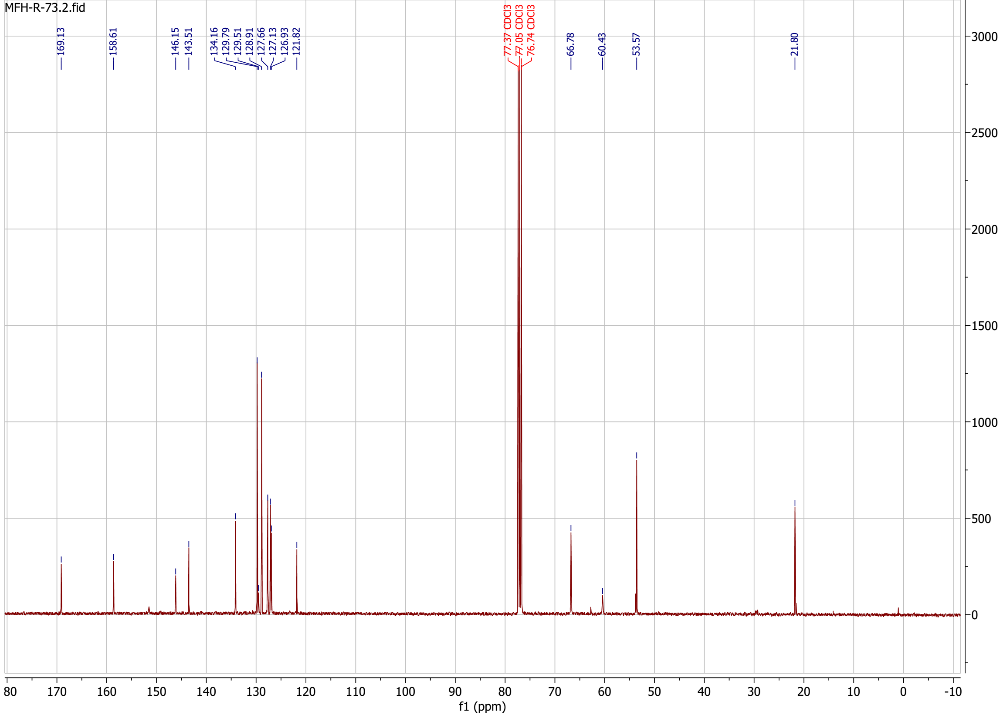
¹³C-NMR spectrum of compound 29

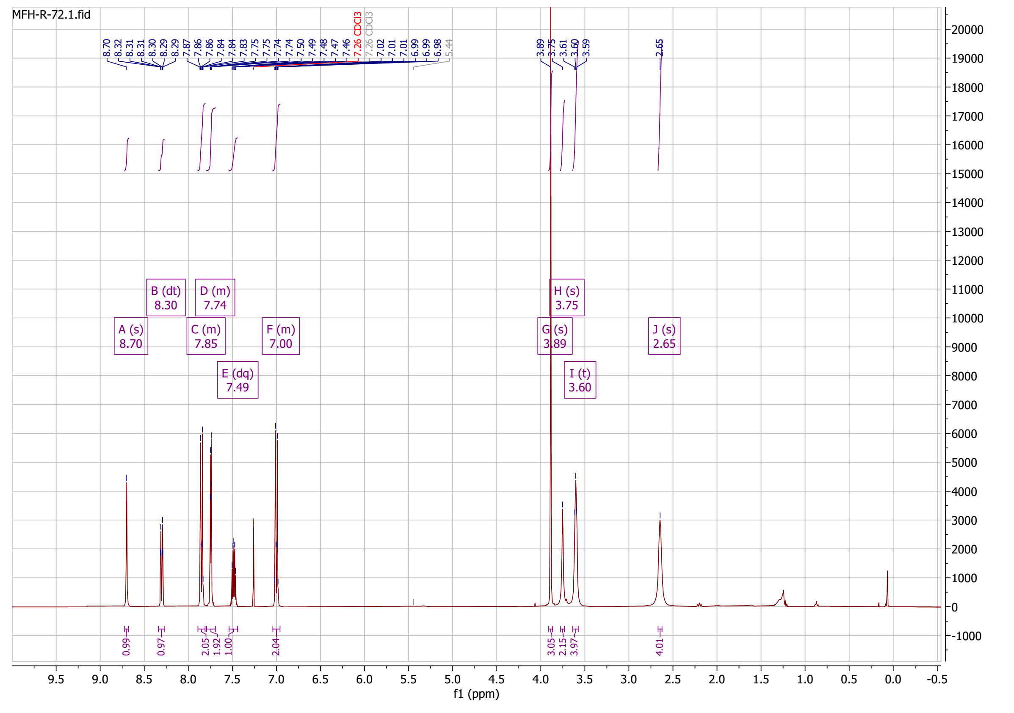
¹H-NMR spectrum of compound 30

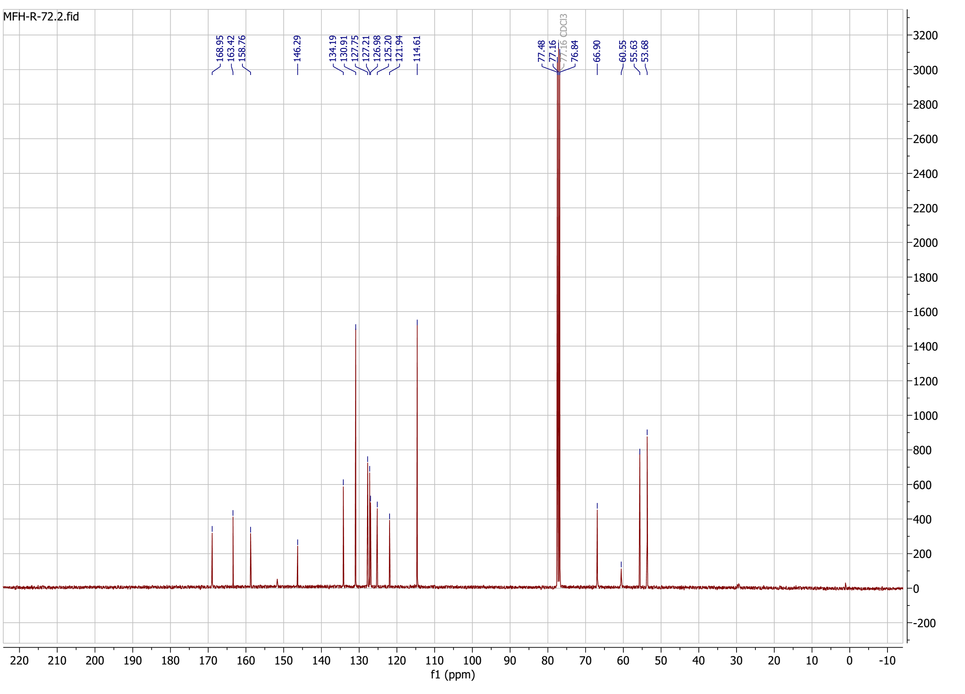
¹³C-NMR spectrum of compound 30

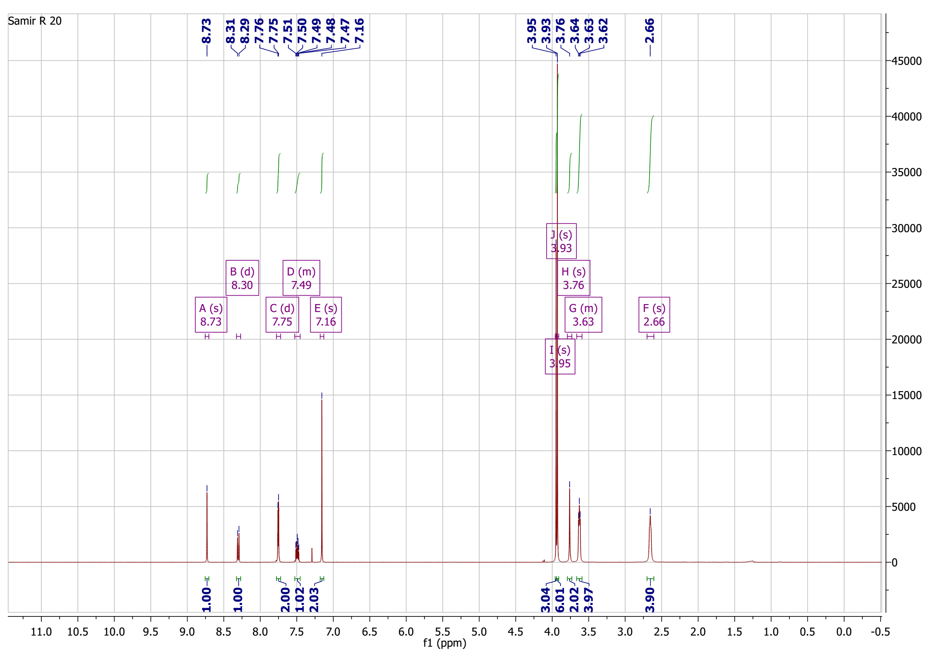
¹H-NMR spectrum of compound 31

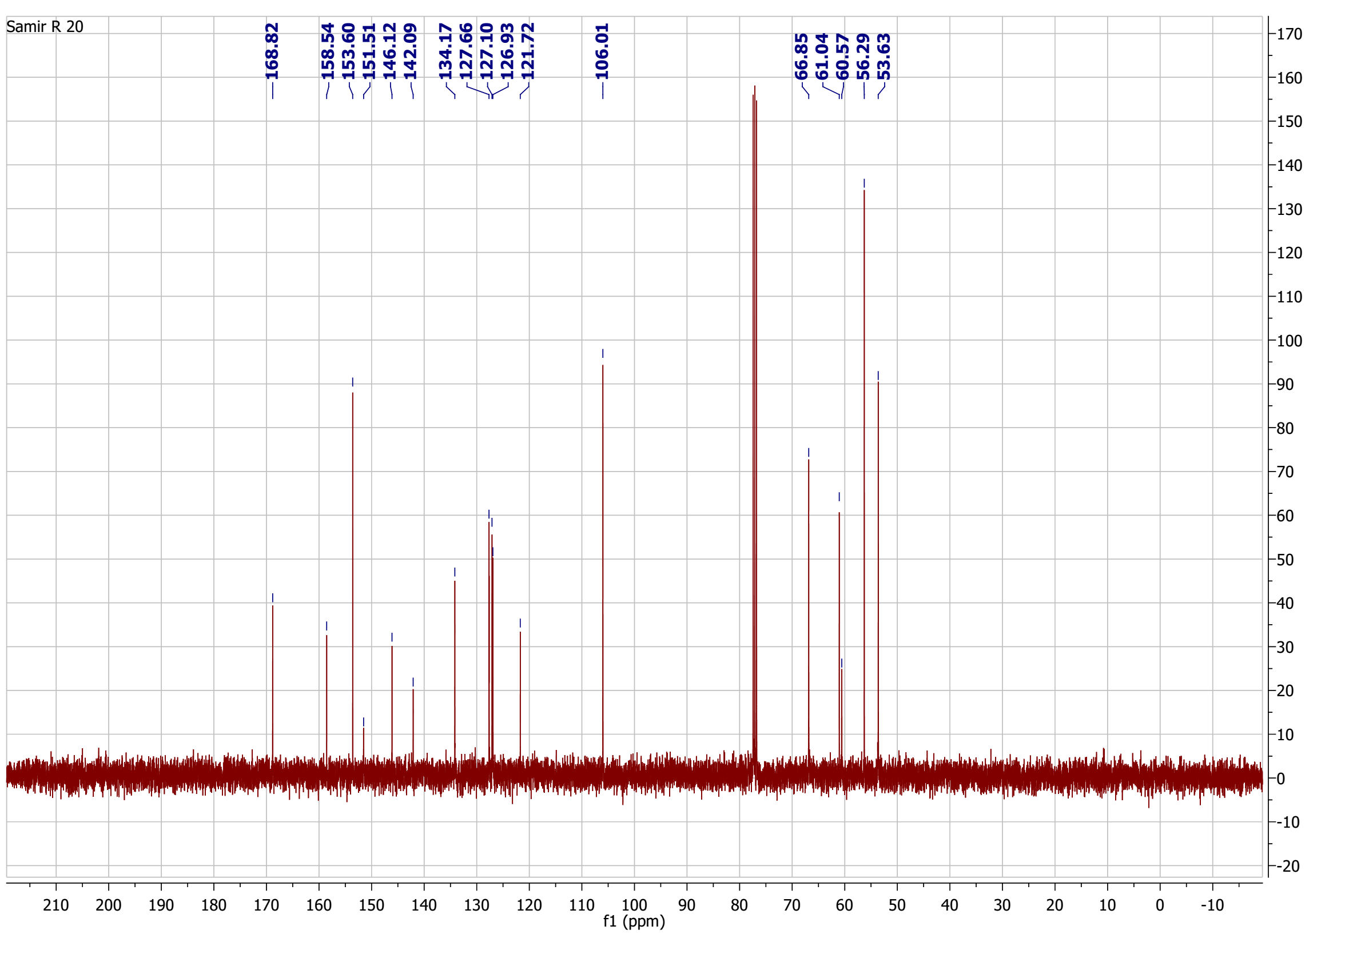
¹³C-NMR spectrum of compound 31

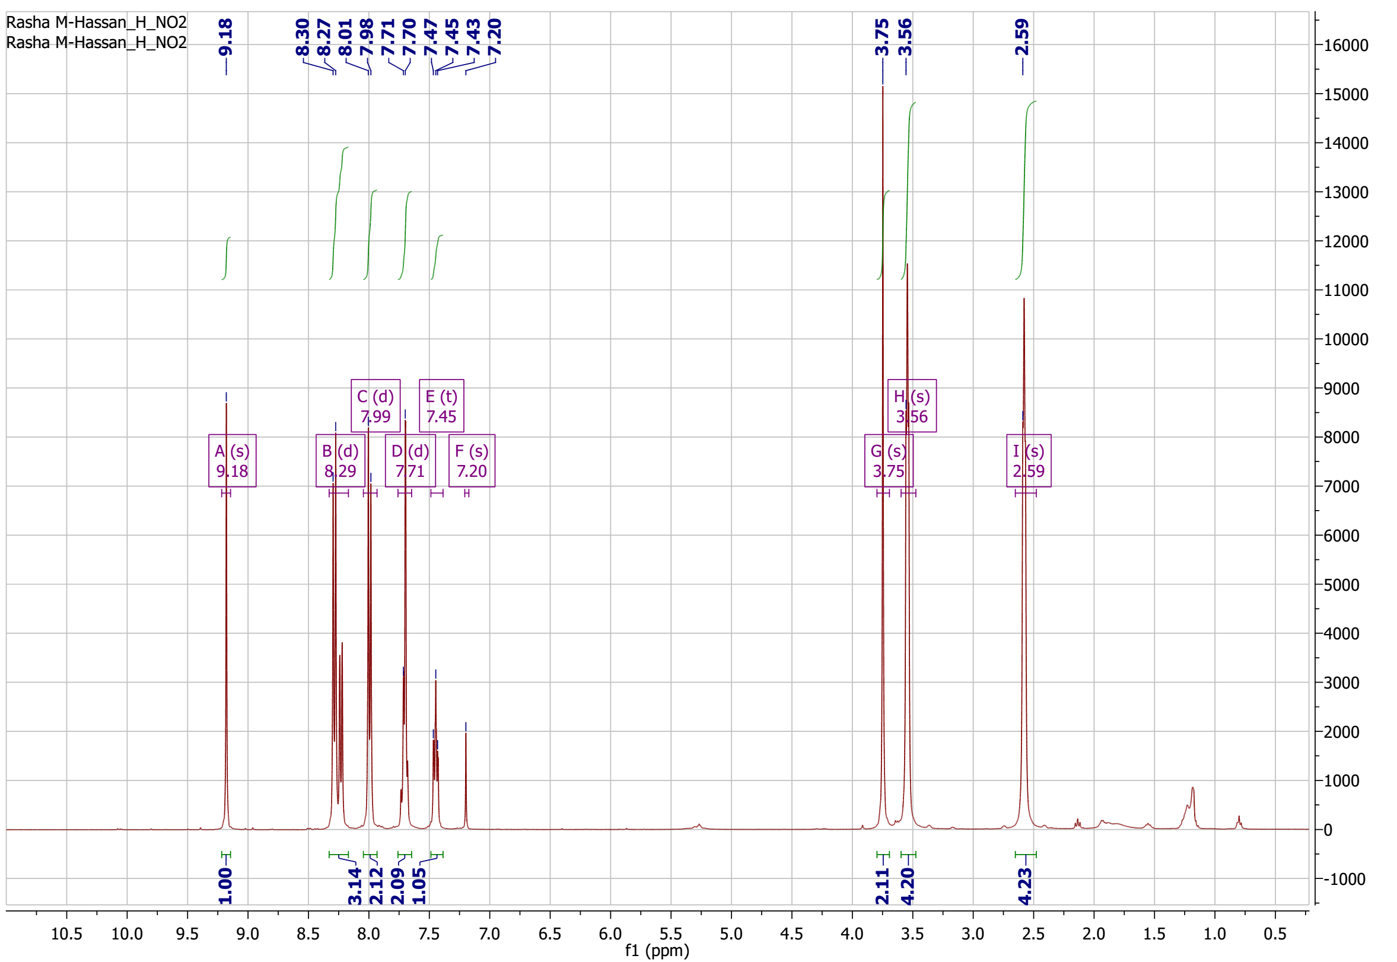
¹H-NMR spectrum of compound 32

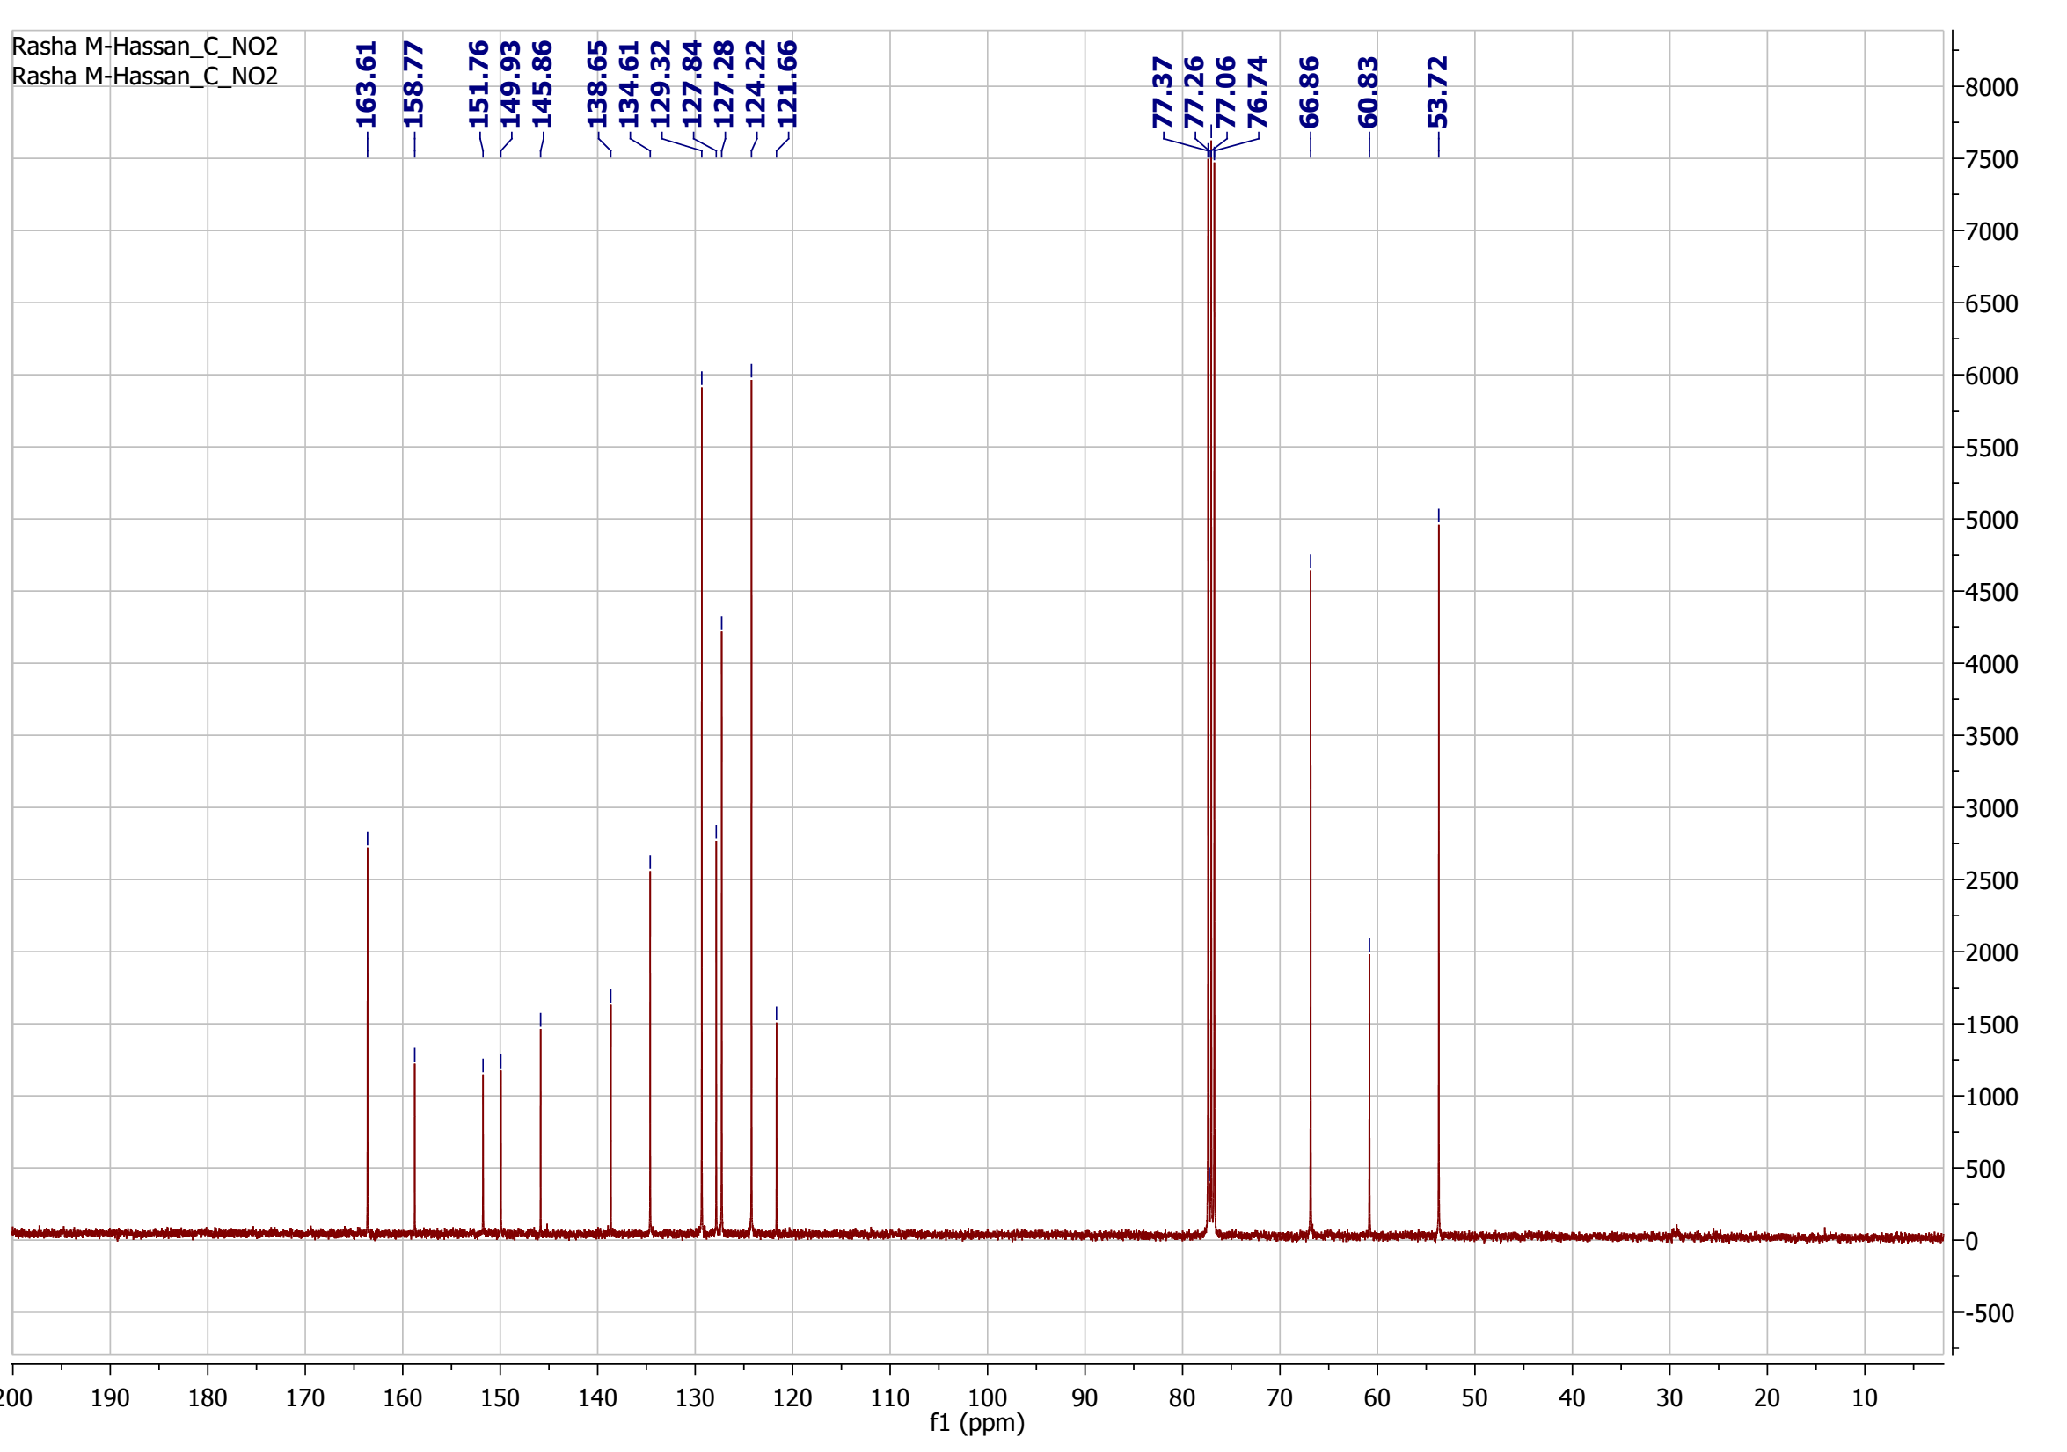
¹³C-NMR spectrum of compound 32

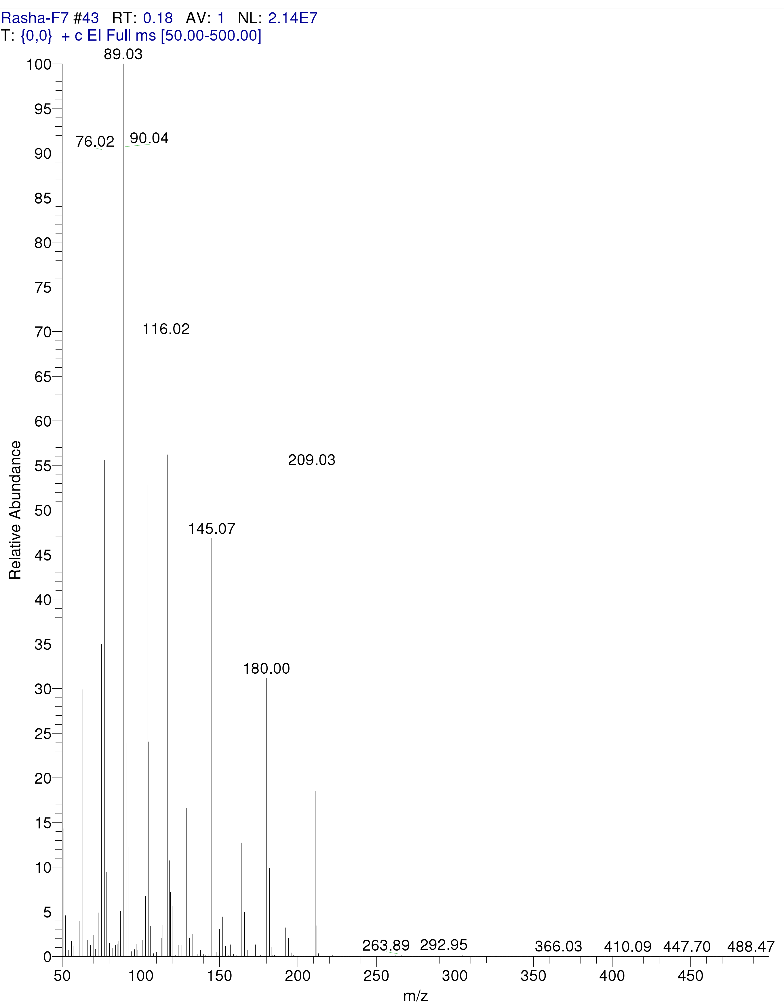Mass spectrum for compound 8
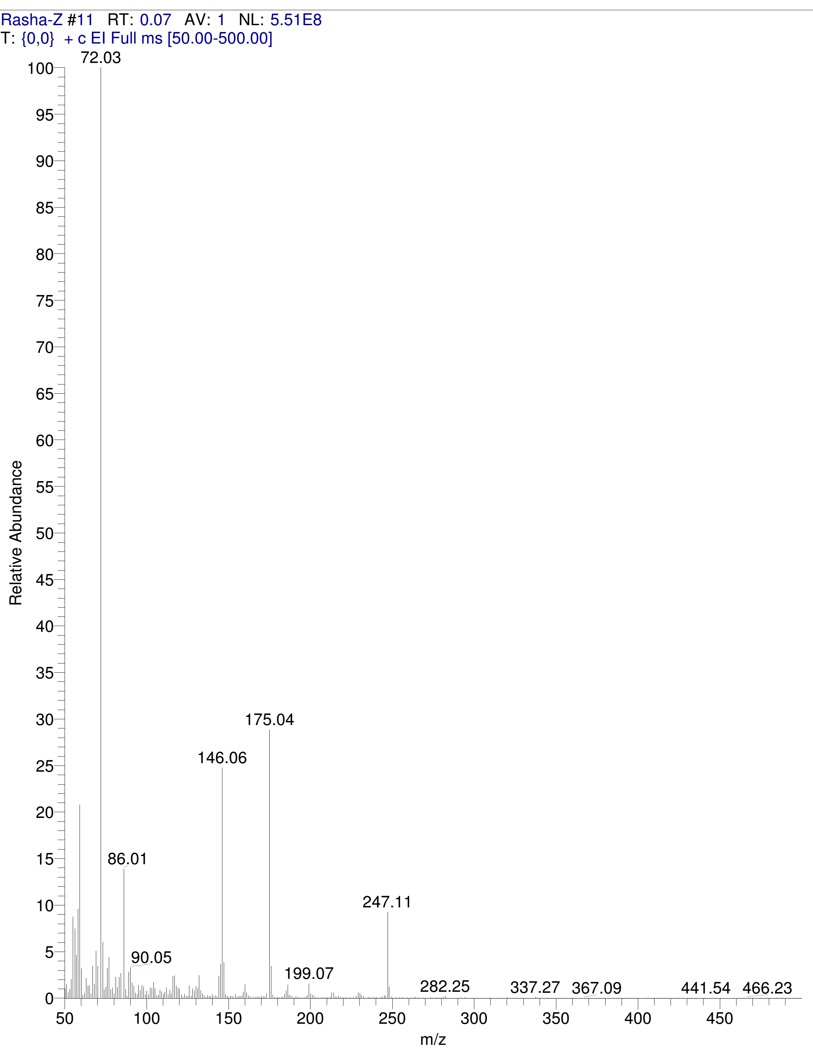
Mass spectrum for compound 5a
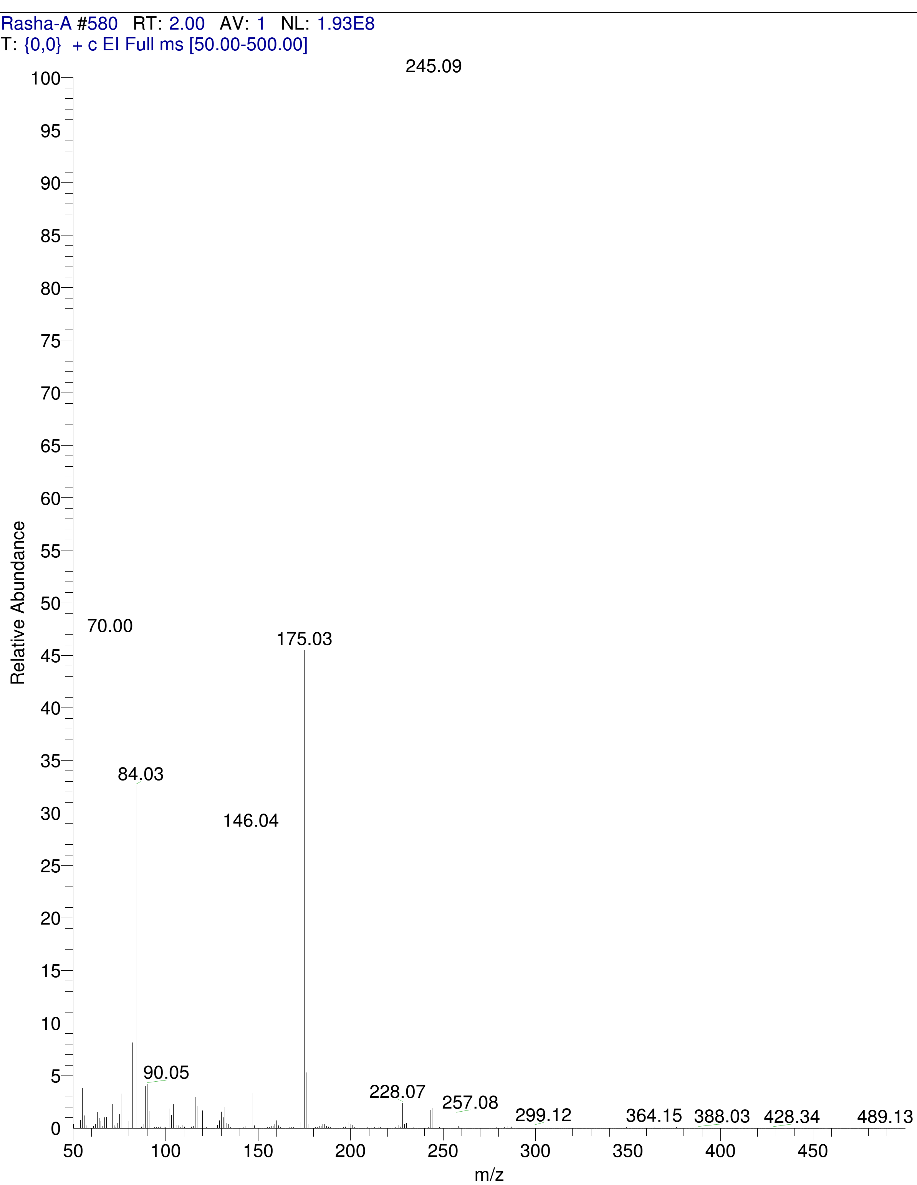Mass spectrum for compound 5b

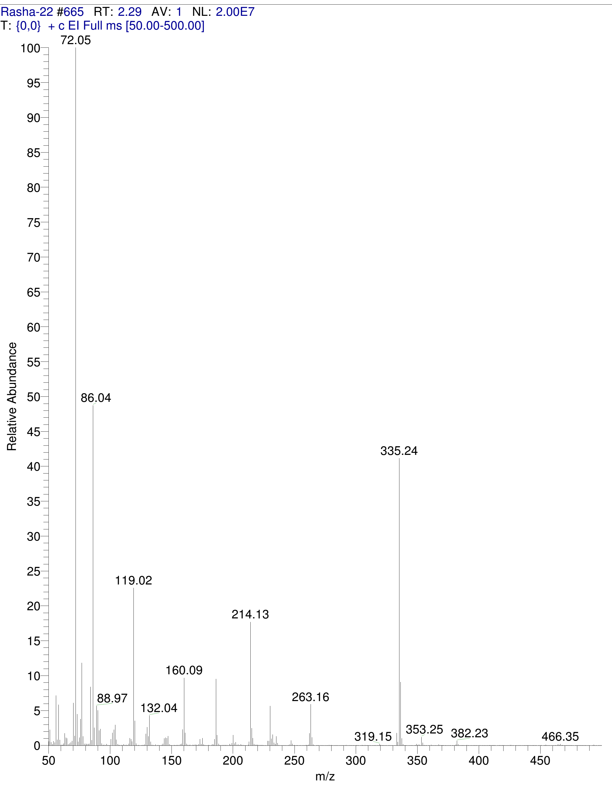
Mass spectrum for compound 9
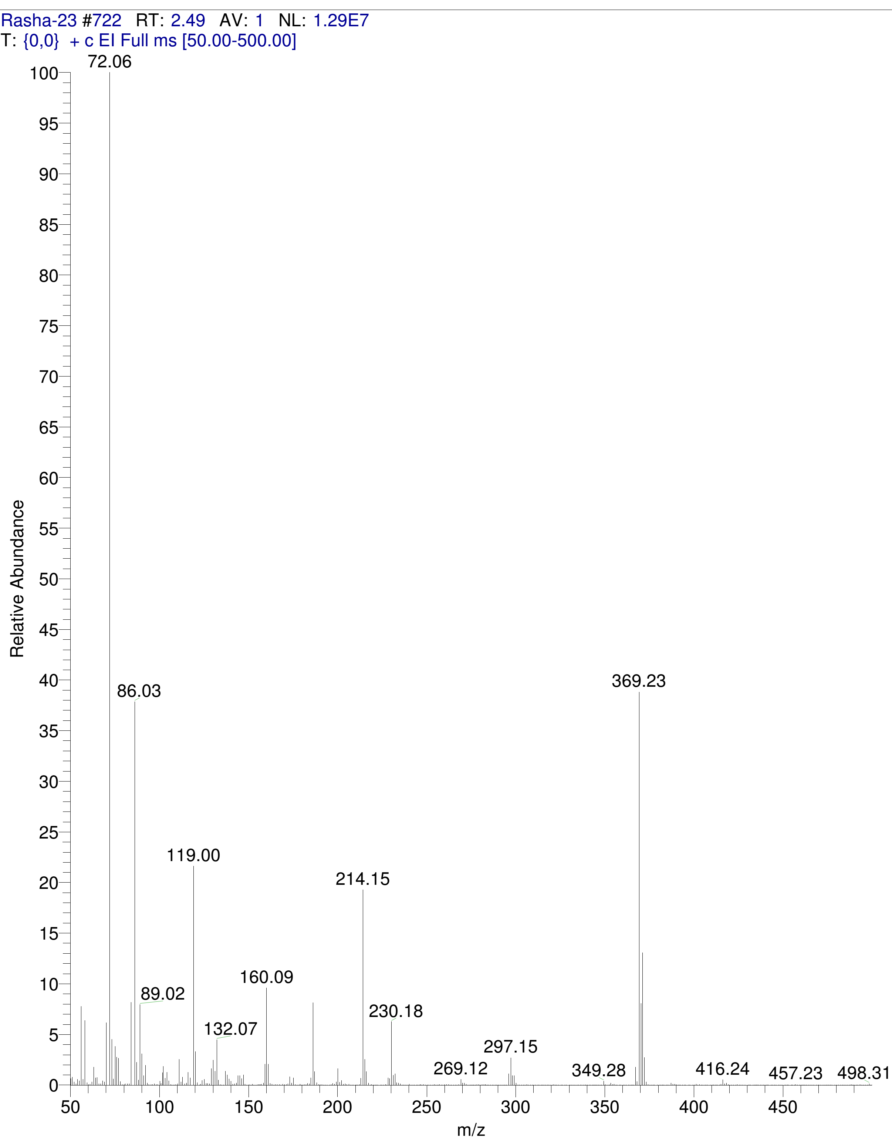
Mass spectrum for compound 10
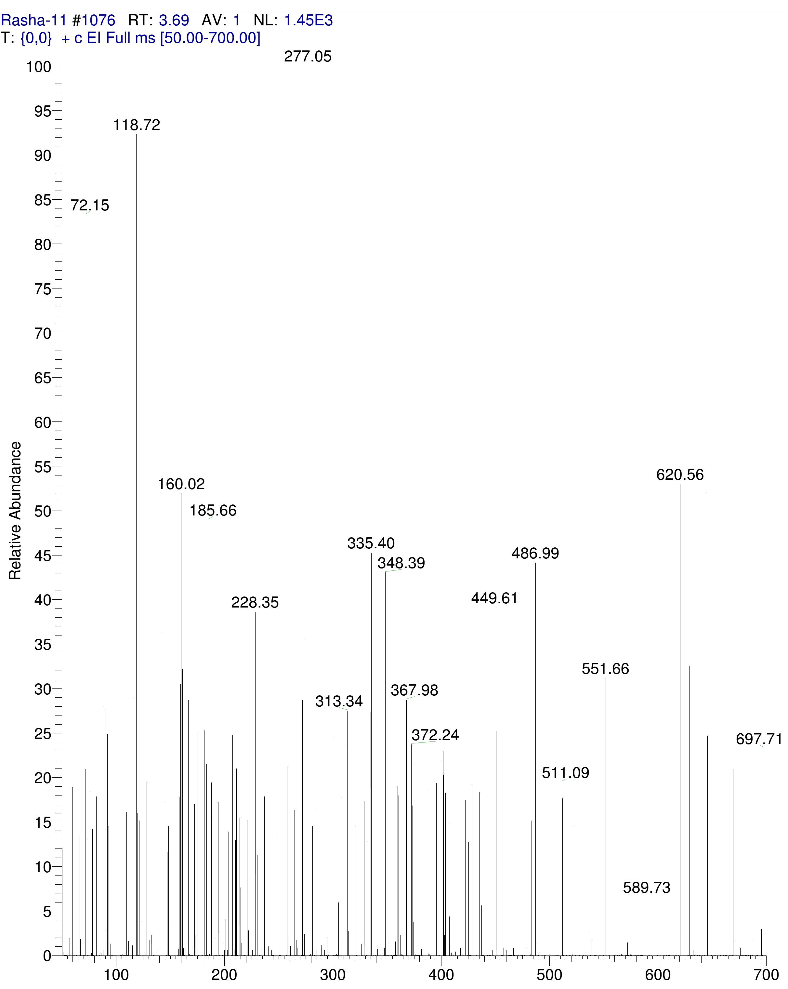
Mass spectrum for compound 11

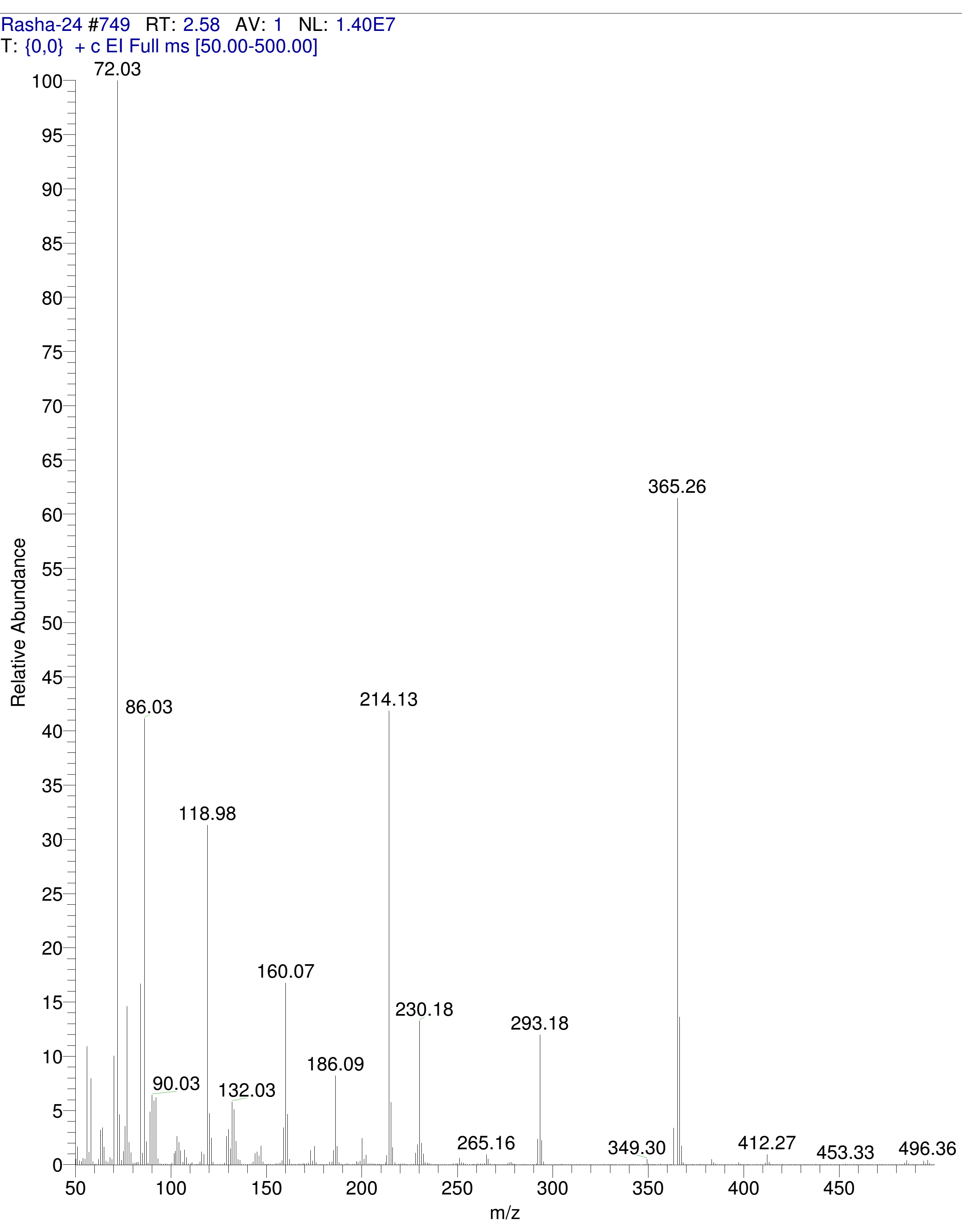
Mass spectrum for compound 12

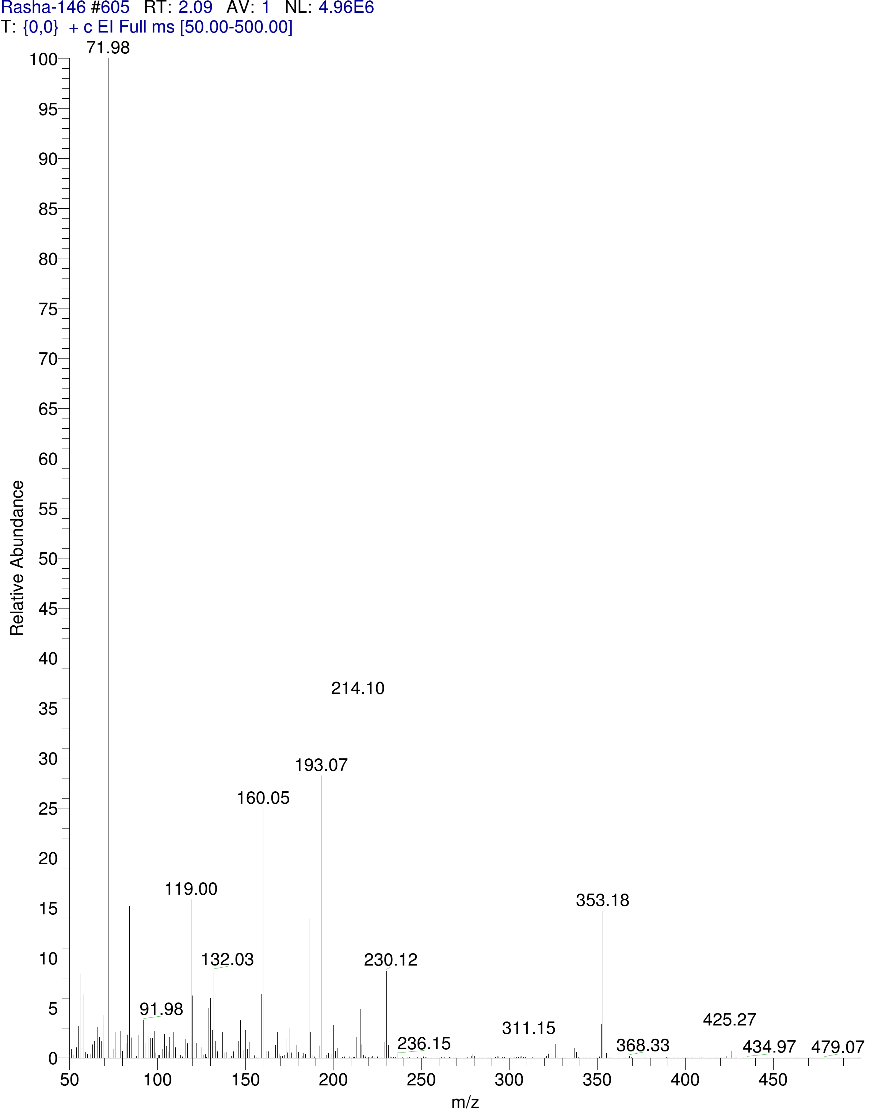
Mass spectrum for compound 13

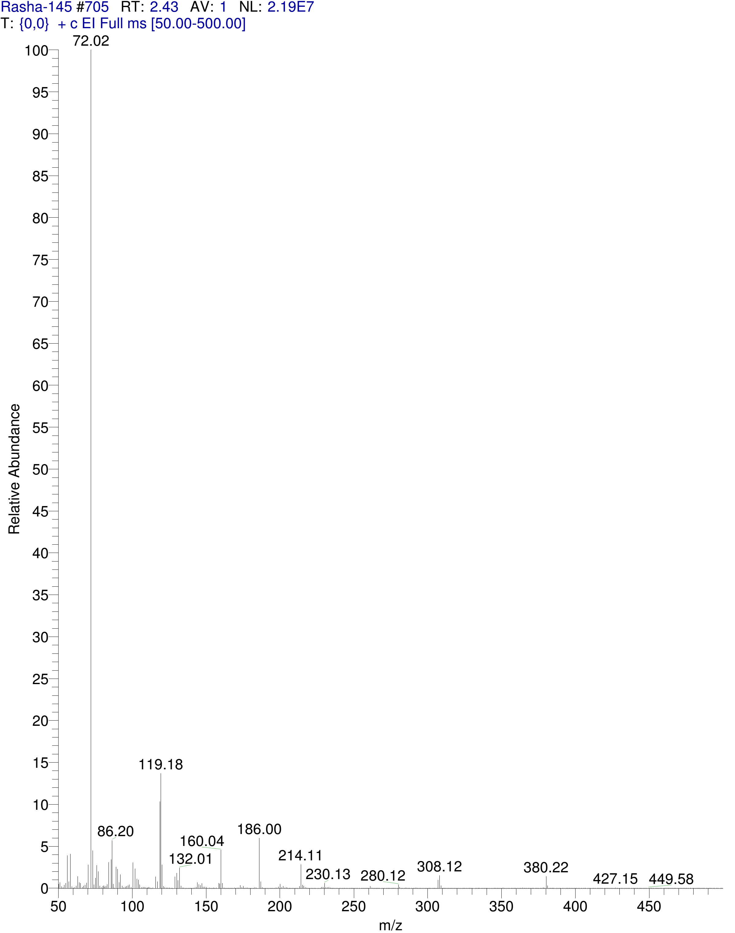
Mass spectrum for compound 14

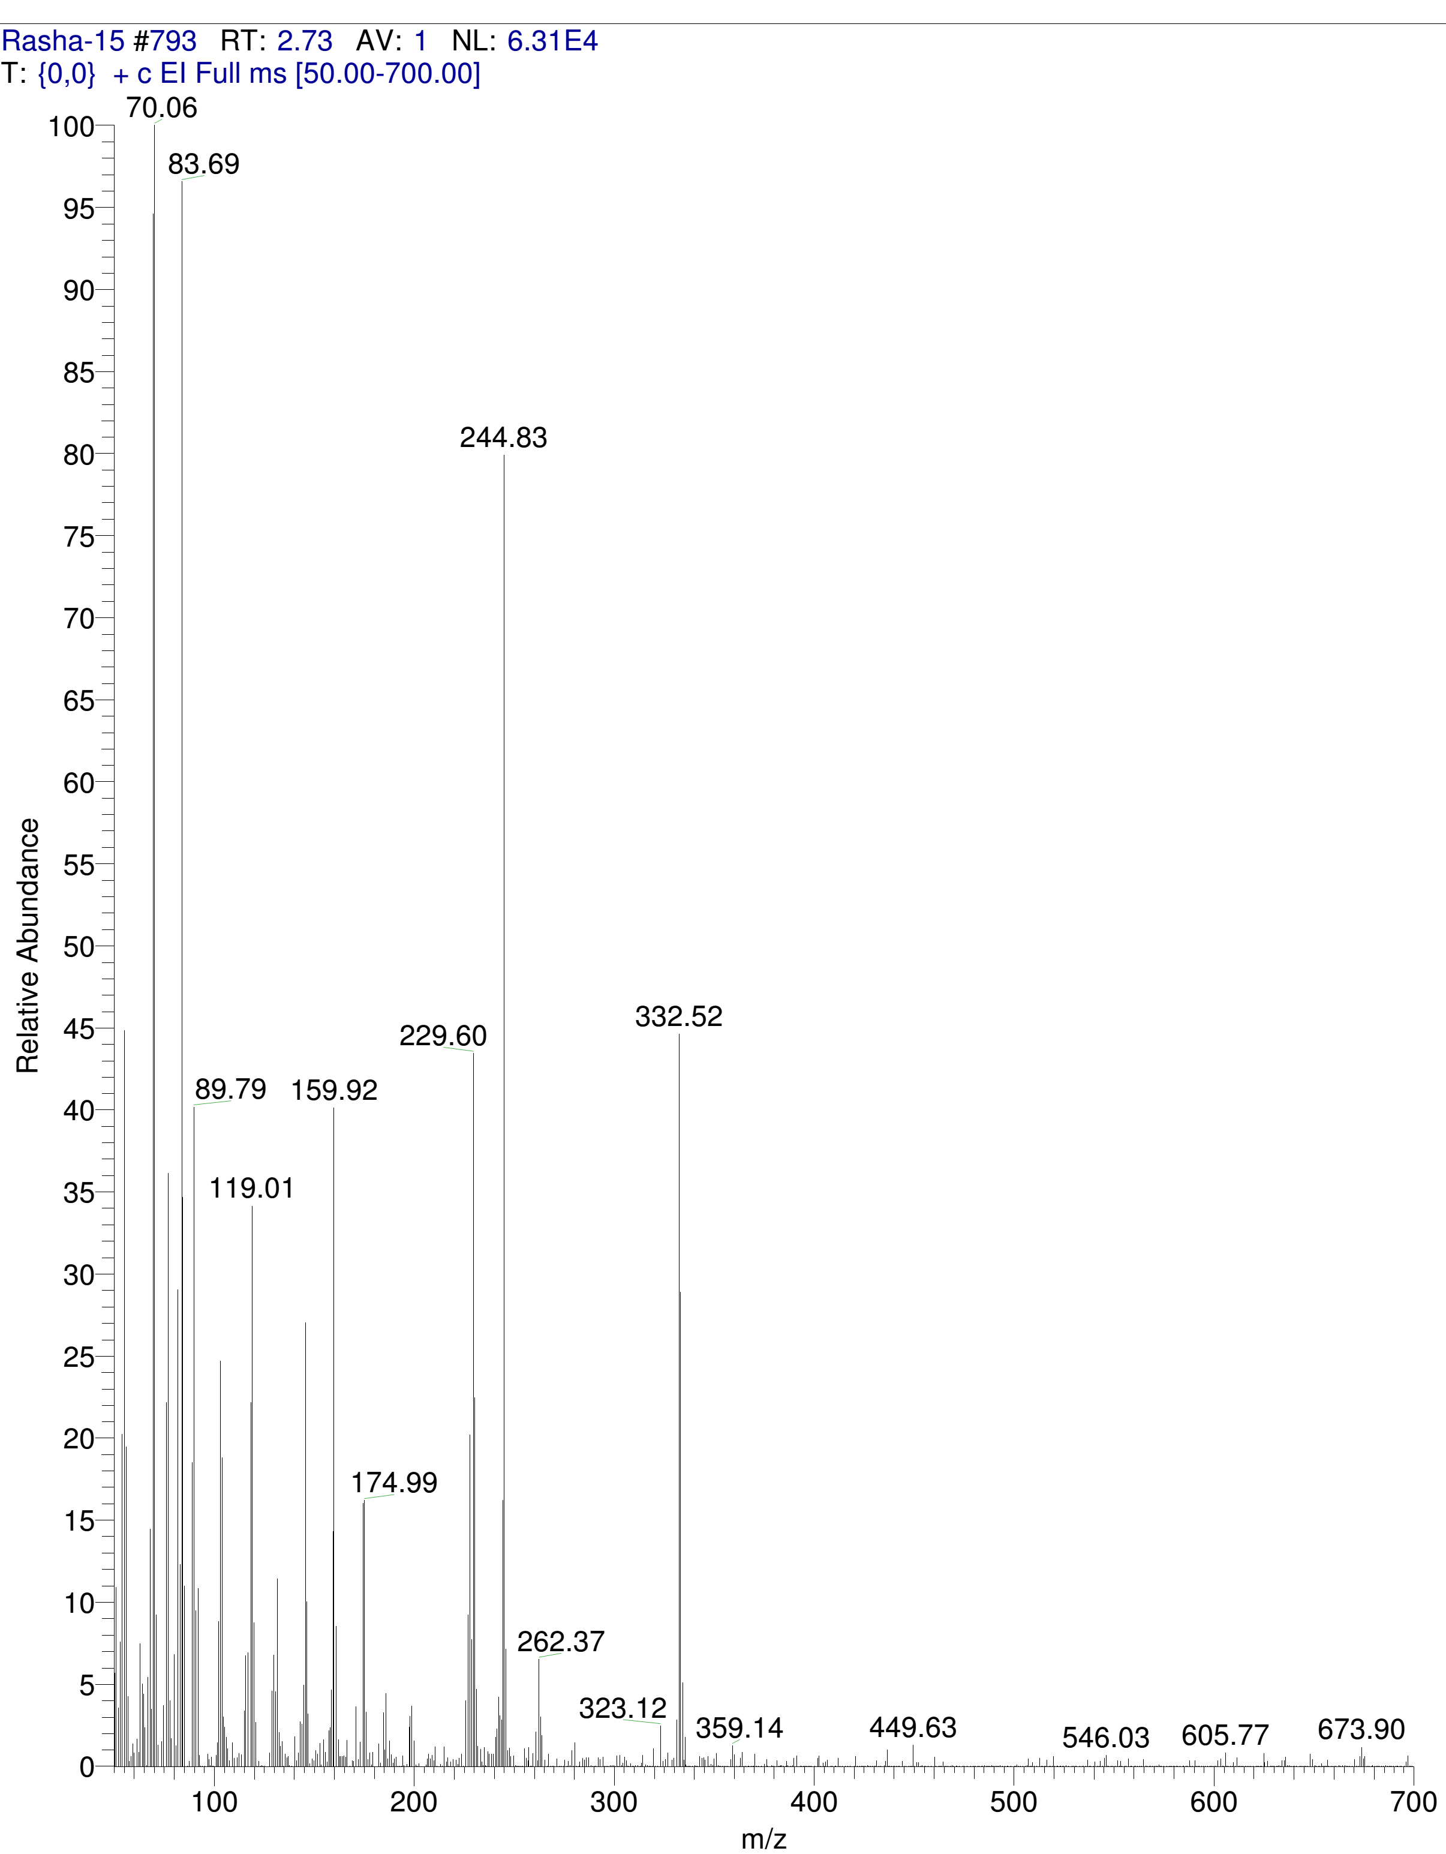
Mass spectrum for compound 15

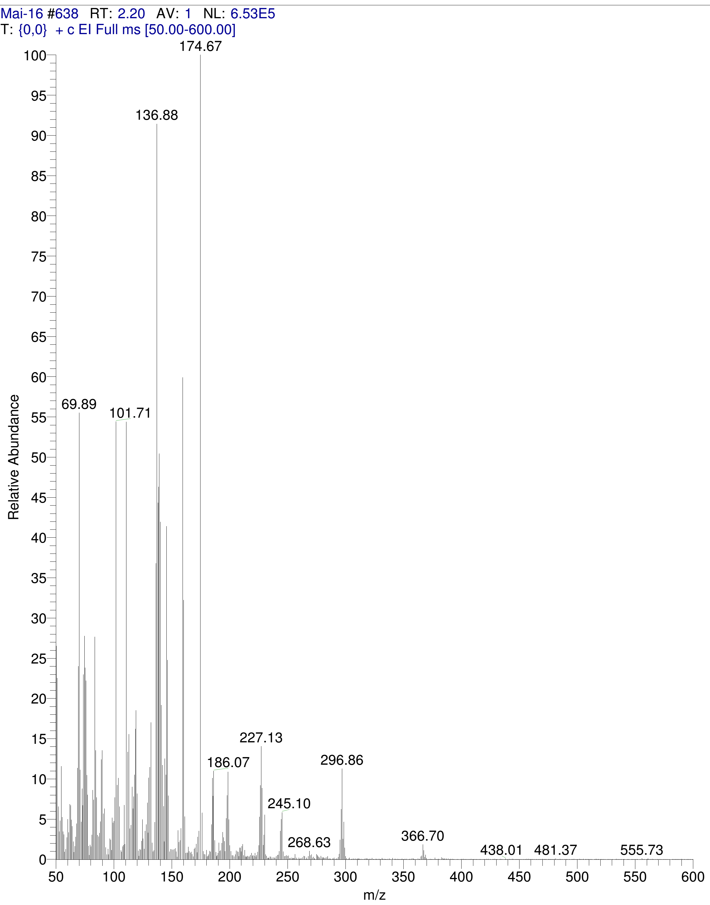
Mass spectrum for compound 16

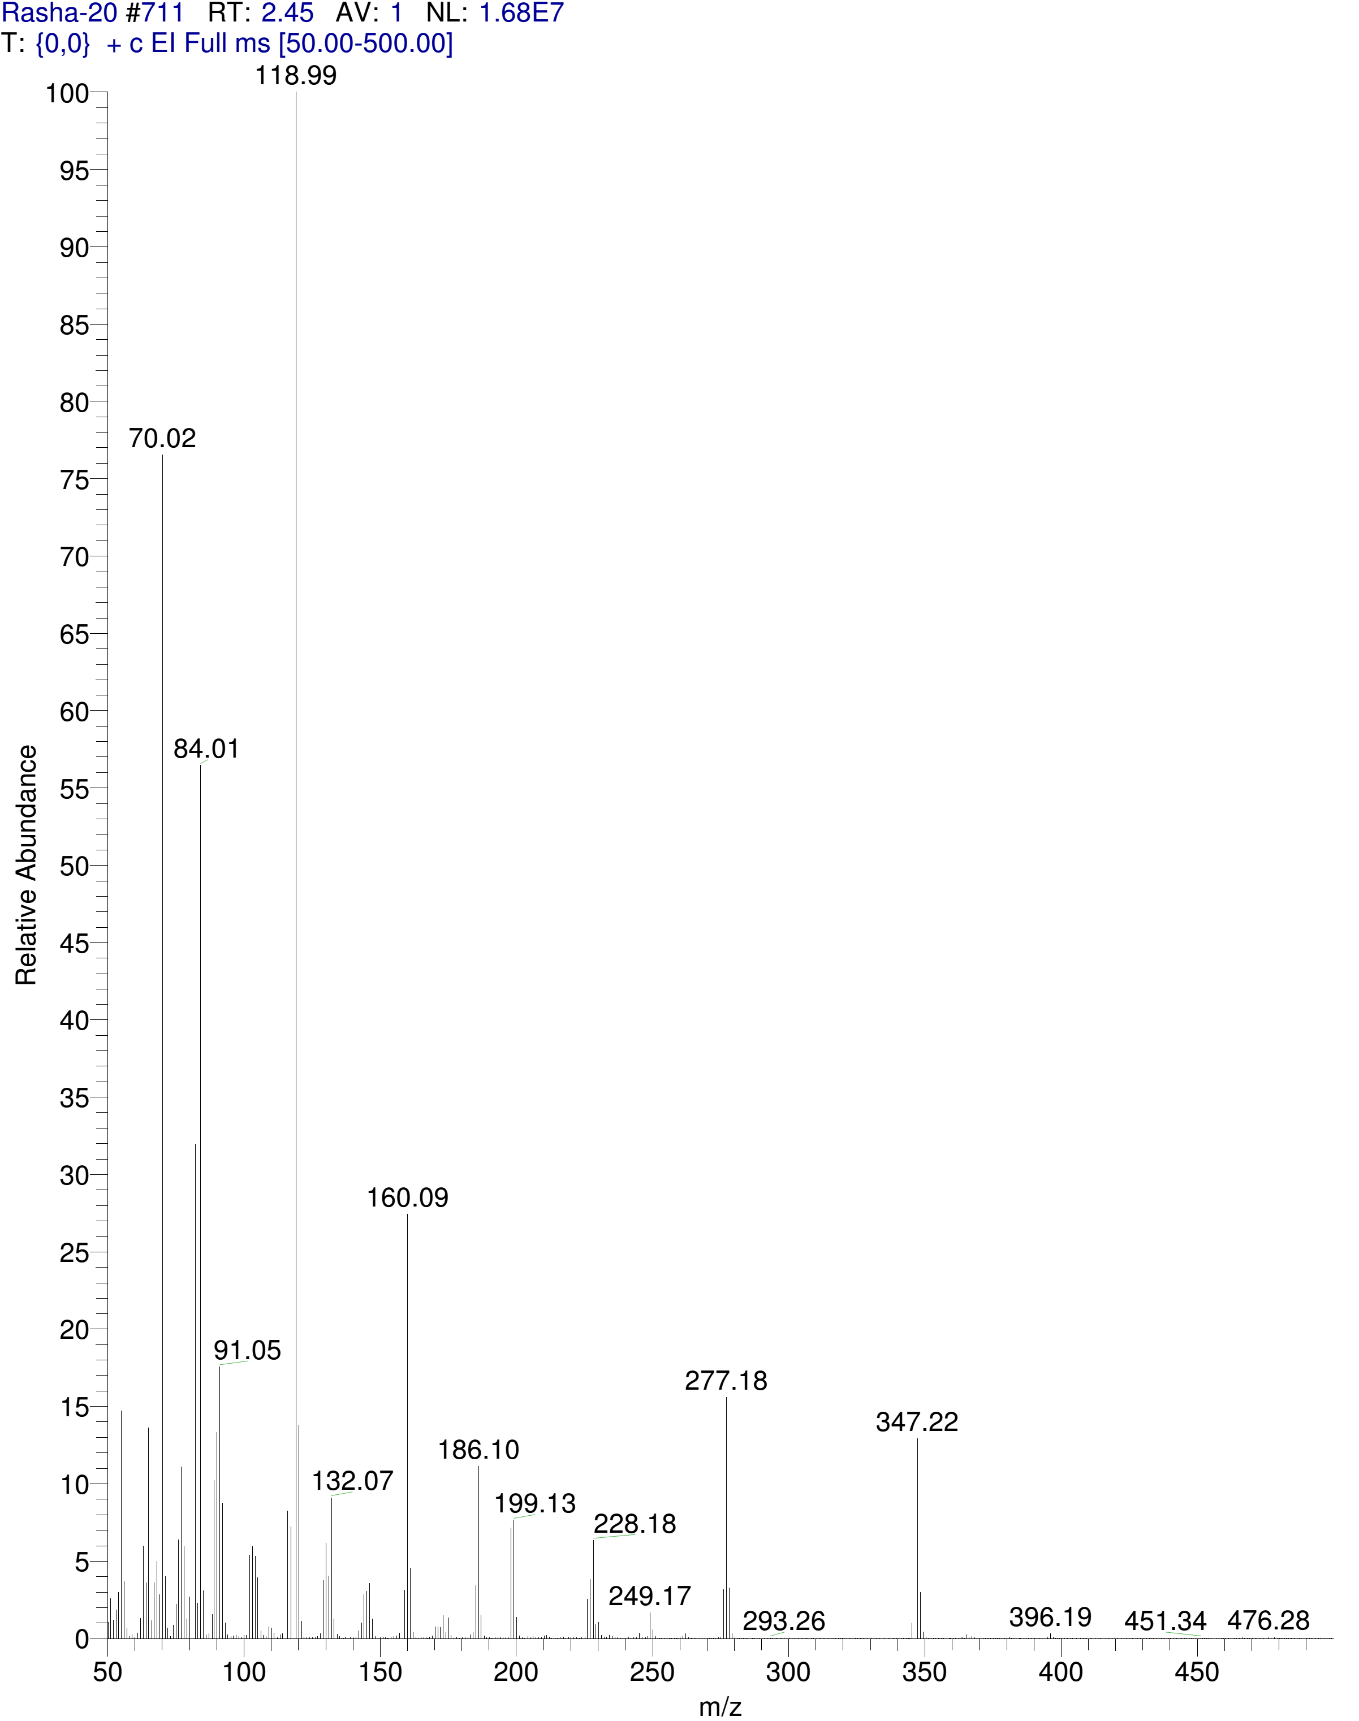
Mass spectrum for compound 17

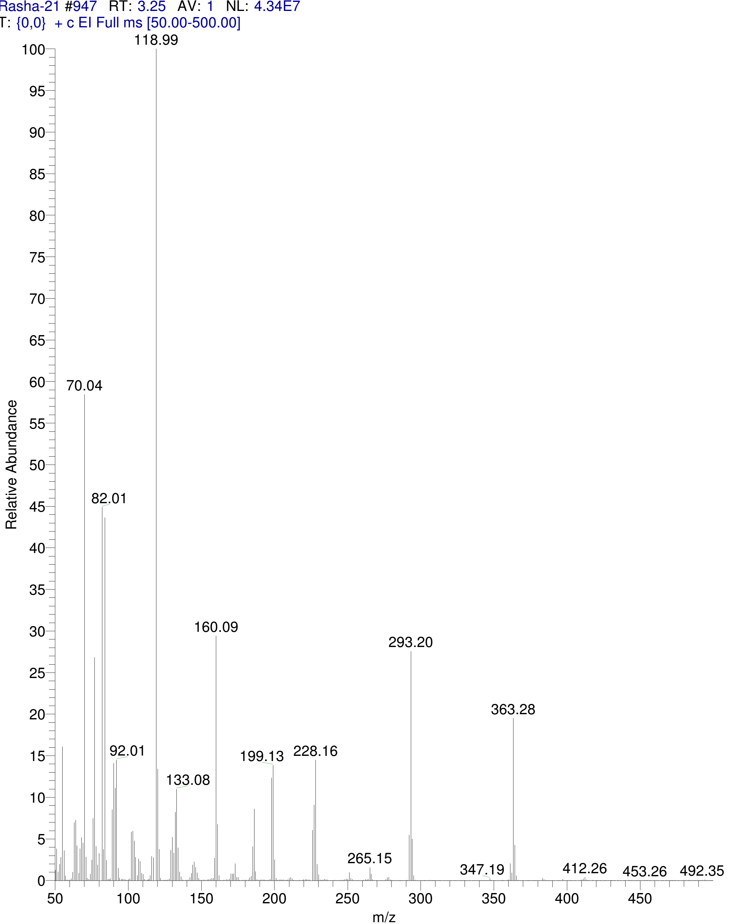
Mass spectrum for compound 18

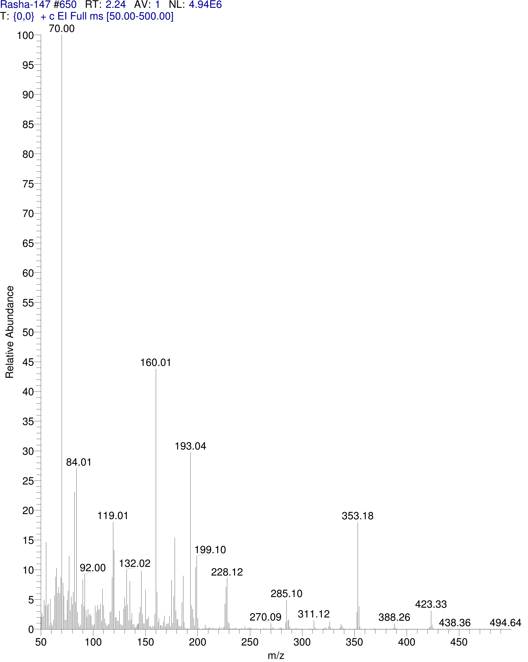
Mass spectrum for compound 19

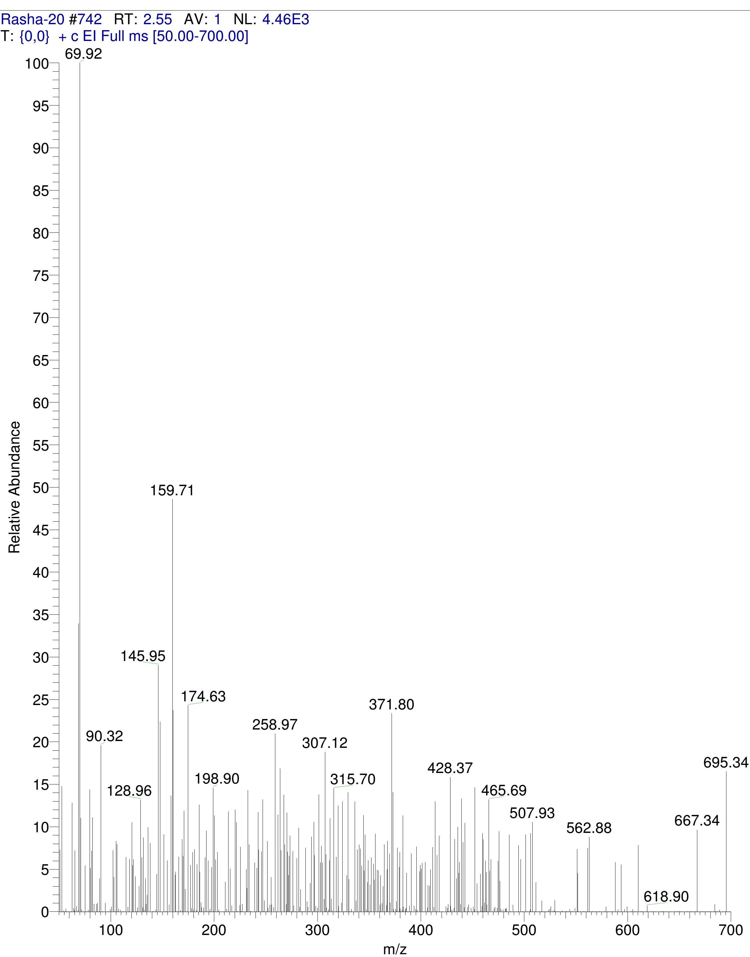
Mass spectrum for compound 20
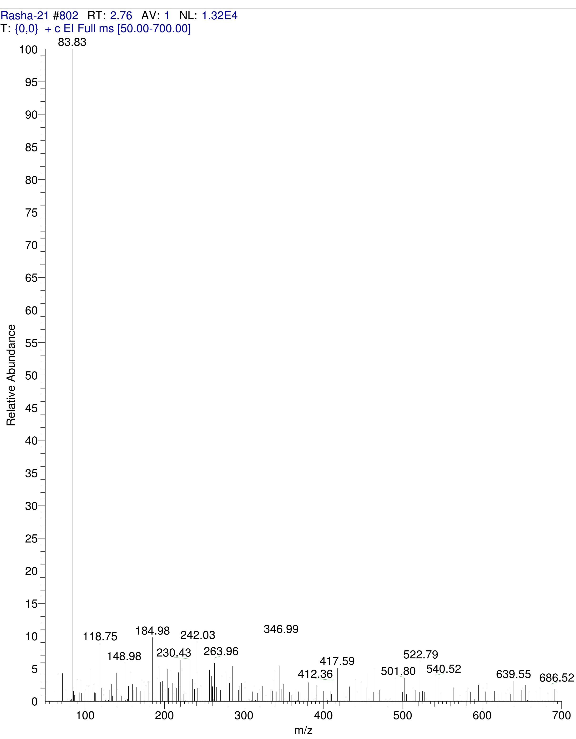
Mass spectrum for compound 21

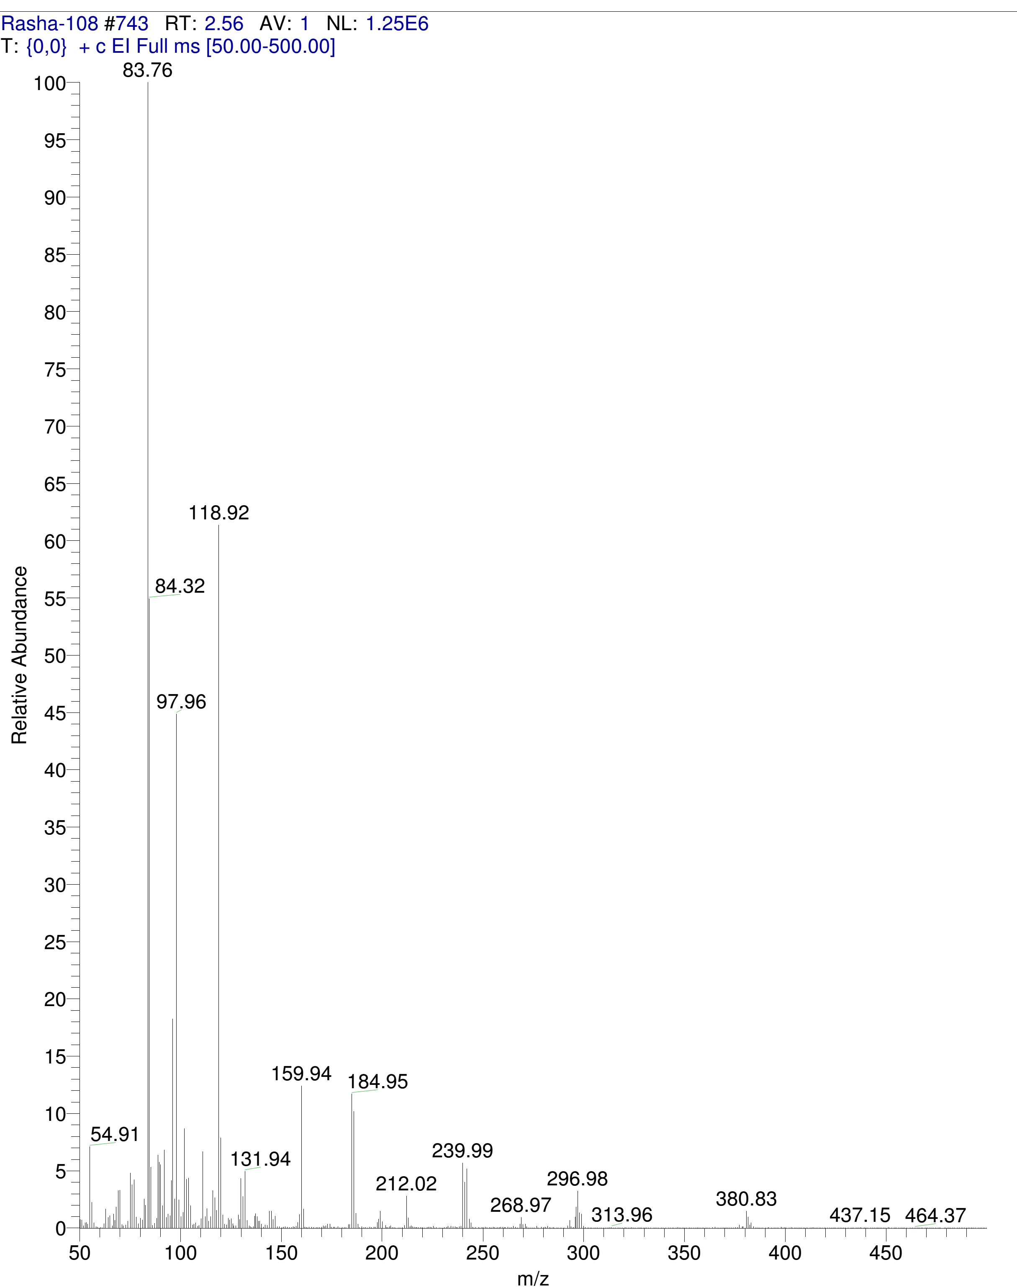
Mass spectrum for compound 22

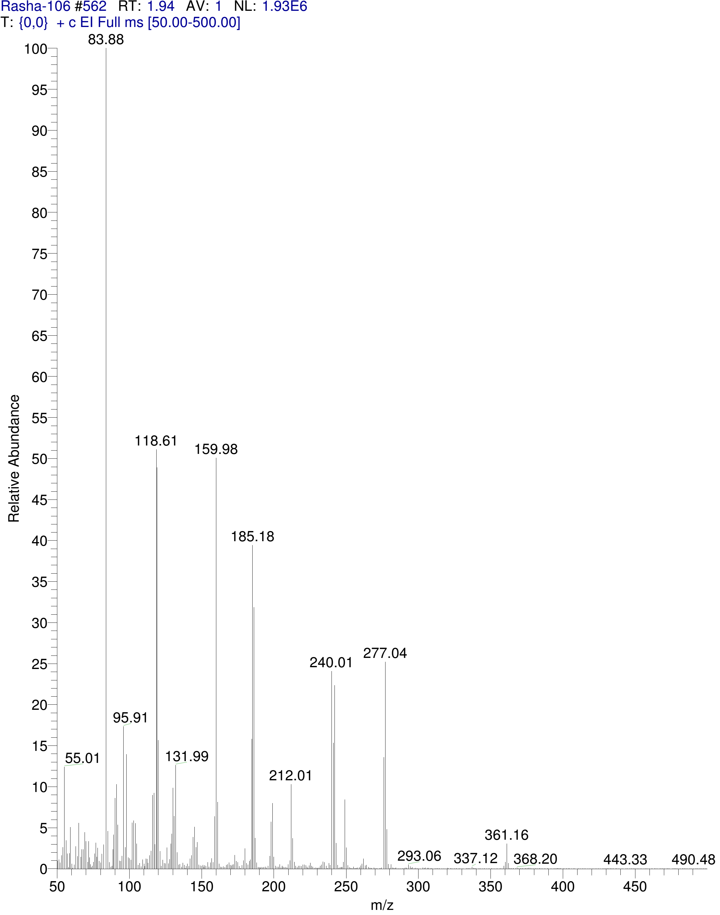
Mass spectrum for compound 23

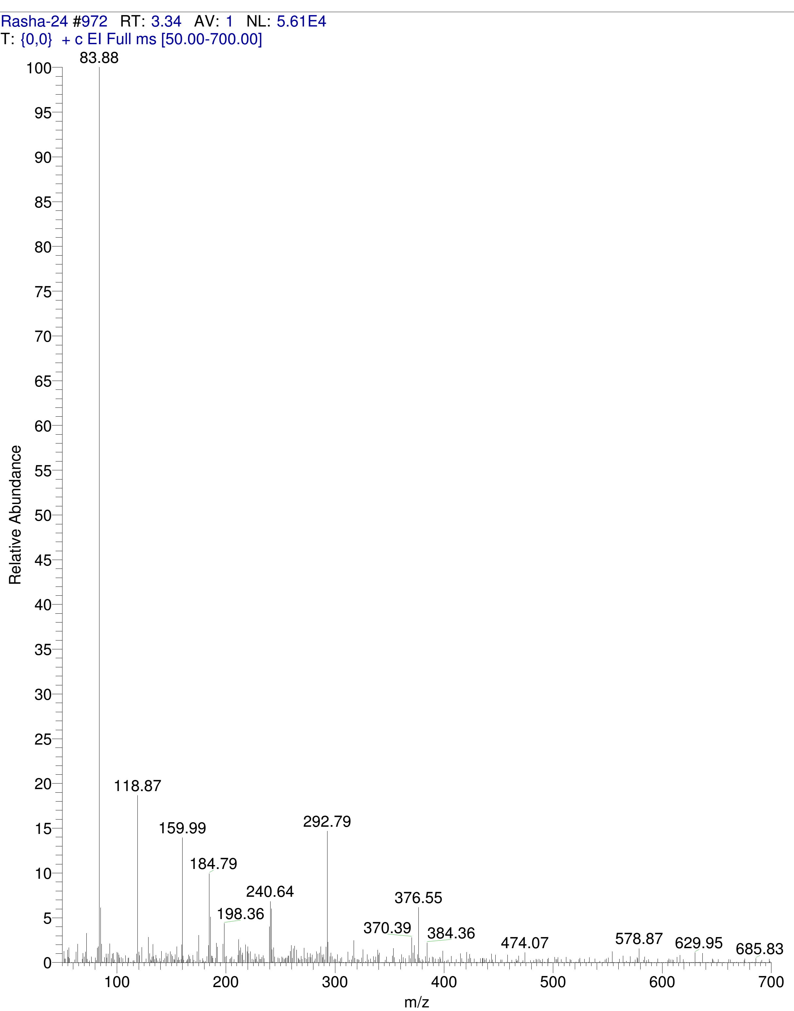
Mass spectrum for compound 24
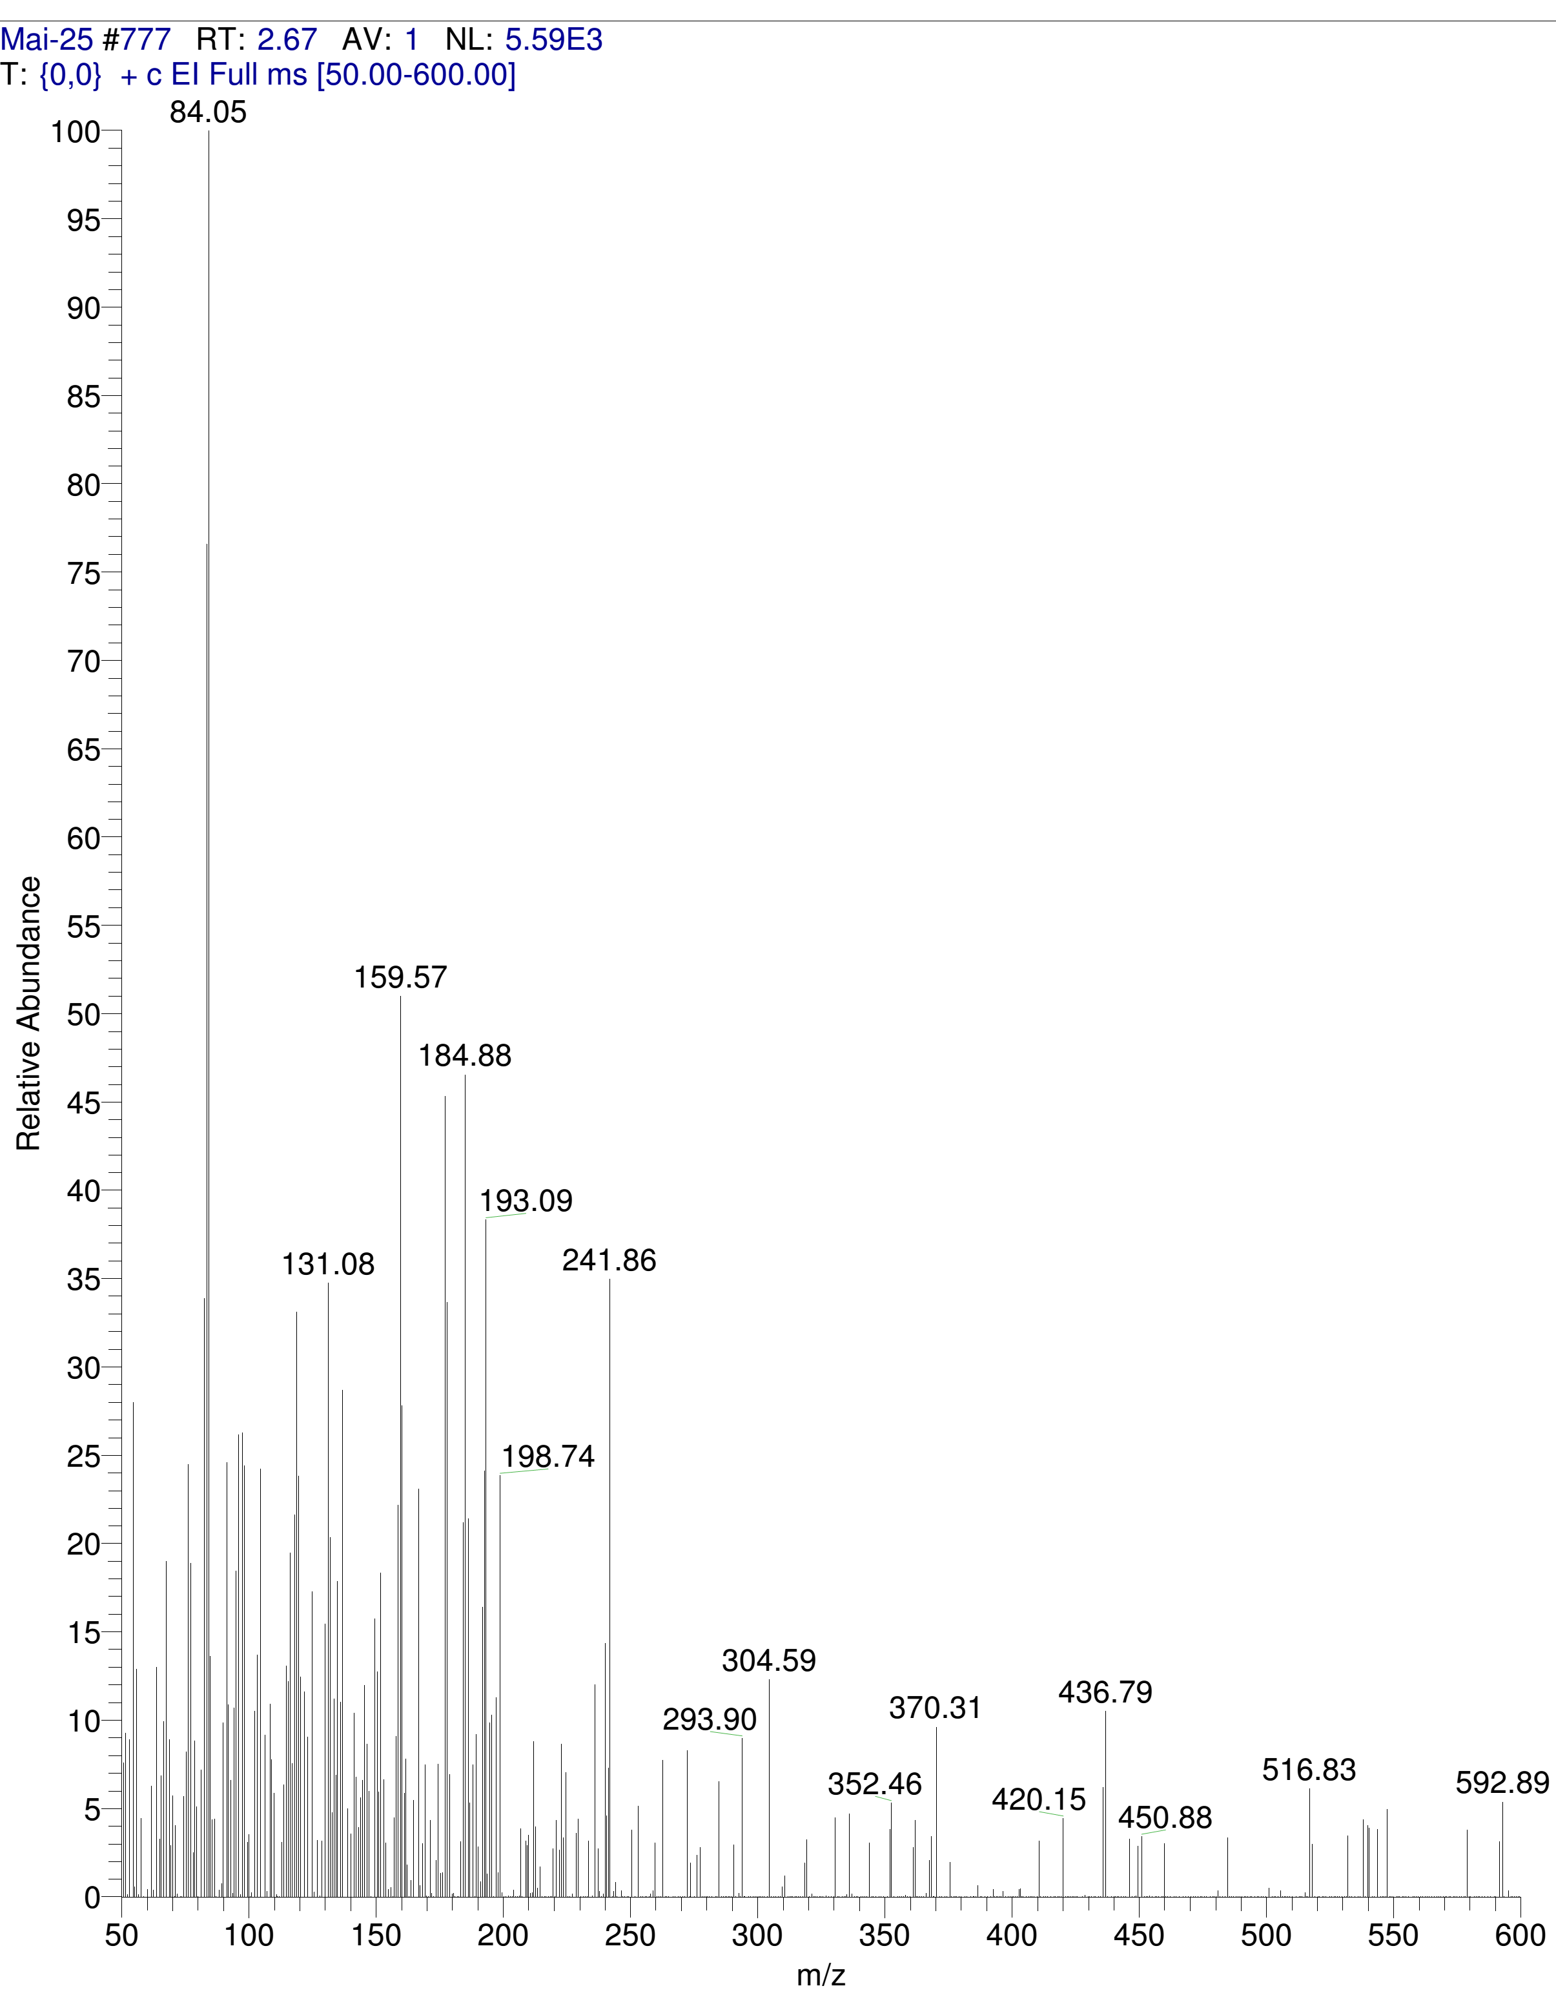
Mass spectrum for compound 25

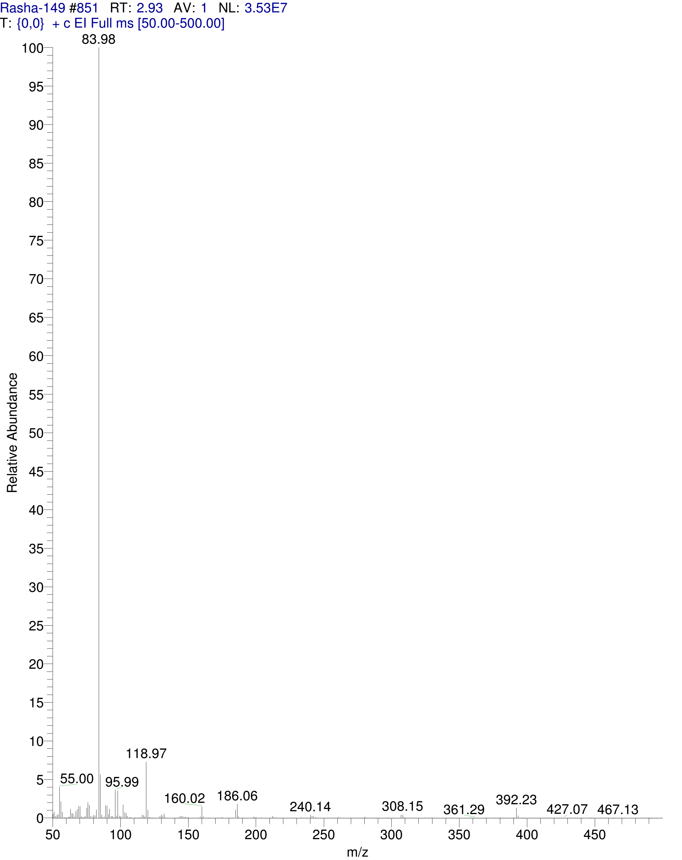
Mass spectrum for compound 26

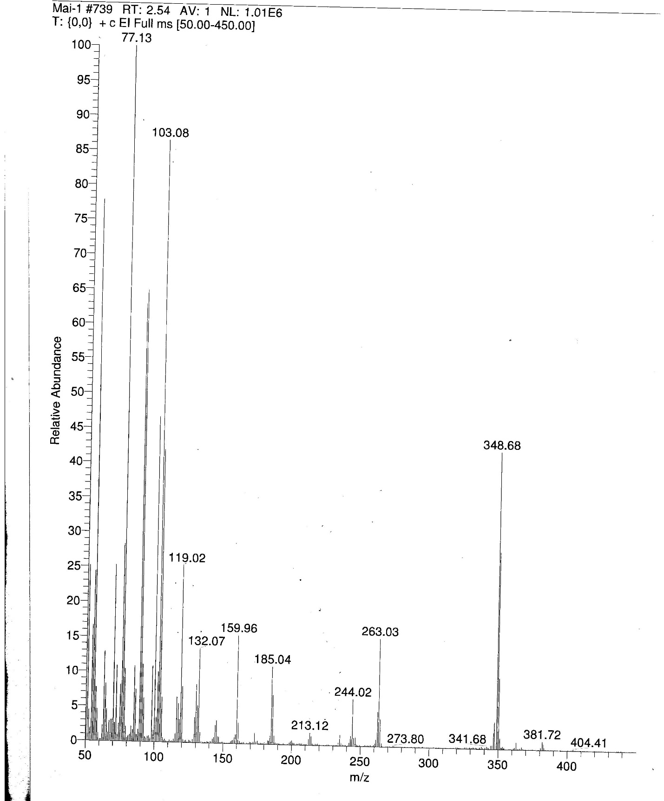
Mass spectrum for compound 27

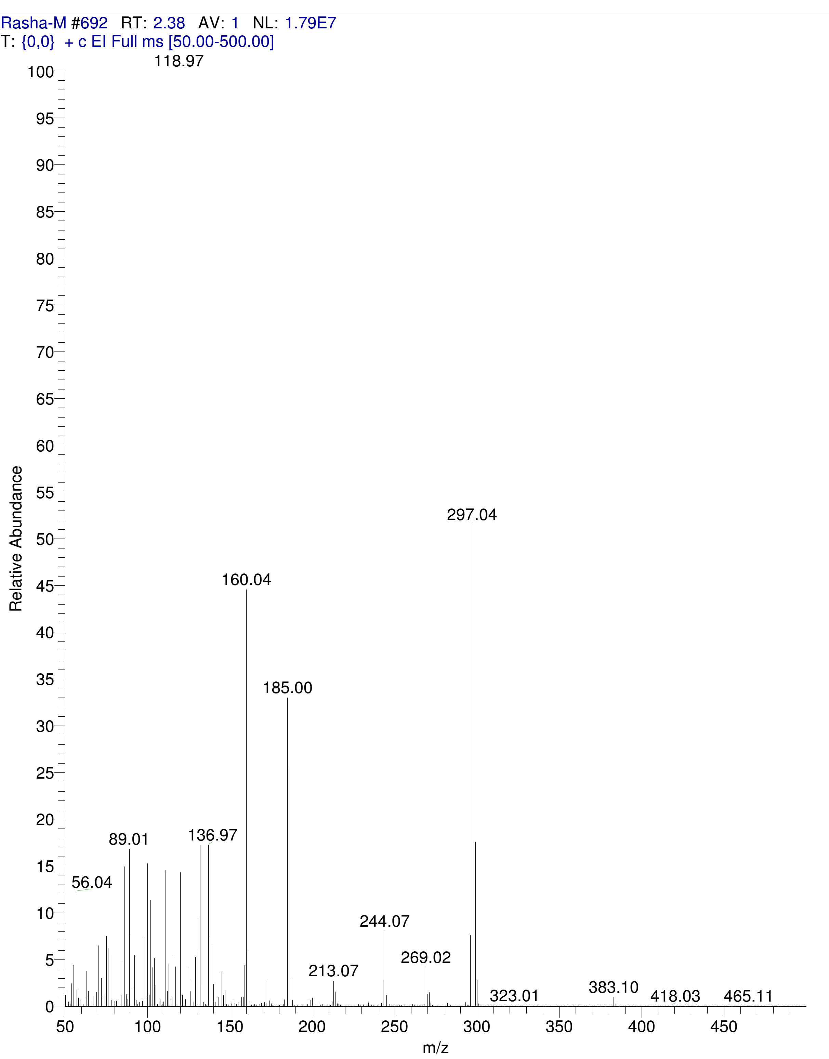
Mass spectrum for compound 28

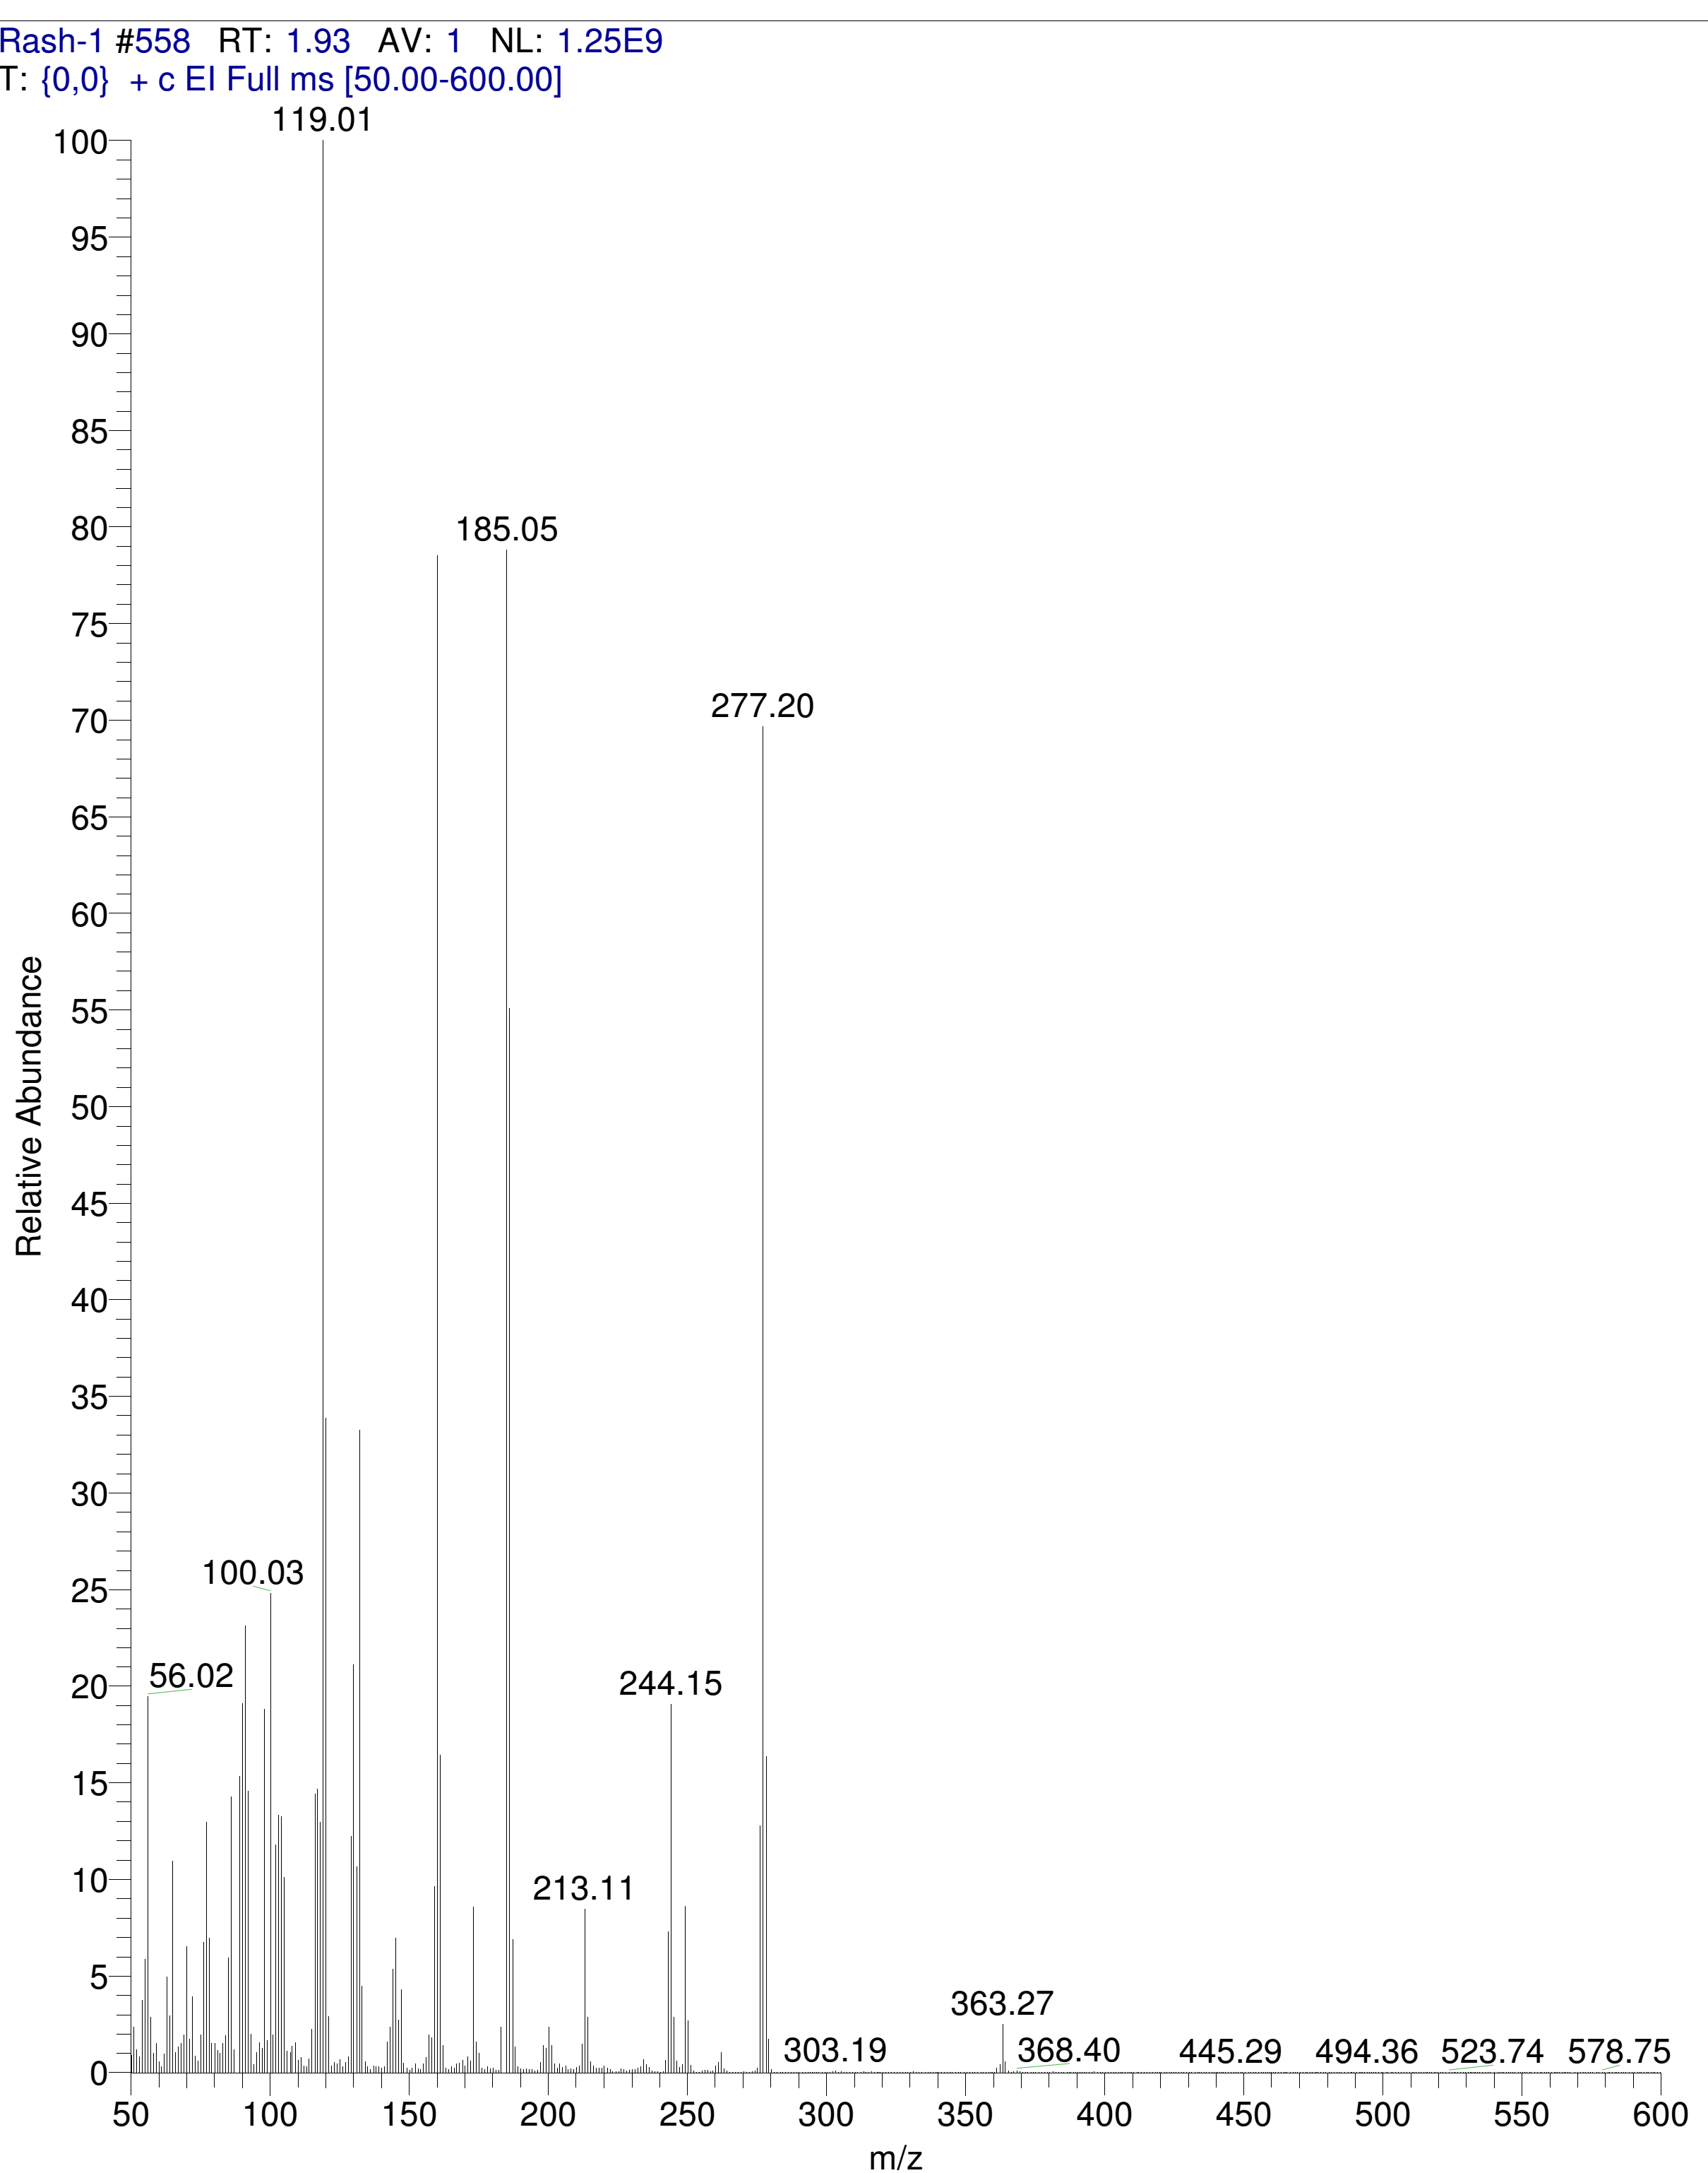
Mass spectrum for compound 29

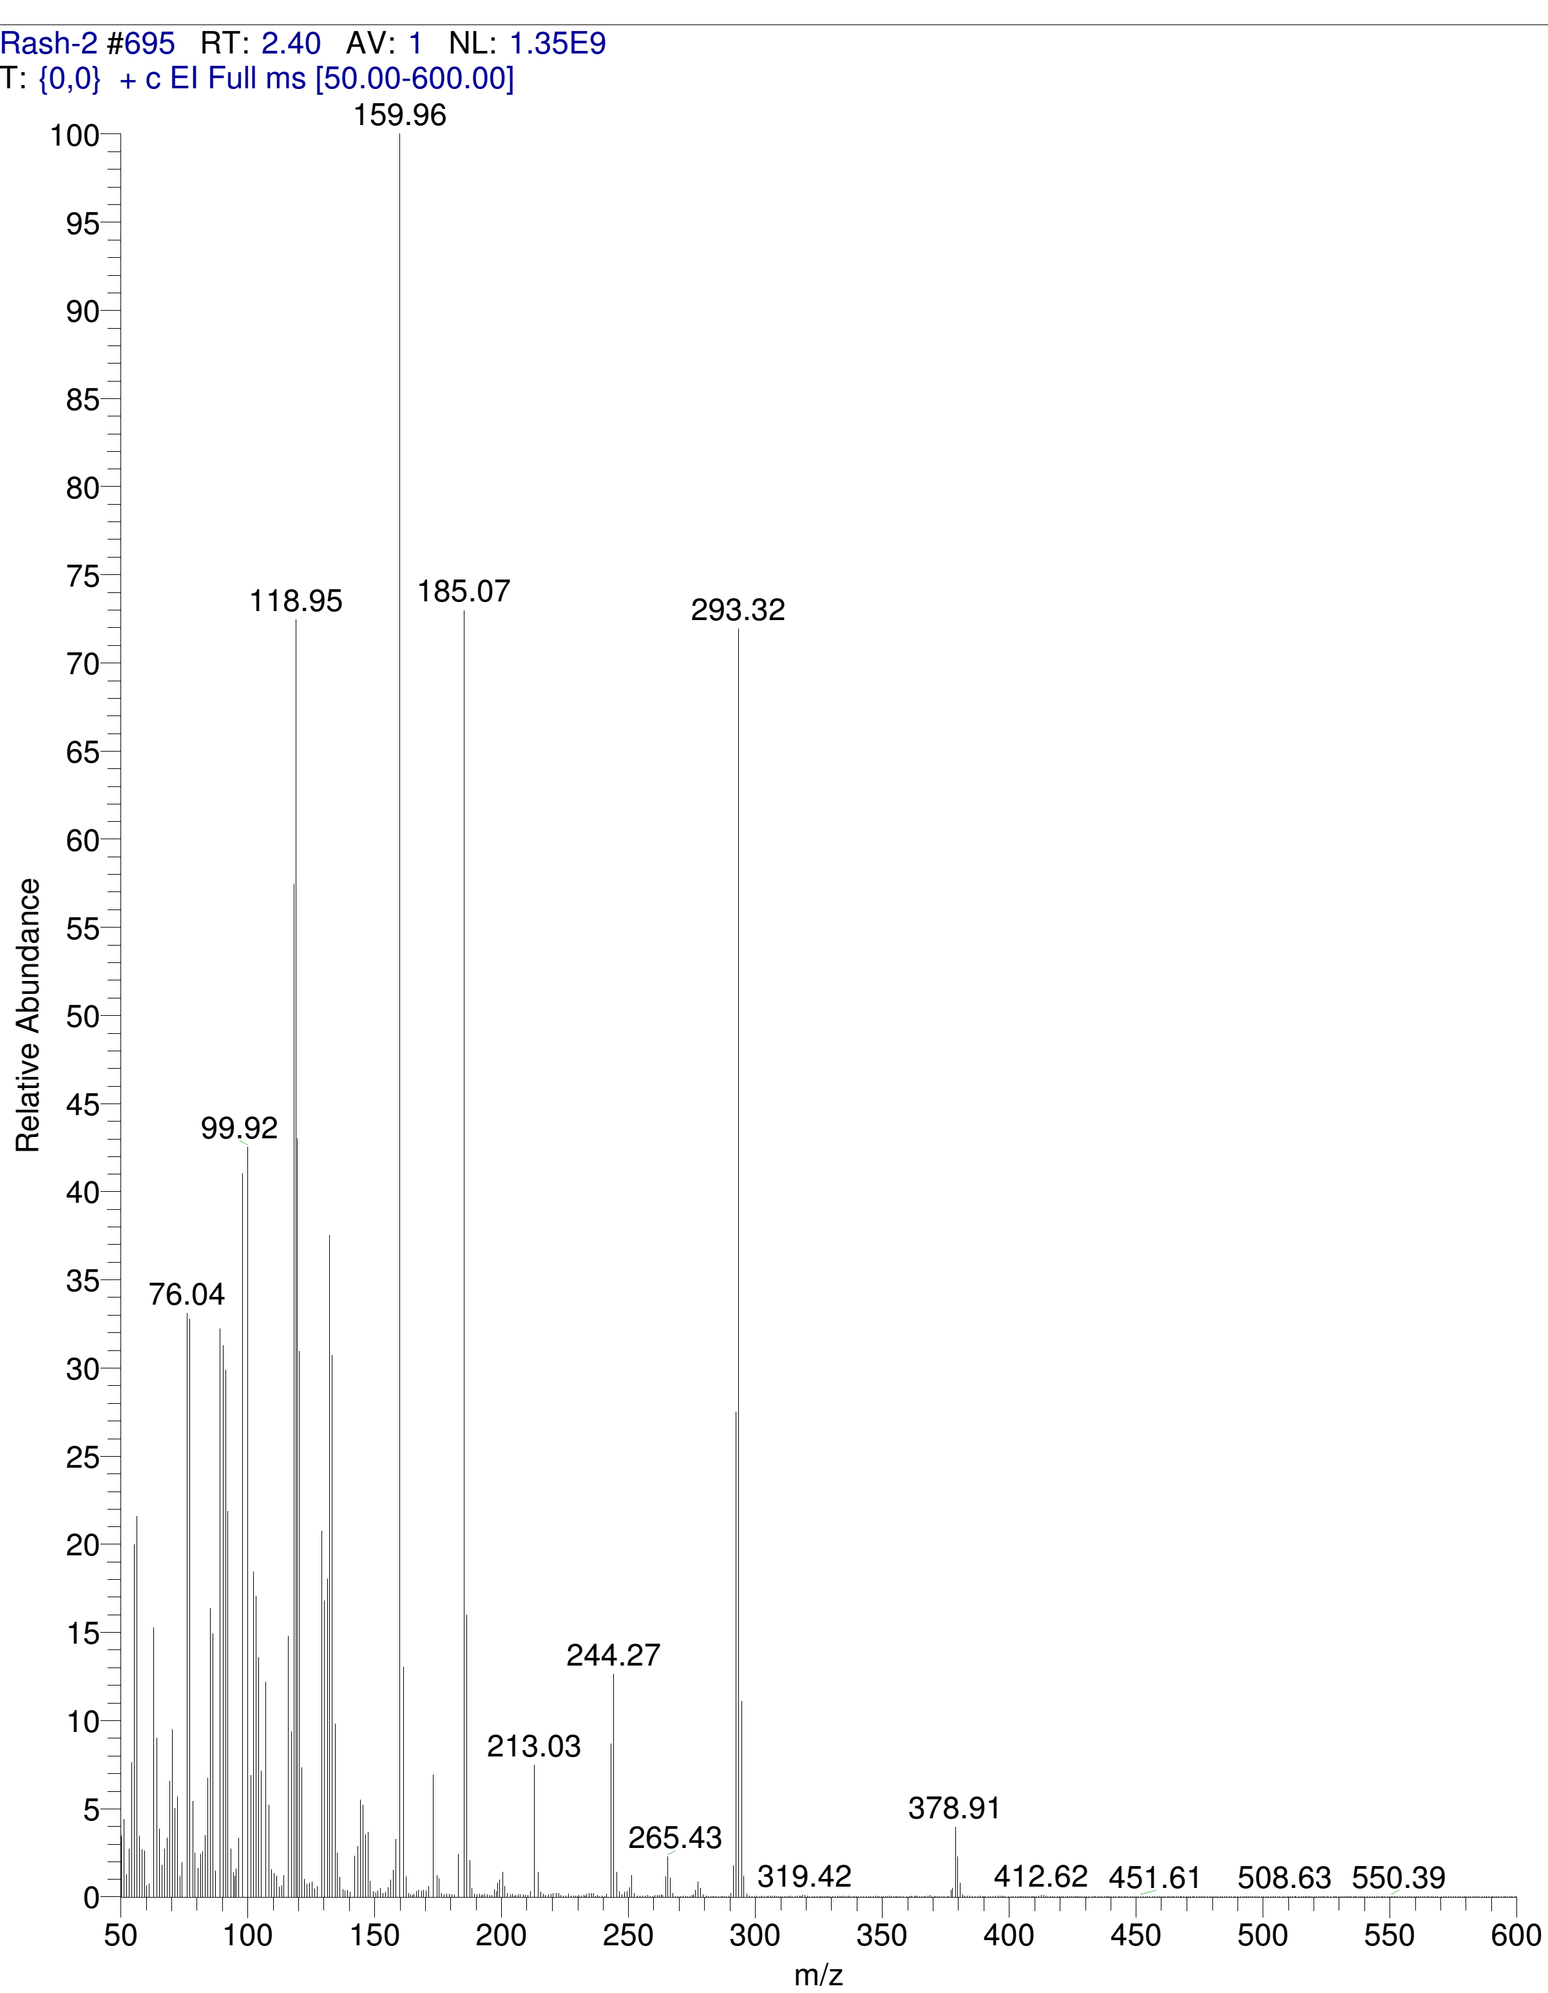
Mass spectrum for compound 30
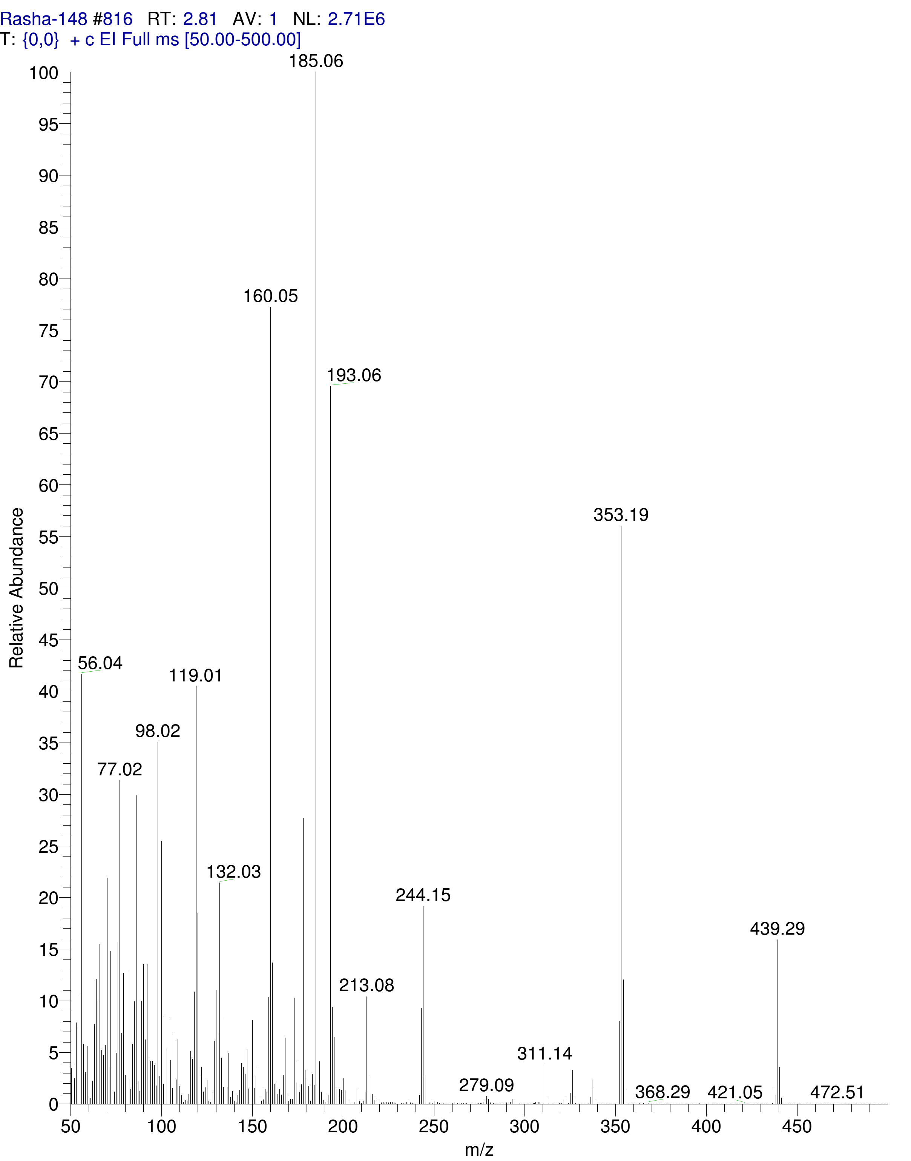
Mass spectrum for compound 31

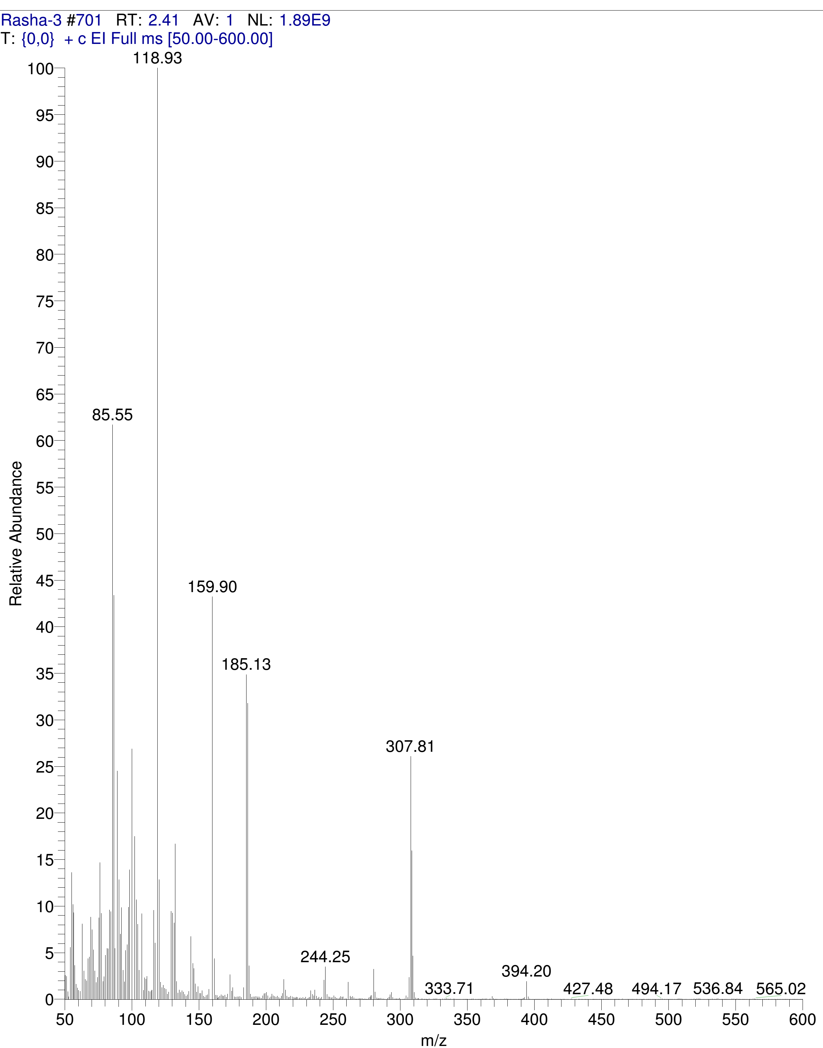

Mass spectrum for compound 32

HPLC chromatograms

Compound | Chromatogram
9
10
11
12
13
14
15
16
17
18
19
20
21
22
23
24
25
26
27
28
29
30
31
32

