Supplementary Material: Molecular-networking-guided isolation of newly discovered anticancer agents from Baltic cyanobacterium Nostoc edaphicum CCNP1411.

Robert Konkel^{1*}, Marta Cegłowska², Łukasz Grabowski³, Wiktoria Jeleniewska³, Monika Zielenkiewicz³, Katarzyna Gonera³, Grzegorz Węgrzyn³, Hanna Mazur-Marzec¹

¹ Department of Marine Biology and Biotechnology, Faculty of Oceanography and Geography, University of Gdansk, Marsz. J. Piłsudskiego 46, PL-81378 Gdynia, Poland
² Department of Marine Chemistry and Biochemistry, Institute of Oceanology, Polish Academy of Sciences, Powstanców Warszawy 55, PL-81712 Sopot, Poland
³ Department of Molecular Biology, Faculty of Biology, University of Gdansk, Wita Stwosza 59, 80-308 Gdańsk, Poland
* correspondence author, robert.konkel@ug.edu.pl

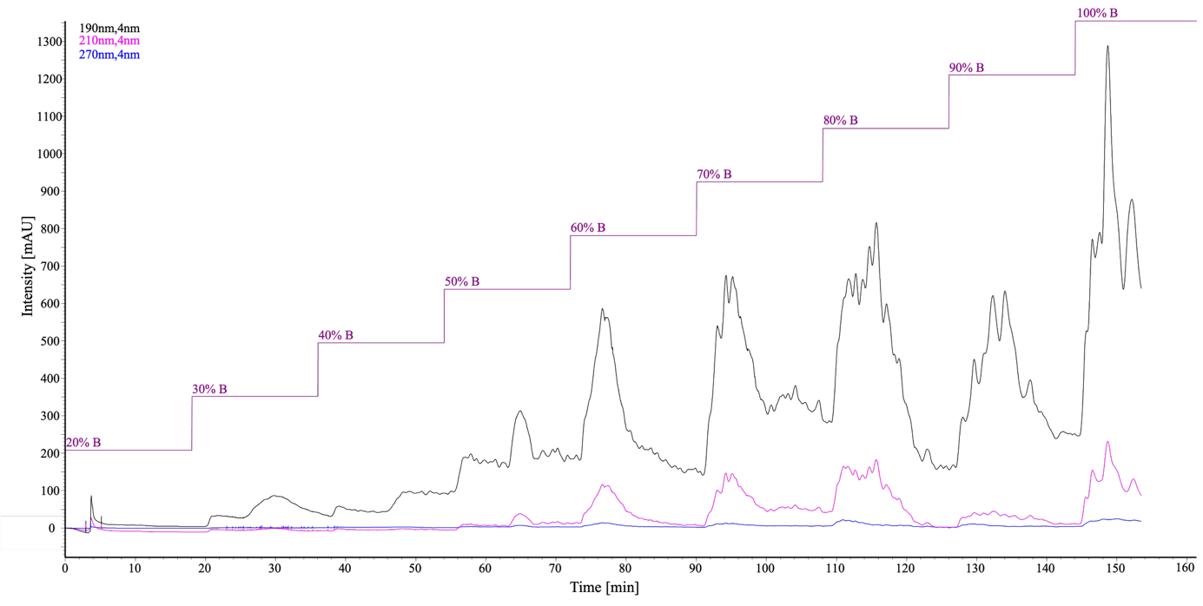
Fig. S1. Chromatogram (190, 210, 270 nm) of Nostoc edaphicum CCNP1411 methanolic extract separated by flash chromatography.

Tab. S1. Cell lines used in the study.
Cell lines |  | medium | purchase
A549 | lung cancer | F-12K | ECACC (Merck KGaA, Darmstadt, Germany)
PC3 | prostate cancer | DMEM | ECACC (Merck KGaA, Darmstadt, Germany)
T47D | breast cancer | RPMI | ECACC (Merck KGaA, Darmstadt, Germany)
HeLa | cervical cancer | DMEM | ECACC (Merck KGaA, Darmstadt, Germany)
C33-A | cervical cancer | DMEM | ATCC (Manassas, VA, USA)
SiHa | cervical cancer | IMEM | ATCC (Manassas, VA, USA)
CaSki | cervical cancer | RPMI | ATCC (Manassas, VA, USA)
SH-SY5Y | neuroblastoma | DMEM/F-12 | ATCC (Manassas, VA, USA)
IMR-32 | neuroblastoma | DMEM | ATCC (Manassas, VA, USA)
HDFa | human dermal fibroblasts | DMEM | Cell Applications (Merck)
HDFc | human dermal fibroblasts | DMEM | Cell Applications (Merck)

Tab. S2. Lipid derivatives identified in the most bioactive fractions of Nostoc edaphicum CCNP1411 and selected for targeted cytotoxicity evaluation. Only compounds detected by LC-MS analysis and commercially available were purchased as analytical standards and tested individually using the MTT assay.
Compound Name | Catalog number | Producent | Molecular formula
Palmitelaidic Acid | BL3H9A3B256A-50MG | BLD Pharmatech | C₁₆H₃₀O₂
Palmitic acid | P0500-10G | Sigma-Aldrich | C₁₆H₃₂O₂
1-Monolinolein | M7640-100MG | Sigma-Aldrich | C₂₁H₃₈O₄
Monoolein | M7765-25MG | Sigma-Aldrich | C₂₁H₄₀O₄
PE 18:1 | 846725P-25MG | Avanti | C₂₃H₄₆NO₇P
PE 16:0 | 856705P-25MG | Avanti | C₂₁H₄₄NO₇P
PE 14:0 | 856735P-25MG | Avanti | C₁₉H₄₀NO₇P

Tab. S3. IC₅₀ values of tested fractions determined in MTT assay on cancer cell lines (A549, C33-A, CaSki, PC3, SiHa, HeLa, T47D, SH-SY5Y), and human dermal fibroblasts (HDFa). Values represent mean IC₅₀ concentrations (µg/mL) ± SD (n = 3), determined by linear regression, n/a indicates fractions that were not analysed due to insufficient or negligible cytotoxic activity within the tested concentration range.
Sample | IC₅₀ [µg/mL]
Sample | A549 | C-33A | CaSki | PC3 | SiHa | HeLa | T47D | SH-SY5Y | IMR-32 | HDFc | HDFa
70% | 215.1 ± 12.9 | 188.9 ± 6.0 | 126.4 ± 3.2 | 214.2 ± 5.3 | 203.7 ± 3.9 | 240.1 ± 15.7 | n/a | 30.5 ± 6.1 | 5.2 ± 1.1 | n/a | n/a
80% | 89.8 ± 2.3 | 99.0 ± 0.3 | 1.2 ± 1.6 | 116.8 ± 5.0 | 103.2 ± 0.5 | 152.4 ± 3.5 | 71.0 ± 0.2 | 2.68 ± 1.7 | 4.0 ± 1.4 | 56.0 ± 14.8 | 202.1 ± 3.2
90% | 83.4 ± 0.5 | 77.1 ± 1.4 | 58.5 ± 2.2 | 87.5 ± 1.4 | 104.6 ± 0.9 | 60.1 ± 0.8 | 107.5 ± 2.9 | 45.1 ± 9.8 | 16.6 ± 2.5 | 95.1 ± 6.3 | 62.0 ± 2.1

Tab. S4. Heatmap of nostocyclopeptides present in Nostoc edaphicum CCNP1411 fractions. The table presents the peak area of the precursor ion for each compound. Colours indicate the relative abundance of the compounds. Previously unidentified analogues of NCPs are marked with an asterisk.
m/z | NCP | 20% | 30% | 40% | 50% | 60% | 70% | 80% | 90% | 100%
549.2671 | NCP 549* | 1.74E+03 | 4.39E+04 | 6.30E+04 | 5.44E+04 | 6.06E+04 | 5.00E+04 | 8.69E+03 | n.d. | n.d.
663.5027 | NCP 663* | 5.47E+03 | 1.95E+04 | 1.24E+04 | 2.98E+03 | 4.10E+03 | 1.87E+03 | n.d. | n.d. | n.d.
677.5582 | NCP E4L | 3.29E+02 | 3.36E+03 | 6.68E+03 | 2.41E+03 | 2.62E+03 | 5.45E+02 | 2.33E+02 | n.d. | n.d.
678.3248 | NCP 678* | n.d. | n.d. | 4.70E+03 | 1.48E+04 | 2.07E+04 | 5.02E+03 | 5.56E+02 | n.d. | n.d.
743.4074 | NCP E2 | 3.89E+02 | 1.15E+04 | 2.81E+04 | 4.61E+04 | 4.07E+03 | 1.40E+04 | n.d. | n.d. | n.d.
743.4092 | NCP E3 | n.d. | n.d. | 2.52E+02 | 1.29E+03 | 6.92E+02 | 9.56E+01 | n.d. | n.d. | n.d.
746.6050 | NCP 747* | n.d. | 6.16E+03 | 1.19E+04 | 4.21E+03 | n.d. | 2.40E+03 | n.d. | n.d. | n.d.
757.4249 | NCP A1 | 5.71E+02 | 2.04E+04 | 5.22E+04 | 1.03E+05 | 1.03E+05 | 3.08E+04 | 3.43E+03 | n.d. | n.d.
761.4201 | NCP E2L | 1.69E+03 | 8.62E+04 | 7.65E+04 | 9.66E+04 | 1.43E+04 | 3.47E+04 | 4.48E+02 | n.d. | n.d.
775.4522 | NCP A1L | 1.14E+03 | 2.96E+04 | 6.41E+03 | 7.49E+03 | 2.78E+03 | 2.69E+03 | 1.88E+03 | n.d. | n.d.
777.3956 | NCP E1 | n.d. | 4.37E+03 | 2.95E+04 | 7.14E+04 | 1.48E+04 | 1.76E+04 | n.d. | n.d. | n.d.
781.3897 | NCP 781* | n.d. | 1.35E+03 | 2.72E+03 | 1.11E+03 | n.d. | 4.21E+02 | n.d. | n.d. | n.d.
785.4206 | NCP 785* | n.d. | n.d. | 4.96E+01 | 1.80E+03 | 5.53E+02 | n.d. | n.d. | n.d. | n.d.
791.4070 | NCP A2 | 1.37E+03 | 3.42E+04 | 8.43E+04 | 2.00E+05 | 2.61E+05 | 7.92E+04 | 1.83E+04 | n.d. | n.d.
793.4238 | NCP 793* | n.d. | 5.96E+02 | 2.17E+04 | 8.16E+03 | 6.86E+03 | 2.96E+03 | n.d. | n.d. | n.d.
795.4060 | NCP 795* | n.d. | 6.78E+03 | 6.62E+03 | 3.65E+03 | 2.73E+03 | 2.65E+03 | 4.61E+02 | n.d. | n.d.
795.4336 | NCP E1L | 3.45E+03 | 1.65E+05 | 2.24E+05 | 2.26E+05 | 2.70E+04 | 1.34E+05 | 1.10E+03 | n.d. | n.d.
797.4100 | NCP 797* | n.d. | n.d. | 3.85E+02 | 1.93E+02 | n.d. | n.d. | n.d. | n.d. | n.d.
809.4423 | NCP A2L | 5.96E+03 | 2.53E+05 | 4.84E+05 | 6.34E+05 | 3.44E+05 | 3.85E+05 | 8.89E+04 | 6.02E+02 | 1.23E+03
839.4309 | NCP 821 | n.d. | 5.39E+02 | 3.93E+03 | 9.82E+02 | 5.18E+02 | n.d. | n.d. | 5.39E+02 | 3.93E+03

Tab. S5. Heatmap of cyanopeptolins present in Nostoc edaphicum CCNP1411 fractions. The table was divided based on the amino acids in the second position of the cyanopeptolin structure. It presents the peak area of the precursor ion for each compound. Colours indicate the relative abundance of the compounds.
m/z | CP-Arg | 20% | 30% | 40% | 50% | 60% | 70% | 80% | 90% | 100%
935.4628 | CP934 | n.d. | n.d. | 6.46E+02 | 3.59E+03 | 1.98E+04 | 3.81E+03 | 2.13E+04 | n.d. | n.d.
945.5042 | CP944 | n.d. | n.d. | n.d. | 7.19E+02 | 3.21E+02 | n.d. | n.d. | n.d. | n.d.
951.4575 | CP950 | n.d. | 9.12E+03 | 2.58E+04 | 5.80E+04 | 5.51E+02 | 1.45E+04 | n.d. | n.d. | n.d.
963.5140 | CP962 | n.d. | n.d. | n.d. | 1.72E+03 | 9.51E+03 | 5.28E+04 | 1.78E+05 | 1.60E+03 | n.d.
965.4736 | CP964 | n.d. | 2.35E+02 | 1.62E+03 | 8.57E+03 | 2.82E+04 | 4.11E+03 | 1.53E+04 | n.d. | n.d.
977.5094 | CP976 | n.d. | n.d. | n.d. | n.d. | n.d. | n.d. | 5.35E+03 | n.d. | n.d.
976.5257 | CP977 | n.d. | n.d. | n.d. | 5.16E+02 | 1.70E+03 | 2.93E+02 | 1.62E+03 | n.d. | n.d.
979.4896 | CP978 | 3.67E+02 | 3.03E+04 | 1.24E+05 | 3.31E+05 | 2.90E+05 | 2.04E+05 | 5.23E+03 | 1.25E+02 | 1.11E+03
981.4674 | CP980 | n.d. | n.d. | n.d. | 5.50E+02 | n.d. | n.d. | n.d. | n.d. | n.d.
991.5255 | CP990 | n.d. | n.d. | n.d. | n.d. | n.d. | 8.78E+02 | 7.39E+04 | 2.01E+03 | n.d.
993.5047 | CP992b | n.d. | n.d. | n.d. | 5.77E+02 | 1.23E+03 | 1.95E+03 | n.d. | n.d. | n.d.
993.5390 | CP992 | n.d. | n.d. | n.d. | 1.27E+03 | 2.31E+04 | 6.20E+04 | 1.75E+05 | 1.00E+03 | n.d.
995.4842 | CP992c | n.d. | 5.88E+02 | 1.80E+03 | 4.51E+03 | n.d. | 1.26E+03 | n.d. | n.d. | n.d.
1005.5412 | CP1005b | n.d. | n.d. | n.d. | n.d. | n.d. | n.d. | 9.49E+03 | n.d. | n.d.
1007.5202 | CP1006b | n.d. | n.d. | 4.88E+01 | 5.85E+02 | 2.02E+03 | 2.09E+02 | 2.76E+03 | n.d. | n.d.
1007.5662 | CP1006 | n.d. | n.d. | n.d. | 6.57E+02 | 1.25E+04 | 6.41E+03 | 9.40E+04 | 9.41E+01 | n.d.
1009.4997 | CP1008 | n.d. | n.d. | 1.17E+02 | 1.72E+03 | 2.64E+03 | 2.26E+03 | n.d. | n.d. | n.d.
1019.5572 | CP1018 | n.d. | n.d. | n.d. | n.d. | n.d. | n.d. | 6.05E+03 | 1.04E+04 | n.d.
1021.5364 | CP1020b | n.d. | n.d. | n.d. | n.d. | n.d. | 7.72E+02 | 7.78E+04 | 9.91E+02 | n.d.
1021.5364 | CP1020 | n.d. | n.d. | n.d. | 3.12E+02 | 3.28E+02 | 3.56E+02 | 1.64E+03 | n.d. | n.d.
1035.5519 | CP1034b | n.d. | n.d. | n.d. | n.d. | n.d. | n.d. | 8.22E+03 | n.d. | n.d.
1035.5523 | CP1034 | n.d. | n.d. | n.d. | n.d. | n.d. | n.d. | 6.33E+03 | n.d. | n.d.
1049.5686 | CP1048 | n.d. | n.d. | n.d. | n.d. | n.d. | n.d. | 6.74E+03 | n.d. | n.d.
m/z | CP-Leu | 20% | 30% | 40% | 50% | 60% | 70% | 80% | 90% | 100%
717.3972 | CP734 | n.d. | n.d. | n.d. | n.d. | n.d. | 1.68E+03 | n.d. | n.d. | n.d.
733.3924 | CP750b | n.d. | n.d. | n.d. | n.d. | 1.60E+03 | 7.80E+02 | n.d. | n.d. | n.d.
874.4358 | CP891 | n.d. | n.d. | n.d. | n.d. | n.d. | 7.90E+03 | n.d. | n.d. | n.d.
890.4300 | CP907 | n.d. | n.d. | n.d. | 9.63E+02 | 3.04E+03 | n.d. | n.d. | n.d. | n.d.
902.4662 | CP919 | n.d. | n.d. | n.d. | n.d. | n.d. | 7.83E+04 | 1.45E+03 | n.d. | n.d.
904.4451 | CP921 | n.d. | n.d. | n.d. | n.d. | 1.41E+03 | 6.69E+03 | n.d. | n.d. | n.d.
916.4825 | CP933 | n.d. | n.d. | n.d. | n.d. | n.d. | 1.46E+03 | n.d. | n.d. | n.d.
918.4611 | CP935 | n.d. | n.d. | n.d. | 3.52E+02 | 5.49E+04 | 1.37E+03 | n.d. | n.d. | 4.72E+01
930.4983 | CP947 | n.d. | n.d. | n.d. | n.d. | n.d. | 7.92E+02 | 1.39E+04 | n.d. | n.d.
932.4770 | CP949 | n.d. | n.d. | n.d. | n.d. | n.d. | 7.41E+04 | 7.22E+02 | n.d. | n.d.
946.4926 | CP963 | n.d. | n.d. | n.d. | n.d. | 6.01E+01 | 2.58E+04 | n.d. | n.d. | n.d.
948.4700 | CP963b | n.d. | n.d. | n.d. | n.d. | n.d. | 6.77E+02 | n.d. | n.d. | n.d.
960.5071 | CP997b | n.d. | n.d. | n.d. | n.d. | n.d. | 4.14E+02 | n.d. | n.d. | n.d.
960.5084 | CP977 | n.d. | n.d. | n.d. | n.d. | n.d. | 2.73E+03 | 1.18E+04 | n.d. | n.d.
974.5237 | CP991 | n.d. | n.d. | n.d. | n.d. | n.d. | 5.76E+02 | 4.47E+02 | n.d. | n.d.
m/z | CP-MeLeu | 20% | 30% | 40% | 50% | 60% | 70% | 80% | 90% | 100%
932.4768 | CP949b | n.d. | n.d. | n.d. | n.d. | 5.11E+02 | 4.56E+01 | n.d. | n.d. | n.d.
946.4934 | CP963b | n.d. | n.d. | n.d. | n.d. | n.d. | 1.40E+03 | n.d. | n.d. | n.d.
m/z | CP-Phe | 20% | 30% | 40% | 50% | 60% | 70% | 80% | 90% | 100%
781.3928 | CP798 | n.d. | n.d. | n.d. | n.d. | n.d. | 1.60E+03 | n.d. | n.d. | n.d.
908.4205 | CP925 | n.d. | n.d. | n.d. | n.d. | n.d. | 2.64E+03 | n.d. | n.d. | n.d.
936.4401 | CP953 | n.d. | n.d. | n.d. | n.d. | 4.71E+01 | 5.45E+04 | 7.32E+02 | n.d. | n.d.
938.4299 | CP955 | n.d. | n.d. | n.d. | n.d. | 3.53E+02 | 4.03E+03 | n.d. | n.d. | n.d.
946.4913 | CP963 | n.d. | n.d. | n.d. | n.d. | n.d. | 6.64E+02 | n.d. | n.d. | n.d.
952.4289 | CP969b | n.d. | n.d. | n.d. | 5.09E+02 | 3.19E+04 | 5.02E+02 | n.d. | n.d. | n.d.
966.4450 | CP983 | n.d. | n.d. | n.d. | n.d. | 5.13E+02 | 4.89E+04 | 4.77E+02 | n.d. | n.d.
966.4613 | CP981 | n.d. | n.d. | n.d. | n.d. | n.d. | 9.13E+02 | 8.19E+03 | n.d. | n.d.
980.4772 | CP997 | n.d. | n.d. | n.d. | n.d. | n.d. | 9.96E+03 | n.d. | n.d. | n.d.
994.4929 | CP1011 | n.d. | n.d. | n.d. | n.d. | n.d. | n.d. | 7.99E+03 | n.d. | n.d.
m/z | CP-MePhe | 20% | 30% | 40% | 50% | 60% | 70% | 80% | 90% | 100%
920.4228 | CP937 | n.d. | n.d. | n.d. | n.d. | n.d. | 4.15E+02 | n.d. | n.d. | n.d.
950.4659 | CP967b | n.d. | n.d. | n.d. | n.d. | n.d. | 7.28E+02 | 1.19E+02 | n.d. | n.d.
m/z | CP-Trp | 20% | 30% | 40% | 50% | 60% | 70% | 80% | 90% | 100%
991.4562 | CP1009 | n.d. | n.d. | n.d. | n.d. | 6.82E+02 | n.d. | n.d. | n.d. | n.d.
m/z | CP-Tyr | 20% | 30% | 40% | 50% | 60% | 70% | 80% | 90% | 100%
767.3765 | CP784 | n.d. | n.d. | n.d. | n.d. | 5.74E+02 | 1.32E+04 | 2.21E+02 | n.d. | n.d.
783.3723 | CP800 | n.d. | n.d. | 4.04E+02 | 3.52E+03 | 1.09E+04 | 5.15E+03 | n.d. | n.d. | 5.29E+01
797.3881 | CP812 | n.d. | n.d. | n.d. | n.d. | 4.33E+03 | 1.44E+04 | 4.40E+02 | n.d. | n.d.
882.4040 | CP899 | n.d. | n.d. | n.d. | n.d. | 8.50E+02 | 2.24E+02 | 5.56E+02 | n.d. | n.d.
898.3988 | CP915 | n.d. | n.d. | 8.61E+01 | 1.29E+03 | n.d. | n.d. | n.d. | n.d. | n.d.
912.4140 | CP929 | n.d. | n.d. | n.d. | n.d. | 9.14E+02 | 3.13E+02 | n.d. | n.d. | n.d.
918.4616 | Cp935b | n.d. | n.d. | n.d. | n.d. | n.d. | 1.11E+03 | n.d. | n.d. | n.d.
924.4139 | CP941 | n.d. | n.d. | n.d. | n.d. | 4.83E+04 | 2.15E+04 | n.d. | n.d. | n.d.
934.4554 | CP951 | n.d. | n.d. | n.d. | 8.86E+01 | 7.06E+02 | n.d. | n.d. | n.d. | n.d.
940.4094 | CP957 | n.d. | n.d. | 2.00E+03 | 5.72E+04 | 1.48E+03 | n.d. | n.d. | n.d. | n.d.
948.4719 | CP965 | n.d. | n.d. | n.d. | n.d. | 5.37E+01 | 1.16E+03 | n.d. | n.d. | n.d.
952.4464 | CP969 | n.d. | n.d. | n.d. | n.d. | 1.69E+04 | 3.47E+05 | 5.57E+03 | n.d. | n.d.
954.4589 | CP971 | n.d. | n.d. | n.d. | 3.35E+02 | 8.56E+04 | 2.62E+03 | n.d. | n.d. | 7.49E+01
968.4395 | CP985 | n.d. | 3.96E+02 | 2.20E+03 | 8.41E+04 | 2.87E+05 | 3.51E+03 | n.d. | n.d. | 2.24E+03
968.4405 | CP983c | n.d. | n.d. | n.d. | n.d. | 3.40E+03 | 2.19E+03 | n.d. | n.d. | n.d.
980.4772 | CP997b | n.d. | n.d. | n.d. | n.d. | n.d. | 1.80E+05 | 3.08E+04 | n.d. | n.d.
982.4559 | CP999b | n.d. | n.d. | n.d. | n.d. | 2.93E+03 | n.d. | n.d. | n.d. | n.d.
982.4567 | CP999 | n.d. | n.d. | n.d. | n.d. | 7.54E+04 | 3.54E+05 | 4.09E+03 | n.d. | n.d.
991.4562 | CP1008b | n.d. | n.d. | n.d. | n.d. | 1.44E+03 | 7.37E+01 | n.d. | n.d. | n.d.
996.4534 | CP1013c | n.d. | n.d. | n.d. | n.d. | 5.03E+03 | 3.67E+03 | n.d. | n.d. | n.d.
994.4712 | CP1011c | n.d. | n.d. | n.d. | n.d. | n.d. | 1.85E+03 | n.d. | n.d. | n.d.
996.4724 | CP1013 | n.d. | n.d. | n.d. | 5.99E+01 | 9.29E+04 | 1.53E+05 | 6.40E+02 | n.d. | 8.56E+01
998.4512 | CP1016 | n.d. | n.d. | n.d. | n.d. | 3.60E+03 | n.d. | n.d. | n.d. | n.d.
1008.5091 | CP1025 | n.d. | n.d. | n.d. | n.d. | n.d. | n.d. | 6.67E+03 | n.d. | n.d.
1010.4873 | CP1027 | n.d. | n.d. | n.d. | n.d. | n.d. | 1.99E+05 | 8.04E+03 | n.d. | n.d.
1010.4667 | CP1027b | n.d. | n.d. | n.d. | n.d. | 9.54E+02 | n.d. | n.d. | n.d. | n.d.
1024.5016 | CP1041c | n.d. | n.d. | n.d. | n.d. | n.d. | 1.13E+03 | n.d. | n.d. | n.d.
1024.5027 | CP1041 | n.d. | n.d. | n.d. | n.d. | n.d. | 2.74E+04 | 2.01E+02 | n.d. | n.d.
1026.4834 | CP1043 | n.d. | n.d. | n.d. | n.d. | n.d. | 2.28E+03 | n.d. | n.d. | n.d.
1043.5435 | CP997 | n.d. | n.d. | n.d. | n.d. | n.d. | 9.33E+03 | 1.03E+03 | n.d. | n.d.
1061.5194 | CP1015 | n.d. | n.d. | n.d. | n.d. | 6.54E+02 | n.d. | n.d. | n.d. | n.d.
 | CP999c | n.d. | n.d. | n.d. | 4.76E+03 | 4.99E+03 | 8.92E+03 | n.d. | n.d. | n.d.
m/z | CP-MeTyr | 20% | 30% | 40% | 50% | 60% | 70% | 80% | 90% | 100%
966.4615 | CP983d | n.d. | n.d. | n.d. | n.d. | n.d. | 3.25E+03 | n.d. | n.d. | n.d.
982.4567 | CP999d | n.d. | n.d. | n.d. | 1.90E+02 | 3.01E+03 | n.d. | n.d. | n.d. | n.d.
996.4719 | CP1014 | n.d. | n.d. | n.d. | n.d. | n.d. | 3.64E+03 | n.d. | n.d. | n.d.

Tab. S6. Heatmap of anabaenopeptides present in Nostoc edaphicum CCNP1411 fractions. The table presents the peak area of the precursor ion for each compound. Colours indicate the relative abundance of the compounds.
m/z | AP | 20% | 30% | 40% | 50% | 60% | 70% | 80% | 90% | 100%
821.4563 | AP820Ne | n.d. | n.d. | n.d. | 1.22E+03 | 5.17E+04 | 9.79E+02 | n.d. | n.d. | n.d.
807.4398 | AP806Ne | n.d. | n.d. | n.d. | n.d. | 1.08E+03 | n.d. | n.d. | n.d. | n.d.
835.4719 | AP SA6 | n.d. | n.d. | n.d. | n.d. | 7.17E+02 | 1.49E+03 | n.d. | n.d. | n.d.

Table S7. List of compounds identified in Nostoc edaphicum CCNP1411 fractions using databases connected with GNPS website visualised in Figure 6.
Class | Name | Systematic name | Mass [M+H]⁺ (Da)
lysophospholipids | PE(18:1(9Z)/0:0) | 1-(9Z-octadecenoyl)-sn-glycero-3-phosphoethanolamine | 480.3090
lysophospholipids | PE(16:0/0:0) | 1-palmitoyl-2-hydroxy-sn-glycero-3-phosphoethanolamine | 454.2934
lysophospholipids | PG(16:0/0:0) | 1-palmitoyl-sn-glycero-3-phosphoglycerol | 485.2879
lysophospholipids | PE(16:1/0:0) | 1-(9Z-hexadecenoyl)-sn-glycero-3-phosphoethanolamine | 452.2777
lysophospholipids | PE(14:0/0:0) | 1-myristoyl-2-hydroxy-sn-glycero-3-phosphoethanolamine | 426.2621
lysophospholipids | C16:0-LPA | 1-Hexadecanoyl-2-sn-glycero-3-phosphate | 409.24
monoacylglycerols | Monolinolenin | 1-(9Z,12Z,15Z-octadecatrienoyl)-glycerol | 353.2688
monoacylglycerols | Monolinolein | 1-(9Z,12Z-octadecadienoyl)-glycerol | 355.2845
monoacylglycerols | Monoolein | 1-(9Z-octadecenoyl)-glycerol | 357.3001
monoacylglycerols | Monoelaidin | 1-(9E-octadecenoyl)-glycerol | 357.3001
monoacylglycerols | Palmitelaidic acid | 9E-hexadecenoic acid | 255.2324
monoacylglycerols | Monopalmitolein (9c) | 1-(9Z-hexadecenoyl)-glycerol | 329.2688
Steroid | 12-OH-3,7-diAc-17-oxetan-steran | (3R,5S,7R,8R,9S,10S,12S,13R,14S,17R)-12-hydroxy-10,13-dimethyl-17-((R)-5-(oxetan-3-yl)pentan-2-yl) hexadecahydro-1H-cyclopenta[a]phenanthrene-3,7-diyl diacetate | 477.32

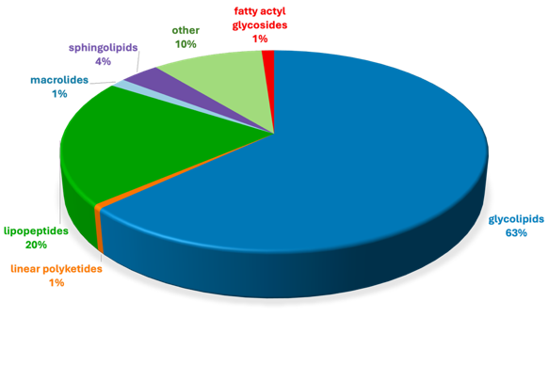
Fig. S2. Chemical class affiliation of compounds eluted mainly in 90% fraction and grouped in Fig. 7. The classification was performed using the SCOPUS tool within the SIRIUS software. Chemical class affiliation was accepted when the NPC score (Natural Product Classifier score) exceeded 0.7, 0 indicates poor annotation and 1 indicates excellent annotation.

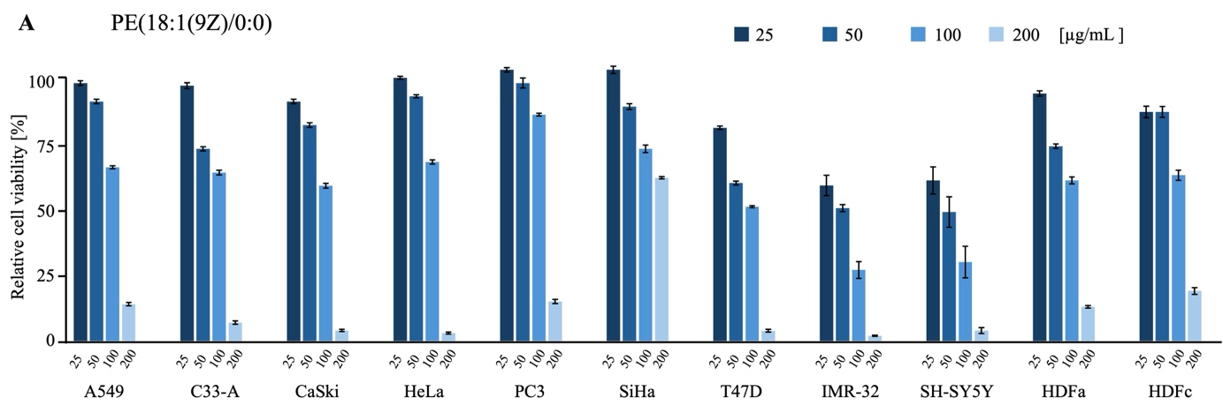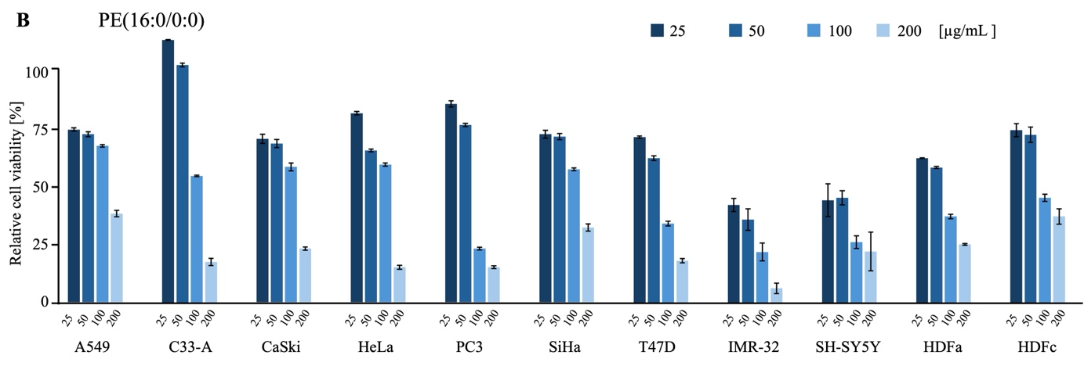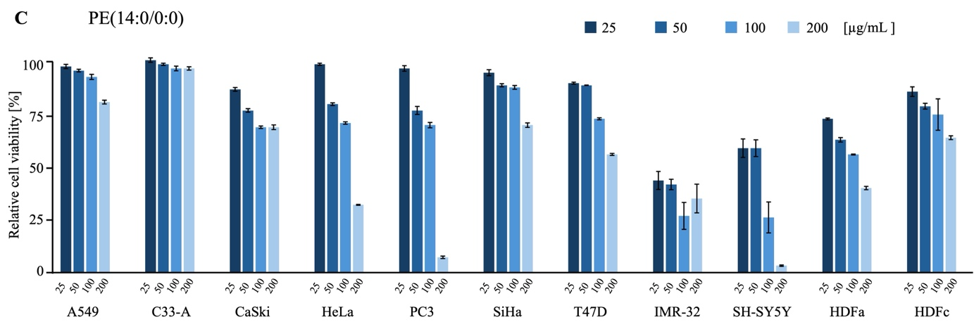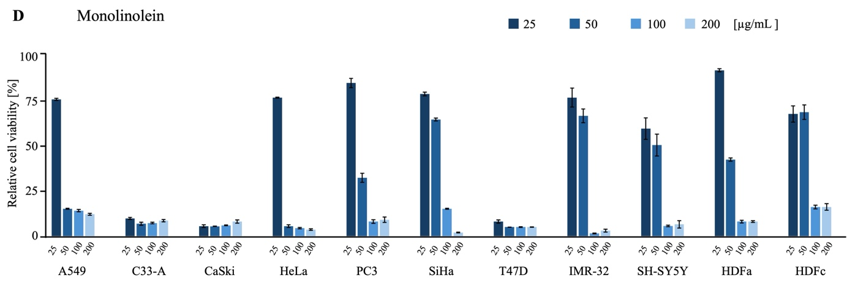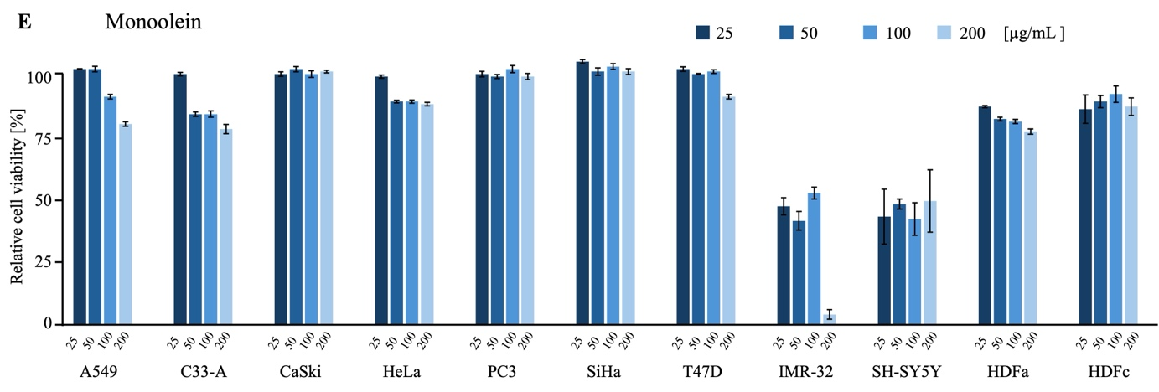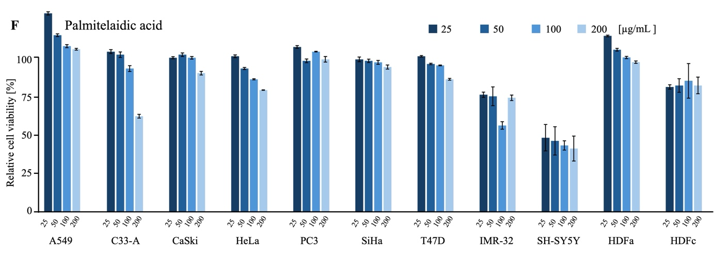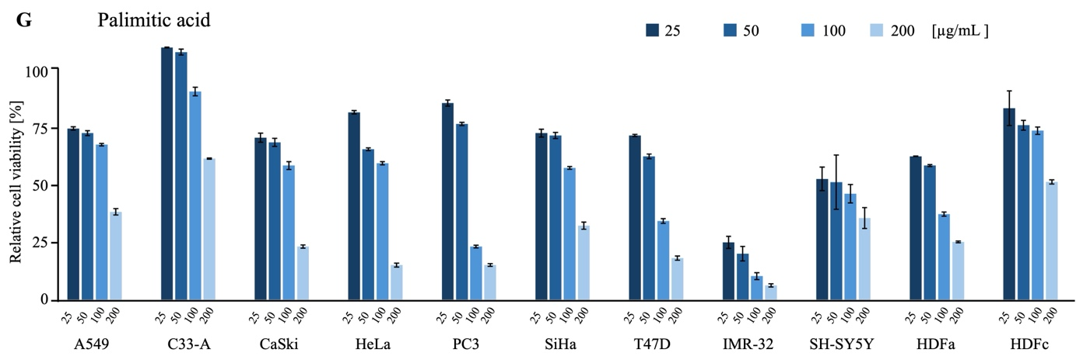
Fig. S3. Relative viability of cancer cell lines (A549, C33-A, CaSki, HeLa, PC3, SiHa, T47D, IMR-32, SH-SY5Y) and human dermal fibroblasts (HDFa, HDFc) after treatment with PE(18:1(9Z)/0:0) (A), PE(16:0/0:0) (B), PE(14:0/0:0) (C), Monolinolein (D), Monoolein (E), Palmitelaidic acid (F) and Palimitic acid (G) at 25, 50, 100, and 200 µg/mL, Cell viability was determined by the MTT assay and is presented as mean ± SD (n = 3), expressed as percentage of untreated control cells.

