Supplementary materials
Table S1
Zero-order correlations between linguistic cues and self- rated SWB and other-rated SWB
 | Study 1 |  |  | Study 2 |  |  | Study 3
 |  | Cue validity | Cue utilization |  | Cue validity | Cue utilization |  | Cue validity | Cue utilization
 | M (SD)ª | Self-rated life satisfaction | Mean other-rated life satisfaction | M (SD)ª | Self-rated happiness | Mean other-rated happiness | M (SD)ª | Self-rated life satisfaction | Mean other-rated life satisfaction
Word count | 71.92 (36.67) | .047 | .149* | 14.08 (3.68) | .034 | -.152 | 77.14 (41.85) | -.175* | .330***
Words/sentence | 14.53 (6.92) | .094 | .126 | 14.08 (3.68) | .034 | -.152 | 15.62 (12.59) | -.045 | .084
Dictionary words | 12.87 (4.95) | -.049 | .144* | 12.70 (10.48) | -.210* | -.046 | 13.54 (5.21) | .089 | .021
Words>6 letters | 90.81 (5.13) | -.039 | -.081 | 85.97 (10.85) | -.017 | -.059 | 90.78 (5.26) | -.038 | -.121
Total function words | 55.43 (5.46) | -.011 | -.031 | 49.39 (13.55) | .018 | -.137 | 57.25 (5.51) | -.225** | -.035
Total pronouns | 14.37 (4.58) | -.006 | -.170* | 12.13 (9.94) | .045 | -.045 | 14.28 (4.65) | .014 | -.250***
Personal pronouns | 11.54 (4.21) | .042 | -.125 | 9.81 (8.72) | .009 | .008 | 11.23 (4.17) | .064 | -.250***
1st pers singular | 7.11 (4.87) | -.102 | -.215** | 7.84 (7.29) | .057 | -.028 | 7.16 (4.47) | -.020 | -.437***
1st pers plural | 3.69 (3.33) | .163* | .104 | 0.39 (2.36) | .009 | .085 | 3.33 (3.07) | .126 | .292**
2nd person | 0.04 (0.28) | -.102 | -.141* | 0.35 (2.98) | -.111 | -.096 | 0.07 (0.43) | .067 | .090
3rd pers singular | 0.34 (1.08) | .019 | .111 | 1.02 (3.87) | -.028 | .073 | 0.23 (0.76) | .007 | -.009
3rd pers plural | 0.34 (0.90) | .151* | .102 | 0.21 (1.21) | .069 | .063 | 0.43 (1) | -.066 | -.015
Impersonal pronouns | 2.83 (2.31) | -.089 | -.110 | 2.31 (4.45) | .082 | -.117 | 3.05 (2.36) | -.086 | -.051
Articles | 8.44 (3.60) | .069 | .086 | 9.41 (7.97) | .062 | .087 | 8.31 (3.61) | -.112 | .221**
Common verbs | 13.96 (3.85) | -.076 | -.192** | 11.9 (9.3) | -.061 | -.144 | 12.26 (4.13) | -.100 | -.329***
Auxiliary verbs | 5.44 (3.07) | -.031 | -.074 | 6.56 (7.44) | -.077 | -.166 | 6.42 (3.59) | -.161* | -.184**
Past tense | 9.61 (4.22) | .026 | -.104 | 1.42 (3.99) | -.144 | -.227** | 8.22 (4.02) | -.071 | -.076
Present tense | 2.61 (2.62) | -.200** | -.203** | 8.81 (8.2) | .024 | -.017 | 3.04 (3.4) | -.001 | -.328***
Future tense | 0.62 (1.16) | .107 | -.013 | 0.75 (2.23) | -.081 | -.119 | 0.53 (1.09) | .021 | .160*
Adverbs | 3.97 (2.81) | -.054 | -.086 | 4.11 (5.95) | -.027 | -.045 | 4.91 (3.8) | .000 | -.086
Prepositions | 14.59 (4.24) | -.001 | .137 | 12.15 (7.64) | .078 | .001 | 14.4 (3.95) | -.012 | .134
Conjunctions | 6.55 (2.82) | -.051 | .157* | 4.03 (5.35) | -.053 | -.066 | 6.48 (3.31) | -.023 | .149*
Negations | 0.51 (1.00) | -.154* | -.298*** | 1.28 (3.00) | -.191* | -.262** | 0.66 (1.3) | -.239*** | -.437***
Quantifiers | 2.92 (2.25) | -.059 | -.057 | 2.03 (4.28) | .033 | .012 | 3.46 (2.48) | -.144* | .144*
Numbers | 0.75 (1.21) | .028 | .092 | 0.45 (2.05) | -.018 | .056 | 1.4 (1.47) | .032 | .092
Swear words | 0.02 (0.22) | -.086 | -.235** | 0.13 (1.61) | -.063 | -.138 | 0.01 (0.11) | .032 | -.021
Social processes | 8.99 (6.02) | .104 | .134 | 3.88 (7.01) | -.012 | .138 | 8.23 (5.24) | .121 | .137*
Family | 1.94 (2.34) | .003 | .010 | 0.06 (0.71) | -.063 | .094 | 1.56 (2.02) | .014 | -.030
Friends | 0.45 (1.03) | -.023 | .007 | 0.18 (1.25) | .079 | .174* | 0.45 (1.11) | .091 | -.029
Humans | 0.38 (0.89) | .043 | .120 | 0.58 (1.95) | .000 | .027 | 0.43 (1.09) | .014 | -.086
Affective processes | 5.14 (3.37) | .062 | .067 | 6.71 (7.51) | -.044 | .195* | 5.02 (5.03) | .121 | -.033
Positive emotion | 4.77 (3.23) | .092 | .146* | 4.60 (6.64) | .104 | .399*** | 4.83 (5.05) | .135* | -.002
Negative emotion | 0.36 (1.14) | -.078 | -.214** | 2.05 (3.94) | -.259** | -.313** | 0.19 (0.62) | -.114 | -.252**
Anxiety | 0.04 (0.29) | -.148* | -.164* | 0.18 (1.21) | -.088 | .007 | 0.06 (0.34) | -.054 | -.147*
Anger | 0.08 (0.45) | -.140* | -.178* | 0.60 (1.97) | .008 | -.176* | 0.05 (0.3) | -.070 | -.142*
Sadness | 0.12 (0.56) | -.006 | -.111 | 0.89 (2.76) | -.295** | -.344*** | 0.04 (0.24) | -.061 | -.125
Cognitive processes | 15.42 (5.16) | .009 | .000 | 11.68 (8.95) | -.084 | -.161 | 15.05 (5.36) | .029 | .109
Insight | 0.37 (0.79) | -.149* | -.132 | 1.58 (3.48) | -.269** | -.187* | 0.55 (1.01) | .034 | .032
Causation | 0.43 (0.82) | -.165* | -.024 | 1.12 (2.94) | .074 | .037 | 0.48 (1.07) | .016 | .025
Discrepancy | 0.7 (1.22) | .090 | .039 | 1.00 (2.73) | -.096 | -.223** | 0.8 (1.42) | -.021 | -.143*
Tentative | 1.93 (1.92) | -.144* | -.110 | 1.05 (2.66) | -.115 | -.056 | 1.71 (1.86) | -.123 | .058
Certainty | 0.8 (1.28) | .024 | -.100 | 1.61 (3.35) | -.019 | -.053 | 0.94 (1.67) | -.011 | -.074
Inhibition | 0.08 (0.36) | -.054 | .059 | 0.69 (2.27) | -.037 | -.013 | 0.07 (0.27) | -.136* | -.057
Inclusive | 10.01 (4.49) | .143* | .164* | 3.83 (5.37) | .057 | .055 | 9.37 (4.79) | .125 | .207**
Exclusive | 1.29 (1.58) | -.100 | -.159* | 0.99 (3.00) | -.063 | -.113 | 1.36 (1.66) | -.083 | -.065
Perceptual processes | 1.9 (1.96) | .041 | .183* | 7.31 (8.61) | -.110 | .032 | 1.96 (3.11) | .052 | .065
See | 1.36 (1.69) | .032 | .189** | 4.50 (6.90) | -.026 | -.010 | 1.3 (1.91) | .038 | .026
Hear | 0.11 (0.48) | -.002 | .032 | 0.58 (2.32) | -.066 | .143 | 0.13 (0.46) | -.096 | .118
Feel | 0.28 (0.74) | -.003 | -.049 | 1.53 (3.45) | -.073 | -.074 | 0.33 (1.5) | .080 | -.007
Biological processes | 2.95 (2.51) | .048 | -.010 | 3.20 (5.63) | -.015 | .037 | 2.3 (2.14) | -.008 | .152*
Body | 0.24 (0.76) | -.150* | -.035 | 1.57 (3.78) | .001 | .022 | 0.2 (0.55) | .052 | -.033
Health | 0.18 (0.61) | .006 | .034 | 0.88 (2.79) | -.091 | -.137 | 0.16 (0.7) | -.073 | -.118
Sexual | 0.25 (0.78) | .022 | -.029 | 0.38 (1.96) | .036 | -.008 | 0.17 (0.57) | .088 | -.027
Ingestion | 2.28 (2.17) | .095 | .010 | 0.61 (2.48) | -.086 | .094 | 1.78 (1.88) | -.033 | .238***
Relativity | 21.98 (6.06) | .027 | .073 | 19.06 (11.69) | .069 | .055 | 22.27 (6.1) | .041 | .139*
Motion | 5.64 (2.82) | -.011 | .073 | 3.86 (4.96) | .045 | .138 | 5.58 (3.73) | .156* | -.098
Space | 7.29 (3.85) | .009 | .028 | 8.57 (8.14) | .147 | .045 | 6.73 (3.53) | -.141* | .210**
Time | 8.94 (3.77) | .047 | .036 | 6.39 (7.74) | -.090 | -.080 | 9.25 (3.94) | .019 | .096
Work | 0.48 (1.64) | -.081 | -.130 | 0.69 (2.27) | -.034 | -.106 | 0.48 (0.95) | -.078 | .039
Achievement | 0.92 (1.8) | -.101 | -.067 | 1.88 (4.11) | -.133 | .011 | 1.14 (1.52) | -.110 | -.062
Leisure | 5.69 (3.29) | -.014 | -.041 | 1.93 (4.54) | .015 | .285** | 5.13 (3.28) | .030 | -.026
Home | 1.93 (2.37) | .033 | -.187** | 0.47 (1.94) | .139 | -.038 | 1.64 (2.01) | -.020 | -.038
Money | 1.25 (1.62) | .129 | -.020 | 0.73 (2.61) | .102 | .058 | 1.17 (1.85) | -.006 | -.096
Religion | 0.51 (1.19) | -.033 | -.004 | 0.05 (0.66) | .028 | .027 | 0.31 (0.86) | .011 | -.018
Death | 0.04 (0.34) | -.115 | -.227** | 0.16 (1.07) | .049 | -.075 | 0.04 (0.26) | -.108 | -.141*
Assent | 0.11 (0.46) | .042 | .096 | 0.24 (1.29) | .023 | .117 | 0.21 (1.44) | .091 | .034
Nonfluencies | 0.11 (0.58) | -.005 | -.056 | 0 (0) | - | - | 0.12 (0.69) | .099 | -.050
Fillers | 0.08 (0.36) | -.107 | -.074 | 0.35 (1.60) | .050 | -.039 | 0.14 (0.46) | .054 | -.044
Note. * p < .05, ** p < .01, ***p < .001. ª Percentages from a given category out of the total number of words used (e.g., a mean of 4.60 for positive emotion (Study 2) means that on average 4.60% of all words used in haikus could be categorized as expressing positive emotions).

Moderation by haiku topic valence, Study 2
We tested the following moderation effects:
- Negative emotion words x topic valence
- Anxiety words x topic valence
- Anger words x topic valence
- Sadness words x topic valence
- Positive emotion words x topic valence
We did that for both self-rated and other-rated happiness as dependent variables.
As a measure of topic valence, we computed the average score across the two raters. It followed a close-to-normal distribution (s. below) and we treated it as a continuous variable.
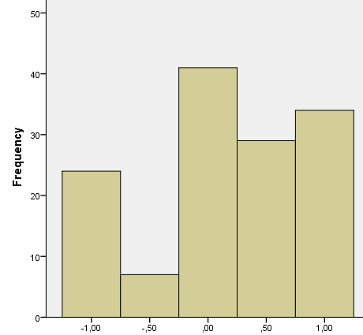
In addition, we repeated the analyses using each rater’s valence score separately (using two dummies: positive vs. other and negative vs. other). Overall, we tested 30 different models (5 emotion words, 3 measures of haiku topic valence and 2 dependent variables).
None of the 15 models with other-rated happiness as dependent variable showed significant emotion words x topic valence interactions.
Of the 15 models with self-rated happiness as dependent variable, the following interactions reached significance:
1) anxiety words x mean valence rating: b = .19, p = .032
2) anxiety words x positive valence dummy (rater 1): b = .37, p = .031
3) anxiety words x positive valence dummy (rater 2): b = .38, p = .028
These effects show that for negative valence haikus, happier targets were less likely to use anxiety words, whereas for positive valence haikus, the use of anxiety words was not associated with self-rated happiness (for neutral valence haikus, anxiety words count was 0).
4) positive emotion words x negative valence dummy (rater 1): b = -.77, p = .022. For negative valence haikus, more (vs. less) happy targets were less likely to use positive emotion words; whereas for neutral and positive valence haikus, more (vs. less) happy targets were more likely to use positive emotion words.
5) positive emotion words x negative valence dummy (rater 2): b = -1.29, p = .001 and positive emotion words x positive valence dummy (rater 2): b = -.67, p = .021. For negative valence haikus, more (vs. less) happy targets were less likely to use positive emotion words; for neutral valence haikus, more (vs. less) happy targets were more likely to use positive emotion words; for positive valence haikus, positive emotion words were unrelated to self-rated happiness.
Overall, most interactions did not reach significance and the interpretation of the few that did, is not consistent with the idea that the use of positive emotion words is more diagnostic for negative valence topics and the use of negative emotion words is more diagnostic for positive valence topics.

Figure S1
Serial mediation, Study 2
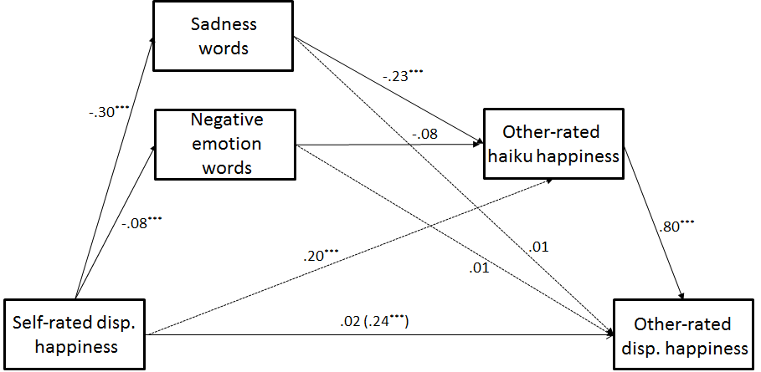
Note. Self-rated disp. happiness = targets’ judgment of their own happiness; Other-rated disp. happiness = raters’ judgment of targets’ happiness; Other-rated haiku happiness = raters’ judgment of haiku happiness; Dashed paths are estimated but not used in the calculation of indirect effects. Indirect effect via sadness words: .05 95% CI [.03; .08]; indirect effect via negative emotion words: .005 95% CI [-.001; .013].

Figure S2
Serial mediation, Study 2
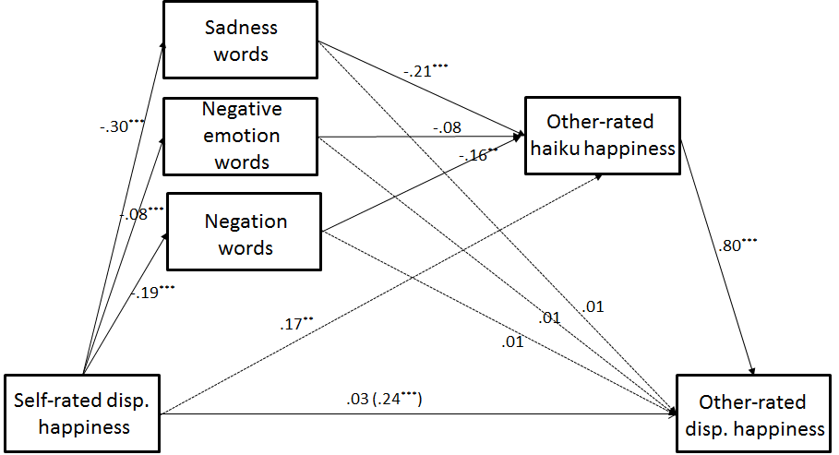
Note. Self-rated disp. happiness = targets’ judgment of their own happiness; Other-rated disp. happiness = raters’ judgment of targets’ happiness; Other-rated haiku happiness = raters’ judgment of haiku happiness; Dashed paths are estimated but not used in the calculation of indirect effects. Indirect effect via sadness words: .05 95% CI [.03; .08]; indirect effect via negative emotion words: .005 95% CI [-.001; .013]; indirect effect via negation words: .02 95% CI [.01; .04].

