Supplemental Materials
Dilemmas used in Studies 1 and the pilot-study
Standard Trolley:
You are at the wheel of a runaway trolley quickly approaching a fork in the tracks. On the tracks extending to the left is a group of five railway workers. On the tracks extending to the right is a single railway worker. If you do nothing, the trolley will proceed to the left, causing the deaths of the five workers.
[Harmful deontological emphasis] In that case these five workers would see the approaching trolley unable to flee from their dire situation before being hit by the trolley. They would die an agonizing death.
The only way to avoid the deaths of these workers is to hit a switch on your dashboard that will cause the trolley to proceed to the right, causing the death of the single worker.
[Harmful utilitarian emphasis] In that case the single worker would see the approaching trolley unable to flee from his dire situation before being hit by the trolley. He would die an agonizing death.

Nuclear Reactor:
You are the inspector of a nuclear power plant. You suspect violations of safety regulations. As you are on a tour with the head of the plant, alarms go off. A fuel rod is overheating. The emergency cooling system won’t start and a chain reaction begins, which will lead to a meltdown. To avoid an explosion a vent will open, releasing a nuclear cloud which will poison the citizens of a city nearby. The plant itself is protected by an air filtration system.
The only option to avoid the meltdown is to manually flood the room with liquid nitrogen. The nitrogen will take up just enough heat to avoid a disaster. But the nitrogen will also reach rooms with employees, which will die.
If you do nothing, the nuclear cloud will kill thousands of people in the nearby city.
[Harmful deontological emphasis] They will be poisoned by the nuclear cloud, leading to a painful, conscious death.
If you flood the reaction chamber, the employees in the rooms around the reactor will die.
[Harmful utilitarian emphasis] They will suffocate and freeze at the same time, leading to a painful, conscious death.

Hospital Guard
You are the late-night watchman in a hospital. Due to an accident in the building next door, there are deadly fumes rising up through the hospital’s ventilation system. In a certain room of the hospital are three patients. In another room there is a single patient. If you do nothing, the fumes will rise up into the room containing the three patients and cause their deaths.
[Harmful deontological emphasis] These patients would only notice the fumes when their muscles are already paralyzed, so that they won't be able to get help. The patients will feel their heartbeats slowing down, knowing that they will die in a matter of minutes, helpless, but fully conscious.
Because emergency personnel won't reach the room in time to evacuate the patients, the only way to avoid the deaths of these patients is to hit a certain switch, which will cause the fumes to bypass the room containing the three patients. As a result of doing this, the fumes will enter the room containing the single patient.
[Harmful utilitarian emphasis] This patient would only notice the fumes when his muscles are already paralyzed, so that he won't be able to get help. The patient will feel his heartbeat slowing down, knowing, that he will die in a matter of minutes, helpless, but fully conscious.

Energy source:
You are a scientist and together with a colleague you have discovered a new and powerful energy source that is cheap, save and clean. You realize that this energy source could bring the end of pollution and poverty on a global scale.
Your colleague, however, wants to sell your discovery to the military who would build a new dangerous weapon based on it. You know your colleague well enough to know that he will sell the discovery at the first opportunity to the highest bidder. You know also, that he will contact potential buyers via e-mail. Some of these buyers are willing to try to turn your discovery into a devastating weapon. You can stop your colleague from selling the plans, by directing a flammable gas into the laboratory of your colleague, causing an explosion as soon he turns on his computer. Everyone would think of this as a lab accident and the plans for the energy source would not be sold to those creating a weapon from them.
[Harmful utilitarian emphasis] Your colleague, however, would have no chance of escaping the explosion. The burning machines in the laboratory would emit poisonous fumes. It would get rapidly hotter in the room. Your colleague would either painfully suffocate or even burn to death.
[Harmful deontological emphasis] By doing so, you would prevent new fuel for conflicts and wars all around the world. You would prevent rich countries from getting more dangerous and devastating weapons. The number of killings prevented by this would be immeasurable.

Vaccination
You work for the Bureau of Health, a government agency. You are deciding whether or not your agency should encourage the use of a certain recently developed vaccine. The vast majority of people who take the vaccine develop an immunity to a certain deadly disease, but a very small number of people who take the vaccine will actually get the disease that the vaccine is designed to prevent.
All the available evidence, which is very strong, suggests that the chances of getting the disease due to lack of vaccination are much higher than the chances of getting the disease by taking the vaccine. However, some innocent people will be infected if you endorse the use of the vaccine.
[Harmful utilitarian emphasis] Because of your decision, you would be responsible for the deaths of these people through the horrible disease. Without your endorsement, these people would probably have survived and they would not have left their family and friends mourning.
[Harmful deontological emphasis] By endorsing the vaccine, you have the opportunity to save many people who would have died of the horrible disease otherwise. With your endorsement of the vaccine, these people would probably have survived and they would not leave their family and friends mourning.

Airplane hijacking
You are an air force general and you have command over a squadron of fighter jets stationed close to a major city. You received the message that a passenger plane has been hijacked by terrorists. There are no laws prescribing how to react to such a situation. One possibility is to order your pilots to shoot the aircraft down.
[Harmful utilitarian emphasis] If you give the order to shoot the aircraft, the hijackers and all passengers will burn in the explosion or be shredded by bursting metal debris. This would be a most painful death.
If you do not give the order, it is possible, that the hijackers will crash the airplane into a building in the nearby city, resulting in the deaths of many more people.
[Harmful deontological emphasis] These people would burn in the explosion or be shredded by bursting metal debris. This would be a most painful death.

Organ transplant
You are a doctor. You have five patients, each of whom is about to die due to a failing organ of some kind.
[Harmful deontological emphasis] Before their deaths they will gain consciousness in the middle of an operation and then die a most painful death.
A new patient is brought into the emergency room after a severe car accident. This person is so severely injured, that he would die, without immediate surgery. For medical reasons, tranquilizers cannot be used on this patient.
During the long and complicated surgery, in which you are involved, you notice that one of the nurses is about to use the wrong medication. You know that this mistake can be deadly. If you ignore it, and thereby let the mistake happen, the patient will die.
[Harmful utilitarian emphasis] Before his death he will gain consciousness in the middle of the operation and then die a most painful death.
On the other hand, this would give you the opportunity to transplant the organs of this patient into your other five patients. If you do this, these five patients will remain alive.

Mine Shaft
You work as a miner. The only way out of the mine in which you work is via containers that are also used to transport the mined materials to the surface. In these containers is room for up to three people. It is the end of a workday and miners from the lower levels of the mine ride past you to the surface.
While you wait for a container, you notice that the cable supporting the containers is about to tear. If the cable tears, all miners who are currently in the containers will fall to their deaths.
[Harmful deontological emphasis] They would see you looking at the emergency button and they would see the cable tearing. Then they would drop rapidly into the mine shaft. They would have no chance of escaping death and they would be crushed on a rock at the bottom of the shaft.
The only way of stopping this is to press an emergency button, releasing the lowest container. This would reduce the weight sufficiently to prevent the cable from tearing, thereby the other miners would be saved. In the lowest container is one miner who would die in that case.
[Harmful utilitarian emphasis] He would see you pressing the emergency button and he would see his container being released from the cable. Then he would drop rapidly into the mine shaft. He would have no chance of escaping death and he would be crushed on a rock at the bottom of the shaft.

Dilemmas used in Study 2
Standard Trolley

English
You are at the wheel of a runaway trolley quickly approaching a fork in the tracks. On the tracks extending to the left is a group of five railway workers. On the tracks extending to the right is a single railway worker. If you do nothing, the trolley will proceed to the left, causing the deaths of the five workers.
[Harmful deontological emphasis] In that case these five workers would see the approaching trolley unable to flee from their dire situation before being hit by the trolley. They would die an agonizing death.
The only way to avoid the deaths of these workers is to hit a switch on your dashboard that will cause the trolley to proceed to the right, causing the death of the single worker.
[Harmful utilitarian emphasis] In that case the single worker would see the approaching trolley unable to flee from his dire situation before being hit by the trolley. He would die an agonizing death.

German
Sie stehen am Steuer eines Bahnwagens, der sich schnell auf eine Weiche zubewegt. Auf den Schienen auf der linken Seite steht eine Gruppe von fünf Gleisarbeitern. Auf den Schienen rechts steht ein einzelner Arbeiter. Wenn Sie nichts tun, wird der Wagen auf der linken Spur weiterfahren und den Tod der fünf Arbeiter verursachen.
[Harmful deontological emphasis] Die fünf Arbeiter würden in diesem Fall den Zug auf sich zukommen sehen, wären aber nicht in der Lage zu fliehen, bevor sie vom Wagen erfasst werden und eines schmerzhaften Todes sterben.
Die einzige Möglichkeit den Tod dieser Arbeiter zu verhindern besteht darin, einen Hebel auf Ihrem Armaturenbrett zu bedienen, der bewirkt, dass der Wagen auf die rechte Spur umgelenkt wird, was den Tod des einzelnen Arbeiters verursachen würde.
[Harmful utilitarian emphasis] Der einzelne Arbeiter würde in diesem Fall den Zug auf sich zukommen sehen, wäre aber nicht in der Lage zu fliehen, bevor er vom Wagen erfasst wird und eines schmerzhaften Todes stirbt.

Picture
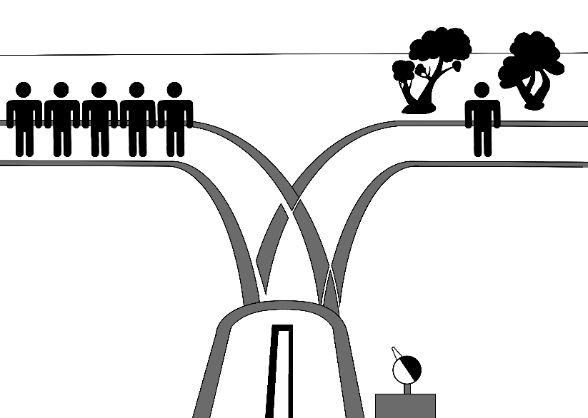

Aiplane Hijacking

English
You are an air force general and you have command over a squadron of fighter jets stationed close to a major city. You received the message that a passenger plane has been hijacked by terrorists. There are no laws prescribing how to react to such a situation. One possibility is to order your pilots to shoot the aircraft down.
[Harmful utilitarian emphasis] If you give the order to shoot the aircraft, the hijackers and all passengers will burn in the explosion or be shredded by bursting metal debris. This would be a most painful death.
If you do not give the order, it is possible, that the hijackers will crash the airplane into a building in the nearby city, resulting in the deaths of many more people.
[Harmful deontological emphasis] These people would burn in the explosion or be shredded by bursting metal debris. This would be a most painful death.

German
Sie sind Pilot eines Kampfflugzeuges, der an einer Übung der Luftwaffe in der Nähe einer großen Stadt teilnimmt. Plötzlich erhalten Sie Informationen, die besagen, dass ein Passagierflugzeug von einer Gruppe von Terroristen gekapert wurde. Es ist Ihnen nicht möglich Kontakt mit dem kommandierenden General aufzunehmen. Wenn Sie nichts unternehmen, besteht die Möglichkeit, dass die Terroristen das Flugzeug in ein Hochhaus in der nahegelegenen Stadt steuern werden, was zum Tod sehr vieler Menschen führen wird.
[Harmful utilitarian emphasis]Sie alle werden durch die Explosion des Flugzeuges oder durch umherfliegende Metallteile getötet. Sie werden bei lebendigem Leibe verbrennend einen qualvollen Tod sterben.
Aus diesem Grund müssen Sie allein eine Entscheidung treffen: Eine Möglichkeit, ist es das Passagierflugzeug abzuschießen. Wenn Sie das Flugzeug abschießen, werden sowohl die Passagiere als auch die Terroristen sterben.
[Harmful deontological emphasis] Sie alle werden durch die Explosion des Flugzeuges oder durch umherfliegende Metallteile getötet. Sie werden bei lebendigem Leibe verbrennend einen qualvollen Tod sterben.

Picture
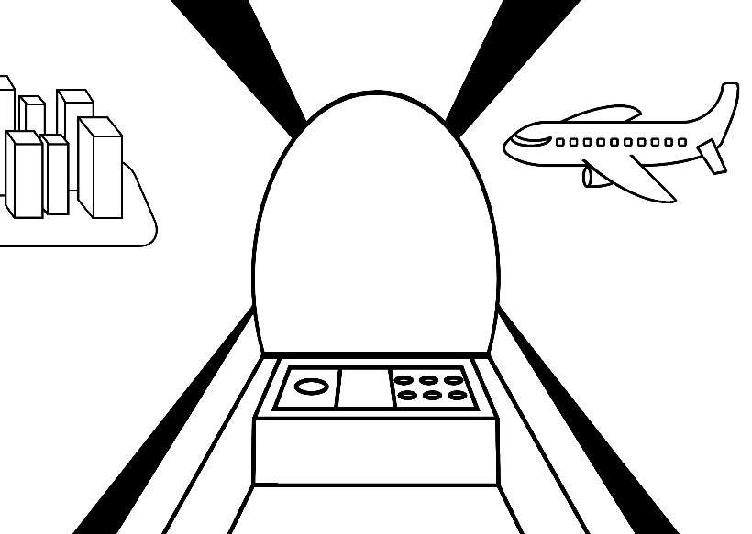

Hospital Guard

English
You are the late-night watchman in a hospital. Due to an accident in the building next door, there are deadly fumes rising up through the hospital’s ventilation system. In a certain room of the hospital are three patients. In another room there is a single patient. If you do nothing, the fumes will rise up into the room containing the three patients and cause their deaths.
[Harmful deontological emphasis] These patients would only notice the fumes when their muscles are already paralyzed, so that they won't be able to get help. The patients will feel their heartbeats slowing down, knowing that they will die in a matter of minutes, helpless, but fully conscious.
Because emergency personnel won't reach the room in time to evacuate the patients, the only way to avoid the deaths of these patients is to hit a certain switch, which will cause the fumes to bypass the room containing the three patients. As a result of doing this, the fumes will enter the room containing the single patient.

[Harmful utilitarian emphasis] This patient would only notice the fumes when his muscles are already paralyzed, so that he won't be able to get help. The patient will feel his heartbeat slowing down, knowing, that he will die in a matter of minutes, helpless, but fully conscious.

German
Sie sind Nachtwächter in einem Krankenhaus. Wegen eines Unfalls in einem Nachbargebäude steigen tödliche Dämpfe durch das Belüftungssystem des Krankenhauses. In einem bestimmten Raum des Krankenhauses liegen drei Patienten, in einem anderen Raum liegt ein einzelner Patient. Wenn sie nichts machen, werden die Dämpfe in den Raum mit den drei Patienten steigen und deren Tod verursachen.
[Harmful deontological emphasis] Diese werden das erst merken, wenn ihre Muskeln schon so sehr gelähmt sind, dass sie nicht mehr in der Lage sind, Hilfe zu holen. Die Patienten merken, wie ihr Herz immer schwächer wird, bis es schließlich ganz aufhört zu schlagen. Sie wissen, dass sie in wenigen Minuten tot sein werden und sind dieser Situation völlig hilflos ausgeliefert.
Da Rettungskräfte die Patienten nicht rechtzeitig erreichen würden, ist die einzige Möglichkeit den Tod dieser Patienten zu verhindern einen Knopf zu drücken, der bewirkt, dass die Dämpfe den Raum, in dem drei Patienten liegen, umgehen. Dadurch werden sie jedoch in den Raum mit dem einzelnen Patienten gelangen.
[Harmful utilitarian emphasis] Dieser wird das erst merken, wenn seine Muskeln schon so sehr gelähmt sind, dass er nicht mehr in der Lage ist, Hilfe zu holen. Der Patient merkt, wie sein Herz immer schwächer wird, bis es schließlich ganz aufhört zu schlagen. Er weiß, dass er in wenigen Minuten tot sein wird und ist dieser Situation völlig hilflos ausgeliefert.

Picture
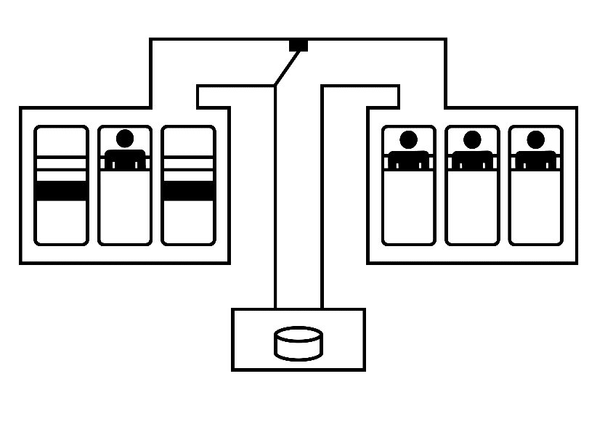

Mineshaft

English
You work as a miner. The only way out of the mine in which you work is via containers that are also used to transport the mined materials to the surface. In these containers is room for up to three people. It is the end of a workday and miners from the lower levels of the mine ride past you to the surface.
While you wait for a container, you notice that the cable supporting the containers is about to tear. If the cable tears, all miners who are currently in the containers will fall to their deaths.
[Harmful deontological emphasis] They would see you looking at the emergency button and they would see the cable tearing. Then they would drop rapidly into the mine shaft. They would have no chance of escaping death and they would be crushed on a rock at the bottom of the shaft.
The only way of stopping this is to press an emergency button, releasing the lowest container. This would reduce the weight sufficiently to prevent the cable from tearing, thereby the other miners would be saved. In the lowest container is one miner who would die in that case.
[Harmful utilitarian emphasis] He would see you pressing the emergency button and he would see his container being released from the cable. Then he would drop rapidly into the mine shaft. He would have no chance of escaping death and he would be crushed on a rock at the bottom of the shaft.

German
Sie sind ein Minenarbeiter. Der einzige Weg aus der Mine sind die Kübel, mit denen auch die abgebauten Steine nach oben gefahren werden. In diese Kübel passen bis zu drei Menschen auf einmal. Es ist das Ende eines Arbeitstages und Minenarbeiter aus tieferen Etagen der Mine fahren an Ihnen vorbei nach oben. Während Sie auf einen Kübel warten, um nach oben zu fahren, bemerken Sie, dass eines der Kabel das die Kübel hält kurz davor ist, zu reißen. Wenn das Kabel reißt, werden alle Minenarbeiter, die gerade in den Kübeln sind, in den Tod stürzen.
[Harmful deontological emphasis] Sie würden sehen, wie Sie den Notfallknopf nicht drücken und das Kabel reißt und sie würden immer schneller in den Abgrund stürzen. Sie haben keine Chance ihrem Tod zu entkommen und werden ganz unten an den Felsen zerschellen.
Die einzige Möglichkeit das zu verhindern ist, einen Notfallknopf zu drücken, der automatisch den untersten Kübel vom Kabel löst und somit das Gewicht gerade genügend reduziert, damit das Kabel nicht reißt und die anderen Minenarbeiter alle gerettet sind. Im untersten Kübel ist ein Minenarbeiter, der dann sterben wird.
[Harmful utilitarian emphasis] Er würde sehen, wie Sie den Notfallknopf drücken und wie sein Kübel sich vom Kabel aushakt und er würde immer schneller in den Abgrund stürzen. Er hat keine Chance seinem Tod zu entkommen und wird ganz unten an den Felsen zerschellen.

Picture
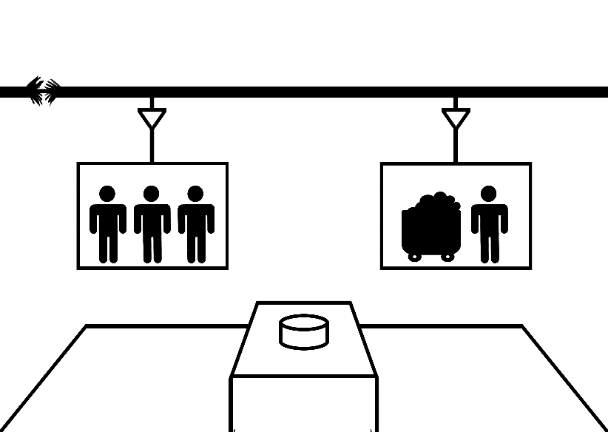

Motor Way

English
You are driving on a highway at night. A car accident happened a couple of meters in front of you. In the crashed vehicle are five people. Due to reduced vision, you were unable to spot them in time. Disorientated, these people run towards the road. You are too fast to stop in time. At the same time a motorbike is trying to overtake you with high speed. If you do nothing you will crash into the group of five people eventually killing them.
[Harmful deontological emphasis] They would crash on the pavement, breaking their bones in the process. They would die in agonizing pain and before help could arrive.
If you try to avoid the family you will hit the motorcyclist, who will fall. The fall would kill him.
[Harmful utilitarian emphasis] He would crash on the pavement, breaking his bones in the process. He would die in agonizing pain and before help could arrive.

German
Sie fahren mit Ihrem Auto nachts auf einer Autobahn. Einige Meter vor Ihnen hat sich auf vor kurzem ein Autounfall ereignet. In dem verunglückten Fahrzeug befinden sich fünf Personen. Aufgrund der schlechten Sichtverhältnisse, haben Sie das verunglückte Fahrzeug nicht rechtzeitig bemerken können. Orientierungslos rennen die Fahrzeuginsassen auf die Straße, doch Sie sind zu schnell, um noch rechtzeitig bremsen zu können. Zugleich versucht ein Motorrad Sie mit hoher Geschwindigkeit zu überholen. Wenn Sie nichts unternehmen, fahren Sie weiter geradewegs auf die fünf Personen zu, werden diese mit Ihrem Fahrzeug erfassen und letztendlich töten.
Aufgrund des Aufpralls brächen nahezu sämtliche Knochen der Personen in der Gruppe und sie würden einen qualvollen Tod erleiden, noch ehe Hilfe käme.
Wenn Sie versuchen der Gruppe auszuweichen, werden Sie in der Folge mit dem Motorradfahrer zusammenprallen. Dieser würde fallen und schließlich durch diesen Fall sterben.
[Harmful utilitarian emphasis] Aufgrund seines Falls brächen nahezu sämtliche Knochen des Motorradfahrers und er würde einen qualvollen Tod erleiden, noch ehe Hilfe käme.

Picture
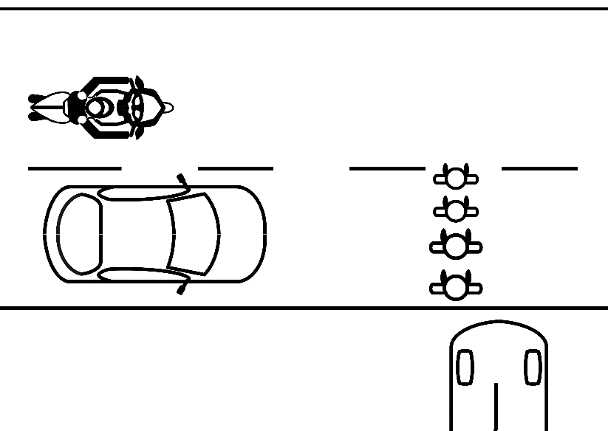
Wild Water

English
You have been on a white-water raft. The river swells due to heavy rain. You left the river at the last possible exit before a nearby waterfall. While you are waiting for the shuttle bus to pick you up, you notice a rafting boat coming down the river. As they see the exit the passengers start cheering. One of the passengers loses balance and falls into the water. As the others try to pull him back to the boat, they are drifting past the exit point. The single passenger in the water is driven away by the currents. To rescue people who are beyond the exit point a steel rope with a winch is stretched over the river. But since the river is swollen it is now about one meter below the water line. The passenger in the water might save himself with the rope, but it’s too low for the boat.
If you do nothing the boat with the passengers will be driven over the rope and towards the waterfall. They would fall and die eventually.
[Harmful deontological emphasis] Although they would try desperately to fight against the current, they would eventually be pulled under water. Once they lose their strength, the ice cold water would fill their lungs and they would drown in agony.
If you turn the winch the steel rope will rise out of the water. The passengers in the boat will be able to rescue themselves but it will be too high for the single person in the water to grab it. He will be forced over the waterfall and die.
[Harmful utilitarian emphasis] Although he would try desperately to fight against the current, he would eventually be pulled under water. Once he loses his strength, the ice cold water would fill his lungs and he would drown in agony.

German
Sie haben eine Wildwasser-Schlauchboot Tour unternommen, diese jedoch unterbrochen als der Fluss aufgrund heftiger Regenfälle gefährlich hoch anstieg. Den Fluss haben Sie schließlich an der letztmöglichen Anlegestelle vor einem nahegelegenen Wasserfall verlassen. Während Sie warten, bemerken Sie ein Boot, welches den Fluss hinunterfährt. Als die Passagiere dieses Bootes die Anlegestelle sehen, an der Sie den Fluss verlassen haben, beginnen sie zu jubeln. Einer der Passagiere verliert das Gleichgewicht und fällt in den Fluss. Während die anderen Passagiere versuchen Ihn aus dem Wasser zurück ins Boot zu ziehen, treibt das Boot an der letzten Anlegestelle vor dem Wasserfall vorbei. Um Menschen, deren Boote sich bereits hinter der letztmöglichen Anlegestelle befinden noch retten zu können, wurde ein Stahlseil mit einer Seilwinde über den Fluss gespannt. Allerdings ist der Fluss so sehr angestiegen ist, dass das Stahlseil sich bereits einen Meter unter der Wasseroberfläche befindet. Der Passagier des Bootes, der zuvor über Bord gegangen ist, könnte das Seil noch zu greifen bekommen und sich somit retten, für das Boot mit den restlichen Passagieren liegt das Seil jedoch zu tief unter Wasser. Wenn sie nichts unternehmen, wird das Boot samt Passagiere über das Seil hinweg und auf den Wasserfall zu getrieben werden. Die Passagiere werden schließlich fallen und sterben.
[Harmful deontological emphasis] Obwohl diese noch verzweifelt versuchen mit all ihrer Kraft gegen die starke Strömung anzukämpfen, werden sie schließlich unter Wasser gezogen werden. Sobald sie ihre Kräfte verlassen, wird das eiskalte Wasser letztlich ihre Lungen fluten und sie werden qualvoll ertrinken.
Wenn Sie an der Seilwinde drehen, wird sich das Seil aus dem Wasser erheben. Die Passagiere des Bootes wären somit in der Lage sich zu retten, aber für den Passagier, der zuvor über Bord gegangen ist, wird das Seil zu hoch hängen, als dass dieser sich ebenfalls noch retten könnte.
[Harmful utilitarian emphasis] Obwohl dieser noch verzweifelt versucht mit all seiner Kraft gegen die starke Strömung anzukämpfen, wird er schließlich unter Wasser gezogen werden. Sobald ihn seine Kräfte verlassen, wird das eiskalte Wasser letztlich seine Lungen fluten und er wird qualvoll ertrinken.

Picture
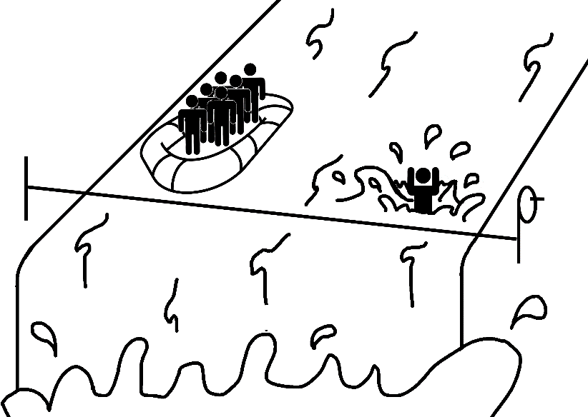

Coast Guard

English
You work at an observation platform for the coast guard. After a sunny day, an unexpected storm is coming. You saw a boat carrying one person near the coast. The coast guard in your area has only one helicopter available to rescue people. Because there is no way of contacting the person on the boat, you have sent the helicopter to rescue this exact person. A few moments after the helicopter leaves, you notice another boat carrying five people, which is also on the ocean. You cannot contact either of the two boats to warn them. If the people either boat are not rescued by the helicopter, they will most likely be hit by the storm and die. The helicopter only has time to rescue the people on one boat, because it would be hit by the storm otherwise. If you do nothing, the helicopter will proceed on its course and rescue the person on the first boat. In that case, the people on the second boat will be killed in the storm.
[Harmful deontological emphasis] These people would most likely be thrown overboard by the storm and either drown, fighting against the wind and cold water or be shattered on the cliffs nearby, dying from internal injuries and broken bones.
Your only option to avoid that outcome is to signal the helicopter to change its course and rescue the people on the second boat instead. In that case the person on the first boat will die.
[Harmful utilitarian emphasis] This Person would most likely be thrown overboard by the storm and either drown, fighting against the wind and cold water or be shattered on the cliffs nearby, dying from internal injuries and broken bones.

German

Sie arbeiten auf einer Beobachtungsplattform der Küstenwache. Nach einem sonnigen Tag zieht ein unvorhergesehener Sturm auf. Da sehen Sie ein Boot mit einem einzelnen Passagier in der Nähe der Küste. Der Küstenwache in Ihrer Gegend steht derzeit jedoch nur ein Rettungshelikopter zur Bergung zur Verfügung. Sie haben den Helikopter losgeschickt um den Passagier in Not zu retten. Sie bemerken kurz nachdem der Helikopter gestartet ist, dass sich ebenfalls ein zweites Boot mit fünf Passagieren vor der Küste in Gefahr befindet. Sie können mit keinem der beiden Boote Kontakt aufnehmen, um diese zu warnen. Wenn die Passagiere des einen oder des anderen Bootes nicht gerettet werden sollten, werden sie höchstwahrscheinlich in den Sturm hineingeraten und sterben. Der Helikopter hat nur genug Zeit um die Passagiere eines Bootes zu retten bevor dieser selbst in den Sturm hineingerät. Wenn Sie nichts unternehmen, bleibt der Helikopter auf Kurs und wird den Passagier des von Ihnen zuerst gesichteten Bootes retten. In diesem Fall werden die Passagiere des anderen Bootes in dem kommenden Sturm sterben.
[Harmful deontological emphasis] Sie würden im Sturm von Bord fallen und entweder gegen den Wind und das eiskalte Wasser ankämpfend ertrinken oder gegen die nahegelegenen Felsen geschleudert an inneren Verletzungen sterben.
Die einzige Möglichkeit dies zu verhindern, besteht darin dem Helikopter zu signalisieren, dass dieser den Kurs wechseln soll und anstelle dessen das Boot mit den fünf Passagieren zu retten. In diesem Fall würde der einzelne Passagier auf dem zuerst gesichteten Boot sterben.
[Harmful utilitarian emphasis] Dieser würde im Sturm von Bord fallen und entweder gegen den Wind und das eiskalte Wasser ankämpfend ertrinken oder gegen die nahegelegenen Felsen geschleudert an inneren Verletzungen sterben.

Picture
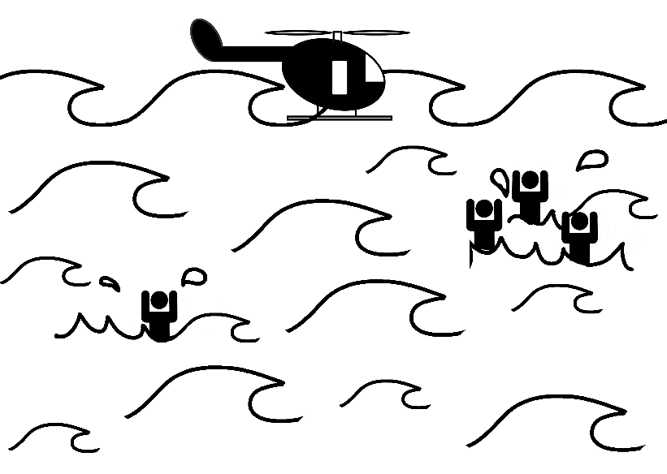
Cave Rescue

English
A group of people is on an expedition in a cave near the coast. One of these people is their expedition guide and should lead them out of the cave. However, the guide got stuck on the way out in a small passage. You are in charge of the rescue team who has been called to the scene of the accident. After inspecting the situation, you have come to the conclusion that the cave will soon be flooded by sea water. Every member of the group except for the guide, whose had reaches outside of the cave would drown.
[Harmful deontological emphasis] The group would eventually no longer be able to breath and finally die a slow and most painful death in the ice cold sea water.
The only way to save these members of the expedition is to drill a hole from outside through a very unstable cave ceiling through which they could be rescued. This way the members of the expedition trapped in the cave can be saved. However, because of the drilling, the ceiling at the entrance would cave in which would kill the leader of the expedition.
[Harmful utilitarian emphasis] He would be crushed by falling rocks and finally die a slow and most painful death in the ice cold sea water.

German
Eine Gruppe von fünf Personen unternimmt eine Expedition in eine Höhle an einer Meeresküste. Eine dieser Personen ist der Leiter der Expeditionsgruppe und sollte diese aus der Höhle führen. Allerdings blieb dieser auf dem Weg nach draußen in der engen Öffnung der Höhle stecken. Sie sind der Chef des Bergungsteams, welches zum Unglücksort gerufen wurde. Nach Begutachtung der Situation kommen Sie zu dem Schluss, dass in Kürze das Wasser in der Höhle so hoch ansteigen wird, dass alle außer dem Leiter der Expeditionsgruppe, dessen Kopf aus der Öffnung der Höhle herausragt, ertrinken werden.
[Harmful deontological emphasis] Diese würden schließlich keine Luft mehr bekommen können und letztlich einen langsamen und schmerzvollen Tod im eiskalten Meereswasser erleiden.
Der einzige Weg die anderen Mitglieder der Expeditionsgruppe zu retten, besteht darin, von außen ein Loch durch die äußerst instabile Höhlendecke zu bohren, durch welches diese geborgen werden könnten. Dadurch, werden Sie zwar die Mitglieder der Expeditionsgruppe, welche in der Höhle gefangen sind, retten können, allerdings würde aufgrund der Bohrungen die Höhle im Bereich der Öffnung einstürzen, was zum Tod des Leiters der Expeditionsgruppe führen würde.
[Harmful utilitarian emphasis] Dieser würde von herabfallenden Felsbrocken zerquetscht und schließlich einen langsamen und schmerzvollen Tod erleiden.

Picture
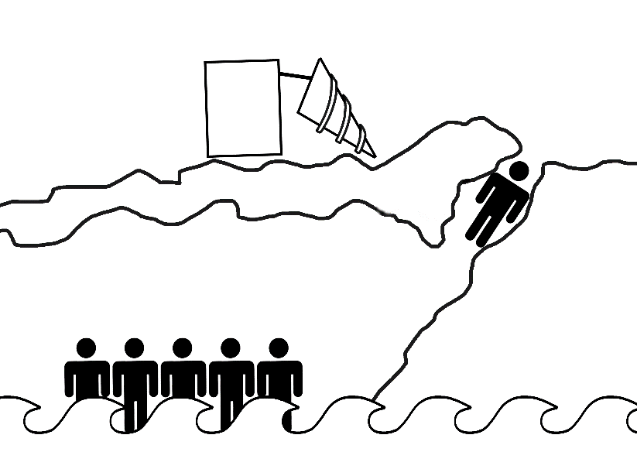
Office Fire

English
You are head of operation of a group of fire fighters who have been called to a burning office building. After gaining access to the security cameras of the building, you can see that five people are trapped in a room on the third floor because the corridor in front of the room is on fire. Another person is at the end of the burning corridor near an emergency exit. Because of injuries this person is moving very slowly towards the emergency exit. This person will most likely reach the exit in time before being caught by the fire. At the same time, you notice that the fire will soon reach the room in which the group of five people are trapped. If this happens, they would die.
[Harmful deontological emphasis] They would be burned alive in a sea of flames and finally die a most agonizing death.
The only way to save the five people in the office is to activate the emergency system of the building manually, because you and your colleagues won’t be able to extinguish the fire in time. The emergency system will suck the oxygen out of the corridor and smother the fire this way. The five people trapped in the office could be rescued. However, this would also mean that the person in the corridor would suffocate before being able to reach the emergency exit.
[Harmful utilitarian emphasis] This person would inevitably suffocate before reaching the emergency exit, slowly and writhing in pain.

German

Sie sind der Einsatzleiter einer Gruppe von Feuerwehrleuten, die zu einem Brand eines Bürogebäudes gerufen wurden. Da Sie es geschafft haben Zugriff auf die Überwachungskameras in dem Gebäude zu bekommen, können Sie sehen, dass im dritten Stockwerk fünf Personen aufgrund eines Feuers in einem der Flure in einem Büroraum gefangen sind. Eine weitere Person befindet sich am anderen dieses Ende des Flurs in der Nähe des Notausgangs. Diese bewegt sich aufgrund von Verletzungen nur sehr langsam auf den Notausgang zu und wird diesen wahrscheinlich noch rechtzeitig erreichen bevor die Flammen diese erreichen können. Gleichzeitig können Sie erkennen, dass das Feuer in Kürze in jenen Büroraum eindringen wird, in welchem sich die anderen fünf Personen befinden und diese in der Folge sterben werden.
[Harmful deontological emphasis] Diese würden bei lebendigem Leibe in einem Meer von Flammen langsam verbrennen und schließlich qualvoll sterben.
Die einzige Möglichkeit die fünf in dem Büroraum gefangenen Personen zu retten, besteht darin das Notfallsystem des Gebäudes manuell zu aktivieren, da das Feuer nicht schnell genug von Ihnen und Ihren Kollegen gelöscht werden kann. Dies würde dazu führen, dass der Sauerstoff aus dem Flur gesogen wird und das Feuer in der Folge somit ersticken würde. Die fünf zuvor im Büroraum eingesperrten Personen können gerettet werden. Allerdings würde dies ebenfalls bedeuten, dass die Person im Flur ersticken würde, noch bevor diese den Notausgang erreichen kann.
[Harmful utilitarian emphasis] Die Person im Flur würde unweigerlich kurz bevor sie den Notausgang erreicht, sich vor Schmerzen windend qualvoll und langsam ersticken.

Picture
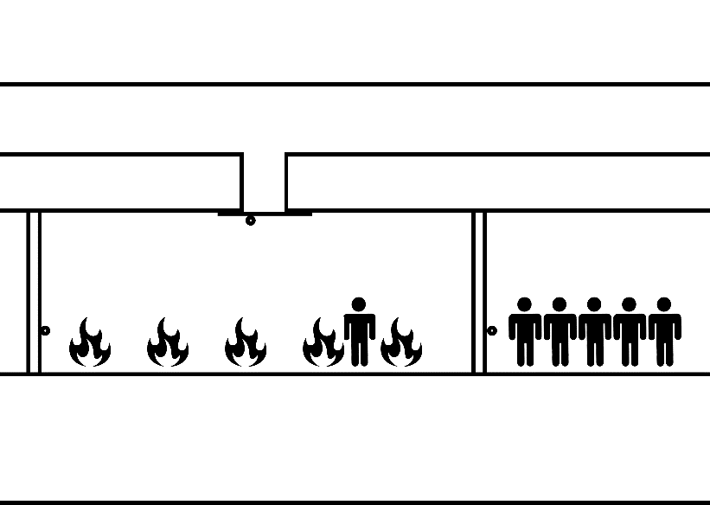

Biking Accident

English
You are an expert motorcycle rider and you have gone on vacation in order to participate in Bike Week. Thousands of other motorcycle riders from across the country have come to ride in this event. As you are riding down the road in the front of a large group of other riders you see that someone up ahead is losing control of his bike. As you watch him fall, you know that you could easily ride around the fallen rider but if you do, the riders behind you will run over each other trying to avoid the crash. This would result in a large pile-up and several deaths.
[Harmful deontological emphasis] The other riders of the group would notice the fallen rider too late. They would crash into each other and as a result break almost all of their bones. Because of the severe injuries this would lead to an excruciating death for the other riders.
You, as an expert, could lay your bike over on its side while throwing yourself clear, allowing the bike to slide into the fallen rider. This would warn the riders behind you of a wreck and prevent a large pile-up, but would also certainly kill the fallen rider.
[Harmful utilitarian emphasis] He would see the bike sliding towards him, but would not be able to dodge in time before being hit. The bike would crash into him and as a result break almost all of his bones. Because of the severe injuries this would lead to an excruciating death for this rider.

German
Sie sind ein erfahrener Motorradfahrer und nehmen an der diesjährigen Motorradwoche teil. Tausende von anderen Motorradfahren aus dem ganzen Land sind mit ihren Motorrädern angereist, um ebenfalls an dieser Veranstaltung teilzunehmen. Während Sie vor einer größeren Gruppe von Motorradfahrern eine Straße entlangfahren, verliert ein Fahrer vor Ihnen die Kontrolle über sein Motorrad. Als Sie sehen wie dieser fällt, wird Ihnen klar, dass Sie problemlos um den gefallenen Fahrer herumfahren könnten. Allerdings würde das bedeuten, dass die Fahrer hinter Ihnen den gefallenen Fahrer zu spät bemerken würden und bei dem Versuch, einen Aufprall mit dem gefallenen Fahrer zu vermeiden, einander überfahren würden. Dies würde zu einer Massenkarambolage führen und letztlich den Tod mehrerer Fahrer bedeuten.
[Harmful deontological emphasis] Die Motorradfahrer dieser Gruppe würden den gefallenen Fahrer zu spät bemerken und so käme es zu mehreren Zusammenstößen in Folge derer nahezu sämtliche Knochen der Fahrer brächen. Diese würden schließlich aufgrund ihrer Verletzungen einen äußerst schmerzvollen Tod erleiden.
Als erfahrener Fahrer könnten Sie ihr Motorrad während der Fahrt in Schräglage bringen, unterdessen sicher abspringen und somit das Motorrad auf den gefallenen Motorradfahrer zu schlittern lassen. Dies würde die Fahrer hinter Ihnen vor einem möglichen Unglück warnen und eine Massenkarambolage verhindern. Jedoch würde dieses Manöver unweigerlich zum Tod des gefallenen Motorradfahrers führen.
[Harmful utilitarian emphasis] Er wird Ihr Motorrad auf sich zu schlittern sehen, diesem jedoch nicht rechtzeitig ausweichen können, bevor es zum Aufprall kommt. In der Folge brächen nahezu sämtliche Knochen des gefallenen Fahrers, welcher schließlich aufgrund seiner Verletzungen einen äußerst schmerzvollen Tod erleiden würde.

Picture
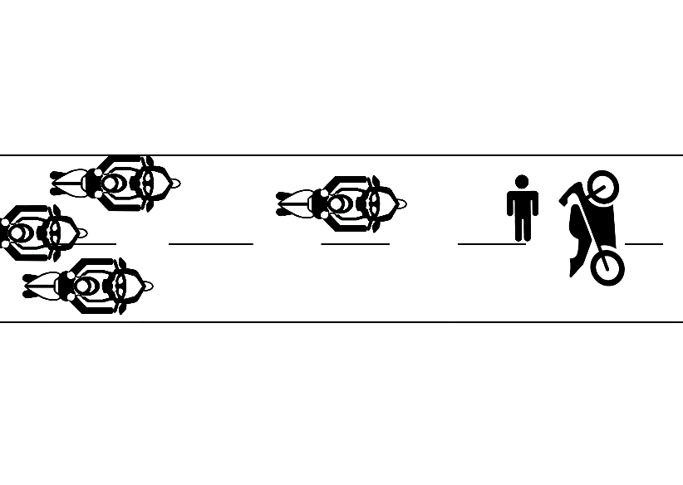

 | No emphasis |  | Harmful Utilitarian |  | Harmful Deontological
Dilemma | Pilot | Study 1 | Pilot | Study 1 | Pilot | Study 1
Standard Trolley | 0.197 | 0.093 | 0.135 | 0.073 | 0.354 | 0.351
Nuclear Reactor | 0.467 | 0.426 | 0.337 | 0.290 | .747 | 0.550
Hospital Guard | 0.065 | 0.195 | -0.156 | 0.043 | 0.327 | 0.252
Energy Source | -0.048 | -0.195 | -0.561 | -0.355 | 0.015 | -0.220
Vaccination | 0.146 | 0.083 | -0.138 | -0.022 | 0.309 | 0.263
Airplane Hijacking | 0.047 | -0.056 | -0.166 | 0.026 | 0.318 | 0.089
Organ Transplant | -1.010 | -0.890 | -0.919 | -0.735 | -1.120 | -0.804
Mineshaft | 0.038 | 0.083 | 0.290 | 0.150 | 0.479 | 0.281
Standardized mean endorsements of the utilitarian option for each dilemma in Study 1 and the pilot-study.

