Appendix

Flow Short Scale ‘FSS’ (Rheinberg et al. 2003)
- My thoughts ran fluidly and smoothly
- My thoughts seemed to happen naturally and on their own
- I knew what I was doing each step of the way
- I lost track of time
- I was totally absorbed into the experience
- I had no difficulty concentrating
- My mind was completely clear
- I felt that I had everything under control
- I was completely lost in thought
- I felt just the right amount of challenge

Items rated from 1(not at all) to 7(very much so)

Core Flow State Scale (Jackson and Martin 2006)
- I was ‘totally involved’
- It felt like ‘everything clicked’
- I was ‘tuned in’ to what I was doing
- I was ‘in the zone’
- I felt ‘in control’
- I was ‘switched on’
- It felt like I was ‘in the flow’ of things
- It felt like ‘nothing else mattered’
- I was ‘in the groove’
- I was ‘totally focused’ on what I was doing
Items rated from 1 (strongly disagree) to 5 (strongly agree)

Flow Short Scale ‘MJ-FSS’ (Martin and Jackson 2008)
- I felt that I was competent enough to meet the high demands of the situation
- I had a good idea while I was performing about how well I was doing
- I did things spontaneously and automatically without having to think
- I had a strong sense of what I wanted to do
- I was completely focused on the game
- I had a feeling of total control
- I was not worried about what others were thinking of me
- The way time passed seemed to be different from normal
- The experience was extremely rewarding
*items rated from 1 (Strongly disagree) to 7 (Strongly agree)

FLOW (quote) QUESTIONNAIRE (Csikszentmihalyi and Csikszentmihalyi 1988)

Please read the following quotes. The questions that follow are based on them.

“My mind isn’t wandering. I am not thinking of something else. I am totally involved in what I am doing. My body feels good. I don’t seem to hear anything else. The world seems to be cut off from me. I am less aware of myself and my problems.”
“My concentration is like breathing I never think of it. When I start, I really do shut out the world. I am really quite oblivious to my surroundings after I really get going. I think that the phone could ring, and the doorbell could ring or the house burn down or something like that. When I start I really do shut out the world. Once I stop I can let it back in again.”

“I am so involved in what I am doing. I don’t see myself as separate from what I am doing.”

Did you feel the experience that the quotes explained at ANY POINT while listening to the sound clip?

________YES _______NO

Self-awareness scale (Govern and Marsch 2001)
- I was concerned about what other people were thinking of me
- I was concerned about the way I presented myself
- I was self-conscious about the way I looked
*items rated from 1(Strongly Disagree) to 7 (Strongly Agree)

Toronto Mindfulness Scale (Lau, Bishop, Segal, Buis, Anderson, Carlson, Shapiro and Carmody 2006)

Decentering Dimension
- I experienced myself as separate from my changing thoughts and feelings
- I experienced my thoughts more as events in my mind than as a necessarily accurate reflection of the way things ‘really’ are
- I was aware of my thoughts and feelings without over-identifying with them
Openness Dimension
- I was more concerned with being open to my experiences than controlling or changing them
- I approached every experience by trying to accept it, no matter whether it was pleasant or unpleasant

*Items rated from 1 (not at all) to 5 (very much)

PANAS Positive Items (Watson, Clark and Tellegen 1988)
- Interested 2. Excited 3. Strong 4. Enthusiastic
5. Proud 6. Alert 7. Inspired 8. Determined
9. Attentive 10. Active
*Items rated from 1 (not at all) to 5 (extremely)

Telepresence Scale (Kim and Biocca 1997)
- I forgot about my surroundings outside of the game
- When I played I was in the world of the game
- After playing, I felt like I came back to the ‘real’ world
- Playing the game made me momentarily forget where I was
- The world created by the game was more real for me than the ‘real’ world
- The game created a new world to be in and that world suddenly disappeared when I stopped playing
- When I was playing, my body was in the room, but my mind was inside the world created by the game
*Items rated from 1 (not at all) to 7 (very much)

The Two Dimensional Flow Scale (TDFS)
Please answer the following questions based on your experience in the activity you just engaged in.
F₁ – My thoughts ran fluidly and smoothly
F₂- I knew what I was doing each step of the way
F₃- I felt that I had everything under control
A₁- I lost track of time
A₂- I felt like it was just me and the ‘activity’
A₃- I was unaware of anything else
*items rated from 1 (not at all) to 7 (very much so)
*F- fluency items, A- absorption items
*If the activity that participants engaged in is known, replace ‘activity’ with the name of the actual activity in item A₂ and in the instructions.

Sudoku Puzzles

Easy
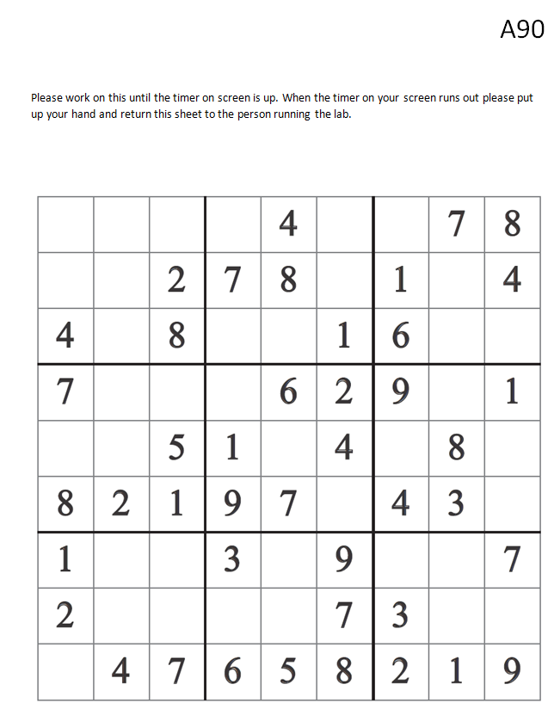

Moderate
