Supplemental material
Five Reasons to Cry – FRC – A Taxonomy for Common Antecedents of Emotional Crying

List of tables
Table S1 – all studies. Interrater reliabilities (overall agreement and agreement on each category)
Table S2 – Study 1. FRC Questionnaire
Table S3 – Study 1. Likelihood Ratio Tests – multinomial regression – Emotions - FRC
Table S4 – Study 1. Parameter estimates for multinomial regression – Emotions - FRC
Table S5 – Study 1. Frequency of words used to describe crying episode
Table S6 – Study 1. Percentages of cases when other person/ animal was involved in the crying episode
Table S7 – Study 1. Percentages of cases when person/ animal involved in crying was personally known
Table S8 – Study 1. Type of person/animal involved in crying
Table S9 – Study 1. Regressing 8 DIAMONDS on episode-type (1 = crying; 0 = non-crying)
Table S10 – Study 1. Regressing emotions on episode-type (1 = crying; 0 = non-crying)
Table S11 – Study 1. Regressing needs on episode-type (1 = crying; 0 = non-crying)
Table S12 – Study 2. List of all measures of measures assessed in Study 2
Table S13 – Study 2. Multilevel model regressing time on affect and arousal
Table S14 – Study 2. Multilevel model regressing time and reason on affect and arousal

List of figures
Figure S1 – Study 1. Emotion intensity for FRC
Figure S2 – Study 1. 8 DIAMONDS ratings for crying and non-crying situations
Figure S3 – Study 1. Emotion intensity ratings for crying and non-crying situations
Figure S4 – Study 1. Need frustration/satisfaction ratings for crying and non-crying situations
Figure S5 – Study 2. Time-course of affect for FRC
Figure S6 – Study 2. Time-course of arousal for FRC
Figure S7 – Study 2. Emotion intensity for FRC
Figure S8 – Study 2. 8 DIAMONDS for FRC
Table S1 – all studies. Interrater reliabilities (overall agreement and agreement on each category).
 | Pilot Study | Validity Check | Study 1 | Study 2
 | κ | κ | κ | κ
overall agreement | .90 | .87 | .87 | .83
loneliness | .91 | .94 | .88 | .79
impotence | .89 | .94 | .87 | .76
overload | .89 | .73 | .76 | .82
harmony | .63 | .85 | .84 | .68
media | .95 | .83 | .94 | .93
Notes. κ = Fleiss’ Kappa. We also calculated Light’s Kappa for the overall agreement, as it more appropriate in the present case. Results were identical for Light’s and Fleiss’ Kappa.

Additional information – Pilot Study.
Additional measures. We instructed participants to rate their crying episodes regarding the 8 DIAMONDS and crying characteristics (i.e., duration and intensity) and to fill in the HEXACO Personality Inventory (Ashton & Lee, 2007).
Sample size. We aimed to compare crying and non-crying episodes in an exploratory analysis. We decided to refer to already published data on non-crying episodes. This approach allowed us to keep the Pilot Study short and thus cost-effective. We identified a recent article by Horstmann et al. (2020, Study 2) in which everyday episodes were rated with regard to situation characteristics in an experience sampling study. We collected data on crying episodes and aimed to keep the sample composition and size comparable to that of Horstmann and colleagues (Study 2: N = 274, M_{age} = 24.22, SD_{age} = 6.35, range_{age} = 17 – 53, 231 women, 41 men, 20 not specified, 90.51% students).

Table S2 – Study 1. FRC Questionnaire.
German | English
Anweisung:  Auf dieser Seite sehen Sie einige Gründe warum Menschen weinen. Welcher dieser Gründe beschreibt den Auslöser Ihres Weinens am besten? | Instruction:  On this page you see some reasons why people cry. Which of these reasons best describes the trigger of your crying?
1) Ich habe mich mit jemandem gestritten.  2) Ich habe jemanden vermisst.  3) Ich habe mich von jemandem ausgeschlossen gefühlt.  4) Der Tod von jemandem hat mich betroffen gemacht.  5) Die Erkrankung von jemandem hat mich betroffen gemacht.  6) Das Leid von jemandem hat mich betroffen gemacht.  7) Ich war mit einer Aufgabe überfordert.  8) Ich habe mir Selbstvorwürfe gemacht.  9) Ich habe mir Sorgen bezüglich der Zukunft gemacht.  10) Jemand hat mir etwas sehr Schönes gesagt oder für mich getan.  11) Ich habe etwas sehr Schönes / Bewegendes erlebt oder beobachtet.  12) Ich habe mich mit jemandem sehr verbunden gefühlt.  13) Ich habe eine rührende Szene in einem Film/ einer Serie gesehen.  14) Ich habe einen rührenden Videoclip gesehen.  15) Ein anderer Medieninhalt hat mich zum Weinen gebracht (Lied, Podcast, Nachrichten, Buch, Anzeige, Werbung, Videospiel, Post in sozialem Netzwerk, etc.)  16) anderer Grund … (offenes Antwortformat) | 1) I had a fight with someone.  2) I missed someone.  3) I felt excluded from someone.  4) The death of someone affected me.  5) The illness of someone affected me.  6) The suffering of someone affected me.  7) I was overwhelmed with a task.  8) I blamed myself.  9) I was worried about the future.  10) Someone said something very nice to me or did something nice for me.  11) I experienced or observed something very beautiful / moving.  12) I felt very connected to someone.  13) I saw a touching scene in a movie/series.  14) I saw a touching videoclip.  15) Another piece of media content made me cry (song, podcast, news, book, advertisement, commercial, video game, social network post, etc.).  16) other reason … (open response)
Zuordnung/classification:
Loneliness: 1, 2, 3
Impotence: 4, 5, 6
Overload: 7, 8, 9
Harmony: 10, 11, 12
Media: 13, 14, 15

Table S3 – Study 1. Likelihood Ratio Tests – multinomial regression – Emotions - FRC.
 | -2 Log Likelihood of Reduced Model |  | χ² | df | p
happy | 1546.22 |  | 99.56 | 4 | <.001
inspired | - |  | - | - | -
enthusiastic | - |  | - | - | -
proud | 1454.90 |  | 8.24 | 4 | 0.083
excited | 1452.64 |  | 5.98 | 4 | 0.201
sad | - |  | - | - | -
afraid | 1449.98 |  | 3.33 | 4 | 0.505
anxious | 1468.06 |  | 21.40 | 4 | <.001
ashamed | 1466.26 |  | 19.60 | 4 | 0.001
angry | 1489.59 |  | 42.94 | 4 | <.001
intercept | 1596.21 |  | 149.55 | 4 | <.001
Notes. Model fit information: χ²(28) = 486.93 p < .001; Negelkerke’s R² = .54

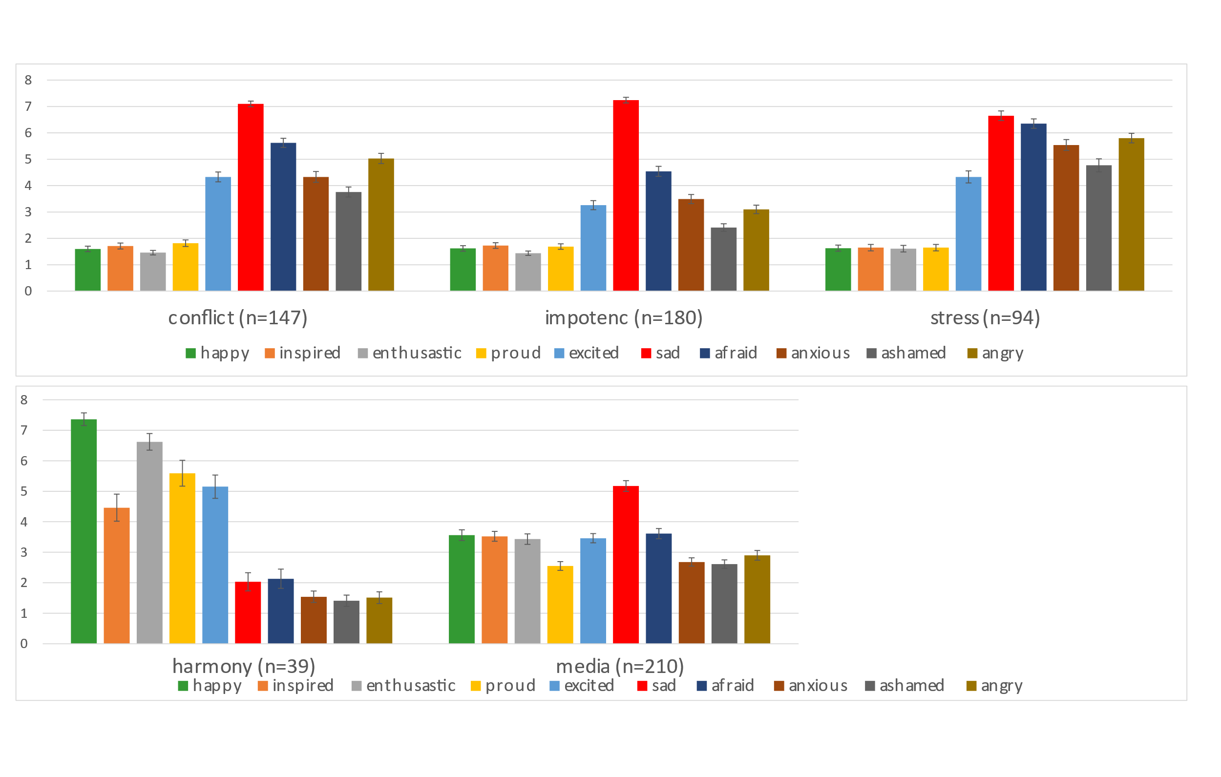
Figure S1 – Study 1. Emotion intensity for FRC. Error-bars denote +/- 1 SE.

Table S4 – Study 1. Parameter estimates for multinomial regression – Emotions - FRC.
 | B | SE | Wald | df | p | exp(B) | 95% CI for exp(B)
 |  |  |  |  |  |  | Lower Bound | Upper Bound
loneliness
happy | -0.50 | 0.11 | 22.46 | 1 | <.001 | 0.61 | 0.49 |  | 0.75
inspired
enthusiastic
proud | 0.07 | 0.10 | 0.58 | 1 | 0.446 | 1.08 | 0.89 |  | 1.30
excited | 0.10 | 0.06 | 2.44 | 1 | 0.118 | 1.10 | 0.98 |  | 1.24
sad
afraid | 0.08 | 0.07 | 1.50 | 1 | 0.220 | 1.09 | 0.95 |  | 1.24
anxious | 0.16 | 0.07 | 5.10 | 1 | 0.024 | 1.17 | 1.02 |  | 1.34
ashamed | 0.03 | 0.06 | 0.20 | 1 | 0.659 | 1.03 | 0.91 |  | 1.17
angry | 0.17 | 0.06 | 7.57 | 1 | 0.006 | 1.18 | 1.05 |  | 1.34
intercept | -1.44 | 0.40 | 13.06 | 1 | <.001 |  | -1.44 |  | 0.40
impotence
happy | -0.53 | 0.09 | 38.17 | 1 | <.001 | 0.59 | 0.50 |  | 0.70
inspired
enthusiastic
proud | 0.07 | 0.09 | 0.69 | 1 | 0.406 | 1.08 | 0.90 |  | 1.28
excited | 0.02 | 0.06 | 0.13 | 1 | 0.720 | 1.02 | 0.91 |  | 1.14
sad
afraid | 0.03 | 0.06 | 0.24 | 1 | 0.623 | 1.03 | 0.91 |  | 1.16
anxious | 0.18 | 0.07 | 7.10 | 1 | 0.008 | 1.20 | 1.05 |  | 1.37
ashamed | -0.14 | 0.07 | 4.84 | 1 | 0.028 | 0.87 | 0.76 |  | 0.98
angry | -0.10 | 0.06 | 3.10 | 1 | 0.078 | 0.90 | 0.80 |  | 1.01
intercept | 0.91 | 0.31 | 8.37 | 1 | 0.004 |  | 0.91 |  | 0.31
Table S4 (continued)
 |  |  |  |  |  |  | 95% CI for exp(B)
 | B | SE | Wald | df | p | exp(B) | Lower Bound |  | Upper Bound
overload
happy | -0.29 | 0.13 | 4.79 | 1 | 0.029 | 0.75 | 0.58 |  | 0.97
inspired
enthusiastic
proud | -0.10 | 0.13 | 0.61 | 1 | 0.434 | 0.90 | 0.70 |  | 1.17
excited | 0.01 | 0.07 | 0.01 | 1 | 0.922 | 1.01 | 0.87 |  | 1.16
sad
afraid | 0.12 | 0.09 | 1.68 | 1 | 0.194 | 1.13 | 0.94 |  | 1.35
anxious | 0.35 | 0.08 | 17.60 | 1 | <.001 | 1.42 | 1.20 |  | 1.67
ashamed | 0.14 | 0.07 | 3.68 | 1 | 0.055 | 1.15 | 1.00 |  | 1.32
angry | 0.31 | 0.08 | 15.62 | 1 | <.001 | 1.36 | 1.17 |  | 1.58
intercept | -3.92 | 0.63 | 38.54 | 1 | <.001 |  | -3.92 |  | 0.63
harmony
happy | 0.81 | 0.21 | 14.82 | 1 | <.001 | 2.25 | 1.49 |  | 3.39
inspired
enthusiastic
proud | 0.23 | 0.10 | 5.65 | 1 | 0.017 | 1.25 | 1.04 |  | 1.51
excited | 0.17 | 0.10 | 2.70 | 1 | 0.100 | 1.18 | 0.97 |  | 1.44
sad
afraid | 0.17 | 0.16 | 1.14 | 1 | 0.287 | 1.19 | 0.87 |  | 1.62
anxious | -0.27 | 0.23 | 1.37 | 1 | 0.241 | 0.76 | 0.49 |  | 1.20
ashamed | -0.33 | 0.27 | 1.53 | 1 | 0.217 | 0.72 | 0.42 |  | 1.21
angry | 0.25 | 0.23 | 1.20 | 1 | 0.273 | 1.28 | 0.82 |  | 2.01
intercept | -7.93 | 1.66 | 22.66 | 1 | <.001 |  | -7.93 |  | 1.66
Notes. SE = standard error; CI = Confidence Interval.

Additional analyses - Study 1.
Language analysis. We used the r-package ‘udpipe’ (Straka & Straková, 2017) to examine the wording used to describe crying episodes. We counted the most frequent nouns, verbs and adjectives used in each FRC category.
Girlfriend/friend, conflict and partner were the most frequently used nouns for loneliness. Death, mother and father were the most frequently used nouns for impotence. Situation, stress and work were the most frequently used nouns for overload. Joy, time and girlfriend/friend were the most frequently used nouns for harmony. Movie, video and scene were the most frequently used nouns for media. Detailed results are depicted in Table S5.
The linguistic differences found between the FRC could serve as starting point to train a machine-learning algorithm. Future studies that demonstrate successful categorization of crying reports through an algorithm would provide further evidence in favor of the validity of the FRC.
Table S5 – Study 1. Frequency of words used to describe crying episode. We listed the five most frequently used nouns, verbs and adjectives per category (frequency is given in parentheses).
 | nouns | verbs | adjectives
loneliness
 | girlfriend/friend (27)  conflict (20)  partner (16)  boyfriend/friend (15)  relationship (10) | cry (48)  have (34)  argue (28)  feel (19)  miss (13) | sad (15)  last (8)  hard (8)  good (5)  long (5)
impotence
 | death (37)  mother (23)  father (22)  funeral (12)  dog (12) | die (48)  learn (36)  think (31)  cry (29)  make (8) | deceased (21)  sad (14)  good (10)  other (5)  close (5)
Table S5 (continued)
overload
 | situation (19)  stress (16)  work (16)  future (8)  tears (6) | have (28)  cry (17)  feel (12)  overwhelmed (5)  make (7) | overwhelmed (8)  current (5)  sad (4)  strong (4)  frequent (3)
harmony
 | joy (8)  time (5)  girlfriend/ friend (4)  son (4)  moment (4) | cry (11)  be glad (5)  make (4)  get (2)  go (2) | nice (5)  long (3)  good (3)  better (2)  other (2)
media
 | movie (109)  video (28)  scene (28)  serial (17)  eyes (16) | watch (148)  have (34)  cry (25)  touched (19)  hear (18) | touching (54)  sad (30)  emotional (21)  moist (10)  easy (6)
Note. Straka, M., & Straková, J., (2017). Tokenizing, POS Tagging, Lemmatizing and Parsing UD 2.0 with UDPipe. In Proceedings of the CoNLL 2017 Shared Task: Multilingual Parsing from Raw Text to Universal Dependencies (pp 88– 99). Association for Computational Linguistics. http://dx.doi.org/10.18653/v1/K17-3009

Involved person/ animal. For exploratory analyses we asked participants to specify whether another person or animal was involved in the crying episode, or not. If another person or animal was involved in crying, we asked whether the other creature was personally known and (if yes) in which category it fell (i.e., family, friends, work or pet).
We found considerable differences regarding whether a person/animal was involved in crying. For example, pets were never involved in overload- and loneliness-related crying. So, pets seem to be involved in emotional distress less likely than our fellow humans. Although of a more qualitative nature, these findings speak in favor of our taxonomy.
FRC differed whether another person or animal was involved in the crying episode, χ²(4) = 120.22, p < .001 (Table S6). In the majority of cases, another creature was involved for loneliness (84%), impotence (78%) and harmony (90%). Another person was less likely involved for overload (39%) and media (41%). FRC also differed whether the creature involved was personally known or not, χ²(4) = 265.64, p < .001 (Table S7). In most cases (> 89%), the involved person or animal was personally known. Only in media, the involved creature was typically not personally known. Across all reasons, family members were most often involved in crying. However, FRC also differed regarding the type of creature involved in crying, χ²(12) = 50.55, p < .001 (Table S8). The prevalence for work-related persons involved in crying was highest for overload (27%) and low (< 10%) for all other categories. Friends were somewhat more involved in loneliness (18%), impotence (16%) and harmony (22%) than in overload (6%) and media (7%). Pets were never involved in loneliness (0%) and overload (0%) but in impotence (14%) and harmony (9%).
Table S6 – Study 1. Percentages of cases when other person/ animal was involved in the crying episode.
 |  | loneliness  (n=147) |  | impotence  (n=180) |  | overload  (n=94) |  | harmony  (n=39) |  | media  (n=210) |  | total  (n=670)
person/ animal involved |  | 83.67% |  | 77.77% |  | 39.36% |  | 89.74% |  | 41.43% |  | 66.40%
no person/ animal involved |  | 16.33% |  | 22.23% |  | 60.64% |  | 10.26% |  | 58.57% |  | 33.60%
Table S7 – Study 1. Percentages of cases when person/ animal involved in crying was personally known.
 |  | loneliness  (n=123) |  | impotence  (n= 140) |  | overload  (n=37) |  | harmony  (n=35) |  | media  (n=87) |  | total  (n=422)
personally known |  | 97.56% |  | 96.43% |  | 89.19% |  | 91.43% |  | 16.09% |  | 78.14%
not personally known |  | 2.44% |  | 3.57% |  | 10.81% |  | 8.57% |  | 83.91% |  | 21.86%
Table S8 – Study 1. Type of person/animal involved in crying.
 | loneliness  (n = 120) |  | impotence  (n = 135) |  | overload  (n = 33) |  | harmony  (n = 32) |  | media  (n = 14) |  | total  (n=334)
family | 77.50% |  | 66.67% |  | 66.67% |  | 59.38% |  | 85.72%
friends | 17.50% |  | 15.56% |  | 6.06% |  | 21.88% |  | 7.14%
pets | 0.00% |  | 14.07% |  | 0.00% |  | 9.37% |  | 0.00%
work | 5.00% |  | 3.70% |  | 27.27% |  | 9.37% |  | 7.14%

Differences between crying and non-crying episodes. To compare crying and non-crying episodes, we instructed participants to describe one non-crying episode of the previous day. They were randomly assigned to report on an episode at 10:00, 12:00, 14:00, 16:00, 18:00, 20:00, or 22:00. After reconstructing the non-crying episode, participants were instructed to rate it regarding the 8 DIAMONDS, need frustration/satisfaction and emotion intensity.
8 DIAMONDS. A logistic regression revealed that six of the 8 DIAMONDS differentiated between crying- and non-crying episodes, χ²(8) = 689.45, p < .001 (Table S9; Figure S2). An increase in intellect, adversity, negativity and deception by one unit each, increased the relative probability that the episode was a crying (compared to non-crying) episode by 12%, 13%, 29% and 18%, respectively. An increase in duty and positivity by one unit each, decreased the relative probability for a crying episode by 35% and 26%.

Table S9 – Study 1. Regressing 8 DIAMONDS on episode-type (1 = crying; 0 = non-crying).
 |  |  |  |  |  |  |  |  |  |  | 95% CI for exp(B)
 |  | B |  | SE |  | Wald |  | p |  | exp(B) |  | lower | upper
Constant |  | 0.74 |  | 0.22 |  | 10.89 |  | .001
duty |  | -0.43 |  | 0.03 |  | 169.01 |  | < .001 |  | 0.65 |  | 0.61 | 0.69
intellect |  | 0.12 |  | 0.04 |  | 10.71 |  | .001 |  | 1.12 |  | 1.05 | 1.20
adversity |  | 0.12 |  | 0.06 |  | 4.36 |  | 0.37 |  | 1.13 |  | 1.01 | 1.26
mating |  | 0.06 |  | 0.03 |  | 2.98 |  | 0.084 |  | 1.06 |  | 0.99 | 1.13
positivity |  | -0.30 |  | 0.03 |  | 87.31 |  | < .001 |  | 0.74 |  | 0.69 | 0.79
negativity |  | 0.26 |  | 0.04 |  | 45.07 |  | < .001 |  | 1.29 |  | 1.20 | 1.39
deception |  | 0.16 |  | 0.06 |  | 7.45 |  | .006 |  | 1.18 |  | 1.05 | 1.33
sociality |  | -0.03 |  | 0.03 |  | 0.85 |  | .357 |  | 0.97 |  | 0.92 | 1.03
Notes. Nagelkerke’s R² = .51, f² = 1.04

Figure S2 – Study 1. 8 DIAMONDS ratings for crying and non-crying situations. Error-bars denote +/- 1 SE.

Emotion Intensity. Due to high correlation among the MEQ-items we omitted sad (r = .67 with afraid), enthusiastic (r = . 81 with happy), inspired (r = .64 with happy) and anxious (r = .74 with afraid) from the regression analysis. The logistic regression revealed that five of the six remaining emotions differentiated between crying- and non-crying episodes, χ²(6) = 446.33, p < .001 (Table S10; Figure S3). An increase in excited, afraid and angry by one unit each, increased the relative probability that the episode was a crying (compared to non-crying) episode by 19%, 14% and 11%, respectively. An increase in happy and proud by one unit each, decreased the relative probability for crying episode by 20% and 16%.
Need frustration/ satisfaction. The logistic regression revealed that four of the six need measures differentiated between crying- and non-crying episodes, χ²(6) = 439.16, p < .001 (Table S11; Figure S4). An increase in relatedness frustration and relatedness satisfaction by one unit each, increased the relative probability that the episode was a crying (compared to non-crying) episode by 40% and 35%, respectively. An increase in competence satisfaction and autonomy satisfaction by one unit each, decreased the relative probability for crying episode by 30% and 23%.

Table S10 – Study 1. Regressing emotions on episode-type (1 = crying; 0 = non-crying).
 |  |  |  |  |  |  |  |  |  |  | 95% CI for exp(B)
 |  | B |  | SE |  | Wald |  | p |  | exp(B) |  | lower | upper
Constant |  | -0.24 |  | 0.18 |  | 1.76 |  | 0.185
happy |  | -0.22 |  | 0.04 |  | 35.48 |  | < .001 |  | 0.80 |  | 0.75 | 0.86
proud |  | -0.18 |  | 0.04 |  | 21.01 |  | < .001 |  | 0.84 |  | 0.77 | 0.90
excited |  | 0.18 |  | 0.03 |  | 25.93 |  | < .001 |  | 1.19 |  | 1.12 | 1.28
afraid |  | 0.13 |  | 0.03 |  | 14.54 |  | < .001 |  | 1.14 |  | 1.07 | 1.22
ashamed |  | 0.08 |  | 0.04 |  | 3.24 |  | 0.072 |  | 1.08 |  | 0.99 | 1.17
angry |  | 0.11 |  | 0.04 |  | 7.37 |  | 0.007 |  | 1.11 |  | 1.03 | 1.20
Notes. Nagelkerke’s R² = .36, f² = 0.56

Figure S3 – Study 1. Emotion intensity ratings for crying and non-crying situations. Error-bars denote +/- 1 SE.

Table S11 – Study 1. Regressing needs on episode-type (1 = crying; 0 = non-crying).
 |  |  |  |  |  |  |  |  |  |  | 95% CI for exp(B)
 |  | B |  | SE |  | Wald |  | p |  | exp(B) |  | lower | upper
Constant |  | 0.60 |  | 0.20 |  | 8.78 |  | .003
competence frustration |  | 0.01 |  | 0.05 |  | 0.02 |  | 0.887 |  | 1.01 |  | 0.92 | 1.10
competence satisfaction |  | -0.35 |  | 0.04 |  | 78.55 |  | <.001 |  | 0.70 |  | 0.65 | 0.76
autonomy frustration |  | -0.02 |  | 0.04 |  | 0.30 |  | 0.586 |  | 0.98 |  | 0.90 | 1.06
autonomy satisfaction |  | -0.24 |  | 0.04 |  | 32.82 |  | <.001 |  | 0.78 |  | 0.72 | 0.85
relatedness frustration |  | 0.33 |  | 0.05 |  | 52.21 |  | <.001 |  | 1.40 |  | 1.27 | 1.53
relatedness satisfaction |  | 0.30 |  | 0.03 |  | 89.54 |  | <.001 |  | 1.35 |  | 1.27 | 1.43
Notes. Nagelkerke’s R² = .35, f² = 0.54

Figure S4 – Study 1. Need frustration/satisfaction ratings for crying and non-crying situations. Error-bars denote +/- 1 SE.
Table S12 – Study 2. List of all measures of measures assessed in Study 2
Trait measures
HEXACO Personality Inventory-Revised (Ashton & Lee, 2007)
Distress Disclosure Index (Kahn & Hessling, 2001)
Beliefs about Crying Scale – subscale: helpful (Sharman et al., 2019b)
Satisfaction with Life Scale (Diener et al., 1985)
WHO-5 Well-Being Index (Topp et al., 2015)
Experiences in Close Relationships–Revised Scale (Fraley et al., 2000)
State measures
Self-Assessment Manikins – valence and arousalª (Bradley & Lang, 1994)
Inclusion of the Other in the Self Scale^{b,c} (Gächter et al., 2015)
Crying Characteristics^{b} (Becht & Vingerhoets. 2002)
S8-I - Situational Eight DIAMONDS^{b,c} (Rauthmann & Sherman, 2018)
Multidimensional Emotion Questionnaire^{b,c} – intensity of emotions (Klonski et al., 2019)
Description of crying episode^{b}
- description of situation.
- were did the crying episode took place?
- how many persons were present?
- what did the other person(s) do?
- did trigger of crying and crying occur at the same time?
- did crying change the situation?
- felt better or worse, more calm or more agitated after crying?
Description of episode in which participant felt like crying^{c}
- description of situation.
- were did the episode took place?
- how many persons were present?
- what did the other person(s) do?
Note. ªwas assessed every evening, ^{b}was assessed when crying episode was reported, ^{c}was assessed when participant felt like crying during the day.

R-Code for power-analysis – Study 2.
library(kappaSize)
CI5Cats(kappa0=0.8,kappaL=0.70,kappaU = 0.90 ,props=c(0.23,0.27,0.14,0.05,0.31), raters=3,alpha=0.05)
#Please note that we converted the relative frequencies of the FRC from Study 1 so that they sum to 1.

Table S13 – Study 2. Multilevel model regressing time on affect and arousal.
 | Affect predicted by time |  |  |  | Arousal predicted by time
Predictors | Estimates | CI | p |  | Estimates | CI | p
Intercept | 3.67 | -3.53 – 3.81 | <.001 |  | 2.44 | 2.29 – 2.59 | <.001
Time | 0.01 | -0.01 – 0.03 | .362 |  | 0.00 | -0.02 – 0.02 | .934
Time² | 0.02 | 0.01 – 0.03 | <.001 |  | -0.04 | -0.05 – 0.03 | <.001
Random Effects
σ² | 0.62 |  |  |  | 0.99
τ₀₀ | 0.29 |  |  |  | 0.32
ICC | 0.32 |  |  |  | 0.31
N | 71 |  |  |  | 71
Observation | 1547 |  |  |  | 1547
Marginal R²/ Conditional R² | 0.007/ 0.327 |  |  |  | 0.016/ 0.322
Notes. τ₀₀ = variance between individuals, σ² = variance between crying episodes.

Table S14 – Study 2. Multilevel model regressing time and reason on affect and arousal.
 | Affect predicted by time |  |  |  | Arousal predicted by time
Predictors | Estimates | CI | p |  | Estimates | CI | p
Intercept | 3.87 | 3.69 – 4.04 | <.001 |  | 2.17 | 1.99 – 2.36 | <.001
Time | 0.01 | -0.03 – 0.05 | .673 |  | -0.02 | -0.07 – 0.02 | .263
Time² | 0.00 | -0.02 – 0.02 | .986 |  | -0.02 | -0.04 – 0.01 | .196
Loneliness | -0.41 | -0.59 –  -0.23 | <.001 |  | 0.45 | 0.26 – 0.64 | <.001
Impotence | -0.04 | -0.38 – 0.30 | .820 |  | 0.15 | -0.21 – 0.52 | .405
Overload | -0.34 | -0.52 –  -0.16 | <.001 |  | 0.44 | 0.24 – 0.63 | <.001
Harmony | 0.14 | -0.11 – 0.40 | .265 |  | .021 | -0.06 – 0.48 | .125
Time * Loneliness | 0.00 | -0.05 – 0.05 | .954 |  | 0.05 | -0.01 – 0.10 | .112
Time * Impotence | -0.01 | -0.12 – 0.09 | .810 |  | -0.01 | -0.13 – 0.10 | .822
Time * Overload | -0.01 | -0.05 – 0.06 | .788 |  | 0.03 | -0.03 – 0.09 | .272
Time * Harmony | -0.01 | -0.08 – 0.07 | .873 |  | 0.02 | -0.06 – 0.10 | .662
Time² * Loneliness | 0.04 | 0.01 – 0.07 | .021 |  | -0.02 | -0.06 – 0.01 | .136
Time² * Impotence | 0.02 | -0.04 – 0.08 | .488 |  | -0.06 | -0.12 – 0.00 | .060
Time² * Overload | 0.04 | 0.01 – 0.07 | .004 |  | -0.04 | -0.07 – 0.01 | .010
Time² * Harmony | -0.03 | -0.07 – 0.01 | .176 |  | 0.01 | -0.04 – 0.06 | .674
Random Effects
σ² | 0.61 |  |  |  | 0.70
τ₀₀ | 0.26 |  |  |  | 0.28
ICC | 0.30 |  |  |  | 0.28
N | 71 |  |  |  | 71
Observation | 1547 |  |  |  | 1547
Marginal R²/ Conditional R² | 0.032/ 0.321 |  |  |  | 0.046/ 0.316
Notes. τ₀₀ = variance between individuals, σ² = variance between crying episodes.

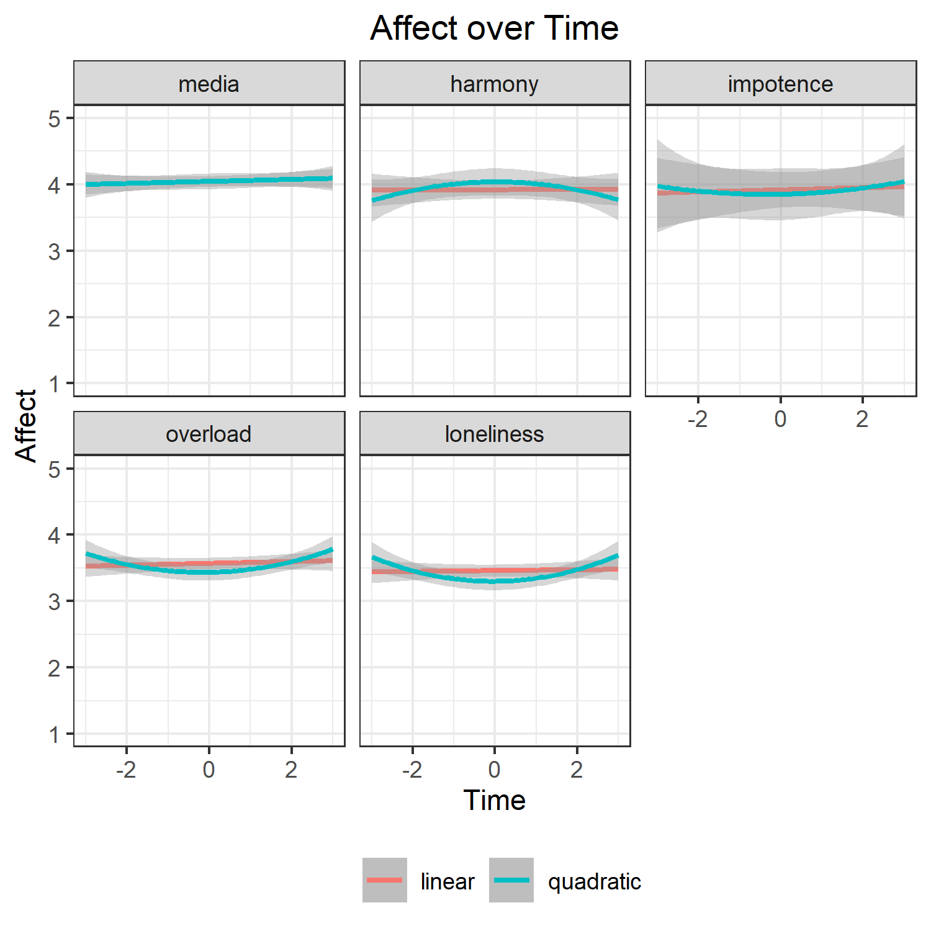
Figure S5 – Study 2. Time-course of affect (t=0: crying day).

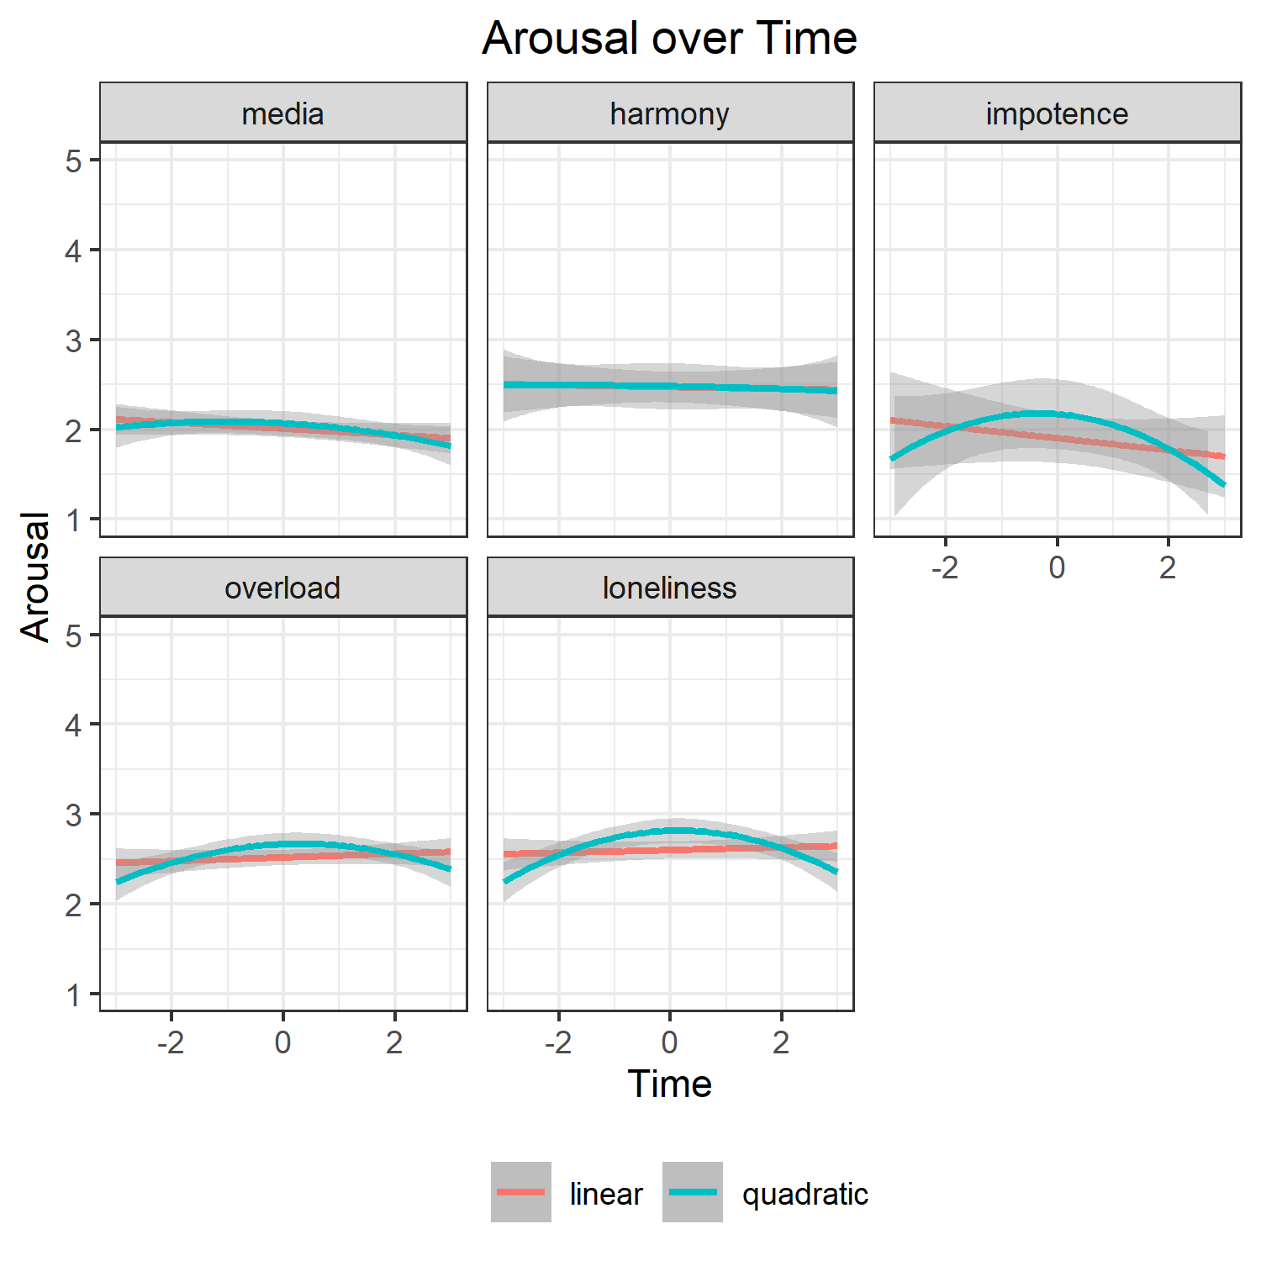
Figure S6 – Study 2. Time-course of arousal (t=0: crying day).

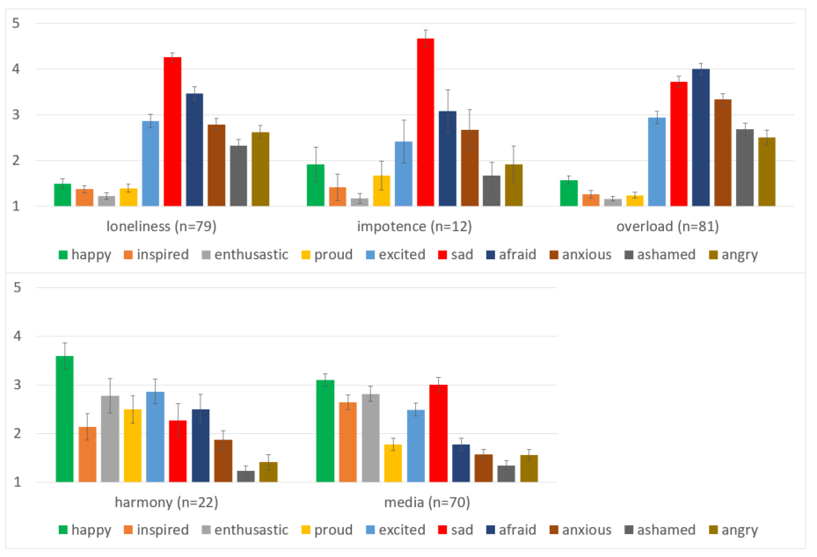
Figure S7 – Study 2. Emotion intensity for FRC. Error-bars denote +/- 1 SE.

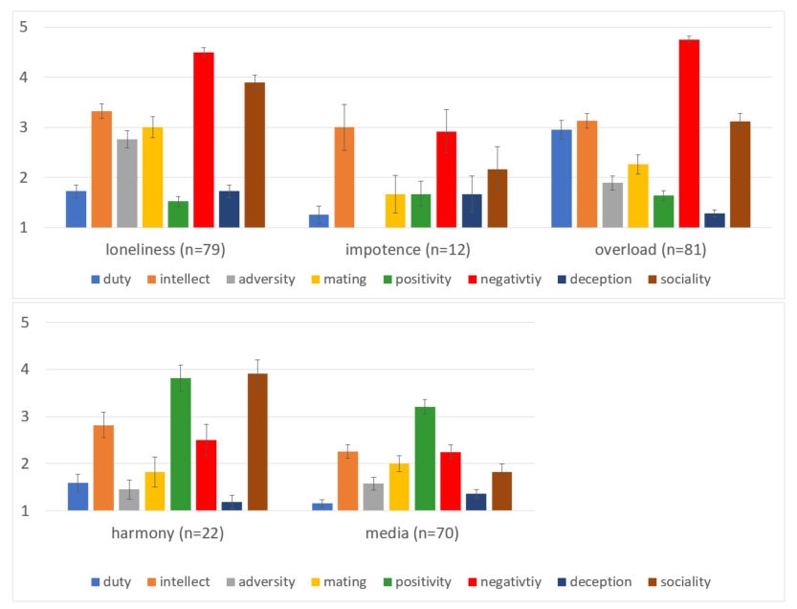
Figure S8 – Study 2. 8 DIAMONDS for FRC. Error-bars denote +/- 1 SE

