Seizing and Freezing to Life Outcomes: Need for Cognitive Closure Intensifies Affective Reactions to Major Events

Seung Eun Cha^{1,2}, Xyle Ku³, Soeun Sarah Lee³, and Incheol Choi^{3,4}
¹ Department of Psychology, University of Wisconsin-Madison
² Institute on Aging, University of Wisconsin-Madison
³ Department of Psychology, Seoul National University
⁴ Center for Happiness Studies, Seoul National University

Motivation and Emotion
Online Supplemental Material
Table S1
Descriptive Statistics and Bivariate Correlations in Study 1
 | M (SD) | Age | Gender | Ethnicity | Baseline AWB_1 | Baseline AWB_2 | Event nature | Event  importance | DSS | Event | NFC | AWB_1 | AWB_2
Age | 44.89 (13.37) | 1 | $-$.023 | $-$.200*** | .134* | .145* | .214*** | .176** | $-$.244*** | .022 | $-$.090 | .078 | .089
Gender | - |  | 1 | $-$.097 | $-$.117* | $-$.099 | .038 | .130* | $-$.072 | $-$.017 | .167** | $-$.064 | $-$.111
Ethnicity | - |  |  | 1 | .118* | .070 | $-$.051 | $-$.095 | .092 | .028 | $-$.041 | .061 | .052
Baseline AWB_1 | 2.37 (4.71) |  |  |  | 1 | .881*** | .003 | $-$.063 | $-$.363*** | .064 | $-$.157** | .444*** | .455**
Baseline AWB_2 | 2.58 (4.20) |  |  |  |  | 1 | .034 | $-$.010 | $-$.415** | .093 | $-$.154** | .442** | .505**
Event  nature | 2.04 (2.08) |  |  |  |  |  | 1 | .077 | $-$.084 | $-$.191** | $-$.070 | $-$.234*** | $-$.199***
Event importance | 6.40 (1.11) |  |  |  |  |  |  | 1 | $-$.085 | .116 | .081 | .042 | .050
DSS | 3.03  (.97) |  |  |  |  |  |  |  | 1 | $-$.015 | .023 | $-$.185** | $-$.183**
Event | - |  |  |  |  |  |  |  |  | 1 | .009 | .706*** | .694**
NFC | 4.18 (.83) |  |  |  |  |  |  |  |  |  | 1 | $-$.099 | $-$.151*
AWB_1 | 1.79 (6.12) |  |  |  |  |  |  |  |  |  |  | 1 | .939***
AWB_2 | 2.36 (5.60) |  |  |  |  |  |  |  |  |  |  |  | 1
Note. AWB = Affective Well-Being. Event (1 = Negative event, 2 = Positive event). AWB_1 indicates six-item affective well-being measure described in the manuscript and AWB_2 indicates affective well-being measured by PANAS short version. DSS = Dialectical Self-Scale. * p < .05, ** p < .01, *** p < .001.

Table S2
Regression Analyses in Study 1
Six-item measure
Variables | B | SE | p
Intercept | $-$11.28 | 1.78 | <.0001
Age | .00 | .02 | .97
Gender | $-$.08 | .46 | .86
Ethnicity | .21 | .56 | .71
Baseline affective well-being | .50 | .05 | <.0001
Dialectical self | $-$.24 | .24 | .33
Event | 8.31 | .43 | <.0001
NFC | $-$2.48 | .83 | .003
Event $×$ NFC | 1.43 | .52 | .007
PANAS short-version
Variables | B | SE | p
Intercept | $-$9.56 | 1.57 | <.0001
Age | .00 | .01 | .83
Gender | $-$.55 | .40 | .17
Ethnicity | .21 | .49 | .66
Baseline affective well-being | .57 | .05 | <.0001
Dialectical self | .00 | .22 | .98
Event | 7.31 | .37 | <.0001
NFC | $-$2.81 | .73 | .001
Event $×$ NFC | 1.48 | .45 | .001

Study 1
Additional Analyses
We conducted two additional analyses. First, since individuals who perceive the event as highly significant are more likely to experience substantial emotional consequences (Verduyn et al., 2011), we additionally measured the event importance with Verduyn et al.’s (2011) single-item scale (i.e., “How important was this event or situation?”; 0 = “not important at all” to 7 = “very important”). Using Process Macro model 3 (Hayes, 2013), we examined whether the predicted two-way interaction between the event condition and NFC was qualified by how much the event was important to the experiencer. The results indicated that that was not the case (B = .27, SE = .60, p = .65, 95% CI [$-$.91, 1.45]), which suggests that the moderating role of NFC in affective well-being remained constant regardless of the event importance.
Second, we examined whether the content of the event influences the effects of NFC, as participants recalled various major events ranging from passing an important exam to political events. To do so, we recruited two trained research assistants who reviewed the writing task that the participants completed and coded whether their responses were personal (e.g., passing an important exam) or societal (e.g., the presidential election) events on a 7-point Likert scale (1 = “highly personal event” to 7 = “highly societal event”). As the inter-rater reliability computed by intraclass correlation coefficient (ICC) was high, ICC(1) = .91, p < .001, the two coders’ indices were averaged to form a single index of event nature. We then tested the three-way interaction between the event condition, NFC, and the event nature on the recalled affective well-being using Process Macro model 3 (Hayes, 2013). The results indicated that the three-way interaction was not significant (B = $-$.21, SE = .35, p = .54, 95% CI [$-$.90, .47]), suggesting that the effect of NFC on recalled affective well-being was not influenced by the degree of how much experienced major event was personal or societal.
Table S3
Descriptive Statistics and Bivariate Correlations in Study 2
 | M (SD) | Age | Gender | Ethnicity | Baseline AWB_1 | Baseline AWB_2 | Event | NFC | AWB_1 | AWB_2
Age | 42.30 (12.90) | 1 | $-$.061 | $-$.243*** | .215*** | .197*** | $-$.019 | $-$.132* | .038 | .120*
Gender | - |  | 1 | $-$.019 | $-$.108 | $-$.116* | .067 | .317*** | $-$.007 | $-$.038
Ethnicity | - |  |  | 1 | $-$.006 | .011 | .021 | .005 | .027 | .010
Baseline AWB_1 | 3.39 (4.83) |  |  |  | 1 | .881*** | .011 | $-$.195*** | .209*** | .283***
Baseline AWB_2 | 3.68 (4.06) |  |  |  |  | 1 | .098 | $-$.161* | .316*** | .416***
Event | - |  |  |  |  |  | 1 | $-$.057 | .841*** | .780***
NFC | 4.04 (.61) |  |  |  |  |  |  | 1 | $-$.142* | $-$.168**
AWB_1 | 1.25 (6.50) |  |  |  |  |  |  |  | 1 | .944***
AWB_2 | 2.47 (5.89) |  |  |  |  |  |  |  |  | 1
Note. AWB = Affective Well-Being. Event (1 = Negative event, 2 = Positive event). AWB_1 indicates the six-item affective well-being measure described in the manuscript, and AWB_2 indicates affective well-being measured by PANAS short version. * p < .05, ** p < .01, *** p < .001.

Table S4
Regression Analyses in Study 2
Six-item measure
Variables | B | SE | p
Intercept | $-$16.35 | 1.34 | <.0001
Age | .01 | .02 | .71
Gender | $-$.38 | .42 | .36
Ethnicity | .25 | .50 | .61
Baseline affective well-being | .26 | .04 | <.0001
Event | 10.91 | .39 | <.0001
NFC | $-$2.85 | .99 | .004
Event $×$ NFC | 1.61 | .64 | .013
PANAS short-version
Variables | B | SE | p
Intercept | $-$13.71 | 1.26 | <.0001
Age | .03 | .01 | .04
Gender | $-$.38 | .39 | .34
Ethnicity | .14 | .47 | .77
Baseline affective well-being | .46 | .05 | <.0001
Event | 8.84 | .37 | <.0001
NFC | $-$2.76 | .93 | .003
Event $×$ NFC | 1.53 | .60 | .011

Table S5
Descriptive Statistics and Bivariate Correlations in Study 3
 | M (SD) | Age | Gender | SES | PO | Support | NFC | Win AWB | Lose AWB | T1 AWB | T2 AWB | T3 AWB | T4 AWB
Age | 47.05 (13.07) | 1 | .054* | .014 | $-$.027 | .021 | .111*** | .344*** | $-$.111*** | .172*** | .095** | .146*** | .117***
Gender | - |  | 1 | .022 | $-$.037 | $-$.013 | .090*** | $-$.072** | $-$.003 | .042 | $-$.005 | .028 | .039
SES | 5.26 (1.71) |  |  | 1 | .057* | .115*** | .067** | .104*** | .065** | .346*** | .332*** | .362*** | .342***
PO | 3.94 (1.27) |  |  |  | 1 | .561*** | .077*** | $-$.048* | .034 | $-$.016 | .163*** | .092** | .064
Support | - |  |  |  |  | 1 | .071** | $-$.062** | .015 | .026 | .213*** | .130*** | .077*
NFC | 4.02 (0.64) |  |  |  |  |  | 1 | .125*** | $-$.149*** | $-$.069** | $-$.026 | $-$.039 | $-$.030
Win AWB | 3.46 (3.29) |  |  |  |  |  |  | 1 | $-$.396*** | .337*** | .155*** | .280*** | .267***
Lose AWB | $-$2.48 (3.52) |  |  |  |  |  |  |  | 1 | .081** | .144*** | .082** | .094**
T1 AWB | 1.76 (3.63) |  |  |  |  |  |  |  |  | 1 | .655*** | .734*** | .736***
T2 AWB | 1.13 (4.19) |  |  |  |  |  |  |  |  |  | 1 | .778*** | .775***
T3 AWB | 1.62 (4.17) |  |  |  |  |  |  |  |  |  |  | 1 | .859***
T4 AWB | 1.77 (4.17) |  |  |  |  |  |  |  |  |  |  |  | 1
Note. PO = Political Orientation. AWB = Affective Well-Being. Win (Lose) AWB = Predicted AWB for positive (negative) election outcome. Gender (1 = male, 2 = female). Support (1 = Loser (Lee supporter), 2 = Winner (Yoon supporter)). * p < .05, ** p < .01, *** p < .001.
Table S6
Descriptives of Variables at Each Time Point in Study 3
 |  | NFC |  | Political orientation |  | Subjective socio-economic status |  | Age |  | Gender | Attrition rate
Support | N | M | SD | M | SD | M | SD | M | SD | N (male %)
T1
Loser | 1,034 | 3.98 | .63 | 3.31 | 1.04 | 5.09 | 1.68 | 46.81 | 11.86 | 56.3%
Winner | 799 | 4.07 | .65 | 4.75 | 1.08 | 5.49 | 1.73 | 47.36 | 14.48 | 57.6%
T2 |  |  |  |  |  |  |  |  |  |  | 35%
Loser | 582 | 4.00 | .60 | 3.31 | 1.02 | 5.09 | 1.69 | 47.85 | 11.93 | 56.2%
Winner | 609 | 4.10 | .64 | 4.77 | 1.10 | 5.41 | 1.73 | 48.59 | 14.38 | 58.1%
T3 |  |  |  |  |  |  |  |  |  |  | 17%
Loser | 474 | 3.97 | .59 | 3.29 | .98 | 5.10 | 1.64 | 48.25 | 11.77 | 58%
Winner | 510 | 4.10 | .65 | 4.78 | 1.11 | 5.39 | 1.76 | 49.22 | 14.17 | 59.2%
T4 |  |  |  |  |  |  |  |  |  |  | 14%
Loser | 398 | 3.95 | .58 | 3.30 | .98 | 5.12 | 1.63 | 48.60 | 11.74 | 60.8%
Winner | 444 | 4.13 | .63 | 4.79 | 1.12 | 5.37 | 1.78 | 50.15 | 13.91 | 59.7%

Figure S1
Two-way Interaction of NFC and Support in Study 3 Predicted Affective Well-Being for the Hypothetical Election Outcome
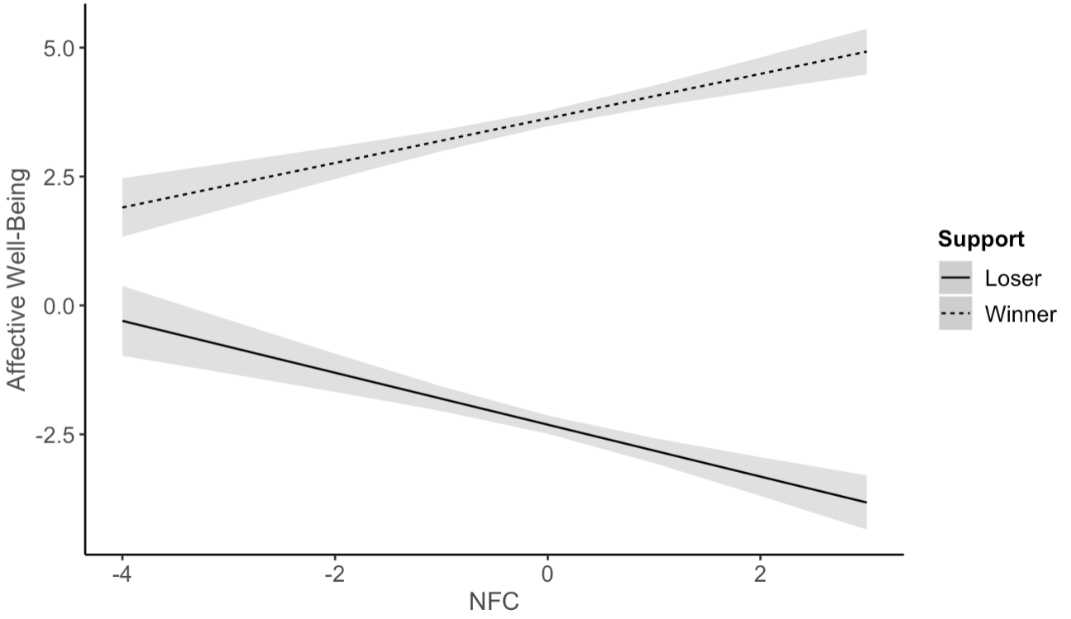
Note. Shaded areas indicate 95% confidence intervals. Solid line indicates when participants imagined losing (i.e., hypothetical loser), and the dashed line indicates when participants imagined winning (i.e., hypothetical winner).

Study 3
Overall Affective Well-Being Trajectories of the Presidential Election
We investigated the general affective well-being trajectories around when the 20th presidential election took place in South Korea. To do so, we regressed the two-way interaction of ${time}^{3}$ X support to affective well-being, while controlling for the demographic variables (see Table S7). The results indicated that which candidate participants supported significantly interacted with the${time}^{3}$ (B = .42, SE = .09, p < .001). For further analysis, we conducted pairwise comparisons between who they supported at each time point (see Table S8). Specifically, there were no significant differences in the affective well-being between the supporters of Lee and Yoon at Time 1, which was before the election ($t_{(loser-winner)}$= .52, p = .60). However, significant differences emerged between the supporters on the day after the finalization of the election outcome ($t_{(loser-winner)}$= – 7.42, p < .0001), in that those who supported the loser (i.e., negative event) showed much worse affective well-being than those who supported the winner (i.e., positive event). These differences remained significant throughout Time 3 and Time 4, despite showing lesser differences as the time proceeded ($t_{(loser-winner)}$= – 4.40, p < .0001; $t_{(loser-winner)}$= – 2.53, p = .01). To sum up, the presidential election outcome significantly altered the general affective well-being trajectories across six weeks.
Figure S2
Two-way Interaction of the Time and Support in Study 3
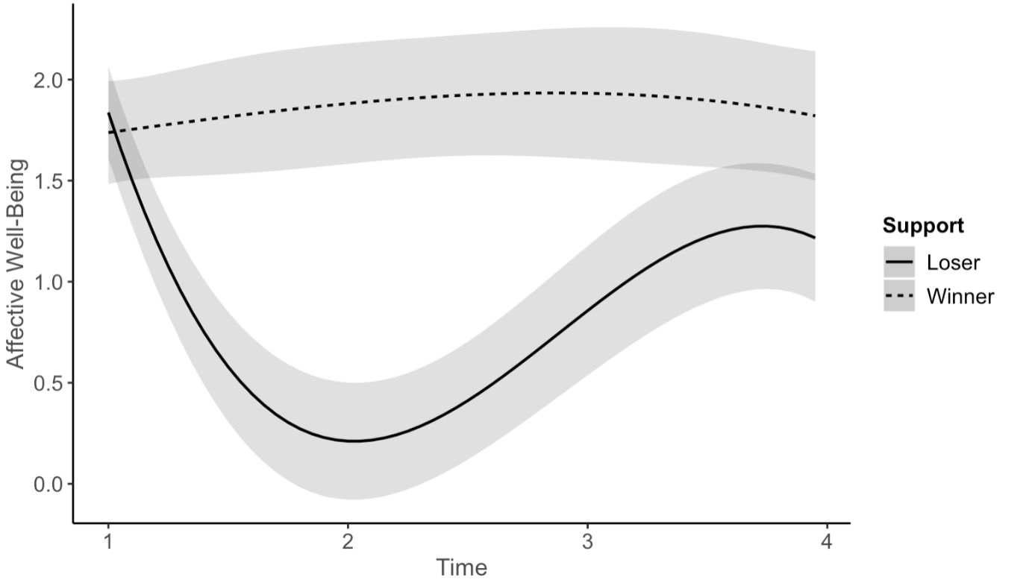
Note. Shaded areas indicate 95% confidence intervals. The X-axis indicates the four-time points, and the Y-axis indicates affective well-being. Solid line indicates participants who supported the loser (1 = Lee supporter), and dotted line indicates participants who supported the winner (2 = Yoon supporter).
Table S7
Estimates and Standard Errors of Multilevel Regression Analysis for the General Trends in Study 3
 | B | SE
Intercept | 8.24*** | .68
Controls
Age | .04*** | .01
Gender | .11 | .15
PO | $-$.02 | .07
SES | .74*** | .04
Independent variables
Support | $-$6.74*** | .96
Time | $-$9.78*** | 1.06
$${Time}^{2}$$ | 3.72*** | .48
$${Time}^{3}$$ | $-$.43*** | .06
Two-way interaction
Time $×$ Support | 9.91*** | 1.48
${Time}^{2}$ $×$ Support | $-$3.69*** | .66
${Time}^{3}$ $×$ Support | .42*** | .09
Note. PO = Political Orientation. Gender (1 = male, 2 = female). Support (1 = Loser (Lee supporter), 2 = Winner (Yoon supporter)). * p < .05., ** p < .01, *** p < .001.

Table S8
Pairwise Contrasts of the Support at Each Time Point in Study 3
Time | Estimate | SE | t | p
1 | .10 | .19 | .52 | .60
2 | $-$1.67 | .23 | $-$7.42 | < .0001
3 | $-$1.08 | .25 | $-$4.40 | < .0001
4 | $-$.62 | .25 | $-$2.53 | .01

Table S9
Model Comparisons in Study 3
 | Unconditional model |  |  | Time model |  |  | ${Time}^{2}$ model |  |  | ${Time}^{3}$ model
 | B |  | SE | B | SE |  | B | SE | B |  |  | SE
Intercept | 1.53*** |  | .08 | 1.67*** | .09 |  | 2.66*** | .17 | 4.83*** |  |  | .48
Time |  |  |  | $-$.08** | .03 |  | $-$1.16*** | .16 | $-$4.69*** |  |  | .75
$${Time}^{2}$$ |  |  |  |  |  |  | .22*** | .03 | 1.83*** |  |  | .34
$${Time}^{3}$$ |  |  |  |  |  |  |  |  | $-$.22*** |  |  | .05
 |  |  |  |  |  | Model comparisons
$${∆x}^{2}$$ |  |  |  |  |  | 77.95 |  | 89.95 |  |  | 16.03
p |  |  |  |  |  | < .001 |  | < .001 |  |  | .007

References
Hayes A. F. (2013). Introduction to mediation, moderation, and conditional process analysis: A regression-based approach. The Guilford Press.
Verduyn, P., Van Mechelen, I., & Tuerlinckx, F. (2011). The relation between event processing and the duration of emotional experience. Emotion, 11(1), 20-28. https://doi.org/10.1037/a0021239

