Figure S1
Assessments of Warmth Regarding the Type of Anomaly (Palsy vs. Scar), Including Individual Differences in Emphatic Concern
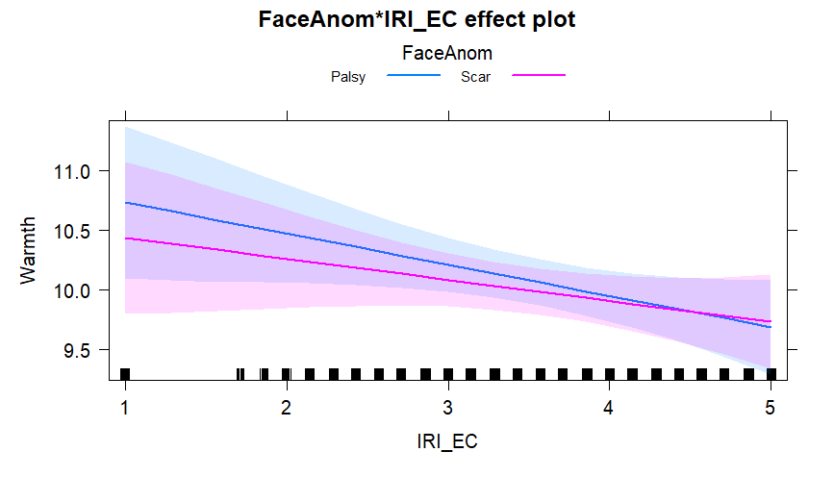
Figure S2
Assessments of Warmth Regarding the Type of Anomaly (Palsy vs. Scar), Including Individual Differences in Perspective Taking
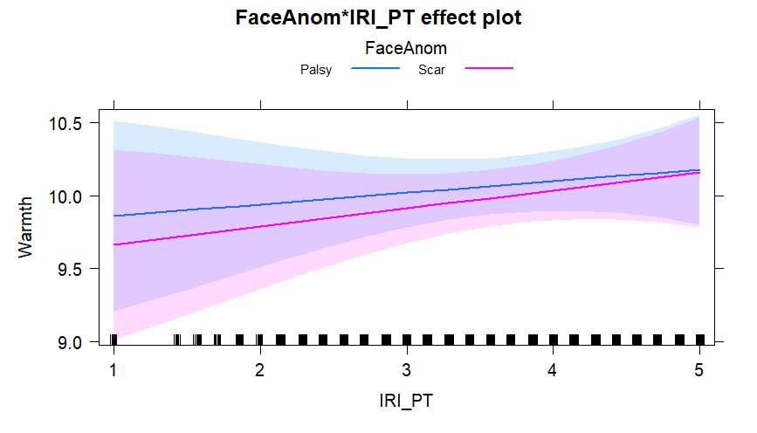

Figure S3
Assessments of Warmth Regarding the Type of Anomaly (Palsy vs. Scar), Including Individual Differences in Personal Distress
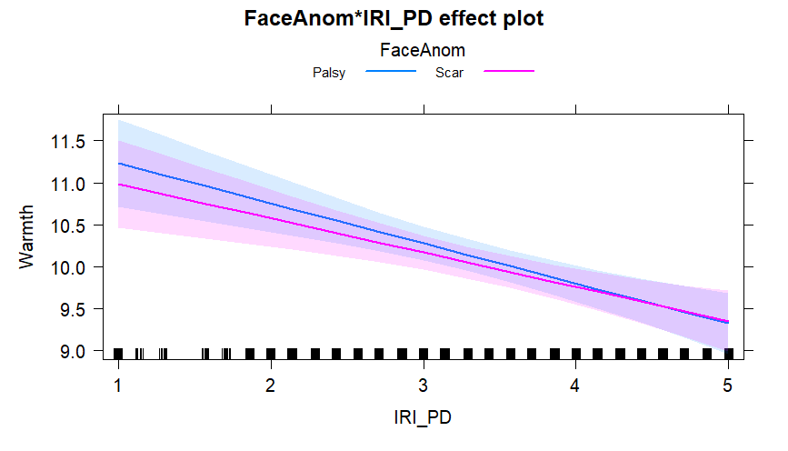
Figure S4
Assessments of Competence Regarding the Type of Anomaly (Palsy vs. Scar), Including Individual Differences in Emphatic Concern

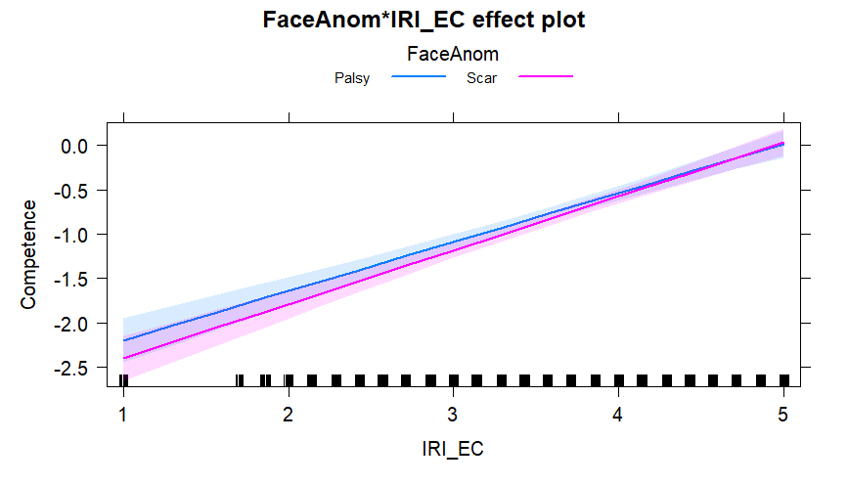
Figure S5
Assessments of Competence Regarding the Type of Anomaly (Palsy vs. Scar), Including Individual Differences in Perspective Taking
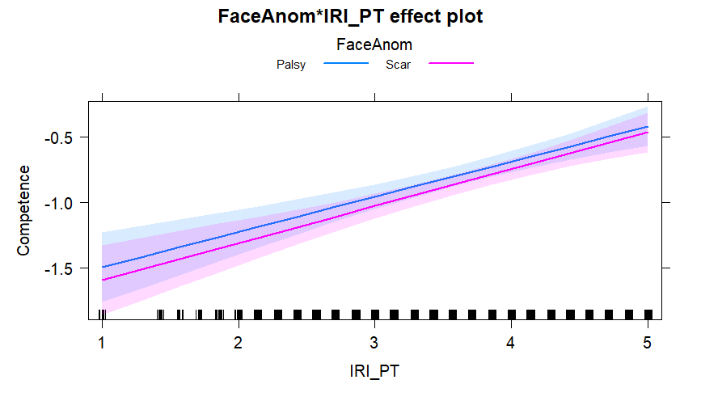
Figure S6
Assessments of Competence Regarding the Type of Anomaly (Palsy vs. Scar), Including Individual Differences in Personal Distress
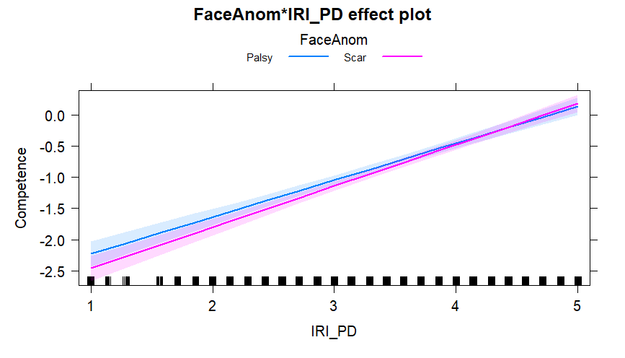
Figure S7
Assessments of Mechanistic Dehumanization Regarding the Type of Anomaly (Palsy vs. Scar), Including Individual Differences in Emphatic Concern
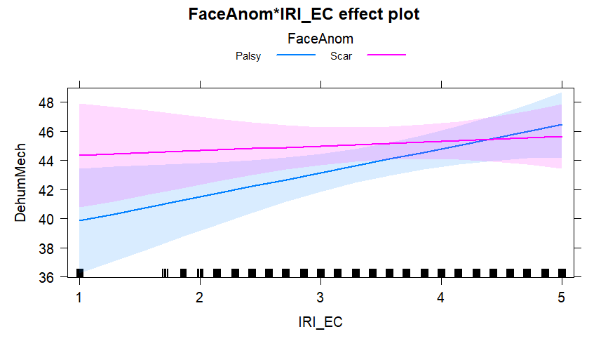

Figure S8
Assessments of Mechanistic Dehumanization Regarding the Type of Anomaly (Palsy vs. Scar), Including Individual Differences in Perspective Taking
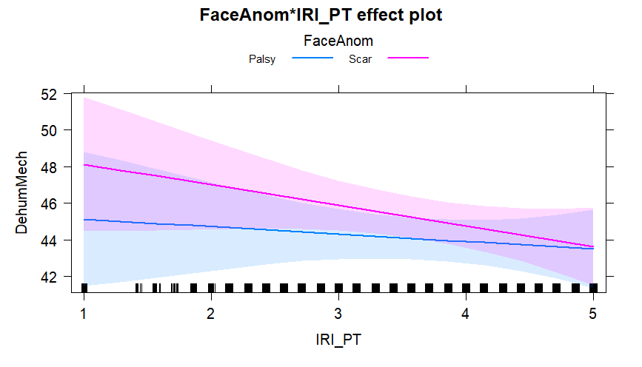
Figure S9
Assessments of Mechanistic Dehumanization Regarding the Type of Anomaly (Palsy vs. Scar), Including Individual Differences in Personal Distress
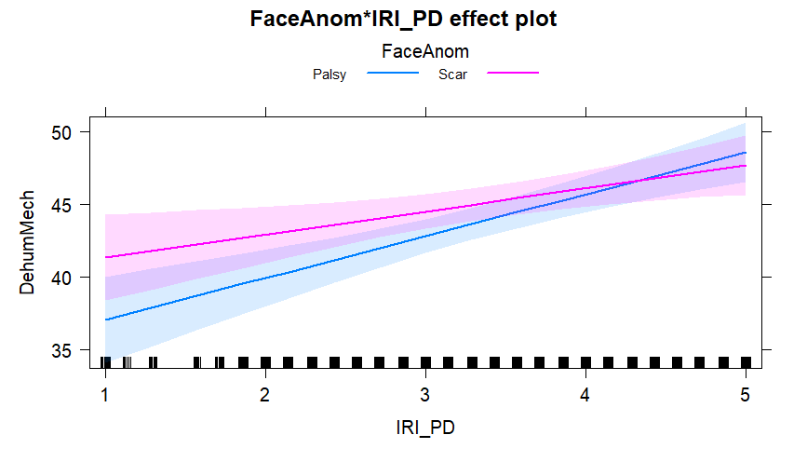
Figure S10
Assessments of Animalistic Dehumanization Regarding the Type of Anomaly (Palsy vs. Scar), Including Individual Differences in Emphatic Concern
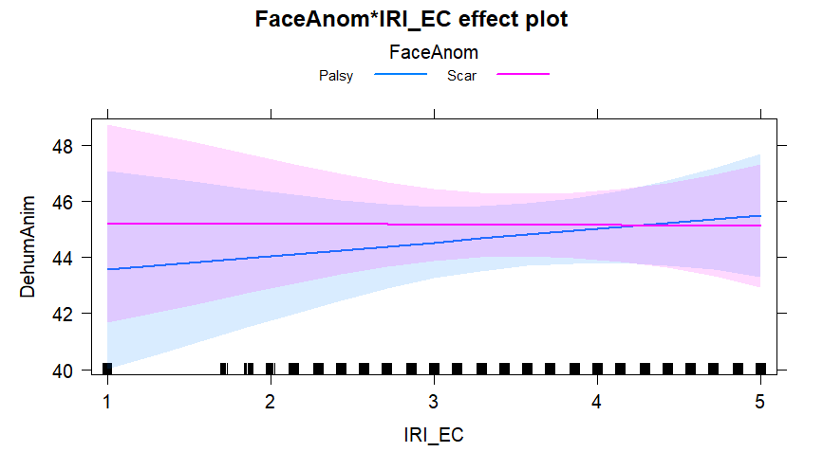

Figure S11
Assessments of Animalistic Dehumanization Regarding the Type of Anomaly (Palsy vs. Scar), Including Individual Differences in Perspective Taking
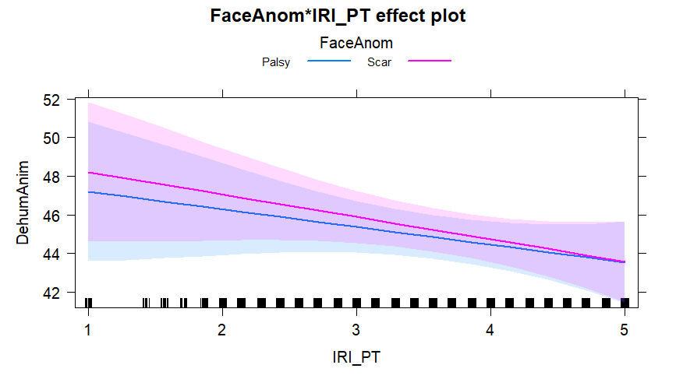
Figure S12
Assessments of Animalistic Dehumanization Regarding the Type of Anomaly (Palsy vs. Scar), Including Individual Differences in Personal Distress
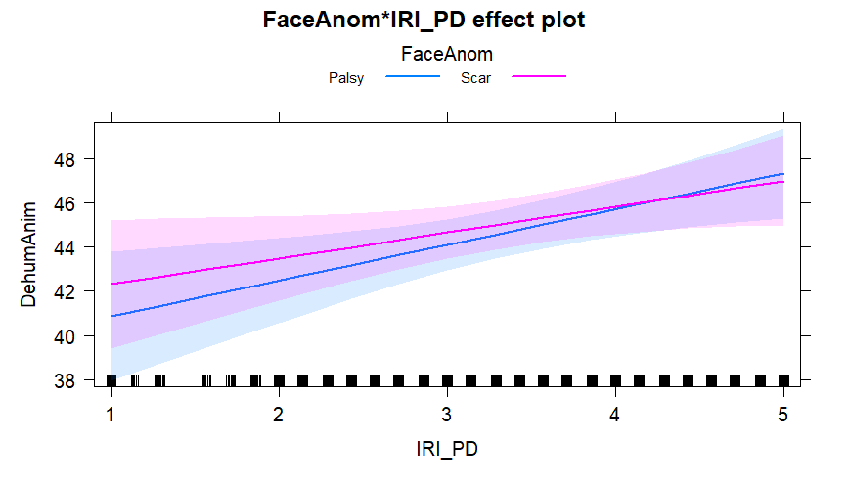
Figure S13
Assessments of Warmth Regarding the Type of Anomaly (Palsy vs. Scar), Including Individual Differences in Sensitivity to Pathogen Disgust
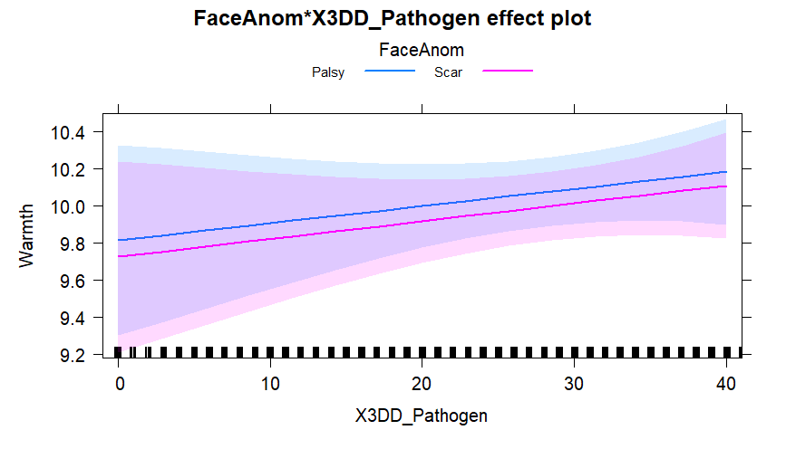

Figure S14
Assessments of Warmth Regarding the Type of Anomaly (Palsy vs. Scar), Including Individual Differences in Sensitivity to Sexual Disgust
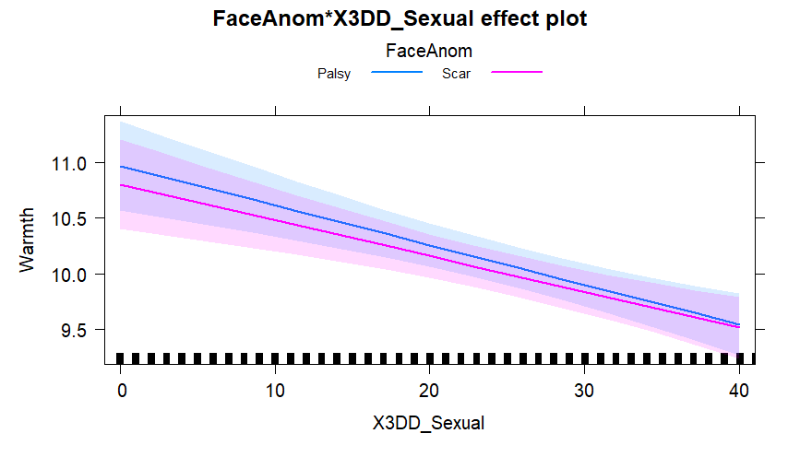
Figure S15
Assessments of Warmth Regarding the Type of Anomaly (Palsy vs. Scar), Including Individual Differences in Sensitivity to Moral Disgust
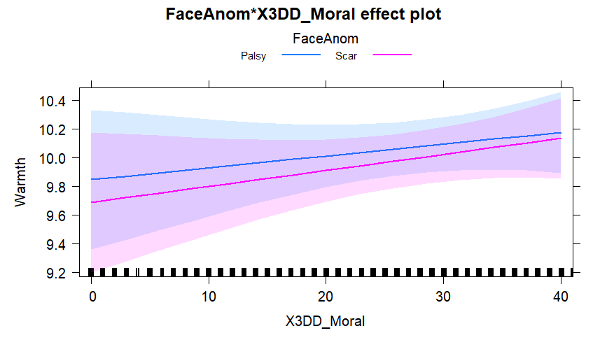

Figure S16
Assessments of Competence Regarding the Type of Anomaly (Palsy vs. Scar), Including Individual Differences in Sensitivity to Pathogen Disgust
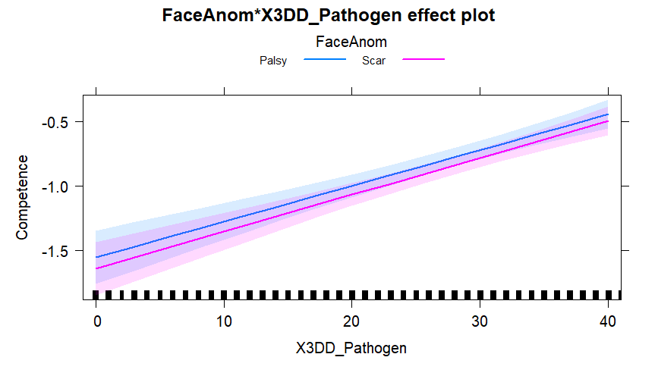
Figure S17
Assessments of Competence Regarding the Type of Anomaly (Palsy vs. Scar), Including Individual Differences in Sensitivity to Moral Disgust
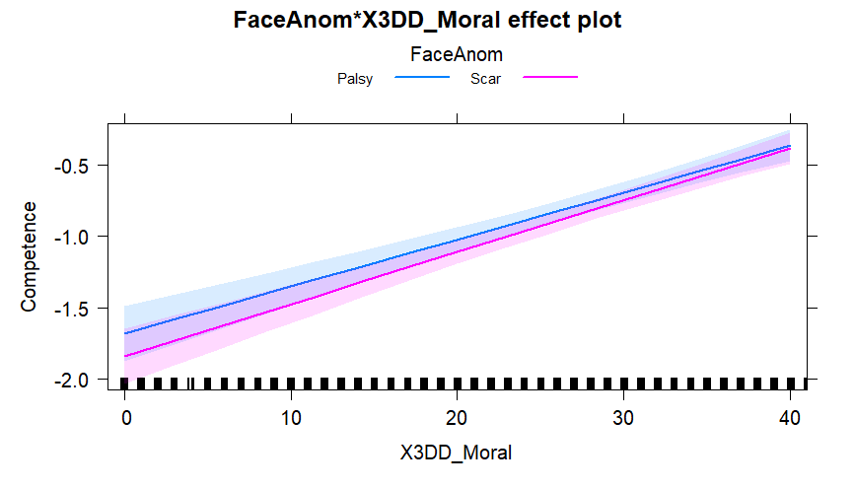
Figure S18
Assessments of Competence Regarding the Type of Anomaly (Palsy vs. Scar), Including Individual Differences in Sensitivity to Sexual Disgust
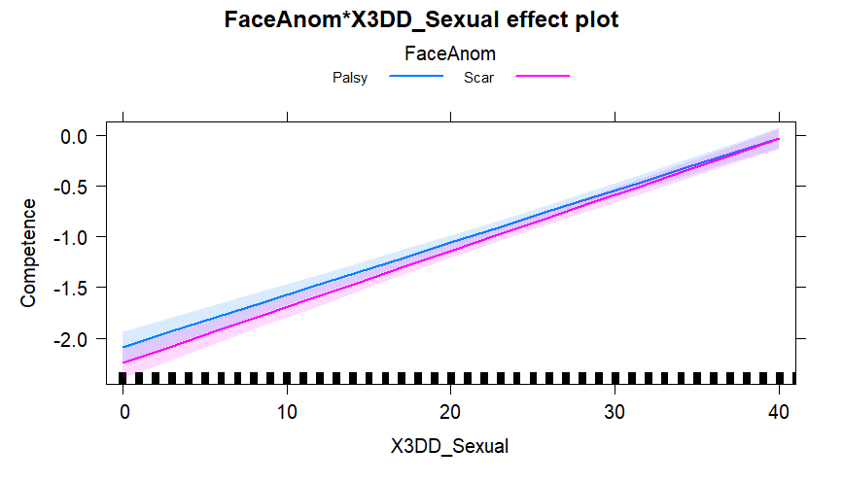
Figure S19
Assessments of Mechanistic Dehumanization Regarding the Type of Anomaly (Palsy vs. Scar), Including Individual Differences in Sensitivity to Pathogen Disgust
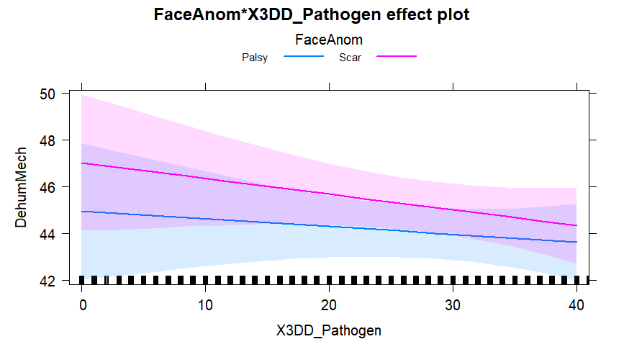
Figure S20
Assessments of Mechanistic Dehumanization Regarding the Type of Anomaly (Palsy vs. Scar), Including Individual Differences in Sensitivity to Moral Disgust
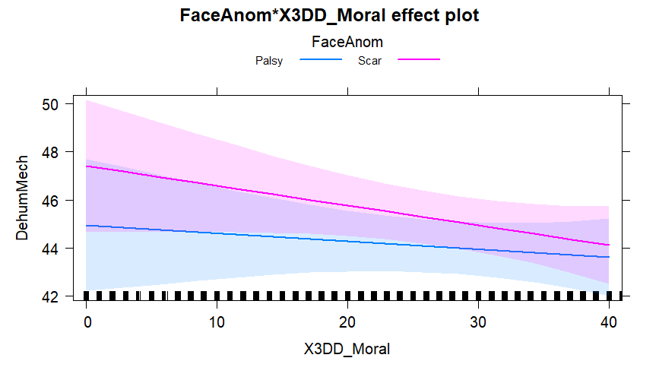

Figure S21
Assessments of Mechanistic Dehumanization Regarding the Type of Anomaly (Palsy vs. Scar), Including Individual Differences in Sensitivity to Sexual Disgust

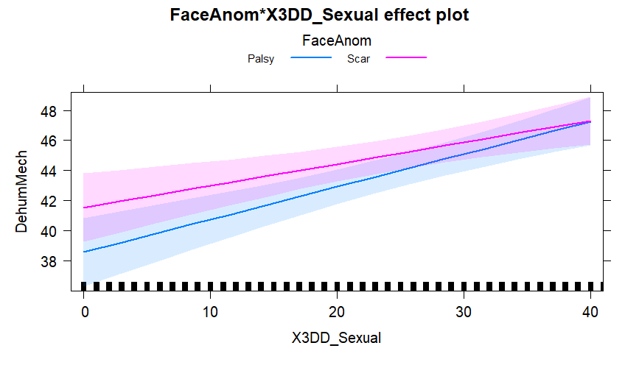
Figure S22
Assessments of Animalistic Dehumanization Regarding the Type of Anomaly (Palsy vs. Scar), Including Individual Differences in Sensitivity to Pathogen Disgust
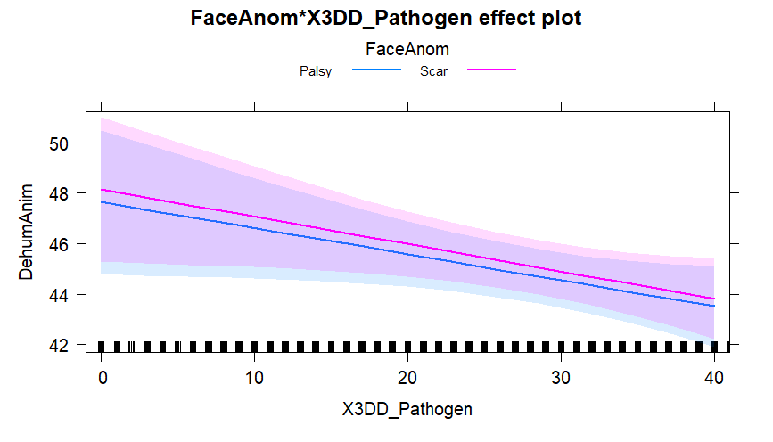
Figure S23
Assessments of Animalistic Dehumanization Regarding the Type of Anomaly (Palsy vs. Scar), Including Individual Differences in Sensitivity to Moral Disgust
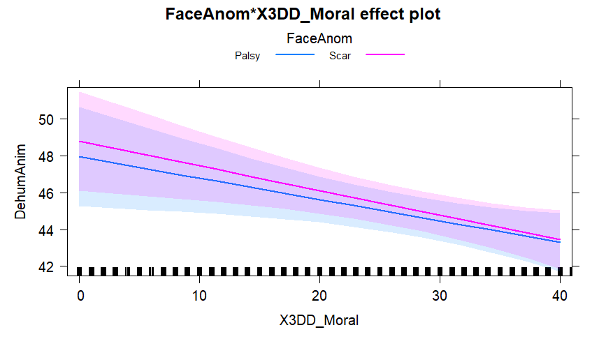
Figure S24
Assessments of Animalistic Dehumanization Regarding the Type of Anomaly (Palsy vs. Scar), Including Individual Differences in Sensitivity to Sexual Disgust
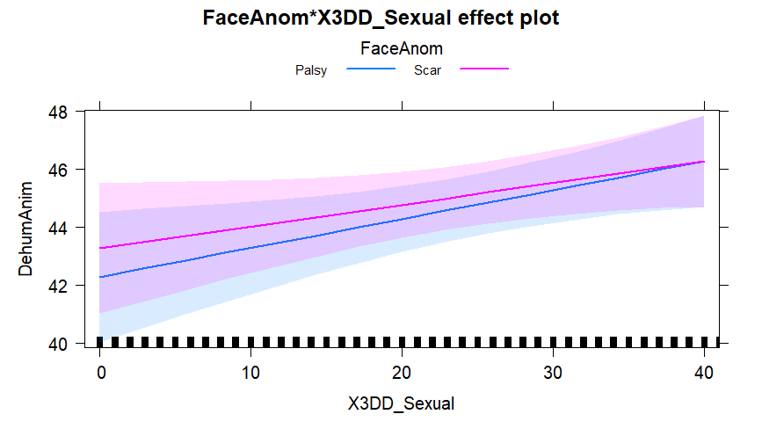
Simple Slopes Analyses for Empathy
To follow up significant interactions between anomaly type and empathy subscales, we performed simple slopes analyses to examine differences in perceived competence and mechanistic dehumanization across levels (−1 SD, mean, +1 SD) of empathic concern, personal distress, and perspective taking.

Competence × Empathic Concern
At low levels of empathic concern, participants rated palsy faces as significantly more competent than scarred faces, b = 0.097, SE = 0.031, z = 3.14, p = .002. This effect was also significant at the mean level, b = 0.063, SE = 0.029, z = 2.19, p = .029, but was no longer significant at high levels, b = 0.029, SE = 0.031, z = 0.93, p = .352.

Competence × Personal Distress
A similar pattern was found for personal distress. Participants with low levels of personal distress rated palsy faces as more competent than scarred faces, b = 0.114, SE = 0.031, z = 3.68, p = .0002. This effect was significant at the mean level, b = 0.063, SE = 0.029, z = 2.19, p = .029, but not at high levels, b = 0.012, SE = 0.031, z = 0.39, p = .693.

Mechanistic Dehumanization × Empathic Concern
At low empathic concern, participants attributed significantly more mechanistic dehumanization to palsy than to scarred faces, b = -1.945, SE = 0.545, z = -3.57, p = .0004. This pattern persisted at the mean level, b = -1.128, SE = 0.519, z = -2.17, p = .030, but disappeared at high levels, b = -0.311, SE = 0.545, z = -0.57, p = .568.

Mechanistic Dehumanization × Perspective Taking
At low levels of perspective taking, participants rated palsy faces as more mechanistically dehumanized than scarred faces, b = -1.574, SE = 0.545, z = -2.89, p = .004. The effect remained significant at the mean, b = -1.129, SE = 0.519, z = -2.18, p = .030, but not at high levels, b = -0.685, SE = 0.544, z = -1.26, p = .208.

Mechanistic Dehumanization × Personal Distress
Participants with low personal distress reported greater mechanistic dehumanization for palsy compared to scarred faces, b = -2.072, SE = 0.544, z = -3.81, p < .001. The difference remained significant at the mean, b = -1.130, SE = 0.518, z = -2.18, p = .029, but was no longer significant at high levels, b = -0.188, SE = 0.544, z = -0.35, p = .730.
Simple Slopes Analyses for Sensitivity to Disgust
To further examine the significant interactions between facial anomaly type and disgust sensitivity on competence and mechanistic dehumanization ratings, we conducted simple slopes analyses probing the effects of anomaly type at low (−1 SD), mean, and high (+1 SD) levels of the relevant disgust subscales.
Competence × Moral Disgust
At low levels of moral disgust sensitivity, individuals rated palsy faces as significantly more competent than scarred faces, b = 0.094, SE = 0.031, z = 3.04, p = .002. This effect remained significant at mean levels, b = 0.063, SE = 0.029, z = 2.19, p = .029, but was no longer significant at high levels of moral disgust, b = 0.032, SE = 0.031, z = 1.04, p = .299.
Competence × Sexual Disgust
Similarly, for sexual disgust, participants low in sensitivity rated palsy faces as significantly more competent than scarred faces, b = 0.103, SE = 0.031, z = 3.33, p = .001. This difference was also significant at the mean, b = 0.064, SE = 0.029, z = 2.21, p = .027, but not at the high level, b = 0.024, SE = 0.031, z = 0.78, p = .437.
Mechanistic Dehumanization × Moral Disgust
At low levels of moral disgust, participants attributed significantly more mechanistic dehumanization to palsy faces than to scarred faces, b = -1.567, SE = 0.544, z = -2.88, p = .004. This difference persisted at mean levels, b = -1.126, SE = 0.519, z = -2.17, p = .030, but was not significant at high levels, b = -0.686, SE = 0.544, z = -1.26, p = .207.
Mechanistic Dehumanization × Sexual Disgust
The same pattern emerged for sexual disgust. At low levels, participants again perceived palsy faces as more mechanistically dehumanized than scarred faces, b = -1.885, SE = 0.545, z = -3.46, p = .001. This effect remained significant at the mean, b = -1.128, SE = 0.519, z = -2.17, p = .030, but disappeared at the high level, b = -0.372, SE = 0.544, z = -0.68, p = .494.

