Supplement
Self-determination: Independent effects of choice and affective processing
on the late positive potential (LPP)

Supplement - Experiment 1
The following descriptions are typical examples of positive and negative image content by category. Positive pictures included smiling/laughing people (human), houses or architectural details with palm trees (buildings), joyful people on bicycles or in roller-coaster cars (vehicles), idyllic landscapes (nature), animal babies (animals), fans cheering at a soccer match (action), a pleasantly laid dining table (utensil), and wide, open street scenes (street). Negative pictures comprised crying individuals (human), damaged or destroyed buildings (buildings), cars photographed after accidents (vehicles), trash on the street (nature), an injured dog (animal), violent scenes involving weapons (action), images of weapons (utensil), and violent street protests (street). Neutral sets contained category-typical scenes with minimal affective load.
Table 1
Picture stimuli by category, database, and valence
Category | Name picture | Database | Valence
Building | Landscapes_035_v.jpg | NAPS (Nencki) | positive
Building | Landscapes_054_h.jpg | NAPS (Nencki) | positive
Building | 5779.jpg | IAPS | positive
Building | 7545.jpg | IAPS | positive
Building | 9470.jpg | IAPS | negative
Building | 9471.jpg | IAPS | negative
Building | 9921.jpg | IAPS | negative
Building | 9925.jpg | IAPS | negative
Building | 2541.jpg | IAPS | neutral
Building | 7180.jpg | IAPS | neutral
Building | 7491.jpg | IAPS | neutral
Building | 7500.jpg | IAPS | neutral
Human | 2340.jpg | IAPS | positive
Human | Faces_116_h.jpg | NAPS (Nencki) | positive
Human | Faces_127_h.jpg | NAPS (Nencki) | positive
Human | 2057.jpg | IAPS | positive
Human | People_125_h.jpg | NAPS (Nencki) | negative
Human | 2800.jpg | IAPS | negative
Human | People_001_h.jpg | NAPS (Nencki) | negative
Human | Faces_290_h.jpg | NAPS (Nencki) | negative
Human | 2190.jpg | IAPS | neutral
Human | 2394.jpg | IAPS | neutral
Human | 2516.jpg | IAPS | neutral
Human | 2749.jpg | IAPS | neutral
Vehicle | 015.jpg | EMOPIC | positive
Vehicle | 032.jpg | EMOPIC | positive
Vehicle | 045.jpg | EMOPIC | positive
Vehicle | 055.jpg | EMOPIC | positive
Vehicle | 9910.jpg | IAPS | negative
Vehicle | 9911.jpg | IAPS | negative
Vehicle | 9920.jpg | IAPS | negative
Vehicle | Objects_003_h.jpg | NAPS (Nencki) | negative
Vehicle | 7130.jpg | IAPS | neutral
Vehicle | 7140.jpg | IAPS | neutral
Vehicle | 7590.jpg | IAPS | neutral
Vehicle | 7595.jpg | IAPS | neutral
Nature | 5811.jpg | IAPS | positive
Nature | 5831.jpg | IAPS | positive
Nature | 5833.jpg | IAPS | positive
Nature | 5760.jpg | IAPS | positive
Nature | 9520.jpg | IAPS | negative
Nature | 9530.jpg | IAPS | negative
Nature | Landscapes_139_h.jpg | NAPS (Nencki) | negative
Nature | Landscapes_026_h.jpg | NAPS (Nencki) | negative
Nature | 5120.jpg | IAPS | neutral
Nature | 5130.jpg | IAPS | neutral
Nature | 5510.jpg | IAPS | neutral
Nature | 5740.jpg | IAPS | neutral
Animal | 1440.jpg | IAPS | positive
Animal | 1460.jpg | IAPS | positive
Animal | 1710.jpg | IAPS | positive
Animal | 1750.jpg | IAPS | positive
Animal | 1300.jpg | IAPS | negative
Animal | 9560.jpg | IAPS | negative
Animal | 9571.jpg | IAPS | negative
Animal | Animals_077_h.jpg | NAPS (Nencki) | negative
Animal | 1419.jpg | IAPS | neutral
Animal | 1450.jpg | IAPS | neutral
Animal | 1670.jpg | IAPS | neutral
Animal | 1910.jpg | IAPS | neutral
Action | People_051_h.jpg | NAPS (Nencki) | positive
Action | People_172_v.jpg | NAPS (Nencki) | positive
Action | People_183_h.jpg | NAPS (Nencki) | positive
Action | Faces_321_h.jpg | NAPS (Nencki) | positive
Action | 3500.jpg | IAPS | negative
Action | 3530.jpg | IAPS | negative
Action | 6313.jpg | IAPS | negative
Action | 6360.jpg | IAPS | negative
Action | 2383.jpg | IAPS | neutral
Action | 2480.jpg | IAPS | neutral
Action | 2487.jpg | IAPS | neutral
Action | 7550.jpg | IAPS | neutral
Utensil | Objects_084_v.jpg | NAPS (Nencki) | positive
Utensil | 7041.jpg | IAPS | positive
Utensil | 7186.jpg | IAPS | positive
Utensil | 7052.jpg | IAPS | positive
Utensil | 6230.jpg | IAPS | negative
Utensil | 6300.jpg | IAPS | negative
Utensil | 9594.jpg | IAPS | negative
Utensil | People_072.jpg | NAPS (Nencki) | negative
Utensil | 7004.jpg | IAPS | neutral
Utensil | 7175.jpg | IAPS | neutral
Utensil | 7040.jpg | IAPS | neutral
Utensil | 7050.jpg | IAPS | neutral
Street | Landscapes_059_v.jpg | NAPS (Nencki) | positive
Street | 2530.jpg | IAPS | positive
Street | 5900.jpg | IAPS | positive
Street | 2594.jpg | IAPS | positive
Street | 2683.jpg | IAPS | negative
Street | 2691.jpg | IAPS | negative
Street | 6821.jpg | IAPS | negative
Street | 9330.jpg | IAPS | negative
Street | 2880.jpg | IAPS | neutral
Street | 7038.jpg | IAPS | neutral
Street | 7100.jpg | IAPS | neutral
Street | 9210.jpg | IAPS | neutral
Note. NAPS = Nencki Affective Picture System; IAPS = International Affective Picture System; EMOPIC = EmoPicS.

Table 2
Absolute frequencies of category choices in the time production task
Category | Self |  |  | No Choice
 | M | (Min; Max) | SD | M | (Min; Max) | SD
action | $$11.12$$ | $$(0.9;18)$$ | $$4.30$$ | $$13.94$$ | $$(5.6;21)$$ | $$3.50$$
animal | $$13.36$$ | $$(4.5;27.7)$$ | $$5.29$$ | $$13.39$$ | $$(7;22.8)$$ | $$3.75$$
building | $$13.09$$ | $$(1.8;48.6)$$ | $$7.94$$ | $$12.52$$ | $$(7.3;19.2)$$ | $$2.63$$
human | $$15.81$$ | $$(5.4;32.1)$$ | $$5.89$$ | $$11.74$$ | $$(3.8;19.3)$$ | $$3.12$$
nature | $$14.90$$ | $$(5.2;42.2)$$ | $$6.77$$ | $$12.92$$ | $$(5.7;19)$$ | $$3.05$$
street | $$10.85$$ | $$(3.6;18)$$ | $$3.33$$ | $$11.74$$ | $$(5.3;19.1)$$ | $$3.00$$
utensil | $$10.63$$ | $$(1.8;19.8)$$ | $$4.19$$ | $$12.27$$ | $$(8.6;15.6)$$ | $$1.83$$
vehicle | $$10.24$$ | $$(1.8;18)$$ | $$4.56$$ | $$11.49$$ | $$(6.1;17.7)$$ | $$3.14$$
Note. $N=32$; $M=$ Mean; Min = Minimum; Max = Maximum.

Table 3
Ratings of Arousal for each emotion per category
Category | Neutral |  | Negative |  |  | Positive
 | M (Min; Max) | SD |  | M (Min; Max) | SD |  | M (Min; Max) | SD
street | $$3.6 (1.5;7.5)$$ | $$1.5$$ |  | $$6.8 (2.3;8.3)$$ | $$1.4$$ |  | $$5.3 (3.3;7.8)$$ | $$1.2$$
animal | $$3.6 (1.3;6.3)$$ | $$1.3$$ |  | $$7.0 (2.0;8.8)$$ | $$1.2$$ |  | $$5.7 (1.5;9.0)$$ | $$1.7$$
human | $$4.1 (2.3;7.5)$$ | $$1.3$$ |  | $$6.9 (1.8;8.8)$$ | $$1.4$$ |  | $$6.2 (1.8;9.0)$$ | $$1.6$$
action | $$3.5 (1.3;6.0)$$ | $$1.3$$ |  | $$7.1 (2.5;8.8)$$ | $$1.5$$ |  | $$5.3 (2.25;7.8)$$ | $$1.3$$
nature | $$3.0 (1.0;5.8)$$ | $$1.3$$ |  | $$7.1 (1.8;8.5)$$ | $$1.3$$ |  | $$5.8 (1.8;8.5)$$ | $$1.7$$
building | $$3.8 (1.0;7.8)$$ | $$1.4$$ |  | $$6.8 (1.8;9.0)$$ | $$1.3$$ |  | $$5.4 (1.5;8.5)$$ | $$1.9$$
vehicle | $$3.4 (1.3;7.0)$$ | $$1.5$$ |  | $$6.3 (1.5;9.0)$$ | $$1.6$$ |  | $$5.8 (1.3;8.8)$$ | $$1.6$$
utensil | $$2.3 (1.0;6.3)$$ | $$1.2$$ |  | $$6.1 (1.5;8.0)$$ | $$1.5$$ |  | $$3.3 (1.0;6.8)$$ | $$1.5$$
Note. $N=32$; $M=$ Mean; Min = Minimum; Max = Maximum.

Table 4
Ratings of Valence for each emotion per category
Category | Neutral |  | Negative |  | Positive
 | M (Min; Max) | SD | M (Min; Max) | SD | M (Min; Max) | SD
street | $$5.6 (4.0;7.8)$$ | $$0.9$$ | $$3.0 (1.0;5.5)$$ | $$1.2$$ | $$7.2 (5.8;8.5)$$ | $$0.8$$
animal | $$6.2 (4.0;7.3)$$ | $$0.8$$ | $$2.0 (1.0;3.8)$$ | $$0.7$$ | $$7.9 (5.0;9.0)$$ | $$1.0$$
human | $$6.0 (4.5;8.0)$$ | $$0.8$$ | $$2.6 (1.0;4.0)$$ | $$0.8$$ | $$7.4 (4.0;9.0)$$ | $$1.1$$
action | $$5.4 (3.5;6.5)$$ | $$0.7$$ | $$2.3 (1.0;4.3)$$ | $$1.0$$ | $$6.5 (3.8;8.8)$$ | $$1.0$$
nature | $$4.7 (2.8;7.0)$$ | $$0.8$$ | $$2.0 (1.0;3.5)$$ | $$0.7$$ | $$7.8 (4.3;9.0)$$ | $$1.1$$
building | $$5.8 (4.5;7.5)$$ | $$0.8$$ | $$2.6 (1.0;5.3)$$ | $$1.0$$ | $$7.9 (6.0;9.0)$$ | $$0.9$$
vehicle | $$5.5 (4.3;7.0)$$ | $$0.7$$ | $$2.4 (1.0;4.0)$$ | $$0.9$$ | $$6.8 (2.5;8.8)$$ | $$1.2$$
utensil | $$5.1 (3.3;6.3)$$ | $$1.3$$ | $$3.2 (1.0;5.0)$$ | $$1.2$$ | $$6.3 (4.5;8.3)$$ | $$0.9$$
Note. $N=32$; $M=$ Mean; Min = Minimum; Max = Maximum.

Table 5
Linear Mixed-Effects Model Estimates and 95% Confidence Intervals for Choice × Emotion Interaction Effects for Behavioral Data
comparison | β | 95% CI | t
no choice vs. self vs. x negative vs. neutral | -6.76 | [-34.03, 20.52] | -0.48
no choice vs. self x negative vs. positive | 20.70 | [-6.58, 47.97] | 1.47
Note. Fixed effects were estimated using linear mixed-effects models (LMMs) with random intercepts for participant (vp). ‘No Choice’ served as the reference category for factor choice and ‘negative’ as the reference category for factor emotion. Accordingly, the reported interaction terms indicate whether the effect of condition (“self” vs. “no choice”) differed for neutral and positive stimuli relative to negative stimuli. Larger absolute t values indicate stronger evidence for an effect. β = unstandardized regression coefficient; CI = confidence interval.

Table 6

Pre-stimulus CNV Permutation Analysis: Cluster-mass permutation results for the factor choice
Start | End | Cluster Mass | p-value
25 | 31 | 31.346 | 0.3972
226 | 232 | 38.670 | 0.3718
237 | 238 | 8.575 | 0.4974
Note. Alternative hypothesis: two-sided. Statistic: Fisher(1, 31). Resampling method: Rd_kheradPajouh_renaud (permutation). Type of resampling: permutation Number of dependent variables: 501; Number of resamples: 5000. Multiple comparisons procedure: cluster-mass (sum). Threshold = 4.159615.

Figure 1
Cluster-mass permutation results for the pre-stimulus CNV in Experiment 1
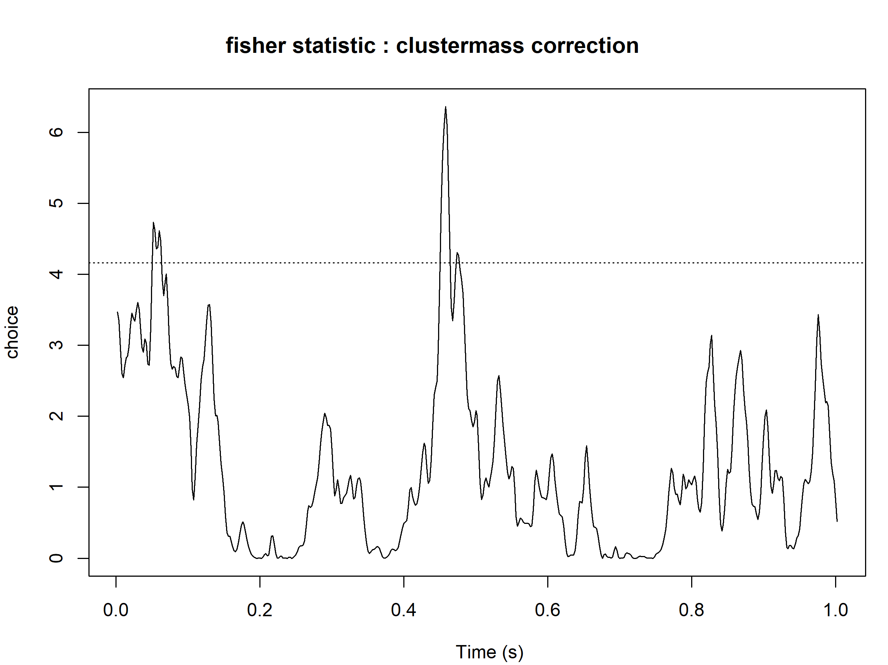
Note. The plot displays the time-resolved Fisher statistics comparing ‘self’ and ‘no choice’ conditions across the 0 to 1000 ms interval.

LPP Permutation Analysis
Cluster mass permutation tests revealed no significant condition x emotion interactions for LPP amplitudes. For 472 – 656 ms, LPP amplitudes were significantly higher for ‘self’ compared to ‘no choice’ trials (self: $M=3.17,SE=.64$; no choice: $M=2.60,SE=.61$; $t(31)=-3.4,p<.001,d=-.60$). Also, for 864 - 1000 ms, LPP amplitudes were significantly higher for ‘self’ compared to ‘no choice’ trials (self: $M=1.29,SE=.51$; no choice: $M=.64,SE=.49$; $t(31)=-3.1,p<.001,d=-.55$). A robust main effect of emotion was found for two clusters (224 - 292 ms and 298 - 968 ms). Descriptive statistics involving paired sample t-tests on LPP mean amplitudes for both significant clusters revealed for 224 - 292 ms significantly higher LPP amplitudes for neutral compared to positive pictures (neutral: $M=2.84,SE=.80$; positive: $M=1.91,SE=.78$; $t(31)=4.13,p<.001,d=.73$), and significantly higher LPP amplitudes for negative $M=2.66,SE=.86$ compared to positive pictures $t(31)=4.25,p<.001,d=.75$). Paired sample t-tests on LPP mean amplitudes for 298 - 968 ms showed significantly higher LPP amplitudes for negative compared to neutral (neutral: $M=2.04,SE=.54$; negative: $M=3.10,SE=.62$; $t(31)=-5.05,p<.001,d=-.89$), and positive pictures ($M=1.73,SE=.52$; $t(31)=6.09,p<.001,d=1.08$).

Table 7
Cluster-mass permutation results for the factor choice
Start | End | Cluster Mass | p-value
42 | 54 | 105.487 | 0.1972
82 | 84 | 21.179 | 0.4240
87 | 88 | 9.303 | 0.5024
91 | 104 | 80.247 | 0.2398
106 | 114 | 50.941 | 0.3078
117 | 128 | 74.869 | 0.2504
141 | 149 | 49.042 | 0.3146
152 | 154 | 15.020 | 0.4568
156 | 158 | 16.874 | 0.4494
172 | 172 | 4.174 | 0.5736
182 | 184 | 14.194 | 0.4642
187 | 189 | 13.942 | 0.4668
191 | 193 | 13.499 | 0.4740
196 | 198 | 14.800 | 0.4578
201 | 218 | 114.688 | 0.1866
236 | 328 | 795.399 | 0.0314
331 | 368 | 288.535 | 0.0810
372 | 373 | 8.967 | 0.5138
382 | 383 | 9.136 | 0.5068
387 | 389 | 15.260 | 0.4560
391 | 394 | 18.237 | 0.4384
396 | 413 | 126.728 | 0.1712
422 | 423 | 10.246 | 0.4904
426 | 428 | 15.378 | 0.4556
432 | 501 | 550.438 | 0.0442
Note. Alternative hypothesis: two-sided. Statistic: Fisher(1, 31). Resampling method: Rd_kheradPajouh_renaud permutation. Dependent variables: 501; Resamples: 5000. Multiple comparisons: cluster-mass (sum). Threshold = 4.159615.

Table 8
Cluster-mass permutation results for the factor emotion
Start | End | Cluster Mass | p-value
47 | 50 | 16.030 | 0.4216
112 | 146 | 310.882 | 0.0536
149 | 484 | 5324.378 | 0.0002
487 | 490 | 13.866 | 0.4346
496 | 501 | 24.983 | 0.3622
Note. Alternative hypothesis: two-sided. Statistic: Fisher(2, 62). Resampling method: Rd_kheradPajouh_renaud permutation. Dependent variables: 501; Resamples: 5000. Multiple comparisons: cluster-mass (sum). Threshold = 3.145258.

Table 9
Cluster-mass permutation results for the interaction choice × emotion
Start | End | Cluster Mass | p-value
64 | 67 | 14.940 | 0.4290
103 | 103 | 3.266 | 0.5660
156 | 157 | 6.348 | 0.5492
164 | 164 | 3.266 | 0.5660
248 | 249 | 6.779 | 0.5186
282 | 292 | 54.233 | 0.2548
302 | 304 | 11.262 | 0.4588
308 | 310 | 11.046 | 0.4600
312 | 316 | 21.488 | 0.3890
328 | 329 | 6.812 | 0.5178
334 | 335 | 6.733 | 0.5206
349 | 360 | 51.822 | 0.2620
362 | 363 | 7.284 | 0.5036
443 | 444 | 6.560 | 0.5322
468 | 469 | 7.355 | 0.5028
473 | 478 | 25.430 | 0.3708
Note. Alternative hypothesis: two-sided. Statistic: Fisher(2, 62). Resampling method: Rd_kheradPajouh_renaud permutation. Dependent variables: 501; Resamples: 5000. Multiple comparisons: cluster-mass (sum). Threshold = 3.145258. No significant clusters (all $p>.25$).

Figure 2
Cluster-mass permutation results for the LPP in Experiment 1
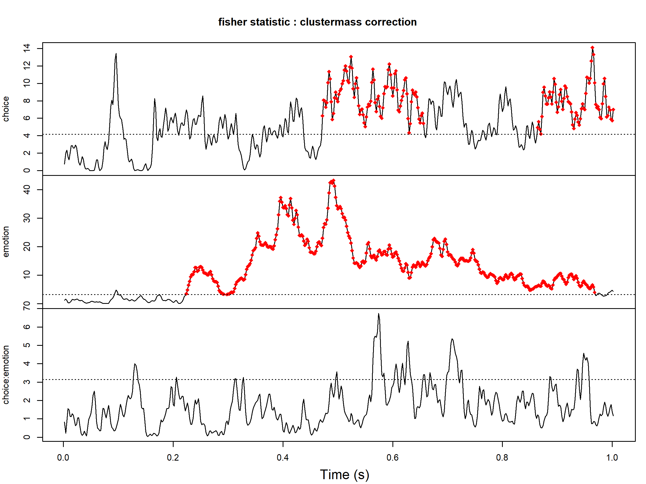

Note. The plot displays the time-resolved Fisher statistics comparing ‘self’ and ‘no choice’ [top panel], neutral, negative and positive [middle panel] and their interaction [bottom panel] conditions across the 0 to 1000 ms interval.

Table 10
Linear Mixed-Effects Model Estimates and 95% Confidence Intervals for Choice × Emotion Interaction Effects Extracted from Significant Cluster-Based Permutation Time Windows
time window (ms) | main effect | comparison | β | 95% CI | t
472–656 | choice | self vs. no choice x negative vs. neutral | -0.77 | [-0.06, 1.59] | 1.79
 |  | self vs. no choice x negative vs. positive | 0.01 | [-0.82, 0.83] | 0.01
864-1000 | choice | self vs. no choice x negative vs. neutral | 0.62 | [-0.21, 1.45] | 1.46
 |  | self vs. no choice x negative vs. positive | -0.11 | [-0.94, 0.71] | -0.27
224-292 | emotion | self vs. no choice x negative vs. neutral | 0.21 | [-0.51, 0.93] | 0.57
 |  | self vs. no choice x negative vs. positive | -0.25 | [-0.98, 0.47] | -0.68
298-968 | emotion | self vs. no choice x negative vs. neutral | 0.67 | [-0.04, 1.38] | 1.82
 |  | self vs. no choice x negative vs. positive | -0.00 | [-0.71, 0.71] | -0.01
Note. Fixed effects were estimated using linear mixed-effects models (LMMs) fitted with random intercepts for participant (vp). Mean ERP amplitudes were averaged across the significant permutation cluster and subsequently analyzed to obtain conventional effect estimates and 95% confidence intervals. ‘No Choice’ served as the reference category for factor choice and ‘negative’ as the reference category for factor emotion. Accordingly, the reported interaction contrasts indicate whether the condition effect (self vs. no choice) differed for neutral and positive stimuli relative to negative stimuli. The t statistic reflects the ratio between the estimated effect and its standard error. β = unstandardized regression coefficient; CI = confidence interval.

Table 11
Bayes Factors (BF₁₀) for the Condition × Emotion Interaction Across Time Windows
experiment | effect | time window (ms) | BF₁₀ | MC error (%)
1 | main effect choice | 472–656 | 0.51 | 13.68
1 | main effect choice | 846–1000 | 0.39 | 4.5
1 | main effect emotion | 224–292 | 0.17 | 2.82
1 | main effect emotion | 298–968 | 0.54 | 2.27
Müller et al. (2021) | interaction effect | 600-650 | 1.04 | 4.15
Müller et al. (2021) | interaction effect | 650-700 | 1.48 | 3.46
Note. BF₁₀ values represent the comparison of the full model (including the condition × emotion interaction) against the additive model (excluding the interaction). MC error denotes the Monte Carlo sampling error of the Bayes factor estimation. For Müller et al., the sample size was N = 19. MC error denotes the Monte Carlo sampling error of the Bayes factor estimation.

Supplement - Experiment 2
Table 12
Absolute frequencies of category choices in active viewing task
Category | Self |  | No Choice
 | M (Min; Max) | SD | M (Min; Max) | SD
action | $$11.95 (0;34.5)$$ | $$6.64$$ | $$13.94 (4.8;24.2)$$ | $$4.43$$
animal | $$15.26 (0;49.1)$$ | $$9.22$$ | $$13.42 (4.8;24.2)$$ | $$4.25$$
building | $$11.23 (1.6;24.6)$$ | $$6.05$$ | $$12.04 (6.3;19.3)$$ | $$4.01$$
human | $$13.18 (3.5;27.0)$$ | $$5.29$$ | $$11.76 (1.6;27.0)$$ | $$5.24$$
nature | $$16.49 (0;34.9)$$ | $$7.64$$ | $$12.63 (3.5;22.2)$$ | $$5.05$$
street | $$11.04 (3.2;37.9)$$ | $$6.03$$ | $$12.41 (6.3;19.4)$$ | $$3.78$$
utensil | $$11.77 (0;24.6)$$ | $$5.55$$ | $$10.99 (3.2;17.5)$$ | $$3.77$$
vehicle | $$9.08 (0;17.5)$$ | $$4.97$$ | $$12.82 (5.3;27.0)$$ | $$4.78$$
Note. $N=32$; $M=$ Mean; Min = Minimum; Max = Maximum.

Figure 3
Distribution of the percentage of correctly answered control questions
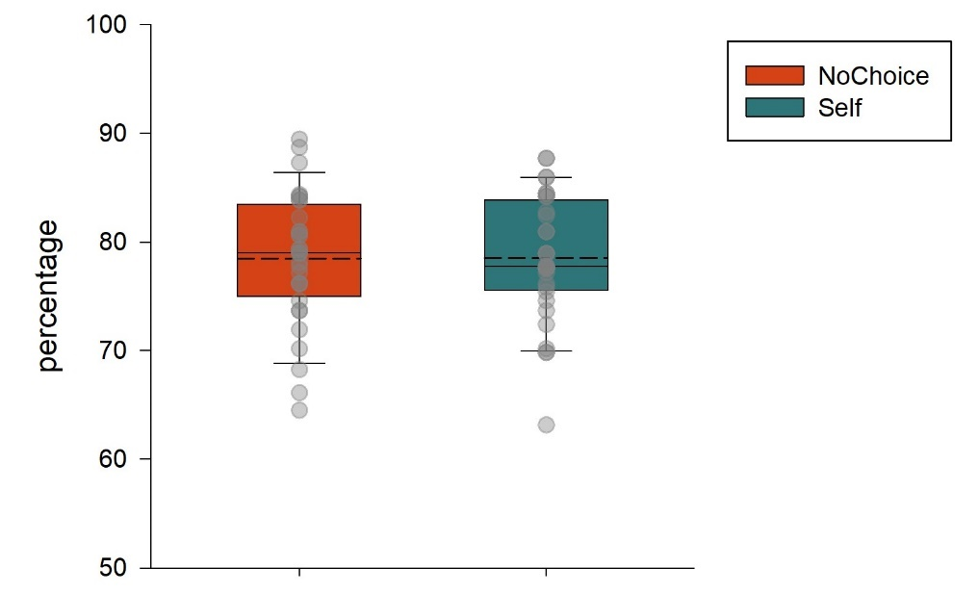
Note. Dashed line depicts means, solid line depicts medians, error bars define outliers with values greater than 1.5 interquartile range of the median.

Table 13

Pre-stimulus CNV analysis Cluster-mass permutation results for the factor condition
Start | End | Cluster Mass | p-value
164 | 170 | 36.531 | 0.4686
172 | 202 | 245.935 | 0.0924
204 | 224 | 161.418 | 0.1598
255 | 255 | 4.988 | 0.6856
260 | 261 | 8.759 | 0.6652
Note. Alternative hypothesis: two-sided. Statistic: Fisher(1, 31). Resampling method: Rd_kheradPajouh_renaud permutation. Dependent variables: 501; Resamples: 5000. Multiple comparisons: cluster-mass (sum). Threshold = 4.159615.

Figure 4
Time course of pre-stimulus CNV interval

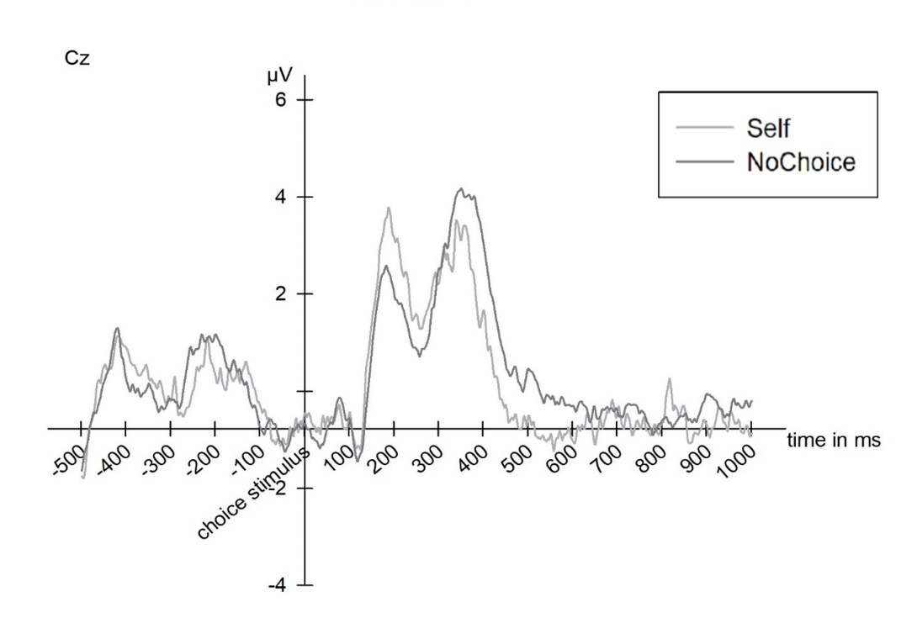
Note. Pre-stimulus CNV ($-500$ – $1000$ ms) interval for ‘self’ compared to ‘no choice’ trials for electrode Cz.

Figure 5
Cluster-mass permutation results for the pre-stimulus CNV in Experiment 2

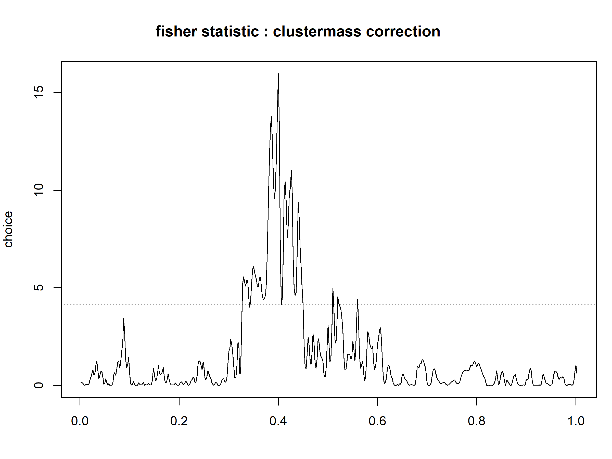
Note. The plot displays the time-resolved Fisher statistics comparing ‘self’ and ‘no choice’ conditions across the 0 to 1000 ms interval.

LPP Permutation Analysis
A main effect of choice was found for one LPP cluster (446–730 ms) (see Figure 6). To further illustrate this choice effect, a paired-sample t-test on LPP mean amplitudes for the significant cluster was calculated. For 446–730 ms, LPP amplitudes were significantly higher for ‘self’ compared to ‘no choice’ trials (self: $M=5.96$, $SE=.75$; no choice: $M=4.84$, $SE=.71$; $t(31)=-3.53$, $p<.001$, $d=-.62$).
A main effect of emotion was found for one cluster (198–950 ms). Descriptive statistics involving paired-sample t-tests on LPP mean amplitudes for 198–950 ms revealed significantly higher LPP amplitudes for negative ($M=6.37$, $SE=.78$) compared to neutral and positive pictures (neutral: $M=4.97$, $SE=.66$; positive: $M=4.05$, $SE=.64$; $t(31)=5.97$, $p<.001$, $d=1.06$), and significantly higher LPP amplitudes for neutral compared to positive pictures ($t(31)=2.45$, $p<.001$, $d=.43$).

Table 14
Cluster-mass permutation results for the factor choice
Start | End | Cluster Mass | p-value
31 | 38 | 52.192 | 0.3292
79 | 108 | 302.246 | 0.0622
120 | 121 | 8.462 | 0.5842
136 | 146 | 63.598 | 0.2930
213 | 215 | 12.898 | 0.5444
218 | 219 | 8.752 | 0.5702
223 | 365 | 1225.199 | 0.0110
380 | 410 | 226.101 | 0.0884
414 | 415 | 8.609 | 0.5750
449 | 450 | 8.959 | 0.5624
456 | 461 | 30.256 | 0.4216
479 | 501 | 130.489 | 0.1562
Note. Alternative hypothesis: two-sided. Statistic: Fisher(1, 31). Resampling method: Rd_kheradPajouh_renaud permutation. Dependent variables: 501; Resamples: 5000. Multiple comparisons: cluster-mass (sum). Threshold = 4.159615.

Table 15
Cluster-mass permutation results for the factor emotion
Start | End | Cluster Mass | p-value
14 | 18 | 19.623 | 0.4358
69 | 71 | 9.619 | 0.5376
77 | 78 | 6.531 | 0.5646
99 | 475 | 4659.914 | 0.0002
485 | 485 | 3.193 | 0.6010
490 | 497 | 30.751 | 0.3552
500 | 501 | 6.650 | 0.5564
Note. Alternative hypothesis: two-sided. Statistic: Fisher(2, 62). Resampling method: Rd_kheradPajouh_renaud permutation. Dependent variables: 501; Resamples: 5000. Multiple comparisons: cluster-mass (sum). Threshold = 3.145258.
Table 16
Cluster-mass permutation results for the factor choice x emotion
Start | End | Cluster Mass | p-value
17 | 18 | 6.766 | 0.5772
121 | 124 | 14.399 | 0.4956
175 | 183 | 30.757 | 0.3774
294 | 296 | 10.357 | 0.5354
Note. Alternative hypothesis: two-sided. Statistic: Fisher(2, 62). Resampling method: Rd_kheradPajouh_renaud permutation. Dependent variables: 501; Resamples: 5000. Multiple comparisons: cluster-mass (sum). Threshold = 3.145258.

Figure 6
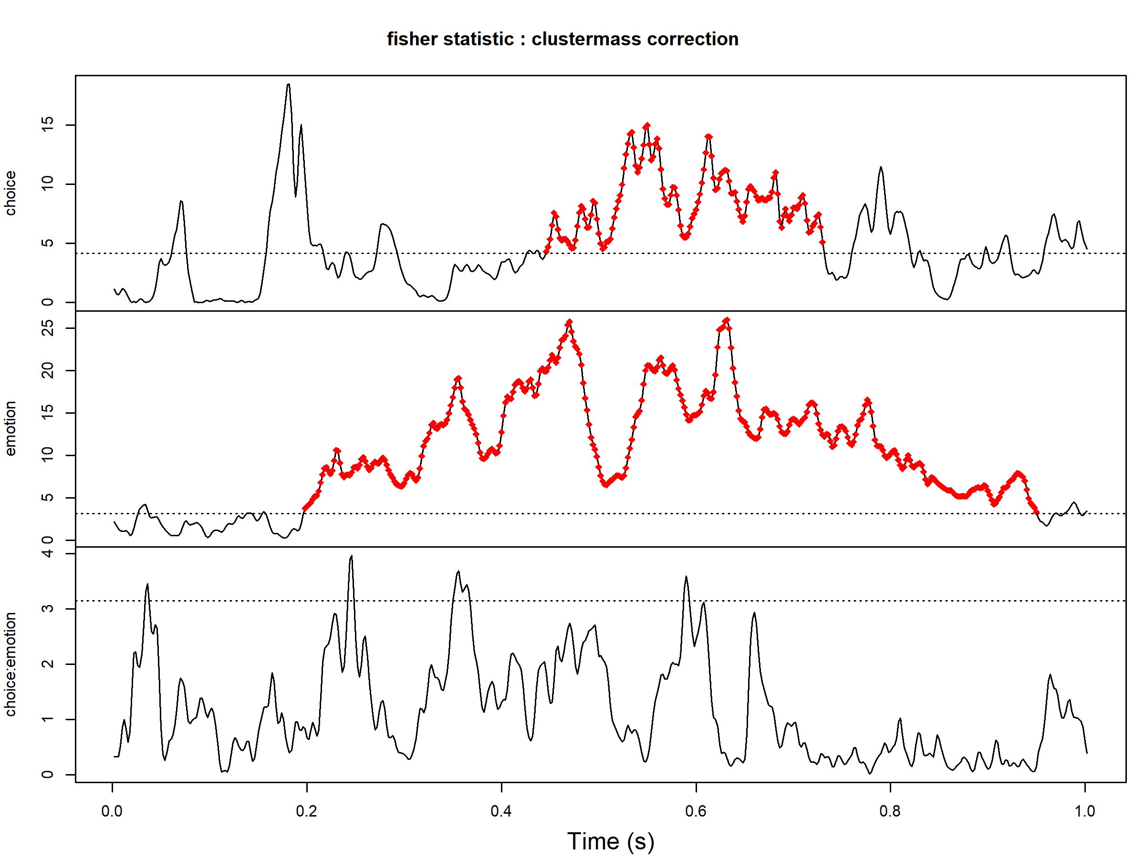
Cluster-mass permutation results for the LPP in Experiment 2

Note. The plot displays the time-resolved Fisher statistics comparing ‘self’ and ‘no choice’ [top panel], neutral, negative and positive [middle panel] and their interaction [bottom panel] conditions across the 0 to 1000 ms interval.
Table 17
Linear Mixed-Effects Model Estimates and 95% Confidence Intervals for Condition × Emotion Interaction Effects Extracted from Significant Cluster-Based Permutation Time Windows
time window (ms) | main effect | comparison | β | 95% CI | t
446-730 | choice | self vs. no choice x negative vs. neutral | 1.12 | [-0.39, 2.62] | 1.44
 |  | self vs. no choice x negative vs. positive | 1.23 | [-0.28, 2.74] | 1.59
198-950 | emotion | self vs. no choice x negative vs. neutral | 0.89 | [-0.45, 2.22] | 1.29
 |  | self vs. no choice x negative vs. positive | 1.01 | [-0.32, 2.35] | 1.47
Note. Fixed effects were estimated using linear mixed-effects models (LMMs) fitted with random intercepts for participant (vp). Mean ERP amplitudes were averaged across the significant permutation cluster and subsequently analyzed to obtain conventional effect estimates and 95% confidence intervals. ‘No Choice’ served as the reference category for factor choice and ‘negative’ as the reference category for factor emotion. Accordingly, the reported interaction contrasts indicate whether the condition effect (self vs. no choice) differed for neutral and positive stimuli relative to negative stimuli. The t statistic reflects the ratio between the estimated effect and its standard error. β = unstandardized regression coefficient; CI = confidence interval.

Table 18
Bayes Factors (BF₁₀) for the Condition × Emotion Interaction Across Experiments and Time Windows
experiment | effect | time window (ms) | BF₁₀ | MC error (%)
2 | main effect choice | 446–730 | 0.30 | 10.67
2 | main effect emotion | 198–950 | 0.25 | 2.00
Note. BF₁₀ values represent the comparison of the full model (including the condition × emotion interaction) against the additive model (excluding the interaction). MC error denotes the Monte Carlo sampling error of the Bayes factor estimation.

