Supplementary Material
Mood Induction Instructions
Positive instructions were as follows: “Now try to vividly recall a positive event from your life (e.g. school graduation/birthday/engagement/marriage/having children) Please, try to fully and vividly recreate the memory in your mind, using all your senses. Immerse yourself in the situation and try to recreate it, as if you are experiencing it once more now. What did you see? What did you hear or smell? How did you feel? You can use the pen and paper provided to take some notes about it while listening to music”.
Negative instructions were identical apart from the first line: “Now try to vividly recall a negative event from your life (e.g. serious injury, accident, death of a loved one)”.
Everyday experiences were also recalled for the neutral control condition: “Now try to vividly recall an everyday activity you do, such as brushing your teeth, reading the news, going grocery shopping” and was then followed by identical instructions as in the other conditions.
Arousal Analyses
Arousal was analyzed as a function of time of the measure (baseline, from baseline to post mood induction, from induction to post PM task), age group (young, old), and valence condition (negative, neutral, positive). Arousal at baseline did not differ as a function of condition, F(2, 233.45) = 0.76, p = .470 $η_{p}^{2}$= .01, and age group, F(1, 117.97) = 3.30, p = .072, $η_{p}^{2}$= .03. The interaction between age group and condition was also not significant, F(2, 232.80) = 1.00, p = .369, $η_{p}^{2}$= .01.
The analysis of post-task and post-induction arousal change revealed a condition by measure by age group interaction, F(2, 232.80) = 21.45, p < .001, $η_{p}^{2}$= .03 (see Figure S1). To break down the interaction, we compared valence between age groups within each condition and time of measurement.

Figure S1
Post-induction and post-task arousal change as a function of age group and valence condition.

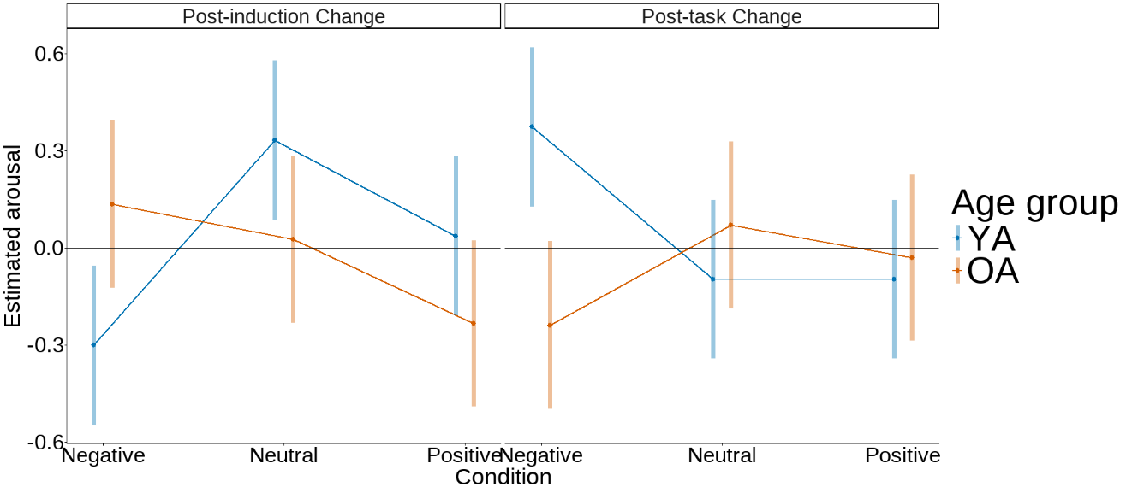
Note. Values at zero (black horizontal line) represent no changes, while values above zero indicate changes towards higher arousal and values below zero indicate changes towards lower arousal.
For the post-induction arousal change, older adults reported significantly higher arousal than their younger counterparts in the negative condition, b_{diff} =0.43, p_{corr} = .017, whereas in the neutral and positive conditions, post-induction arousal did not differ across age groups (ps_{corr} > .092). For the post-task arousal change, the pattern was reversed, as older adults reported significantly less arousal change in the negative condition, compared to younger adults, b_{diff} = -0.613, p_{corr} < .001. For the neutral and positive conditions, the post-task arousal change did not differ across age groups (ps_{corr} > .358).

Table S1
Results of the model predicting PM from valence changes measured after the induction and after the PM tasks, including arousal change measure.
 | PM accuracy
Predictors | Estimates | CI | p
(Intercept) | 0.53 | 0.39 – 0.67 | <.001
Post-task arousal change | 0.08 | -0.05 – 0.21 | .238
Post-induction arousal change | 0.06 | -0.06 – 0.19 | .322
Post-task valence change | 0.20 | 0.05 – 0.34 | .007
Age groupª | -0.36 | -0.64 – -0.08 | .012
Post-induction valence change | 0.18 | 0.05 – 0.32 | .008
Post-task valence change× Age group | -0.09 | -0.36 – 0.19 | .541
Post-induction valence change × Age group | 0.02 | -0.25 – 0.29 | .895
Random Effects
σ² | 0.57
τ₀₀ _{participant} | 0.52
ICC | 0.48
N _{participant} | 117
Observations | 1034
Marginal R² / Conditional R² | 0.055 / 0.509
ªAge group was contrast coded, with 0.5 corresponding to older adults and -0.5 corresponding to young adults.

Emotional characteristics of the stimuli
A summary of the emotional characteristics of the prospective memory cue words and ongoing task words is shown in Table S2. A Wilcoxon rank-sum test showed that the two groups of words did not differ in valence (W = 527.5, p = .912) and arousal (W = 568, p = .799). Figure S2 shows the valence and arousal distributions for the PM cue words and the ongoing task words.

Table S2
Emotional characteristics of the prospective memory cues and ongoing task words.
 |  | Valence |  |  | Arousal
 | N | M(SD) | Min-Max |  | M(SD) | Min-Max
Ongoing task words | 120 | 5.67(1.06) | 2.76-7.20 |  | 4.56(0.96) | 2.50-7.15
PM cues | 9 | 5.79(0.30) | 5.37-6.21 |  | 4.45(0.65) | 3.86-5.82
Note. The values are taken from the Affective Norms for English Words (Bradley & Lang, 1999).

Figure S2
Density plots showing a) valence and b) arousal distributions for the ongoing task and PM cue words.
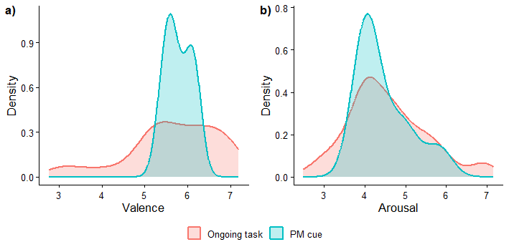

References
Bradley, M. M., & Lang, P. (1999). Affective Norms for English Words (ANEW): Instruction Manual and Affective Ratings.

