Supplementary Table 1 Primers used for quantitative PCR
Gene | Forward primer | Reverse primer
OsFER | AGGGATTCGCCAAATTCTTC | CCTTTCTCAGGATGGTCGAA
NAS1 | AGCGCGGTTGAGAAGGCAGAA | GGCATGTTCCTCGTTTACACTGGC
NAS2 | CGCCAAGAGGCTATCCGTCTGA | GATCAATGCCCAGGCGCCTA
NAS3 | CGAGTGTTCGACTGATCACC | CCGGTGATCTTCTCAACCAA
NAAT1 | TGCTGTGGCAGATCATTTGT | TTGGGTAGCCTGGTCTAGGA
SoyFERH1 | GGGATTTGCCAAGTTCTTCA | TACAATGCATCCCCCTTTTC
YSL15 | TGATCATAGCCTACGCGCTCGG | GCGATGAAGCAGCCAATGCC
YSL18 | GACAAGCGAAGAGGCAAGTC | CGATTCCCACATAAGTTCCG
FRO1 | GGCCACCAAGCAGTCCCTCTTT | CGAAAGGCCCGTCCACAAGA
FRO2 | TCCCTGTTGCCGCTCATTGG | CCCGGGGACGTTTGCAACTT

Supplementary Table 2 Grain quality assessment of transgenic IR64 lines
Sample ID  DESIGNATION | Cooking traits |  |  |  |  | Milling potential  score
Sample ID  DESIGNATION | AC | GT |  | GC | PC  (%) | DB | C
IR64 control | Low |  | HI/I | Soft | 12.2 | 1 | 1
Single transformation
IR64-GlUB4:: SoyferH1-018B-003 | Low |  | I | Soft | 11.6 | 1 | 1
IR64- GlUB4::Osfer1C-088A-006 | Intermediate |  | I | Soft | 12.5 | 1 | 2
IR64-GlUB1:: SoyferH2-176A-002 | Intermediate |  | HI/I | Soft | 12.6 | 1 | 2
Co-transformation
IR64- GlUB1:: SoyferH1-028A-109 | Low |  | HI/I | Soft | 12.5 | 1 | 2
IR64- GlUB1:: SoyferH1-072A-094 | Intermediate |  | HI/I | Soft | 10.1 | 1 | 2
IR64-GlUB1:: SoyferH1-37A-129 | Intermediate |  | I | Soft | 11.7 | 1 | 2
AC = amylose content: waxy (0-2%), very low (3-9%), low (10-19%), intermediate (20-25%), high (>25%); GT = gelatinization temperature: I = intermediate (70-72 °C), HI = high intermediate (73-74 °C), results are from six replicates; GC = gel consistency scored as 1) very flaky rice with hard gel consistency (length of gel, 40 mm or less); 2) flaky rice with medium gel consistency (length of gel, 41 to 60 mm); and 3) soft rice with soft gel consistency (length of gel, more than 61 mm), results are from two replicates; PC = protein content, with range of 8 to 14 considered as normal or marketable; DB = degree of breakage and C = chalkiness score, both classified using the following scale: 1 = mostly whole translucent grains; 2 = few broken/chalky grains, and 3 = >70% of grains are broken; >50% chalky grains

Supplementary Table 3 Comparison of average iron concentration of IR64 transgenic plants (single transformants) with ferritin genes driven by GLUB1 versus GLUB4 promoter. Average iron concentration for each promoter were obtained from 8 transgenic plants
Promoter | T2 ICP (mg kg⁻¹) | T3 ICP (mg kg⁻¹)
GlUB1 | 5.63 ± 0.67 | 4.60 ± 1.20
GlUB4 | 6.21 ± 0.74 | 5.03 ± 1.80

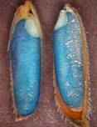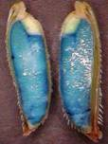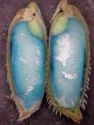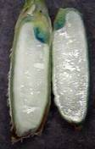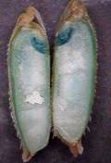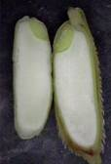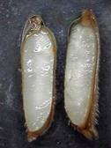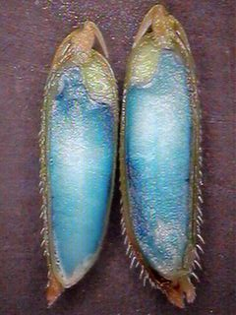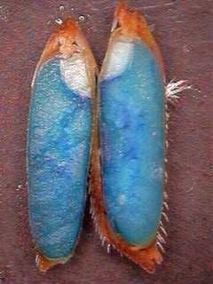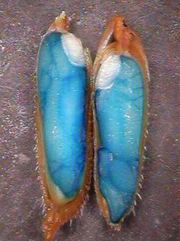
IR64:GLUB1:GUS
IR64:GLUB4:GUS
IR64:GLB:GUS
IR64:35S:GUS
IR64
Dough (15 DAF)
Mature (30 DAF)
Supplementary Fig 1 Histochemical GUS staining of dough (left) and mature seeds (right) of transgenic IR64 plants with different promoter:GUS constructs

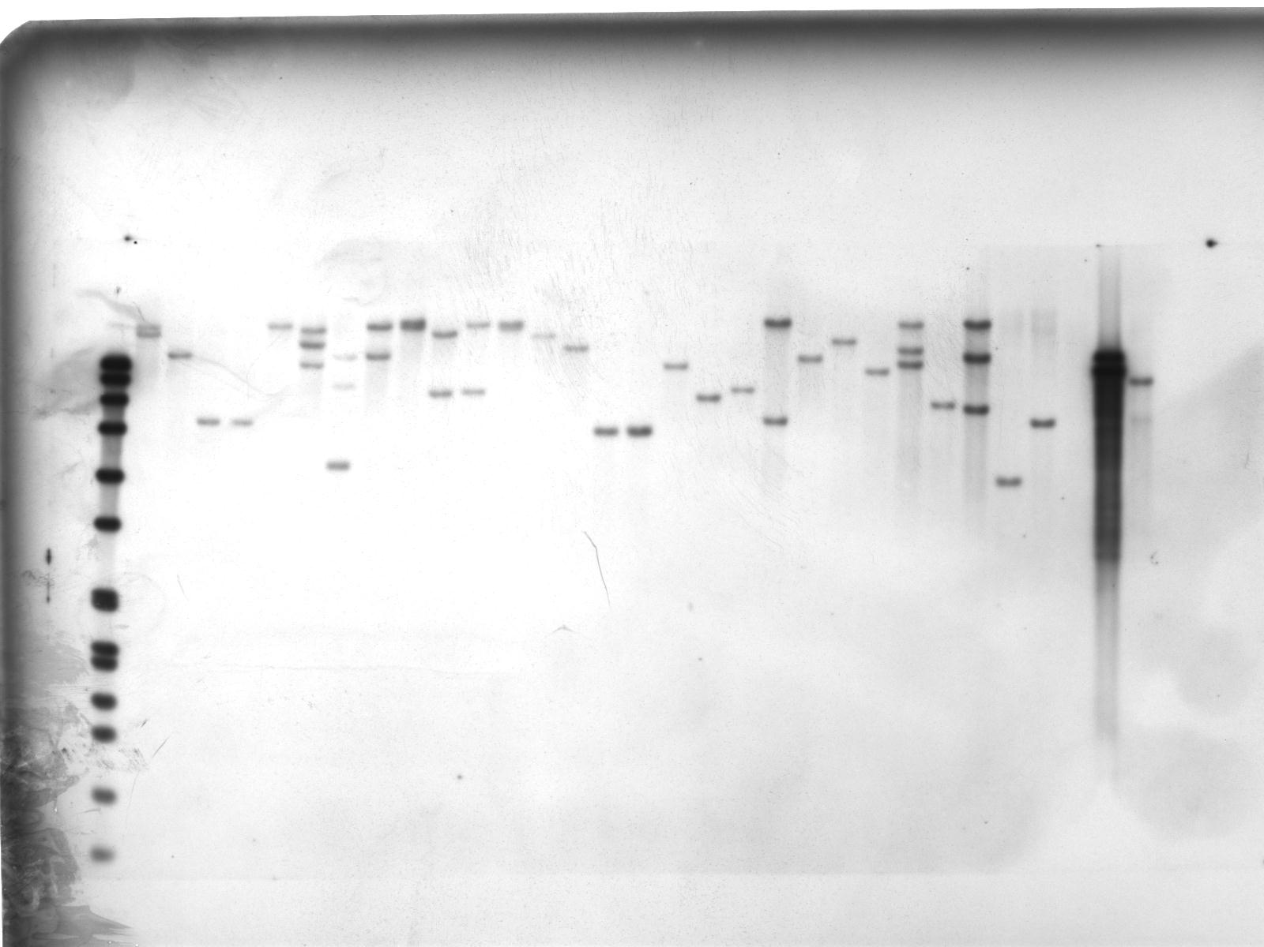
M 1 2 3 4 5 6 7 8 9 10 11 12 13 14 15 16 17 18 19 20 21 22 23 24 25 26 27 28 WT
kb
8.5
7.4
6.1
4.8
3.6
2.7

Supplementary Fig. 2 Southern blot analysis of transgenic IR64 with SoyFERH1 driven by GlUB1 promoter. Genomic DNA from each sample digested with EcoRI, hybridized with a PCR-labeled probe containing 928-bp fragment of SoyFERH1 gene. M = Dig-labeled marker VII, WT = wild-type IR64, 1-28 = T0 events with SoyFERH1gene

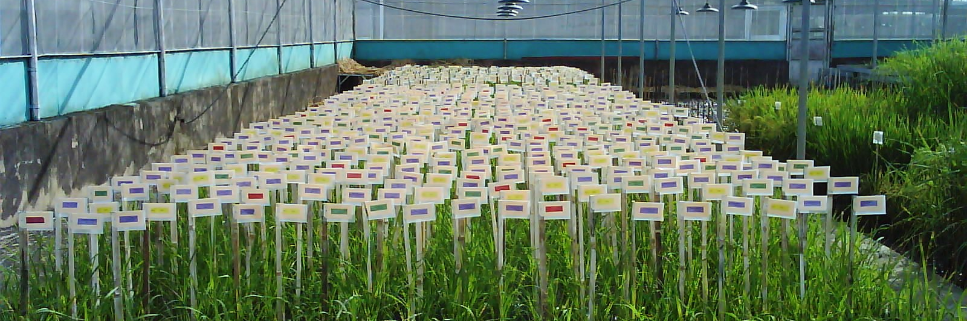

Supplementary Fig. 3 Screenhouse evaluation of phenotype of different T1 transgenic lines

Supplementary Fig. 4 Comparison of iron concentration of IR64 transgenic plants with different ferritin genes

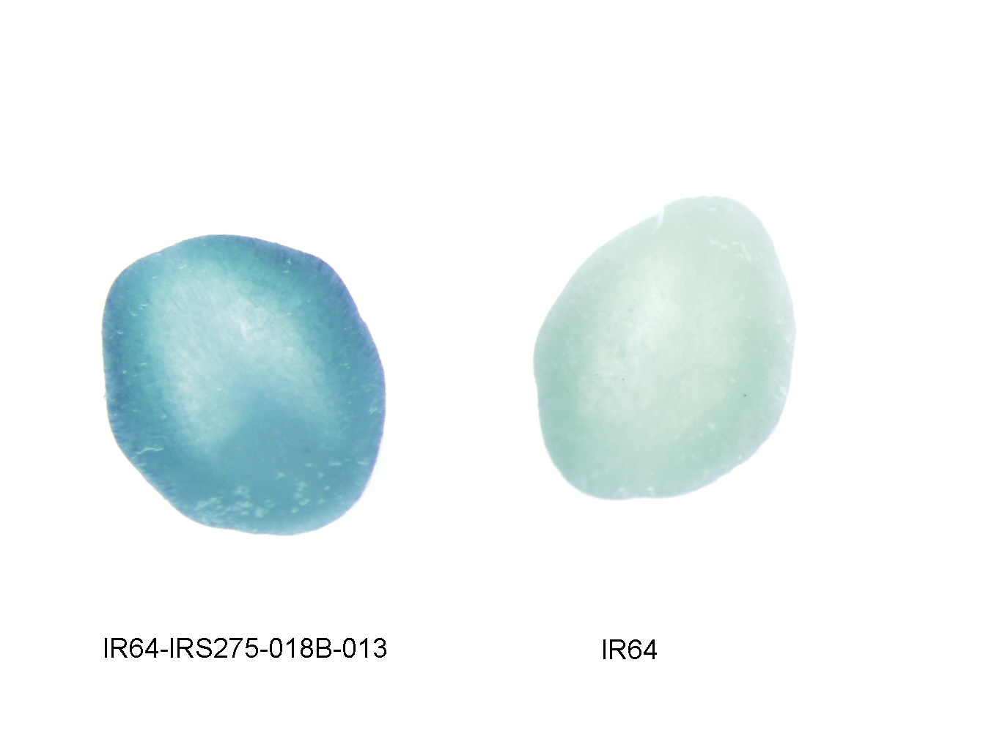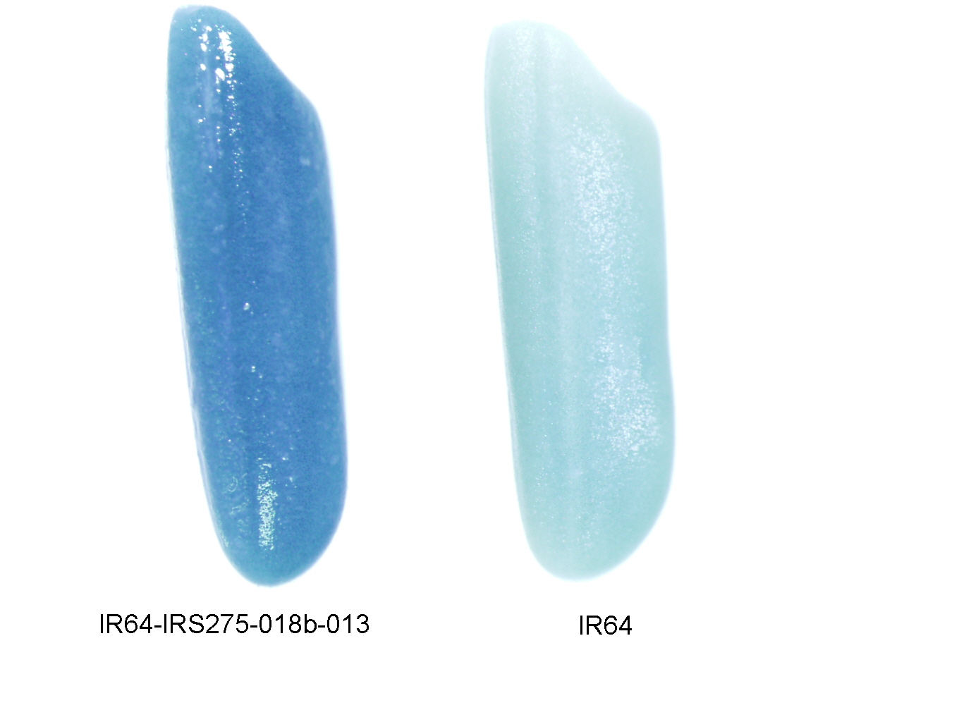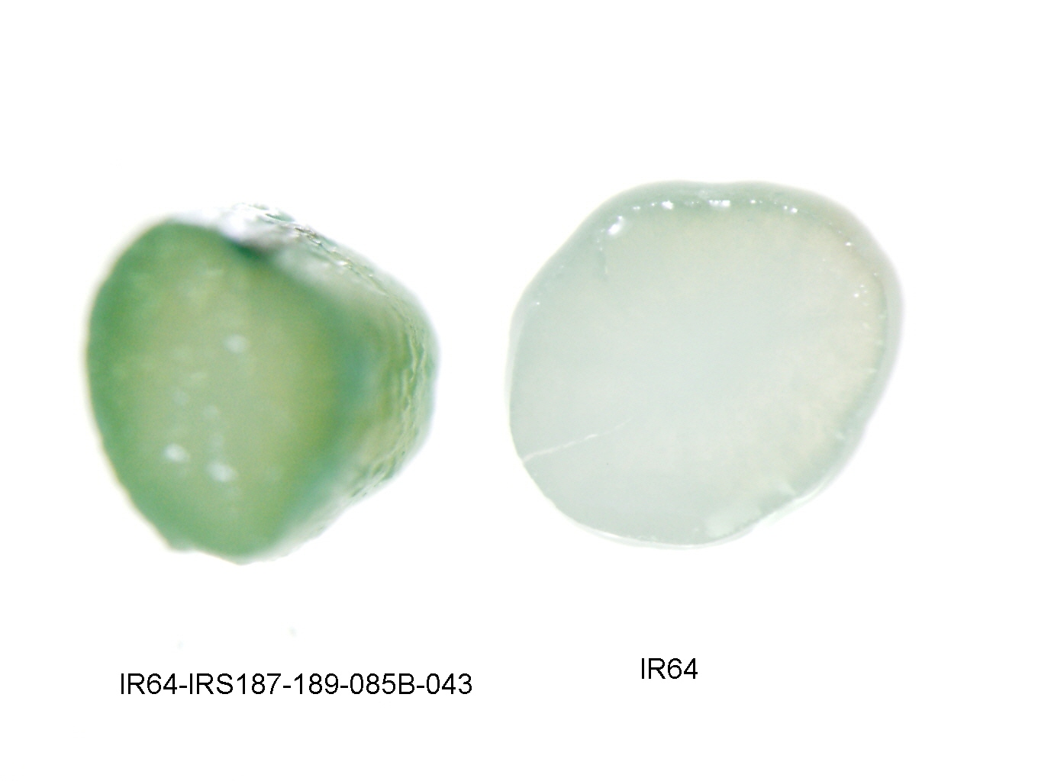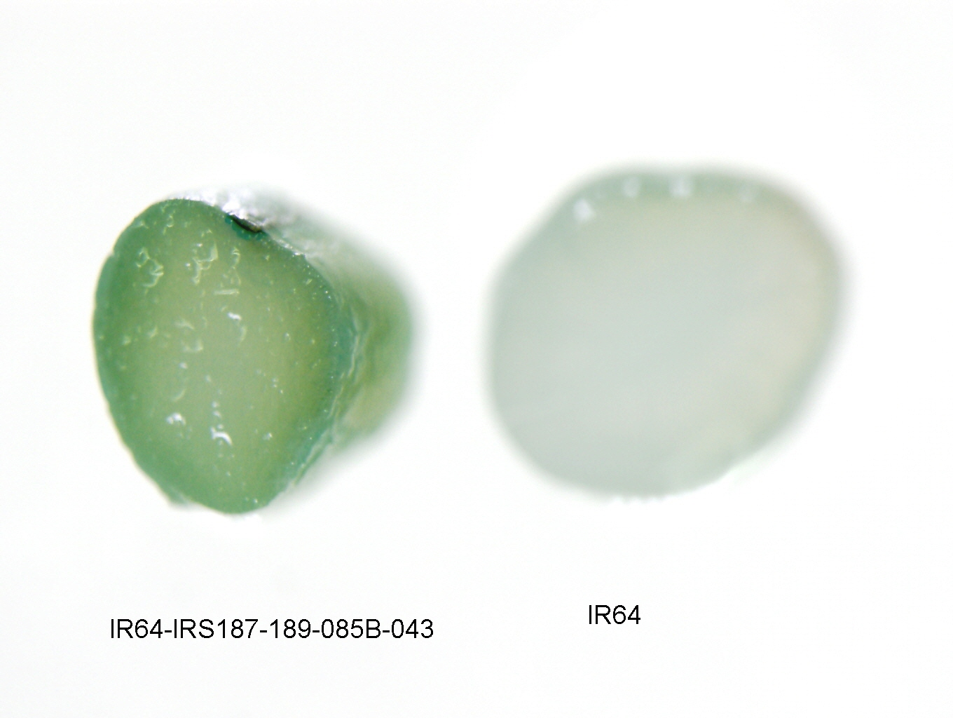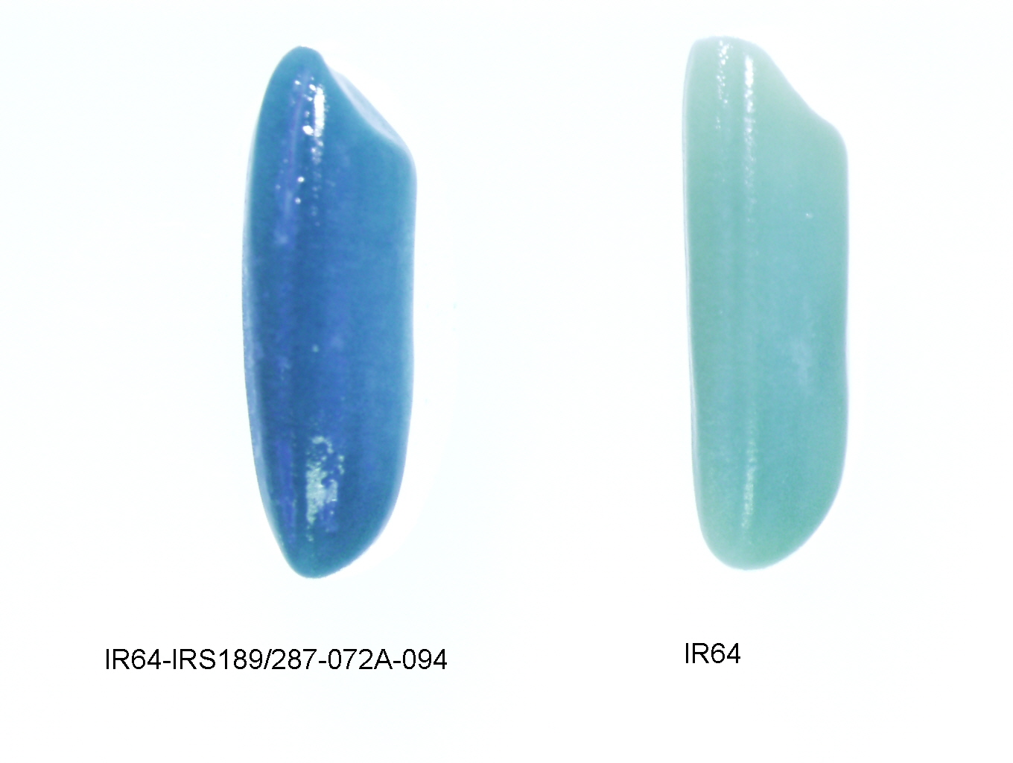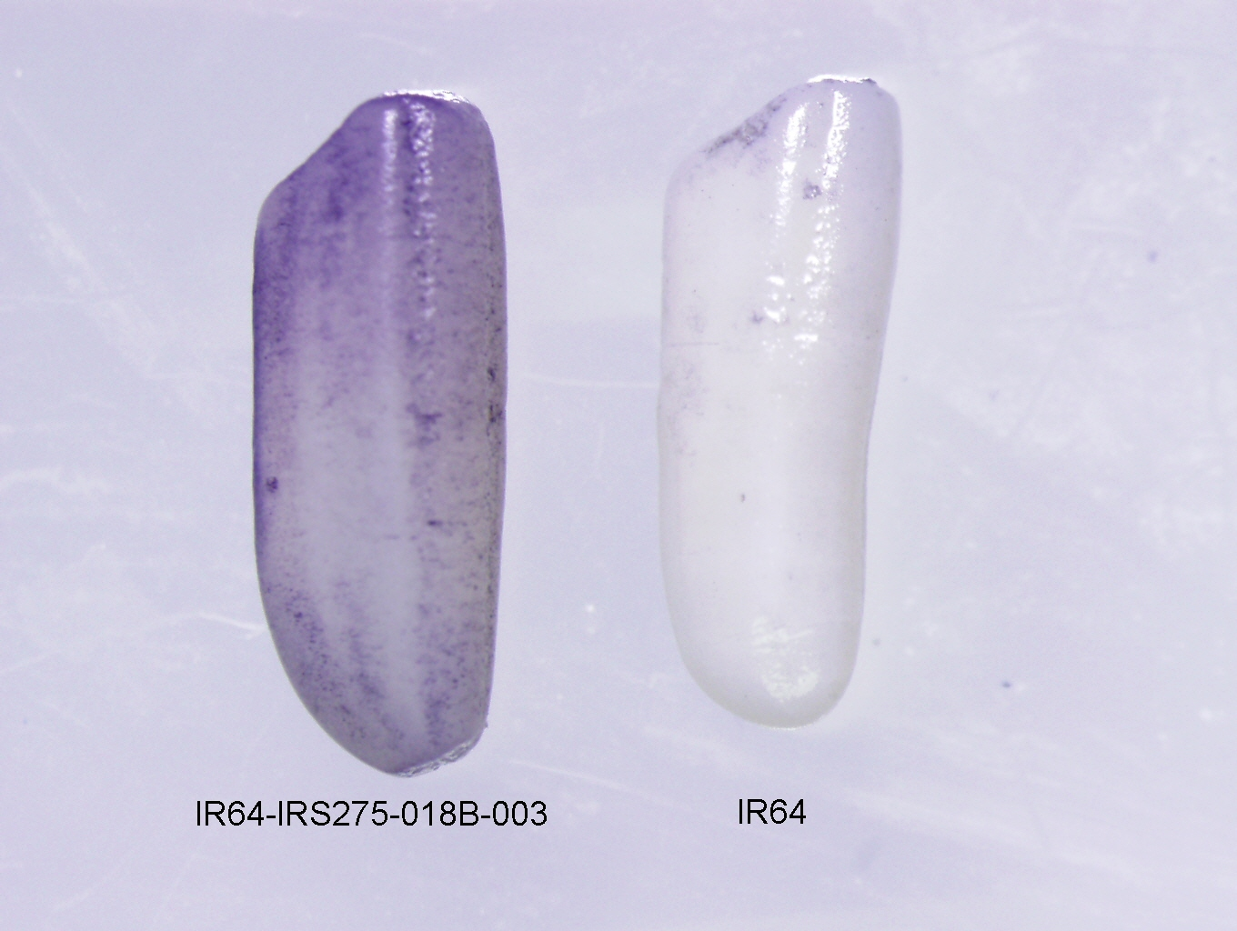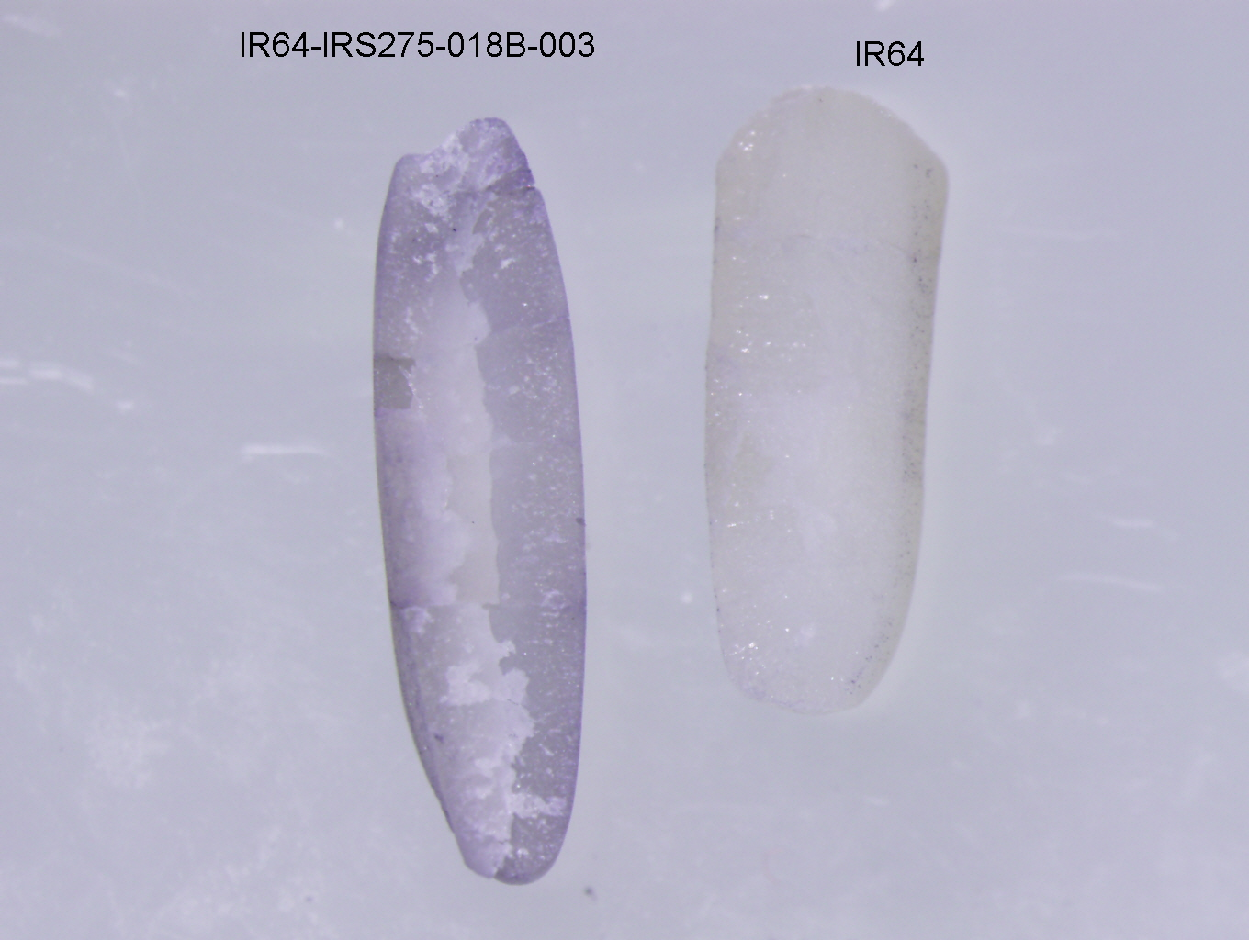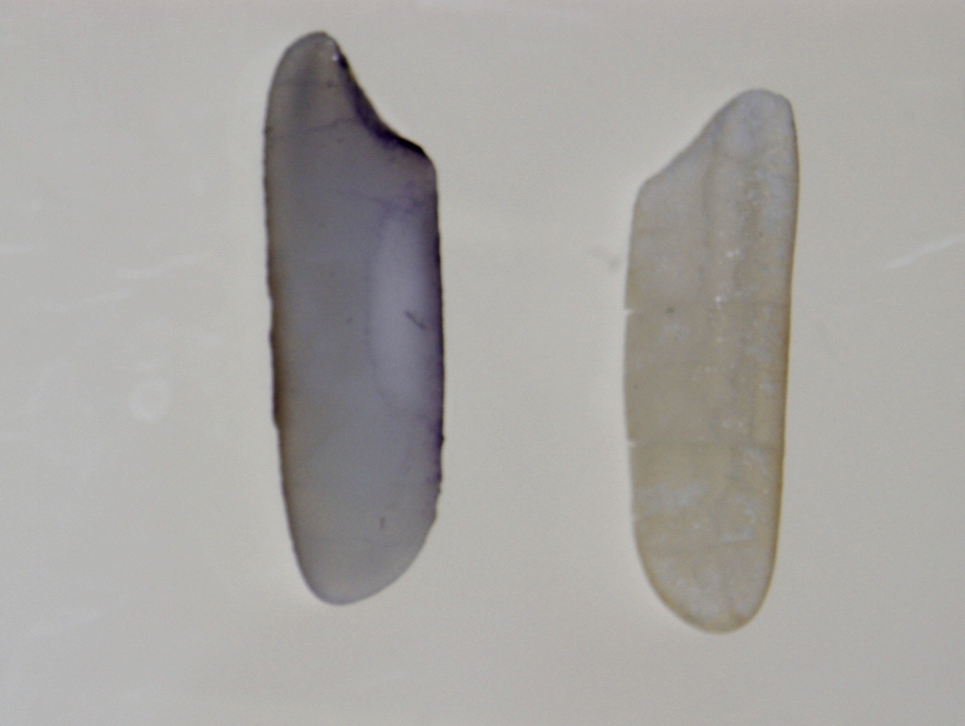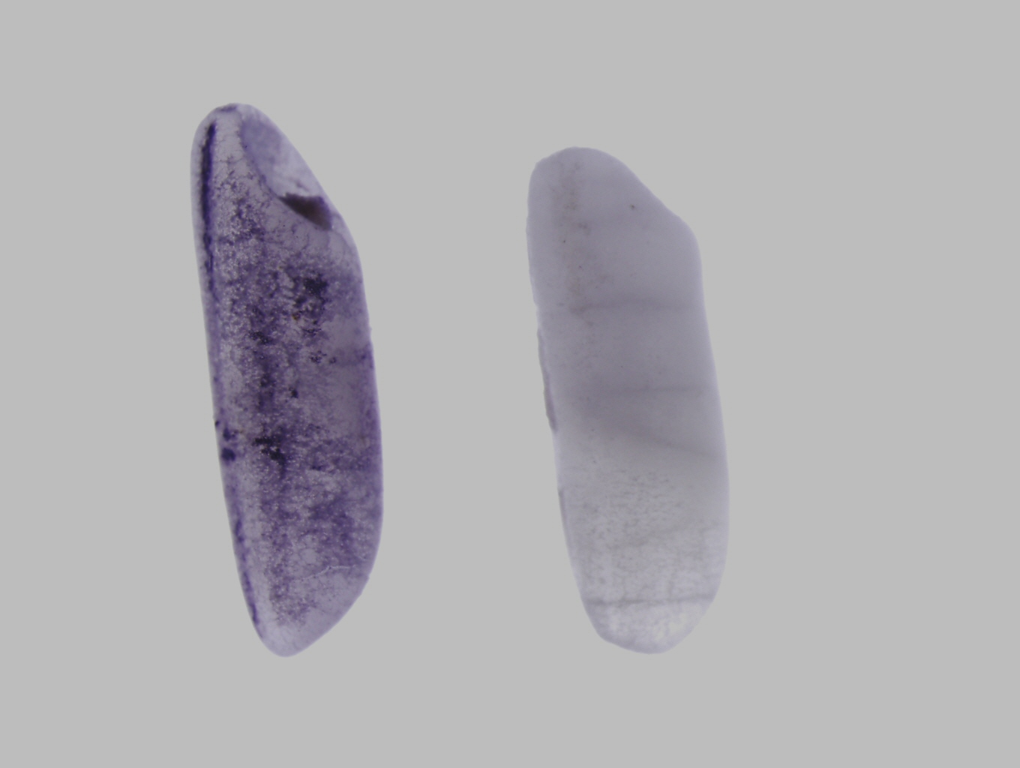
e
f
g
h
a
b
c
d
Transit peptide
α- helix
β- helix
C- helix
D- helix
F- helix

Supplementary Fig. 5 In silico analysis o f amino acid sequence of ferritin from soybean and rice

