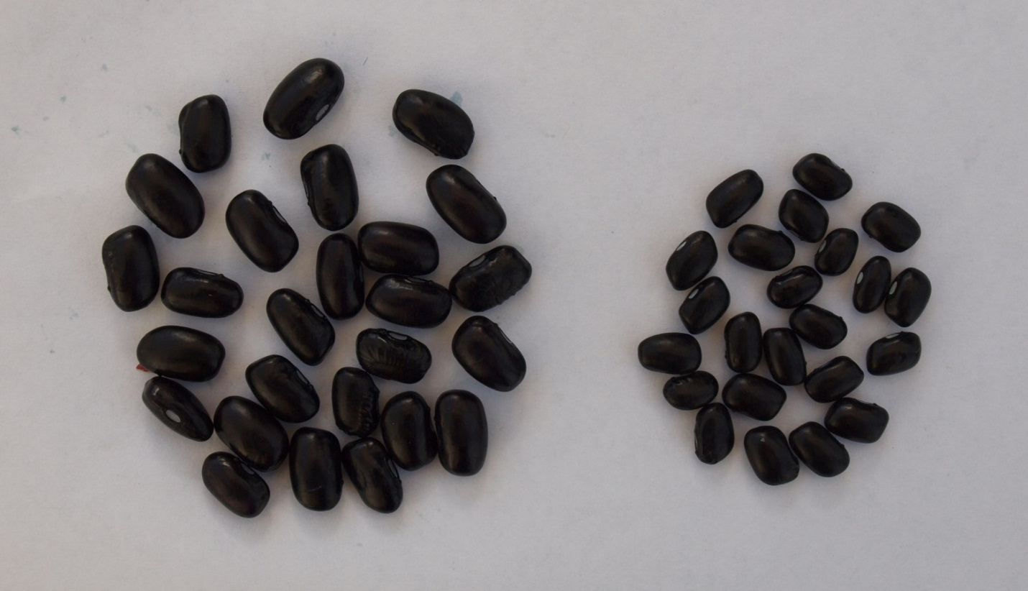
(b)
(a)
Supplementary Fig. 1 Hydrated seeds (a) and stone seeds (b) in a sample of black bean seeds after 16 h soaking in water at 22°C.

