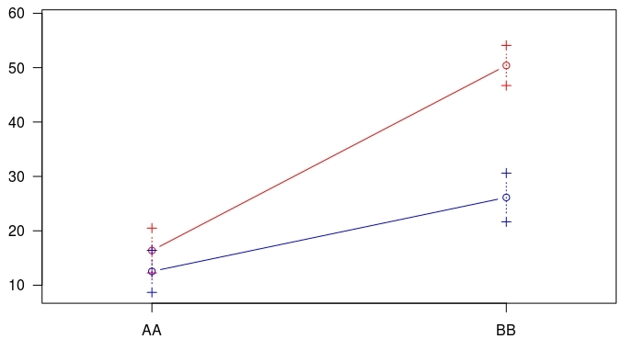
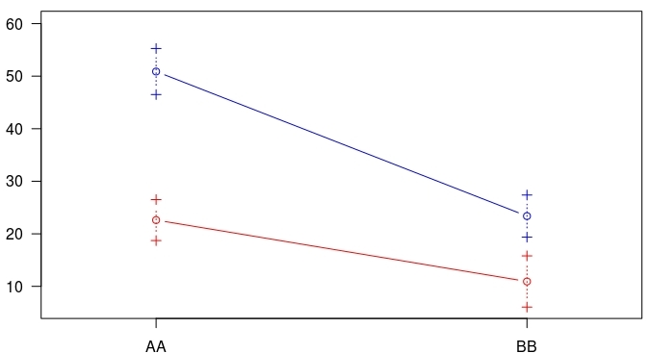
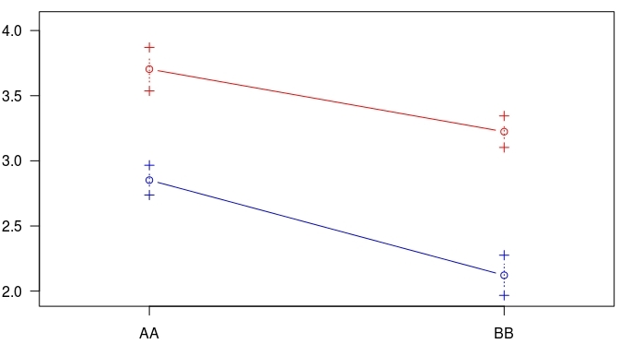
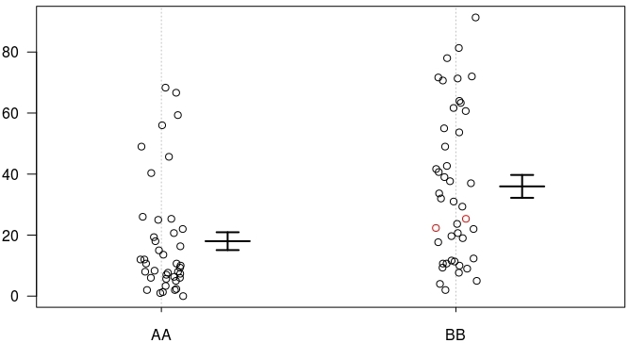
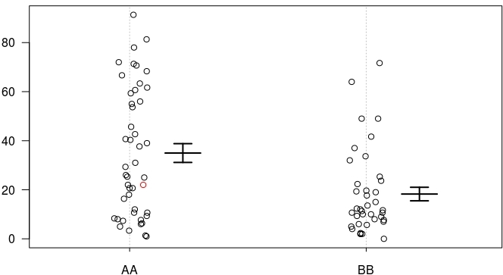
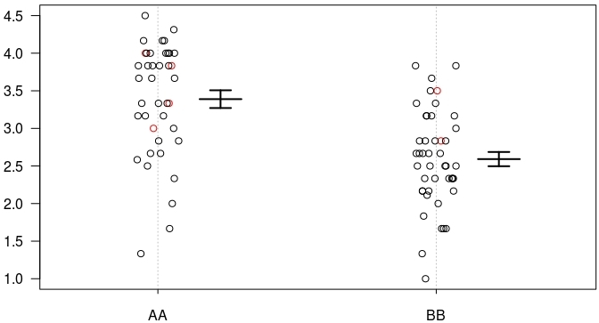
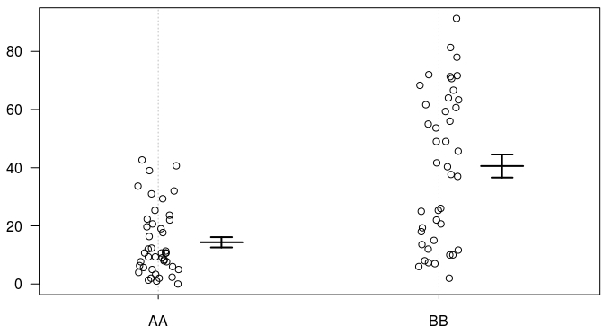
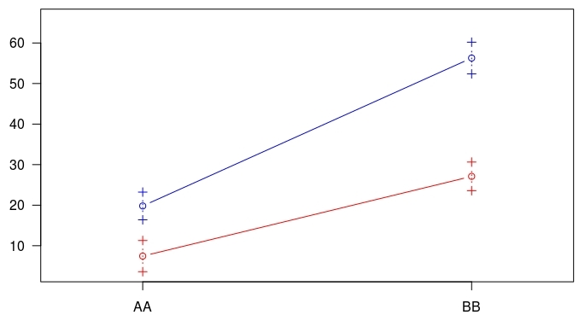
Supplementary Fig. 2 QTL effects (a-d) and interactions (e-h) estimated from the second-harvest seeds at Carman site in 2016. Error bars indicate SE.
Asp
Interaction plot for BM2c0024 and Asp
(f)
BM02c0024
Interaction plot for dCAPS01c5176 and BM02C0024
(g)
Asp
Interaction plot for BM04c0163 and Asp
(h)
SSP
dCAPS01c5176
(b)
SSP
BM02c0024
(c)
VSC
BM04c0163
(d)
SSP
Asp
BK (AA)
H68 (BB)
(a)
ASP
Interaction plot for dCAPS01c5176 and Asp
(e)
BK (AA)
H68 (BB)

