Online Resource 20
Article Title: Genomic prediction applied to high biomass sorghum for bioenergy production
Journal: Molecular Breeding
Authors: Amanda Avelar de Oliveira; Maria Marta Pastina; Vander Filipe de Souza; Rafael Augusto da Costa Parrella; Roberto Willians Noda; Maria Lúcia Ferreira Simeone; Robert Eugene Schaffert; Jurandir Vieira de Magalhães; Cynthia Maria Borges Damasceno; Gabriel Rodrigues Alves Margarido.

Name, affiliation, and email of corresponding author:
Gabriel Rodrigues Alves Margarido
Escola Superior de Agricultura Luiz de Queiroz, USP
Piracicaba, SP 13418-900, Brazil
e-mail: gramarga@usp.br

Cynthia Maria Borges Damasceno
Embrapa Milho e Sorgo
Sete Lagoas, MG 35701-970, Brazil
e-mail: cynthia.damasceno@embrapa.br

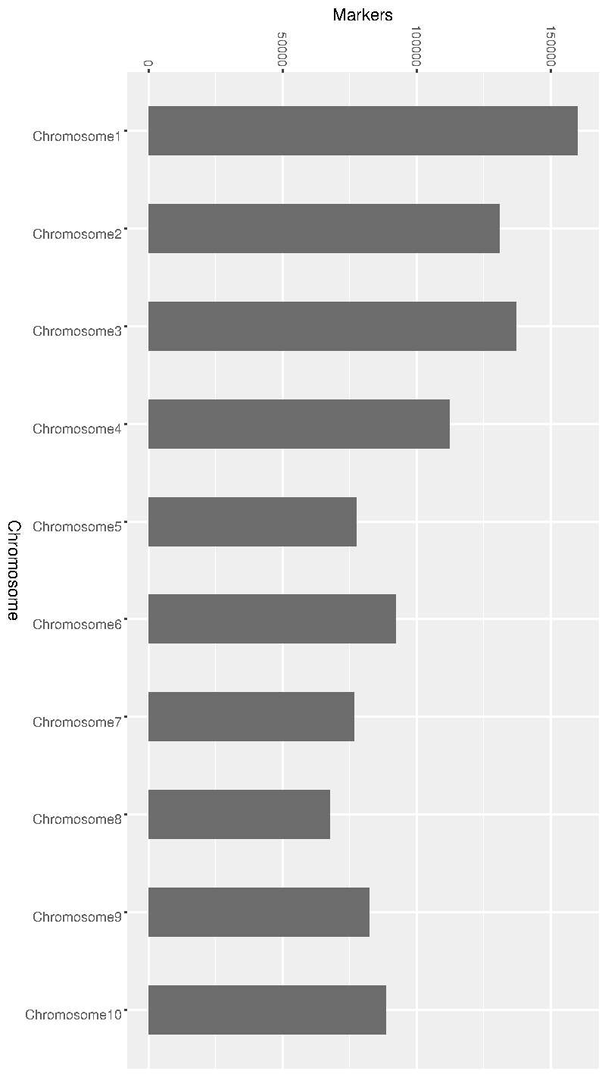
Supplementary Figure 4 Distribution of 1,024,892 markers by 10 sorghum chromosomes

