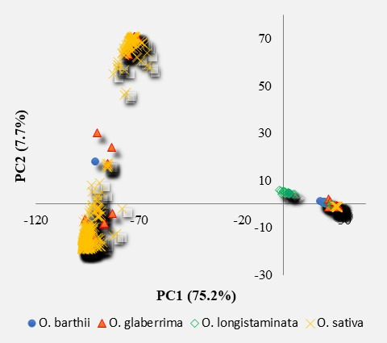
Lowland O. sativa
Upland O. sativa
Supplementary Fig. S1 Plots of PC1 and PC2 from principal component analysis of 3,134 accessions representing O. barthii (51), O. glaberrima (2,422), O. longistaminata (20), and O. sativa and NERICA (641 accessions) using 27,645 polymorphic SNPs. Note markedly lower genetic diversity within and between the three African species complex (O. barthii, O. longistaminata and O. glaberrima) on the right side of the quadrant as compared to the Asian rice (O. sativa). Lowland and upland genotypes are primarily O. sativa spp. indica and japonica, respectively.

