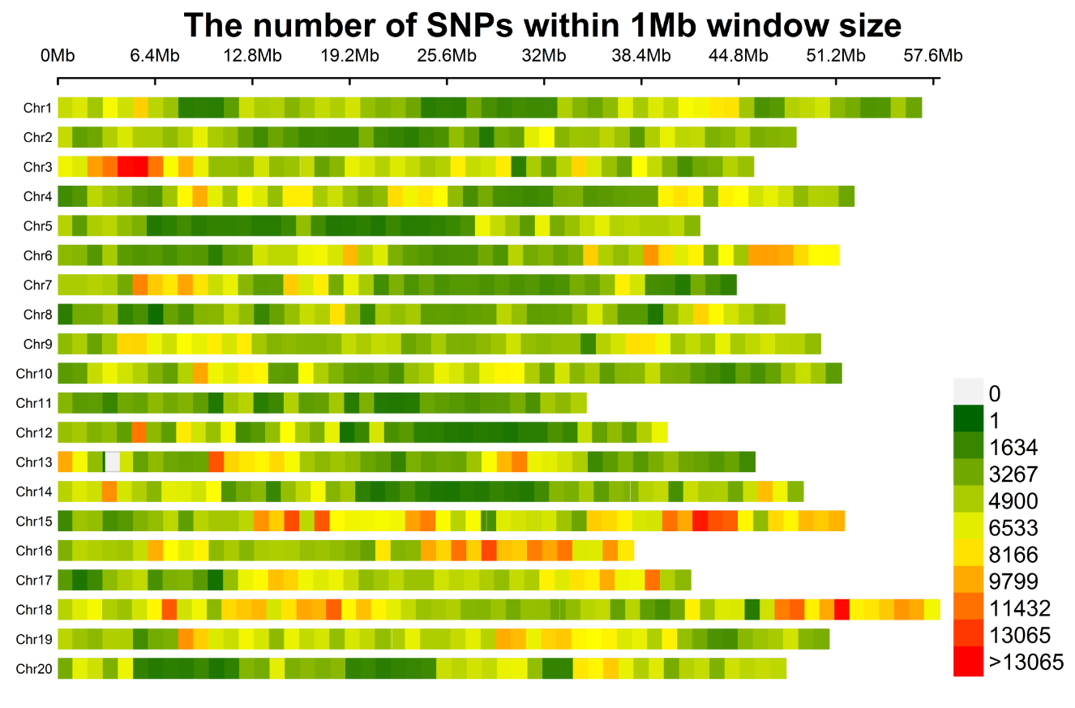
Supplementary Fig. 1 This diagram shows the presence of the 4,665,814 SNPs across twenty soybean chromosomes. Length of chromosomes (Mb) is represented by the horizontal axis; chromosome number is denoted by the vertical axis, and SNP density is depicted by the different colors (number of SNPs per window).

Supplementary Fig. 2 Heat map showed gene expression profile of seven candidate genes identified within the four haplotype blocks; that represents the one, one, four and one genes on Chr.02, Chr.04, Chr.06 and Chr.19. This RNA-seq data was retrieved from the online dataset at SoyBase, and it represents the growth and development stages of soybean. DAF (days to flowering); cm (centimeter).

