Three flavonoids biomarkers of Carrot resistance to Alternaria leaf blight: ACCUMULATION PATTERN AT DIFFERENT PHENOLOGICAL STAGES AND CONSISTENCY ACROSS DIVERSE GENETIC BACKGROUNDS

Molecular breeding

Marie Louisa Ramaroson*¹, Claude Emmanuel Koutouan*¹, Angelina El Ghaziri¹, Raymonde Baltenweck², Patricia Claudel², Philippe Hugueney², Sébastien Huet¹, Anita Suel¹, Linda Voisine¹, Mathilde Briard¹, Jean Jacques Helesbeux³, Latifa Hamama¹, Valérie le Clerc¹, Emmanuel Geoffriau^{1,§}

1 Institut Agro, Université d’Angers, INRAE, IRHS, SFR 4207 QUASAV, Angers, France
2 Université de Strasbourg, INRAE, SVQV UMR-A 1131, F-68000 Colmar, France
3 Université de Strasbourg, INRAE, SVQV UMR-A 1131, F-68000 Colmar, France
§ Correspondence: emmanuel.geoffriau@institut-agro.fr; Tel : +33-(0)2 41 22 54 31
* The first two authors contributed equally to the paper

Online Resource 1: Metabolic data analysis of Trial 1 (H1 susceptible and I2 resistant accessions)

Table of contents
Api7R 2
Two-way ANOVA with interaction 2
Postulates verification 2
Box-Cox transformation 3
Two-way ANOVA without interaction 5
Box-Cox transformation 6
Models comparison 8
Pairwise comparison 8
Lut7R 9
Two-way ANOVA with interaction 9
Postulates verification 9
Box-Cox transformation 10
Two-way ANOVA without interaction 12
Postulates verification 12
Box-Cox transformation 13
Models comparison 15
Pairwise comparison 15
Chry7R 16
Two-way ANOVA with interaction 16
Postulates verification 16
Box-Cox transformation 17
Pairwise comparison 19

Description: Trial 1 data consists of two factors: Accessions (H1 and I2) and Developmental stage (12 levels). The dependent variables are three flavones: Api7R, Lut7R, and Chry7R. These variables are quantitative and continuous. Four repetitions are observed for each combination of the two factors, allowing us to study the interaction between the factors. In this appendix, we detail all the steps of data analysis. The results are presented in Figure 2 of the manuscript.
table(donnees$Accessions, donnees$Developmental_Stage)
2 leaves 3 leaves 4 leaves 5 leaves 6 leaves 9 leaves 12 leaves
H1 4 4 4 4 4 4 4
I2 4 4 4 4 4 4 4

Api7R

Two-way ANOVA with interaction
Mod1=lm(Api7R ~Accessions*Developmental_Stage, data=donnees)

Postulates verification
res1=residuals(Mod1);
ks.test(res1, "pnorm", 0, sd(res1))
Exact one-sample Kolmogorov-Smirnov test
data: res1
D = 0.2227, p-value = 0.006397
alternative hypothesis: two-sided
plot(Mod1,1)
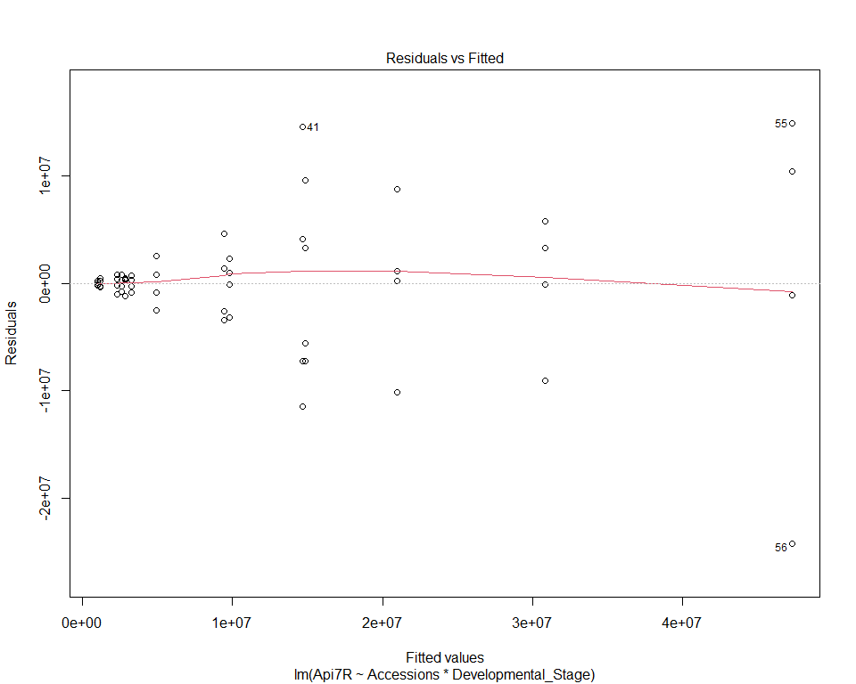
plot(Mod1,2)
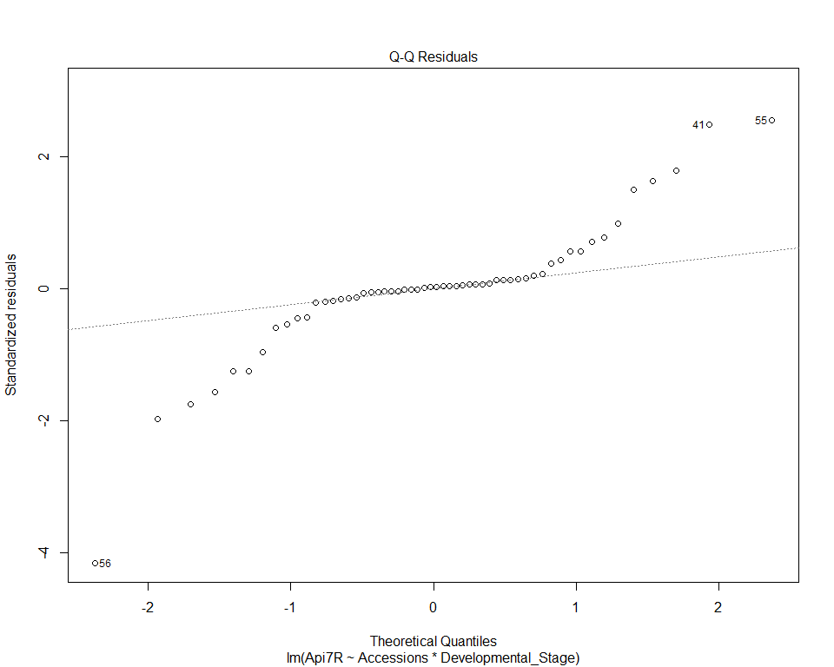

Box-Cox transformation
summary(p1 <- powerTransform(Mod1))
mydata_bc <- transform(donnees, Api7R_bc=bcPower(Api7R,coef(p1)))
Mod1_bc <- lm(Api7R_bc~ Accessions*Developmental_Stage,
data=mydata_bc)
ks.test(residuals(Mod1_bc),"pnorm",0, sd(residuals(Mod1_bc)))
Exact one-sample Kolmogorov-Smirnov test
data: residuals(Mod1_bc)
D = 0.12024, p-value = 0.3639
alternative hypothesis: two-sided
plot(Mod1_bc,1)
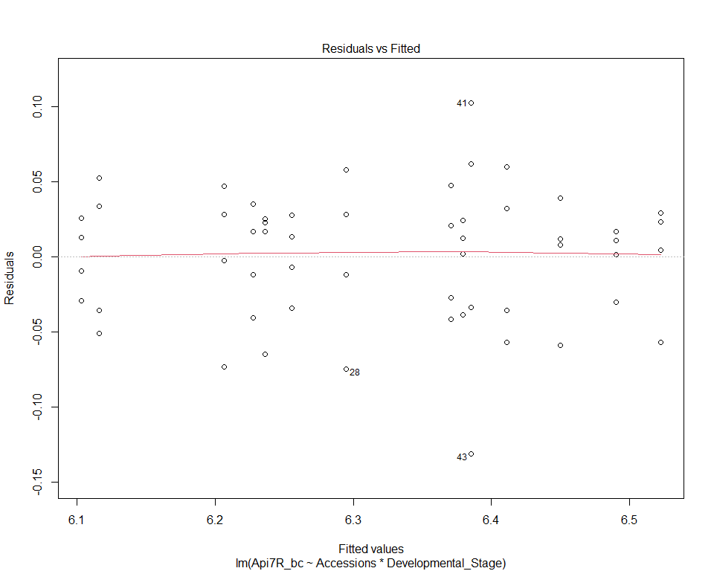
plot(Mod1_bc,2)
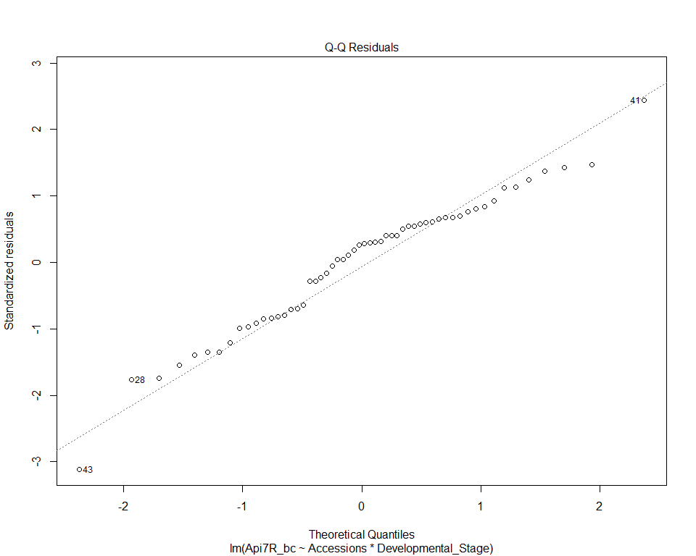
anova(Mod1_bc)
Analysis of Variance Table
Response: Api7R_bc
Df Sum Sq Mean Sq F value Pr(>F)
Accessions 1 0.70469 0.70469 298.6007 < 2.2e-16 ***
Developmental_Stage 6 0.18923 0.03154 13.3640 2.084e-08 ***
Accessions:Developmental_Stage 6 0.01675 0.00279 1.1831 0.3338
Residuals 42 0.09912 0.00236
---
Signif. codes: 0 '***' 0.001 '**' 0.01 '*' 0.05 '.' 0.1 ' ' 1

Two-way ANOVA without interaction
Mod1bis=lm(Api7R ~Accessions+Developmental_Stage, data=donnees)
res=residuals(Mod1bis)
ks.test(res,"pnorm", 0, sd(res))
Exact one-sample Kolmogorov-Smirnov test
data: res
D = 0.11447, p-value = 0.4237
alternative hypothesis: two-sided
plot(Mod1bis,2)
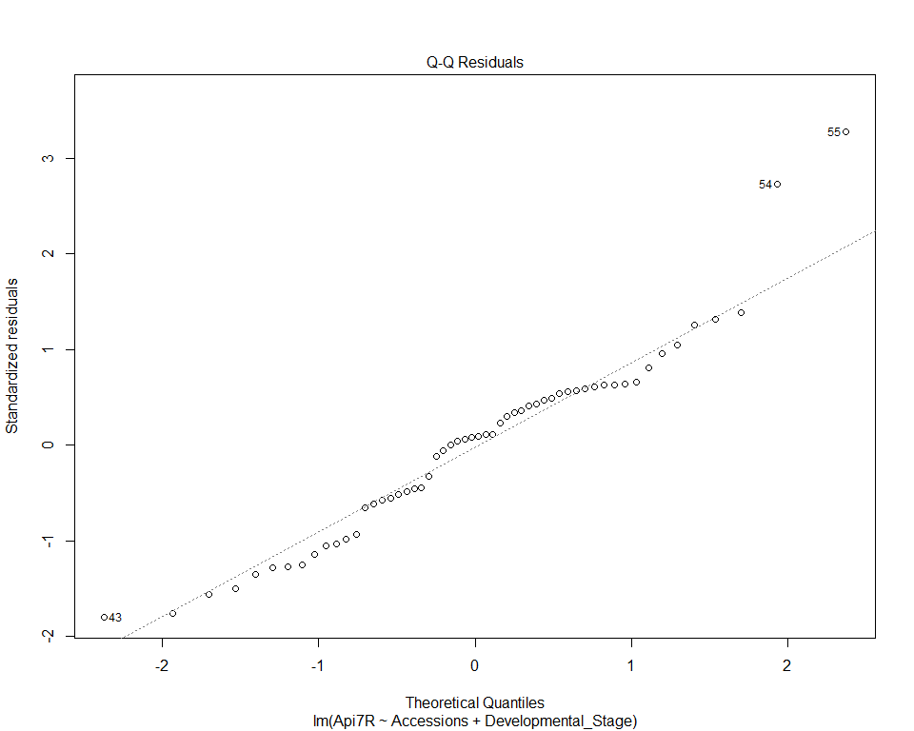
plot(Mod1bis,1)
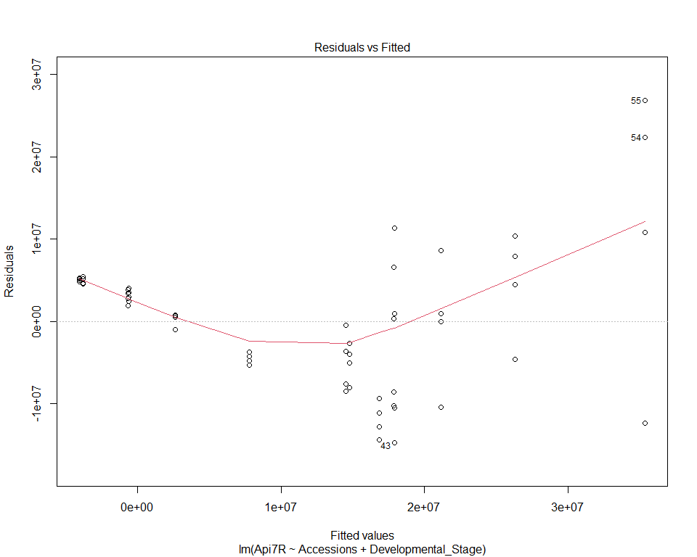

Box-Cox transformation
summary(p2 <- powerTransform(Mod1bis))
mydata_bc <- transform(donnees, Api7R_bc=bcPower(Api7R,coef(p2)))
Mod1bis_bc <- lm(Api7R_bc~ Accessions+Developmental_Stage, data=mydata_bc)
res=residuals(Mod1bis_bc)
ks.test(res,"pnorm", 0, sd(res))
Exact one-sample Kolmogorov-Smirnov test
data: res
D = 0.14015, p-value = 0.2014
alternative hypothesis: two-sided
plot(Mod1bis_bc,1)
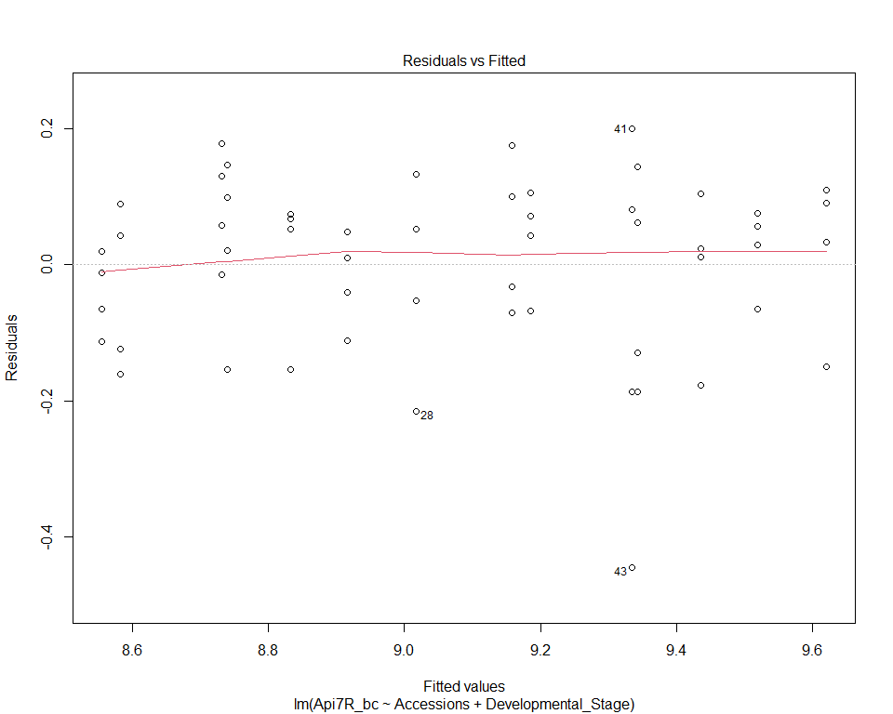
plot(Mod1bis_bc,2)
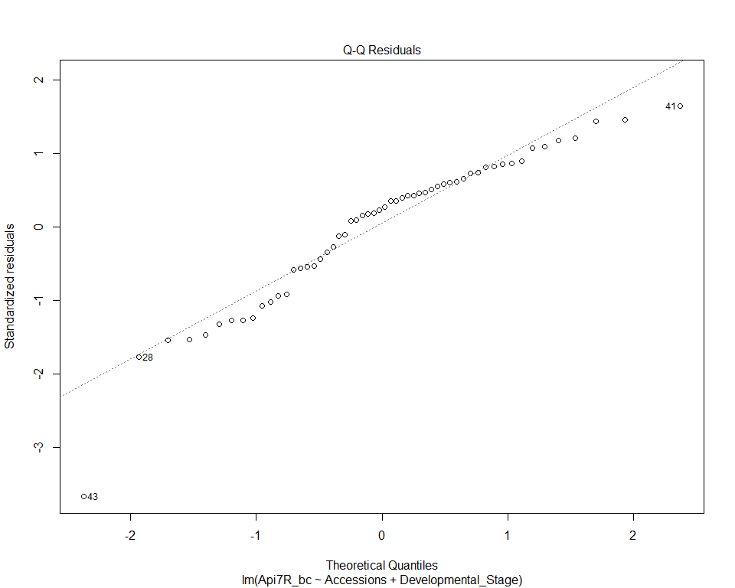
anova(Mod1bis_bc)
Analysis of Variance Table
Response: Api7R_bc
Df Sum Sq Mean Sq F value Pr(>F)
Accessions 1 5.0751 5.0751 295.151 < 2.2e-16 ***
Developmental_Stage 6 1.3598 0.2266 13.181 9.388e-09 ***
Residuals 48 0.8254 0.0172
---
Signif. codes: 0 '***' 0.001 '**' 0.01 '*' 0.05 '.' 0.1 ' ' 1

Models comparison
model_complet= aov(Api7R_bc~ Accessions*Developmental_Stage,data=mydata_bc)
model_rduit=aov(Api7R_bc ~Accessions+Developmental_Stage, data=mydata_bc)
anova(model_complet,model_rduit)
Analysis of Variance Table
Model 1: Api7R_bc ~ Accessions * Developmental_Stage
Model 2: Api7R_bc ~ Accessions + Developmental_Stage
Res.Df RSS Df Sum of Sq F Pr(>F)
1 42 0.72242
2 48 0.82536 -6 -0.10294 0.9975 0.4397

Pairwise comparison
emm_Api7R_1 <- emmeans(Mod1bis_bc, pairwise ~ Developmental_Stage |Accessions)
cld_Acc=cld(emm_Api7R_1, Letter="abcdefghijk")
cld_df <- as.data.frame(cld_Acc)
cld_df_ordered <- cld_df %>%
arrange(factor(Accessions, levels = levels(donnees$Accessions)),
factor(Developmental_Stage, levels = levels(donnees$Developmental_Stage)))
cld_df_ordered
Developmental_Stage Accessions emmean SE df lower.CL upper.CL .group
2 leaves H1 8.582970 0.04956237 48 8.483319 8.682622 a
3 leaves H1 8.555990 0.04956237 48 8.456338 8.655642 a
4 leaves H1 8.740268 0.04956237 48 8.640617 8.839920 ab
5 leaves H1 8.732216 0.04956237 48 8.632565 8.831868 ab
6 leaves H1 8.832815 0.04956237 48 8.733163 8.932466 bc
9 leaves H1 8.916744 0.04956237 48 8.817092 9.016396 bc
12 leaves H1 9.017844 0.04956237 48 8.918192 9.117496 c
2 leaves I2 9.185057 0.04956237 48 9.085405 9.284709 a
3 leaves I2 9.158076 0.04956237 48 9.058425 9.257728 a
4 leaves I2 9.342355 0.04956237 48 9.242703 9.442007 ab
5 leaves I2 9.334303 0.04956237 48 9.234651 9.433955 ab
6 leaves I2 9.434901 0.04956237 48 9.335249 9.534553 bc
9 leaves I2 9.518831 0.04956237 48 9.419179 9.618483 bc
12 leaves I2 9.619931 0.04956237 48 9.520279 9.719583 c
Confidence level used: 0.95
P value adjustment: tukey method for comparing a family of 7 estimates
significance level used: alpha = 0.05
NOTE: If two or more means share the same grouping symbol,
then we cannot show them to be different.
But we also did not show them to be the same.

Lut7R

Two-way ANOVA with interaction
Mod2=lm(Lut7R~Accessions*Developmental_Stage, data=donnees)

Postulates verification
res2=residuals(Mod2)
ks.test(res2, "pnorm", 0, sd(res2))
Exact one-sample Kolmogorov-Smirnov test
data: res2
D = 0.23952, p-value = 0.002599
alternative hypothesis: two-sided
plot(Mod2,1)
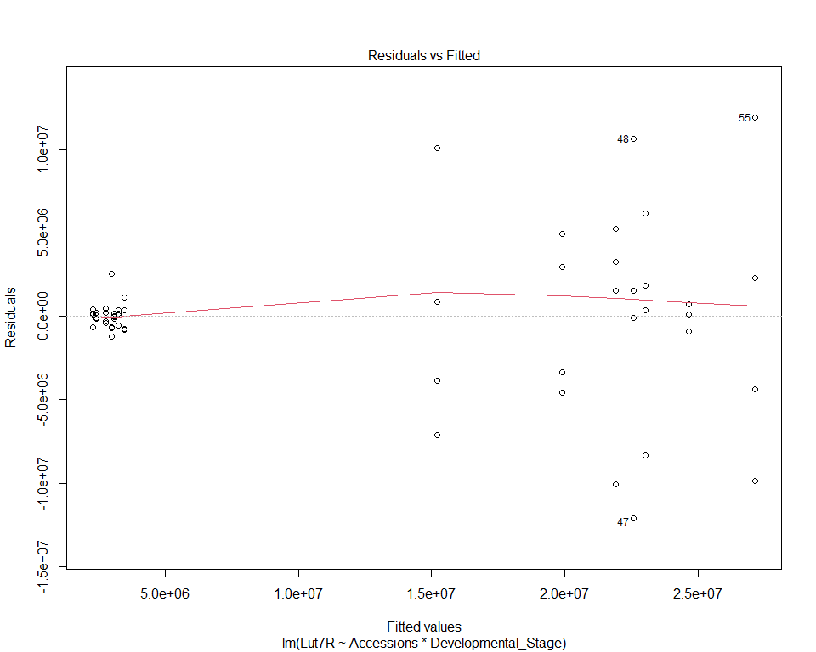
plot(Mod2,2)
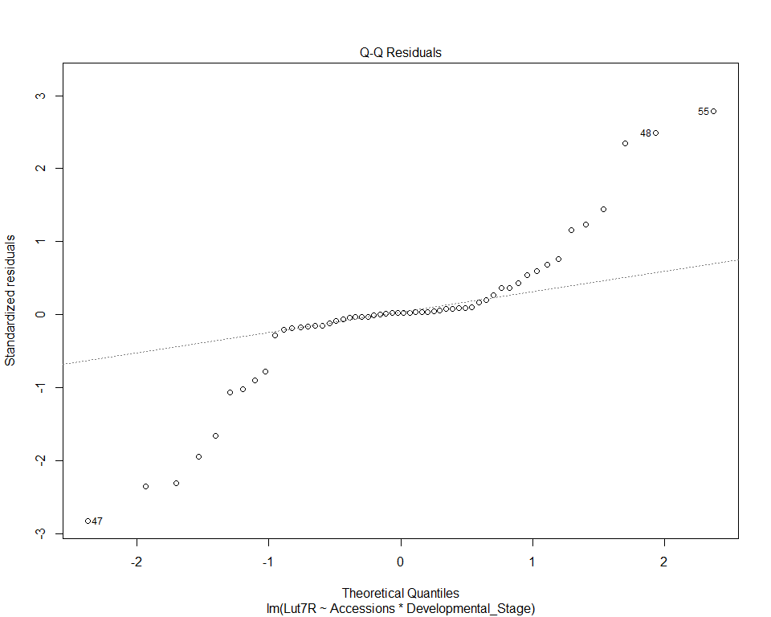

Box-Cox transformation
summary(p2 <- powerTransform(Mod2))
mydata2_bc <- transform(donnees, Lut7R_bc=bcPower(Lut7R,coef(p2)))
Mod2_bc <- lm(Lut7R_bc~ Accessions*Developmental_Stage,data=mydata2_bc)
ks.test(residuals(Mod2_bc), "pnorm", 0, sd(residuals(Mod2_bc)))
Exact one-sample Kolmogorov-Smirnov test
data: residuals(Mod2_bc)
D = 0.10162, p-value = 0.5744
alternative hypothesis: two-sided
plot(Mod2_bc,1)
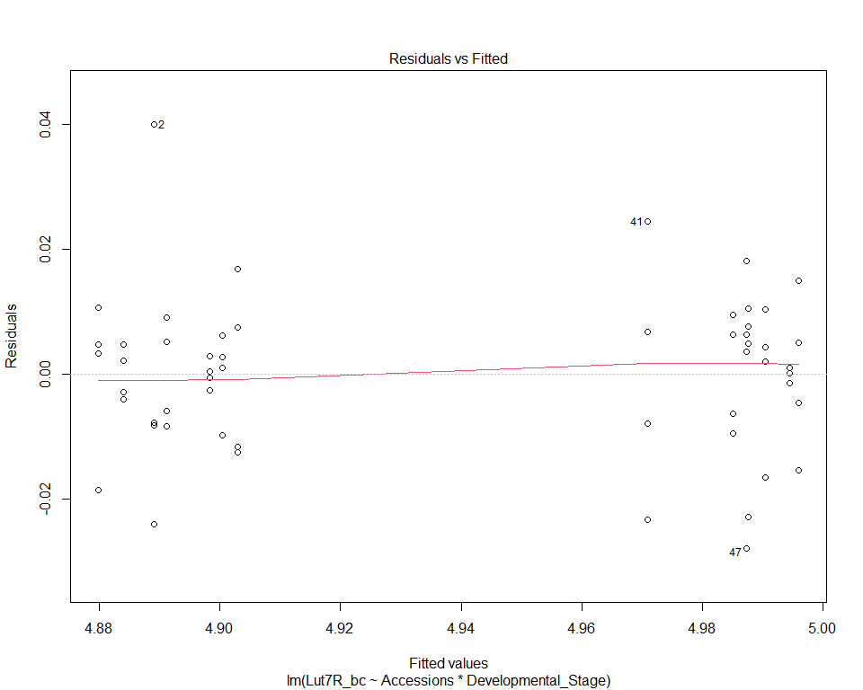
plot(Mod2_bc,2)
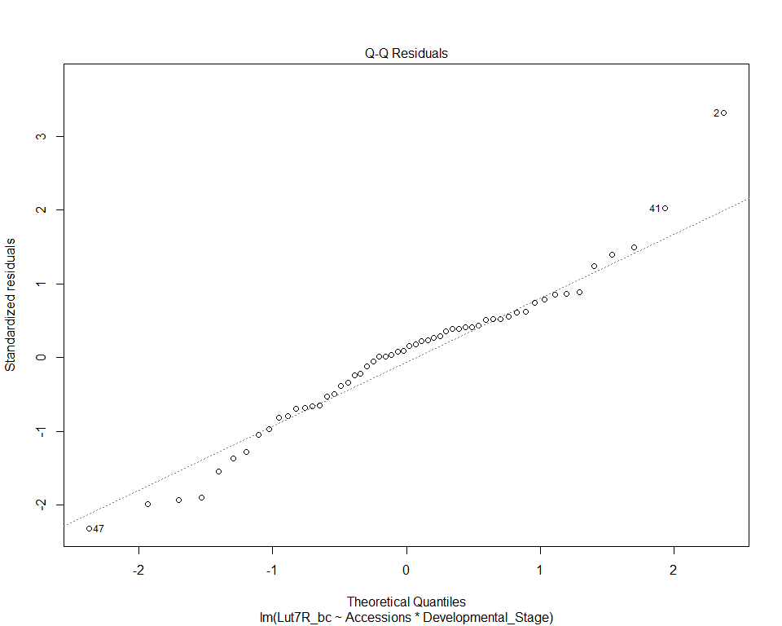
anova(Mod2_bc)
Analysis of Variance Table
Response: Lut7R_bc
Df Sum Sq Mean Sq F value Pr(>F)
Accessions 1 0.126351 0.126351 652.6962 < 2e-16 ***
Developmental_Stage 6 0.002254 0.000376 1.9407 0.09643 .
Accessions:Developmental_Stage 6 0.001183 0.000197 1.0184 0.42662
Residuals 42 0.008130 0.000194
---
Signif. codes: 0 '***' 0.001 '**' 0.01 '*' 0.05 '.' 0.1 ' ' 1

Two-way ANOVA without interaction
Mod2bis=lm(Lut7R ~Accessions+Developmental_Stage, data=donnees)

Postulates verification
res=residuals(Mod2bis)
ks.test(res,"pnorm", 0, sd(res))
Exact one-sample Kolmogorov-Smirnov test
data: res
D = 0.13709, p-value = 0.222
alternative hypothesis: two-sided
plot(Mod2bis,1)
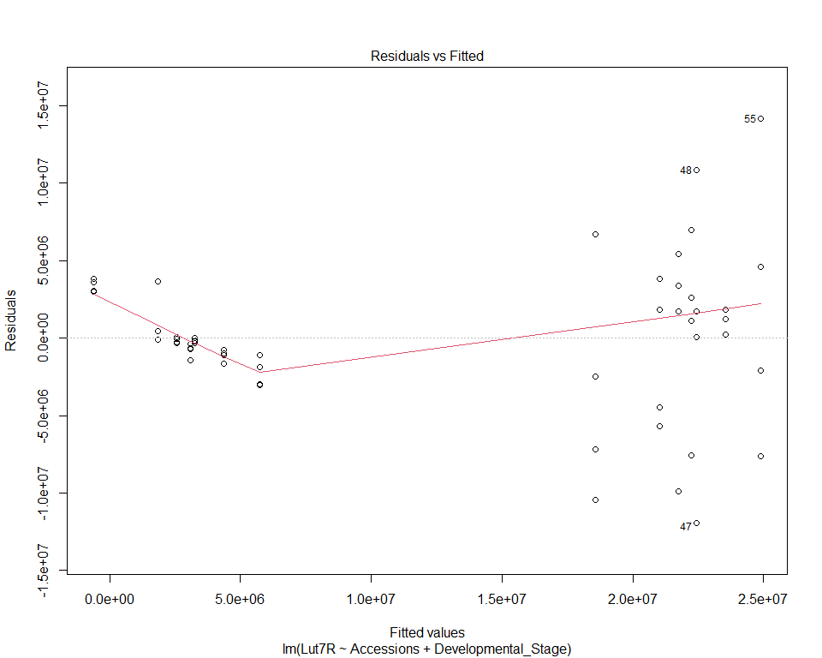
plot(Mod2bis,2)
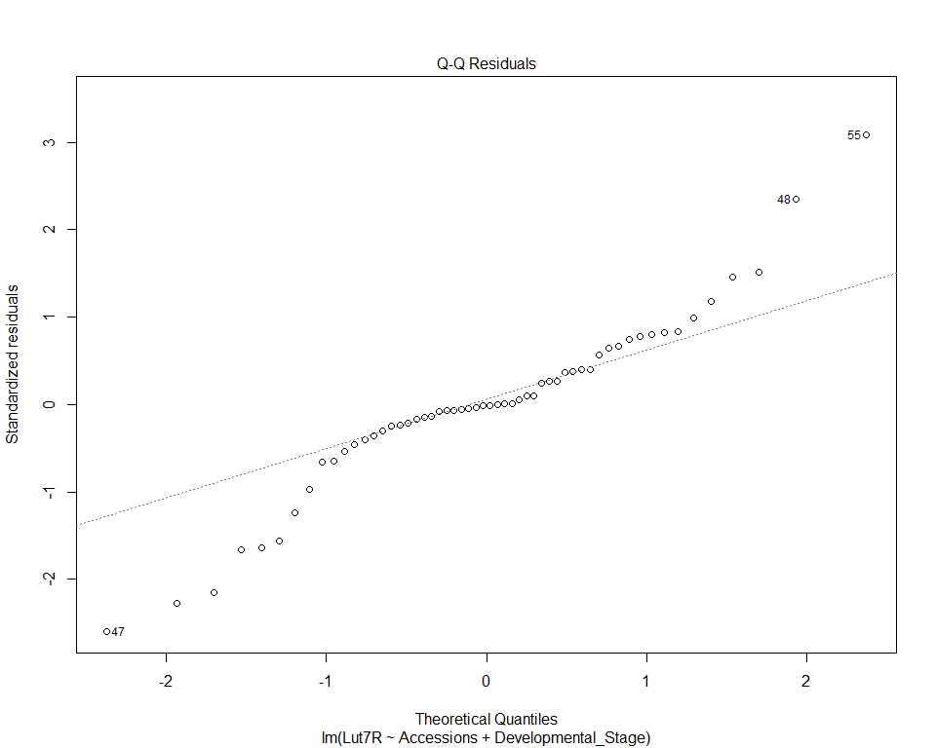

Box-Cox transformation
summary(p2 <- powerTransform(Mod2bis))
mydata_bc <- transform(donnees, Lut7R_bc=bcPower(Lut7R,coef(p2)))
Mod2bis_bc <- lm(Lut7R_bc~ Accessions+Developmental_Stage, data=mydata_bc)
res=residuals(Mod2bis_bc)
ks.test(res,"pnorm", 0, sd(res))
Exact one-sample Kolmogorov-Smirnov test
data: res
D = 0.080884, p-value = 0.8284
alternative hypothesis: two-sided
plot(Mod2bis_bc,1)
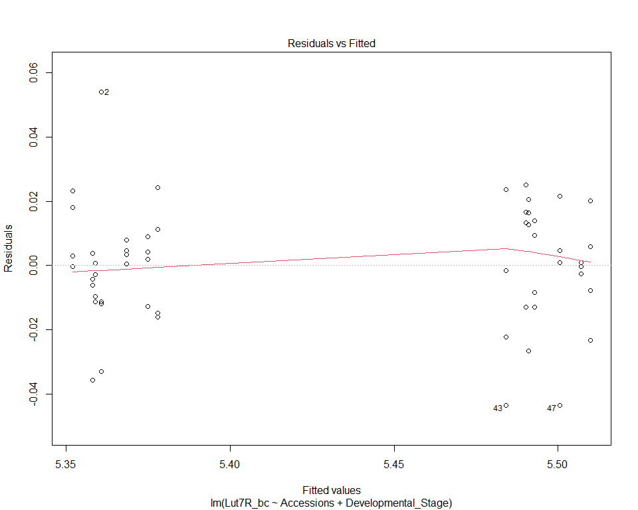
plot(Mod2bis_bc,2)
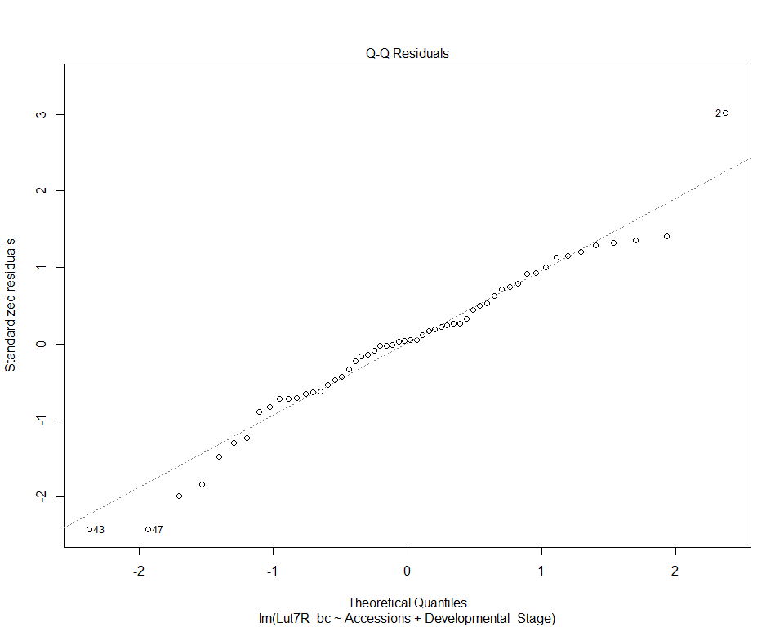
anova(Mod2bis_bc)
Analysis of Variance Table
Response: Lut7R_bc
Df Sum Sq Mean Sq F value Pr(>F)
Accessions 1 0.243881 0.243881 650.0851 < 2e-16 ***
Developmental_Stage 6 0.004343 0.000724 1.9296 0.09508 .
Residuals 48 0.018007 0.000375
---
Signif. codes: 0 '***' 0.001 '**' 0.01 '*' 0.05 '.' 0.1 ' ' 1

Models comparison
model_complet= aov(Lut7R_bc ~Accessions*Developmental_Stage, data=mydata_bc)
model_rduit=aov(Lut7R_bc ~Accessions+Developmental_Stage, data=mydata_bc)
anova(model_complet,model_rduit)
Analysis of Variance Table
Model 1: Lut7R_bc ~ Accessions * Developmental_Stage
Model 2: Lut7R_bc ~ Accessions + Developmental_Stage
Res.Df RSS Df Sum of Sq F Pr(>F)
1 42 0.015744
2 48 0.018007 -6 -0.0022635 1.0064 0.4341

Pairwise comparison
emm_Lut7R_1 <- emmeans(Mod2bis_bc, pairwise ~ Developmental_Stage |Accessions)
cld_Acc=cld(emm_Lut7R_1, Letter="abcdefghijk")
cld_df <- as.data.frame(cld_Acc)
cld_df_ordered <- cld_df %>%
arrange(factor(Accessions, levels = levels(donnees$Accessions)),
factor(Developmental_Stage, levels = levels(donnees$Developmental_Stage)))
cld_df_ordered
Developmental_Stage Accessions emmean SE df lower.CL upper.CL .group
2 leaves H1 5.360750 0.007320733 48 5.346031 5.375470 a
3 leaves H1 5.358198 0.007320733 48 5.343478 5.372917 a
4 leaves H1 5.358952 0.007320733 48 5.344232 5.373671 a
5 leaves H1 5.352106 0.007320733 48 5.337387 5.366825 a
6 leaves H1 5.368483 0.007320733 48 5.353764 5.383202 a
9 leaves H1 5.374995 0.007320733 48 5.360276 5.389715 a
12 leaves H1 5.377869 0.007320733 48 5.363150 5.392588 a
2 leaves I2 5.492735 0.007320733 48 5.478016 5.507455 a
3 leaves I2 5.490183 0.007320733 48 5.475463 5.504902 a
4 leaves I2 5.490937 0.007320733 48 5.476217 5.505656 a
5 leaves I2 5.484091 0.007320733 48 5.469372 5.498810 a
6 leaves I2 5.500468 0.007320733 48 5.485749 5.515187 a
9 leaves I2 5.506980 0.007320733 48 5.492261 5.521700 a
12 leaves I2 5.509854 0.007320733 48 5.495135 5.524573 a
Confidence level used: 0.95
P value adjustment: tukey method for comparing a family of 7 estimates
significance level used: alpha = 0.05
NOTE: If two or more means share the same grouping symbol,
then we cannot show them to be different.
But we also did not show them to be the same.

Chry7R

Two-way ANOVA with interaction
Mod3=lm(Chry7R~Accessions*Developmental_Stage, data=donnees)

Postulates verification
res3=residuals(Mod3)
ks.test(res3, "pnorm", 0, sd(res))
Exact one-sample Kolmogorov-Smirnov test
data: res3
D = 0.51786, p-value = 1.865e-14
alternative hypothesis: two-sided
plot(Mod3,1)
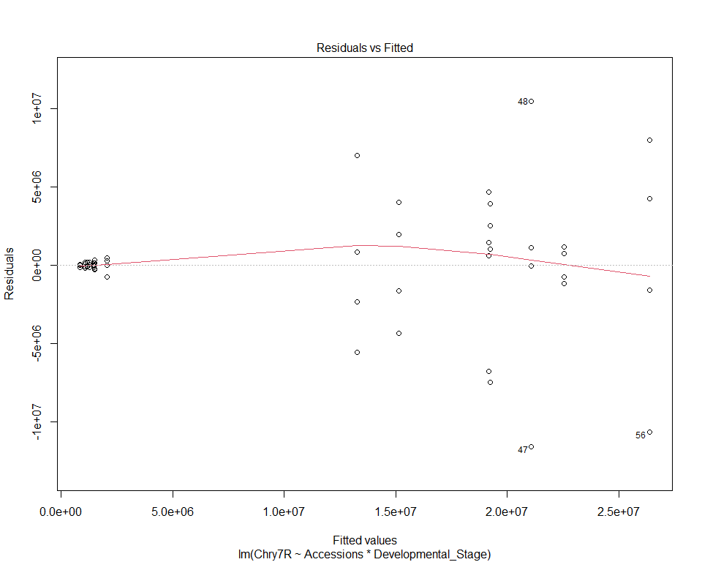
plot(Mod3,2)
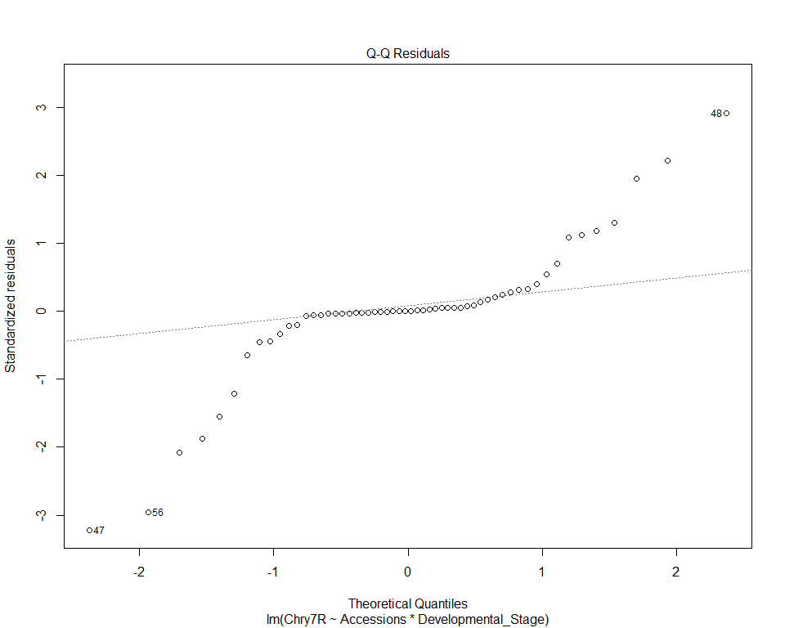

Box-Cox transformation
summary(p3 <- powerTransform(Mod3))
mydata3_bc <- transform(donnees, Chry7R_bc=bcPower(Chry7R,coef(p3)))
Mod3_bc <- lm(Chry7R_bc~ Accessions*Developmental_Stage,data=mydata3_bc)
ks.test(residuals(Mod3_bc), "pnorm", 0, sd(residuals(Mod3_bc)))
Exact one-sample Kolmogorov-Smirnov test
data: residuals(Mod3_bc)
D = 0.10602, p-value = 0.5206
alternative hypothesis: two-sided
plot(Mod3_bc,1)
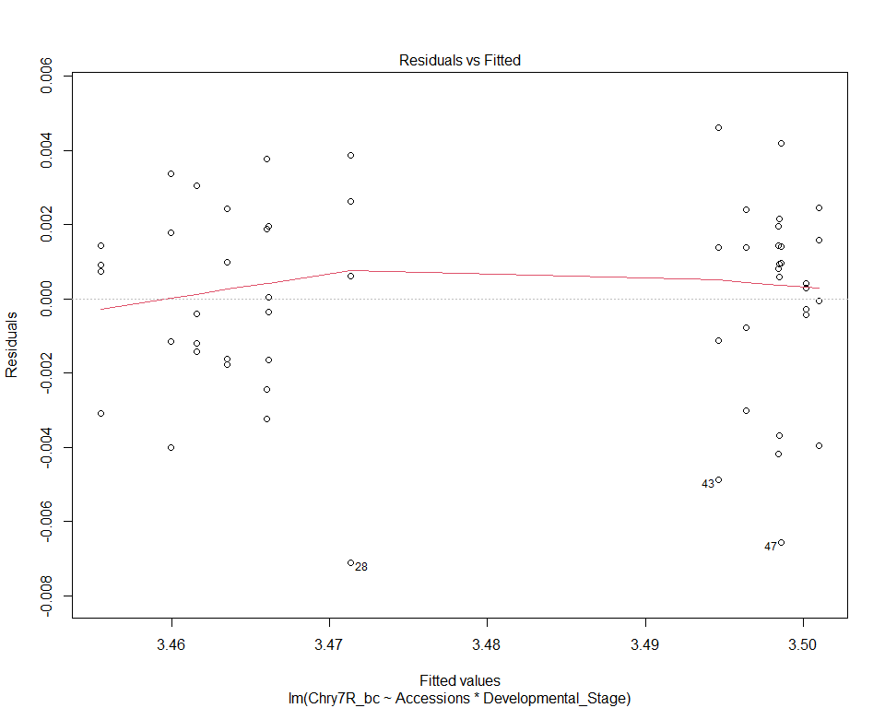
plot(Mod3_bc,2)
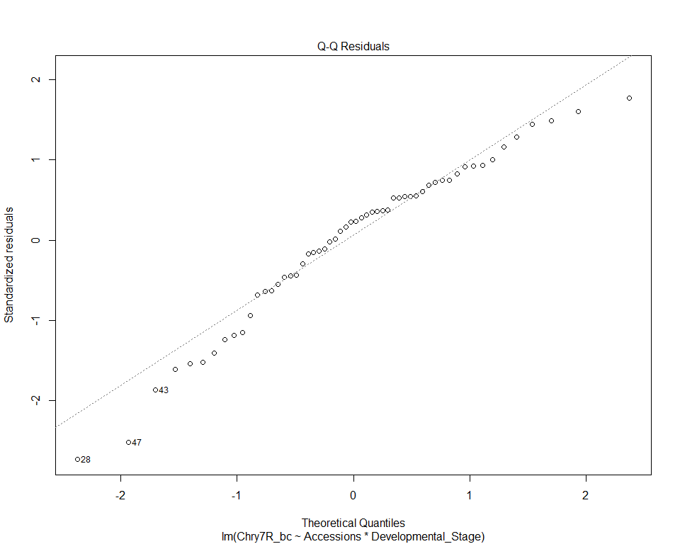
anova(Mod3_bc)
Analysis of Variance Table
Response: Chry7R_bc
Df Sum Sq Mean Sq F value Pr(>F)
Accessions 1 0.0169644 0.0169644 1870.0087 < 2.2e-16 ***
Developmental_Stage 6 0.0005280 0.0000880 9.7008 1.07e-06 ***
Accessions:Developmental_Stage 6 0.0002007 0.0000334 3.6866 0.004949 **
Residuals 42 0.0003810 0.0000091
---
Signif. codes: 0 '***' 0.001 '**' 0.01 '*' 0.05 '.' 0.1 ' ' 1

Pairwise comparison
emm_Chry7R_2 <- emmeans(Mod3_bc, pairwise ~ Developmental_Stage | Accessions)
cld2_chry=cld(emm_Chry7R_2, Letter="abcdefghijk")
cld2_df <- as.data.frame(cld2_chry)
cld2_df_ordered <- cld2_df %>%
arrange(factor(Accessions, levels = levels(donnees$Accessions)),
factor(Developmental_Stage, levels = levels(donnees$Developmental_Stage)))
cld2_df_ordered
Developmental_Stage Accessions emmean SE df lower.CL upper.CL .group
2 leaves H1 3.455534 0.001505974 42 3.452495 3.458573 a
3 leaves H1 3.459941 0.001505974 42 3.456902 3.462980 ab
4 leaves H1 3.461575 0.001505974 42 3.458536 3.464614 ab
5 leaves H1 3.463514 0.001505974 42 3.460474 3.466553 b
6 leaves H1 3.466118 0.001505974 42 3.463079 3.469157 bc
9 leaves H1 3.466046 0.001505974 42 3.463007 3.469086 bc
12 leaves H1 3.471330 0.001505974 42 3.468290 3.474369 c
2 leaves I2 3.496395 0.001505974 42 3.493356 3.499434 a
3 leaves I2 3.498436 0.001505974 42 3.495397 3.501475 a
4 leaves I2 3.498477 0.001505974 42 3.495438 3.501516 a
5 leaves I2 3.494654 0.001505974 42 3.491615 3.497693 a
6 leaves I2 3.498622 0.001505974 42 3.495583 3.501662 a
9 leaves I2 3.500151 0.001505974 42 3.497112 3.503190 a
12 leaves I2 3.500993 0.001505974 42 3.497954 3.504033 a
Confidence level used: 0.95
P value adjustment: tukey method for comparing a family of 7 estimates
significance level used: alpha = 0.05
NOTE: If two or more means share the same grouping symbol,
then we cannot show them to be different.
But we also did not show them to be the same.

