Three flavonoids biomarkers of Carrot resistance to Alternaria leaf blight: ACCUMULATION PATTERN AT DIFFERENT PHENOLOGICAL STAGES AND CONSISTENCY ACROSS DIVERSE GENETIC BACKGROUNDS

Molecular breeding

Marie Louisa Ramaroson*¹, Claude Emmanuel Koutouan*¹, Angelina El Ghaziri¹, Raymonde Baltenweck², Patricia Claudel², Philippe Hugueney², Sébastien Huet¹, Anita Suel¹, Linda Voisine¹, Mathilde Briard¹, Jean Jacques Helesbeux³, Latifa Hamama¹, Valérie le Clerc¹, Emmanuel Geoffriau^{1,§}

1 Institut Agro, Université d’Angers, INRAE, IRHS, SFR 4207 QUASAV, Angers, France
2 Université de Strasbourg, INRAE, SVQV UMR-A 1131, F-68000 Colmar, France
3 Université de Strasbourg, INRAE, SVQV UMR-A 1131, F-68000 Colmar, France
§ Correspondence: emmanuel.geoffriau@institut-agro.fr; Tel : +33-(0)2 41 22 54 31
* The first two authors contributed equally to the paper

Online Resource 4: Disease data analysis (Trial 2)

Table of contents

Trial2_DS <- read_excel("données ALB et metabo.xlsx",sheet = "données ALB")
The following is a summary of the dataset of trial 2.
summary(Trial2_DS, maxsum=8)
Accessions repetition Score
PRESTO :4 1:7 Min. :3.000
H1 :3 2:8 1st Qu.:4.000
A92 :4 3:8 Median :5.000
B18 :4 4:8 Mean :5.452
BOLERO :4 3rd Qu.:6.000
BRILLYANCE:4 Max. :9.000
VALOR :4
I2 :4

Linear mixed model
model=lmer(Score~Accessions+(1|repetition), data=Trial2_DS)

Postulates verification
res=residuals(model)
shapiro.test(res)
Shapiro-Wilk normality test
data: res
W = 0.96432, p-value = 0.3777
plot(model)
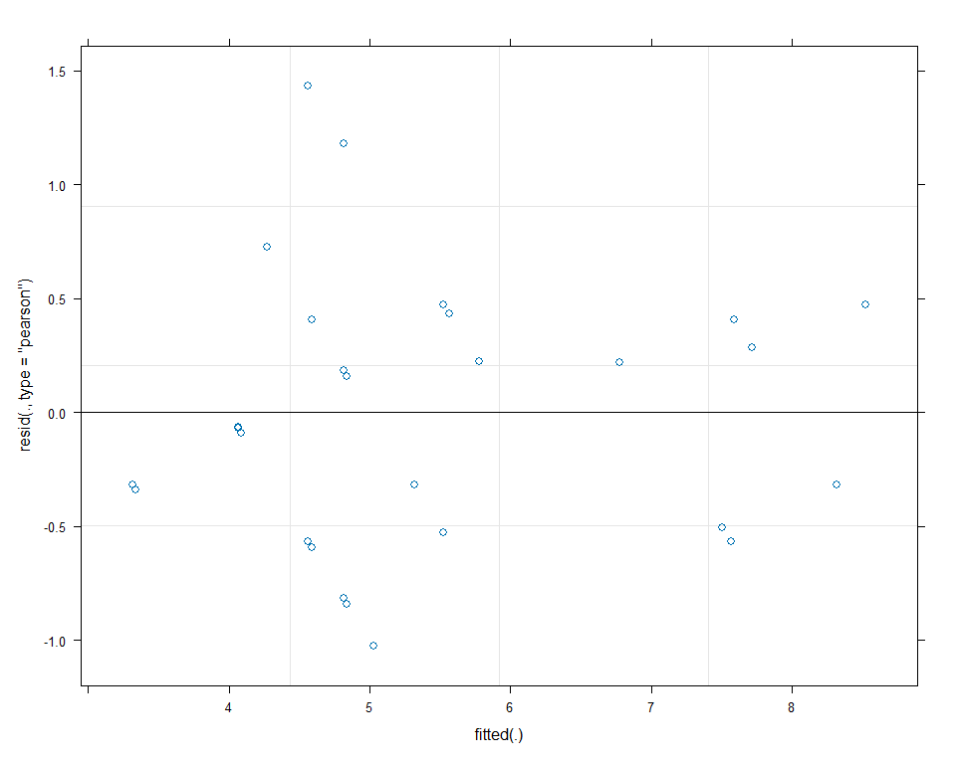

Effects of Accessions and repetitions
Anova(model, test="F")
Analysis of Deviance Table (Type II Wald F tests with Kenward-Roger df)
Response: Score
F Df Df.res Pr(>F)
Accessions 15.339 7 20.033 8.676e-07 ***
---
Signif. codes: 0 '***' 0.001 '**' 0.01 '*' 0.05 '.' 0.1 ' ' 1
ranova(model)
ANOVA-like table for random-effects: Single term deletions
Model:
Score ~ Accessions + (1 | repetition)
npar logLik AIC LRT Df Pr(>Chisq)
<none> 10 -32.274 84.548
(1 | repetition) 9 -35.165 88.329 5.7809 1 0.0162 *
---
Signif. codes: 0 '***' 0.001 '**' 0.01 '*' 0.05 '.' 0.1 ' ' 1

Pairwise comparisons
em_acc=emmeans(model, pairwise ~ Accessions, adjust = "tukey")
cld_results <- cld(em_acc, Letters = letters, adjust = "tukey")
Note: adjust = "tukey" was changed to "sidak"
because "tukey" is only appropriate for one set of pairwise comparisons
cld_results
Accessions emmean SE df lower.CL upper.CL .group
BRILLYANCE 3.75 0.441 11.7 2.29 5.21 a
BOLERO 4.50 0.441 11.7 3.04 5.96 a
A92 5.00 0.441 11.7 3.54 6.46 a
I2 5.00 0.441 11.7 3.54 6.46 a
VALOR 5.25 0.441 11.7 3.79 6.71 a
B18 5.25 0.441 11.7 3.79 6.71 a
H1 7.19 0.491 14.9 5.63 8.75 b
PRESTO 8.00 0.441 11.7 6.54 9.46 b
Degrees-of-freedom method: kenward-roger
Confidence level used: 0.95
Conf-level adjustment: sidak method for 8 estimates
P value adjustment: tukey method for comparing a family of 8 estimates
significance level used: alpha = 0.05
NOTE: If two or more means share the same grouping symbol,
then we cannot show them to be different.
But we also did not show them to be the same.

